DMCF CHATBOT
A PROJECT REPORT
APRIL 2025

Submitted by
CHANAKEYAN R K - 22CT08
JAYABALAJI K - 22CT12
NISHANTH P - 22CT19
ROOBAN G - 22CT23
SATHISH KANNAN R - 23CTI01
Guided by
Mrs. BENAZIRBEGAM S. B.E,
Submitted in partial fulfillment for the award of the Diploma in

“COMPUTER ENGINEERING”

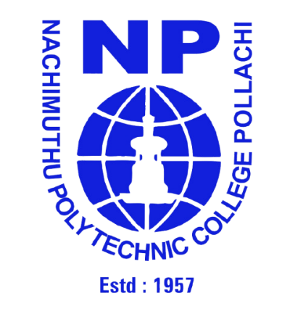

NACHIMUTHU POLYTECHNIC COLLEGE

POLLACHI-642 003
Government Aided * Autonomous Institution * Approved by AICTE, New Delhi
Affiliated to State Board of Technical Education & Training, Tamilnadu.
Accredited by NBA (Civil, Mech, ECE, Automobile, EEE, Textile & Computer)

NACHIMUTHUPOLYTECHNICCOLLEGE

POLLACHI-642 003
Government Aided * Autonomous Institution * Approved by AICTE, New Delhi
Affiliated to State Board of Technical Education & Training, Tamilnadu.
Accredited by NBA (Civil, Mech, ECE, Automobile, EEE, Textile & Computer)

BONAFIDE CERTIFICATE
Certified that this Project report entitled

“DMCF CHATBOT”

Is the Bonafide record work carried out by

NAME: NISHANTH P ROLL NO: 22CT19
During the academic year 2024-2025.

PROJECT GUIDE HEAD OF THE DEPARTMENT

Submitted for the practical examination held on …………….

INTERNAL EXAMINER EXTERNAL EXAMINER
NAME: NAME:
DESIGNATION: DESIGNATION:

