ASSIGNMENT – 2
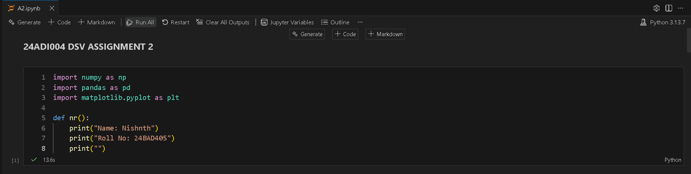
Q1. Rolling Sensor Analysis
You will analyse a set of sensor data.
Sensor Data: python sensor = np.array([22.1, 22.5, 23.0, 24.8, 25.1, 26.0, 27.5, 28.0])
Tasks:
- Compute the rolling mean with a window size of 3.
- Compute the rolling standard deviation.
- Identify any anomalous values that are more than 1.5 times the standard deviation.
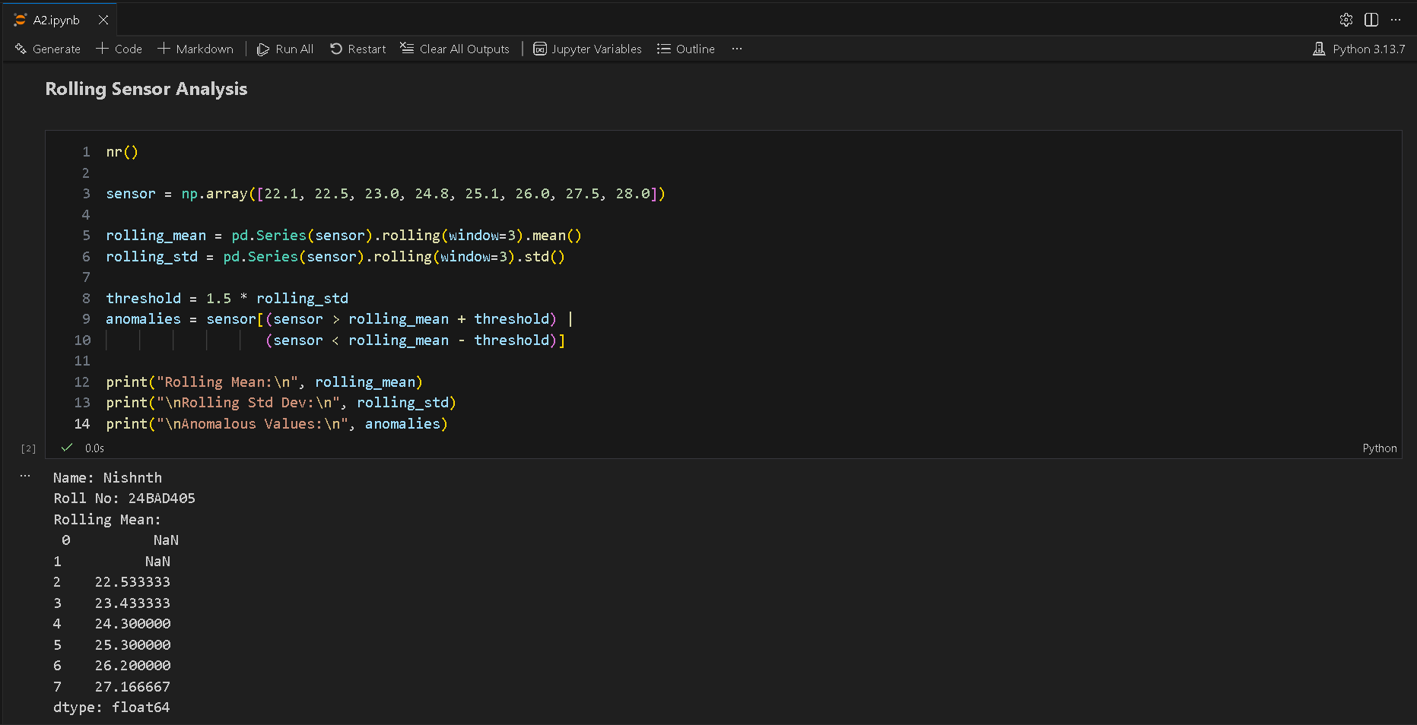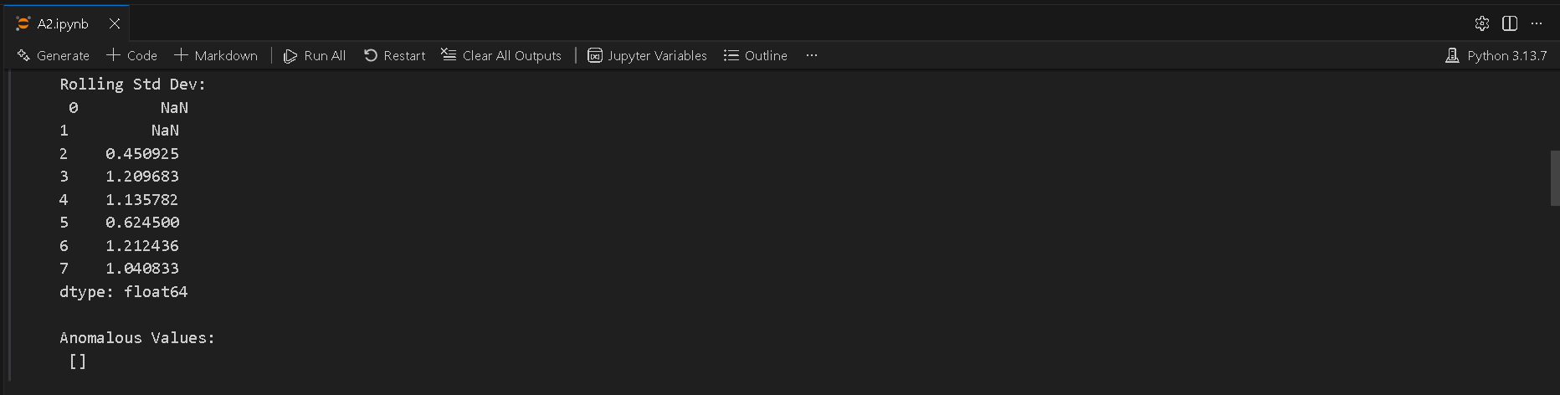

Q2. Distance Matrix Computation
You will calculate distances between points.
Points: python points = np.array([[2, 3], [5, 4], [8, 7], [1, 6]])
Task:
- Compute the Euclidean distance matrix using NumPy broadcasting.
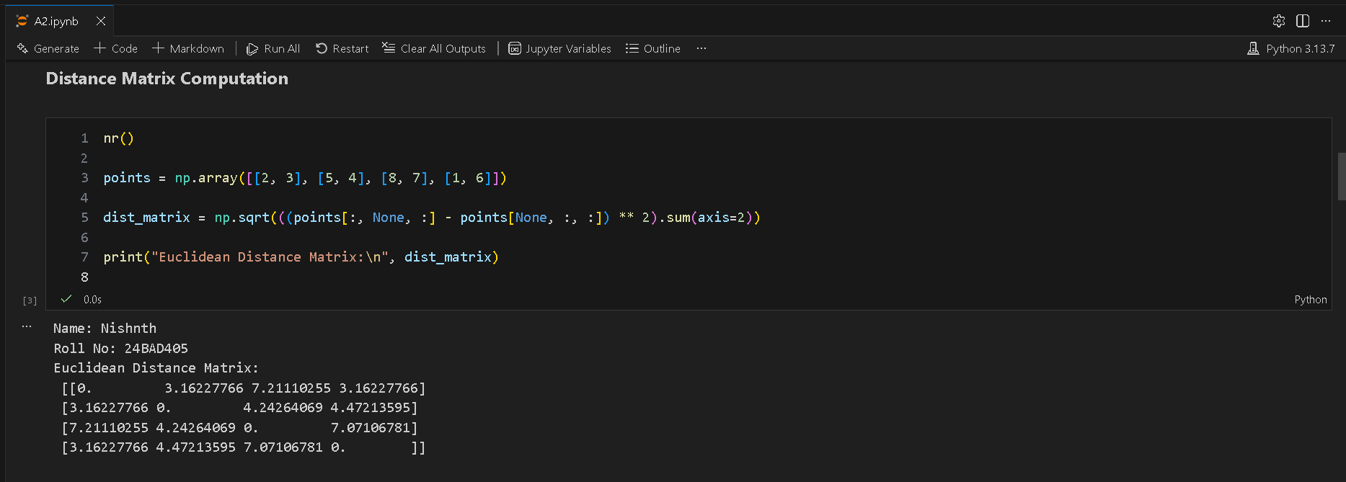

Q3. Monte Carlo Risk Estimation
You will perform a risk estimation using random returns.
Returns: python np.random.seed(10) returns = np.random.normal(0.001, 0.02, 10000)
Tasks:
- Calculate the expected return.
- Estimate the probability of loss.
- Compute the 95% confidence interval.
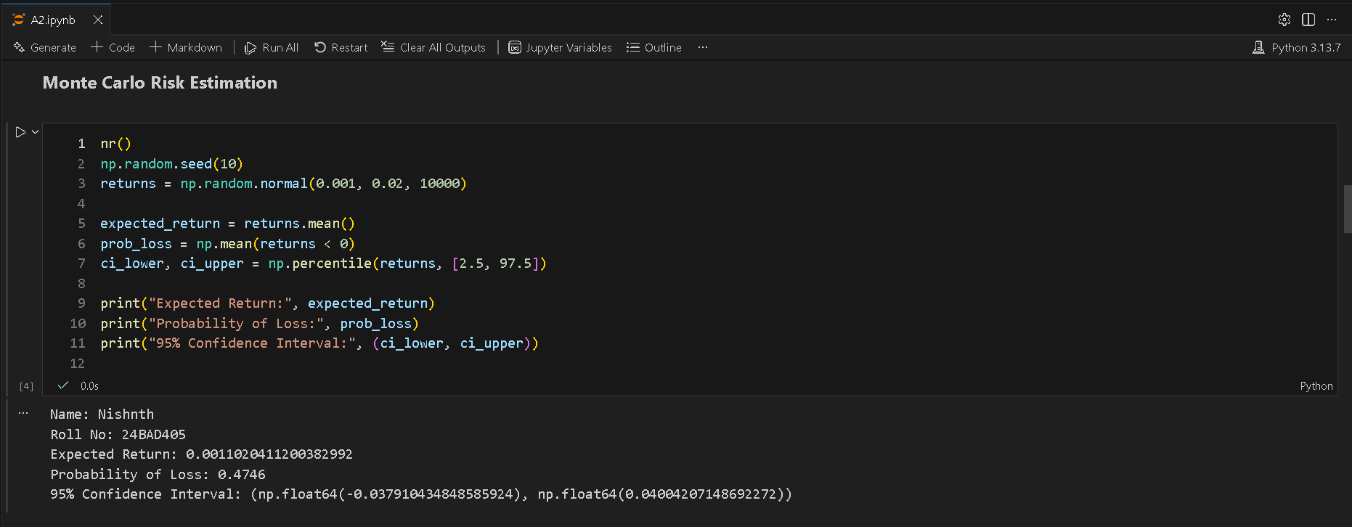

Q4. Sparse Interaction Analysis
You will analyze a sparse interaction matrix.
Interactions: python interactions = np.array([[0, 0, 5, 0], [1, 0, 0, 0], [0, 0, 0, 3], [4, 0, 0, 0]])
Tasks:
- Compute the sparsity percentage of the matrix.
- Normalize the rows of the matrix.
- Extract the top interaction for each row.
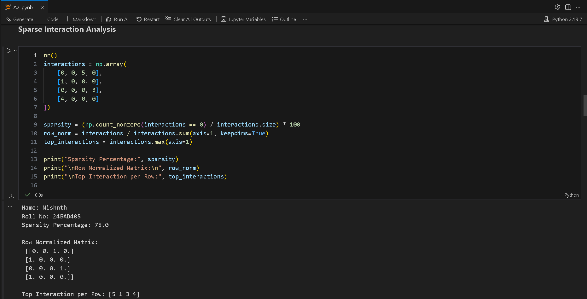

Q5. Student Performance Analysis
You will analyze student performance data.
Data: python data = { "Student": ["A", "B", "C", "D", "E"], "Math": [78, 85, 67, 90, 72], "Physics": [74, 88, 69, 92, 70], "Attendance": [82, 90, 76, 95, 80] }
Tasks:
- Compute the average score for each student.
- Assign grades based on the average scores using specific conditions.
- Identify the top performer among the students.
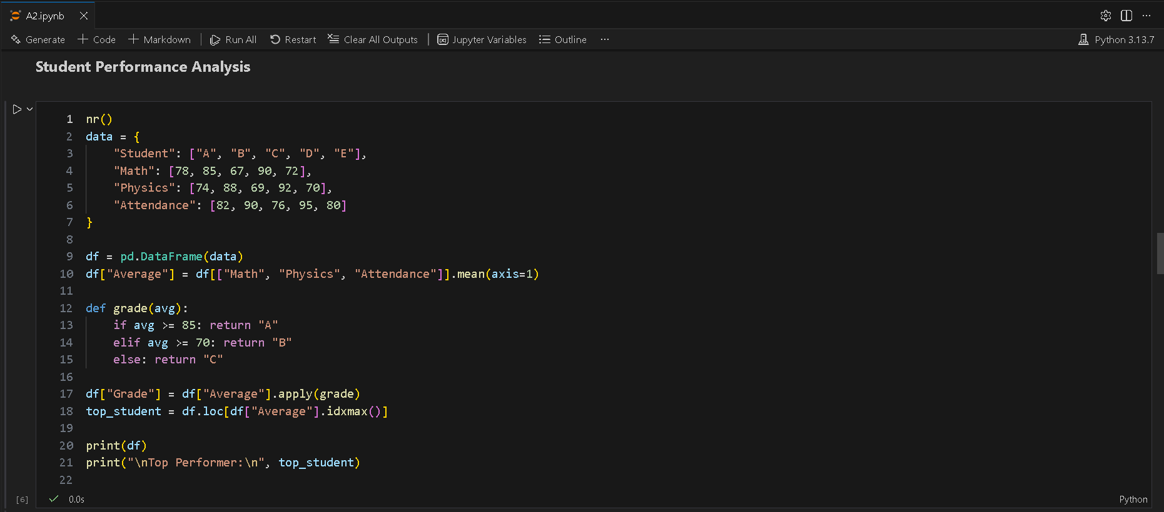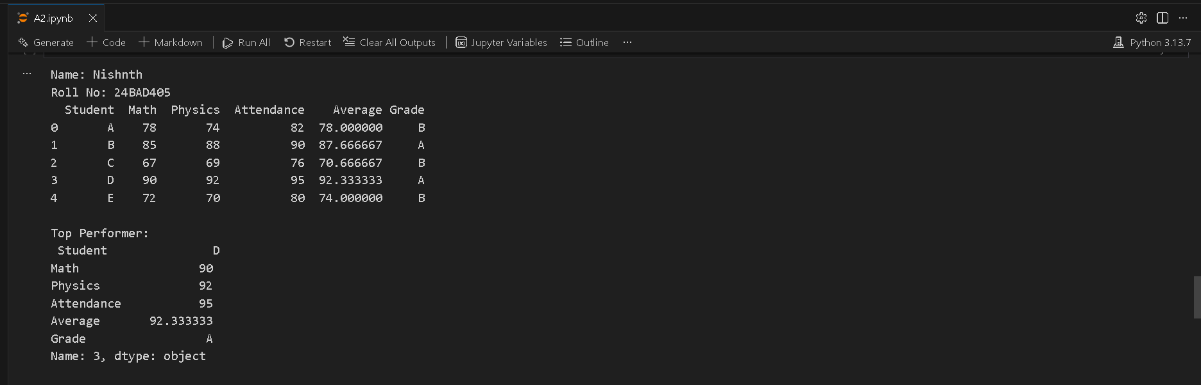

Q6. Time-Series Feature Engineering
You will work with time-series data.
Timestamps and Values: python timestamps = pd.date_range("2024-01-01", periods=10, freq="6H") values = [12, 18, 20, 22, 19, 15, 14, 17, 21, 23]
Tasks:
- Extract the hour and day from the timestamps.
- Create cyclic features using sine and cosine transformations.
- Identify the hour with the peak activity.
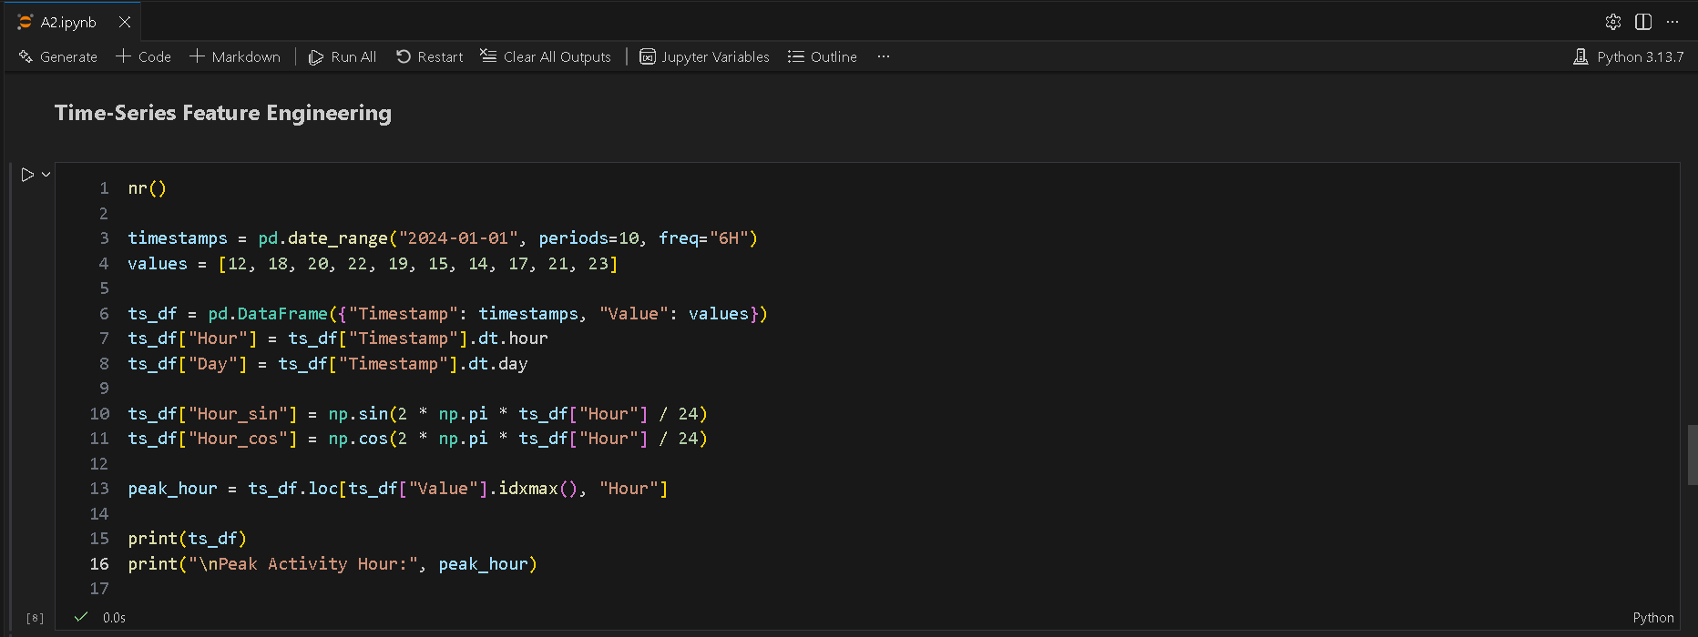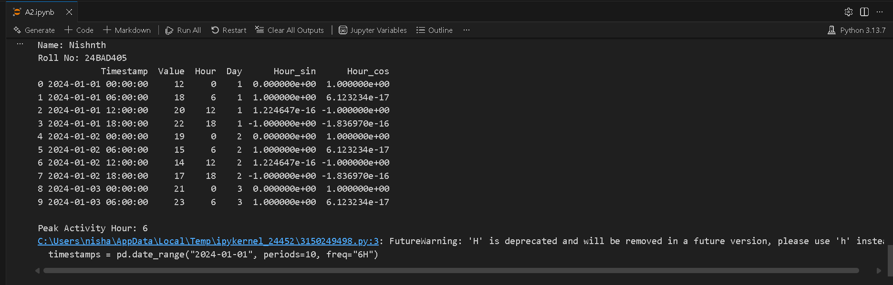

Q7. Data Leakage Detection
You will check for data leakage between training and testing datasets.
Training Data: python train = pd.DataFrame({ "id": [1, 2, 3, 4], "score": [65, 70, 80, 90], "result": [0, 0, 1, 1] })
Testing Data: python test = pd.DataFrame({ "id": [3, 5], "score": [80, 75], "result": [1, 0] })
Tasks:
- Identify any overlapping records between the training and testing datasets.
- Detect any columns that may cause leakage.
- Compute the percentage of leakage.
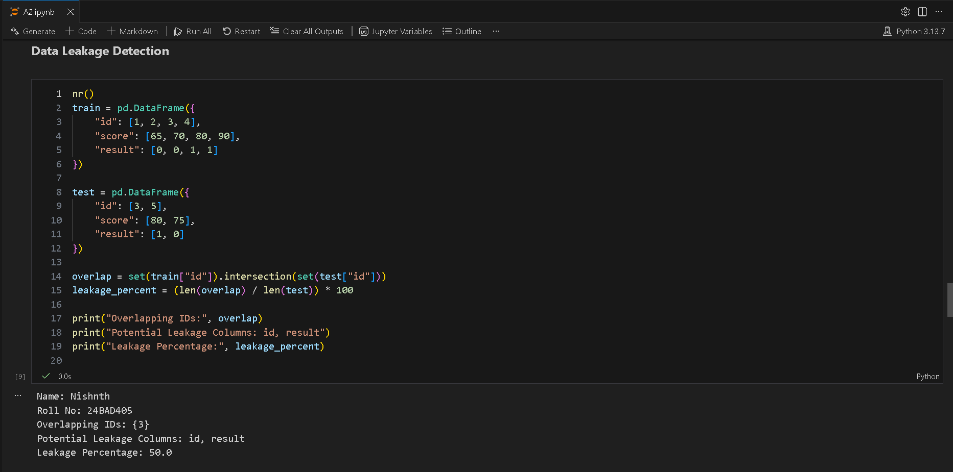

Q8. Memory Optimization
You will optimize memory usage in a DataFrame.
DataFrame: python df = pd.DataFrame({ "A": np.random.randint(0, 1000, 10000), "B": np.random.rand(10000), "C": ["category"] * 10000 })
Task:
- Reduce the memory usage of the DataFrame and report the memory usage before and after optimization.
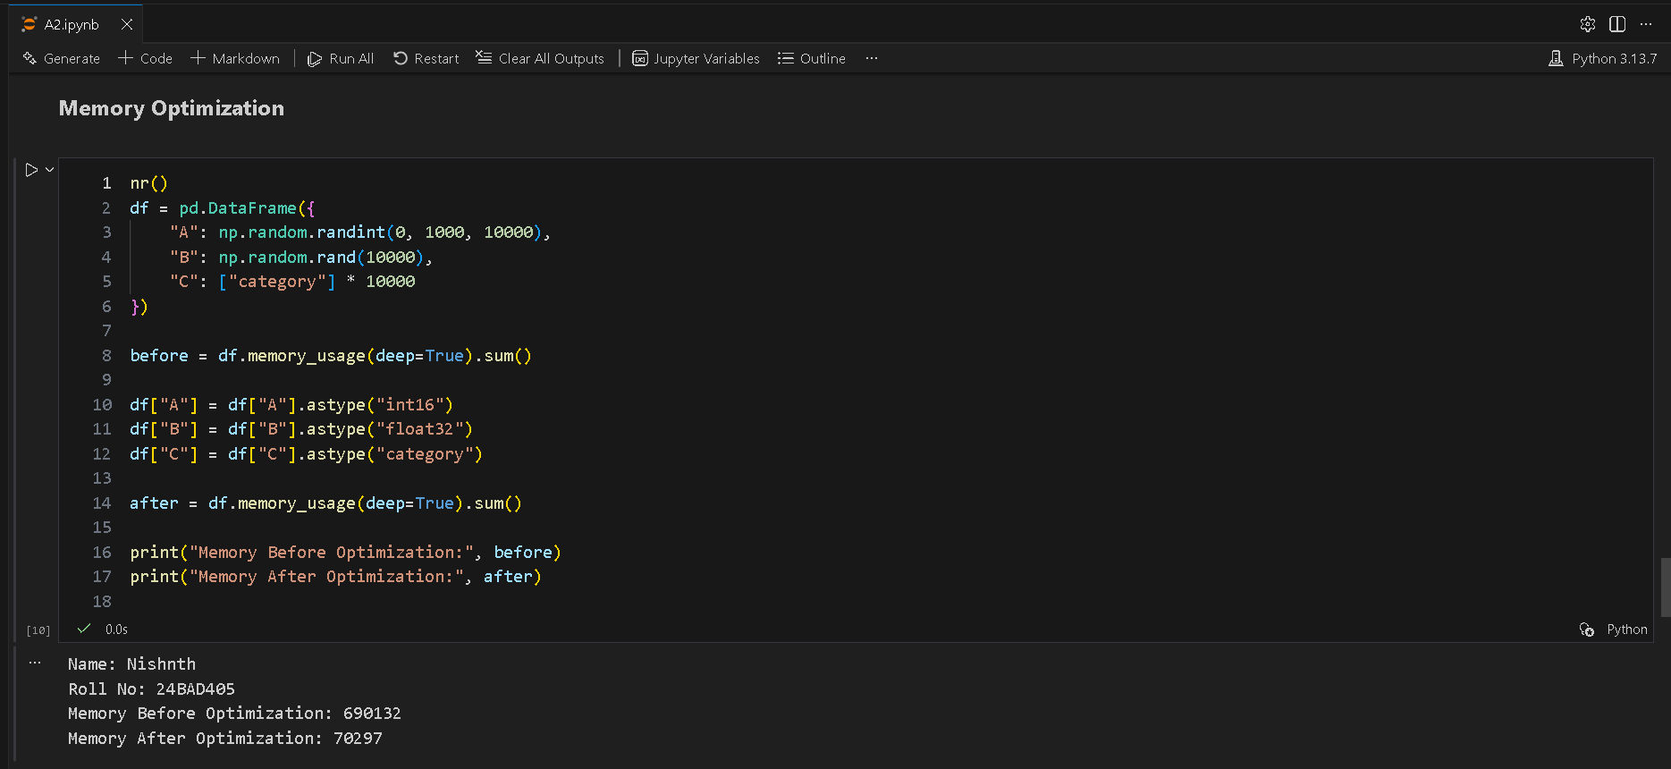

Q9. Uncertainty Visualization (Matplotlib)
You will create a line graph with uncertainty visualization.
Data: python x = np.arange(1, 11) y = np.array([10, 12, 15, 18, 20, 22, 24, 23, 25, 27]) error = np.array([1, 1.2, 1.5, 1.3, 1.4, 1.6, 1.8, 1.7, 1.9, 2.0])
Task:
- Plot a line graph with a shaded error region and annotate the point of maximum uncertainty.
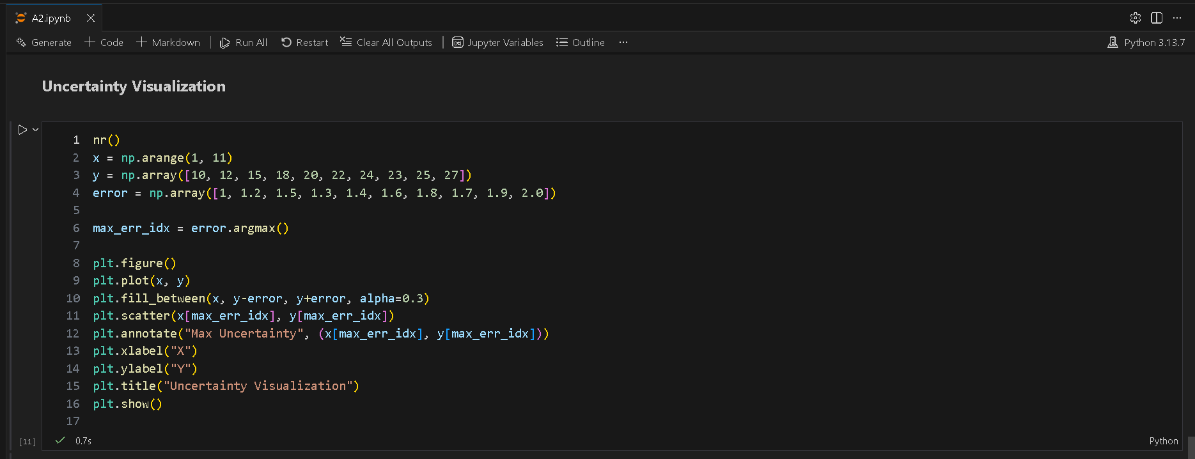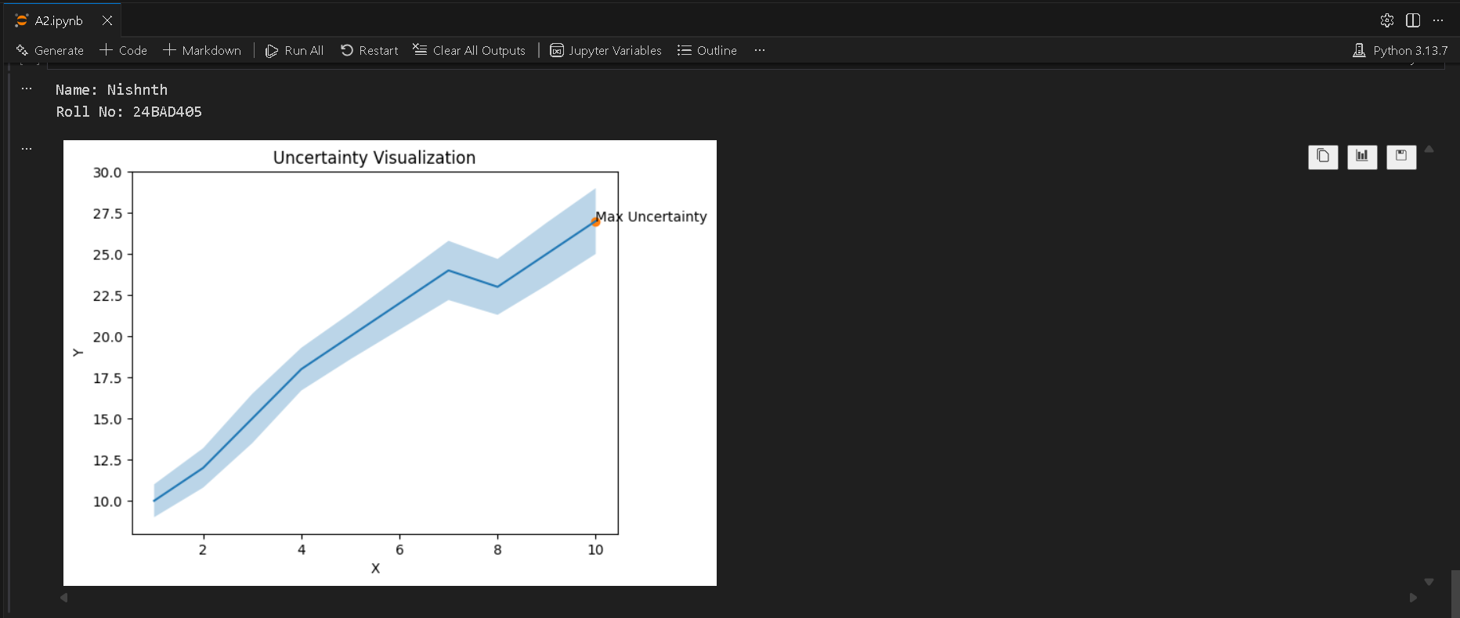

Q10. Correlation Heatmap (Matplotlib only)
You will compute and visualize a correlation matrix.
DataFrame: python df = pd.DataFrame({ "Temp": [30, 32, 34, 36, 38], "Humidity": [70, 65, 60, 55, 50], "Pressure": [1012, 1010, 1008, 1006, 1004] })
Task:
- Compute and visualize the correlation matrix without using Seaborn.
