Experiment Number : 6 Date:

Title of the Experiment: Simulation of Relational Algebra Operations
PRE LAB EXERCISE
QUESTIONS
- What is relational algebra?
Relational algebra is a procedural query language used to manipulate and retrieve data from relational databases using mathematical operations on relations (tables).
- Define the operations: σ (Selection), π (Projection), and ρ (Renaming).
σ (Selection) filters rows based on a condition, π (Projection) selects specific columns, and ρ (Renaming) changes relation or attribute names.
- What is the difference between set union and set difference in relational algebra?
Set union combines tuples from two relations, while set difference returns tuples present in one relation but not in the other.
- How do you represent a Cartesian product in relational algebra?
A Cartesian product is represented as R × S, producing all possible combinations of tuples from relations R and S.
- Why is relational algebra important in query optimization?
Relational algebra is important in query optimization because it helps convert high-level queries into efficient execution plans using algebraic transformations.

IN LAB EXERCISE

OBJECTIVE:
- To simulate relational algebra operations using SQL queries.
- To understand the theoretical concepts and practical equivalents in SQL.

RESOURCES:
- MySQL/PostgreSQL/SQLite or any RDBMS.
- Sample tables Student and Course.

PROGRAM LOGIC:
Sample Tables;
CREATE TABLE Department (

DeptID VARCHAR(5) PRIMARY KEY,

DeptName VARCHAR(50)

);

CREATE TABLE Employee (

EmpID INT PRIMARY KEY,

Name VARCHAR(50),

DeptID VARCHAR(5),

Salary INT

);

CREATE TABLE NewHires (

EmpID INT PRIMARY KEY,

Name VARCHAR(50),

DeptID VARCHAR(5),

Salary INT

);

CREATE TABLE Manager (

MgrID INT PRIMARY KEY,

Name VARCHAR(50),

DeptID VARCHAR(5),

Salary INT

);

CREATE TABLE AllDepts (

DeptID VARCHAR(5) PRIMARY KEY

);
Data Available
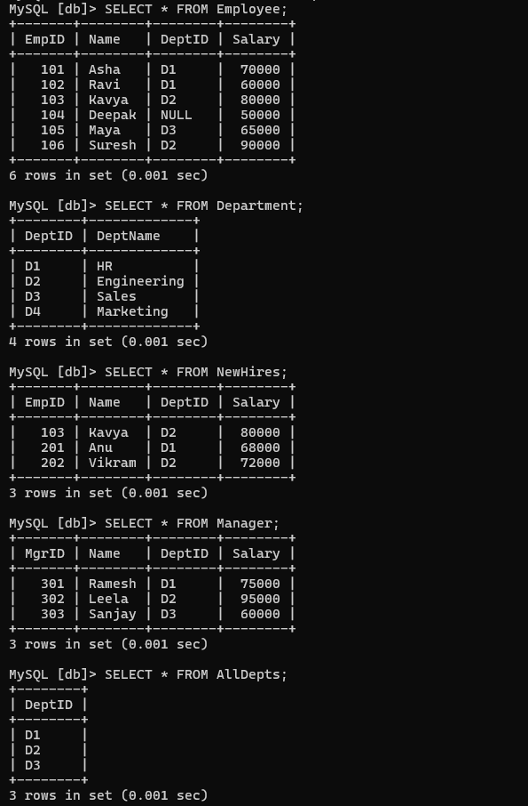

Selection ($σ$)
RA: $σ_{\text{Salary}>65000\text{ AND DeptID}=\text{’D1’}}\left(\text{Employee}\right)$
SQL:
SELECT *
FROM Employee
WHERE Salary > 65000 AND DeptID = 'D1';
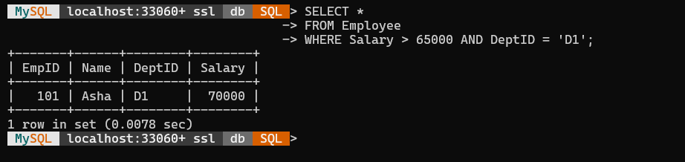

Projection ($π$)
RA: $π_{\text{Name, Salary}}\left(\text{Employee}\right)$
SQL:
SELECT DISTINCT Name, Salary
FROM Employee;
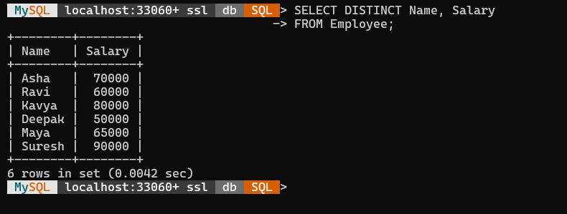

Cartesian Product ($×$)
RA: $\text{Employee}×\text{Department}$
SQL:
SELECT *
FROM Employee
CROSS JOIN Department;
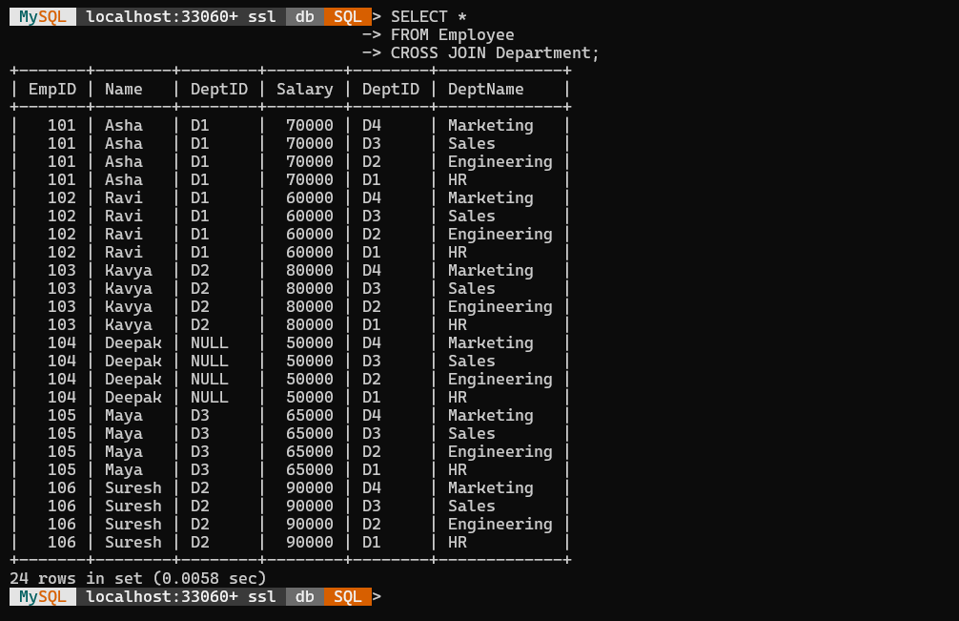

Union ($∪$)
RA: $\text{Employee}∪\text{NewHires}$
SQL:
SELECT * FROM Employee
UNION
SELECT * FROM NewHires;

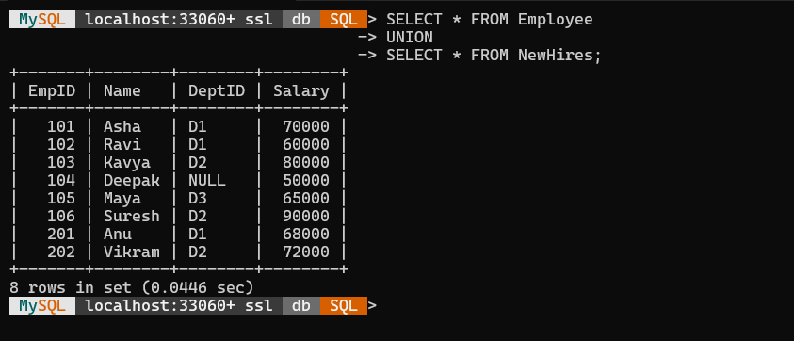

Set Difference ($-$)
RA: $\text{Employee}-\text{NewHires}$
SQL:
SELECT * FROM Employee
EXCEPT
SELECT * FROM NewHires;
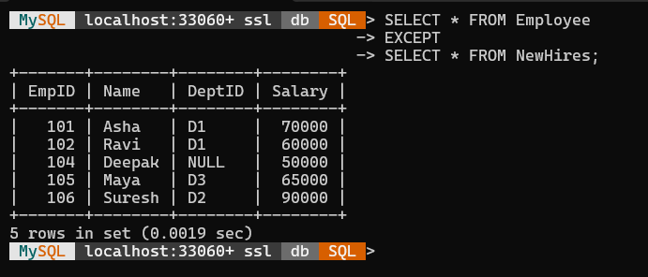

Set Intersection ($∩$)
RA: $\text{Employee}∩\text{NewHires}$
SQL:
SELECT * FROM Employee
INTERSECT
SELECT * FROM NewHires;
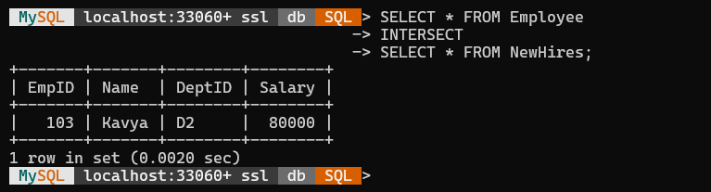

Rename ($ρ$)
RA: $ρ_{\text{E}}\left(\text{Employee}\right)$
$$ρ_{\text{E(ID, WorkerName, D_ID, Pay)}}\left(\text{Employee}\right)$$
SQL:
SELECT *
FROM Employee AS E;
SELECT EmpID AS ID, Name AS WorkerName, DeptID AS D_ID, Salary AS Pay
FROM Employee;
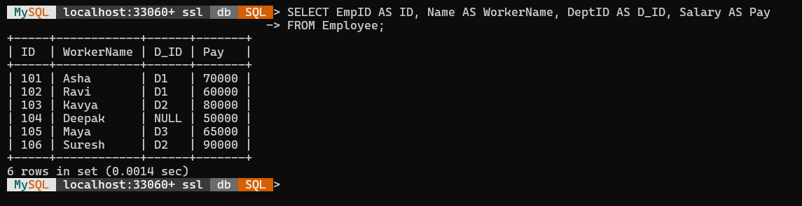

Natural Join ($⋈$)
RA: $\text{Employee}⋈\text{Department}$
SQL:
SELECT *
FROM Employee
NATURAL JOIN Department;
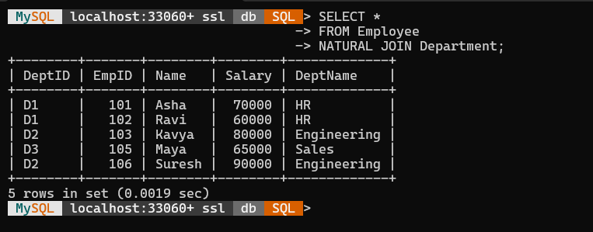

Theta Join ($⋈_{θ}$)
RA: $\text{Employee}⋈_{\text{Employee.DeptID}=\text{Department.DeptID}}\left(\text{Department}\right)$
SQL:
SELECT *
FROM Employee
JOIN Department ON Employee.DeptID = Department.DeptID;
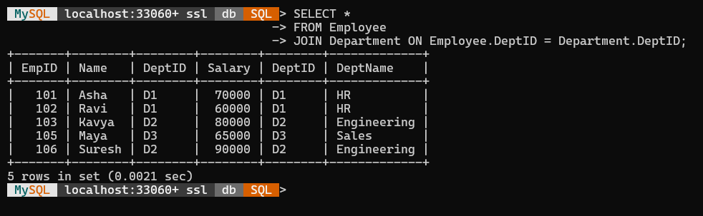
(A non-equijoin example)
RA: $\text{Employee}⋈_{\text{Employee.Salary}>\text{Manager.Salary}}\left(\text{Manager}\right)$
SQL:
SELECT *
FROM Employee
JOIN Manager ON Employee.Salary > Manager.Salary;
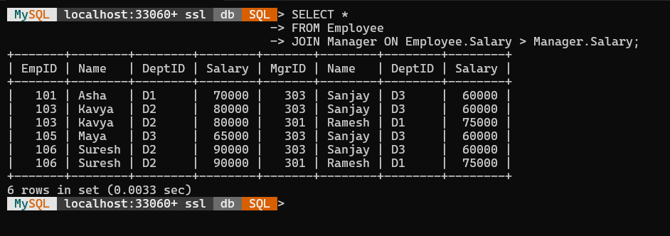
Left Outer Join (⟕)
RA: Employee ⟕ Department
SQL:
SELECT *
FROM Employee
LEFT OUTER JOIN Department ON Employee.DeptID = Department.DeptID;
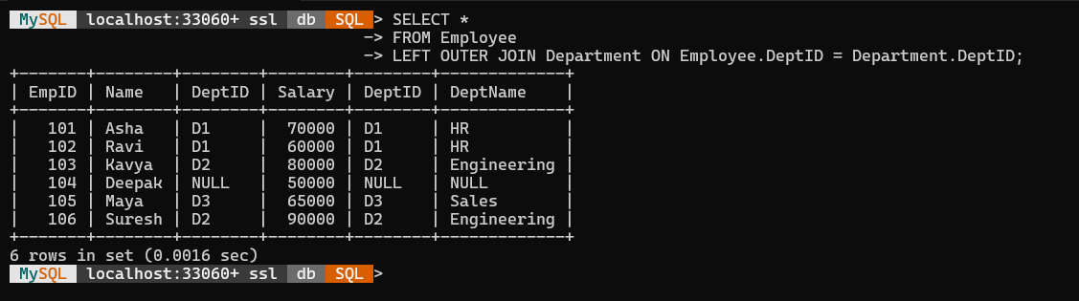

Right Outer Join (⟖)
RA: Employee ⟖ Department
SQL:
SELECT *
FROM Employee
RIGHT OUTER JOIN Department ON Employee.DeptID = Department.DeptID;
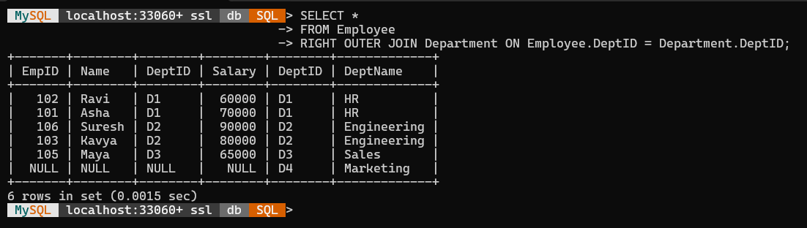
Full Outer Join (⟗)
RA: Employee ⟗ Department
SQL:
SELECT *
FROM Employee
LEFT JOIN Department ON Employee.DeptID = Department.DeptID
UNION
SELECT *
FROM Employee
RIGHT JOIN Department ON Employee.DeptID = Department.DeptID;
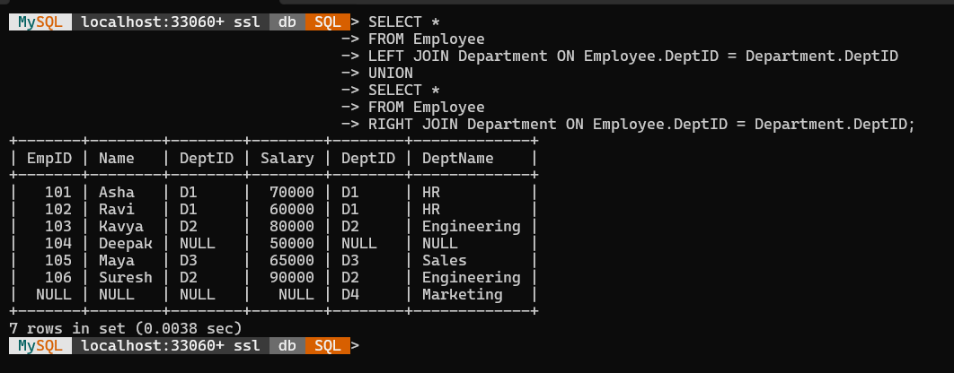

Division ($÷$)
RA: $π_{\text{EmpID, DeptID}}\left(\text{Employee}\right)÷π_{\text{DeptID}}\left(\text{AllDepts}\right)$
SQL:
SELECT DISTINCT T1.EmpID
FROM Employee AS T1
WHERE NOT EXISTS (
SELECT *
FROM AllDepts
WHERE NOT EXISTS (
SELECT *
FROM Employee AS T2
WHERE T2.EmpID = T1.EmpID
AND T2.DeptID = AllDepts.DeptID
)
);
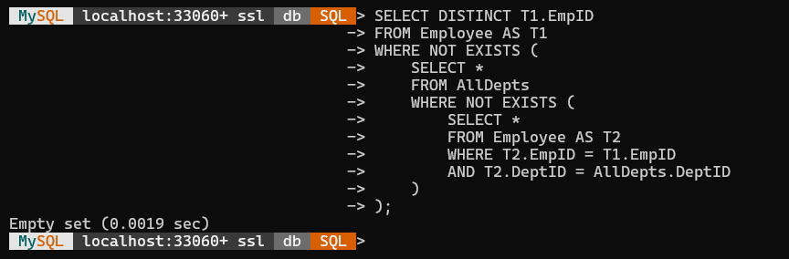

POST LAB EXERCISE

QUESTIIONS:
- What is the purpose of the π (projection) operation?
The π (projection) operation selects specific columns from a relation, removing unwanted attributes and optionally eliminating duplicate rows.
- How does relational algebra help in formalizing database queries?
Relational algebra formalizes database queries by providing mathematical operations to describe how data should be retrieved and manipulated precisely.
- What is the output of a Cartesian product and when is it useful?
The Cartesian product outputs all possible tuple combinations from two relations and is useful for performing joins between related tables.
- How do you avoid duplicates in union operations?
Duplicates in union operations are avoided by using the UNION operator, which automatically removes duplicates (use UNION ALL to keep them).
- How is the selection operation expressed in SQL?
The selection operation in SQL is expressed using the WHERE clause, e.g., SELECT * FROM Employee WHERE Salary > 50000;

ASSESSMENT PATTERN.
Description | Max Marks | Marks Awarded
Pre Lab Exercise | 5
In Lab Exercise | 10
Post Lab Exercise | 5
Viva | 10
Total | 30
Faculty Signature

Experiment Number : 7 Date:

Title of the Experiment: Implementation of SQL Joins (INNER, LEFT, RIGHT, FULL OUTER)
PRE LAB EXERCISE
QUESTIONS
- What is a JOIN in SQL?
A JOIN in SQL combines rows from two or more tables based on a related column between them.
- Differentiate between INNER JOIN and LEFT JOIN.
INNER JOIN returns only matching rows from both tables, while LEFT JOIN returns all rows from the left table and matching rows from the right.
- When would you use a RIGHT JOIN?
A RIGHT JOIN is used when you want all rows from the right table and only matching rows from the left table.
- What is the purpose of FULL OUTER JOIN?
FULL OUTER JOIN returns all rows when there’s a match in either table, combining results of both LEFT and RIGHT joins.
- Can JOINs be performed on more than two tables?
Yes, JOINs can be performed on more than two tables by chaining multiple JOIN conditions together in a single SQL query.

IN LAB EXERCISE

OBJECTIVE:
- To perform different types of JOINs in SQL.
- To understand how JOINs combine data from multiple tables based on a related column.
RESOURCES:
Tables: Departments & Employees
CREATE TABLE departments (
dept_id INT PRIMARY KEY,
dept_name VARCHAR(50)
);
CREATE TABLE employees (
emp_id INT PRIMARY KEY,
emp_name VARCHAR(50),
dept_id INT
);
Table Departments & Employees
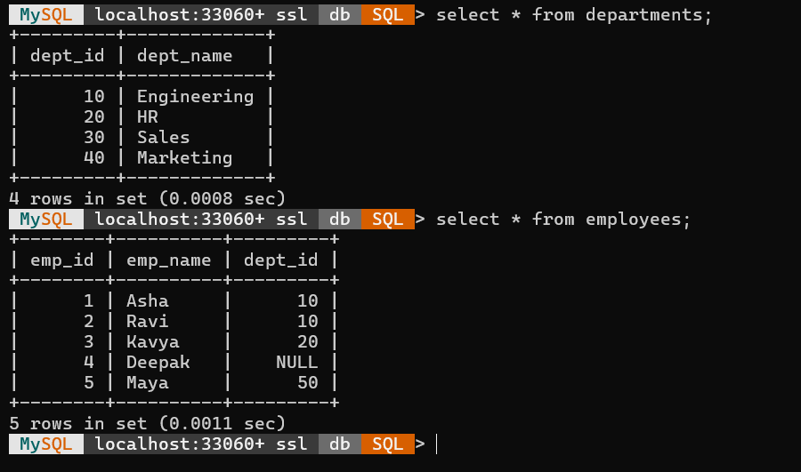
Inner Join
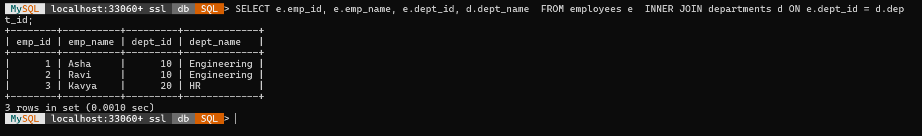
Left Join
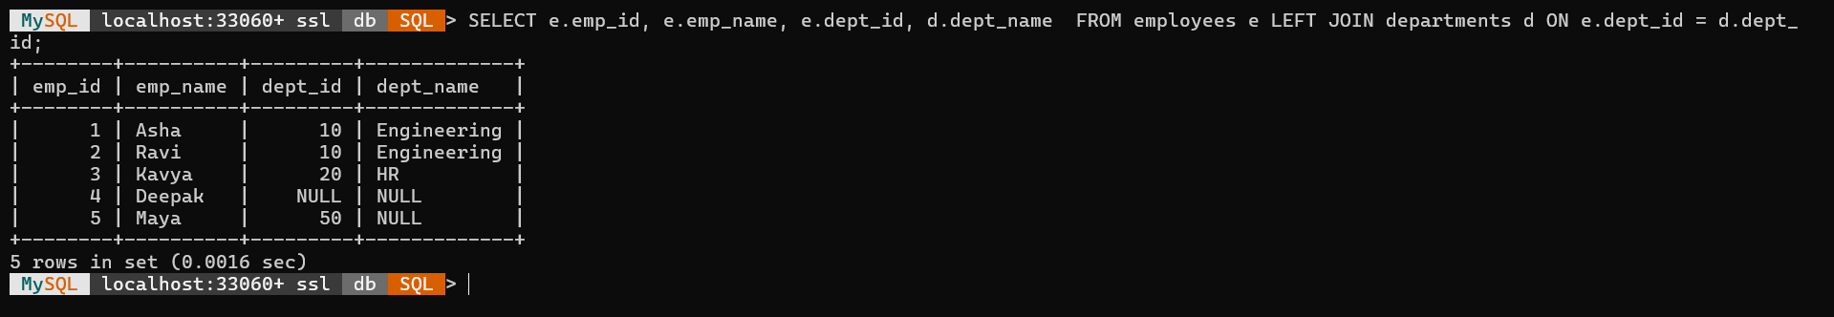
Right Join
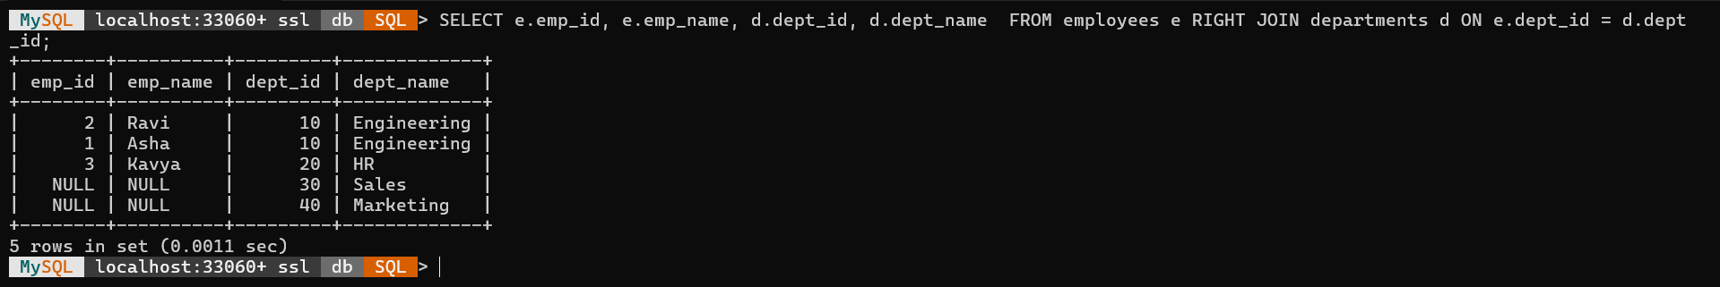
Full Join
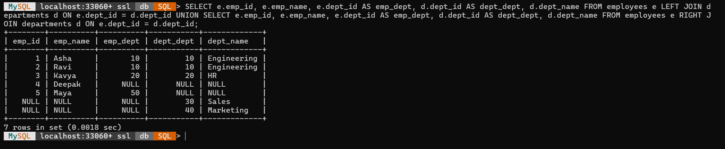

POST LAB EXERCISE

QUESTIIONS:
- What is the output of an INNER JOIN if no matching records are found?
INNER JOIN: Returns an empty result set if no matching records are found in both tables. No rows are displayed when join condition fails.
- How does LEFT JOIN differ from FULL OUTER JOIN?
LEFT JOIN vs FULL OUTER JOIN: LEFT JOIN returns all rows from the left table; FULL OUTER JOIN returns all rows from both tables, including unmatched records.
- Write a query to list students not enrolled in any course.
SELECT * FROM Students WHERE StudentID NOT IN (SELECT StudentID FROM Enrollments);
- Can we join more than two tables in a single SQL query?
Multiple Joins: Yes, SQL allows joining more than two tables in a single query using multiple JOIN conditions in one statement.
- How can NULL values affect the result of JOIN operations?
NULL Effect: NULL values prevent join conditions from matching properly, often excluding those rows from INNER JOIN results unless handled using IS NULL.

ASSESSMENT PATTERN.
Description | Max Marks | Marks Awarded
Pre Lab Exercise | 5
In Lab Exercise | 10
Post Lab Exercise | 5
Viva | 10
Total | 30
Faculty Signature

Experiment Number : 8 Date:

Title of the Experiment: Implementing Transactions Using BEGIN, COMMIT, and ROLLBACK
PRE LAB EXERCISE
QUESTIONS
- What is a transaction in SQL?
Transaction: A transaction in SQL is a sequence of operations performed as a single logical unit of work that must fully complete or fully fail.
- Define the ACID properties of a transaction.
ACID Properties:
Atomicity: All or nothing execution.
Consistency: Maintains database integrity.
Isolation: Transactions don’t interfere.
Durability: Changes persist after commit.
- What is the purpose of the BEGIN, COMMIT, and ROLLBACK statements?
BEGIN: Starts a transaction.
COMMIT: Saves all changes permanently.
ROLLBACK: Undoes changes made within the transaction.
- When would you use ROLLBACK in a real-world scenario?
ROLLBACK Use: Used when an error occurs during a transaction, such as payment failure or invalid data entry, to restore the database to its previous state.
- What is the default behavior of SQL if no transaction boundaries are set?
Default Behavior: If no transaction boundaries are defined, SQL executes each statement independently and automatically commits after every successful operation.

IN LAB EXERCISE

OBJECTIVE:
OBJECTIVE:
- To understand the concept of transactions in SQL.
- To use BEGIN, COMMIT, and ROLLBACK to manage transaction control.
RESOURCES:
- Any SQL-enabled RDBMS (MySQL, PostgreSQL, SQLite).
- Tables: Accounts
PROGRAM LOGIC:
Table Accounts
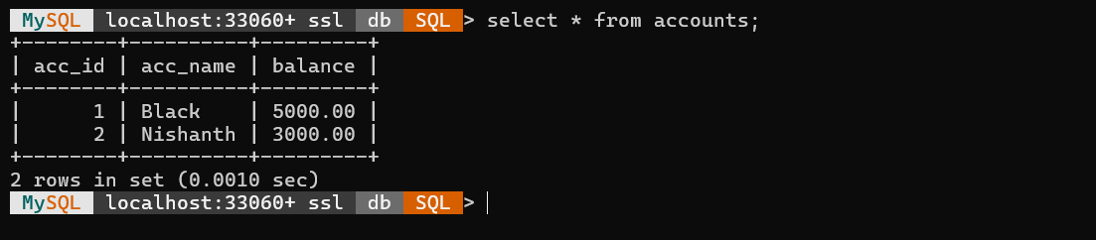
Commit & Roll Back
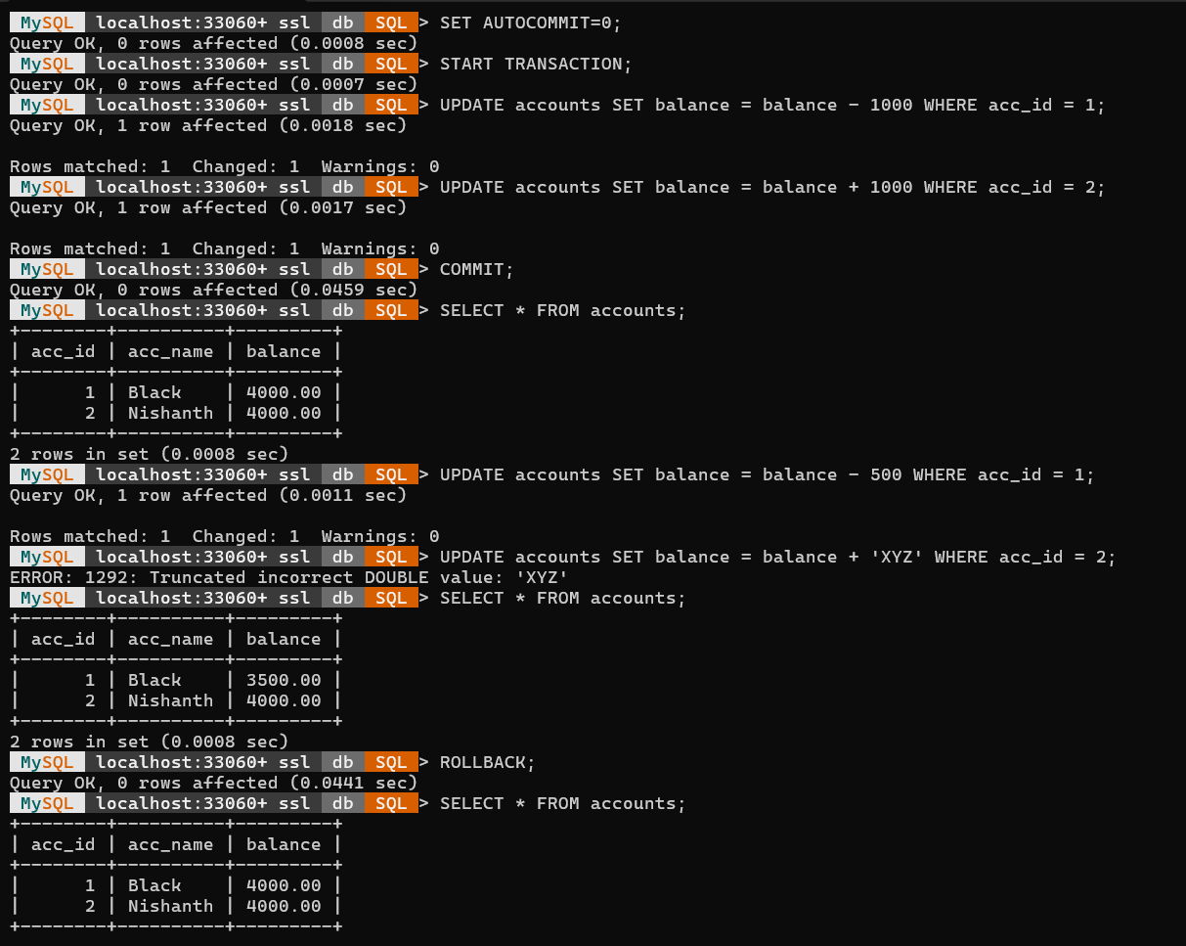
Save Point & Roll Back
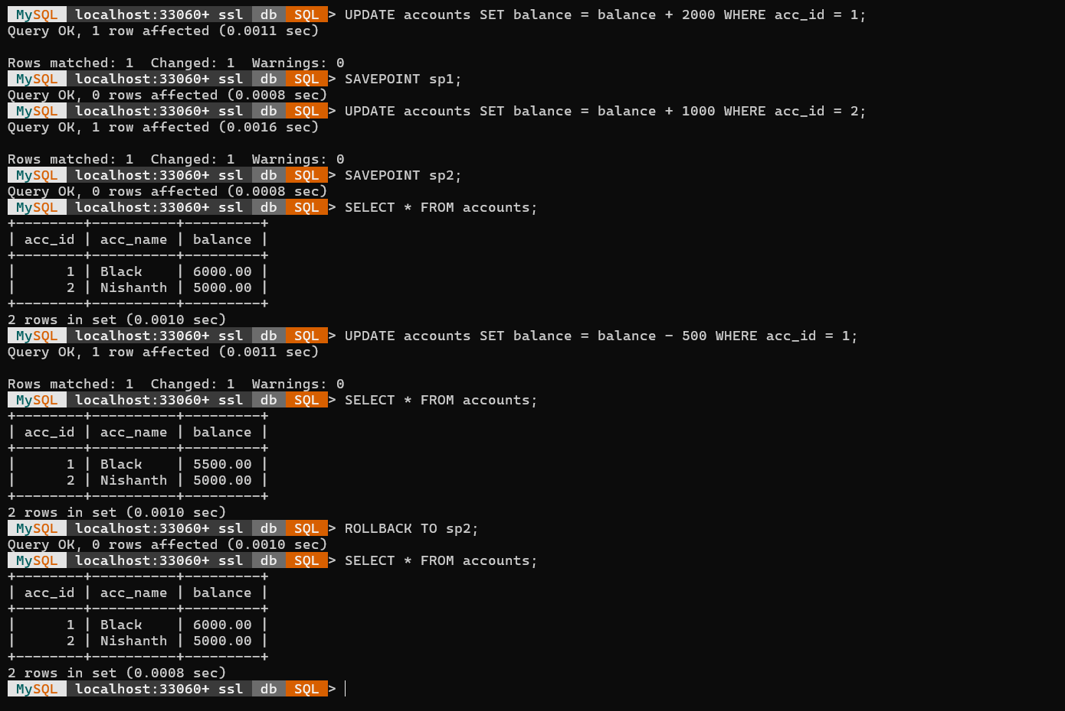

POST LAB EXERCISE

QUESTIIONS:
- What happens if you do not use COMMIT after a transaction?
Without COMMIT: Changes made during the transaction are not saved permanently and can be lost if the session ends or a ROLLBACK is issued.
- Can you undo a COMMIT operation using ROLLBACK?
Undo COMMIT: No, once a COMMIT is executed, the transaction becomes permanent and cannot be undone using ROLLBACK.
- How would you handle a transaction failure in banking applications?
Transaction Failure Handling: Use ROLLBACK to revert all incomplete operations, ensuring that money is neither deducted nor credited incorrectly in banking transactions.
- How does transaction control ensure data consistency?
Data Consistency: Transaction control enforces ACID properties, ensuring all related operations complete successfully together, maintaining accurate and reliable database states.
- What is the difference between auto-commit and manual commit?
Auto-commit: Each SQL statement is automatically committed after execution.
Manual commit: User explicitly uses COMMIT or ROLLBACK to finalize or undo changes.

ASSESSMENT PATTERN.
Description | Max Marks | Marks Awarded
Pre Lab Exercise | 5
In Lab Exercise | 10
Post Lab Exercise | 5
Viva | 10
Total | 30
Faculty Signature

Experiment Number : 9 Date:

Title of the Experiment:
PRE LAB EXERCISE
QUESTIONS
- What is a nested transaction?
Nested Transaction: A transaction that starts within another transaction, allowing multiple sub-transactions under a main transaction for better control.
- How are savepoints used in nested transactions?
Savepoints in Nested Transactions: Savepoints mark specific points within a transaction, enabling partial rollbacks without affecting the entire transaction. Implementing Nested Transactions Using SQL
- Can you partially roll back a transaction?
Partial Rollback: Yes, using ROLLBACK TO SAVEPOINT, you can undo changes made after a savepoint while keeping earlier operations intact.
- What is the difference between SAVEPOINT and ROLLBACK TO?
SAVEPOINT vs ROLLBACK TO: SAVEPOINT creates a checkpoint; ROLLBACK TO reverts the transaction to that checkpoint without ending the overall transaction.
- In what cases are nested transactions useful?
Usefulness: Nested transactions are useful in complex operations like order processing or banking, where multiple dependent steps must be managed safely and independently.

IN LAB EXERCISE

OBJECTIVE:
- To implement nested transactions using SQL.
- To use SAVEPOINT, ROLLBACK TO, and RELEASE SAVEPOINT.

RESOURCES:
- Same Accounts table from the previous experiment.

PROGRAM LOGIC:
Table: Accounts
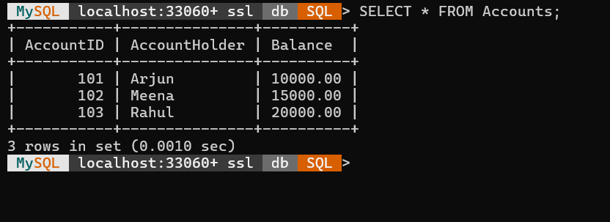
- Start a transaction and define nested operations:
START TRANSACTION;
UPDATE Accounts SET Balance = Balance - 500 WHERE AccountID = 101;
SAVEPOINT after_debit;
SELECT * FROM Accounts;
UPDATE Accounts SET Balance = Balance + 500 WHERE AccountID = 102;
SAVEPOINT after_credit;
SELECT * FROM Accounts;
UPDATE Accounts SET Balance = Balance + 9999999 WHERE AccountID = 103;
ROLLBACK TO after_credit;
COMMIT;

SELECT * FROM Accounts;
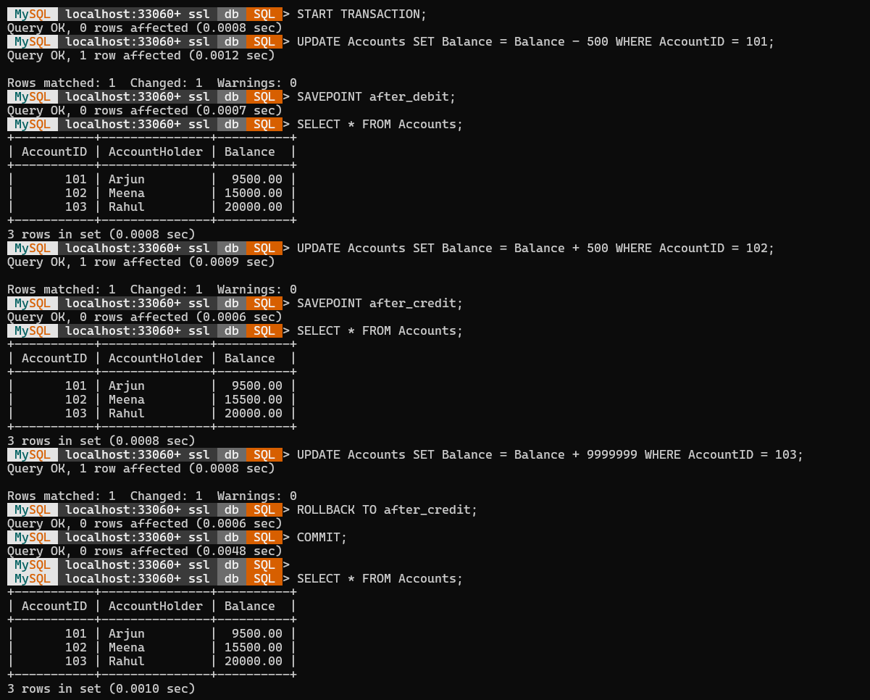
- Using RELEASE SAVEPOINT:
START TRANSACTION;
SAVEPOINT sp1;
SELECT * FROM Accounts;
UPDATE Accounts SET Balance = Balance + 1000 WHERE AccountID = 101;
RELEASE SAVEPOINT sp1;
COMMIT;
SELECT * FROM Accounts;
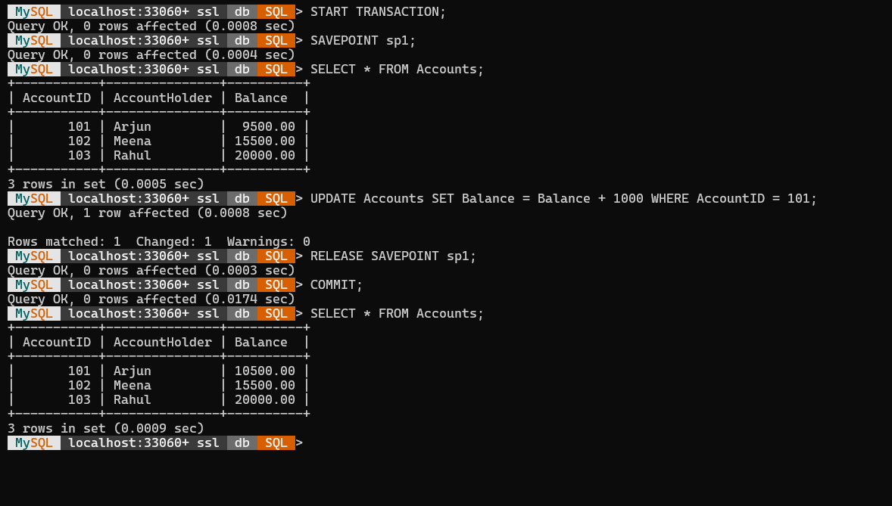
POST LAB EXERCISE

QUESTIIONS:
- How do SAVEPOINT and ROLLBACK TO enhance transaction control?
SAVEPOINT and ROLLBACK TO enhance transaction control by allowing partial rollbacks to specific points within a transaction, avoiding the need to undo the entire transaction.
- Can multiple savepoints be used in a single transaction?
Yes, multiple SAVEPOINTs can be used in a single transaction, enabling finer control and flexibility over multiple stages of complex database operations.
- What is the use of RELEASE SAVEPOINT?
RELEASE SAVEPOINT is used to remove a defined savepoint from the transaction, freeing system resources and ensuring it can no longer be rolled back to.
- Explain a situation where nested transactions are better than flat transactions.
Nested transactions are better when performing multi-step operations (like transferring funds between accounts) where partial errors should be corrected without discarding all previous successful steps.
- Is SAVEPOINT supported in all SQL engines?
No, SAVEPOINT is not supported in all SQL engines; most major systems like MySQL, PostgreSQL, and Oracle support it, but some simpler databases may not.
ASSESSMENT PATTERN.
Description | Max Marks | Marks Awarded
Pre Lab Exercise | 5
In Lab Exercise | 10
Post Lab Exercise | 5
Viva | 10
Total | 30
Faculty Signature

Experiment Number : 10 Date:

Title of the Experiment: CRUD Operations and Querying in NoSQL
PRE LAB EXERCISE
QUESTIONS
- What is NoSQL? How does it differ from SQL databases?
NoSQL is a non-relational database system designed to handle unstructured or semi-structured data. Unlike SQL databases, it doesn’t use tables or fixed schemas and supports flexible, scalable data storage.
- Define the four CRUD operations in the context of NoSQL.
The four CRUD operations in NoSQL are:
Create → Insert new documents or records
Read → Retrieve data from collections
Update → Modify existing documents
Delete → Remove documents from a collection
- What is a collection in MongoDB?
A collection in MongoDB is similar to a table in SQL; it stores multiple documents and doesn’t enforce a fixed schema.
- How are documents represented in MongoDB?
In MongoDB, documents are represented in BSON (Binary JSON) format, containing key-value pairs that can include arrays and nested objects.
- List commonly used MongoDB query operators.
Common MongoDB query operators include:
$eq (equal), $ne (not equal)
$gt, $lt, $gte, $lte (comparison)
$in, $nin (set membership)
$and, $or, $not (logical)
$exists, $regex, $type (conditional).

IN LAB EXERCISE

OBJECTIVE:
- To create a database and collection in MongoDB.
- To perform basic CRUD operations (Create, Read, Update, Delete).
- To query documents using operators and filters.
RESOURCES:
- MongoDB installed (local or cloud-based like MongoDB Atlas).
- MongoDB Compass or CLI (mongo shell).
PROGRAM LOGIC:
- Create a Database and Collection:
use CollegeDB;
db.createCollection("Students");
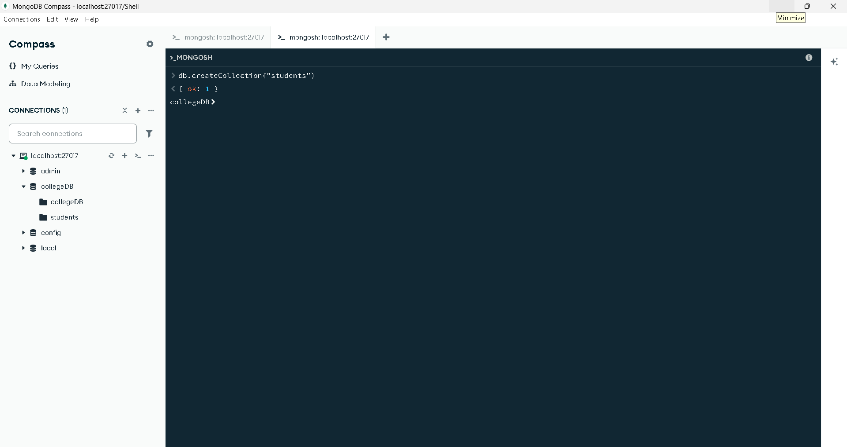

- Insert Documents (Create):
db.students.insertOne({
_id: 1,
name: "Black",
department: "AI & DS",
marks: 88
})
db.students.insertMany([
{ _id: 2, name: "Nishanth", department: "AI & DS", marks: 92 },
{ _id: 3, name: "Kumar", department: "CSE", marks: 76 },
{ _id: 4, name: "Arun", department: "IT", marks: 65 }
])
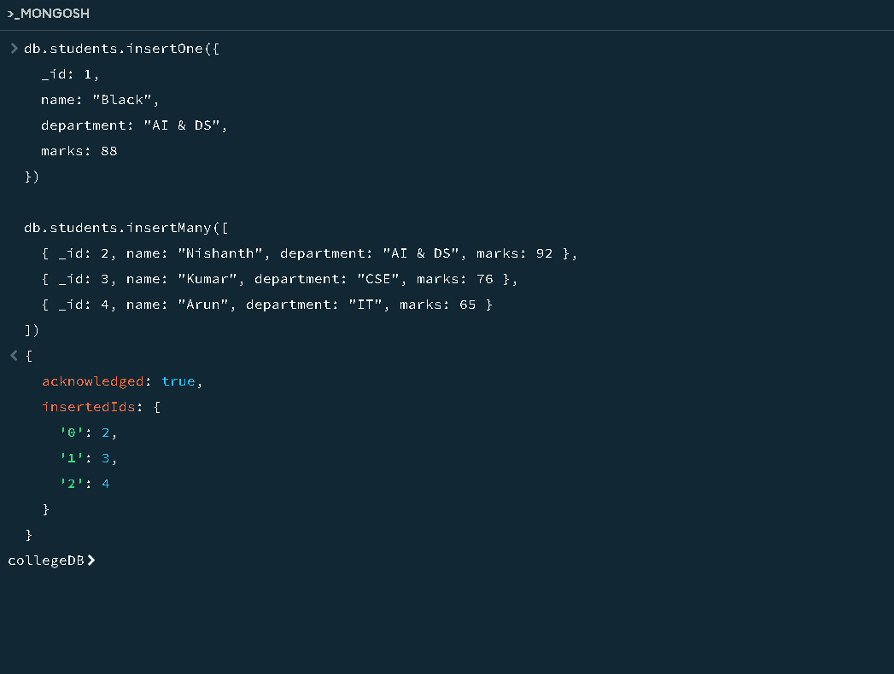

- Read Documents:
db.students.find();
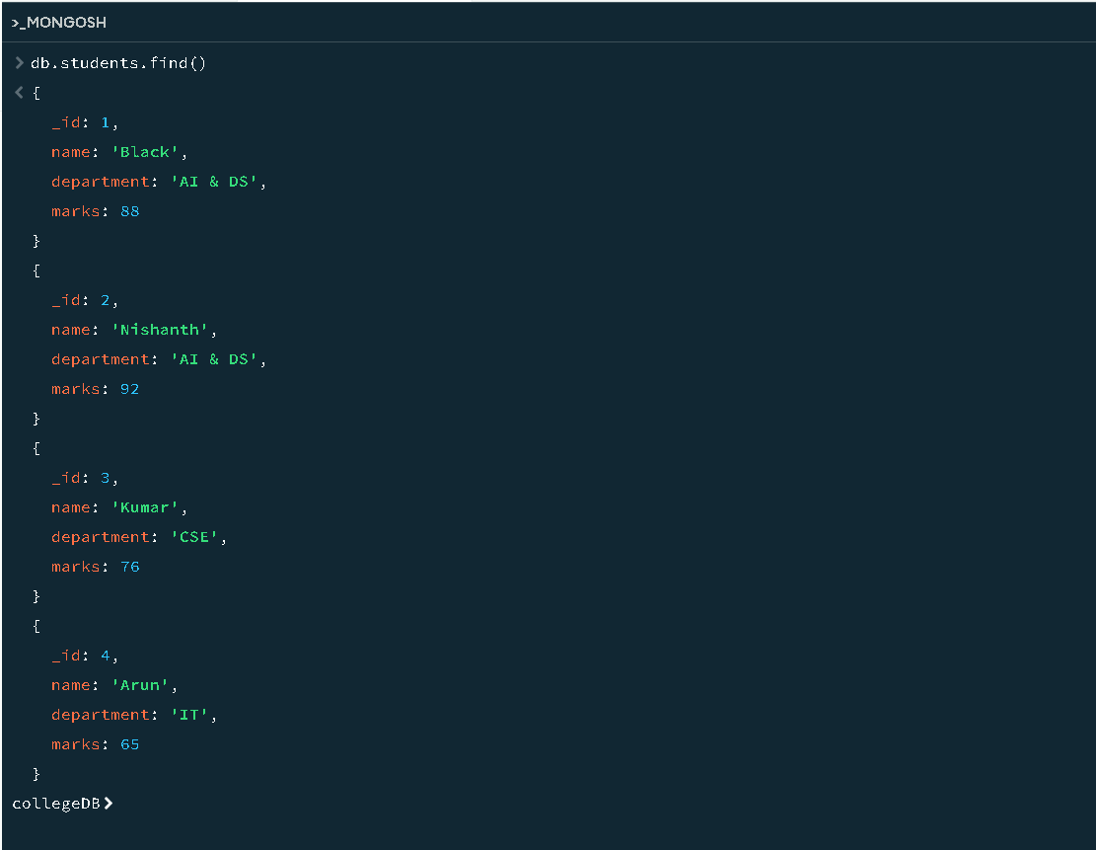
db.students.find({ department: "AI & DS" });
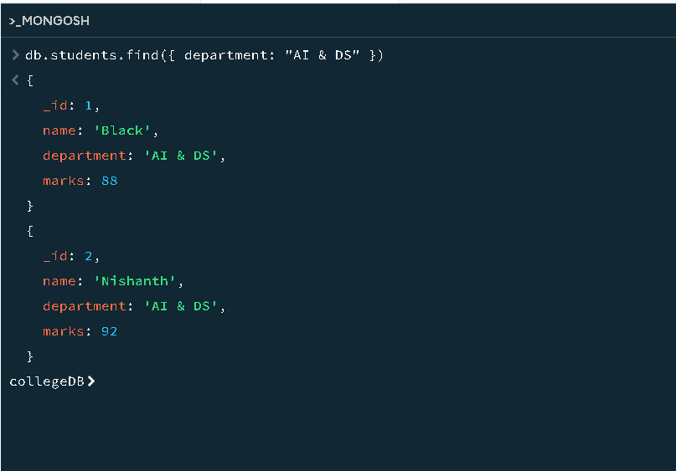

- Update Documents:
db.students.updateOne({ _id: 3 }, { $set: { marks: 82 } })

- Delete Documents:
db.Students.deleteOne({ _id: 4 });
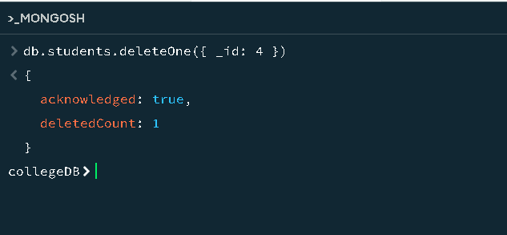

POST LAB EXERCISE

QUESTIIONS:
- How are documents stored in MongoDB?
In MongoDB, documents are stored in collections as BSON (Binary JSON) objects, allowing storage of rich, nested data structures with fields of varying types.
- What is the difference between insertOne() and insertMany()?
insertOne() is used to insert a single document into a collection, whereas insertMany() inserts multiple documents at once in a single operation.
- How does MongoDB handle schema flexibility?
MongoDB provides schema flexibility by allowing documents in the same collection to have different structures, meaning fields and data types can vary across documents.
- What is the purpose of $set, $gt, and $in operators?
The $set operator updates specific fields in a document, $gt checks if a value is greater than a given number, and $in matches any value from a specified list.
- Write a query to find students with marks between 70 and 90.
db.students.find({ marks: { $gte: 70, $lte: 90 } });

ASSESSMENT PATTERN.
Description | Max Marks | Marks Awarded
Pre Lab Exercise | 5
In Lab Exercise | 10
Post Lab Exercise | 5
Viva | 10
Total | 30
Faculty Signature

Experiment Number : 11 Date:

Title of the Experiment: Designing and Aggregating Data in NoSQL Schema
PRE LAB EXERCISE
QUESTIONS
- What is schema design in NoSQL and why is it important?
- How is denormalization used in NoSQL schema modeling?
- Define the purpose of the MongoDB aggregation framework.
- What is the difference between $match, $group, and $project?
- Explain when to embed documents vs reference them in NoSQL.

IN LAB EXERCISE

OBJECTIVE:
- To design a NoSQL schema for a practical use case.
- To perform aggregation operations using MongoDB.
RESOURCES:
- MongoDB (Compass/CLI).
- Knowledge of JSON document structure and aggregation pipelines.
USE CASE SCENARIO:
Online Student Portal:
- Collections:
  - Courses: course_id, course_name, marks
PROGRAM LOGIC:
Insert Data into Collections:
db.students.insertMany([
{
_id: 1,
name: "Black",
department: "AI & DS",
year: 3,
courses: [
{ course_id: "AID101", course_name: "Machine Learning", marks: 88 },
{ course_id: "AID102", course_name: "Data Mining", marks: 92 }
]
},
{
_id: 2,
name: "Nishanth",
department: "AI & DS",
year: 3,
courses: [
{ course_id: "AID101", course_name: "Machine Learning", marks: 95 },
{ course_id: "AID103", course_name: "Deep Learning", marks: 89 }
]
},
{
_id: 3,
name: "Arun",
department: "IT",
year: 2,
courses: [
{ course_id: "IT101", course_name: "Networks", marks: 76 },
{ course_id: "IT102", course_name: "Web Development", marks: 84 }
]
}
])
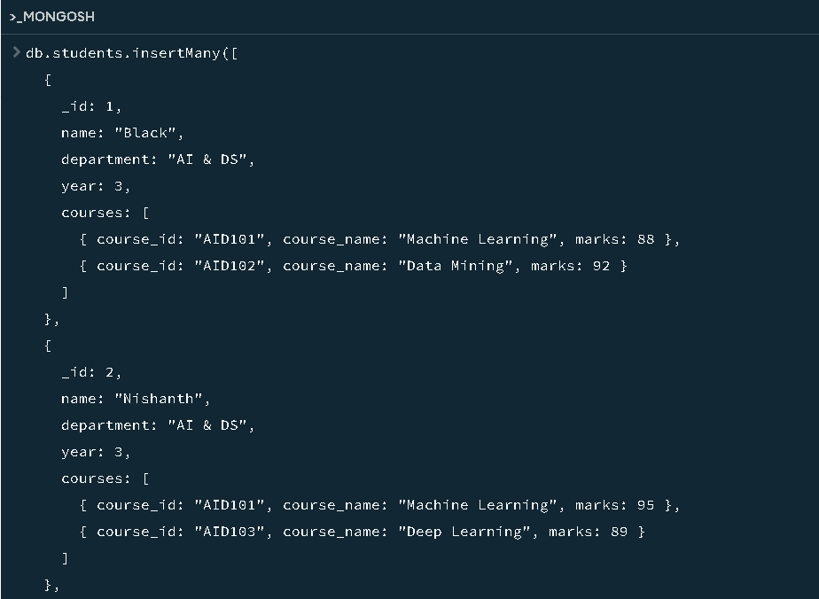
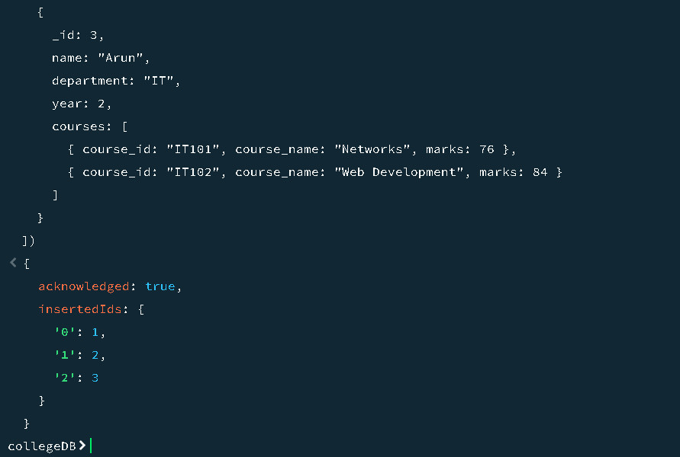

Aggregation Example:
Average
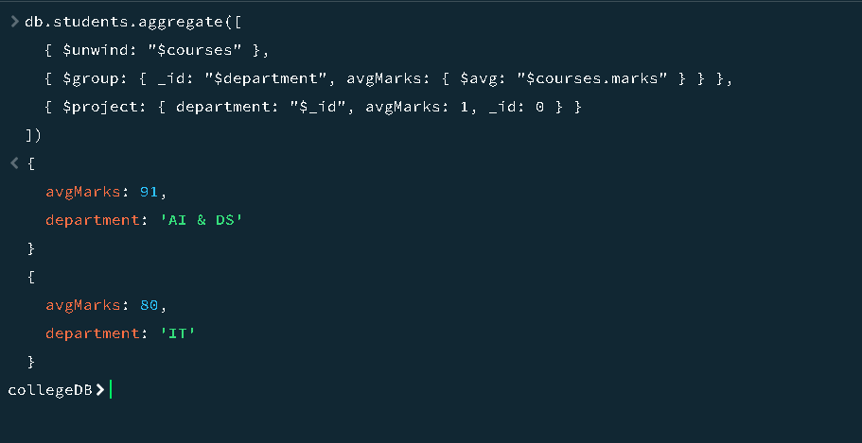
Sum
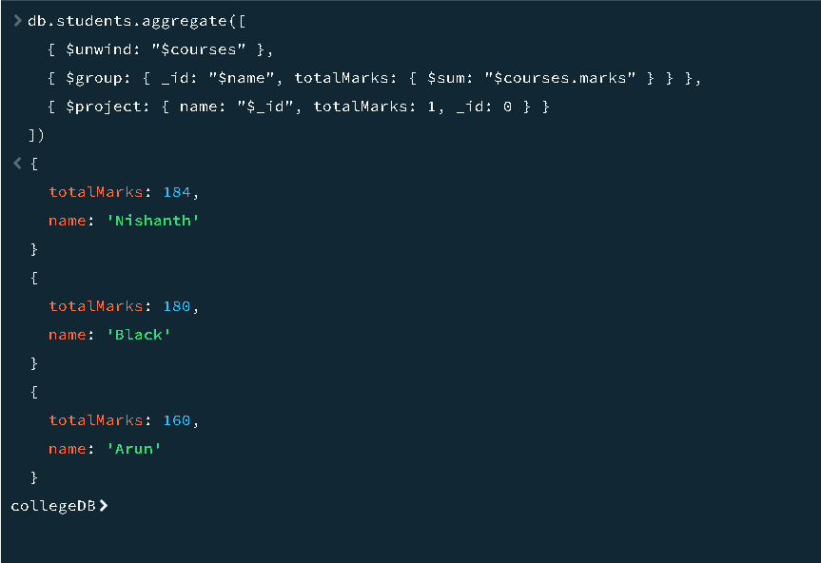

Greater Than
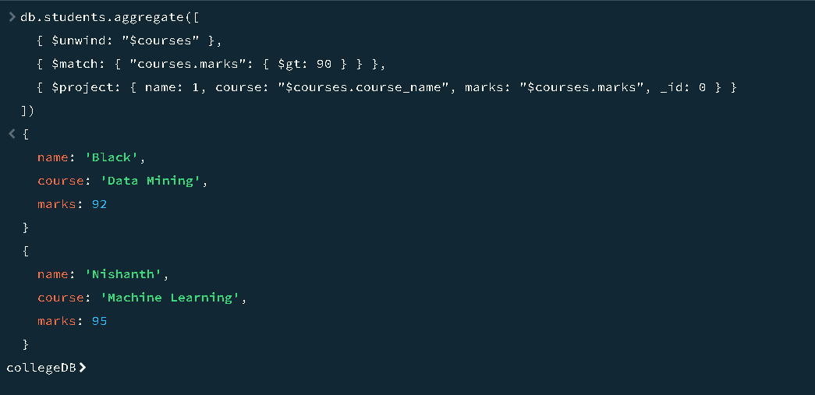
Count
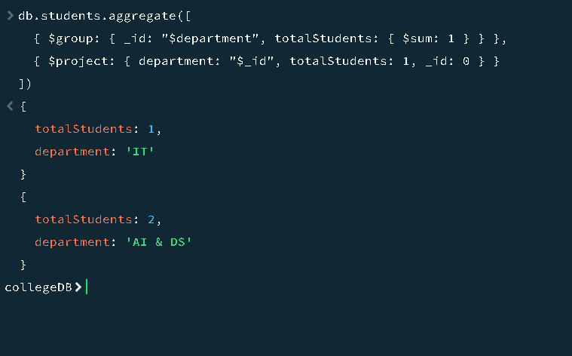
Top1
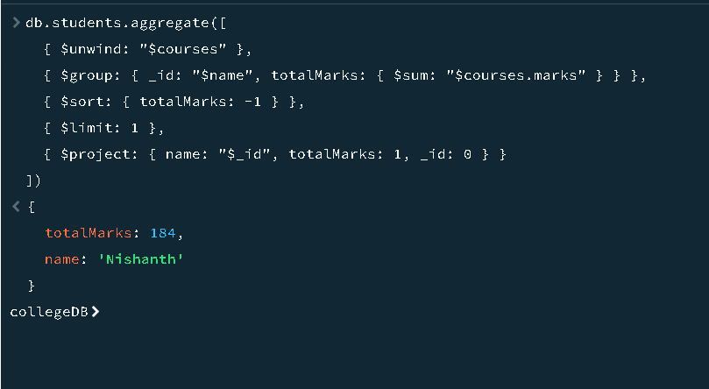

POST LAB EXERCISE

QUESTIIONS:
- How would you design a schema for an e-commerce cart system in NoSQL?
A NoSQL schema for an e-commerce cart system can use a collection named carts, where each document stores user details, cart items, and totals:
- What does the $group operator do in the aggregation pipeline?
The $group operator in MongoDB’s aggregation pipeline groups documents by a specified field and performs aggregate functions like sum, average, count, or max/min on grouped data.
- Why is $lookup used, and how does it simulate JOINs?
$lookup is used to perform a left outer join between two collections. It combines related documents by matching a field in one collection with a field in another, simulating SQL JOIN behavior.
- Compare embedding and referencing with examples.
Embedding stores related data within the same document (e.g., user and their addresses in one document), while referencing stores related data in separate collections using an ID link.
- Write an aggregation pipeline to find the average quantity of books ordered.
db.orders.aggregate([
{ $match: { category: "Books" } },
{ $group: { _id: null, averageQuantity: { $avg: "$quantity" } } }
]);

ASSESSMENT PATTERN.
Description | Max Marks | Marks Awarded
Pre Lab Exercise | 5
In Lab Exercise | 10
Post Lab Exercise | 5
Viva | 10
Total | 30
Faculty Signature

ASSESSMENT RUBRICS
PRE LAB WORK - This evaluates the student’s preparation and understanding before the lab session
Criteria | Excellent (5) | Good (4) | Satisfactory (3) | Needs Improvement (1-2) | Not Attempted (0)
Understanding of Objectives | Demonstrates complete understanding of the lab objectives. | Partial understanding of objectives. | Basic understanding; some gaps present. | Minimal understanding of objectives. | No preparation evident.
Pre-Lab Task Completion | Pre-lab exercises are fully completed and accurate. | Mostly completed with minor errors. | Partially completed; several errors. | Very limited attempt. | No submission.
IN LAB WORK - This evaluates the execution and problem-solving abilities during the lab.
Criteria | Excellent (9-10) | Good (7-8) | Satisfactory (5-6) | Needs Improvement (1-4) | Not Attempted (0)
Implementation Accuracy | Code/solution fully meets the problem statement with no errors. | Mostly correct with minor errors. | Partially correct; significant errors present. | Minimal progress made towards solving the problem. | No implementation.
Problem-Solving Approach | Demonstrates excellent logic and efficiency. | Good logic; minor inefficiencies. | Basic logic; significant inefficiencies. | Poor logic or random attempts. | No problem-solving effort.
Tool/Technology Usage | Effectively uses all relevant tools and software for the course. | Good use of tools with minor gaps. | Basic usage; limited familiarity with tools. | Struggles with tools; frequent errors. | No tool usage evident.
Code/Design Quality | Clean, efficient, and well-documented code/design. | Mostly clean and efficient; minor issues in documentation. | Basic implementation; lacks clarity or efficiency. | Poor quality; messy or unclear code/design. | No code or design submitted.
POST LAB WORK- This evaluates the analysis, reflection, and reporting after the lab session
Criteria | Excellent (5) | Good (4) | Satisfactory (3) | Needs Improvement (1-2) | Not Attempted (0)
Result Analysis | Provides a thorough and accurate analysis of results. | Accurate analysis with minor omissions. | Basic analysis; some errors or omissions. | Limited or unclear analysis. | No analysis provided.
Post-Lab Questions/Reflections | Thoughtful responses; demonstrates deeper understanding. | Good responses with minor gaps in reasoning. | Basic responses; some misconceptions. | Minimal or unclear responses. | No attempt.

