EX06
Selection ($σ$)
RA: $σ_{\text{Salary}>65000\text{ AND DeptID}=\text{’D1’}}\left(\text{Employee}\right)$
SQL:
SELECT *
FROM Employee
WHERE Salary > 65000 AND DeptID = 'D1';

Projection ($π$)
RA: $π_{\text{Name, Salary}}\left(\text{Employee}\right)$
SQL:
SELECT DISTINCT Name, Salary
FROM Employee;

Cartesian Product ($×$)
RA: $\text{Employee}×\text{Department}$
SQL:
SELECT *
FROM Employee
CROSS JOIN Department;

Union ($∪$)
RA: $\text{Employee}∪\text{NewHires}$
SQL:
SELECT * FROM Employee
UNION
SELECT * FROM NewHires;

Set Difference ($-$)
RA: $\text{Employee}-\text{NewHires}$
SQL:
SELECT * FROM Employee
EXCEPT
SELECT * FROM NewHires;

Set Intersection ($∩$)
RA: $\text{Employee}∩\text{NewHires}$
SQL:
SELECT * FROM Employee
INTERSECT
SELECT * FROM NewHires;

Rename ($ρ$)
RA: $ρ_{\text{E}}\left(\text{Employee}\right)$
$$ρ_{\text{E(ID, WorkerName, D_ID, Pay)}}\left(\text{Employee}\right)$$
SQL:
SELECT *
FROM Employee AS E;
SELECT EmpID AS ID, Name AS WorkerName, DeptID AS D_ID, Salary AS Pay
FROM Employee;

Natural Join ($⋈$)
RA: $\text{Employee}⋈\text{Department}$
SQL:
SELECT *
FROM Employee
NATURAL JOIN Department;

Theta Join ($⋈_{θ}$)
RA: $\text{Employee}⋈_{\text{Employee.DeptID}=\text{Department.DeptID}}\left(\text{Department}\right)$
SQL:
SELECT *
FROM Employee
JOIN Department ON Employee.DeptID = Department.DeptID;
(A non-equijoin example)
RA: $\text{Employee}⋈_{\text{Employee.Salary}>\text{Manager.Salary}}\left(\text{Manager}\right)$
SQL:
SELECT *
FROM Employee
JOIN Manager ON Employee.Salary > Manager.Salary;

Left Outer Join (⟕)
RA: Employee ⟕ Department
SQL:
SELECT *
FROM Employee
LEFT OUTER JOIN Department ON Employee.DeptID = Department.DeptID;

Right Outer Join (⟖)
RA: Employee ⟖ Department
SQL:
SELECT *
FROM Employee
RIGHT OUTER JOIN Department ON Employee.DeptID = Department.DeptID;

Full Outer Join (⟗)
RA: Employee ⟗ Department
SQL:
SELECT *
FROM Employee
FULL OUTER JOIN Department ON Employee.DeptID = Department.DeptID;

Division ($÷$)
RA: $π_{\text{EmpID, DeptID}}\left(\text{Employee}\right)÷π_{\text{DeptID}}\left(\text{AllDepts}\right)$
SQL:
SELECT DISTINCT T1.EmpID
FROM Employee AS T1
WHERE NOT EXISTS (
SELECT *
FROM AllDepts
WHERE NOT EXISTS (
SELECT *
FROM Employee AS T2
WHERE T2.EmpID = T1.EmpID
AND T2.DeptID = AllDepts.DeptID
)
);

EX07
Table Departments & Employees
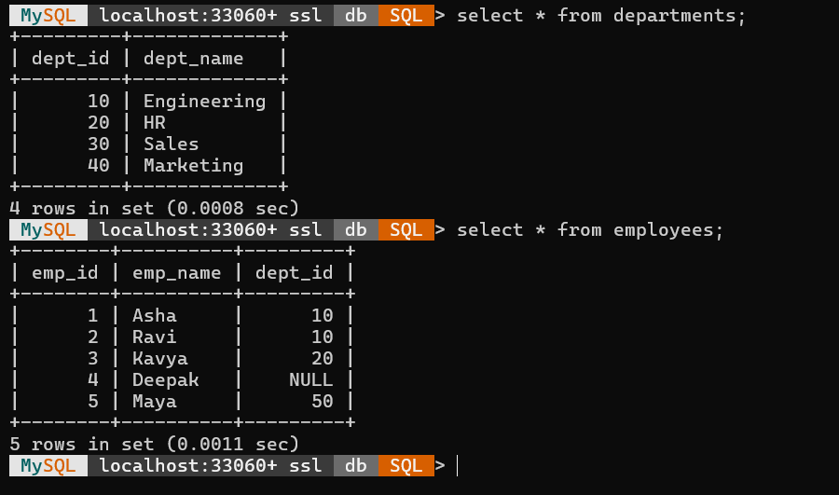
Inner Join
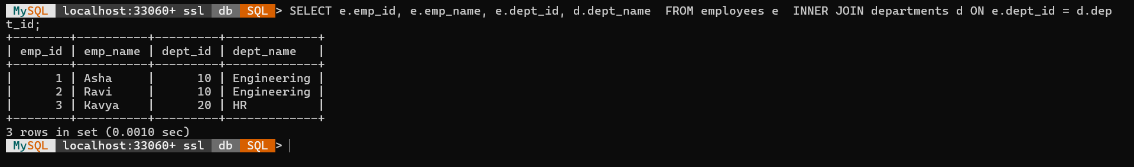
Left Join
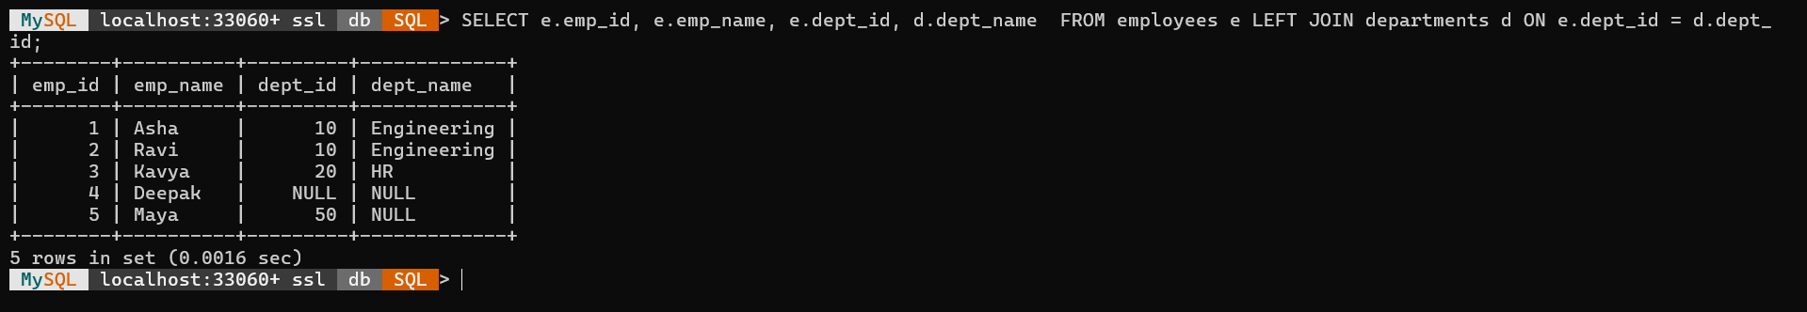
Right Join
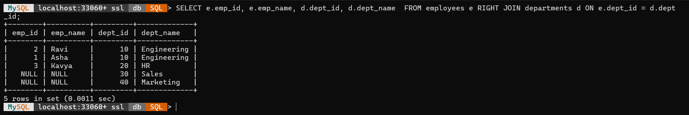
Full Join
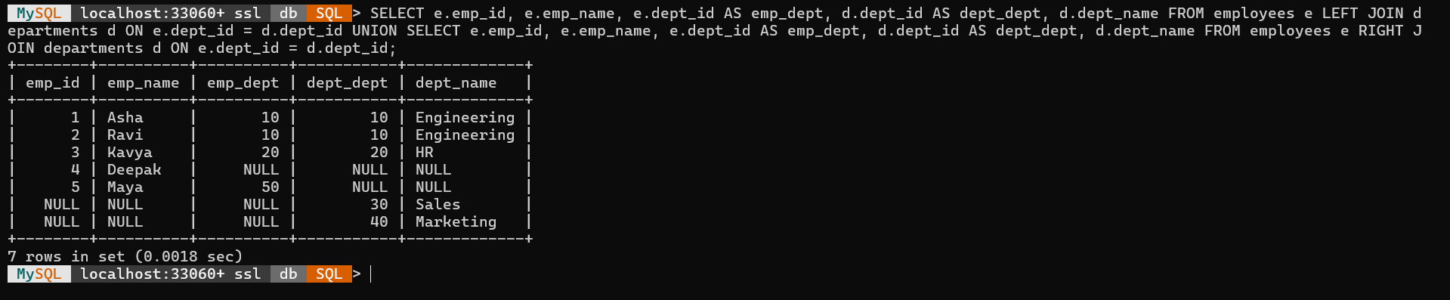

EX08
Table Accounts
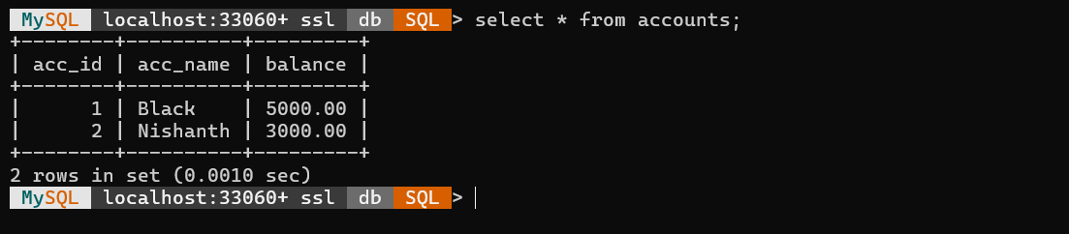
Commit & Roll Back
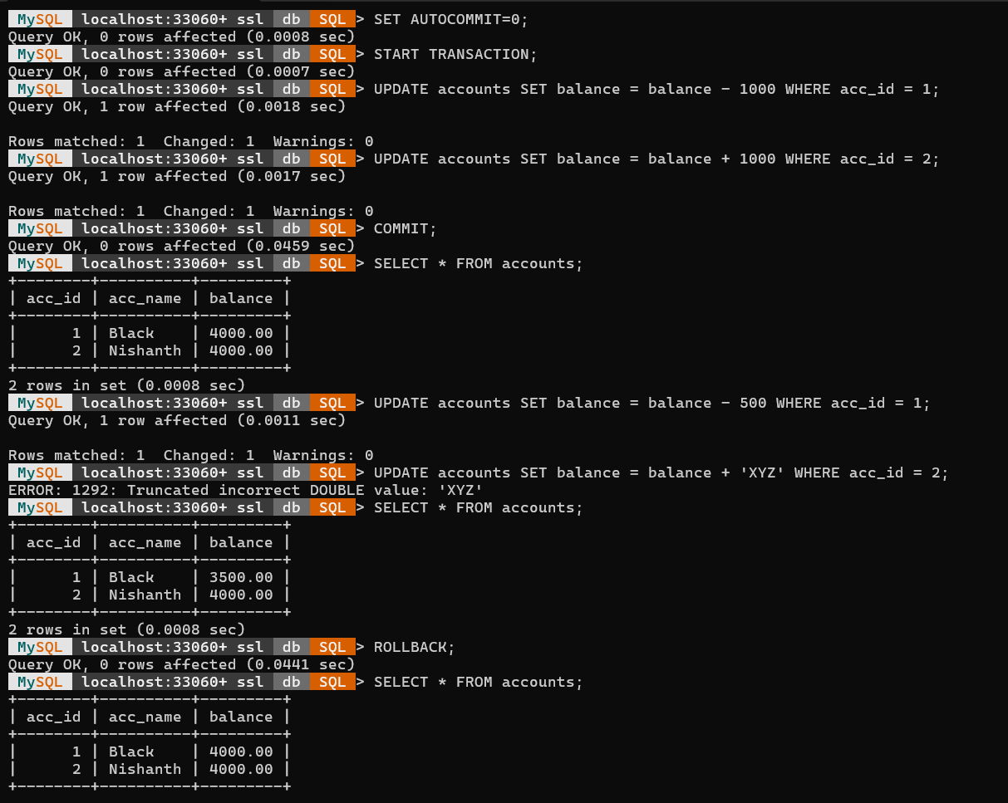

Save Point & Roll Back
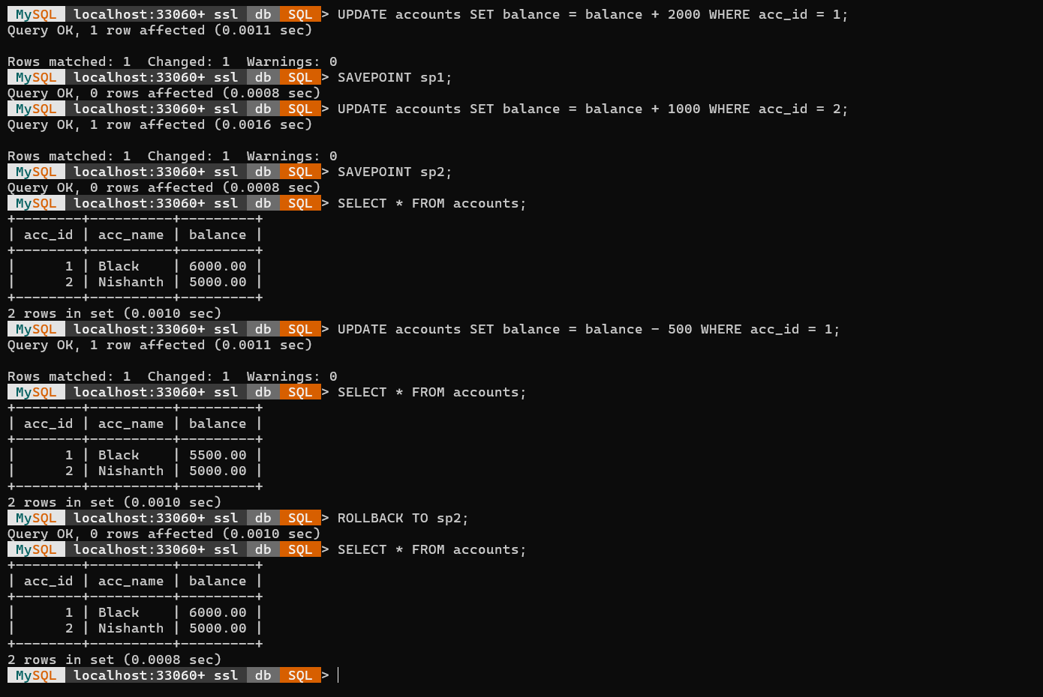

EX09
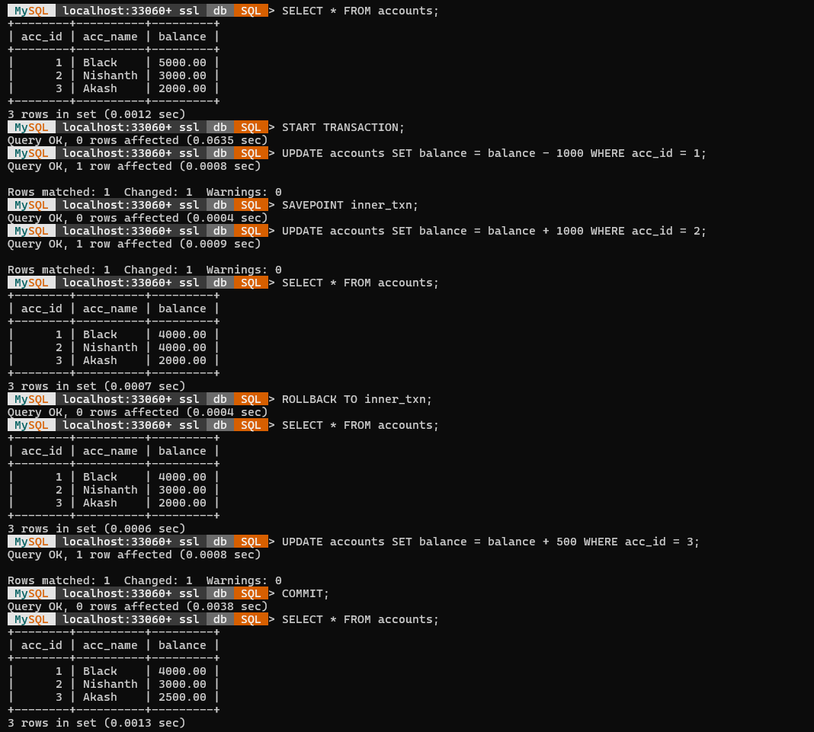

EX10
Create collection
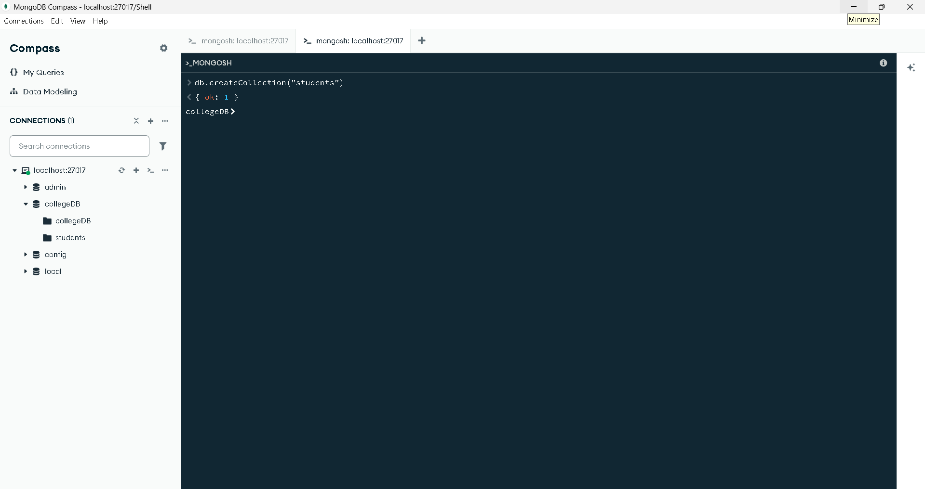
Create
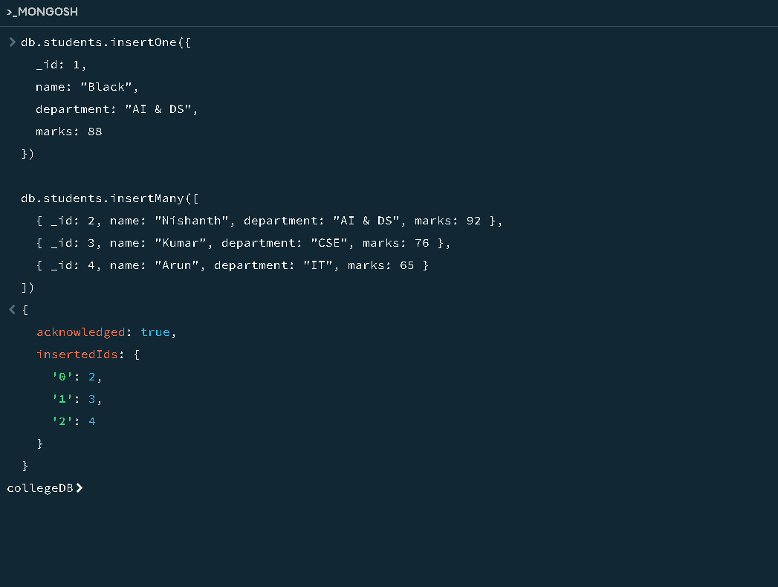
Read
Read All
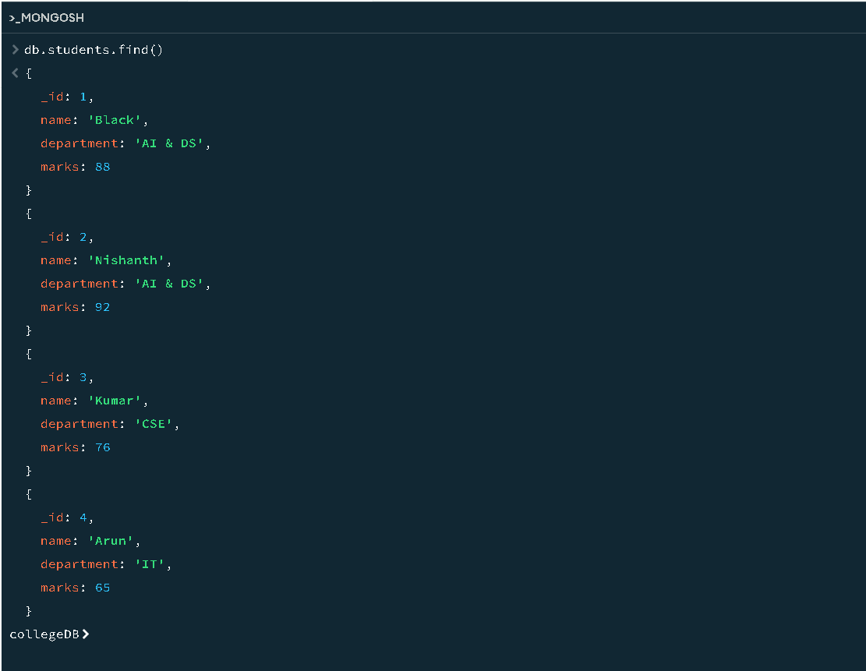

Read with condition
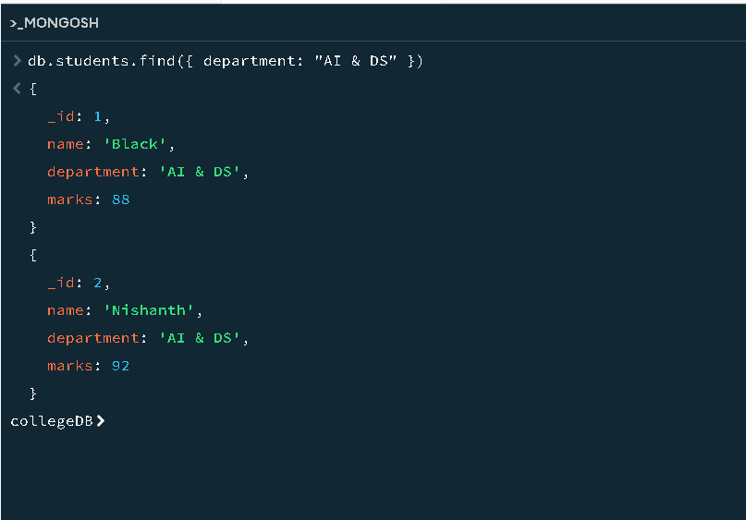
Update
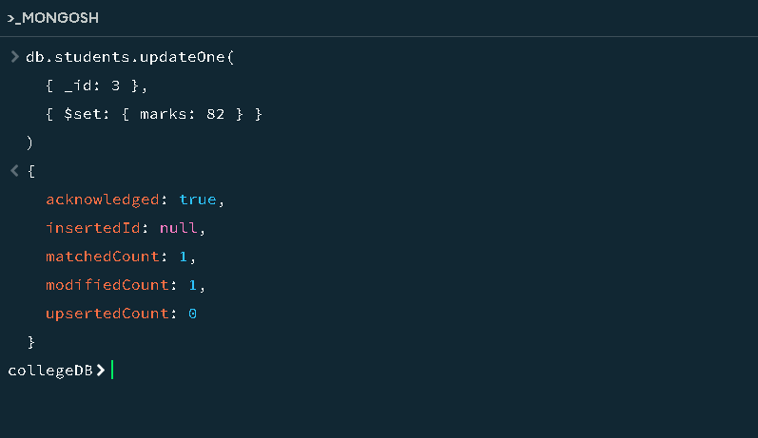

check value updated
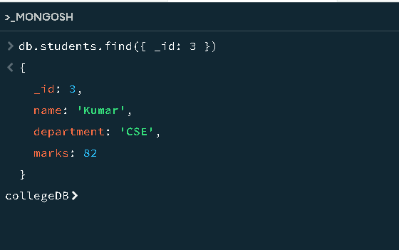
Delete
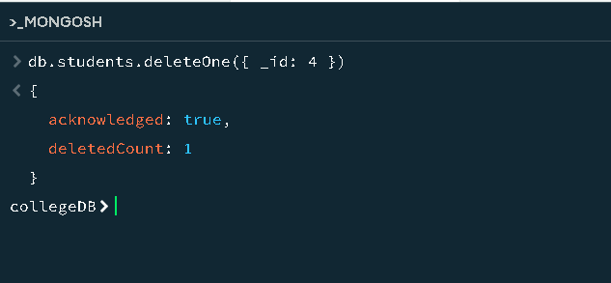

EX11
Designing
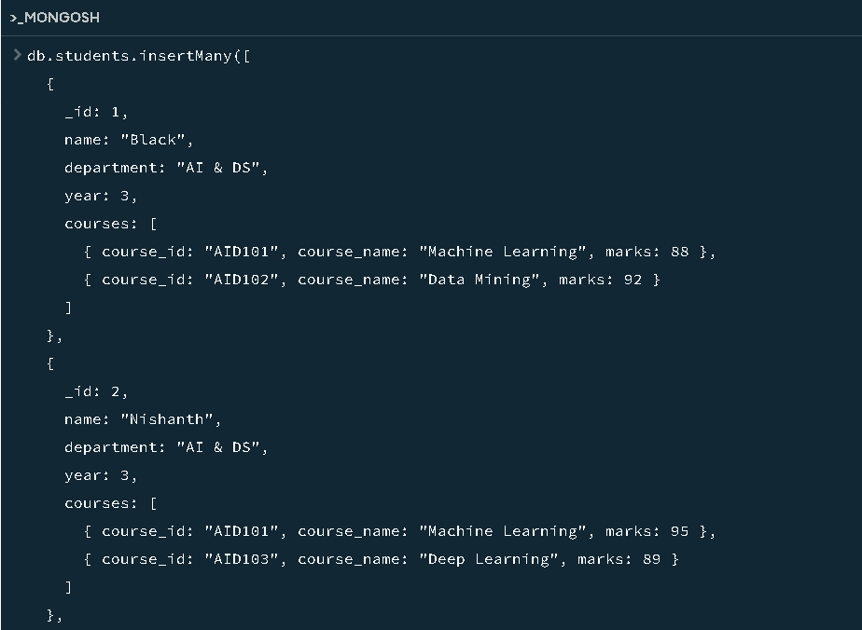
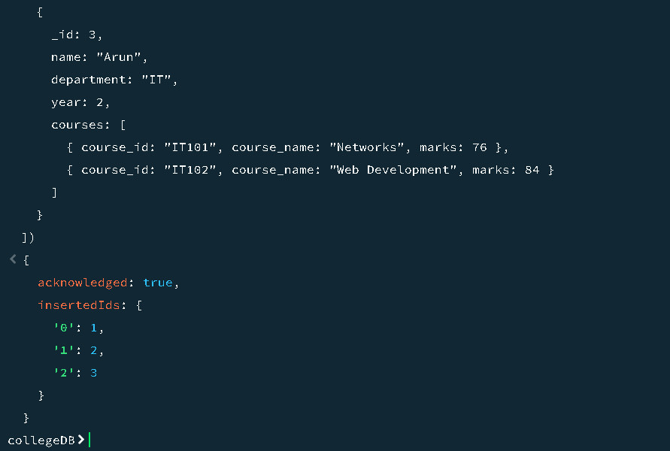
Aggregating Data
(a) Average
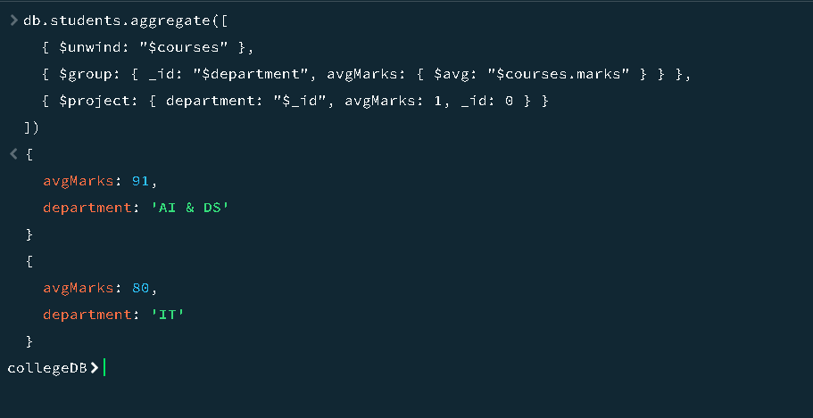
(b) Sum
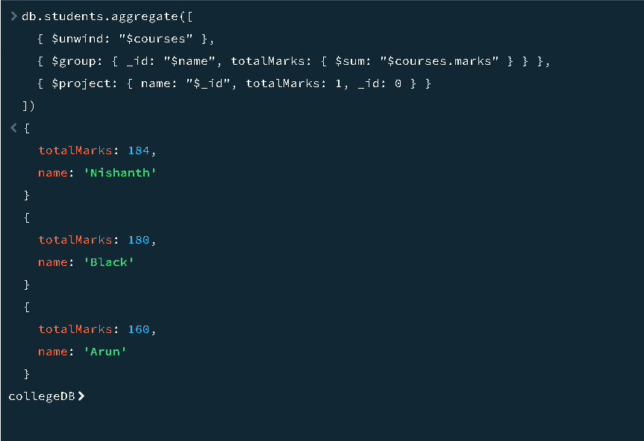

(c) Greater Than
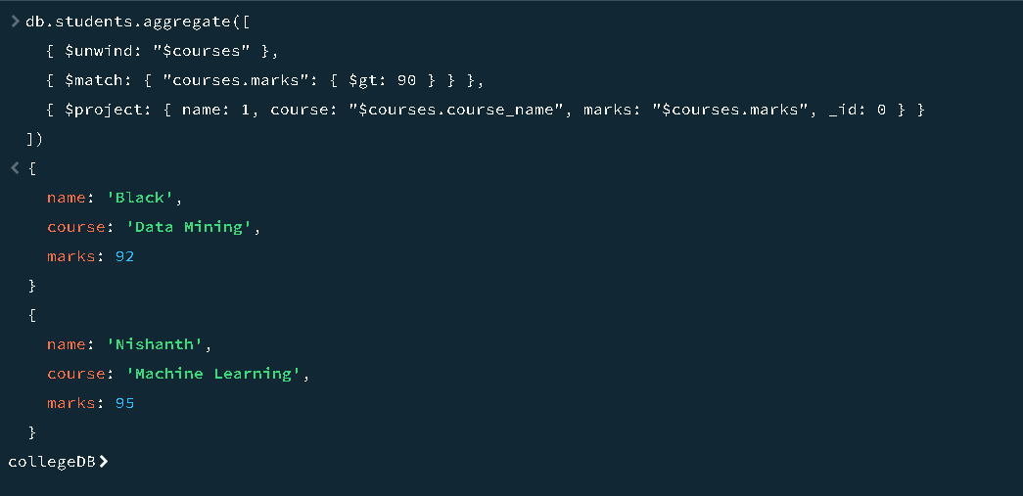
(d) Count
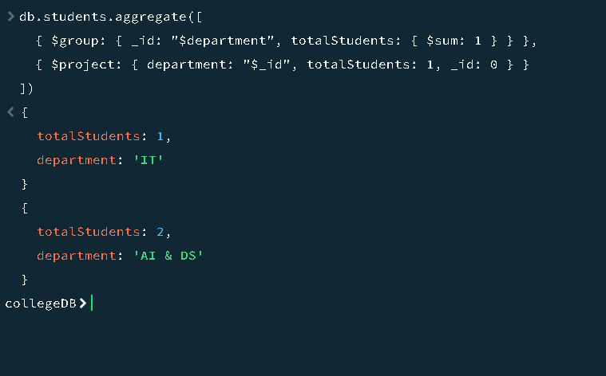

(e)Top1
