Group-12

**REPORT**

**Problem Statement**

*Analysing effect of mood of a person on mouse dynamics for imposter detection*

**Brief Introduction**

*Mouse Dynamics is another behavioural biometric which is used to authenticate a user. A mouse stroke is defined to be the set of points traversed from one click to the next and a set of one or more strokes are used in order to verify a user.*

*The mood of a person affects these behavioural biometrics. So, analysis of mood of a personmay prove to be very crucial while authentication using mouse dynamics.*

*A biometric-based user verification system is essentially a pattern recognition system that acquires biometric datafrom an individual, extracts a feature set to establish a unique user signature and constructs a verification model by trainingit on the set of signatures. User verification is achieved by application of the model to on-line acquired signatures of theinspected user that are constructed using a process that is identical to the one used during the model construction.*

* *General Architecture*

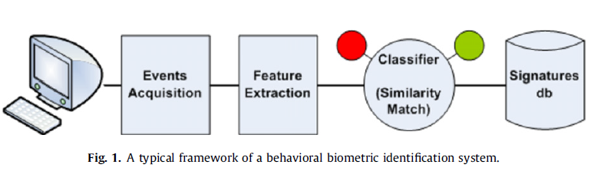

**Fig. 1** *depicts the typical architecture of a behavioural biometrics user verification system. Such systems include thefollowing components:*

* ***Feature acquisition****– captures the events generated by the various input devices used for the interaction (e.g. keyboard,mouse) via their drivers.*
* ***Feature extraction****– constructs a signature which characterizes the behavioural biometrics of the user.*
* ***Classifier*** *– Consists of an inducer (e.g. Support Vector Machines, Artificial Neural Networks, etc.) that is used to build theuser verification model by training on past behaviour, often given by samples. During verification, the induced model isused to classify new samples acquired from the user.*
* ***Signature database*** *– A database of behavioural signatures that were used to train the model. Upon entry of a username, thesignature of the user is retrieved for the verification process.*
* *Mouse based Method*

*Authentication methods identify users at login based on a predetermined sequence of mouse operations that the user needs to follows. During training, the sequence is repeated several times by every user. Features are extracted from each sequence and are used to characterize the user. During authentication, the user is required to follow the same sequence. Continuous verification, on the other hand, repeatedly reconfirms the user’s identity throughout the entire session using allmouse activity rather than a predetermined sequence. In this paper we propose a continuous verification method.*

*Six actions were defined during training:-*

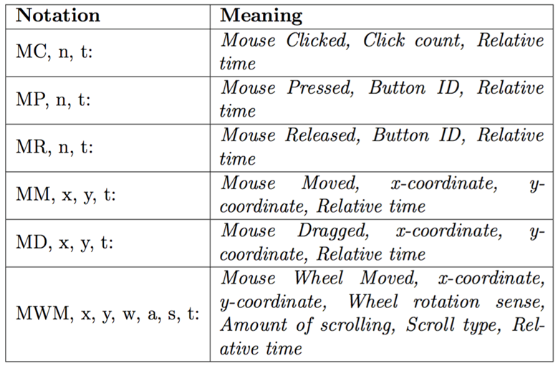

*The mood of a person affects these behavioural biometrics. So, analysis of mood of a personmay prove to be very crucial while authentication using keystroke or mouse dynamics.*

**Methodology**

*We have made use of the fact that Click time, Press time and Release time of mouse completely depends on user and significantly varies from person to person. Using this fact we have made classifier using Artificial Neural Network. Along with the above mentioned parameters, on the basis of mouse movement we have also added angle of movement, horizontal velocity, vertical velocity, velocity, acceleration and jerk as well. Using all the above data we run the classifier and find out the person using the Mouse.*

**Result and Analysis**

*We have made 4 classifier for each neutral and emotional case. Using our classifier we got the maximum accuracy of nearly 55 percent. Majority of classification is done on the basis of speed of movement and angle of movement by the user. Not enough data could be taken for Presses and Releases in Mood analysis part as very few number of clicks where required. So the contribution in final classification from Mouse press and release time is not so good, We completely rely on speed of movement and angle of movement data for a given x and y coordinate as our main classification criteria.*

**Conclusion**

*Mouse events performedin a GUI environment by the user were collected and a hierarchy of mouse actions was defined based on the raw events. In order to characterize each action, features were extracted.The proposed method was evaluated using a dataset that was collected from a variety of users and hardware configurations.*

*In the following we describe several issues that need further investigation in mouse-based verification methods.*

*The original actions intended by the user are logged neither by software nor by observing the user while performing theactions. Accordingly, they are heuristically reconstructed from the raw events which may produce some non-credible actions.*

*Additionally, the obtained actions may vary between different hardware configurations (e.g. optical mouse, touchpad). In order to obtain a higher percentage of credible actions, the parameters that define them should be determinedby a more rigorous method.*

*Furthermore, the data collected from mouse devices may be partially unreliable due to noise. Specifically, lint clogging themoving parts of mechanical mice may affect the functionality of the mouse. However, this type of mice is becoming rare.Optical mice may introduce noise due to their inability to track movement on glossy or transparent surfaces. In some mice,fast movements may be poorly captured.*

*A significant drawback of mouse-based verification in comparison to keyboard-based verification is the variety of mice,mouse pads and software configurations which may influence the performance of the verification. For example, a personusing a laptop in two different places may use the touch pad in one place and an external mouse in the other – thus affectingthe events produced and, consequently, theperformance of any mouse-based verification method. This problem does notexist in keyboard-based verification techniques since the keyboard is an integral part of the laptop.*

*Creating a dataset for continuous verification is more challenging, since the dataset should be diverse and reflect the daily tasks of the users. Furthermore, the dataset should reflect the different physiological states of the user during the day whichmight influence their behavioral biometrics and consequently the verification accuracy. For example, some users are faster inthe morning, while slower at night, or after lunch. Moreover, user postures, such as sitting (common), standing or talking onthe phone while interacting with the computer, are expected to influence the verification accuracy as well.*

**References**

*1)Perveen, N.; Gupta, S.; Verma, K., "Facial expression recognition using facial characteristic points and Gini index," in Engineering and Systems (SCES), 2012*

*Students Conference on , vol., no., pp.1-6, 16-18 March 2012*

*doi: 10.1109/SCES.2012.6199086*

*2) Rajat Kumar Das, SudiptaMukhopadhyay, and Puranjoy Bhattacharya."User Authentication Based on Keystroke Dynamics." IETE Journal of Research 60.3(2014): 229-239.*

*3) Clint Feher, Yuval Elovici, Robert Moskovitch, LiorRokach, AlonSchclar,User identity verification via mouse dynamics, Information Sciences, Volume201, 15 October 2012, Pages 19-36, ISSN 0020-0255,*[*http://dx.doi.org/10.1016/j.ins.2012.02.066*](http://dx.doi.org/10.1016/j.ins.2012.02.066)*.*

*4)Shen, Chao, ZhongminCai, and Xiaohong Guan. "Continuous authentication for mouse dynamics: A pattern-growth approach." IEEE/IFIP International Conferenceon Dependable Systems and Networks (DSN 2012). IEEE *