SCREENSHOTS

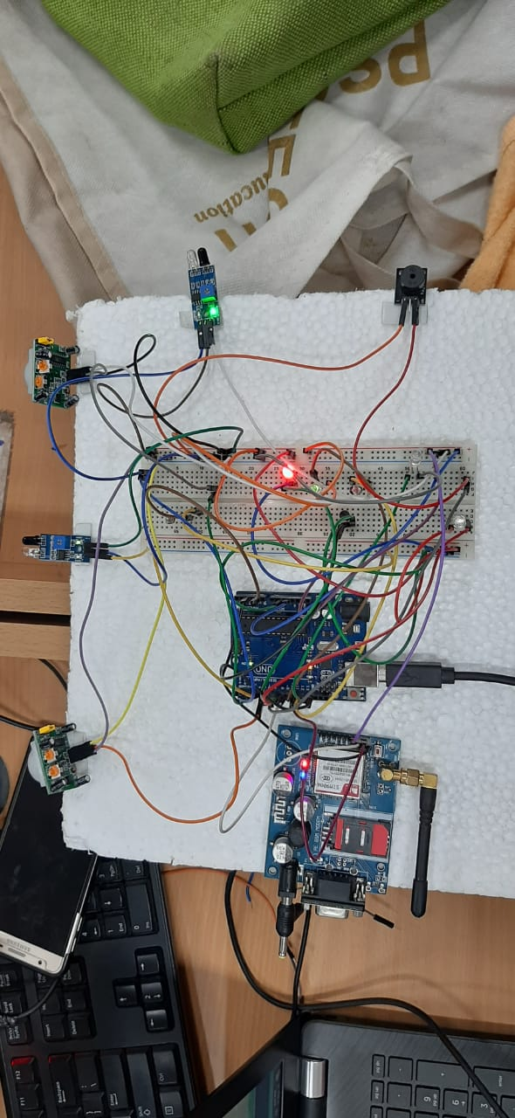

Figure ) Automatic Light Control with Fire Alarm

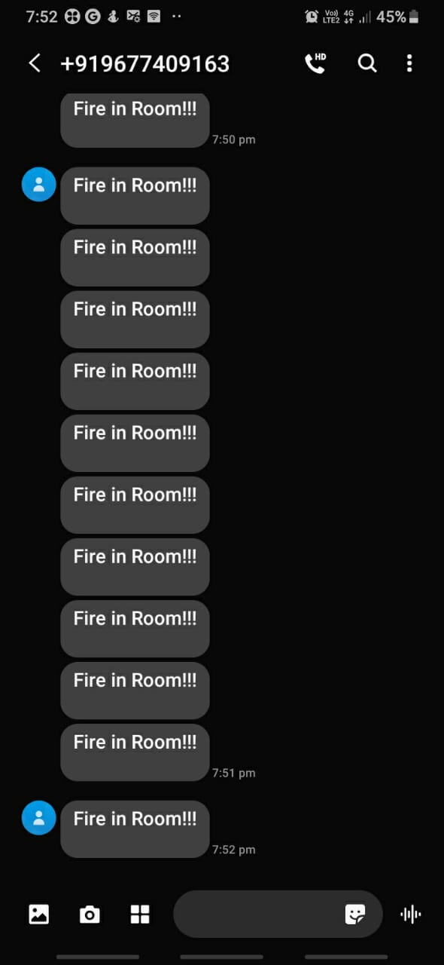

Figure ) SMS alert using GSM