**REPORT 1 – GROUP PROJECT**

***Energy Saver using PIR Sensor***

Submitted towards the professional course

**15Z610 – Embedded Systems Laboratory**

Celciya . K (17z311)

Dhivya . M (17z313)

Nishanth . S (17z332)



**06 February 2020**

***Department of Computer Science and Engineering***

***PSG College of Technology,***

***Coimbatore - 641 004.***

1. **INTRODUCTION**

In the beginning of electrification, switching between electrical devices is done by either connecting or disconnecting them to the power grid. Now-a-days disconnecting a device from its energy source become less popular. And also, there may be a chance to get an electric shock, when the human being is trying to disconnect a device without any precautions. So, switching between electrical device can be made electrically(automatically). This gives an easy way to switch the device (powered ‘on’ or ‘off’) by a remote-control unit or an automated switching circuit based on the number of persons inside in the particular room. So that the electricity consumption is reduced in the absence of persons.

This project presents the workflow to design the Energy Saver using PIR sensor to reduce the electricity consumption especially in the class room.

1. **PROBLEM STATEMENT**

Consider a class room, where there is a chance of high probability that the students might be fail to switch off the fans and lights due to the carelessness. So, the lot of electricity is wasted until manually switch off the fans and lights. This project provides the system which will be focusing on such an issue. This Energy Saver using PIR sensor is used to switch ‘off’ the fans and lights in the absence of students. When a student enters the classroom, the Infrared energy emitted from the living body is focused by the Fresnel lens segment and the PIR sensors were activated and give to the microcontroller which acts as power saving device according to the relay. When motion is detected, it triggers and switch the fan and light ‘on’. If no motion has not been detected, the system will switch ‘off; the fans and lights after 10 minutes. The fan only switches ‘on’ when the room attains a temperature of 25-40-degree C. The speed of fan can be controlled based on the room temperature.

1. **CPOMPONETS REQUIRED**

* Arduino mega
* Bread board
* LM35 – Temperature sensor
* Push button
* 10k ohm resistor
* TIP122 NPN Transistor
* Diode
* PIR (Passive Infrared Radio) Sensor
* DC Motors
* Jumpers

1. **SCHEMATIC DIAGRAM**

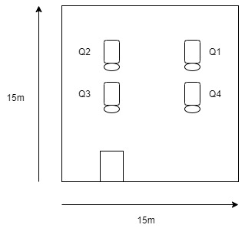

**Figure 1 - Schematic Diagram of the study area**

The study area is a classroom of an area 15m by 15m, the view of the study area and Positioning of the PIR sensor are depicted in Figure 1. Four sensors were positioned in the class room to cover the entire area. The view of the study area and positioning of the sensor are depicted in Figure 1.

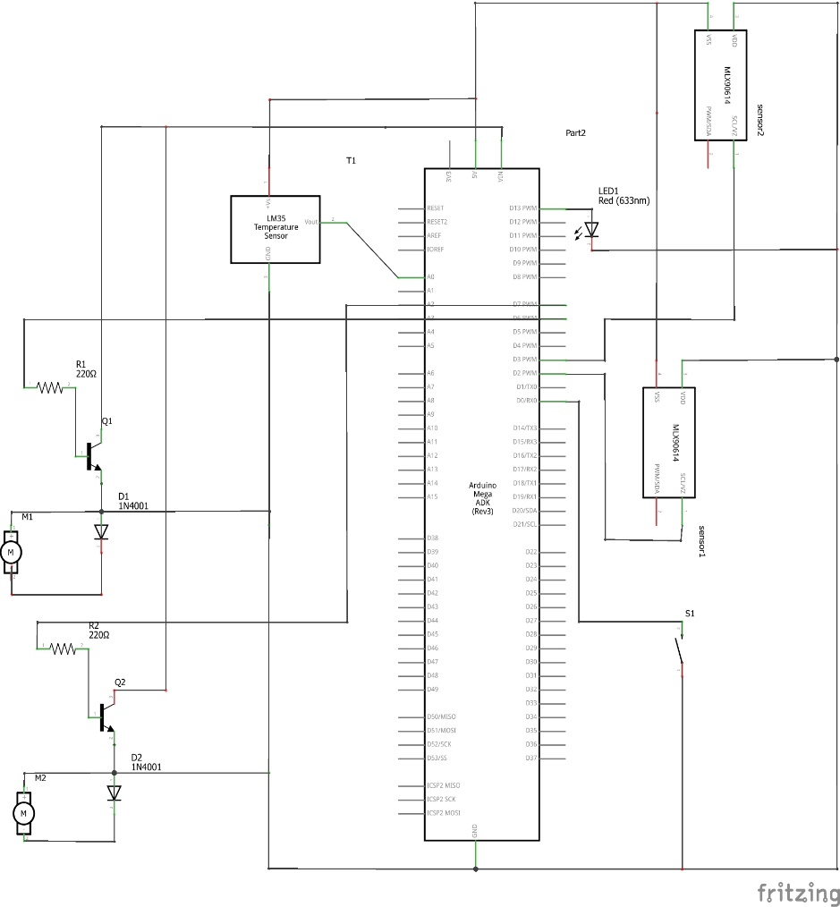

Figure 2) Schematic Diagram

1. **CODE**

int led1 = 13;

int led2 = 12;

int sensorPin1 = 2;

int sensorPin2 = 3;

int sensor1 = 0;

int sensor2 = 0;

int motor1 = 6;

int motor2 = 7;

int temperoryPin = 0;

int tempVal = 0;

int temperature = 0;

int temperaturePin = A0;

int speedFan = 0;

float temp;

void setup() {

pinMode(sensorPin1, INPUT); // Detecting the motion of person in Region 1

pinMode(sensorPin2, INPUT); // Detecting the motion of person in Region 1

pinMode(led1, OUTPUT); // Displaying the motion of person in Region 1

pinMode(led2, OUTPUT); // Displaying the motion of person in Region 2

pinMode(temperoryPin, INPUT); // If a person does not want fan, he can temperorily switch off the fan by enabling the pin (eventhough there is a motion)

pinMode(motor1, OUTPUT); // Enables Fan1

pinMode(motor2, OUTPUT); // Enables Fan2

Serial.begin(9600);

}

void loop() {

sensor1 = digitalRead(sensorPin1); // sensor1 value

sensor2 = digitalRead(sensorPin2); // sensor2 value

tempVal = digitalRead(temperoryPin); // temperory pin value

Serial.print("Temperory Pin : ");

Serial.println(tempVal);

Serial.print("Sensor 1 :");

Serial.println(sensor1);

Serial.print("Sensor 2 :");

Serial.println(sensor2);

temperature = analogRead(temperaturePin); // reading the room temperature

temperature = temperature * 0.48828125; // converting temperature from pin value to Celcius

Serial.print("Temperature : ");

Serial.println(temperature);

// Assigning the speed of fan based on room temperature

if (temperature >= 15 && temperature < 26) {

speedFan = 100;

} else if (temperature > 26 && temperature <= 28) {

speedFan = 150;

} else if (temperature > 28 && temperature <= 32) {

}

if (sensor1 == 1) {

if (tempVal == 1) {

Serial.print("SpeedFan1 : ");

Serial.println(speedFan);

for (int i = 0; i < 5; i++) {

motor(motor1, speedFan);

digitalWrite(led1, HIGH);

}

delay(1000);

// If a person is there and he wants fan in Region 1

}

}

if (sensor2 == 1) {

if (tempVal == 1) {

for (int i = 0; i < 5; i++) {

Serial.print("SpeedFan2 : ");

Serial.println(speedFan);

motortype(motor2, 250);

digitalWrite(led2, HIGH);

}

delay(1000);

// If a person is there and he wants fan in Region 2

}

}

else if (sensor1 == 0) {

motor(motor1, 0);

digitalWrite(led1, LOW);

// If there is no motion in Region 1

delay(1000);

}

else if (sensor2 == 0) {

motor(motor2, 0);

digitalWrite(led2, LOW);

// If there is no motion in Region 2

delay(1000);

}

delay(1000);

Serial.println();

Serial.println();

}

void motor(int type, int speedFan) {

analogWrite(type, speedFan);

delay(1000);

}

void motortype(int type, int speedFan) {

analogWrite(type, speedFan);

delay(1000);

1. **CHALLENGES FACED**

* If the sensor is not placed properly in the class room, the range of the sensors might get interfered because the class room is in a rectangle structure. So, it is difficult to cover the corners because the sensor can detect the motion at 180-degree angle.

1. **CONTRIBUTION OF TEAM MEMBERS**

Dhivya M – Design methodology

Nishanth S – Implementation

Celciya K - Testing and documentation

1. **REFERENCES**

[1] E. Adetiba and e. al, "Automatic Electrical Appliances Control Panel Based on Infrared and Wi-Fi: A Framework for Electrical Energy Conservation," Scientific & Engineering Research, 2011.

[2] Liji and e. al., "control of electrical lights and fans using Tv remote.," 2005.

[3] L. B. Jaafar, "Automatic room temperature control," 2013.

[4] A. A. Adewale and e. al., "design and development of a microcontroller-based automation switch for home appliances," International journal of engineering science intervention, pp. 24-31, 2013.

[5] S. Prasanna and e. al., "Automated Intelligent Power Saving System and Security System," Research India Publications, pp. 1167-1176, 2013. [6] K. Sravani and e. al., "Human Motion Detection”