**INTRODUCTION**:

Temperature measurement is also known as thermometry, describes the process of measuring local temperature for immediate or later evaluation. The temperature of the air near the surface of the Earth is measured at meteorological observatories and weather stations. The world’s average surface air temperature is about 14 degree Celsius. DS18B20 Sensor is used in this project for detection of temperature.

**PROBLEM STATEMENT:**

The motivation of this project is an observation of the variation in temperature in various circumstances. The implementation of this project will help in various practical applications such as closing or opening doors and windows according to the temperature, control any product’s temperature etc.

**COMPONENTS REQUIRED:**

1. ESP8266 - 1
2. DS18B20 Temperature sensor - 1
3. Resistors – 4.7k ohm
4. Jumpers
5. Bread board
6. Blynk app

**SCHEMATIC DIAGRAM:**

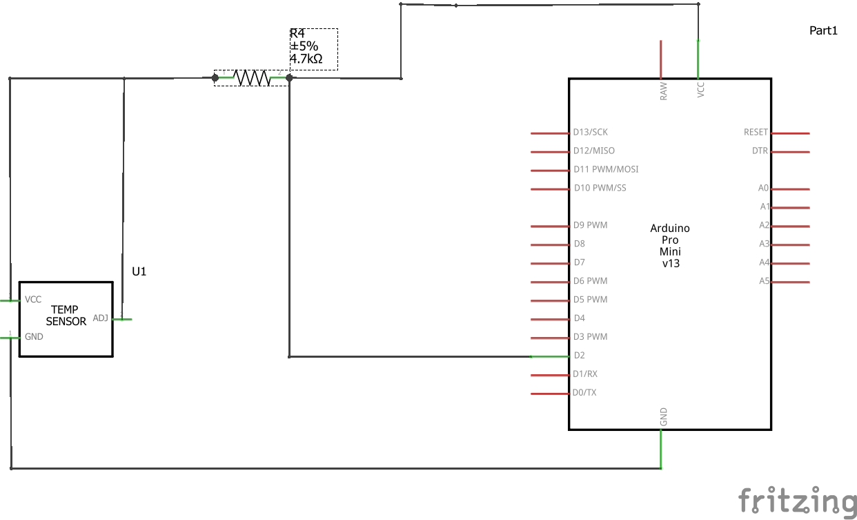

**CODE:**

#define BLYNK_PRINT Serial //used for printing messages on serial monitor port.  
#include <ESP8266WiFi.h> //provides ESP8266 specific wifi routines.  
#include <BlynkSimpleEsp8266.h> //handles all connection routines and data exchange.  
#include <OneWire.h> //to access 1-wire devices made by Dallas.  
#include <DallasTemperature.h>  
const int oneWireBus = 4;  
OneWire oneWire(oneWireBus);  
DallasTemperature sensors(&oneWire);  
  
  
char auth[] = "N8sdpDxd9iifLHGh9xXy3wEzAgZMiiEF";  
char ssid[] = "sss";  
char pass[] = "12345678@";  
  
void setup()  
{  
  Serial.begin(115200); //see the connection status in serial monitor.  
  sensors.begin();  
  Blynk.begin(auth, ssid, pass);   
  sense();  
}  
void sense()  
{  
  sensors.requestTemperatures();  
  float temperatureC = sensors.getTempCByIndex(0);  
  float temperatureF = sensors.getTempFByIndex(0);  
  Serial.print(temperatureC);  
  Serial.println("ºC");  
  Blynk.virtualWrite(V6,temperatureC);  
  Serial.print(temperatureF);  
  Serial.println("ºF");  
 Blynk.virtualWrite(V5,temperatureF);  
  delay(5000);  
}  
void loop()  
{  
  Blynk.run();  
  sense();  
}

**CHALLENGES FACED:**

-NIL-

**CONTRIBUTIONS:**

Kaviya sri.K.S(17z326)-circuit connections.

Sathiya.G(18z474)-circuit+code.

Shalini.D(18z475)-code.

**REFERENCES:**

<https://ui.adsabs.harvard.edu/abs/1996IJSSC..31..933B/abstract>.