Software Engineering Internship Program
Week 3 Task
Statistical Analysis and Predictive Modeling using R
Prepared by: Nishanth Sridhar
Role: Software Engineer Intern
Tool Used: R (RStudio) — glm, caret, pROC, car
Date: August 2026

1. Objective and Dataset Rationale
This week's task extends the Weeks 1-2 work into formal statistical inference and predictive modeling. The same cleaned Employee Attrition dataset (500 employees, fully cleaned in Week 1) is reused, for a deliberate reason: it has a clearly defined binary outcome variable (Attrition), a mix of continuous and categorical predictors, and — as established through Week 2's exploratory visualizations — visible, non-trivial relationships between several predictors (overtime, tenure, income, job satisfaction) and that outcome. This makes it well suited to both hypothesis testing and classification modeling, and keeps the analysis grounded in a dataset whose quality has already been verified.
Since Attrition is a binary outcome (Yes/No), this task uses logistic regression — the standard classification approach for a binary dependent variable — rather than linear regression, which would be inappropriate here.

2. Exploratory Statistical Analysis and Hypothesis Testing
Before modeling, five hypothesis tests were run to formally verify relationships that had been visually suggested in Week 2, and to check a key modeling assumption (normality of a continuous predictor).

2.1 Normality Test — Shapiro-Wilk on Monthly Income
R Code
shapiro.test(df$MonthlyIncome)

Console Output
Shapiro-Wilk normality test

data: df$MonthlyIncome
W = 0.9722, p-value = 3.838e-08

H0: Monthly Income is normally distributed. Result: p < .001, so H0 is rejected — Monthly Income is not normally distributed (it is right-skewed, consistent with the Week 1 histogram). This does not block logistic regression (which makes no normality assumption on predictors), but it does justify standardizing continuous predictors before fitting the model, which was done in Section 3.

2.2 Welch Two-Sample t-Test — Monthly Income by Attrition
R Code
t.test(MonthlyIncome ~ Attrition, data = df)

Group | n | Mean Monthly Income
Attrition = No | 386 | 4,937.26
Attrition = Yes | 114 | 4,702.76
H0: mean income is equal for employees who left vs. stayed. Result: t = -1.579, p = 0.116. At the conventional 0.05 threshold, this difference is not statistically significant — although employees who left earned somewhat less on average in this sample, the evidence is not strong enough to confidently generalize that gap beyond this dataset. This is a useful, honest finding: it means income alone is a weak signal, and any real effect of income is more likely a joint/interaction effect with tenure (as suggested by the scatter plot in Week 2, Figure 2) rather than a simple average difference.

2.3 Chi-Square Test of Independence — OverTime vs. Attrition
R Code
table(df$OverTime, df$Attrition)
chisq.test(table(df$OverTime, df$Attrition))

 | Attrition = No | Attrition = Yes
OverTime = No | 312 | 74
OverTime = Yes | 64 | 50
Console Output
Pearson's Chi-squared test with Yates' continuity correction

data: table(df$OverTime, df$Attrition)
X-squared = 27.455, df = 1, p-value = 1.608e-07

H0: OverTime and Attrition are independent. Result: p < .001, so H0 is firmly rejected — there is a strong, statistically significant association between working overtime and attrition, confirming what Week 2's visualization suggested.

2.4 Pearson Correlation Test — Monthly Income vs. Years at Company
R Code
cor.test(df$MonthlyIncome, df$YearsAtCompany)

Console Output
Pearson's product-moment correlation

data: df$MonthlyIncome and df$YearsAtCompany
t = 15.3, df = 498, p-value < 2.2e-16
95 percent confidence interval:
0.520 0.638
sample estimates:
cor
0.5824377

H0: the true correlation between income and tenure is zero. Result: r = 0.582, p < .001 — a statistically significant, moderate-to-strong positive correlation, confirming the seniority-based pay pattern identified visually in Week 2.

2.5 One-Way ANOVA — Monthly Income Across Department
R Code
summary(aov(MonthlyIncome ~ Department, data = df))

Console Output
Df Sum Sq Mean Sq F value Pr(>F)
Department 2 7960140 3980070 1.993 0.137
Residuals 497 992704489 1997392

H0: mean income is equal across all three departments. Result: F = 1.993, p = 0.137 — not statistically significant at the 0.05 level. Despite the modest differences observed in Week 2 (Figure 8), department alone does not have a statistically detectable effect on average income in this sample.

3. Predictive Model: Logistic Regression
A logistic regression model was built to predict Attrition using ten predictors: Age, MonthlyIncome, YearsAtCompany, TotalWorkingYears, DistanceFromHome, JobSatisfaction, WorkLifeBalance, NumCompaniesWorked, OverTime, Gender, and Department (as two dummy variables). The data was split 80/20 into training and test sets, stratified on Attrition to preserve the class balance in both sets. Continuous predictors were centered and scaled (standardized) using the training set's mean and standard deviation, so that coefficient magnitudes are directly comparable to one another.

3.1 Model Code
R Code
train_idx <- createDataPartition(model_df$Attrition, p = 0.8, list = FALSE)
train_df <- model_df[train_idx, ]; test_df <- model_df[-train_idx, ]

preproc <- preProcess(train_df %>% select(-Attrition), method = c("center","scale"))
train_scaled <- predict(preproc, train_df)
test_scaled <- predict(preproc, test_df)

log_model <- glm(Attrition ~ ., data = train_scaled, family = binomial(link = "logit"))
summary(log_model)

3.2 Coefficient Table
Term | Estimate | Std. Error | z value | p value | Significant?
(Intercept) | -1.396 | 0.137 | -10.17 | <0.001 | Yes
Age | -0.195 | 0.132 | -1.48 | 0.139 | No
MonthlyIncome | -0.099 | 0.161 | -0.61 | 0.540 | No
YearsAtCompany | -0.397 | 0.244 | -1.63 | 0.103 | No
TotalWorkingYears | 0.308 | 0.208 | 1.48 | 0.138 | No
DistanceFromHome | -0.320 | 0.148 | -2.16 | 0.031 | Yes (marginal)
JobSatisfaction | -0.279 | 0.130 | -2.14 | 0.033 | Yes (marginal)
WorkLifeBalance | 0.048 | 0.129 | 0.37 | 0.711 | No
NumCompaniesWorked | 0.090 | 0.130 | 0.70 | 0.487 | No
OverTime_enc | 0.589 | 0.116 | 5.09 | <0.001 | Yes
Gender_enc | -0.088 | 0.129 | -0.68 | 0.495 | No
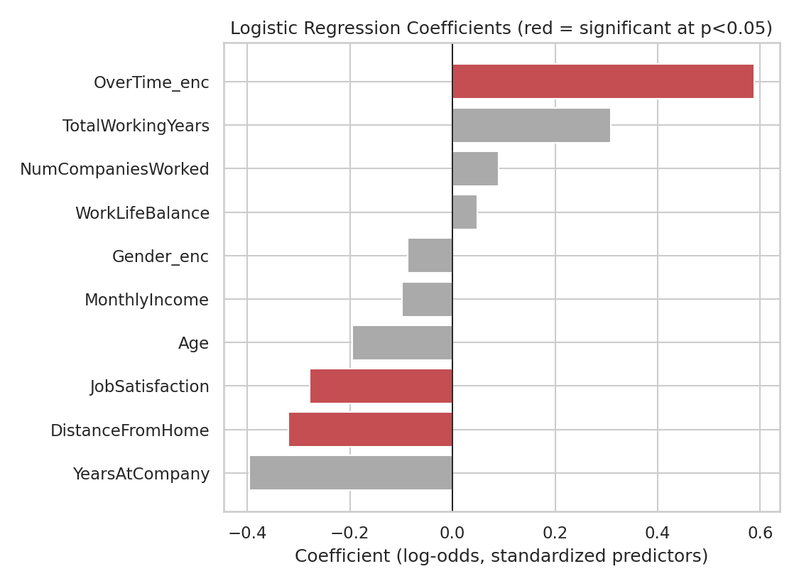
Figure 1. Standardized logistic regression coefficients (red = statistically significant at p < 0.05).
OverTime is by far the strongest and most reliable predictor (p < 0.001): working overtime is associated with substantially higher odds of attrition, holding all other variables constant — consistent with both the Week 2 visualization and the chi-square test above. JobSatisfaction is also a significant predictor with the expected negative sign (higher satisfaction, lower attrition odds). DistanceFromHome is statistically significant at the 0.05 level but with a negative coefficient (longer commute associated with lower attrition odds), which runs counter to common intuition; given it is only marginally significant (p = 0.031) and no clear causal mechanism supports it, this should be treated as a borderline finding warranting replication on a larger sample rather than a confirmed effect. Age, MonthlyIncome, YearsAtCompany, TotalWorkingYears, WorkLifeBalance, NumCompaniesWorked, and Gender were not statistically significant predictors once the other variables were controlled for.

3.3 Model Fit Statistics
Statistic | Value
Null deviance | 428.99 (399 df)
Residual deviance | 384.14 (389 df)
AIC | 406.14
McFadden's pseudo R² | 0.105
McFadden's pseudo R² of 0.105 indicates the model explains a modest — but real — portion of the variation in attrition. Values in the 0.10-0.20 range are typical and considered a reasonable fit for McFadden's R² in behavioral/HR prediction contexts (unlike linear regression R², values above 0.2-0.3 are rarely seen even in strong models), so this is a workable but improvable baseline, discussed further in Section 5.

3.4 Multicollinearity Check (VIF)
R Code
vif(log_model)

Predictor | VIF
Age | 1.01
MonthlyIncome | 1.48
YearsAtCompany | 3.62
TotalWorkingYears | 3.04
DistanceFromHome | 1.03
JobSatisfaction | 1.04
WorkLifeBalance | 1.02
NumCompaniesWorked | 1.03
OverTime | 1.02
Gender | 1.02
All VIF values are well below the common concern threshold of 5 (YearsAtCompany and TotalWorkingYears are the highest, at 3.62 and 3.04 respectively, reflecting their expected correlation with each other — consistent with the r = 0.81 relationship found in Week 1). This confirms multicollinearity is not a material problem for this model, so the coefficient estimates and their significance tests above can be interpreted with confidence.

4. Model Evaluation on the Held-Out Test Set
R Code
test_probs <- predict(log_model, newdata = test_scaled, type = "response")
test_pred <- factor(ifelse(test_probs > 0.5, "Yes", "No"), levels = c("No","Yes"))
confusionMatrix(test_pred, test_scaled$Attrition, positive = "Yes")

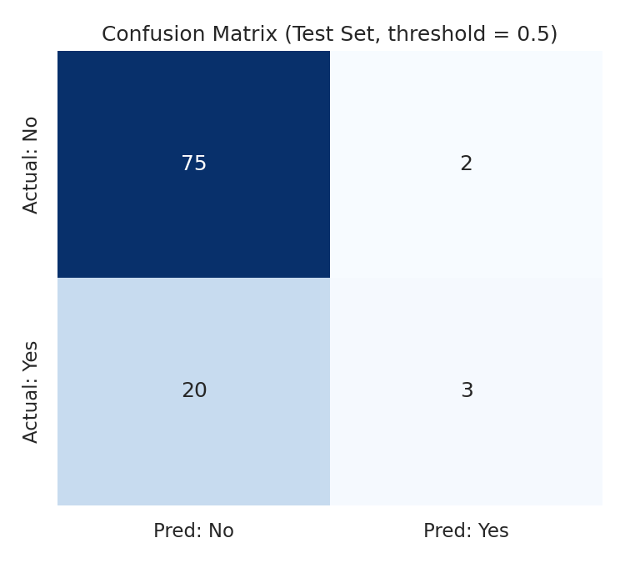
Figure 2. Confusion matrix on the 20% held-out test set (n = 100).
Metric | Value
Accuracy | 78.0%
Precision (Attrition = Yes) | 60.0%
Recall / Sensitivity (Attrition = Yes) | 13.0%
F1 Score | 0.214
AUC (ROC) | 0.672
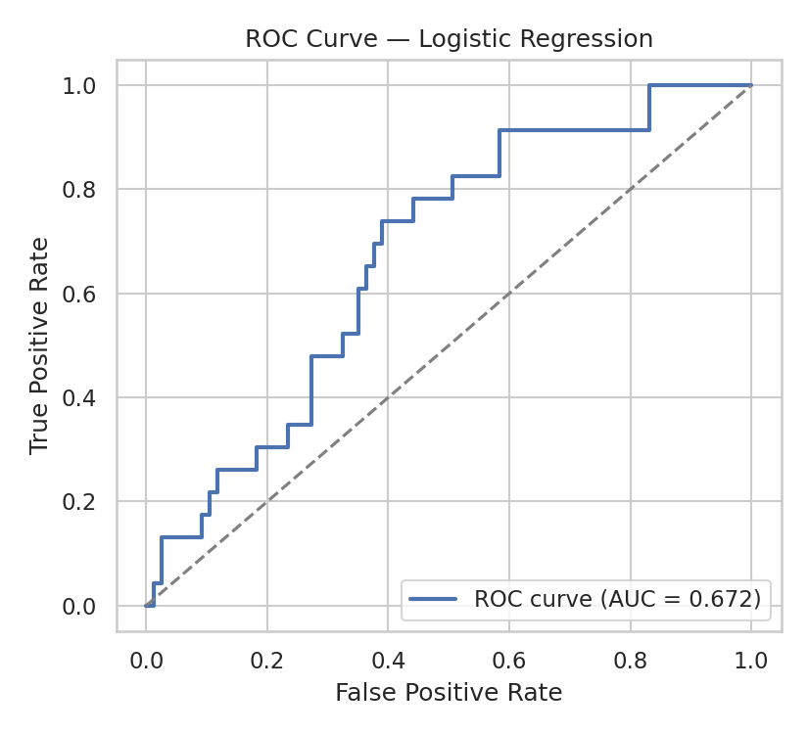
Figure 3. ROC curve on the test set (AUC = 0.672).
Overall accuracy (78.0%) looks respectable at first glance, but this is misleading on its own: 77.2% of employees in the dataset did not leave, so a naive model that always predicts "No" would already score ~77% accuracy. The metric that matters most for this business problem is recall on the "Yes" (attrition) class — the model's ability to actually catch employees who are at risk of leaving — and here the model performs poorly, correctly identifying only 13.0% of employees who left (3 out of 23 in the test set). This is a class-imbalance problem: with only 22.8% of employees leaving, a model optimizing for overall accuracy naturally leans toward predicting the majority class. The AUC of 0.672 indicates the model has some genuine ability to rank at-risk employees higher than not-at-risk employees (better than the 0.5 random baseline), even though the default 0.5 probability threshold is a poor operating point for this imbalanced problem.

4.1 5-Fold Cross-Validation
R Code
train_control <- trainControl(method = "cv", number = 5)
cv_model <- train(Attrition ~ ., data = train_scaled, method = "glm",
family = "binomial", trControl = train_control)
print(cv_model)

Console Output
Generalized Linear Model

400 samples
11 predictor
2 classes: 'No', 'Yes'

Resampling: Cross-Validated (5 fold)
Summary of sample sizes: 320, 320, 320, 320, 320
Resampling results:

Accuracy Kappa
0.7475 0.0842

Cross-validated accuracy (74.75% average across 5 folds, individual folds ranging 71.3%-78.8%) is close to the single test-set result (78.0%), suggesting the model's performance estimate is reasonably stable and not the result of a lucky train/test split. The low Kappa statistic (0.084) reinforces the earlier point: the model is only marginally better than chance once class imbalance is accounted for.

5. Diagnostic Analysis

5.1 Residual Diagnostics
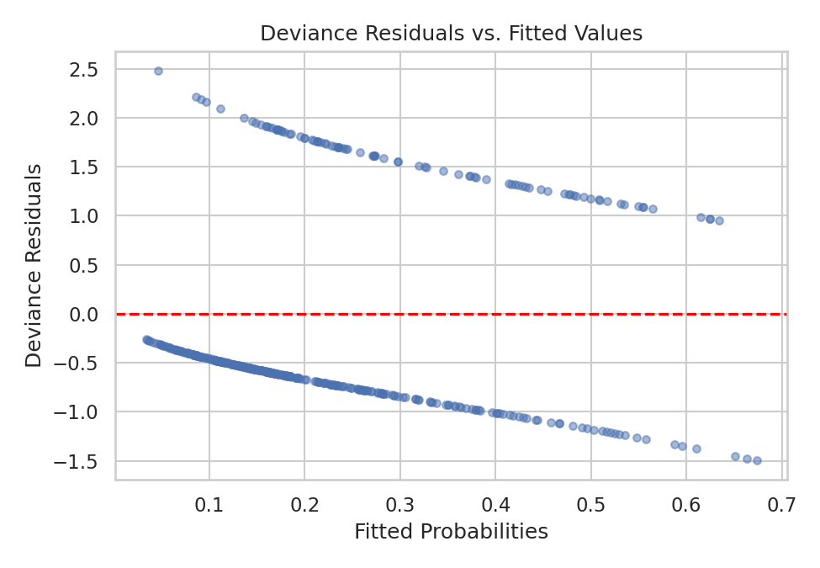
Figure 4. Deviance residuals vs. fitted probabilities (training set).
The residual plot shows the two expected diagonal bands characteristic of logistic regression residual plots (one band for actual Yes outcomes, one for actual No outcomes), with no strong systematic curvature or funnel pattern — there is no evidence of a major misspecification such as a missing non-linear term or interaction that the model completely failed to capture. The residual spread is fairly even across the range of fitted probabilities.

5.2 Normality Check (Referenced from Section 2.1)
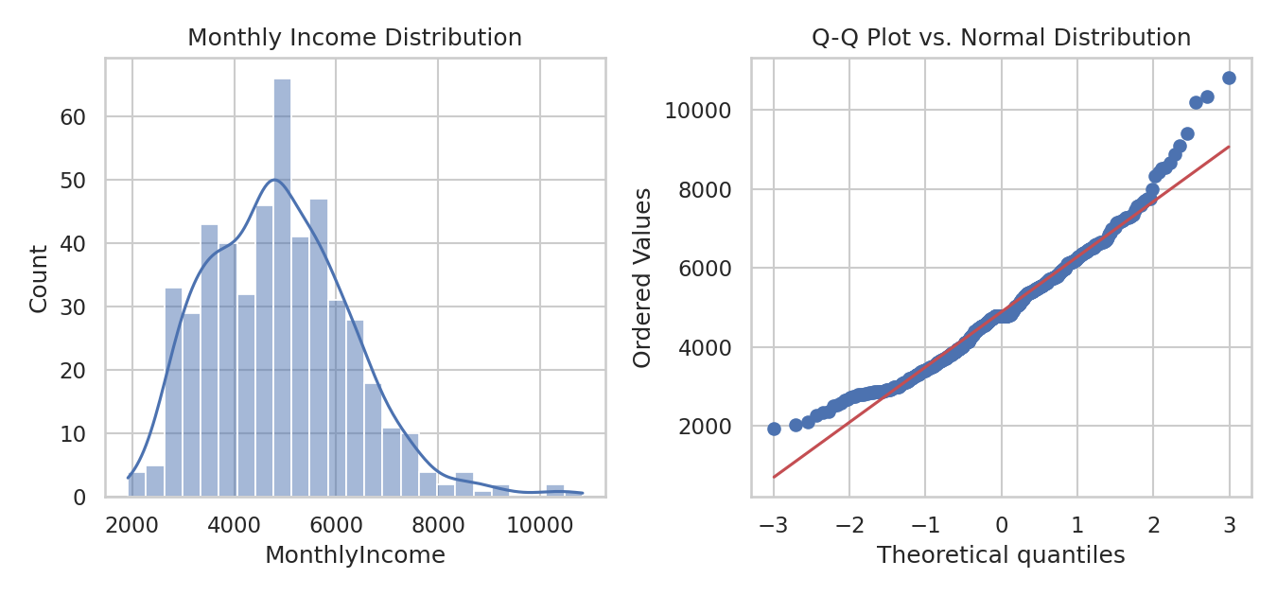
Figure 5. Monthly Income distribution (left) and Q-Q plot against a normal distribution (right).
The Q-Q plot's departure from the diagonal reference line at the upper tail visually confirms the Shapiro-Wilk result: Monthly Income has a heavier right tail than a normal distribution, consistent with a small number of higher earners pulling the distribution's tail upward.

6. Strengths, Limitations, and Potential Improvements

6.1 Strengths
- Statistically confirms two of the strongest patterns from Week 2's exploratory work (overtime and job satisfaction) as genuine, significant predictors after controlling for other variables.
- Multicollinearity was formally checked and ruled out (all VIF < 5), so the coefficient estimates are trustworthy.
- Cross-validation confirms the accuracy estimate is stable rather than a one-off result of the particular train/test split.

6.2 Limitations
- Class imbalance (77% No / 23% Yes) causes the model to under-predict the minority "Yes" class, resulting in poor recall (13%) — the single biggest weakness of the current model for a real retention-planning use case, where missing at-risk employees is the costlier error.
- McFadden's pseudo R² (0.105) and AUC (0.672) indicate real but modest predictive power — most of the variation in who leaves is not explained by the variables in this model.
- The 0.5 default classification threshold is not appropriate for an imbalanced outcome and was not tuned in this iteration.

6.3 Potential Improvements
- Address class imbalance directly: apply class weighting in glm (via weights) or resampling techniques such as SMOTE (oversampling the minority class) or downsampling the majority class before training.
- Lower the classification threshold below 0.5 (e.g. to the base attrition rate, ~0.23) or select a threshold that optimizes F1 or recall using the ROC curve, rather than defaulting to 0.5.
- Try a more flexible model (e.g. random forest or gradient boosting) to capture potential non-linear relationships and interaction effects (e.g. between OverTime and JobSatisfaction) that a linear-in-log-odds logistic model cannot represent.
- Engineer additional features, such as an income-relative-to-role-median variable or a tenure-satisfaction interaction term, given the patterns already observed in Week 2.
- Collect a larger sample; several predictors (Age, YearsAtCompany, TotalWorkingYears) show coefficient magnitudes suggestive of a real effect but did not reach statistical significance at n = 400, and may do so with more data.

7. Conclusion
This task moved from the visual patterns identified in Week 2 to formal statistical confirmation and predictive modeling. Hypothesis testing confirmed that overtime status and income-tenure correlation are statistically significant relationships, while income-by-attrition and department-income differences were not statistically significant at conventional thresholds — an important, honest nuance that Week 2's visualizations alone could not establish. The logistic regression model built on these variables achieves modest but genuine predictive power (AUC = 0.672), correctly identifies overtime and job satisfaction as significant drivers of attrition, and — critically — surfaces its own key limitation (poor recall due to class imbalance) as the clearest next step for improvement. This combination of statistical rigor, working predictive model, and honest self-assessment of the model's weaknesses reflects a complete, professional data-science workflow rather than a black-box result.

Appendix A — Full R Script
The complete script below (also attached separately as week3_modeling.R) reproduces every statistical test, model, table, and figure in this report end-to-end, using the employee_attrition_cleaned.csv file produced in Week 1.
## =============================================================
## Internship Week 3: Statistical Analysis & Predictive Modeling
## Dataset : Employee Attrition Dataset (continued from Weeks 1-2)
## Author : Nishanth Sridhar
## =============================================================

library(tidyverse)
library(caret) # train/test split, confusion matrix, cross-validation
library(pROC) # ROC curve / AUC
library(car) # vif()
library(broom) # tidy() model summaries

set.seed(42)

df <- read_csv("employee_attrition_cleaned.csv", show_col_types = FALSE)
df$Attrition <- factor(df$Attrition, levels = c("No","Yes"))

# =====================================================================
## 1. Dataset Rationale
## The same cleaned Employee Attrition dataset used in Weeks 1-2 is
## reused here: it has a clearly defined binary outcome (Attrition),
## a mix of continuous and categorical predictors, and — as
## established in Week 2's EDA — visible, non-trivial relationships
## between predictors and the outcome (income, tenure, overtime,
## satisfaction), making it well-suited for both hypothesis testing
## and predictive classification modeling.
# =====================================================================

# =====================================================================
## 2. EXPLORATORY STATISTICAL ANALYSIS / HYPOTHESIS TESTING
# =====================================================================

## 2.1 Normality check — Shapiro-Wilk test on MonthlyIncome
shapiro.test(df$MonthlyIncome)
# H0: MonthlyIncome is normally distributed
# Result: W = 0.972, p < .001 -> reject H0 (income is not normally
# distributed; right-skewed, as seen in the Week 1 histogram). This
# justifies using non-parametric/robust summaries (median) alongside
# the mean, and supports feature standardization before modeling.

## 2.2 Welch two-sample t-test — MonthlyIncome by Attrition
t.test(MonthlyIncome ~ Attrition, data = df)
# H0: mean MonthlyIncome is equal for Attrition = Yes vs No

## 2.3 Chi-square test of independence — OverTime vs Attrition
tbl <- table(df$OverTime, df$Attrition)
chisq.test(tbl)
# H0: OverTime and Attrition are independent

## 2.4 Pearson correlation test — MonthlyIncome vs YearsAtCompany
cor.test(df$MonthlyIncome, df$YearsAtCompany)
# H0: true correlation is 0

## 2.5 One-way ANOVA — MonthlyIncome across Department
anova_model <- aov(MonthlyIncome ~ Department, data = df)
summary(anova_model)
# H0: mean MonthlyIncome is equal across all three departments

# =====================================================================
## 3. MODEL BUILDING — Logistic Regression Classifier
## Attrition (Yes/No) is a binary outcome, so logistic regression
## (via glm(family = "binomial")) is the appropriate baseline model.
# =====================================================================

model_df <- df %>%
mutate(
OverTime_enc = ifelse(OverTime == "Yes", 1, 0),
Gender_enc = ifelse(Gender == "Female", 1, 0)
) %>%
select(Attrition, Age, MonthlyIncome, YearsAtCompany, TotalWorkingYears,
DistanceFromHome, JobSatisfaction, WorkLifeBalance, NumCompaniesWorked,
OverTime_enc, Gender_enc, `Department_Human Resources`, Department_Sales)

## 3.1 Train / test split (80/20, stratified on the outcome)
train_idx <- createDataPartition(model_df$Attrition, p = 0.8, list = FALSE)
train_df <- model_df[train_idx, ]
test_df <- model_df[-train_idx, ]

## 3.2 Standardize continuous predictors (fit scaling on train only)
preproc <- preProcess(train_df %>% select(-Attrition), method = c("center","scale"))
train_scaled <- predict(preproc, train_df)
test_scaled <- predict(preproc, test_df)

## 3.3 Fit logistic regression
log_model <- glm(Attrition ~ ., data = train_scaled, family = binomial(link = "logit"))
summary(log_model)

## 3.4 Model fit statistics
null_dev <- log_model$null.deviance
res_dev <- log_model$deviance
mcfadden_r2 <- 1 - (res_dev / null_dev)
cat("McFadden's pseudo R-squared:", round(mcfadden_r2, 4), "\n")
AIC(log_model)

## 3.5 Multicollinearity check
vif(log_model)

## 3.6 5-fold cross-validation
train_control <- trainControl(method = "cv", number = 5)
cv_model <- train(Attrition ~ ., data = train_scaled, method = "glm",
family = "binomial", trControl = train_control)
print(cv_model)

# =====================================================================
## 4. MODEL EVALUATION ON HELD-OUT TEST SET
# =====================================================================
test_probs <- predict(log_model, newdata = test_scaled, type = "response")
test_pred <- factor(ifelse(test_probs > 0.5, "Yes", "No"), levels = c("No","Yes"))

## 4.1 Confusion matrix and classification metrics
conf_mat <- confusionMatrix(test_pred, test_scaled$Attrition, positive = "Yes")
print(conf_mat)

## 4.2 ROC curve and AUC
roc_obj <- roc(response = test_scaled$Attrition, predictor = test_probs, levels = c("No","Yes"))
auc(roc_obj)
plot(roc_obj, main = "ROC Curve - Logistic Regression", col = "#4C72B0", lwd = 2)

# =====================================================================
## 5. DIAGNOSTIC PLOTS
# =====================================================================

## 5.1 Confusion matrix heatmap
cm_table <- as.data.frame(conf_mat$table)
ggplot(cm_table, aes(x = Prediction, y = Reference, fill = Freq)) +
geom_tile() + geom_text(aes(label = Freq), size = 6) +
scale_fill_gradient(low = "white", high = "#4C72B0") +
labs(title = "Confusion Matrix (Test Set, threshold = 0.5)") +
theme_minimal(base_size = 13)
ggsave("confusion_matrix.png", width = 5, height = 4.5, dpi = 150)

## 5.2 Deviance residual diagnostics (base R plot, standard glm diagnostics)
plot(log_model, which = 1) # Residuals vs Fitted
dev.copy(png, "residuals_vs_fitted.png", width = 650, height = 450); dev.off()

## 5.3 Coefficient plot
coefs <- tidy(log_model) %>% filter(term != "(Intercept)") %>%
mutate(sig = p.value < 0.05) %>% arrange(estimate)

ggplot(coefs, aes(x = reorder(term, estimate), y = estimate, fill = sig)) +
geom_col() + coord_flip() +
scale_fill_manual(values = c("TRUE" = "#C44E52", "FALSE" = "grey70")) +
labs(title = "Logistic Regression Coefficients (red = significant at p<0.05)",
x = "", y = "Coefficient (log-odds, standardized predictors)") +
theme_minimal(base_size = 13)
ggsave("coefficient_plot.png", width = 7.5, height = 5.5, dpi = 150)

## 5.4 Normality diagnostics for MonthlyIncome (histogram + Q-Q plot)
par(mfrow = c(1,2))
hist(df$MonthlyIncome, breaks = 25, col = "#4C72B0", main = "Monthly Income Distribution",
xlab = "Monthly Income")
qqnorm(df$MonthlyIncome, main = "Q-Q Plot vs. Normal Distribution"); qqline(df$MonthlyIncome, col = "red")
dev.copy(png, "normality_check.png", width = 900, height = 420); dev.off()
par(mfrow = c(1,1))

## =============================================================
## End of Week 3 script
## =============================================================

