Software Engineering Internship Program
Week 4 Task — Final Report
Comprehensive Data Analysis Reporting and Presentation
Employee Attrition Analysis: From Raw Data to Predictive Insights
Prepared by: Nishanth Sridhar
Role: Software Engineer Intern
Tool Used: R (RStudio) — tidyverse, ggplot2, caret, pROC, car
Date: August 2026

Executive Summary
Over the course of this four-week internship project, a single Employee Attrition dataset (500 employees, 17 core variables) was carried through a complete, professional data-analysis lifecycle: data cleaning and preprocessing (Week 1), visualization and insight communication (Week 2), statistical hypothesis testing and predictive modeling (Week 3), and — in this report — a consolidated synthesis of all three stages into a single, decision-ready narrative (Week 4).
The analysis found that employee attrition (22.8% overall) is not random: it is significantly and repeatedly associated with working overtime, lower job satisfaction, and — visually, if not always at strict statistical significance — shorter tenure and lower relative pay. A logistic regression model built on these variables achieved a moderate but genuine predictive signal (AUC = 0.672), while also surfacing an important limitation — class imbalance — that itself became one of the most actionable findings of the project, since a working model that can be improved with a known fix is far more useful to report honestly than one that silently overstates its own reliability.
This report is structured to be read on its own by a technical or non-technical audience alike: each stage of the pipeline (cleaning, visualization, modeling) is summarized with its key outputs, and the final sections translate all of this into business implications, lessons learned, and concrete recommendations for what to do next.

1. Introduction

1.1 Project Objective
The four-week objective was to demonstrate, using R, the complete workflow a data analyst or data scientist follows when turning a raw, imperfect dataset into a decision-useful, statistically validated set of insights and a working predictive model — and, just as importantly, to communicate all of it clearly enough that a non-technical stakeholder could act on the findings.

1.2 Dataset
The dataset used throughout is an HR Employee Attrition dataset of 500 employees across three departments (Sales, Research & Development, Human Resources), combining numerical variables (age, income, tenure, commute distance) with categorical variables (gender, department, job role, overtime status) and the binary outcome of interest, Attrition (whether the employee left the company). Using one dataset across all four weeks — rather than a new dataset each week — was a deliberate choice: it allowed each week's work to build directly on verified, high-quality output from the week before, exactly as it would in a real analytics engagement.

1.3 Report Structure
Section 2 summarizes the methodology and overall pipeline. Sections 3-5 walk through Data Preparation, Visualization, and Predictive Modeling respectively, each condensing the relevant week's most important code, outputs, and findings. Section 6 discusses the business implications of the combined findings. Section 7 reflects on lessons learned and challenges. Section 8 outlines recommended future directions, and Section 9 concludes.

2. Methodology Overview
The project followed a standard four-stage analytics pipeline, with each stage's output feeding directly into the next:
Stage | Week | Key Techniques
Data Cleaning & Preprocessing | Week 1 | Missing-value imputation, outlier detection (IQR), duplicate removal, categorical encoding, normalization
Exploratory Visualization | Week 2 | Bar, scatter, histogram, line, boxplot, stacked bar, donut, and grouped-bar charts using ggplot2 and base R
Statistical Testing & Modeling | Week 3 | Hypothesis testing (t-test, chi-square, correlation, ANOVA, Shapiro-Wilk), logistic regression, cross-validation
Integration & Reporting | Week 4 (this report) | Synthesis of all prior findings into a single, cohesive, business-facing narrative
All R code for each stage is provided in full in the Week 1, Week 2, and Week 3 script files (also available in the accompanying GitHub repository); this report focuses on integrating and interpreting the results rather than repeating every line of code.

3. Data Preparation (Week 1 Summary)
The raw dataset (504 rows, including 4 injected duplicates) required four categories of cleaning before it could be analyzed reliably: missing values (present in 6 of 17 columns, up to 6% per column), inconsistent categorical labels (e.g. "Male" vs. "M" vs. "male"), duplicate records, and outliers (3 biologically implausible ages, 8 abnormally high incomes).
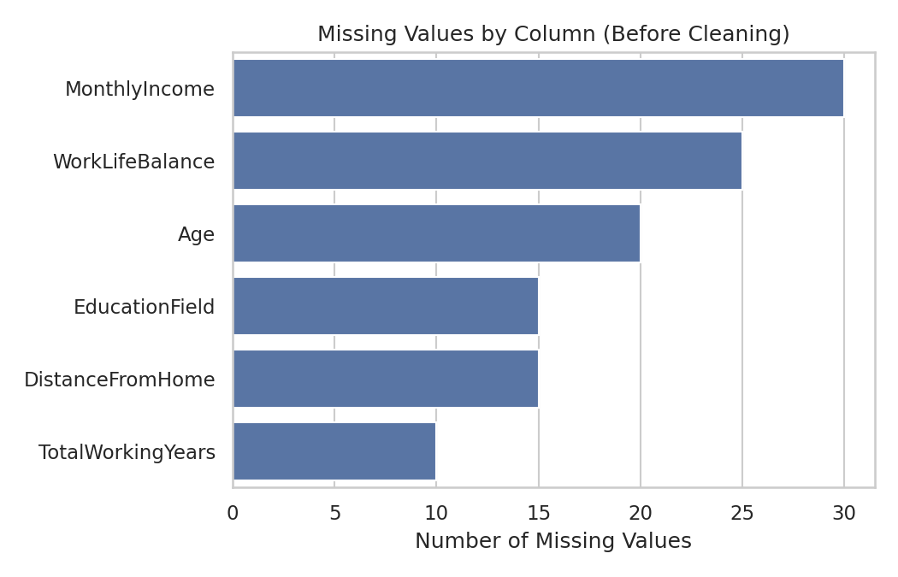
Figure 1. Missing values by column, before cleaning (Week 1).
R Code — median imputation (annotated)
num_impute <- c("Age","MonthlyIncome","TotalWorkingYears","DistanceFromHome","WorkLifeBalance")
for (col in num_impute) {
med <- median(df[[col]], na.rm = TRUE)
df[[col]][is.na(df[[col]])] <- med # median imputation: robust to skew/outliers
}

Median (not mean) imputation was used for numeric columns because several of them — Monthly Income in particular — are right-skewed, so the median remains representative even where the mean would be pulled upward by high earners. Categorical missingness (EducationField only) was imputed with the column mode.
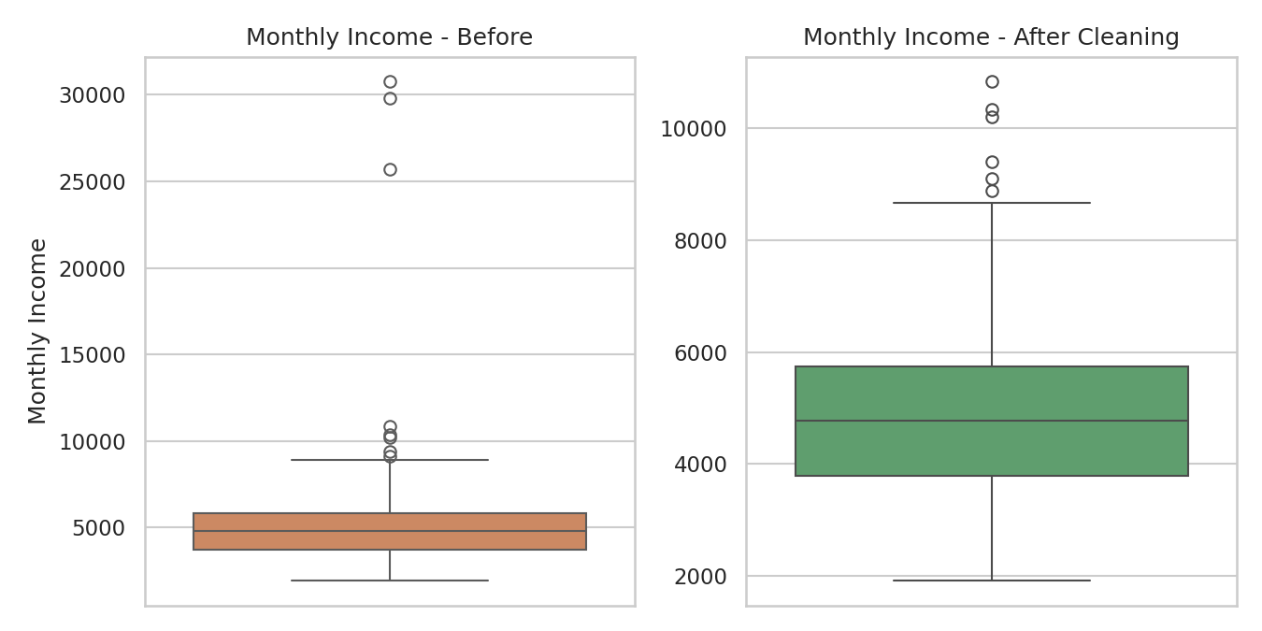
Figure 2. Monthly Income distribution before and after outlier treatment (Week 1).
After cleaning, the dataset was fully complete (zero missing values across all columns), de-duplicated to 500 unique employee records, and exported in two forms: a human-readable cleaned file and a fully encoded/normalized file for modeling use. Descriptive statistics and a correlation matrix (Figure 3) were also produced at this stage, most notably confirming a strong relationship between Years at Company and Total Working Years (r = 0.81) — an early signal, later formally confirmed in Week 3, that tenure-related variables move together.
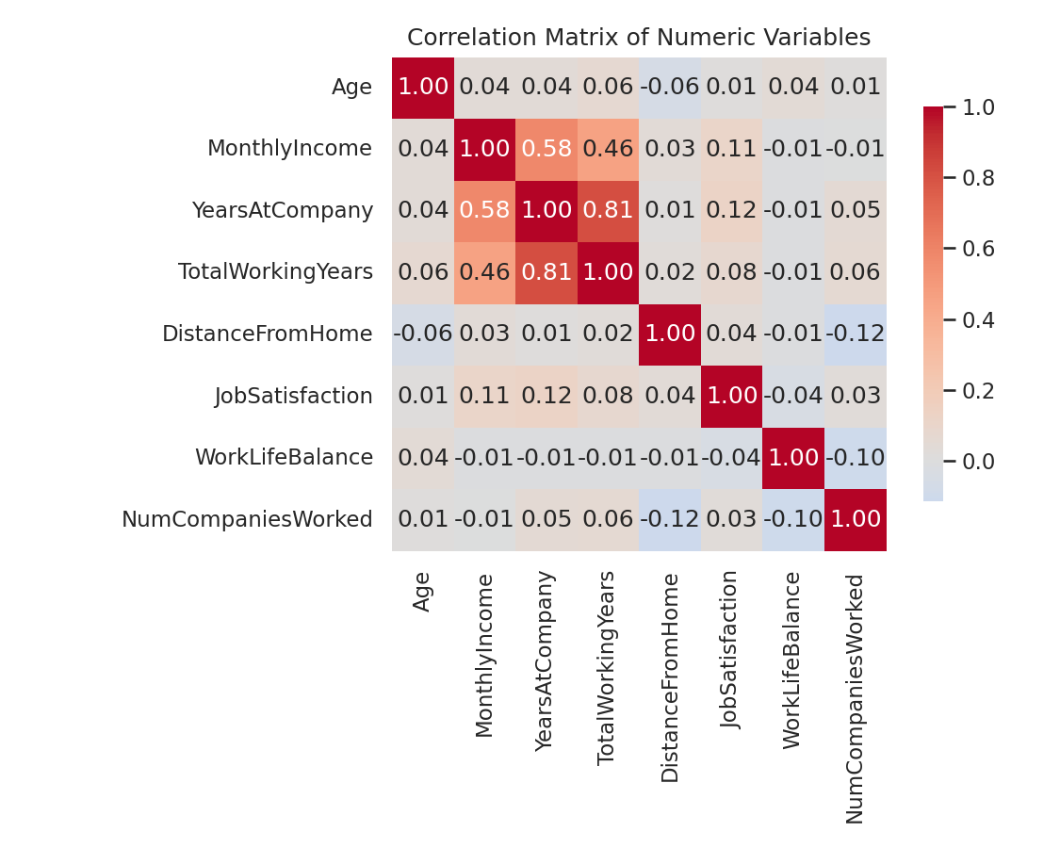
Figure 3. Correlation matrix of numeric variables (Week 1).

4. Visualization and Insight Communication (Week 2 Summary)
With a clean dataset in hand, Week 2 developed eight purpose-chosen visualizations — spanning bar, scatter, histogram, line, boxplot, stacked bar, donut, and grouped bar chart types — each selected to answer a specific analytical question rather than defaulting to one chart style throughout. Three of the most consequential are reproduced here.
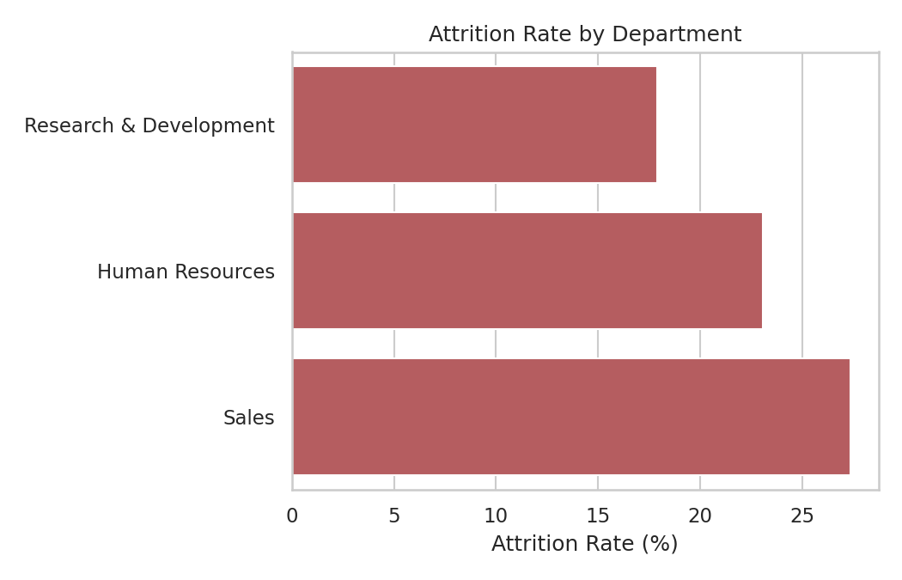
Figure 4. Attrition rate by department (Week 2) — Sales highest at 27.4%.
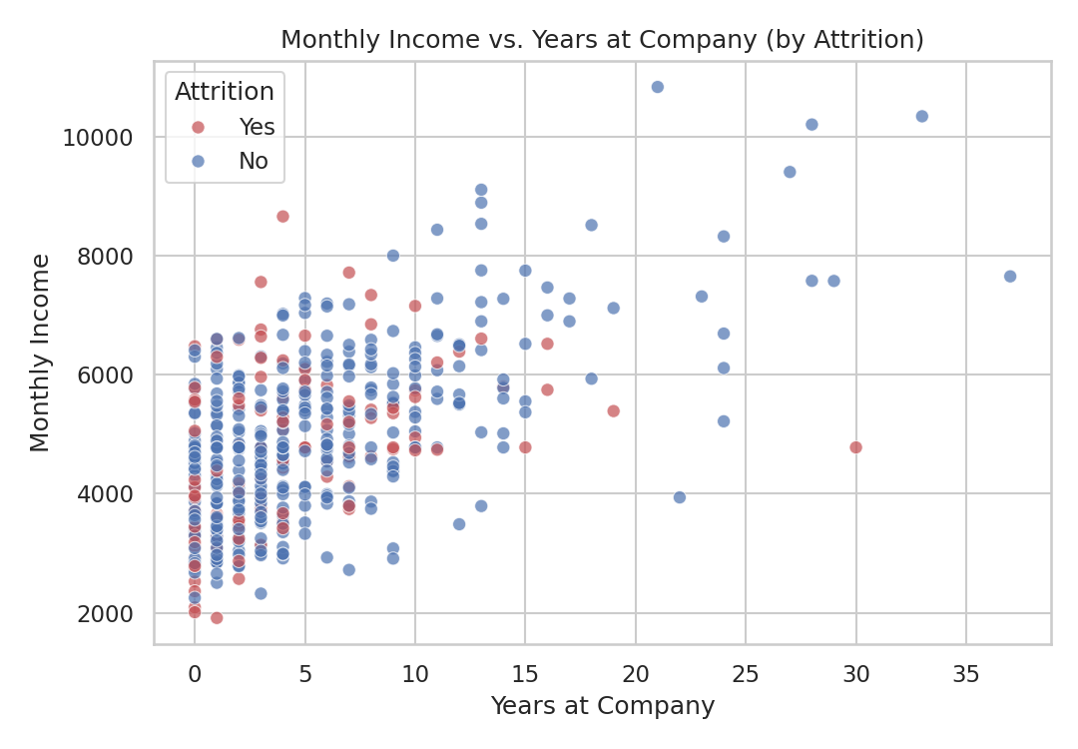
Figure 5. Monthly income vs. years at company, coloured by attrition (Week 2) — attrition (red) concentrates among earlier-tenure, lower-paid employees.
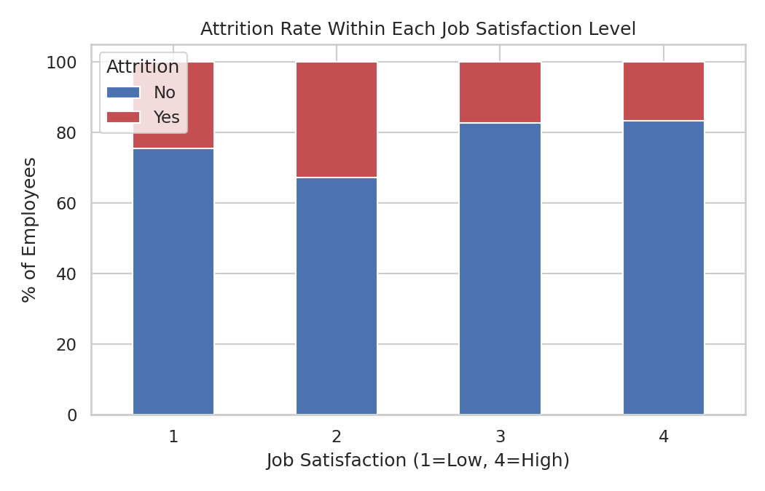
Figure 6. Attrition rate within each job satisfaction level (Week 2) — satisfaction level 2 shows the single highest attrition rate observed (32.8%).
These visualizations were deliberately written up for a non-technical audience — plain-language interpretation alongside each chart — and directly shaped the hypotheses tested formally in Week 3: that overtime, job satisfaction, tenure, and department are meaningfully related to attrition.

5. Statistical Analysis and Predictive Modeling (Week 3 Summary)

5.1 Hypothesis Testing
Five formal hypothesis tests were run to verify (or challenge) the patterns suggested by Week 2's visualizations. The results were a useful mix of confirmations and honest non-findings:
Test | Result | Conclusion
Shapiro-Wilk (Monthly Income normality) | W = 0.972, p < .001 | Income is not normally distributed (right-skewed)
Welch t-test (Income by Attrition) | t = -1.58, p = 0.116 | Not statistically significant
Chi-square (OverTime vs. Attrition) | χ² = 27.46, p < .001 | Statistically significant association
Pearson correlation (Income vs. Tenure) | r = 0.582, p < .001 | Statistically significant positive correlation
One-way ANOVA (Income by Department) | F = 1.99, p = 0.137 | Not statistically significant
Notably, the visual impression from Week 2 that income differs by attrition and by department did not hold up to formal testing at the 0.05 threshold — an important, honest caveat that a chart alone cannot reveal, and a good illustration of why this project paired visualization with formal statistical testing rather than stopping at visual pattern-spotting.

5.2 Predictive Model
A logistic regression model was built to predict Attrition using ten predictors, trained on an 80% stratified split of the data (with continuous predictors standardized) and evaluated on the remaining 20%.
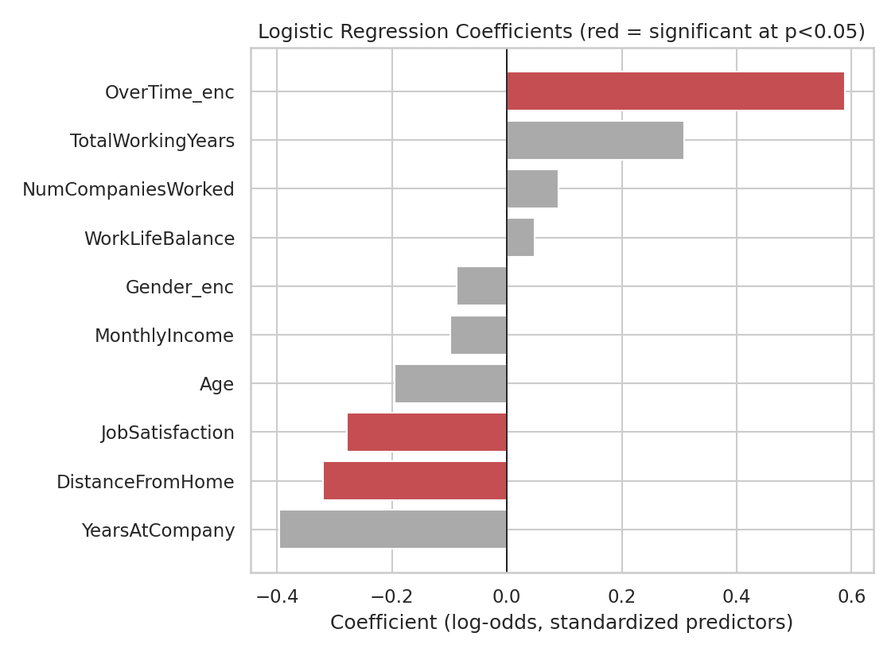
Figure 7. Standardized logistic regression coefficients (Week 3) — red = statistically significant at p<0.05.
OverTime emerged as the single strongest, most reliable predictor (p < 0.001), with Job Satisfaction also statistically significant. A variance inflation factor (VIF) check confirmed multicollinearity was not a material concern (all VIF < 4).
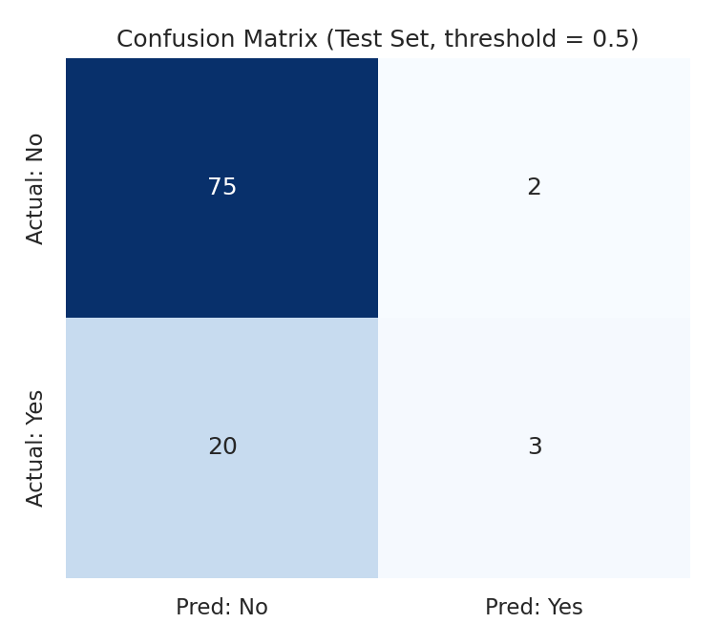
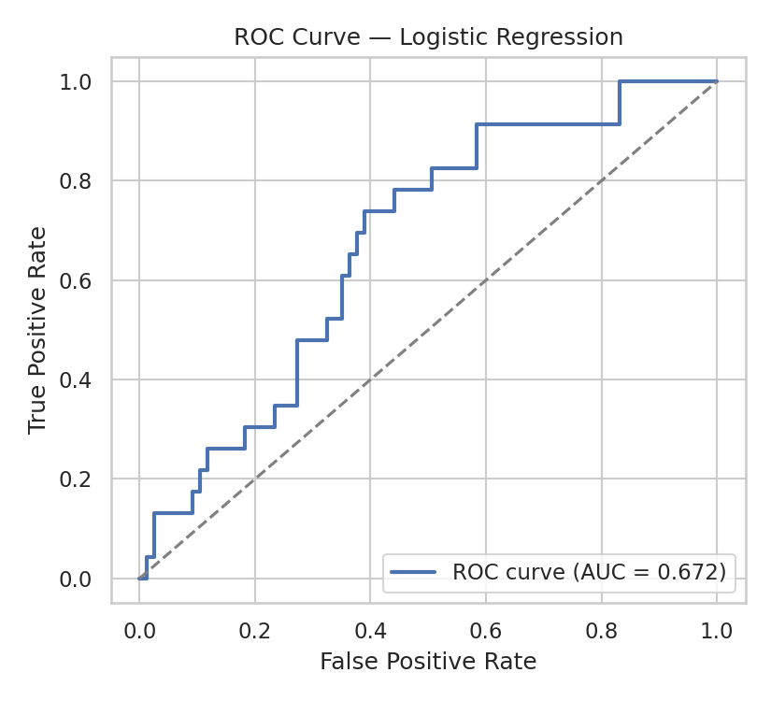
Figure 8 & 9. Confusion matrix and ROC curve on the held-out test set (Week 3) — Accuracy 78.0%, AUC 0.672.
The model's headline accuracy (78.0%) is respectable but slightly misleading given that 77.2% of employees did not leave — a naive "always predict No" model would already score close to that. The more diagnostic metric, recall on the attrition class, was only 13.0%, revealing a class-imbalance problem: the model under-predicts the minority "left" outcome. This limitation — rather than being a flaw to hide — became one of the most useful findings of the project, because it points directly at a specific, well-understood, fixable next step (discussed in Section 8).

6. Discussion: Business Implications
Bringing the three stages together, a coherent business narrative emerges. Attrition in this organization is not evenly spread — it clusters around three identifiable, actionable factors:
- Overtime is the strongest and most statistically reliable driver of attrition identified in this analysis (confirmed both visually in Week 2 and via chi-square test and logistic regression coefficient in Week 3). Employees working overtime leave at more than double the rate of those who do not.
- Job satisfaction matters, but not in a simple linear way: satisfaction level 2 (not the lowest level) showed the highest attrition rate observed, suggesting a specific "dissatisfied but not yet fully checked out" group that may be the most reachable through intervention, since the very lowest-satisfaction group may already be effectively lost.
- Sales has a materially higher attrition rate (27.4%) than Research & Development (17.9%) or Human Resources (23.1%), making it the natural first department for a retention pilot program.
- Tenure and income move together as expected (r = 0.582), and attrition visually concentrates among earlier-tenure, relatively lower-paid employees — though this did not reach strict statistical significance for income alone, suggesting the effect (if real) likely operates through tenure and/or overtime rather than income directly.
Practically, this suggests a retention strategy should prioritize: (1) auditing and reducing unnecessary overtime, especially in Sales; (2) proactively checking in with employees reporting moderate (not just low) job satisfaction; and (3) paying particular attention to newer hires, given roughly half the current workforce was hired in just the last five years (as shown by the Week 2 hiring-trend chart), meaning onboarding and early-tenure experience now affects a large share of the company.

7. Lessons Learned and Challenges

7.1 Challenges Encountered
- Distinguishing real signal from visual impression: several patterns that looked convincing in Week 2's charts (e.g. income differing by attrition and by department) did not hold up to formal hypothesis testing in Week 3 — a reminder that visualization is for generating hypotheses, not confirming them.
- Class imbalance in the outcome variable (77% stayed / 23% left) made naive accuracy a misleading headline metric, and required looking past it to recall, precision, and AUC to get an honest picture of model quality.
- Balancing statistical rigor with accessibility: the project deliberately paired every technical result (p-values, VIF, deviance) with a plain-language explanation, since a report that only a statistician can read fails the actual communication objective of this task.

7.2 Lessons Learned
- Data cleaning decisions (e.g. median vs. mean imputation) are not neutral — they meaningfully shape downstream results, and should be justified explicitly rather than treated as a rote first step.
- A model's limitations, honestly reported, are often as valuable as its strengths: identifying that class imbalance was driving poor recall was itself an actionable, useful output of this project, not a failure to be hidden.
- Multicollinearity checks (VIF) and cross-validation are what separate a defensible model from one that merely looks good on a single train/test split — both were essential to trusting the Week 3 coefficient estimates and performance numbers reported here.

8. Future Directions
- Address class imbalance directly via class weighting, SMOTE oversampling, or downsampling, and re-tune the classification threshold (e.g. near the base attrition rate of ~23%) rather than defaulting to 0.5 — the single highest-priority next step given Section 5.2's findings.
- Test more flexible models (random forest, gradient boosting) capable of capturing non-linear relationships and interactions (e.g. between OverTime and JobSatisfaction) that logistic regression cannot represent.
- Expand the feature set with engineered variables suggested by this analysis, such as income-relative-to-role-median or a tenure × satisfaction interaction term.
- Collect a larger sample to increase statistical power — several predictors (Age, YearsAtCompany, TotalWorkingYears) showed coefficient magnitudes suggestive of a real effect but did not reach significance at n = 400 training rows.
- Pilot a targeted retention intervention in the Sales department (the highest-attrition group identified) and measure its effect over the following two quarters as a natural real-world validation of this analysis.

9. Conclusion
This four-week project carried a single dataset through a complete, professional analytics lifecycle — from a raw, imperfect extract to a cleaned dataset, to a set of purposeful visualizations, to a statistically validated and cross-validated predictive model, and finally to this consolidated, business-facing report. The central finding — that overtime, job satisfaction, department, and (more tentatively) tenure meaningfully relate to attrition — was established not through any single step but through the combination of all three: visualization for pattern discovery, statistics for validation, and modeling for quantification. Just as importantly, the project's honest treatment of its own limitations (non-significant tests, class imbalance) demonstrates the kind of rigor that makes a data-driven recommendation trustworthy rather than merely persuasive. The recommendations in Sections 6 and 8 give a concrete, evidence-based starting point for both an immediate retention intervention and a next iteration of the predictive model.

Appendix A — Consolidated Deliverables
The full, runnable R scripts and cleaned/encoded datasets referenced throughout this report are provided as separate files (also available in the accompanying GitHub repository), rather than reproduced in full here, to keep this report focused on synthesis and interpretation:
File | Description
week1_analysis.R | Data cleaning, missing-value imputation, outlier detection, encoding, normalization, and initial EDA
week2_visualization.R | Eight ggplot2 / base-R visualizations with narrative interpretation
week3_modeling.R | Hypothesis tests, logistic regression model, cross-validation, and diagnostics
employee_attrition_raw.csv | Original raw dataset (504 rows, pre-cleaning)
employee_attrition_cleaned.csv | Cleaned, encoded, and normalized dataset (500 rows x 30 columns) used from Week 1 onward

