Software Engineering Internship Program
Week 2 Task
Data Visualization and Insight Communication using R
Prepared by: Nishanth Sridhar
Role: Software Engineer Intern
Tool Used: R (RStudio) — ggplot2, base plotting system
Date: August 2026

1. Objective
This week's task builds directly on the Week 1 data-cleaning work and shifts focus to data visualization and insight communication. The goal is to design a set of clear, purposeful visualizations in R — using ggplot2 and R's base plotting system — that surface trends, patterns, and anomalies in the data, and to explain each one in plain language so that a non-technical audience (e.g. an HR manager or business stakeholder) could understand the findings without needing to read any code.
The same cleaned Employee Attrition dataset from Week 1 (employee_attrition_cleaned.csv — 500 employees, fully cleaned and complete) is used here, so that the visualizations build on a verified, high-quality data foundation rather than introducing a new, unvetted dataset.

2. Data Overview
The dataset contains 500 employee records with demographic, compensation, tenure, and satisfaction variables, plus the target variable Attrition (whether the employee left the company). For this task, one derived variable was added: HireYear, calculated as the current year (2026) minus YearsAtCompany, in order to construct a time-based trend visualization (Section 3.5).
Variable Used | Role in this week's visualizations
Department, JobRole | Categorical grouping variables
MonthlyIncome | Primary continuous outcome (compensation)
YearsAtCompany, HireYear | Tenure / time dimension
Age | Continuous demographic variable
JobSatisfaction, Gender, EducationField | Categorical variables for composition/comparison charts
Attrition | Binary outcome variable, used as a colour/grouping dimension throughout

3. Visualizations, Code, and Interpretation
Eight visualizations were developed, deliberately spanning different chart families (bar, scatter, histogram, line, boxplot, stacked bar, donut, grouped bar) so that each is matched to the specific analytical question it answers, rather than defaulting to one chart type throughout. Each subsection below states why that chart type was chosen, shows the R code used to generate it, and interprets the resulting insight.

3.1 Bar Chart — Attrition Rate by Department
Why a bar chart: a bar chart is the clearest way to compare a single rate (attrition %) across a small number of unordered categories (departments). Length is the easiest visual encoding for humans to compare accurately.
R Code
attr_dept <- df %>%
group_by(Department) %>%
summarise(attrition_rate = mean(Attrition == "Yes") * 100) %>%
arrange(attrition_rate)

ggplot(attr_dept, aes(x = reorder(Department, attrition_rate), y = attrition_rate)) +
geom_col(fill = "#C44E52") +
geom_text(aes(label = paste0(round(attrition_rate,1), "%")), hjust = -0.1) +
coord_flip() +
labs(title = "Attrition Rate by Department", x = "", y = "Attrition Rate (%)") +
theme_minimal(base_size = 13)

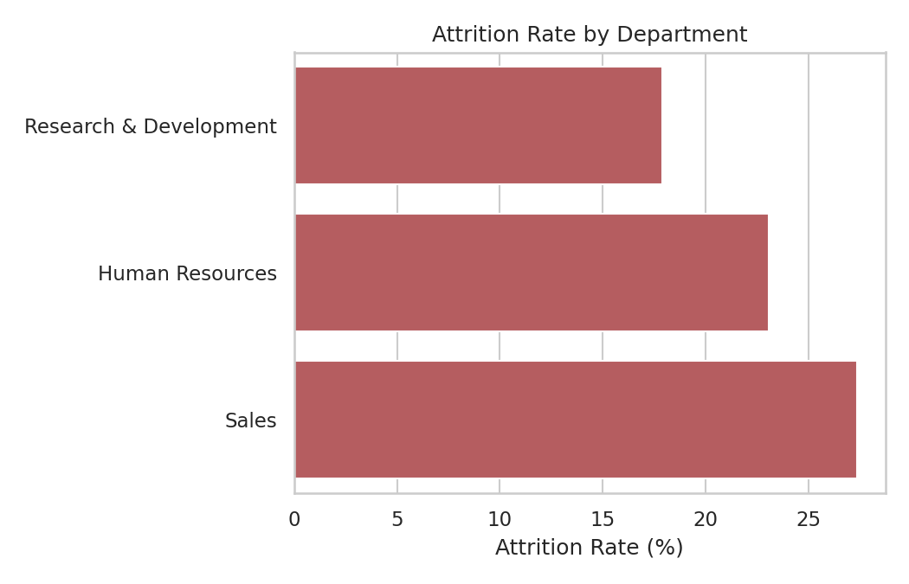
Figure 1. Attrition rate by department.
Insight: Sales has the highest attrition rate at 27.4%, followed by Human Resources at 23.1% and Research & Development at 17.9%. This is a nearly 10-point gap between the highest- and lowest-attrition departments, making Department a meaningful variable for HR to prioritize retention efforts around — most plausibly Sales, given that role's typical exposure to overtime and performance pressure.

3.2 Scatter Plot — Monthly Income vs. Years at Company (by Attrition)
Why a scatter plot: to examine the relationship between two continuous variables (income and tenure) while simultaneously showing how a third categorical variable (attrition) is distributed across that relationship — something a bar chart or table cannot show.
R Code
ggplot(df, aes(x = YearsAtCompany, y = MonthlyIncome, color = Attrition)) +
geom_point(alpha = 0.7, size = 2) +
scale_color_manual(values = c("No" = "#4C72B0", "Yes" = "#C44E52")) +
labs(title = "Monthly Income vs. Years at Company (by Attrition)")

cor(df$MonthlyIncome, df$YearsAtCompany)

Console Output
[1] 0.58

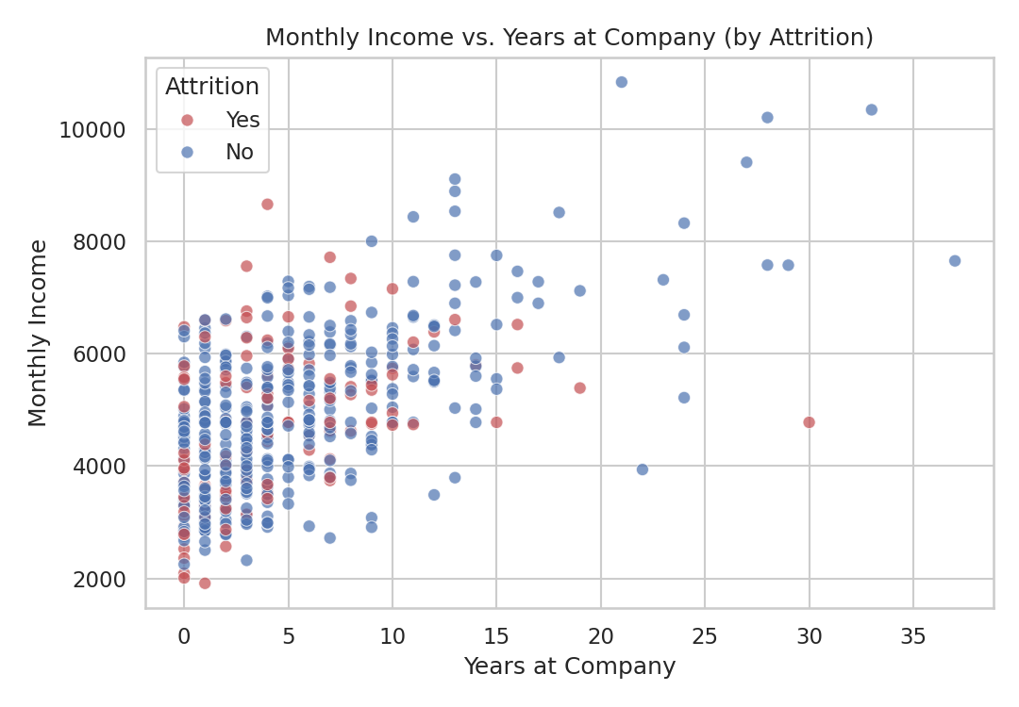
Figure 2. Monthly income vs. years at company, coloured by attrition.
Insight: there is a clear positive relationship between tenure and income (r = 0.58) — employees who have stayed longer earn more, consistent with typical seniority-based pay progression. The red (attrition = Yes) points are visibly concentrated in the lower-left region of the plot: employees who leave tend to be earlier in their tenure and on the lower end of the income band for their tenure level. This suggests early-career, comparatively lower-paid employees are the group most at risk of leaving.

3.3 Histogram — Age Distribution by Attrition Status
Why a histogram: a histogram is the standard chart for showing the shape of a continuous variable's distribution (Age); stacking it by Attrition additionally shows whether that distribution shifts for the group that leaves versus the group that stays.
R Code
ggplot(df, aes(x = Age, fill = Attrition)) +
geom_histogram(bins = 18, position = "stack", color = "white") +
scale_fill_manual(values = c("No" = "#4C72B0", "Yes" = "#C44E52")) +
labs(title = "Age Distribution by Attrition Status")

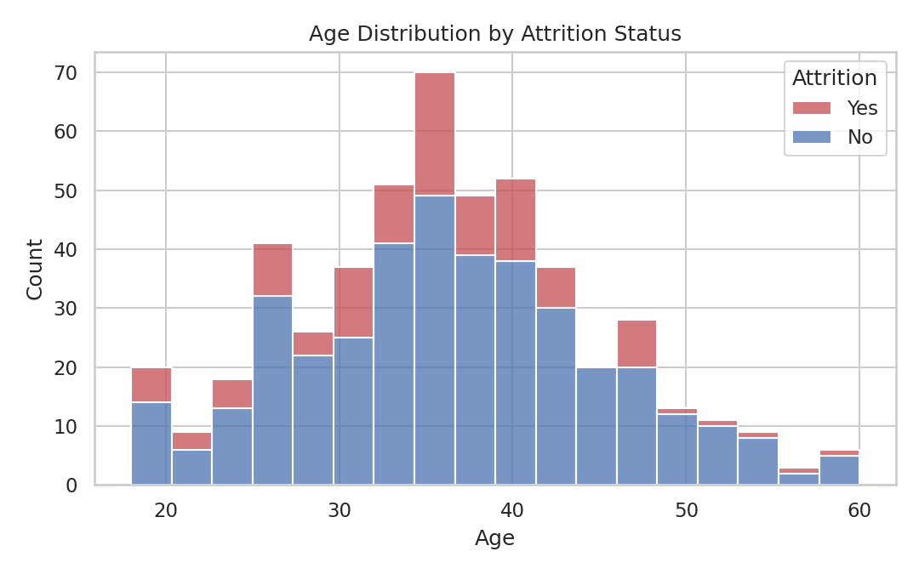
Figure 3. Age distribution, stacked by attrition status.
Insight: the overall age distribution is roughly bell-shaped and centered in the mid-30s, as established in Week 1. Attrition (the red segment) is present across all age bands but is proportionally a bit more concentrated among younger employees, reinforcing the pattern seen in Figure 2 — early-career employees are somewhat more likely to leave than long-tenured, older employees.

3.4 Line Chart — Hiring Trend Over Time
Why a line chart: a line chart is the correct choice whenever the x-axis represents a continuous sequence — here, calendar year — because it emphasizes the trend/trajectory over time rather than just comparing isolated values.
R Code (base plotting system)
hires_per_year <- df %>% count(HireYear, name = "new_hires") %>% arrange(HireYear)
hires_per_year <- hires_per_year %>% mutate(cumulative = cumsum(new_hires))

plot(hires_per_year$HireYear, hires_per_year$new_hires, type = "o", pch = 16,
col = "#4C72B0", xlab = "Year", ylab = "New Hires",
main = "Hiring Trend Over Time (Current Employees, by Hire Year)")
par(new = TRUE)
plot(hires_per_year$HireYear, hires_per_year$cumulative, type = "o", pch = 15,
col = "#55A868", axes = FALSE, xlab = "", ylab = "")
axis(side = 4); mtext("Cumulative Headcount", side = 4, line = 3)

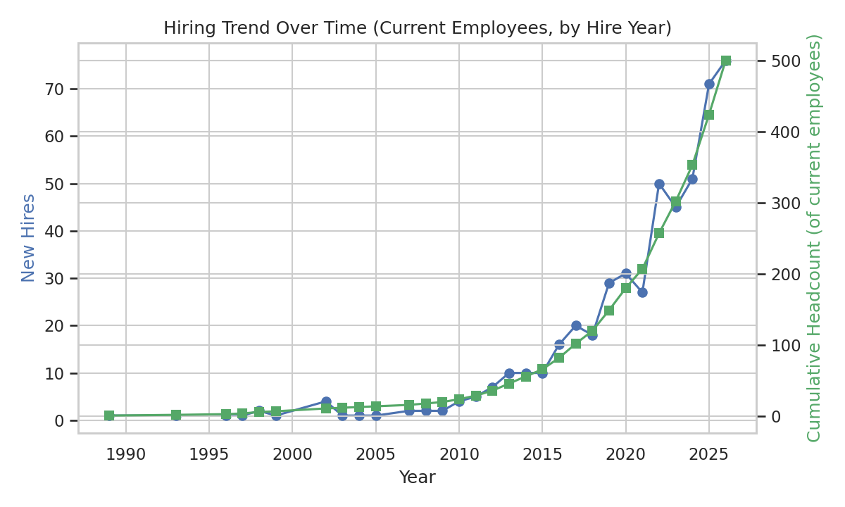
Figure 4. New hires per year (blue) and cumulative headcount of current employees (green), by hire year.
Insight: this chart is built from currently-employed staff only (it does not include people who have already left), so it naturally shows a sharp ramp-up in recent years — 2022 to 2026 alone account for roughly half of the current workforce (293 of 500 employees), consistent with a company in a fast-growth phase. The steepening slope of the cumulative line highlights that retention and onboarding processes for this large, recently-hired cohort will matter disproportionately for near-term attrition trends.

3.5 Boxplot — Monthly Income Distribution by Job Role
Why a boxplot: boxplots are the most effective way to compare the spread, median, and outliers of a continuous variable (income) across several categories (job roles) at once, without the visual clutter that many overlapping histograms would create.
R Code
role_order <- df %>% group_by(JobRole) %>%
summarise(med = median(MonthlyIncome)) %>% arrange(med) %>% pull(JobRole)
df$JobRole <- factor(df$JobRole, levels = role_order)

ggplot(df, aes(x = MonthlyIncome, y = JobRole, fill = JobRole)) +
geom_boxplot(show.legend = FALSE) +
labs(title = "Monthly Income Distribution by Job Role")

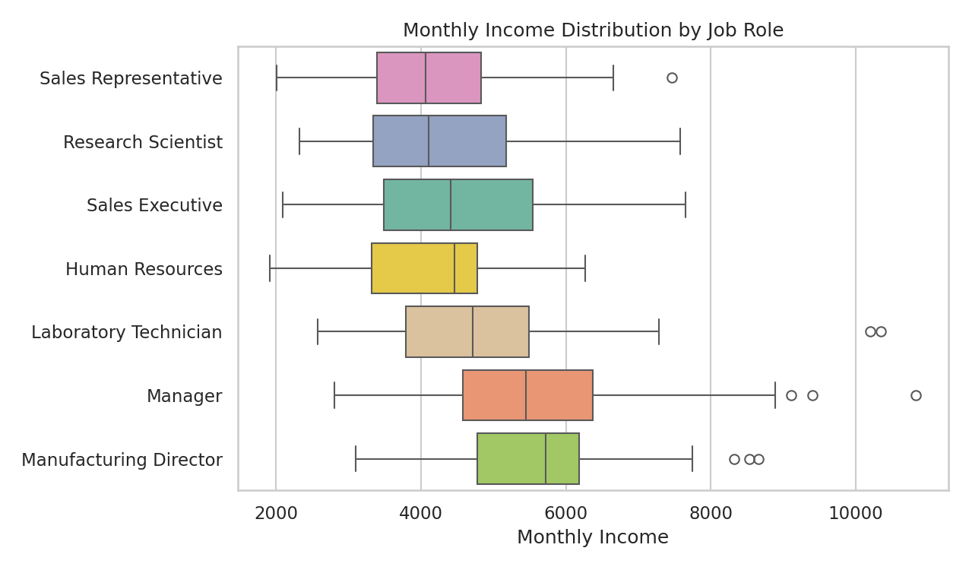
Figure 5. Monthly income distribution by job role, ordered by median income.
Insight: Manufacturing Director and Manager roles command the highest median incomes (5,718 and 5,443 respectively), while Sales Representative and Research Scientist sit at the lower end (4,063 and 4,103). The boxplot also reveals that income spread (box width) is noticeably wider for Manager — reflecting that 'Manager' spans multiple departments with different pay bands — compared to more tightly-clustered individual-contributor roles like Laboratory Technician.

3.6 Stacked Bar Chart — Attrition Rate Within Each Job Satisfaction Level
Why a stacked (100%) bar chart: this format is ideal for showing how a binary outcome (Attrition Yes/No) is proportionally distributed within each level of an ordinal variable (JobSatisfaction, 1–4), making the relationship between satisfaction and attrition immediately visible as a proportion rather than raw counts.
R Code
jobsat_attr <- df %>%
count(JobSatisfaction, Attrition) %>%
group_by(JobSatisfaction) %>%
mutate(pct = n / sum(n) * 100)

ggplot(jobsat_attr, aes(x = factor(JobSatisfaction), y = pct, fill = Attrition)) +
geom_col(position = "stack") +
scale_fill_manual(values = c("No" = "#4C72B0", "Yes" = "#C44E52")) +
labs(title = "Attrition Rate Within Each Job Satisfaction Level")

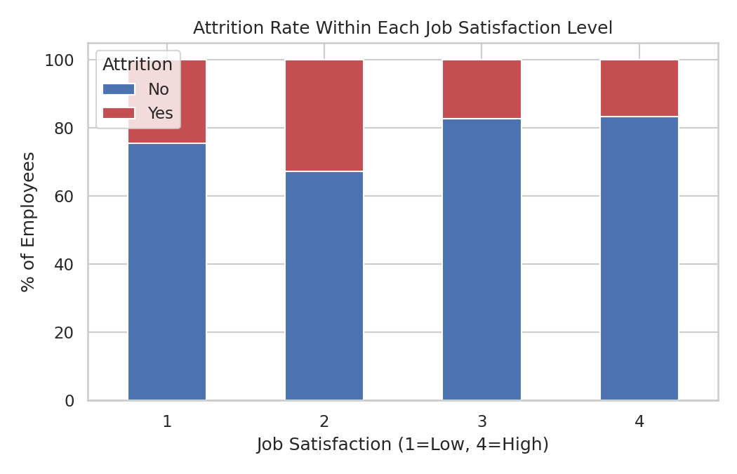
Figure 6. Attrition proportion within each job satisfaction level.
Insight: attrition is clearly satisfaction-sensitive. Employees reporting the lowest satisfaction (level 1) leave at 24.6%, and those at level 2 leave at the highest rate observed, 32.8% — compared to just 17.3% and 16.8% for satisfaction levels 3 and 4. This is one of the strongest and most actionable patterns in the dataset: satisfaction level 2 in particular stands out as a red flag zone worth investigating further (e.g. whether it reflects employees who are dissatisfied but not yet at the lowest extreme, and therefore still have options and are acting on them).

3.7 Donut Chart — Education Field Distribution
Why a donut chart: for a single categorical variable's composition, a donut (or pie) chart is an intuitive, non-technical-audience-friendly way to show relative proportions — appropriate here because EducationField has a manageable number of categories (six) and the goal is simply to communicate workforce composition, not enable precise value comparison.
R Code
edu <- df %>% count(EducationField) %>% mutate(pct = n / sum(n) * 100)

ggplot(edu, aes(x = 2, y = pct, fill = EducationField)) +
geom_col(color = "white") +
coord_polar(theta = "y") +
xlim(0.5, 2.5) +
labs(title = "Education Field Distribution") +
theme_void()

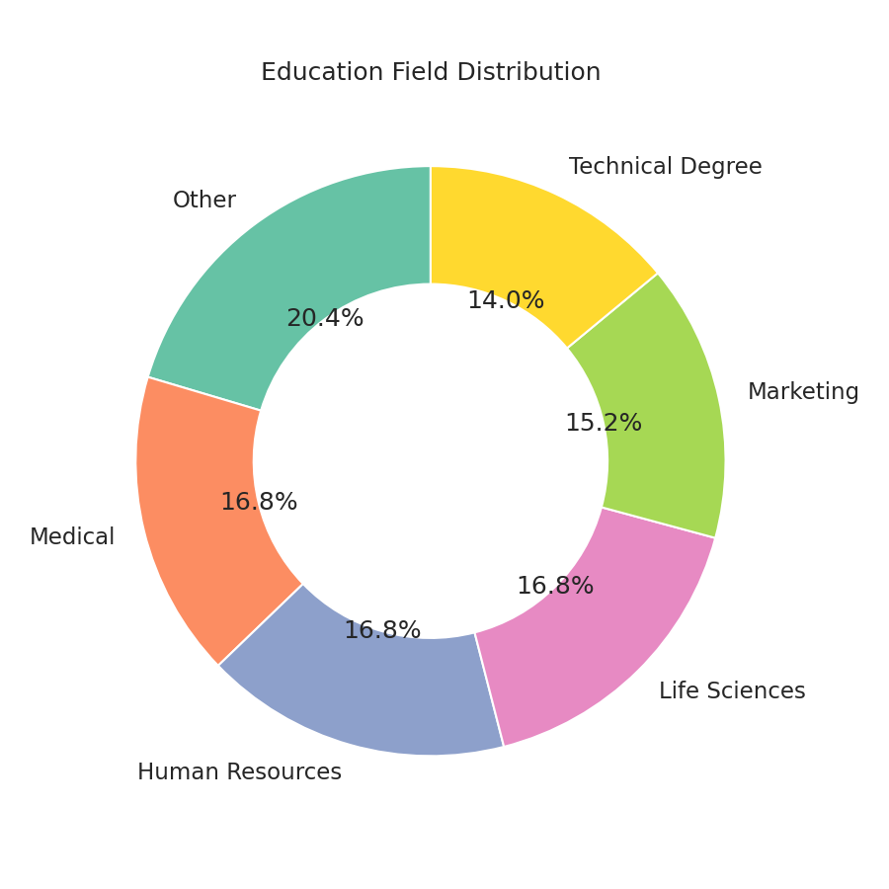
Figure 7. Workforce composition by education field.
Insight: the workforce is fairly evenly spread across education fields, with 'Other' the single largest group (20.4%) and Medical, Human Resources, and Life Sciences each close behind (16.8% each). No single field dominates, suggesting the company draws talent from a genuinely diverse educational background rather than one or two feeder disciplines.

3.8 Grouped Bar Chart — Average Monthly Income by Department and Gender
Why a grouped (dodged) bar chart: this is the standard way to compare a numeric summary (mean income) across two categorical dimensions side-by-side (department and gender), letting the reader compare both within a department (across genders) and across departments in one view.
R Code
inc_g <- df %>% group_by(Department, Gender) %>%
summarise(avg_income = mean(MonthlyIncome), .groups = "drop")

ggplot(inc_g, aes(x = Department, y = avg_income, fill = Gender)) +
geom_col(position = position_dodge(width = 0.7), width = 0.6) +
scale_fill_manual(values = c("Male" = "#4C72B0", "Female" = "#DD8452")) +
labs(title = "Average Monthly Income by Department and Gender")

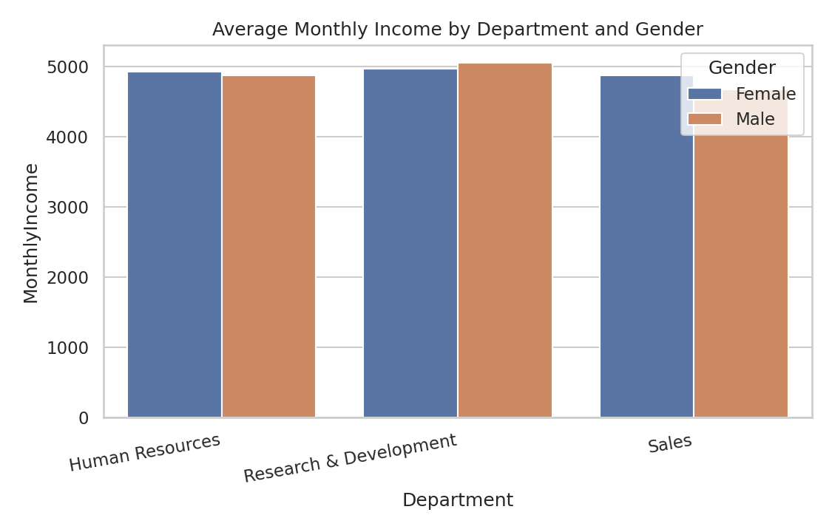
Figure 8. Average monthly income by department and gender.
Insight: average income between genders is broadly comparable within each department, with differences generally under 4% — e.g. Research & Development shows Male 5,058 vs. Female 4,965, and Sales shows Female 4,870 vs. Male 4,678 (here Female average is actually higher). No department shows a large or systematic pay gap in this sample, which is a reassuring finding worth validating further as the dataset grows, but should not be read as a substitute for a proper role-adjusted pay-equity analysis.

4. Summary of Key Insights
- Sales has the highest attrition rate (27.4%) of the three departments — a clear priority area for retention focus.
- Attrition is concentrated among earlier-tenure, comparatively lower-paid employees (Figure 2), and skews slightly younger (Figure 3).
- The current workforce has grown sharply in the last five years — roughly half of all current employees were hired between 2022 and 2026 (Figure 4), meaning onboarding and early retention quality now affects a large share of the company.
- Manufacturing Director and Manager are the highest-paid roles by median income; Sales Representative and Research Scientist the lowest (Figure 5).
- Job satisfaction level 2 shows the single highest attrition rate observed (32.8%) — higher even than the lowest satisfaction level — making it a specific group worth investigating (Figure 6).
- The workforce draws from a diverse mix of educational backgrounds, with no single field dominating (Figure 7).
- No large or systematic gender pay gap is visible within departments in this sample (Figure 8).

5. Conclusion
This week's task translated the cleaned Week 1 dataset into a set of purpose-built visualizations, each chosen to match a specific analytical question rather than applying a single default chart type throughout. Together, the eight visualizations tell a coherent story: attrition risk in this dataset is concentrated among early-tenure, lower-paid, moderately-dissatisfied employees, disproportionately in the Sales department, within a workforce that has grown rapidly in the last few years. These insights — communicated visually and in plain language — would give a non-technical HR stakeholder a clear, evidence-based starting point for a retention strategy, and would form natural hypotheses for a predictive attrition model in a later stage of this internship.

Appendix A — Full R Script
The complete script below (also attached separately as week2_visualization.R) reproduces every chart and statistic in this report end-to-end, using the employee_attrition_cleaned.csv file produced in Week 1.
## =============================================================
## Internship Week 2: Data Visualization & Insight Communication
## Dataset : Employee Attrition Dataset (continued from Week 1)
## Author : Nishanth Sridhar
## =============================================================

library(tidyverse) # ggplot2, dplyr, readr
library(scales) # percent/label formatting on axes

# ---- 1. Load the cleaned Week 1 dataset -----------------------------
df <- read_csv("employee_attrition_cleaned.csv", show_col_types = FALSE)

# Derive HireYear (used for the time-trend chart in Section 5)
CURRENT_YEAR <- 2026
df <- df %>% mutate(HireYear = CURRENT_YEAR - YearsAtCompany)

# =====================================================================
## 2. BAR CHART — Attrition rate by Department
## Chart type chosen: horizontal bar chart, for comparing a rate (%)
## across a small number of unordered categories.
# =====================================================================
attr_dept <- df %>%
group_by(Department) %>%
summarise(attrition_rate = mean(Attrition == "Yes") * 100) %>%
arrange(attrition_rate)

ggplot(attr_dept, aes(x = reorder(Department, attrition_rate), y = attrition_rate)) +
geom_col(fill = "#C44E52") +
geom_text(aes(label = paste0(round(attrition_rate,1), "%")), hjust = -0.1) +
coord_flip() +
labs(title = "Attrition Rate by Department",
x = "", y = "Attrition Rate (%)") +
theme_minimal(base_size = 13)
ggsave("bar_attrition_dept.png", width = 7, height = 4.5, dpi = 150)

# =====================================================================
## 3. SCATTER PLOT — Monthly Income vs. Years at Company, by Attrition
## Chart type chosen: scatter plot, to reveal the relationship between
## two continuous variables while a third categorical variable (colour)
## shows how attrition is distributed across that relationship.
# =====================================================================
ggplot(df, aes(x = YearsAtCompany, y = MonthlyIncome, color = Attrition)) +
geom_point(alpha = 0.7, size = 2) +
scale_color_manual(values = c("No" = "#4C72B0", "Yes" = "#C44E52")) +
labs(title = "Monthly Income vs. Years at Company (by Attrition)",
x = "Years at Company", y = "Monthly Income") +
theme_minimal(base_size = 13)
ggsave("scatter_income_years.png", width = 7.2, height = 5, dpi = 150)

cor(df$MonthlyIncome, df$YearsAtCompany) # correlation coefficient referenced in the narrative

# =====================================================================
## 4. HISTOGRAM — Age distribution split by Attrition
## Chart type chosen: stacked histogram, to compare the shape of a
## continuous distribution (Age) across two groups (Attrition Yes/No).
# =====================================================================
ggplot(df, aes(x = Age, fill = Attrition)) +
geom_histogram(bins = 18, position = "stack", color = "white") +
scale_fill_manual(values = c("No" = "#4C72B0", "Yes" = "#C44E52")) +
labs(title = "Age Distribution by Attrition Status", x = "Age", y = "Count") +
theme_minimal(base_size = 13)
ggsave("hist_age_attrition.png", width = 7.2, height = 4.5, dpi = 150)

# =====================================================================
## 5. LINE CHART — Hiring trend over time (current employees, by hire year)
## Chart type chosen: dual-axis line chart, the standard choice for
## showing a trend over a continuous time axis (year) together with a
## cumulative running total.
# =====================================================================
hires_per_year <- df %>% count(HireYear, name = "new_hires") %>% arrange(HireYear)
hires_per_year <- hires_per_year %>% mutate(cumulative = cumsum(new_hires))

# Base R dual-axis version (kept close to how it is often taught):
par(mar = c(5, 4, 4, 4) + 0.3)
plot(hires_per_year$HireYear, hires_per_year$new_hires, type = "o", pch = 16,
col = "#4C72B0", xlab = "Year", ylab = "New Hires",
main = "Hiring Trend Over Time (Current Employees, by Hire Year)")
par(new = TRUE)
plot(hires_per_year$HireYear, hires_per_year$cumulative, type = "o", pch = 15,
col = "#55A868", axes = FALSE, xlab = "", ylab = "")
axis(side = 4)
mtext("Cumulative Headcount", side = 4, line = 3)
legend("topleft", legend = c("New hires (that year)", "Cumulative headcount"),
col = c("#4C72B0", "#55A868"), pch = c(16, 15), bty = "n")
dev.copy(png, "line_hiring_trend.png", width = 800, height = 480); dev.off()

# =====================================================================
## 6. BOXPLOT — Monthly Income distribution by Job Role
## Chart type chosen: boxplot, ideal for comparing the spread, median,
## and outliers of a continuous variable across several categories.
# =====================================================================
role_order <- df %>% group_by(JobRole) %>%
summarise(med = median(MonthlyIncome)) %>% arrange(med) %>% pull(JobRole)
df$JobRole <- factor(df$JobRole, levels = role_order)

ggplot(df, aes(x = MonthlyIncome, y = JobRole, fill = JobRole)) +
geom_boxplot(show.legend = FALSE) +
labs(title = "Monthly Income Distribution by Job Role",
x = "Monthly Income", y = "") +
theme_minimal(base_size = 13)
ggsave("box_income_role.png", width = 8.5, height = 5, dpi = 150)

# =====================================================================
## 7. STACKED BAR — Attrition rate within each Job Satisfaction level
## Chart type chosen: 100%-stacked bar chart, best for showing how a
## binary outcome (Attrition) is proportionally distributed within
## each level of an ordinal variable (JobSatisfaction).
# =====================================================================
jobsat_attr <- df %>%
count(JobSatisfaction, Attrition) %>%
group_by(JobSatisfaction) %>%
mutate(pct = n / sum(n) * 100)

ggplot(jobsat_attr, aes(x = factor(JobSatisfaction), y = pct, fill = Attrition)) +
geom_col(position = "stack") +
scale_fill_manual(values = c("No" = "#4C72B0", "Yes" = "#C44E52")) +
labs(title = "Attrition Rate Within Each Job Satisfaction Level",
x = "Job Satisfaction (1 = Low, 4 = High)", y = "% of Employees") +
theme_minimal(base_size = 13)
ggsave("stackedbar_jobsat_attrition.png", width = 7, height = 4.5, dpi = 150)

# =====================================================================
## 8. DONUT CHART — Education Field distribution
## Chart type chosen: donut chart, a simple, non-technical-audience-
## friendly way to show the composition of a single categorical variable.
# =====================================================================
edu <- df %>% count(EducationField) %>% mutate(pct = n / sum(n) * 100,
label = paste0(EducationField, " (", round(pct,1), "%)"))

ggplot(edu, aes(x = 2, y = pct, fill = EducationField)) +
geom_col(color = "white") +
coord_polar(theta = "y") +
xlim(0.5, 2.5) +
labs(title = "Education Field Distribution", fill = "Education Field") +
theme_void(base_size = 13)
ggsave("donut_education_field.png", width = 6, height = 6, dpi = 150)

# =====================================================================
## 9. GROUPED BAR CHART — Average Monthly Income by Department and Gender
## Chart type chosen: grouped (dodged) bar chart, for comparing a
## numeric summary (mean income) across two categorical dimensions
## side-by-side (Department x Gender).
# =====================================================================
inc_g <- df %>% group_by(Department, Gender) %>%
summarise(avg_income = mean(MonthlyIncome), .groups = "drop")

ggplot(inc_g, aes(x = Department, y = avg_income, fill = Gender)) +
geom_col(position = position_dodge(width = 0.7), width = 0.6) +
scale_fill_manual(values = c("Male" = "#4C72B0", "Female" = "#DD8452")) +
labs(title = "Average Monthly Income by Department and Gender",
x = "", y = "Average Monthly Income") +
theme_minimal(base_size = 13) +
theme(axis.text.x = element_text(angle = 10, hjust = 1))
ggsave("bar_income_dept_gender.png", width = 7.5, height = 4.8, dpi = 150)

## =============================================================
## End of Week 2 script
## =============================================================

