The Lighthouse Project

The Lighthouse Project
“Helping people find their way back”

Motto
Support, not solve.

Mission Statement
To equip teenagers with the awareness skills to recognise when their peers are struggling emotionally and provide them with guidance on right ways to approach and manage such situations.

Primary Aim
To build emotionally aware peer communities where addressing poor mental health amongst one another is treated as a major life skill - teenagers are better equipped to recognise distress in others and respond appropriately.

Our Belief
This project is built on the belief that the first and most immediate support system for many teenagers is not a professional, institution, or “trusted adult” - but rather, their friends.
Many current approaches to youth mental health awareness unintentionally create distance between teenagers and support systems by:
- placing responsibility primarily on the person already struggling,
- categorising emotional difficulties through labels and diagnoses too early,
- relying on other support systems that teenagers may realistically hesitate to use.
Instead, this initiative focuses on preparing peers to become more emotionally aware, approachable, and capable of handling such conversations appropriately.
The goal is not to turn teenagers into therapists or replace professional help.
The goal is to ensure fewer young people feel unseen, isolated, or unsupported in the moments before professional help is ever reached.

What makes us different
- Unlike the general approach, our project focuses on training the people surrounding those struggling with their mental health rather than placing that burden on the individual themselves
- Our system is based supporting not solving - we aim to help people gain the appropriate skills to form a reliable support system amongst teenagers rather than diagnosing people with problems
- We cater to realistic teenage behaviour - ensuring that we target the first and most likely support systems (friends) of those in need of help.

The Team

Organisational Structure
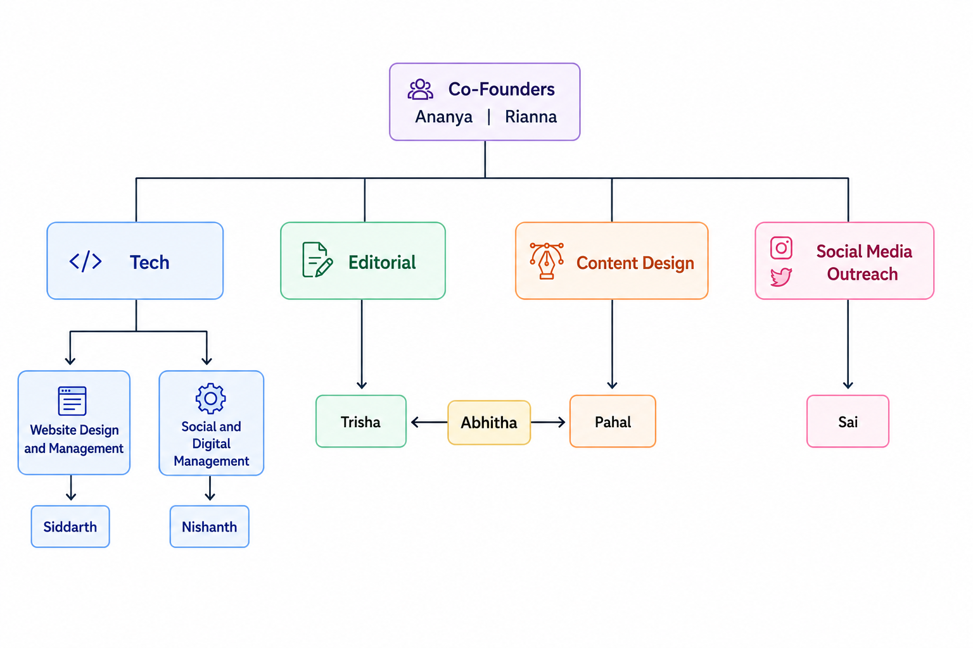

Designations & their responsibilities
{ these are liable to increase/ decrease as the project grows in the future :) }

- Director of Digital Infrastructure - Siddarth
- Making website
- Maintaining website
- Social and Digital Manager - Nishanth
- Managing LinkedIn, Email and other social media platforms
- Designing Applications (Google forms, etc.)
- Aiding editorial and design team with content for social media
- Editorial Director - Trisha
- Written content for posts, reels, social media, etc
- Written content for website
- Scripts for reels and videos
- Head of Visual Director - Pahal
- Designing posts, reels and other social media content
- Designing logo and aesthetics of the project
- Creating designs for future events/ projects
- Content Operations Manager - Abhitha
- Ensuring both design and editorial work harmoniously
- Researching educational content for posts and reels
- Director of Outreach and Human Resources- Sai
- Contacting other organizations
- Research - possible future ventures and keeping track of trends
- Responding to emails, messages, etc
- Filtering Applicants

