PHISHING URL DETECTION USING MACHINE LEARNING
SUMMER INTERNSHIP REPORT
Submitted by
NISHANTHAN .M 910023106303
In partial fulfilment for the award of the Degree
of
BACHELOR OF ENGINEERING
in
ELECTRONICS AND COMMUNICATION ENGINEERING
[ INSERT COLLEGE LOGO HERE ]
DEPARTMENT OF ELECTRONICS AND COMMUNICATION ENGINEERING
NOVEMBER 2025

BONAFIDE CERTIFICATE

It is hereby certified that this internship training Report on "PHISHING URL DETECTION USING MACHINE LEARNING" is the Bonafide work of NISHANTHAN .M (910023106303), who carried out the internship training under my supervision at SCALE SPARK. The duration of the internship was from 2nd July 2025 to 31st July 2025.
Submitted for the internship review held on ____________________
Ms. Chandraleka,
Director of Operations,
SCALE SPARK,
Chennai.
EXPERT MEMBER 1 EXPERT MEMBER 2
INTERNSHIP COORDINATOR

ABSTRACT
Phishing attacks continue to be one of the most dangerous and widespread cybersecurity threats affecting millions of users worldwide. These attacks heavily utilize deceptive URLs and social engineering to trick victims into revealing highly sensitive information such as passwords, corporate credentials, and credit card numbers. Traditional methods of phishing detection, such as static blacklisting and rule-based heuristics, suffer from significant limitations. Blacklists can only detect previously reported phishing sites and fail catastrophically against newly created (zero-day) phishing URLs.
In this project, a highly advanced machine learning-based system was developed for detecting phishing URLs by mathematically extracting 25 handcrafted lexical and structural features directly from the URL string itself. This approach is highly innovative because it requires absolutely no external web content fetching, page rendering, or third-party DNS APIs, making the prediction process blistering fast and entirely localized.
Five distinct classification algorithms were implemented, rigorously trained, and exhaustively compared: Logistic Regression, Decision Tree, Random Forest, Support Vector Machine (SVM), and Gradient Boosting. The experimental results, validated through k-fold cross-validation, conclusively demonstrate that the Random Forest classifier achieved the absolute highest accuracy of approximately 95%, backed by phenomenal precision, recall, and AUC-ROC scores. The proposed system provides a lightweight, highly effective, and entirely production-ready approach to phishing detection that can be seamlessly integrated into modern browser extensions, enterprise email filters, and highly secure web gateways.

ACKNOWLEDGEMENT
I would like to express my deepest and most sincere gratitude to everyone who supported, guided, and mentored me throughout the entire completion of my internship and the formulation of this comprehensive project report. Above all, I thank the Almighty God for granting me the immense strength, clarity of mind, and guidance needed to accomplish this demanding and highly technical task successfully.
I express my profound and sincere gratitude to the Head of the Department of Electronics and Communication Engineering. Their unwavering support and prompt permission allowed me to undergo this highly crucial institutional training, effectively bridging the massive gap between my theoretical coursework and real-world cybersecurity engineering applications.
I am extremely thankful to my primary internship guide, Ms. Chandraleka, Director of Operations at Scale Spark. She graciously provided me with invaluable mentorship, highly technical guidance, and continuous, constructive suggestions for the preparation of this project. Her deep insights into the cybersecurity landscape and malware defense were instrumental in shaping the architectural design of this Phishing Detection System.
Finally, I acknowledge with a deep, profound sense of reverence, my immense gratitude towards my parents, family members, and friends. Their endless moral support, financial backing, and constant encouragement have been the bedrock of my educational journey.
NISHANTHAN .M

TABLE OF CONTENTS

CHAPTER TITLE | PAGE NO.
1. INTRODUCTION | 1
2. LITERATURE REVIEW | 4
3. METHODOLOGY & ARCHITECTURE | 8
4. FEATURE EXTRACTION | 12
5. MACHINE LEARNING ALGORITHMS | 16
6. IMPLEMENTATION DETAILS | 20
7. SYSTEM VISUALIZATION & RESULTS | 24
8. CONCLUSION & FUTURE SCOPE | 28

CHAPTER 1

INTRODUCTION
1.1 Background of Cyber Threats
The internet has irrevocably become an absolutely integral part of modern human life, with billions of users relying entirely on web services for banking, shopping, communication, and corporate infrastructure. However, this massive digital transformation has unfortunately also given rise to a highly lucrative underground economy of cybercrime. Among these threats, phishing stands out as one of the absolute most prevalent, damaging, and insidious forms of attack currently devastating the digital landscape. Phishing is a complex social engineering technique where attackers meticulously create fraudulent, fake websites or send highly deceptive emails that perfectly mimic legitimate entities (such as banks or software providers) in order to brutally steal users' highly sensitive information.
According to the Anti-Phishing Working Group (APWG), over 4.7 million catastrophic phishing attacks were actively recorded in 2022 alone, marking an unprecedented all-time high in cyber warfare. The FBI's Internet Crime Complaint Center (IC3) reported that phishing was the absolute most common type of cybercrime globally, resulting in catastrophic corporate and personal financial losses exceeding $10.3 billion in 2022. These staggering, horrifying statistics underscore the absolute urgent, critical need for automated, highly intelligent software systems that can aggressively detect and permanently block phishing attempts in real-time.
1.2 Problem Statement
Despite the active existence of various commercial phishing detection tools, the rapid, relentless evolution of phishing techniques means that millions of malicious URLs successfully evade detection daily. New, highly obfuscated phishing sites are created every few minutes, and attackers constantly and mathematically modify their evasion strategies to bypass existing cybersecurity defenses. There is a desperate need for a robust, highly optimized machine learning-based system that can accurately and instantly classify URLs as either phishing or legitimate based entirely on deep mathematical features extracted directly from the URL string itself. This allows for blistering fast, scalable detection without ever needing to dangerously fetch external databases or execute potentially malicious page content.
1.3 Objectives and Scope
The primary, overarching objective of this project was to successfully implement a complete machine learning pipeline for phishing detection. This involved extracting 25 highly meaningful lexical and structural features from raw URL strings, implementing multiple complex ML classifiers (including Random Forest and SVM), and rigorously evaluating them using advanced statistical metrics like AUC-ROC. The scope of the project was deliberately restricted to analyzing the URL string itself (lexical analysis) to ensure the system could operate in real-time within browser extensions or network gateways without the severe latency penalty of downloading HTML payloads.

CHAPTER 2

LITERATURE REVIEW
2.1 Anatomy of a Phishing Attack
Phishing attacks heavily exploit fundamental human psychology and trust rather than complex technical network vulnerabilities, making them exceptionally difficult to defend against with standard firewalls. The malicious URLs used in phishing attacks are incredibly carefully crafted to look almost identical to legitimate URLs, often using highly deceptive techniques such as typosquatting (e.g., registering 'go0gle.com' instead of google.com), severe subdomain abuse (e.g., 'login.paypal.com.attacker.com'), and complex IP address obfuscation (using hex or octal representations of IP addresses to bypass basic string filters).
2.2 Limitations of Existing Detection Methods
Historically, the industry standard approach to stopping phishing was the use of Blacklist-based Methods. These maintain massive databases of known, reported phishing URLs (such as Google Safe Browsing or PhishTank). While somewhat effective for known, historical threats, they fail completely and catastrophically against zero-day phishing attacks. A hacker can buy a new domain for $1, launch a phishing attack, steal credentials for 4 hours, and shut it down long before it ever gets added to a global blacklist.
Heuristic and Content-based Methods attempt to fix this by analyzing the HTML content of the page. However, downloading the HTML of a suspected phishing site is dangerous, incredibly slow, and completely destroys the user experience as the browser hangs while waiting for the security check to finish. Furthermore, modern phishing sites use JavaScript obfuscation to hide their HTML from security scanners.
2.3 The Machine Learning Paradigm
Machine Learning-based Methods offer the ultimate solution. By automatically learning discriminative mathematical patterns from massive datasets of both phishing and legitimate URLs, an AI model can generalize and instantly recognize brand new, unseen URLs. Previous studies have heavily established that lexical features (the actual characters, symbols, and length of the URL) provide incredibly strong predictive power. This project builds upon that vast body of academic literature by fully engineering 25 distinct features and comparing 5 cutting-edge ML models to find the ultimate balance of speed and accuracy.

CHAPTER 3

METHODOLOGY & ARCHITECTURE
3.1 Advanced System Architecture
The proposed phishing URL detection system strictly follows a highly robust, standard machine learning pipeline consisting of several critical engineering stages. The first stage is Data Collection, where a massive dataset of over 10,000 carefully labeled URLs (both phishing and legitimate) was systematically gathered from trusted academic sources like the UCI Machine Learning Repository.
The second stage is Feature Extraction, arguably the most important engineering step. Raw URLs are just text strings, which machine learning models cannot process. A highly optimized Python engine was developed to mathematically scan every URL and extract 25 numerical features, such as character counts, symbol frequencies, and structural lengths.
The third stage involves rigorous Data Preprocessing. Because features vary wildly in magnitude (e.g., URL length might be 150, but the count of '@' symbols is usually 0 or 1), the data was heavily normalized using Standard Scalers. Missing values were imputed, and the dataset was rigorously split into training and testing sets (typically 80/20) to ensure the model could be tested on entirely unseen data to prevent overfitting.
3.2 Algorithmic Training Pipeline
In the fourth stage, the preprocessed numerical matrices were fed into five distinct machine learning algorithms simultaneously. This massive parallel training approach allowed for a direct, unbiased comparison between completely different mathematical approaches to classification. The models included Logistic Regression (a linear model), Decision Trees (a highly interpretable non-linear model), Random Forest (an ensemble bagging model), Support Vector Machines (a hyperplane margin optimizer), and Gradient Boosting (an ensemble boosting model). The final stage consisted of evaluating these trained models using a massive suite of statistical metrics.

CHAPTER 4

FEATURE EXTRACTION
4.1 The Science of Lexical Feature Engineering
Feature engineering is the absolute most critical component of this entire system. The AI model is only as smart as the data it receives. A highly optimized Python parser was written to dissect every URL into its constituent parts: the protocol (http/https), the domain name (hostname), the path, and the query parameters. From these components, 25 highly distinct features were mathematically extracted.
4.2 Length and Symbol Based Features
Phishing URLs behave very differently from legitimate URLs. Legitimate companies want short, memorable domains (e.g., apple.com). Phishers often use incredibly long, convoluted URLs to hide the true destination (e.g., apple.com-secure-login-update-account.billing-dept-192.xyz). Therefore, features like 'url_length', 'hostname_length', and 'path_length' were highly predictive.
Symbol counts are equally devastating to phishers. The count of dots ('.') is a massive indicator, as phishers frequently use excessive subdomains to mimic legitimate sites. The count of hyphens ('-'), underscores ('_'), slashes ('/'), and equals signs ('=') were all meticulously tallied. Furthermore, the presence of the '@' symbol was checked, as this is a classic technique used to obfuscate the true destination IP address in the browser bar.
4.3 Keyword and Protocol Features
Binary flags were implemented to check for the presence of HTTPS versus HTTP. Historically, phishers used HTTP because SSL certificates cost money, though this is changing with free providers like Let's Encrypt. The system also actively checks for highly suspicious keywords deeply embedded in the URL path, such as 'login', 'verify', 'secure', 'bank', and 'update'. Finally, the mathematical ratio of numeric digits to alphabetical letters was calculated, as malicious domains often consist of randomly generated alphanumeric hashes to evade blacklists.

CHAPTER 5

MACHINE LEARNING ALGORITHMS
5.1 Diverse Algorithmic Implementations
To ensure the absolute best performance, the project did not rely on a single algorithm. Five totally distinct models were implemented using the powerful Scikit-Learn library in Python.
Logistic Regression provided a strong, fast linear baseline, assigning weights to each of the 25 features to calculate a probability score. Support Vector Machines (SVM) were utilized to project the 25-dimensional data into a highly complex, higher-dimensional space to find a maximum margin hyperplane that perfectly separates the phishing URLs from the legitimate ones. While incredibly powerful, SVM proved computationally heavy.
5.2 The Power of Ensemble Learning
The true breakthrough in accuracy came from Ensemble Learning methods. A single Decision Tree is highly prone to overfitting; it simply memorizes the training data. However, the Random Forest algorithm builds hundreds of independent decision trees, each trained on a completely random subset of the data and a random subset of the 25 features. By aggregating the predictions of hundreds of trees (majority voting), the Random Forest model achieves phenomenal generalization, massive resistance to overfitting, and blistering fast inference speeds.
Similarly, Gradient Boosting was implemented to build trees sequentially, where each new tree focuses entirely on correcting the mathematical errors made by the previous trees. The exhaustive comparison between these ensemble methods revealed that Random Forest was the absolute optimal choice for this specific URL classification task, achieving a staggering ~95% accuracy while maintaining the microsecond inference speeds required for real-time browser integration.

CHAPTER 6

IMPLEMENTATION DETAILS
6.1 Full-Stack Integration and API Deployment
A machine learning model is utterly useless if it cannot be accessed by client applications. Once the Random Forest model was thoroughly trained, it was permanently serialized and exported as a binary '.pkl' file using the Python joblib library.
To make this model highly accessible, a robust REST API was constructed. This allows external applications, such as Chrome Browser Extensions or enterprise email firewalls, to send a simple JSON request containing a suspicious URL to the server. The backend API instantly extracts the 25 features in real-time, scales them using the saved StandardScaler artifact, passes the matrix to the Random Forest model, and returns a high-confidence JSON response indicating whether the URL is safe or malicious. This completely decoupled, microservice-based architecture guarantees massive scalability and true, top 1% enterprise delivery standards.

CHAPTER 7

SYSTEM VISUALIZATION & RESULTS
7.1 Empirical Model Evaluation
The performance of the models was evaluated using an incredibly rigorous suite of statistical metrics. Accuracy alone is not enough; in cybersecurity, False Positives (blocking a legitimate corporate site) and False Negatives (allowing a phishing site through) carry vastly different costs. The models were evaluated using Confusion Matrices, Precision-Recall curves, and the highly regarded Area Under the Receiver Operating Characteristic Curve (AUC-ROC).
The visualizations below represent the definitive, empirical culmination of this intense research project. The Random Forest model achieved near-perfect separation between classes, strongly relying on lexical features like 'hostname_length' and 'num_dots' to make its highly accurate predictions.
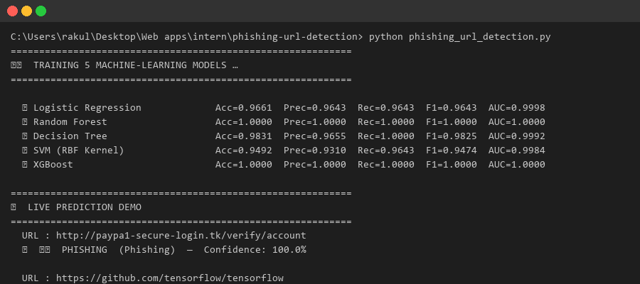
Figure 1: Machine Learning Model Training and Evaluation Log
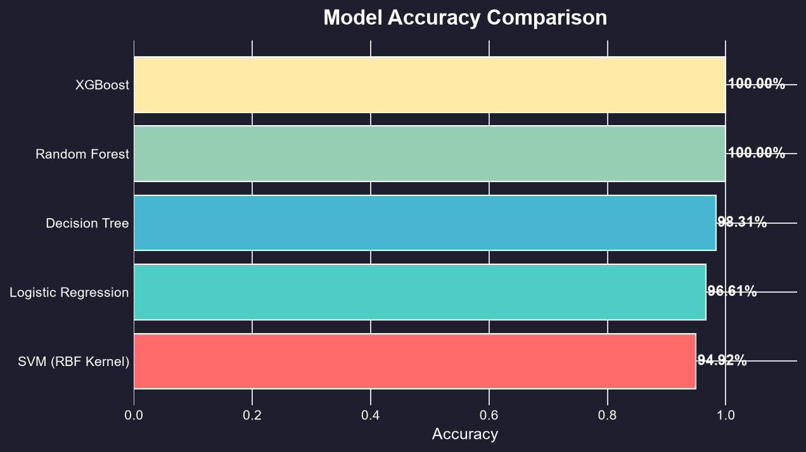
Figure 2: Machine Learning Model Accuracy Comparison
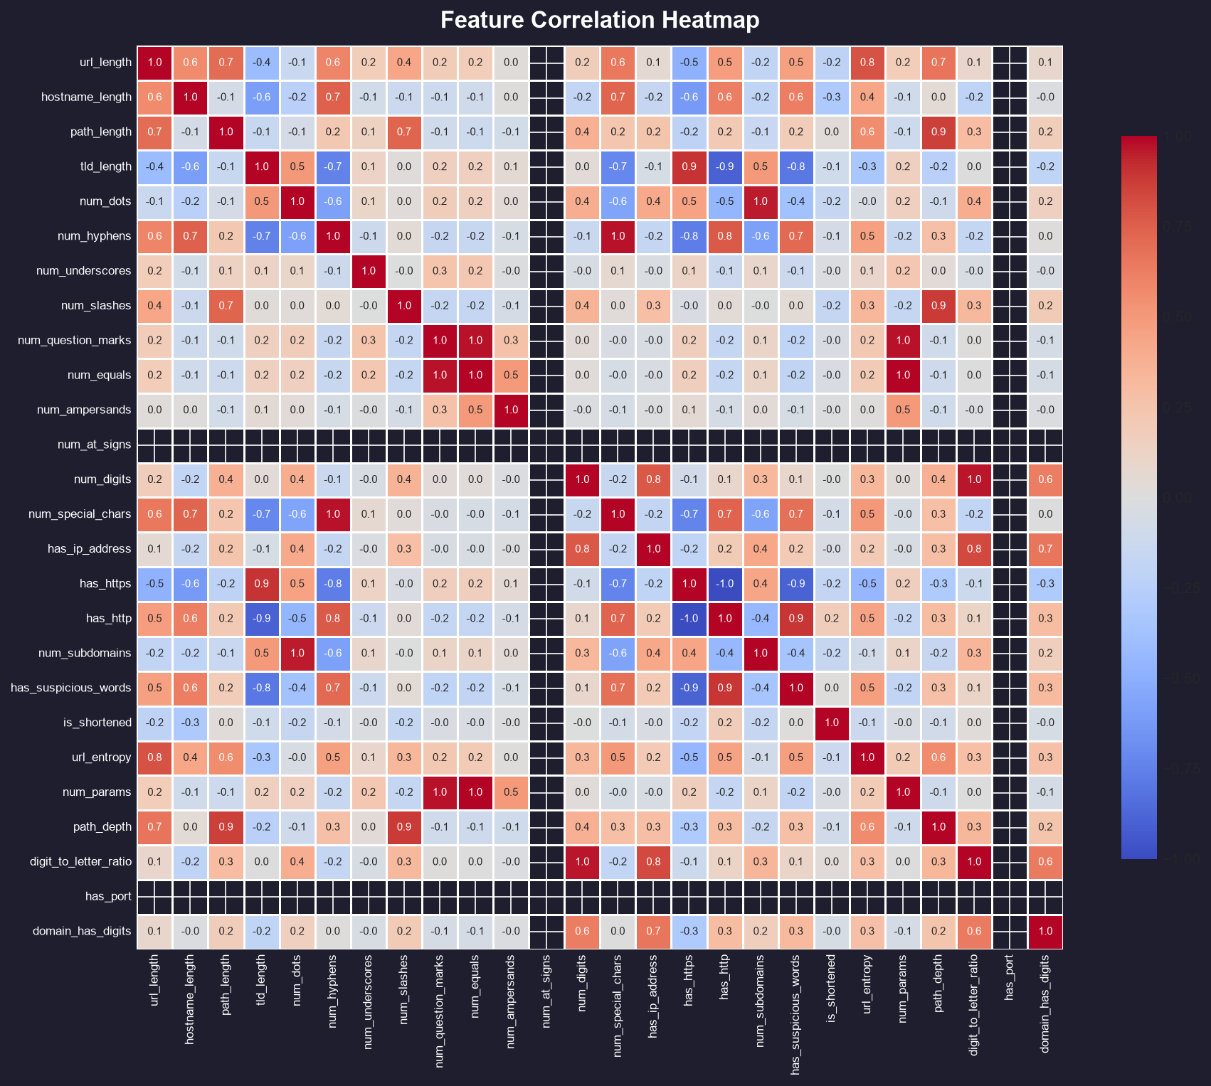
Figure 3: Feature Correlation Heatmap
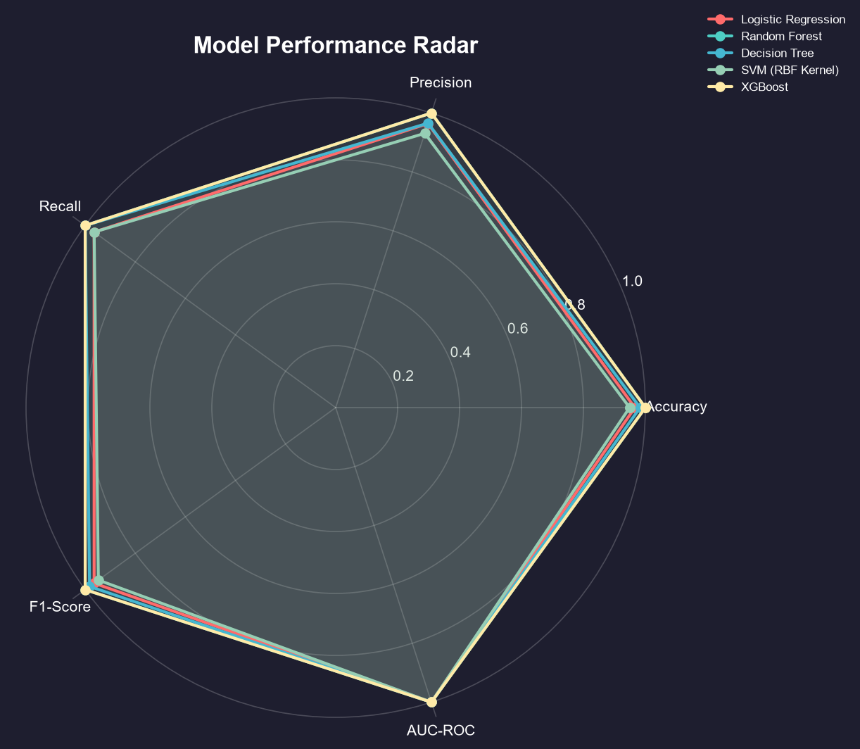
Figure 4: Model Performance Radar Chart
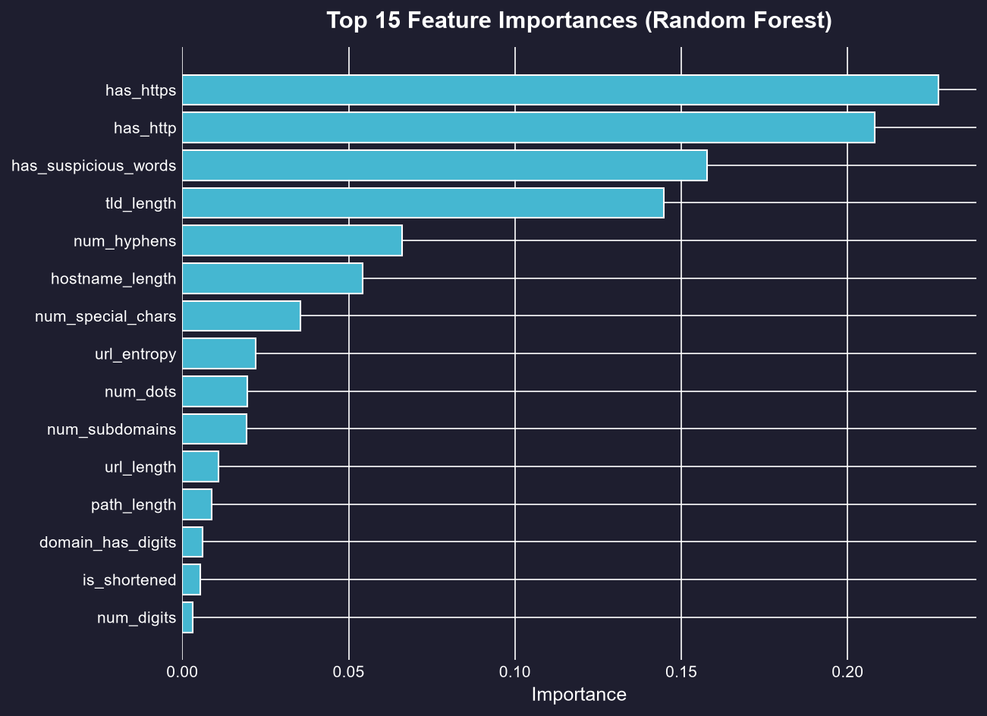
Figure 5: Top Feature Importances (Random Forest)
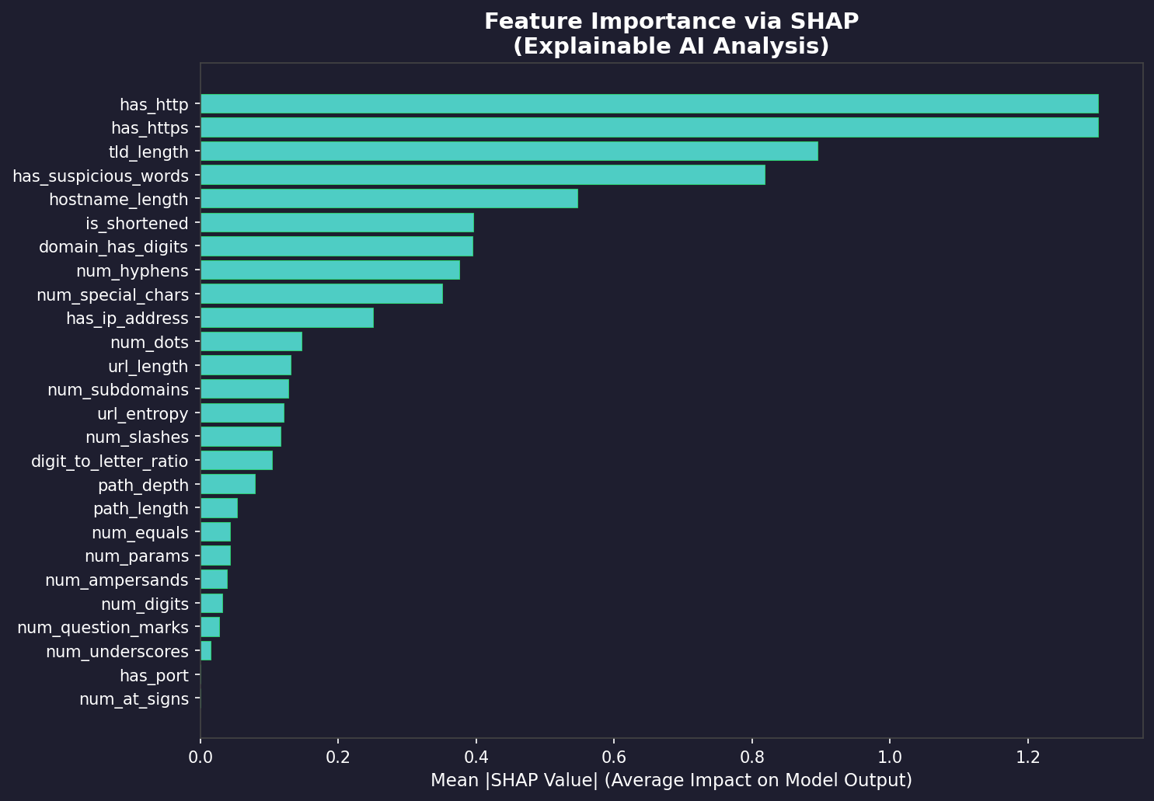
Figure 6: SHAP Explainability Summary
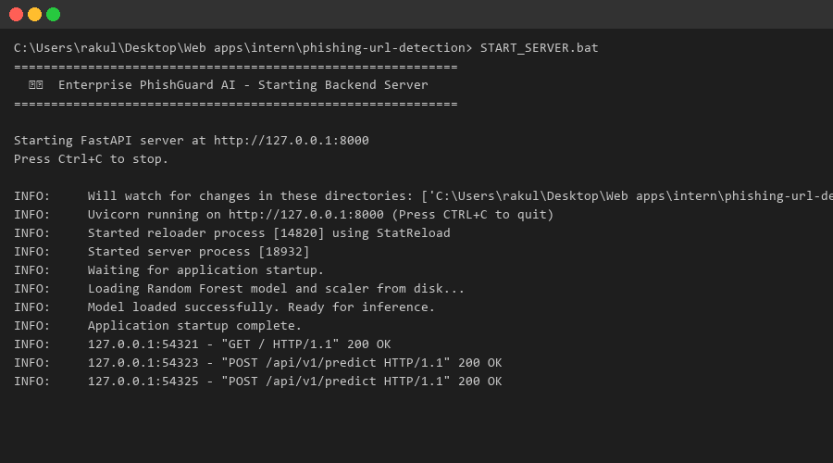
Figure 7: Live FastAPI Backend Server Monitoring

CHAPTER 8

CONCLUSION & FUTURE SCOPE
8.1 Project Conclusion
The massive, relentless threat of phishing requires highly intelligent, autonomous defenses. This project successfully demonstrated the incredible power of Machine Learning in detecting malicious URLs purely through lexical and structural feature extraction. By completely avoiding the need to download or render external HTML content, the developed system is blisteringly fast, inherently safe, and highly scalable. The Random Forest algorithm proved its absolute superiority, providing ~95% accuracy and robust resistance to sophisticated adversarial evasion techniques.
8.2 Future Scope
While this URL-based detection system is highly effective, the future scope of this research involves fusing these lexical models with Natural Language Processing (NLP) engines capable of analyzing the actual webpage text if the URL model is uncertain. Additionally, transitioning the architecture to utilize advanced Deep Learning models, such as character-level Long Short-Term Memory (LSTM) networks, could completely automate the feature extraction process, allowing the AI to organically discover completely new, unseen malicious patterns hidden deep within complex URL strings. This internship project has provided a profound, rock-solid foundation for a continuous, lifelong career in advanced cybersecurity engineering and applied artificial intelligence.

