|  |  |
| --- | --- |
|  | **Attendance Marking For Classroom**  **Technical Design Document** |
| |  |  |  |  | | --- | --- | --- | --- | |  | **Prepared By / Last Updated By** | **Reviewed By** | **Approved By** | | **Name** | Nishanth-**(2088500)** Ayush-**(2088603)**  Mohit-**(2088576)** P.PardhaSaradhi Reddy-**(2088506)**  Dinesh Vuppalapati – **(2088586)** Bhumika D –**(2088585)**  COHERT CODE: **ADM21DFO13** | Trainer & Mentor Logeshwaram  (t-Logesh) |  | | **Role** | Member & Team Leader  Member  Member  Member  Member  Member | Trainer & Mentor | Mentor | | **Signature** |  |  |  | | **Date** | 20-04-2022 |  |  | |
|  |

Table of Contents

1.0 Introduction 3

1.1 Purpose of this document 3

1.2 Project overview 3

2.0 Solution Summary 4

2.1 Scope 4

2.2 Assumptions 4

2.3 Dependencies 5

2.4 Risks 5

3.0 Schematic Diagram 6

4.0 System Design 7

4.1 Proposed design 7

4.2 Component inventory 8

5.0 Database Design 8

5.1 Data Model 8

5.2 Tables Structure 8

6.0 Appendices 10

6.1 Glossary 10

6.2 Other 10

7.0 Terms & Conditions 10

8.0 Change Log 10

# Introduction

## Purpose of this document

The purpose of this document is to document the technical design, component details and Database design. This will also capture the scope, assumptions, risk, dependencies of this project.

## Project overview

# The main aim of Student attendance system project is to maintain attendance records of student for any organization school or college. In this asp.net project post we will discuss attendance system project for school students. We developed this attendance system as website application using C# language in Visual Studio ASP.Net and use sql server for database server.

Attendance marking for classroom project used to maintain and track user attendance records for any organization. This system wants the fundamental details of the admin,user to authenticate the registered details. System allow admin to add trainer details and also allow admin to update the session details and update the skill set.

User wants to search for session based on session id or skill id and enroll for required session.System allow admin to approve the enrollment of users and system generate report on the course based on learner feedback. Admin allows users to add feedback for course. System provide validations like forgot userid forgot password and finally user and admin logout from the system.

# Solution Summary

## Scope

The scope of the project is the system on which the software is installed, i.e. the project is developed as a desktop application, and it will work for a particular institute or organization. But later on the project can be modified to operate it online.

All the attendance marked by the users is stored directly on database. Admin can view,update and edit the details in real time.So this project is very useful for any institutions for managing attendance record

## Assumptions

1.You’ll have access to all the resources you need to complete the project, both human and material.

2.Project team members will have the resources they need to complete their individual tasks on time, from specialized equipment and software down to electricity during working hours.

3.Personnel costs will not change during the project cycle.

4.Other material and resource costs will remain consistent throughout the project.

5.The overall cost of day-to-day operations will not increase.

6.All equipment will be in working condition through the project cycle.

7.The scope of the project will not change throughout the life cycle.

## Dependencies

Attendance Marking for classroom is independent project and hence it is not dependent on any of the modules. The modules created are all unique and hence cannot be dependent on the previously developed modules. The modules developed consist of many functions which will help in easy access of the data.

## Risks

Risk comes in many fashions during the system process.

The risks involved in the system may be due to the unauthorized access of the user or the admin. For example: entering invalid credentials and trying to login from the wrong credentials.

The other risk may include of losing data by any chance from the admin or user or trainer. The data entered maybe very crucial and also losing the data may create a blunder and some other risks are

**1. Malware**

Digital hackers are watching your every move and trick you to download malware and take control of your computer remotely. They use malware to attack computer networks to perpetrate crimes.  Fraudsters use virus, malware, spyware, spams, and phishing to gain access to your sensitive personal information

**2. Theft & Loss**

Unauthorized users without permissions who have access to sensitive data can cause harm to institutions as a result of theft. There is a risk of the sensitive academic data will be leaked by staff. It becomes easy to lose your storage media with backup data due to misplacement or theft.

**3. Unsafe data**

If adequate safety precautions are not taken when files and documents are shared in website, smartphones and tablets via internet networks, the information contained on them might gain access to the devices and get exposed to risks. We can make use of cloud deployments to manage the system better and better.

**4. Negligence**

When data is stored in computers or laptops, it has become so natural that people lose the information when files are accidentally deleted or even it could fall into the wrong hands. Ensure a proper backup strategy to keep your data on important devices and run them smoothly.

**5. Third party APIs**

Quite often, Users tend to use their credentials for accessing 3rd party APIs. When you integrate third party application into the existing system, you could be exposing the institution and its data at risk.

# Schematic Diagram

A schematic, or schematic diagram, is a representation of the elements of a [system](https://en.wikipedia.org/wiki/System) using abstract, graphic [symbols](https://en.wikipedia.org/wiki/Symbol) rather than realistic pictures. It gives an overview of overall system

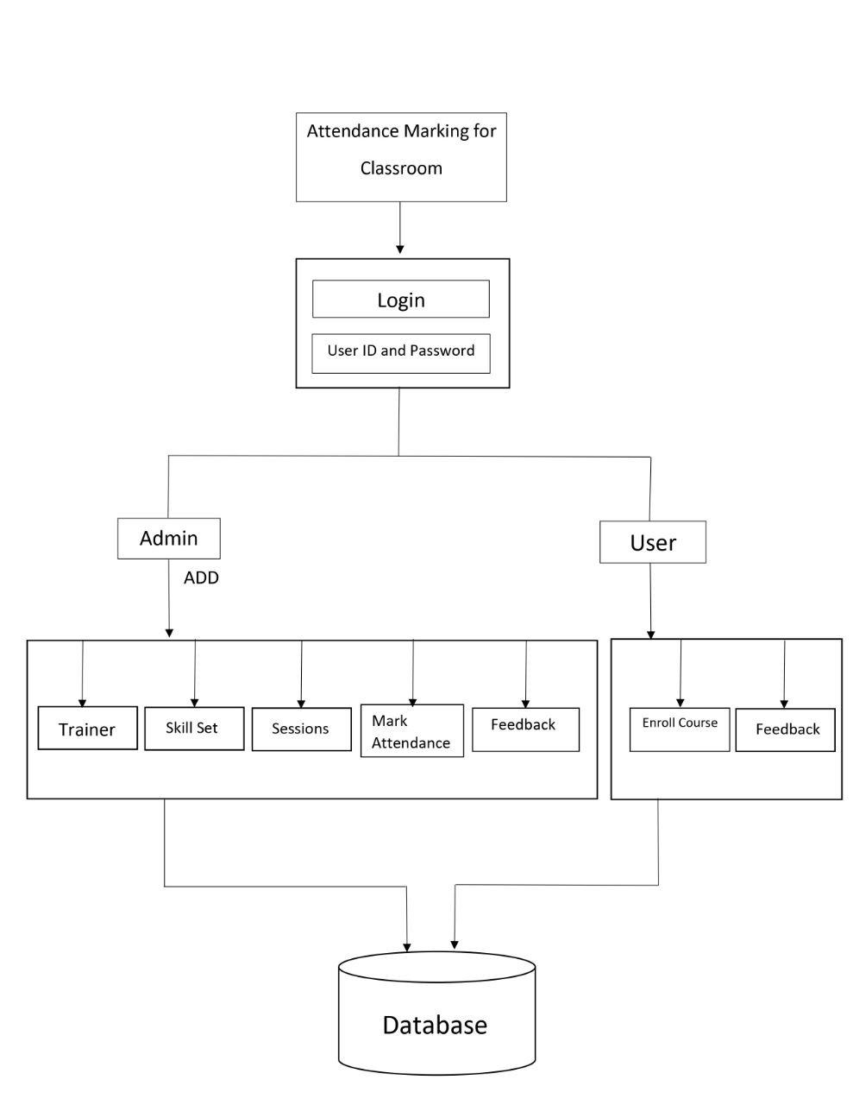

# System Design

## Proposed design

To overcome the drawbacks of the existing manual attendance marking system, the proposed system has been evolved. This project aims to reduce the paper work and saving time to generate accurate results from the users attendance. The system provides with the best user interface. The efficient reports can be generated by using this proposed system.

Advantages of Proposed System

1.It is trouble-free to use.  
2.It is a relatively fast approach to enter attendance  
3.Is highly reliable, approximate result from user  
4.Best user Interface  
5.Efficient reports

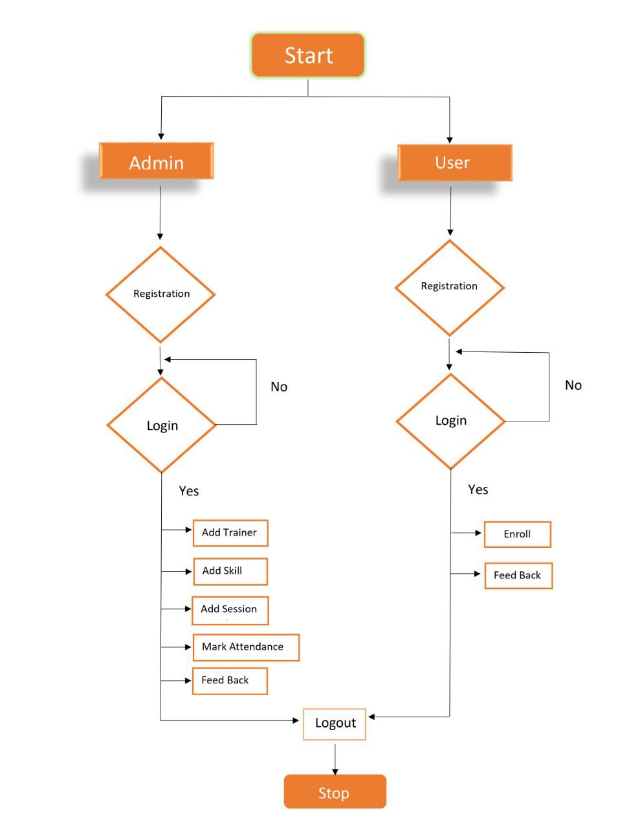

## Component inventory

1.Admin Module

2.User Module

3.Trainer Module

# Database Design

## Data Model

1. Admin
2. User
3. Trainer
4. Skillset
5. Session details
6. Enroll
7. Feedback

## Tables Structure

**ADMIN REGISTRATION:**

|  |  |  |
| --- | --- | --- |
| **Column Name** | **Data Type** | **Allow Nulls** |
| FirstName | Varchar(50) | Yes |
| LastName | Varchar(50) | Yes |
| Age | Varchar(50) | Yes |
| Gender | Varchar(50) | Yes |
| Contact_Number | Varchar(50) | Yes |
| Admin_Id | int | No |
| Password | Varchar(50) | Yes |

**USER REGISTRATION:**

|  |  |  |
| --- | --- | --- |
| **Column Name** | **Data Type** | **Allow Nulls** |
| FirstName | Varchar(50) | Yes |
| LastName | Varchar(50) | Yes |
| Emp_Id | int | No |
| Email | Varchar(50) | Yes |
| Password | Varchar(50) | Yes |

**USER LOGIN**

|  |  |  |
| --- | --- | --- |
| **Column Name** | **Data Type** | **Allow Nulls** |
| id | int | No |
| Username | Varchar(50) | Yes |
| Password | Nvarchar(50) | Yes |

**TRAINER REGISTRATION**

|  |  |  |
| --- | --- | --- |
| **Column Name** | **Data Type** | **Allow Nulls** |
| Trainer_Id | int | No |
| Trainer_Name | Varchar(50) | Yes |
| Contact_Number | Varchar(50) | Yes |
| Email | Varchar(50) | Yes |
| Skill_Id | int | Yes |
| Session_id | int | Yes |

**SKILL SET**

|  |  |  |
| --- | --- | --- |
| **Column Name** | **Data Type** | **Allow Nulls** |
| Skill_Id | int | No |
| Skill_Type | Varchar(50) | Yes |
| Skill_Des | Nvarchar(50) | Yes |

**SESSION DETAILS**

|  |  |  |
| --- | --- | --- |
| **Column Name** | **Data Type** | **Allow Nulls** |
| Session_Id | int | No |
| Session_Des | Varchar(50) | Yes |
| Skill_Id | int | Yes |
| Session_Date | date | Yes |
| Session_Time | time(7) | Yes |
| Available_Slots | int | Yes |

**ENROLL**

|  |  |  |
| --- | --- | --- |
| **Column Name** | **Data Type** | **Allow Nulls** |
| Sno | int | No |
| Skill_Id | int | Yes |
| Session_Id | int | Yes |

**FEEDBACK**

|  |  |  |
| --- | --- | --- |
| **Column Name** | **Data Type** | **Allow Nulls** |
| Id | int | No |
| subject | nvarchar(50) | Yes |
| msg | nvarchar(50) | Yes |
| Session_Id | int | Yes |

# Appendices

## Glossary

|  |  |
| --- | --- |
| **Acronyms** | **Definitions** |
|  |  |

## Other

# Terms & Conditions

***Disclaimer: Please do not circulate or distribute this document outside of Cognizant Network, We have a Zero Tolerance Policy. Kindly adhere to 100% Compliance at all times.***

# Change Log

*Please note that this table needs to be maintained even if a Configuration Management tool is used.*

|  |  |  |  |  |
| --- | --- | --- | --- | --- |
| Version Number | Changes made | | | |
| V<n.n> | *<If the change details are not explicitly documented in the table below, reference should be provided here>* | | | |
| Page no | Changed by | Effective date | Changes effected |
|  |  |  |  |
|  |  |  |  |
|  |  |  |  |
|  |  |  |  |