**NISHANTHI S**

Helpdesk Senior Associate

+(91) 8778649376

**CAREER OBJECTIVE**

I want to be a successful person in my life with my leadership qualities with at most sincerity. Being honest and truthful towards myself with smart working skill are my traits. With the help of my knowledge and education, aiming for mutual growth of the company and myself.

**WORK EXPERIENCE**

**Company Name:** NTT Data Global Delivery Services

**Designation**: Helpdesk Senior Associate

**Period**: March 2019 to till date

**Tools :** Service now , oracle 6.0 , SQL Developer 11.2.0 ,Autosys , SAP 750

**Key Responsibilities:**

* Monitoring and assigning Incident tickets in service now.
* Working in WinSCP for file transfer from server and PUTTY to interact with the server directly.
* Monitoring SAP APO Supply chain , in CAP & CIP and HBT/SPS Systems ,We may also have to notify the Failures to L2 Team
* Working in INTELLIGRATED Process to Creating and deactivate Active directory for new hire user or existing and assigning responsibilities .`
* Working in Remote desktop(RDP) and performing required process .
* Unlock user account and Reset the password for users .
* Check with user to find out the exact issue and we provide solution to that and resolve the tickets in Service now .
* Doing reports for daily created and closed & pending tickets and trending report.
* Weekly basis sent WSR to concern teams.
* Monitoring alerts for EMEA and NA regions , if any down URL received will inform to the Concern team within SLA .
* Using Autosys tool to find the job status and implement the jobs , we also changing time zone or any changes for implemented jobs in Prod and Non prod systems.
* In Autosys tool we have uploaded calendar(Year end activity) for Jobs .
* Manually scheduling and monitoring jobs in oracle , if any jobs are long running or got failed , intimate to Team
* Month end and year end I had manually scheduled jobs in oracle and monitoring the jobs.
* SQL Data base we ran the query and find error to take corrective action in Prod System .
* Working in SUS Project (Material Management ) checking PO Status
* If any PO’s stuck in portal we have check and intimate the buyer to fix the issue.
* Daily basis we have checking any PO’s got stuck in 51,03,26 status in SAP for PMT and HBT System.
* Creating vendor setup for NEW users have to access the portal.
* Account Transfer and Account Reactivation can be done for required users.

**Achievements:**

* ITIL V4 Foundation Completed internally .
* Got Highest customer satisfaction rating (CSAT) .
* In Year end I will Import Calendar for Prod and Non Prod systems for next year jobs .

**Company Name:** PRECISION INFOMATIC PVT.LTD

**Designation**: Service desk Executive

**Period**: June-2018

## Ticketing Tool: Gemini openex

**Key Responsibilities:**

• Alerting application team if the issue is not getting fixed after performing the SOP's

• Track all updates, highlights, open items, issues/risks and generate reports on the same

* Monitoring the Batches continuously in regular time Intervals.
* Maintain the overall assets records for the organization.
* Provided guidance and instructions over the phone for minor technical issues
* Utilized Remote Access and Desk Service Tools to provide on-site troubleshooting assistance from distant location.
* Worked on Time office management tool to provide Biometric access to the employees.
* Able to prioritize the work based on the demand.
* Create tickets based on the request .

**Company Name:** ALLSEC TECHNOLOGIES PVT.LTD

**Designation**: Customer care Executive

**Period**: September 2017 -May2018

**Tool**: SAP

* Meet the difficulties of customer queries .
* Identify the technical problem in the electronic equipments and provide resolution by taking remote of that equipment.
* Dealing with calls in a highly professional manner
* Responding to customers who have special communication needs, such as language

difficulties

* Answering any queries quickly and efficiently
* Quickly understanding the callers point of view and empathize with them.

**Achievements:**

• Got highest customer satisfaction rating .

**WORKSHOPS ATTENDED**

* I have attended the “**ADVANCED EXCEL WORKSHOP** “ conducted by Microsoft trainer and completed project in “**Google Data Studio ”**
* I have attended the workshops on “**SYSTEM ON CHIP DESIGN WITH EDK”** and “**IOT USING RASPBERRY**” and “**ARDUINO**” and I undergone the in plant training for “**FUNDAMENTALS OF TELECOM** “in **BSNL**

**Education**

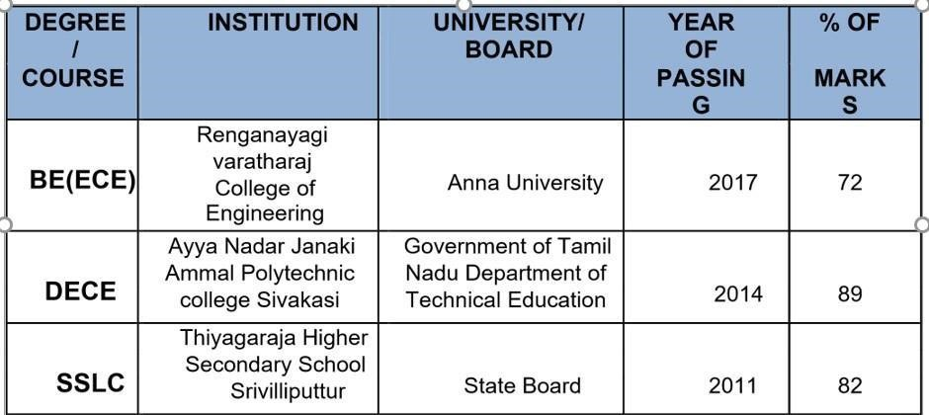

**PERSONAL PROFILE**

**Name :** Nishanthi.S

**Father’s Name :** Mr**.**K.Sivan Anaintha Perumal

**Date of Birth :** 16-07-1996

**Marital Status :** Single

**Languages Known :** English, Tamil

**DECLARATION**

I hereby declare that the information furnished above is true to the best of my knowledge.

**Place** :

**Date : (**Nishanthi.S)