**EXP 3 SERVLET PROGRAM**

# AIM:

To create an HTML webpage that displays "Hello World" in the center of the page inside a styled box using CSS for alignment and styling.

# ALGORITHM:

1. Start
2. Create an HTML document with a <head> and <body> section.
3. Inside the <head> section:
   * Set the title of the page.
   * Add meta tags for character set and viewport settings.
   * Define CSS styles to center the text and style the box.
4. In the <body> section:
   * Use a <div> element with a class box to wrap the text.
   * Inside the <div>, add an <h1> tag with the text "Hello World" in bold.
5. Use **CSS** Flexbox to center the box both vertically and horizontally.
6. Apply **s**tyles to the box, including:
   * Padding
   * Border
   * Border-radius
   * Box-shadow
   * Background color
7. Save the file and open it in a web browser.
8. End.

## PROGRAM:

<!DOCTYPE html>

<html>

<head>

<title>hello world</title>

<meta charset="UTF-8">

<meta name="viewport" content="width=device-width, initial-scale=1.0">

<style>

body {

display: flex;

justify-content: center; align-items: center;

height: 100vh; margin: 0;

background-color: #f0f0f0;

}

.box {

padding: 20px; background-color: white; border: 2px solid black; border-radius: 10px;

box-shadow: 5px 5px 15px rgba(0, 0, 0, 0.2); text-align: center;

}

</style>

</head>

<body>

<div class="box">

<h1><b>HELLO! THIS IS HARSHA HERE!!!</b></h1>

</div>

</body>

</html>

## Output:

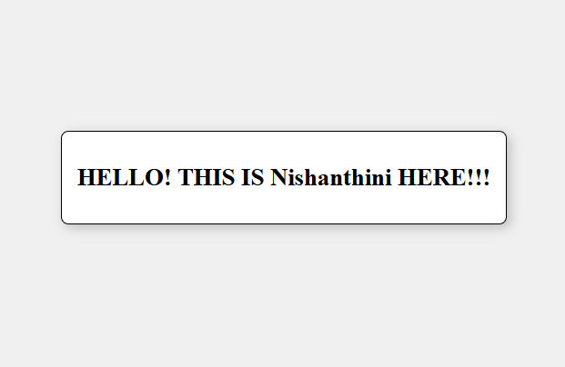

**RESULT:** Thus, the servlet program was successfully executed.