**EXP 4: WEB FORM DEVELOPED USING SERVLET PROGRAM**

# AIM:

To create a web form that accepts a user's name and age, processes the data using JavaScript, and displays the submitted details with a stylish UI and animations.

## ALGORITHM:

### Step 1: Start

**Step 2: Design the Web Form**

* Create an HTML form with two input fields:
  + Name (Text Input)
  + Age (Number Input)
* Add a submit button.

### Step 3: Apply CSS Styles

* Use **gradient background, smooth input effects, button hover effects, and animations**.
* Style the form, inputs, button, and result display area.

### Step 4: Write JavaScript for Form Handling

* Attach an **event listener** to the form submit event.
* Get user input values (name and age).
* Validate input fields (ensure **name is not empty** and **age is valid**).
* If validation fails, **show an alert**.
* If valid, display the submitted details dynamically.

### Step 5: Show Output Dynamically

* Use JavaScript to update the UI and **display the submitted data in a formatted box**.
* Use **smooth animations** for better user experience.

**Step 6: End**

## PROGRAM:

<!DOCTYPE html>

<html lang="en">

<head>

<meta charset="UTF-8">

<meta name="viewport" content="width=device-width, initial-scale=1.0">

<title>User Form</title>

<style>

/* Import Google Font */ @import

url('https://fonts.googleapis.com/css2?family=Poppins:wght@300;400;600&display=swap');

/* Page Styling */ body {

font-family: 'Poppins', sans-serif;

background: linear-gradient(135deg, #ff9a9e, #fad0c4); display: flex;

justify-content: center; align-items: center; height: 100vh; margin: 0;

animation: fadeIn 1s ease-in-out;

}

/* Form Container */

.container { background: white; padding: 25px; border-radius: 12px;

box-shadow: 0px 5px 15px rgba(0, 0, 0, 0.2); width: 350px;

text-align: center;

transition: transform 0.3s ease-in-out;

}

.container:hover { transform: scale(1.05);

}

h2 {

color: #ff4d6d; font-weight: 600;

margin-bottom: 15px;

text-shadow: 1px 1px 2px rgba(0, 0, 0, 0.2);

}

/* Input Fields */ label {

font-weight: 600;

color: #444; display: block; margin: 10px 0 5px;

}

input {

width: 100%; padding: 10px;

border: 2px solid #ff4d6d; border-radius: 8px;

font-size: 16px; outline: none;

transition: all 0.3s ease-in-out;

}

input:focus {

border-color: #ff165d;

box-shadow: 0px 0px 10px rgba(255, 22, 93, 0.4);

}

/* Submit Button */ button {

background: #ff4d6d; color: white;

border: none; padding: 12px; cursor: pointer; width: 100%; font-size: 18px; font-weight: 600;

border-radius: 8px; margin-top: 15px;

transition: background 0.3s ease-in-out, transform 0.2s;

}

button:hover { background: #ff165d; transform: scale(1.05);

}

button:active { transform: scale(0.95);

}

/* Output Box */

.output { display: none;

margin-top: 20px; padding: 15px; border-radius: 8px; background: #e0f7fa; color: #00796b;

font-size: 16px; text-align: left;

box-shadow: 0px 4px 10px rgba(0, 0, 0, 0.1); animation: slideIn 0.5s ease-in-out;

}

/* Animations */ @keyframes fadeIn {

from { opacity: 0; transform: translateY(-10px); } to { opacity: 1; transform: translateY(0); }

}

@keyframes slideIn {

from { opacity: 0; transform: translateY(20px); } to { opacity: 1; transform: translateY(0); }

}

</style>

</head>

<body>

<div class="container">

<h2>Enter Your Details</h2>

<form id="userForm">

<label for="name">Name:</label>

<input type="text" id="name" name="name" required placeholder="Enter your name...">

<label for="age">Age:</label>

<input type="number" id="age" name="age" required placeholder="Enter your age...">

<button type="submit">Submit</button>

</form>

<div class="output" id="output"></div>

</div>

<script>

document.getElementById("userForm").addEventListener("submit", function(event) { event.preventDefault(); // Prevent form submission

let name = document.getElementById("name").value.trim(); let age = document.getElementById("age").value.trim();

if (name === "" || age === "" || age <= 0) { alert("⚠◻ Please enter a valid name and age."); return;

}

// Display the submitted data with an animation

let outputBox = document.getElementById("output"); outputBox.innerHTML =

`<h3>✅ Submitted Details</h3>

<p><b>Name:</b> ${name}</p>

<p><b>Age:</b> ${age}</p>`; outputBox.style.display = "block";

});

</script>

</body>

</html>

## OUTPUT:

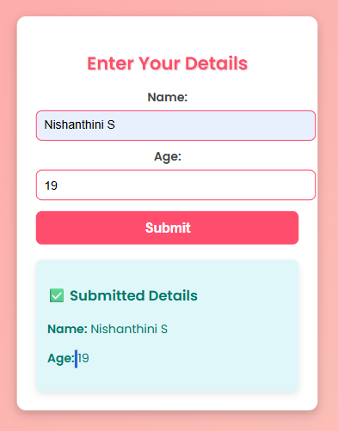

**RESULT:** The creation of web form using servlet program was executed successfully.