**EXP 5 HTTP GET and POST methods**

# AIM:

To demonstrate the difference between HTTP GET and POST methods using a Java Servlet by creating a form that sends data using both methods.

# ALGORITHM:

Step 1: Create an HTML form with GET and POST methods.

Step 2: Develop a Servlet (GetPostServlet.java) to handle requests. Step 3: Implement doGet() to handle GET requests.

Step 4: Implement doPost() to handle POST requests.

Step 5: Configure web.xml to map the Servlet to /GetPostServlet. Step 6: Run the server and observe how GET and POST work differently. **PROGRAM:**

## index.html (Form Page)

html CopyEdit

<!DOCTYPE html>

<html lang="en">

<head>

<meta charset="UTF-8">

<meta name="viewport" content="width=device-width, initial-scale=1.0">

<title>GET vs POST Demo</title>

<link rel="stylesheet" href="styles.css">

</head>

<body>

<div class="container">

<h2>Choose GET or POST Method 🚀</h2>

<form action="GetPostServlet" method="GET">

<input type="text" name="username" placeholder="Enter your name" required>

<button type="submit">Submit with GET</button>

</form>

<form action="GetPostServlet" method="POST">

<input type="text" name="username" placeholder="Enter your name" required>

<button type="submit">Submit with POST</button>

</form>

</div>

</body>

</html>

## styles.css

css CopyEdit body {

font-family: 'Poppins', sans-serif;

background: linear-gradient(to right, #36D1DC, #5B86E5); text-align: center;

display: flex;

justify-content: center; align-items: center; height: 100vh; margin: 0;

}

.container { background: #fff; padding: 20px; border-radius: 15px;

box-shadow: 0 4px 8px rgba(0, 0, 0, 0.2); width: 300px;

}

h2 {

color: #5B86E5;

}

input {

width: 90%; padding: 10px; margin: 10px 0;

border: 1px solid #5B86E5; border-radius: 8px;

text-align: center;

}

button {

background: #36D1DC; color: white;

border: none; padding: 10px 15px; border-radius: 8px; cursor: pointer; transition: 0.3s;

}

button:hover {

background: #1e6e8c;

}

## GetPostServlet.java (Servlet to Handle GET & POST)

java CopyEdit

import java.io.IOException; import java.io.PrintWriter;

import javax.servlet.ServletException; import javax.servlet.annotation.WebServlet; import javax.servlet.http.HttpServlet;

import javax.servlet.http.HttpServletRequest; import javax.servlet.http.HttpServletResponse;

@WebServlet("/GetPostServlet")

public class GetPostServlet extends HttpServlet { private static final long serialVersionUID = 1L;

// Handling GET Request

protected void doGet(HttpServletRequest request, HttpServletResponse response) throws ServletException, IOException {

response.setContentType("text/html"); PrintWriter out = response.getWriter();

String name = request.getParameter("username");

out.println("<html><body>"); out.println("<h2>GET Method Received</h2>");

out.println("<p>Hello, <b>" + name + "</b>! Data sent using GET.</p>"); out.println("</body></html>");

}

// Handling POST Request

protected void doPost(HttpServletRequest request, HttpServletResponse response) throws ServletException, IOException {

response.setContentType("text/html"); PrintWriter out = response.getWriter();

String name = request.getParameter("username");

out.println("<html><body>"); out.println("<h2>POST Method Received</h2>");

out.println("<p>Hello, <b>" + name + "</b>! Data sent using POST.</p>"); out.println("</body></html>");

}

}

## web.xml (Servlet Configuration)

xml

CopyEdit

<web-app xmlns="<http://java.sun.com/xml/ns/javaee>" version="3.0">

<servlet>

<servlet-name>GetPostServlet</servlet-name>

<servlet-class>GetPostServlet</servlet-class>

</servlet>

<servlet-mapping>

<servlet-name>GetPostServlet</servlet-name>

<url-pattern>/GetPostServlet</url-pattern>

</servlet-mapping>

</web-app>

## OUTPUT:

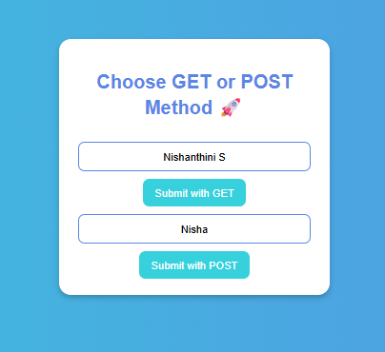

**RESULT:** The Get and Post methods were executed successfully.