**EXP 7 Servlet-based project is to store user preferences**

# AIM:

The goal of this Servlet-based project is to store user preferences (such as theme and language) using cookies and retrieve and display them on subsequent visits.

# ALGORITHM:

Step 1: Load Preferences Page **→ Browser checks for existing cookies.**

Step 2 Retrieve Preferences (GET Request) **→ Servlet reads cookies and applies saved settings.**

Step 3: User Selects Preferences **→ User picks theme and language.**

Step 4: Save Preferences (POST Request) **→ JavaScript sends data to Servlet.**

Step 5: Servlet Stores Preferences **→ Cookies are updated and sent back to the browser.** Step 6: Preferences Applied on Next Visit **→ Browser loads saved settings automatically. PROGRAM:**

**index.html (Frontend - Combined HTML, CSS & JavaScript)**

html CopyEdit

<!DOCTYPE html>

<html lang="en">

<head>

<meta charset="UTF-8">

<meta name="viewport" content="width=device-width, initial-scale=1.0">

<title>Preferences using Cookies</title>

<style>

body {

font-family: 'Poppins', sans-serif;

background: linear-gradient(to right, #ffafbd, #ffc3a0); text-align: center;

display: flex;

justify-content: center; align-items: center; height: 100vh;

margin: 0;

transition: background 0.5s ease-in-out;

}

.container {

background: white; padding: 20px; border-radius: 15px;

box-shadow: 0 4px 8px rgba(0, 0, 0, 0.2);

}

h2 {

}

width: 320px;

color: #ff6f61;

select, button { width: 90%; padding: 10px; margin: 10px 0;

border: 1px solid #ff6f61; border-radius: 8px;

text-align: center;

}

button {

background: #ff6f61; color: white; border: none; cursor: pointer; transition: 0.3s;

}

button:hover { background: #e6514a;

}

.pref-box {

margin-top: 20px; padding: 10px;

background: rgba(255, 255, 255, 0.8); color: black;

border-radius: 10px; font-weight: bold;

}

.hidden {

display: none;

}

.dark-mode {

background: linear-gradient(to right, #333333, #1e1e1e); color: white;

}

.dark-mode .container {

background: rgba(255, 255, 255, 0.1); backdrop-filter: blur(10px);

}

.dark-mode .pref-box {

background: rgba(255, 255, 255, 0.2); color: white;

}

</style>

</head>

<body>

<div class="container">

<h2>Set Your Preferences</h2>

<div id="form-section">

<label for="theme">Choose Theme:</label>

<select id="theme">

<option value="light">Light</option>

<option value="dark">Dark</option>

</select>

<label for="language">Choose Language:</label>

<select id="language">

<option value="English">English</option>

<option value="French">French</option>

</select>

<button onclick="savePreferences()">Save Preferences</button>

</div>

<div id="view-section" class="hidden">

<h2>Your Preferences</h2>

<div class="pref-box">

<p>🌟 Theme: <span id="saved-theme">-</span></p>

<p>🌍 Language: <span id="saved-language">-</span></p>

</div>

<button onclick="resetPreferences()">Change Preferences</button>

</div>

</div>

<script>

function savePreferences() {

let theme = document.getElementById("theme").value;

let language = document.getElementById("language").value;

fetch("PreferenceServlet", { method: "POST",

headers: { "Content-Type": "application/x-www-form-

urlencoded" },

body: `theme=${theme}&language=${language}`

}).then(() => updateView());

}

function updateView() { fetch("PreferenceServlet")

.then(response => response.json())

.then(data => {

document.getElementById("saved-theme").innerText =

data.theme; data.language;

=== "dark");

document.getElementById("saved-language").innerText = document.body.classList.toggle("dark-mode", data.theme

document.getElementById("form- section").classList.add("hidden");

document.getElementById("view- section").classList.remove("hidden");

});

}

function resetPreferences() {

fetch("PreferenceServlet", { method: "DELETE" }).then(() => { document.getElementById("form-

section").classList.remove("hidden");

document.getElementById("view- section").classList.add("hidden");

});

}

window.onload = updateView;

</script>

</body>

</html>

**PreferenceServlet.java (Backend - Java Servlet)**

java CopyEdit

import java.io.IOException;

import javax.servlet.ServletException; import javax.servlet.annotation.WebServlet; import javax.servlet.http.Cookie;

import javax.servlet.http.HttpServlet;

import javax.servlet.http.HttpServletRequest; import javax.servlet.http.HttpServletResponse; import org.json.JSONObject;

@WebServlet("/PreferenceServlet")

public class PreferenceServlet extends HttpServlet {

protected void doPost(HttpServletRequest request, HttpServletResponse response) throws ServletException, IOException {

String theme = request.getParameter("theme"); String language = request.getParameter("language");

Cookie themeCookie = new Cookie("theme", theme);

Cookie languageCookie = new Cookie("language", language);

themeCookie.setMaxAge(60 * 60 * 24 * 7); // 1 Week

languageCookie.setMaxAge(60 * 60 * 24 * 7);

response.addCookie(themeCookie); response.addCookie(languageCookie);

}

protected void doGet(HttpServletRequest request, HttpServletResponse response) throws ServletException, IOException {

String theme = "light"; String language = "English";

Cookie[] cookies = request.getCookies(); if (cookies != null) {

for (Cookie cookie : cookies) {

if ("theme".equals(cookie.getName())) theme = cookie.getValue();

if ("language".equals(cookie.getName())) language = cookie.getValue();

}

}

JSONObject json = new JSONObject(); json.put("theme", theme); json.put("language", language);

response.setContentType("application/json"); response.getWriter().write(json.toString());

}

protected void doDelete(HttpServletRequest request, HttpServletResponse response) throws ServletException, IOException {

Cookie themeCookie = new Cookie("theme", ""); Cookie languageCookie = new Cookie("language", "");

themeCookie.setMaxAge(0); languageCookie.setMaxAge(0);

response.addCookie(themeCookie); response.addCookie(languageCookie);

}

}

**OUTPUT:**

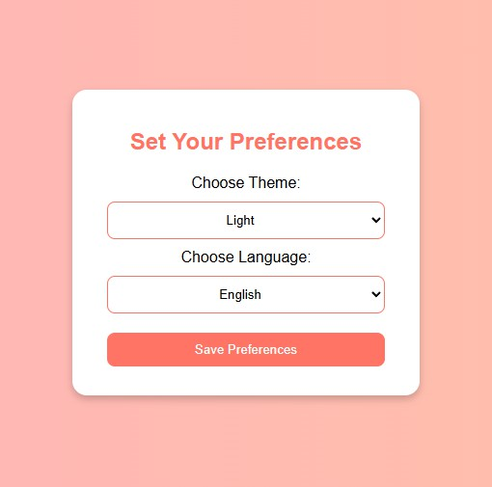

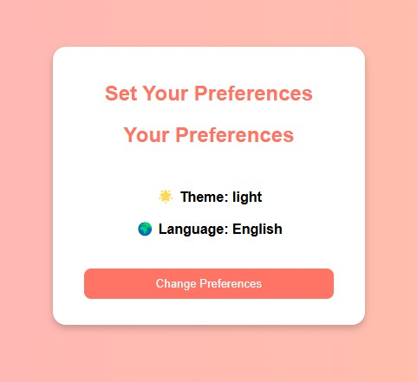

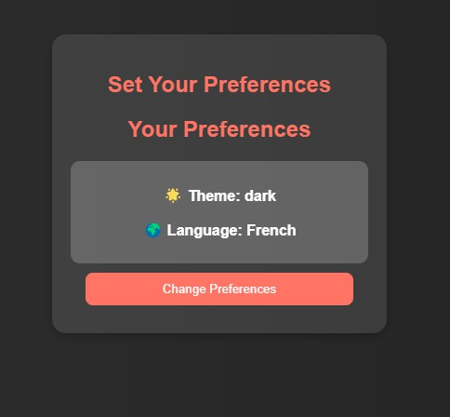

**RESULT:** The Servlet-based project to store user preferences using cookies were executed successfully.