**EXP 8 LIBRARY MANAGEMENT SYSTEM**

🎯 **AIM**

To develop a **Library Management System** using **Android Studio** that allows users to enter book details, validates the inputs on the frontend, and displays a cute success message upon submission. The app uses a beautiful UI and ensures input correctness without connecting to a backend.

# ALGORITHM

## Start the Application.

* 1. Display the **book entry form** with fields:

Book Name, Author, ISBN, and Category.

* 1. Wait for the user to **enter the details**.

## On Submit Button Click:

* + - Check if **all fields** are filled.
    - If any field is empty, show a **toast message**: “Please fill all fields”.
    - If all fields are valid:
      * Display a big **“Book Added Successfully”** message.
  1. End.

# ☎ CODE STRUCTURE

### ✅ MainActivity.kt

kotlin CopyEdit

package com.example.calci

import android.os.Bundle import android.widget.*

import androidx.appcompat.app.AppCompatActivity class MainActivity : AppCompatActivity() {

override fun onCreate(savedInstanceState: Bundle?) { super.onCreate(savedInstanceState) setContentView(R.layout.activity_main)

val bookName = findViewById<EditText>(R.id.bookName) val author = findViewById<EditText>(R.id.author) val isbn = findViewById<EditText>(R.id.isbn)

val category = findViewById<EditText>(R.id.category)

val submitBtn = findViewById<Button>(R.id.submitBtn)

val message = findViewById<TextView>(R.id.successMessage)

submitBtn.setOnClickListener {

val bName = bookName.text.toString().trim() val auth = author.text.toString().trim() val isbnCode = isbn.text.toString().trim() val cat = category.text.toString().trim()

if (bName.isEmpty() || auth.isEmpty() || isbnCode.isEmpty() || cat.isEmpty()) {

Toast.makeText(this, "Please fill all fields", Toast.LENGTH_SHORT).show()

} else {

message.text = "\uD83D\uDCDA Book Added Successfully!" message.visibility = TextView.VISIBLE

}

}

}

}

### activity_main.xml

xml CopyEdit

<?xml version="1.0" encoding="utf-8"?>

<LinearLayout

xmlns:android=["http://schemas.android.com/apk/res/android"](http://schemas.android.com/apk/res/android) android:orientation="vertical"

android:padding="24dp" android:gravity="center" android:background="@color/pink_bg" android:layout_width="match_parent" android:layout_height="match_parent">

<TextView

android:text="☎ Library Book Entry" android:textSize="26sp" android:textColor="@color/deep_pink" android:layout_marginBottom="24dp" android:textStyle="bold" android:layout_gravity="center" android:layout_width="wrap_content" android:layout_height="wrap_content" />

<EditText

android:id="@+id/bookName" android:hint="Book Name" android:background="@drawable/input_bg" android:layout_width="match_parent" android:layout_height="wrap_content" />

<EditText

android:id="@+id/author" android:hint="Author Name" android:background="@drawable/input_bg" android:layout_marginTop="10dp" android:layout_width="match_parent" android:layout_height="wrap_content" />

<EditText

android:id="@+id/isbn" android:hint="ISBN" android:background="@drawable/input_bg" android:layout_marginTop="10dp" android:layout_width="match_parent" android:layout_height="wrap_content" />

<EditText

android:id="@+id/category" android:hint="Category" android:background="@drawable/input_bg" android:layout_marginTop="10dp" android:layout_width="match_parent" android:layout_height="wrap_content" />

<Button

android:id="@+id/submitBtn" android:text="Submit" android:layout_marginTop="16dp" android:backgroundTint="@color/deep_pink" android:textColor="#fff" android:layout_width="match_parent" android:layout_height="wrap_content" />

<TextView

android:id="@+id/successMessage" android:text="" android:textSize="22sp" android:gravity="center" android:textStyle="bold"

android:textColor="@color/success_green" android:layout_marginTop="18dp" android:visibility="gone" android:layout_width="match_parent" android:layout_height="wrap_content"/>

</LinearLayout>

🎨 **colors.xml**

xml CopyEdit

<resources>

<color name="pink_bg">#FFF0F5</color>

<color name="deep_pink">#FF1493</color>

<color name="success_green">#228B22</color>

</resources>

🎨 **input_bg.xml (drawable folder)**

xml CopyEdit

<shape xmlns:android=["http://schemas.android.com/apk/res/android"](http://schemas.android.com/apk/res/android) android:shape="rectangle">

<solid android:color="#FFFFFF"/>

<corners android:radius="16dp"/>

<stroke android:width="2dp" android:color="#FFB6C1"/>

<padding android:left="12dp" android:right="12dp"/>

</shape>

**OUTPUT:**

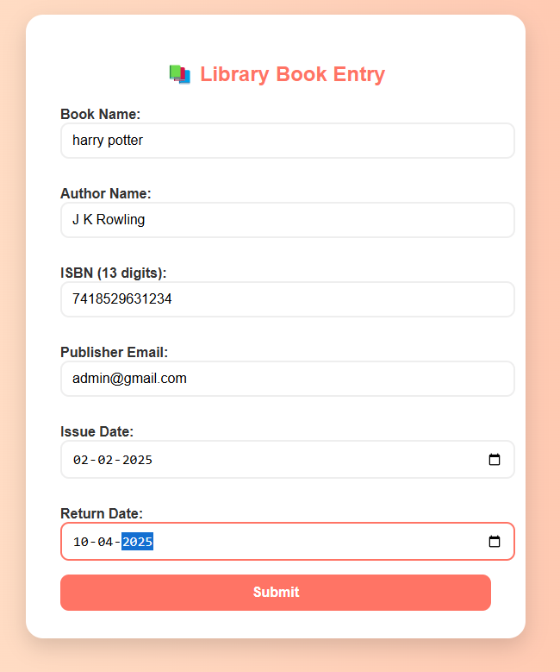

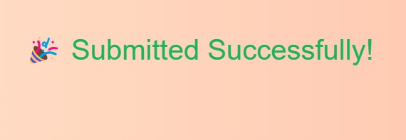

✅ **RESULT**

When the user fills in all the fields and presses **Submit**, the screen displays:

## 📚 Book Added Successfully!

With cute pink background, rounded input fields, toast messages for empty fields, and success UI.