**EXP 9 CALCULATOR APP**

🎯 **AIM**

To develop a **simple and cute Calculator App** in Android Studio using Kotlin, allowing the user to perform basic arithmetic operations (Addition, Subtraction, Multiplication, Division) with a mobile-friendly interface and clear input/output validation.

* **ALGORITHM**
  1. Start the app.
  2. Display two input fields for numbers.
  3. Show buttons: ➕ ➖ ✖◻ ➗ and ◻ (clear).
  4. User enters two numbers and taps a button.
  5. App checks if both inputs are valid numbers:
     + If not: show a toast message “Enter valid numbers”.
     + If valid:
       - Perform the selected operation.
       - Show the result on the screen.
  6. Clear button resets everything.
  7. End.

☎ **CODE**

✅ **MainActivity.kt**

kotlin CopyEdit

package com.example.calci

import android.os.Bundle import android.widget.*

import androidx.appcompat.app.AppCompatActivity

class MainActivity : AppCompatActivity() { private lateinit var num1: EditText private lateinit var num2: EditText private lateinit var result: TextView private lateinit var addBtn: Button private lateinit var subBtn: Button private lateinit var mulBtn: Button private lateinit var divBtn: Button private lateinit var clearBtn: Button

override fun onCreate(savedInstanceState: Bundle?) { super.onCreate(savedInstanceState) setContentView(R.layout.activity_main)

num1 = findViewById(R.id.number1) num2 = findViewById(R.id.number2) result = findViewById(R.id.result) addBtn = findViewById(R.id.add) subBtn = findViewById(R.id.subtract) mulBtn = findViewById(R.id.multiply) divBtn = findViewById(R.id.divide) clearBtn = findViewById(R.id.clear)

addBtn.setOnClickListener { calculate("+") } subBtn.setOnClickListener { calculate("-") } mulBtn.setOnClickListener { calculate("*") } divBtn.setOnClickListener { calculate("/") } clearBtn.setOnClickListener {

num1.text.clear() num2.text.clear() result.text = ""

}

}

private fun calculate(op: String) { val n1Text = num1.text.toString() val n2Text = num2.text.toString()

if (n1Text.isEmpty() || n2Text.isEmpty()) { Toast.makeText(this, "Enter valid numbers",

Toast.LENGTH_SHORT).show()

return

}

val n1 = n1Text.toDouble() val n2 = n2Text.toDouble() val res = when (op) {

"+" -> n1 + n2 "-" -> n1 - n2

"*" -> n1 * n2 "/" -> {

if (n2 == 0.0) {

Toast.makeText(this, "Cannot divide by zero", Toast.LENGTH_SHORT).show()

return

}

n1 / n2

}

else -> 0.0

}

result.text = "Result: $res"

}

}

* **activity_main.xml (Cute Styling UI)**

xml CopyEdit

<?xml version="1.0" encoding="utf-8"?>

<LinearLayout

xmlns:android=["http://schemas.android.com/apk/res/android"](http://schemas.android.com/apk/res/android) android:layout_width="match_parent" android:layout_height="match_parent" android:orientation="vertical" android:background="#FFF1F8"

android:padding="24dp" android:gravity="center">

<TextView

android:text="Cute Calculator 💖" android:textSize="28sp" android:textColor="#E91E63" android:layout_marginBottom="16dp" android:textStyle="bold" android:layout_width="wrap_content" android:layout_height="wrap_content" />

<EditText

android:id="@+id/number1" android:hint="Enter Number 1" android:inputType="numberDecimal" android:layout_width="match_parent" android:layout_height="wrap_content" android:backgroundTint="#E91E63" android:padding="10dp" android:layout_marginBottom="12dp"/>

<EditText

android:id="@+id/number2" android:hint="Enter Number 2" android:inputType="numberDecimal" android:layout_width="match_parent" android:layout_height="wrap_content" android:backgroundTint="#E91E63" android:padding="10dp" android:layout_marginBottom="24dp"/>

<LinearLayout

android:orientation="horizontal" android:layout_width="match_parent" android:layout_height="wrap_content" android:gravity="center" android:layout_marginBottom="16dp">

<Button

android:id="@+id/add" android:text="➕" android:layout_width="0dp" android:layout_weight="1" android:layout_height="wrap_content" android:backgroundTint="#F8BBD0" />

<Button

android:id="@+id/subtract" android:text="➖" android:layout_width="0dp" android:layout_weight="1" android:layout_height="wrap_content" android:backgroundTint="#F8BBD0"

android:layout_marginStart="8dp"/>

<Button

android:id="@+id/multiply" android:text="✖◻" android:layout_width="0dp" android:layout_weight="1" android:layout_height="wrap_content" android:backgroundTint="#F8BBD0" android:layout_marginStart="8dp"/>

<Button

android:id="@+id/divide" android:text="➗" android:layout_width="0dp" android:layout_weight="1" android:layout_height="wrap_content" android:backgroundTint="#F8BBD0" android:layout_marginStart="8dp"/>

</LinearLayout>

<Button

android:id="@+id/clear" android:text="◻ Clear" android:layout_width="wrap_content" android:layout_height="wrap_content" android:backgroundTint="#CE93D8" android:layout_marginBottom="16dp" />

<TextView

android:id="@+id/result" android:textSize="22sp" android:textStyle="bold" android:textColor="#880E4F" android:layout_width="wrap_content" android:layout_height="wrap_content" />

</LinearLayout>

**OUTPUT:**

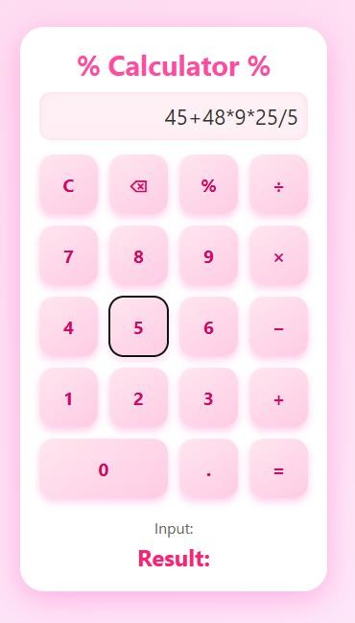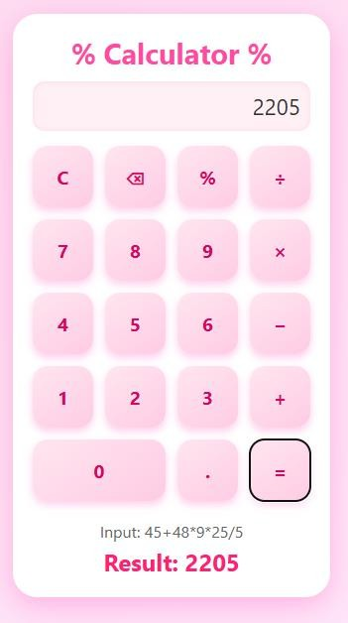

✅ **RESULT**

Once you run the app:

* You can enter two numbers.
* Tap any operation: ➕ ➖ ✖◻ ➗
* Result appears below in bold.
* Clear button resets the input.
* If input is missing or invalid, you’ll see a toast message.