When Narrow Forecasts Become Risky: A Calibration Audit of German Electricity-Demand Forecasts
Github Link:
Student Id:
1. Overview
Precise electricity demand forecasting facilitates energy purchasing, maintenance planning, reserve allocation, and generation scheduling. The balance between the production and consumption of energy, operating expenses, and the dependability of power-system planning can all be impacted by forecasting errors. According to Hsiao (2015), load forecasting is a crucial prerequisite for the efficient, dependable, and safe operation of the electrical system. Satish et al. (2025) make a similar connection between unit commitment, grid dependability, and energy-market decision-making and precise demand forecasts. Forecasts longer than a year are categorized as long-term load forecasting by Hsiao (2015), therefore the two-year horizon this study looks at is a challenging forecasting challenge.
Point precision is not the only factor that determines operational usefulness. Although a small prediction interval may seem accurate, it might lead to false confidence when real demand consistently deviates from its bounds. German electricity demand forecasting is consequently assessed in this study as a risk-calibration issue. SARIMA, SARIMAX, Quantile Gradient Boosting, and an hourly LSTM were compared with mean, naïve, seasonal-naive, and drift benchmarks. While interval coverage, mean interval width, interval score, and boundary failures were used to measure uncertainty, point forecasts were evaluated using MAE, RMSE, sMAPE, MASE, and bias. Which model offers the best practical mix of point accuracy, interval calibration, interpretability, and maintainability? was the research topic. While SARIMA achieved the best, if still insufficient, interval coverage and interval score, seasonal naive produced the lowest point error.
2. Data and Forecast Design
The Open Power System Data time-series repository provided the hourly German electricity load. There were 50,401 rows in the dataset that was downloaded. There were no missing load values or duplicate timestamps found. 50,400 hourly observations were left after creating a normal hourly index. Megawatts of demand were transformed into gigawatts, which were then combined into daily and weekly means. There were 299 weekly observations because only full Monday through Sunday periods with 168 hourly data were kept.
The training set covered the first 195 weeks, from January 11, 2015, to September 30, 2018. A fixed two-year test horizon was constructed by the final 104 weeks, which ran from October 7, 2018, to September 27, 2020. The same observations were used to evaluate each model. Later projections did not include the actual test demand.
Germany's representative weather variable was the temperature in Berlin. Together with measurements of the heating and cooling degrees, the weekly mean, minimum, and maximum temperatures were computed. There were also counts of German public holidays and a Christmas-New Year indicator. Hsiao (2015) shows how contextual factors including temperature, day type, festivals, holidays, special events, and recent past demand affect power use. This gives a clear justification for testing calendar and temperature variables in SARIMAX and Quantile Gradient Boosting.
Only training data was used to fit each scaler. While recursive Quantile Gradient Boosting projections employed previously anticipated median values rather than actual test demand, lag and rolling features were developed using past observations. By doing this, future load information was kept out of subsequent forecasts. However, SARIMAX and Quantile Gradient Boosting were given the actual test-period temperature. Therefore, rather than being completely operational two-year projections based solely on data available at the forecast origin, their outcomes must be viewed as conditional forecasts.
3. Stationarity and Time Series Features
According to Alston (2026), before choosing a model, time-series exploration should look at data regularity, missing observations, trend, periodic behavior, stationarity, and autocorrelation. Therefore, before forecasting, the current investigation looked into data quality, seasonal structure, shifting variability, differencing, and correlation patterns.
A robust yearly demand cycle is depicted in Figure 1. In general, load increases in the winter, decreases in the summer, and sharply decreases during specific holiday weeks. At first, test behavior is similar to the training phase, but demand is far lower throughout the most of 2020. The training data did not include this lower regime, which made structural predicting difficult. To ensure that test data was not utilized to determine the threshold, high-demand weeks were determined using the training-period ninetieth percentile.
Figure 1. Weekly German electrical load with two years of testing and a set training period. There is a consistent decline in 2020 and recurring seasonal peaks in the test horizon that are absent from the training data.
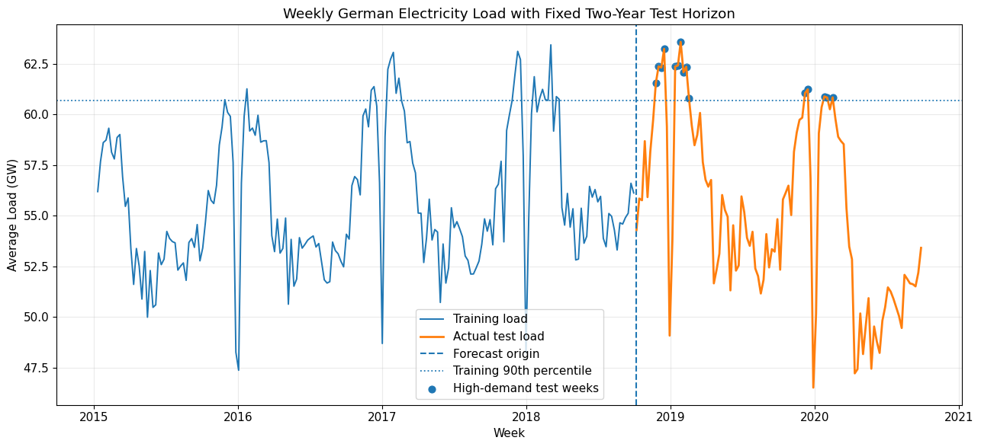
Figure 2's thirteen-week rolling standard deviation ranges from less than 1 GW to nearly 4.5 GW. As a result, the forecast uncertainty varies over time rather than being constant. While some summer and fall seasons are extremely predictable, the early years of 2016, 2017, and 2018 are obviously more unstable. Prediction intervals with a nearly constant width may therefore be excessively wide in stable periods and too small in volatile ones.
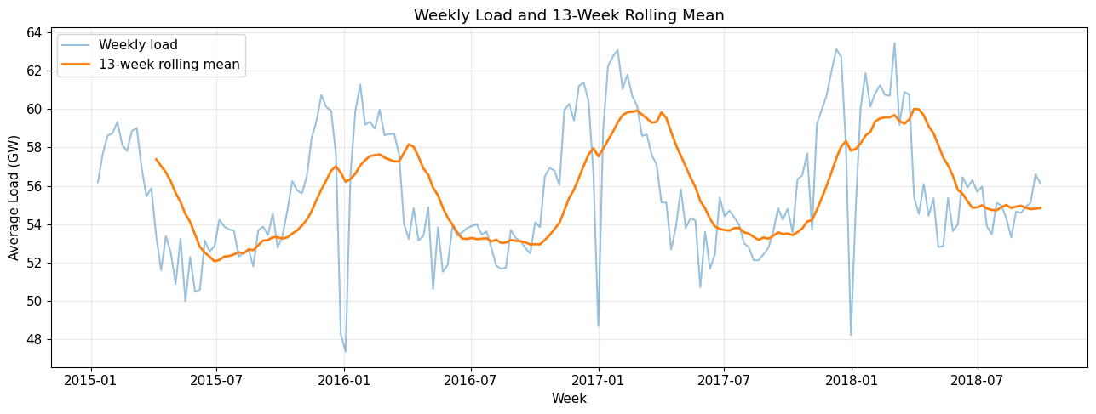
Fig. 2.1 Weekly German electricity load 13-week rolling standard deviation This fluctuation indicates that forecasting uncertainty varies by season and year.
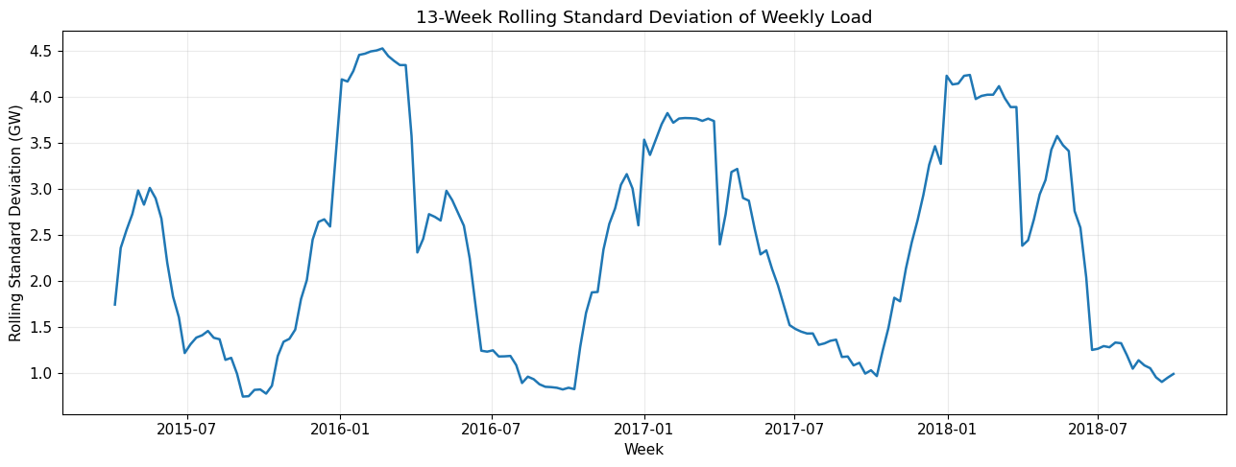
The Augmented Dickey-Fuller statistic for the initial weekly series was -5.003 (p<0.001). 0.1499 was the KPSS statistic (p value > 0.10). Although visual seasonality is still evident, these studies do not offer compelling evidence of a unit root. While the differenced ACF displayed a strong lag-one negative relationship, first and seasonal differencing produced a series that was about mean zero. Over-differencing may be indicated by this. However, rather than relying solely on stationarity tests, differencing orders were retained from the AIC search and evaluated using residual diagnostics and out-of-sample performance.
4. Methods of Prediction
The benchmark models set a minimal performance threshold that more intricate methods had to surpass. Seasonal naïve forecasting repeated the last 52-week cycle, mean forecasting used the historical training average, drift extrapolated the average historical change, and naive forecasting repeated the final training value. Because exploratory research revealed a high annual repetition, seasonal naive was especially suited. According to Alston (2026), benchmark forecasts are a crucial standard for evaluating more sophisticated time-series techniques.
Using p=0,...,6, d=0,...,2, and q=0,...,6, all 147 necessary non-seasonal SARIMA combinations were assessed. The following seasonal comparison was chosen:
SARIMA(1,1,6)(1,1,1)52​
The chosen model successfully converged and had the lowest training AIC of 297.219. The 52-week seasonal period matched the yearly trend seen during investigation. Time plots, histograms, Q-Q plots, residual ACF, and Ljung-Box tests were used to assess residual adequacy.
Temperature-only, calendar-only, and mixed temperature-calendar regressors were used to fit three SARIMAX versions. At 249.786, the entire model had the lowest training AIC. According to Hsiao (2015), nonlinear interactions between demand, temporal rhythms, and environmental factors can be difficult for traditional statistical models to capture. As a result, Quantile Gradient Boosting was added as a nonlinear competitor and fitted independently at the 2.5th, 10th, 50th, 90th, and 97.5th percentiles, yielding around 80% and 95% intervals.
200 estimators were chosen for recursive expanding-window validation, with a learning rate of 0.03, a maximum depth of 2, a minimum leaf size of 5, and a subsample of 0.8. To test nonlinear sequence learning from past demand, the hourly LSTM was incorporated. In order to capture temporal and multiresolution information, Satish et al. (2025) combine LSTM with self-attention, wavelet features, and graph learning. They characterize electricity demand as noisy, nonlinear, seasonal, and variable. The current method, which took 168-hour inputs and forecasted the next 24 hours, was purposefully simpler. Early halting and chronological validation were used to examine three architectures. The best had 20% dropout, 64 units, and two LSTM layers. For comparison, hourly outputs were combined into weekly means.
5. Model Adequacy and Residuals Diagnostics
The chosen SARIMA model had a residual mean of -0.133 GW and a residual standard deviation of 1.282 GW. With only a slight divergence in the tails, the residual skewness was 0.002 and the residual kurtosis was 0.153, indicating a fairly symmetric distribution. There was no evidence of substantial lingering autocorrelation, as indicated by the Ljung-Box p-values of 0.988 (lag 10), 0.557 (lag 20), and 0.747 (lag 52). Additionally, the residual ACF was mostly within its confidence ranges. With the exception of the extremes, the Q-Q plot followed the expected line. Ljung-Box tests and SARIMAX fully reduced residual standard deviation to 0.900 GW.
These diagnostics indicate that the training data was well-represented by both statistical models. However, their coverage and test errors were insufficient. This distinction is important since residual whiteness cannot provide resilience when the distribution changes in the future, but it can evaluate if historical reliance is not explained. Therefore, in-sample adequacy rather than operational supremacy was supported by lower AIC and cleaner residuals.
6. Point prediction outcomes
Seasonal naïve tracks the annual cycle far more accurately than the mean, naive, and drift benchmarks, as shown in Figure 3. Seasonal naïve achieved RMSE 2.988 GW and MAE 2.288 GW. The other three benchmarks had RMSE values more than 4.4 GW. It overestimated throughout the 2020 timeframe of decreased demand, as indicated by the positive bias of 1.748 GW.
Figure 3. benchmark estimates for the predetermined two-year period. The mean, naïve, and drift predictions are not as good at capturing annual peaks, seasonal falls, and holiday troughs as the seasonal naive.
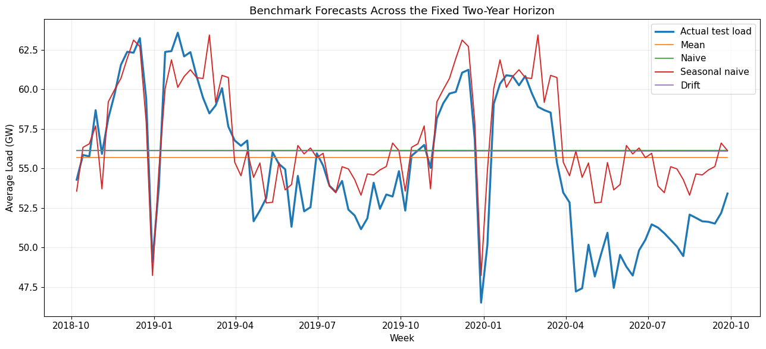
Table 1. Point-forecast precision
Model | MAE | RMSE | sMAPE | Bias
Seasonal naive | 2.288 | 2.988 | 4.21% | 1.748
Quantile Gradient Boosting | 2.594 | 3.286 | 4.78% | 1.548
SARIMAX full | 2.812 | 3.57 | 5.14% | 2.72
SARIMAX temperature | 3.07 | 3.854 | 5.60% | 2.936
SARIMA | 3.308 | 4.038 | 5.99% | 3.143
LSTM | 3.744 | 4.412 | 6.79% | −0.637
In Fig., the primary advanced models are contrasted. Four. Although its RMSE was still 9.95% worse than seasonal naïve, Quantile Gradient Boosting was the best complicated model with MAE 2.594 GW and RMSE 3.286 GW. The overall SARIMAX yielded an RMSE of 3.570 GW and an MAE of 2.812 GW, which was 19.48% worse than seasonal naïve but still better than SARIMA. With an RMSE of 4.038 GW and a bias of 3.143 GW, SARIMA significantly overestimated. The LSTM's bias and RMSE were -0.637 GW and 4.412 GW, respectively. Due to the cancellation of positive and negative errors, the error distribution was wide despite the very small mean bias.
Fig. 4. final comparison between the actual and forecast. SARIMA, SARIMAX, and Quantile Gradient Boosting are greatly overestimating following the continuous fall in 2020, while Seasonal Naïve is often closest to observed demand.
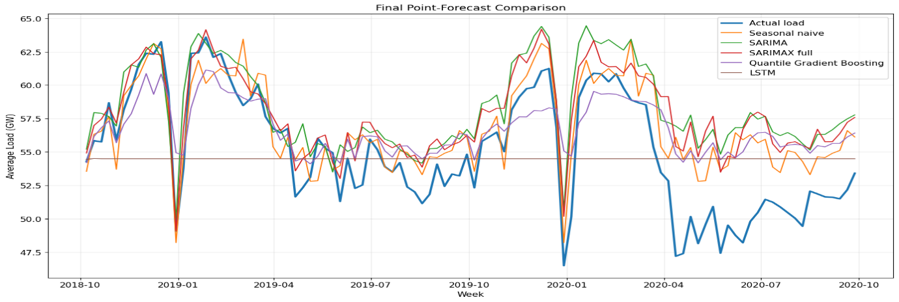
Lastly, the final comparison shows that the fixed two-year projection was not improved by the additional complexity. Seasonal naïve requires the least amount of parameter guessing and has the largest annual structure. Quantile Gradient Boosting did not prolong the ongoing drop in demand, but it did lessen some of the peaks. While the recursively generated LSTM converged to a nearly constant weekly pattern, the SARIMA and SARIMAX models stayed in the higher historical regime. The findings imply that robustness when future behavior changed was not guaranteed by strong validation performance on the historical distribution.
7. Calibration of prediction intervals
Prediction intervals are evaluated using coverage, width, and the interval score, a suitable scoring mechanism that rewards both calibration and sharpness . The percentage of actual observations that fall inside the designated interval is known as coverage. The interval score penalizes excessive width and observations outside the constraints. Sharpness is determined by width. A decent interval should be close to its nominal coverage and quite narrow.
Table 2. Prediction interval performance
Model | Nominal level | Actual coverage | Mean width | Interval score
SARIMA | 80% | 38.46% | 4.887 | 17.052
Quantile Gradient Boosting | 80% | 31.73% | 2.996 | 18.503
SARIMAX temperature | 80% | 33.65% | 3.304 | 20.057
SARIMAX full | 80% | 27.88% | 2.293 | 20.422
SARIMA | 95% | 70.19% | 7.474 | 29.743
Quantile Gradient Boosting | 95% | 55.77% | 7.405 | 39.159
SARIMAX full | 95% | 35.58% | 3.507 | 59.339
With a mean width of 4.887 GW and an interval score of 17.052, SARIMA achieved the highest coverage of theoretical 80% intervals with only 38.46%. While SARIMAX fully accounted for only 27.88%, Quantile Gradient Boosting accounted for 31.73%. At 2.293 GW, the entire SARIMAX interval was the smallest, but this sharpness was misleading because it left out the majority of the data. SARIMA once more achieved the highest results for nominal 95% intervals, with coverage of 70.19%, width of 7.474 GW, and interval score of 29.743. SARIMAX only fully covered 35.58%, whereas Quantile Gradient Boosting was able to cover 55.77%.
The failure of SARIMAX is evident in Figure 5. Of the 104 observations, none were over the upper boundary and 75 were below the lower 80% threshold. As a result, the expected distribution was not only excessively limited but also consistently greater than the actual demand. Quantile Gradient Boosting was ineffective on both sides: 24 observations were above its upper boundary and 47 observations were below its lower boundary. It exaggerated the lower 2020 regime and underestimated important winter peaks.
Fig. 5. SARIMAX observations outside of the standard 80% prediction range. Consistent overforecasting and substantial undercoverage, particularly in 2020, are indicated by the concentration of failures below the bottom border.
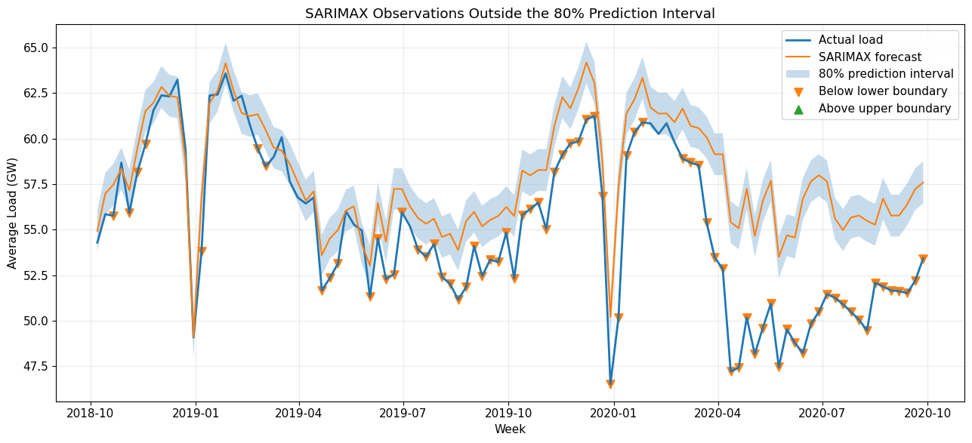
All models fall far below the anticipated 80% and 95% coverage lines, as shown in Figure 6. Quantile Gradient Boosting and SARIMA had nearly identical 95% widths; however, SARIMA covered 70.19% whereas Quantile Gradient Boosting covered 55.77%. Therefore, the machine-learning error involved both an inaccurate interval position and an inadequate width. Even though the intervals were not well measured, SARIMA had the lowest interval score at both levels. These findings distinguish between operational uncertainty resulting from behavioral change, future weather errors, and structural disruption and statistical uncertainty under an assumed historical process.
Figure 6. prediction interval calibration depending on sharpness. Every model falls far short of its stated coverage limits. This suggests that since narrow intervals remove the majority of future observations, they are useless in practice.
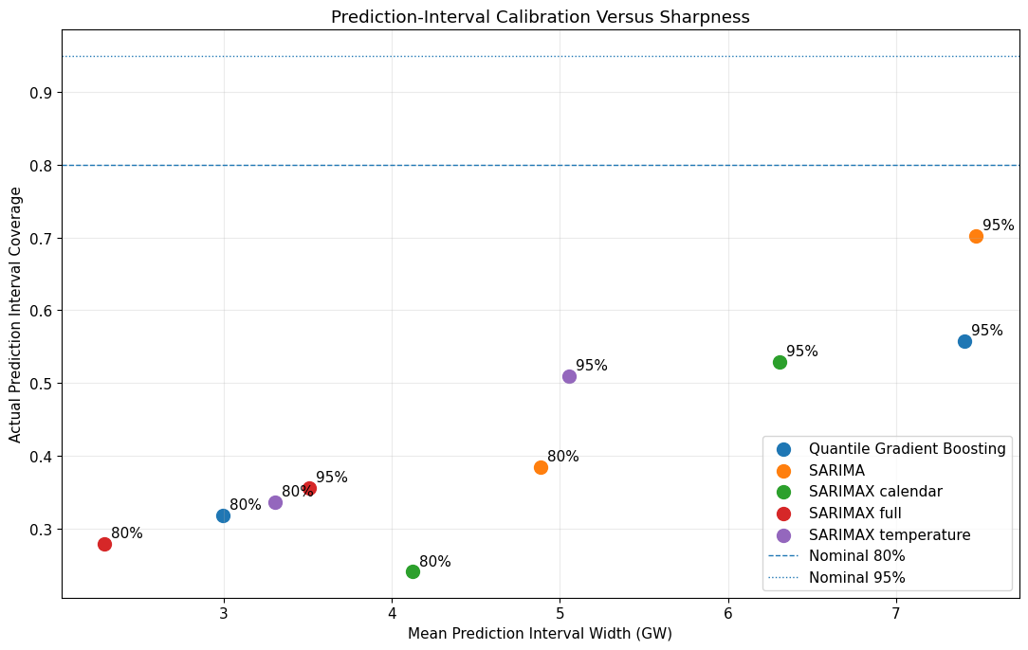
8. Operational Assessment and Suggestions
Because it combines minimal maintenance, perfect transparency, and the lowest inaccuracy, the seasonal naïve has the strongest operational point forecast. SARIMA offers interpretable parameters and model-based intervals. Nevertheless, it requires interval recalibration and has poor point precision. Although SARIMAX relies on future temperature readings and provides the most overconfident intervals, it has lower residual variance and greater central accuracy than SARIMA. The best advanced point model, Quantile Gradient Boosting, has a poor calibration with raw quantile crossing for 11 weeks, however it can provide quantile intervals. LSTM has the worst long-horizon performance, the highest maintenance burden, and the lowest interpretability.
Therefore, the suggested operational strategy is to use SARIMA mainly as an uncertainty-aware challenger and maintain seasonal naïve as the primary point-forecast baseline. Without additional calibration, neither should be utilized at the current intervals. Conformal, bootstrap, or residual-based intervals should be built around the seasonal-naive or Quantile Gradient Boosting forecast in future research. Included should be tests of rolling-origin recalibration, structural-break indications, and detailed weather-forecast uncertainty. This approach prioritizes demonstrated accuracy and open discussion about uncertainty over model complexity. In order to quickly and clearly identify model degradation during upcoming regime shifts, the seasonal benchmark should be routinely monitored.
9. In conclusion
For the two-year German load projection, Quantile Gradient Boosting was the most effective advanced option, while Seasonal Naïve was the best. All of the uncertainty models were significantly undercalibrated, but SARIMA had the best interval coverage and interval score. Despite its tight intervals, SARIMAX full was especially overconfident. The analysis thus shows that operational benefits are not always produced by short periods and complicated models. A distinct seasonal baseline supplemented with recalibrated measurements of uncertainty is the optimal forecasting strategy.

References.

Alston, W.N. (2026) Time Series Analysis 1: Intro and Forecasting. Advanced Research Topics 7PAM2016 lecture slides. University of Hertfordshire.
Hsiao, Y.-H. (2015) ‘Household electricity demand forecast based on context information and user daily schedule analysis from meter data’, IEEE Transactions on Industrial Informatics, 11(1), pp. 33–44. doi: 10.1109/TII.2014.2363584.
Satish, E.G., Prasad, B.R., Aleobahaey, T., Sengupta, D. and Gurupandi, D. (2025) ‘Hybrid self-attention-long short-term memory with GCNN for electricity demand forecasting’, in 2025 2nd International Conference on Intelligent Algorithms for Computational Intelligence Systems. doi: 10.1109/IACIS65746.2025.11211287.

