GB-Apps Tags Implementation

When a dashboard has a single tag:

When the dashboard has a single tag, The tag icon with name and delete icon is shown.

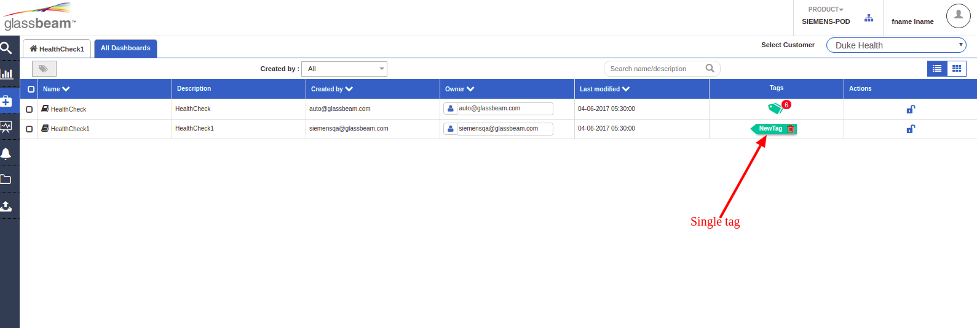

When dashboard has multiple tags

When the dashboard has multiple tags, Multiple tags icon is shown with the count attached as small notification. Which on click expands as dropdron with tag list and delete icon.

