US-15402 Glassbeam apps security implementation

As per proposed document I have designed the mockups for the features as follows.

Password Policies:
Password Strength:
We need to rely on some kind of an indicator to indicate the strength of the password
to the user during registration. The indicator serves as a good reminder for the user as
to the level of difficulty to crack the password.
The below figure shows how the strength of the password is shown to the user.
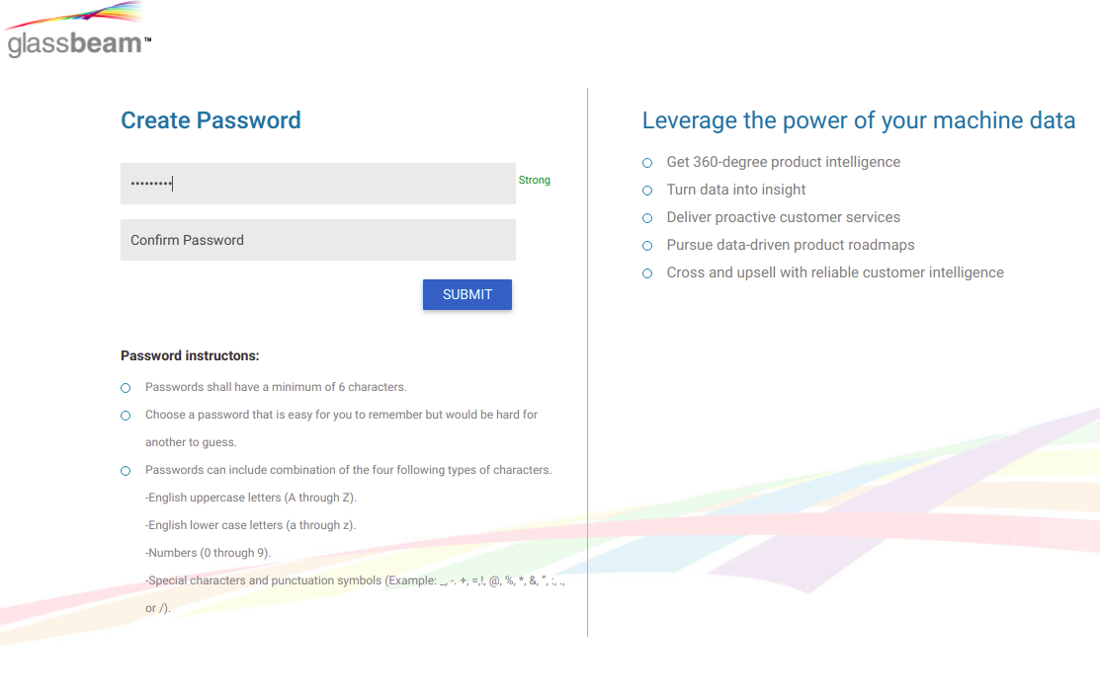
Figure 1: Strong Password
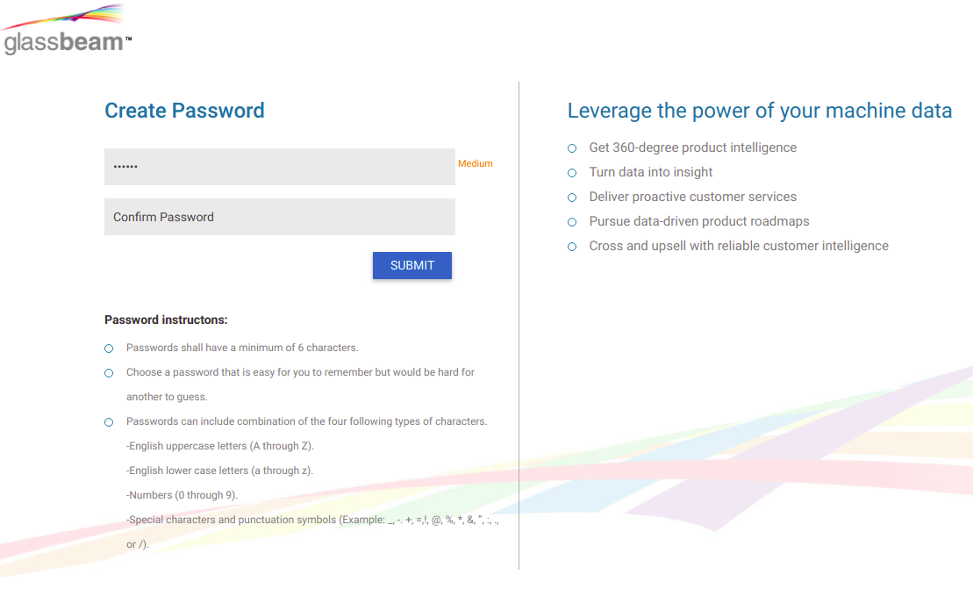
Figure 2: medium Password
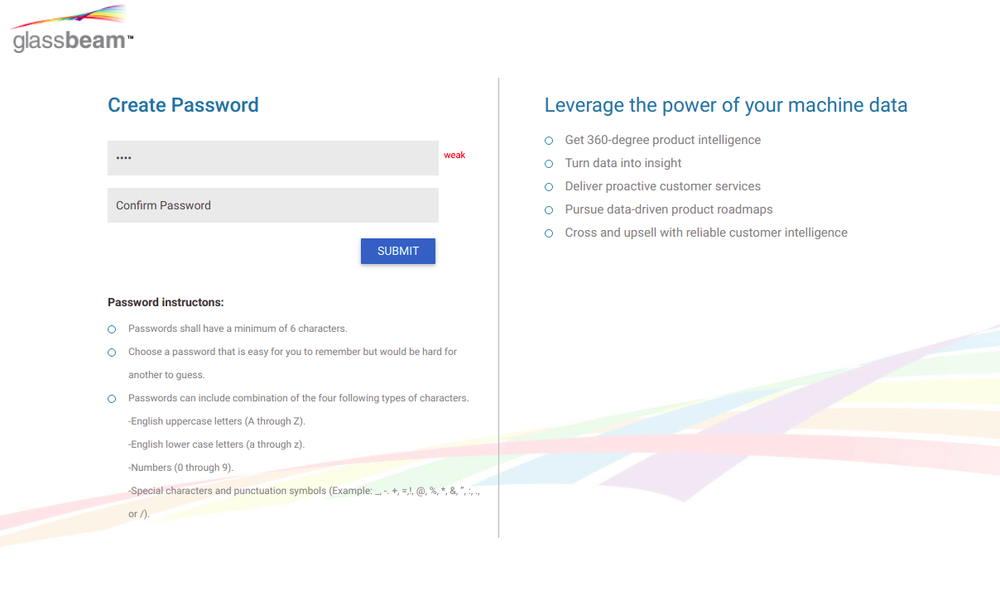
Figure 3: Weak Password

Password Expiry/Duration:
After a certain period of time 60 to 90 days, we can alert the user once he logs in
saying that the password is greater than 90 days, In addition, we can provide an
option to not show the alert and a checkbox stating that he doesn't want to change
his password.
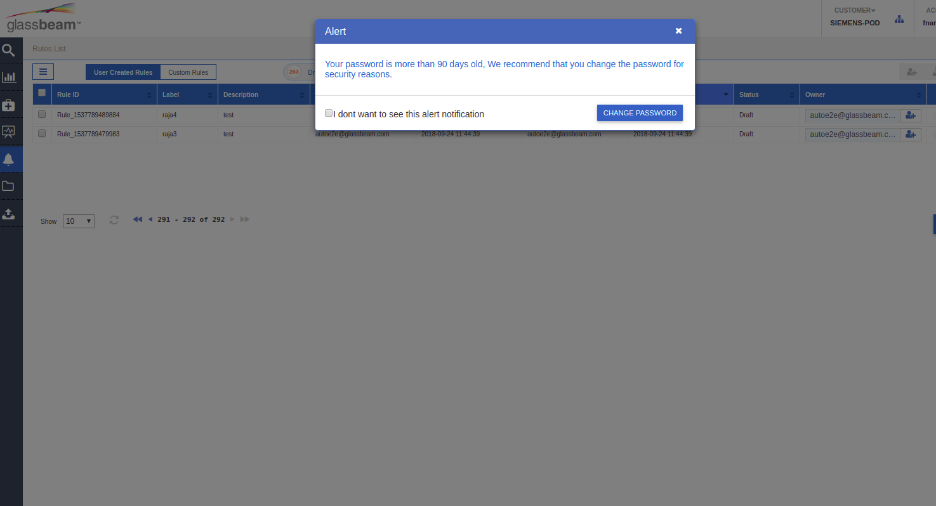
Figure 4: Password Expiry
The user has an option to opt out from this notice if he doesn't want to change his password. The change password will work as per the existing process.

Login/Logout Policies:
Login Captcha:
Google reCaptcha V2 is used for this implementation which is a free captcha service provided by Google.
The captcha will appear on the login screen after sequential failed login attempts. This
would reduce automated brute force attempts. The user would need to solve the
captcha in order to login after failed attempts.
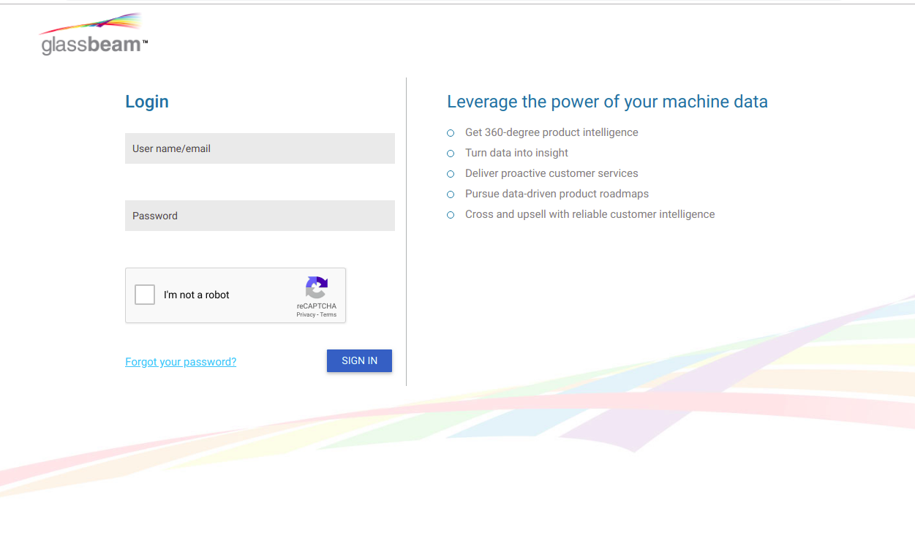
Figure 5: Login Captcha
Failed & Limit login attempts:
Limiting the number of times a user can attempt to log in to your application helps
reduce the risk of brute force attack. A brute force attack happens when an attacker
tries to gain access by guessing your username and password through the process of
cycling through combinations. To help protect against brute force attacks, you want to
limit the number of times any user can try to log in to your website. After ‘n’ number
of attempts, the account can be temporarily blocked for few minutes.
