**EXPERIMENT – 2**

**AIM:** Setting the initial configuration of switch.

**THEORY:** We’ll be setting the configuration of two switches of the following topology:

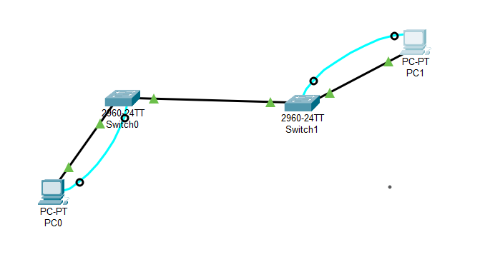

1. **“enable” command:** allows us to go into privilege mode from user mode (initial).



1. **“configure terminal” command:** allows us to go into global configuration mode.



1. **“line console 0” command:** allows us to go to console line configuration.



1. **“exit” command:** allows us to go back into the previous mode by exiting from the current mode.

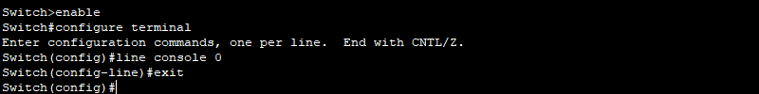

1. **“hostname _name_” command:** this command runs in global configuration mode and is used to rename the switch. Here in place of _name_ we can give any name we want for switch.



1. **“line vty 0 15” command:** allows us to go to virtual terminal line.



1. **“interface vlan 1” command:** allows us to go to virtual interface.



1. **“interface FastEthernet0/(num)” command:** allows us to go to the desired interface and instead of num we enter the number of the interface.



1. **“no hostname” command:** undo the name of the switch to it’s default name.



1. **“enable secret ‘password’” command:** this command is used to set password to privilege mode.



1. **“service password encryption” command:** this command encrypts the password and password is not visible when entered.



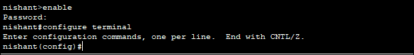

1. **“end” command:** this command takes us directly to privilege mode.



1. **“show running-config” command:** it shows all the running configurations on the device currently

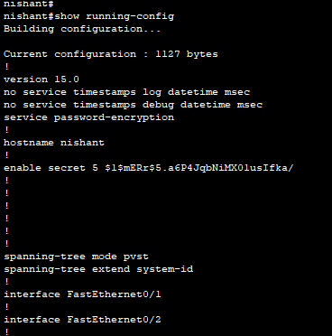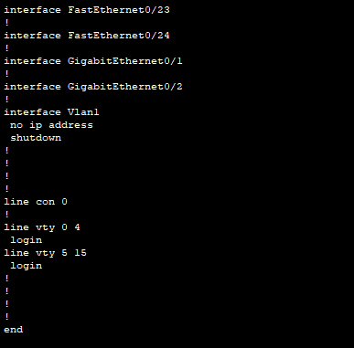

1. **“password ‘password’” and “login” command:** this is used to set password on the interfaces.



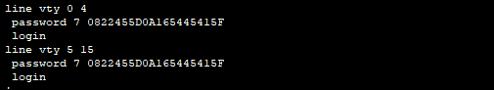

1. **“ip address _ip address_ _subnet mask_” command:** it define a static ip address and subnet mask on interface. There is no default IP address assigned to default VLAN.



1. **“no shutdown” command:** it turns the interface on i.e., the interface move from administration down status to up.

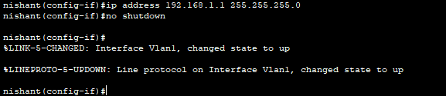

1. **“show ip interface brief” command:** it display the IP address and status of all the switch ports and interfaces.

**Switch0:**

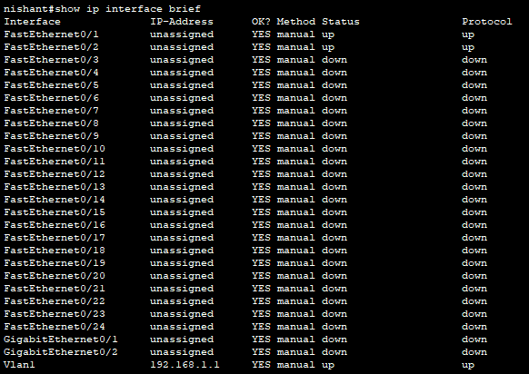

**Switch1:**

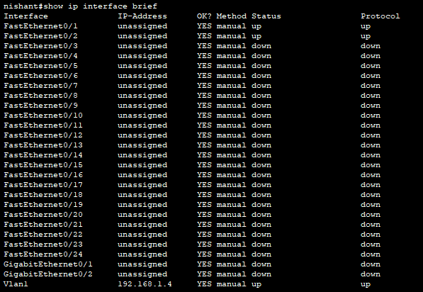

1. **“ping _IP address_” command:** this command is for command prompt. It acts as a test to see if a networked device is reachable.

