**Project Report**

**On**

**HR Helping Hand: The Employee Attrition and performance analysis**

**Submitted as partial fulfilment for the award of**

**BACHELOR OF TECHNOLOGY**

**DEGREE**

**Session 2022-23**

**In**

**Name of discipline**

**By**

**Nishant Kumar 2100320100112**

**Rohit Sharma 2100320100133**

**Mohd. Shahjahan 2100320100104**

**Under the guidance of**

**Dr. Meeta Chaudhry**

**ABES ENGINEERING COLLEGE, GHAZIABAD**

|  |  |  |
| --- | --- | --- |
| **D:\User Data\Desktop\nishant\Mini Project\presentation\abes logo.jpg** | APJAK logo |  |

**AFFILIATED TO**

**DR. A.P.J. ABDUL KALAM TECHNICAL UNIVERSITY, U.P., LUCKNOW**

**(Formerly UPTU)**

**Project Report**

**On**

**HR Helping Hand: The Employee attrition and performance analysis**

**Submitted as partial fulfilment for the award of**

**BACHELOR OF TECHNOLOGY**

**DEGREE**

**Session 2022-23**

**In**

**Name of discipline**

**By**

**Nishant Kumar 2100320100112**

**Rohit Sharma 2100320100133**

**Mohd. Shahjahan 2100320100104**

**Under the guidance of**

**Dr. Meeta Chaudhry**

**ABES ENGINEERING COLLEGE, GHAZIABAD**

|  |  |  |
| --- | --- | --- |
| **D:\User Data\Desktop\nishant\Mini Project\presentation\abes logo.jpg** | APJAK logo |  |

**AFFILIATED TO**

**DR. A.P.J. ABDUL KALAM TECHNICAL UNIVERSITY, U.P., LUCKNOW**

**(Formerly UPTU)**

**STUDENT’S DECLARATION**

We hereby declare that the work being presented in this report entitled

“HR Helping Hand: The employee attrition and performance analysis” is an authentic record of our own work carried out under the supervision of Dr. Meeta Chaudhry.

The matter embodied in this report has not been submitted by us for the award of any other degree.

**Dated:** **Signature of students**

Nishant Kumar

Rohit Sharma

Mohd. Shahjahan

**Department: CSE**

This is to certify that the above statement made by the candidates is correct to the best of my knowledge.

|  |  |
| --- | --- |
|  | Signature of Supervisor  (Dr. Meeta Chaudhry)  Associate Professor  (Computer Science & Engineering Department) |

CERTIFICATE

This is to certify that Project Report entitled “HR Helping Hand: The Employee Attrition and Performance Analysis” which is submitted by Nishant Kumar, Mohd. Shahjahan, Rohit Sharma in partial fulfilment of the requirement for the award of degree B. Tech. in Department of Computer Science & Engineering of Dr. A.P.J. Abdul Kalam Technical University, formerly Uttar Pradesh Technical University is a record of the candidate own work carried out by them under my supervision. The matter embodied in this thesis is original and has not been submitted for the award of any other degree.

**Supervisor** **Project Coordinator**  **HOD’s Signature**

**Date:**

**ACKNOWLEDGEMENT**

*It gives us a great sense of pleasure to present the report of the B. Tech Project undertaken during B. Tech. Second Year. We owe special debt of gratitude to Professor Dr. Meeta Chaudhry Department of Computer Science & Engineering, ABESEC Ghaziabad for his constant support and guidance throughout the course of our work. Her sincerity, thoroughness, and perseverance have been a constant source of inspiration for us. It is only through her efforts that our endeavours have seen light of the day.*

*We also take the opportunity to acknowledge the contribution of Professor Dr. Divya Mishra, Head, Department of Computer Science & Engineering, ABESEC Ghaziabad for her full support and assistance during the development of the project.*

*We also do not like to miss the opportunity to acknowledge the contribution of all faculty members of the department for their kind assistance and cooperation during the development of our project. Last but not the least, we acknowledge our friends for their contribution in the completion of the project.*

*Signature:*

*Name*: Nishant Kumar

*Roll No.:* 2100320100112

*Date*:

*Signature:*

*Name*: Rohit Sharma

*Roll No.:* 2100320100133

*Date*:

*Signature:*

*Name*: Mohd. Shahjahan

*Roll No.:* 2100320100104

*Date*:

**ABSTRACT**

*At present, competitions between the organizations are at high. Every organization wants to the ahead of their competitors but to achieve that position they find difficulties, which is the loss of talented employees. As the employee is the main functioning body of an organization. The rate of growth of an organization or success and failure is relying on the employees and their performances. When a good/devoted employee left the organization without providing any previous information, it affects the growth of the organization, leading to increased costs, decreased productivity, and reduced competitiveness. This study is related to the finding prediction of employee attrition and their performance using machine-learning models.*

*The purpose of the model is to analyze the dataset of employees of an organization which we obtained from various employee surveys within organization and managerial reviews of employees and then calculate the probability of employee, whether the employee is leaving/resigning from the job or continue working with the same organization. Using various Machine-learning approaches, we improve the data analysis of human resource team to manage or build an excellent quality of workspace in an organization and remain in competition.*

**TABLE OF CONTENTS**

 Page

DECLARATION..................................................................................................... I

CERTIFICATE….....................................................................................................II

ACKNOWLEDGEMENTS...................................................................................... III

ABSTRACT.............................................................................................................IV

LIST OF TABLES....................................................................................................V

LIST OF FIGURES..................................................................................................VI

CHAPTER 1   INTRODUCTION

1.1 Problem Introduction

1.1.1 Motivation

1.1.2 Project Objective

1.1.3 Scope of the Project

1.2 Related Previous Work

1.3 Organization of the Report

CHAPTER 2   LITERATURE SURVEY

CHAPTER 3  SYSTEM DESIGN AND METHODOLOGY

3.1 System Design

3.1.1 System Architecture /Diagrammatical View

3.1.2 Flow Charts

3.2 Algorithm(s)

3.2.1 Random Forest Classification

3.2.2 Decision-Tree

3.2.3 Logistic Regression

3.2.4 k-Means clustering

3.2.5 Support Vector Machine

3.2.6 K-Nearest Neighbors

CHAPTER 4   Implementation and Result

4.1 Software and hardware requirements

  4.2 Snapshots

CHAPTER 5 CONCLUSIONS

5.1 Performance evaluation

5.2 Future Direction

REFERENCES... ........................................................................................  34

 APPENDIX ....................................................................................................

APPENDIX ........................................................................................................

**LIST OF TABLES**

|  |  |  |
| --- | --- | --- |
|  | Name | Page No |
| Table 1 | Employee Survey Data. | 21 |
| Table 2 | Manager Survey Data | 22 |
| Table 3 | General Data | 22 |
| Table 4 | Test and Train score of different models | 28 |

**LIST OF FIGURES**

|  |  |  |
| --- | --- | --- |
|  | Name | Page No. |
| Fig. 1 | GUI (Graphical User Interface) | 15 |
| Fig. 2 | Main Window of HR Helping Hand | 16 |
| Fig. 3 | Employee Survey Form Window | 17 |
| Fig. 4 | Employee General Data Form Window | 17 |
| Fig. 5 | Manager Survey Form Window | 18 |
| Fig. 6 | Data Flow Chart | 19 |
| Fig. 7 | Python Libraries | 21 |
| Fig. 8 | Employee survey data distribution. | 22 |
| Fig. 9 | Manager Survey data distribution. | 23 |
| Fig. 10 | Distribution of employee attrition | 24 |
| Fig. 11 | Business Travel VS Attrition | 24 |
| Fig. 12 | Attrition VS Working years of employee | 25 |
| Fig. 13 | Attrition VS Training Time last year | 25 |
| Fig. 14 | Attrition VS Year at company | 26 |
| Fig. 15 | Attrition VS Year since last promotion | 26 |
| Fig. 16 | Attrition VS Year with current manager | 27 |
| Fig. 17 | Distribution of Attrition in department | 27 |
| Fig. 18 | Distribution of Attrition in different age | 28 |
| Fig. 19 | Distribution of Attrition for employee distance from home | 29 |

**CHAPTER 1**

**INTRODUCTION**

Employee attrition refers voluntary departure of employees from organization. Attrition has a crucial impact on organizations, as it increases costs, reduces productivity, and decreases the competitiveness of organizations. Attrition also leads to a decline in morale among the remaining employees and affect the organization's ability to attract new talent.

When a well performance employee leaves the organization without any initial informed to the manager of that organization-faced difficulties. If the manager of organization has any previous information about the employee attrition, then he/she start hiring new employee process and focused on what are the parameters, which influenced the employee’s mentality and performance to resign from job.

To avoid the situation of facing rapid recruitment process, we prepare a model which helping the manager of organization to knowing what and who will be leaving organization so the manager prepares for the situation and take decision according to the stage. In this model, we obtain dataset of an organization with various parameters .After getting data we execute various algorithms like Decision tree, Logistic regression, Naïve Bayesian algorithm, Random Forest classification, Gaussian Naïve Bayes classier, k-means clustering to analyze the dataset and predicate the probability of employee’s attrition rate by taking the most accuracy score giving by algorithm.

* 1. **Problem Introduction**

When an employee leave who is performing well in the organization will leads to decline in company growth, effects the current projects, sets a negative impact on other employees and it take more time and wastage of money in training of new recruits and affect the image of organization. It is very difficult for HR management team to tackle this situation and to avoid the situation of facing rapid recruitment process.

1.1.1. **Motivation**

HR estimates the requirement of human resources in each part of organization and plan to recruit talented people, placing each employee’s progression, employee’s retention, attrition, salaries, and other welfare benefits. Employees are the treasured property of any organization. However, if you quit your job unexpectedly, the company will cost a lot of money. Not only new employees are wasting money and time, but new employees are also spending time making profits for their companies.

1.1.2 **Project Objective**

This aims to identify the critical elements to contribute to employee attrition. Business heavily depends on employees so we here to predict or to find the probability of the employee's attrition. We will use several algorithms such as logistic regression, decision tree, Gaussian Naive Bayes classifier using tenfold cross validation etc.

1.1.3 **Scope of the Project**

This project will help in HR related fields for analysis and decision making related to employee retention by analyzing performance of individual employee using various machine-learning algorithms. It reduces paper work and save time for further recruiting process. One of the branches of analytics is HR analytics, which is developing the system HR units in organizations function, principal to sophisticated proficiency, and improved outcomes overall. The usage of analytics by human resources for many years. Though the assortment, processing, and data analysis have been manual and specified the nature of HR dynamics, the approach has been constraining HR. The prospect to effort predictive analytics in categorizing the employees furthermost likely to grow promoted. Here we apply machine-learning techniques to analyze the employee information for improving his/her position in the organization. Compensation and job performance information from revenue rates and personnel characteristics to payroll and service history, never before have HR executives had such liberated right to use to individual details. In this work, we are applying random forest classification, which facilitates employee classification based on their monthly income and informal way to execute analytics on data. Further, we use clustering techniques based on the performance metrics similarity to analyze employee performance.

**1.2 Related Previous Work**

HR analytics is a field that aims to enhance the performance of HR units in enterprises, leading to better overall results. Analytics has been a part of human resources for many years, but it was traditionally done manually, with limited impact. By utilizing automated selection, processing, and data analysis techniques, HR analytics has become more effective and dynamic, allowing for more advanced proficiency in HR performance.

1.3 **Organization of the Report**

Now we are moving to chapter 2. In chapter 2, we read some immediate review on the research paper of related work. In chapter 3, we describe system design and the methodology and how the interface for user is looking and algorithms used in model. In chapter 4, we specify software and hardware requirement, dataset and the results. In the last chapter 5, the conclusion and the future description of project work is discussed.

**CHAPTER 2**

**LITERATURE SURVEY**

Studying various related literature and research papers, we find that different methods are used to predicate the attrition rate for various machine learning models are used provided with their accuracy rate to improve or compare the model for obtaining better results and in some papers, different techniques like data mining are also used for getting the best result of prediction. An interval-based survey is also taking place within the organization or feedback by employees, a managerial review is conducted about the effect of training and workspace and work environment in the organization, and to find the factors, which are responsible for employee attrition to overcome the attrition rate.

In paper [1] Employee attrition is defined as departure of employee from a company or an organization due to various reasons, such as resignations, retirements, and other factors. This research to identify employees attrition within an organization by utilizing a Random forest classification model, which can help the human resources department determine the factors that contribute to employee turnover. The study found that Informated the maximum accuracy attained by modal is of 89.2% among the tested methods, while Pick K Best and Recursive Feature Elimination have accuracy values of 87.8% and 88.8%, respectively.

In paper [2] Various classification methods were used to determine the probability of new employee attrition, including Decision Trees (DT) Classifier, Logistic Regression (LR), Random forests (RF), and k-Means clustering. The results indicated that the Random forest algorithm achieved the best modal achieve the accuracy of 98%, flowed by the decision tree with an efficiency of 97% and the Logistic regression with an certainity of 78%.

In paper [3] This study identify the most significant factors that devote to employees attrition. Numerous machine learning modals which are based on Decision trees, Logistic regression, and Random forests are used to improve the performance of binomial classification problems. To compare their efficacy, the NB algorithm, KNN method, and SVM algorithm were tested experimentally, and the results were analyzed. SVM, K-nearest Neighbors, and Naive Bayesian algorithms were used to predict developer turnover. The inference show that the Naive Bayes model achieved an efficiency rate of 76%, while the k-Nearest Neighbor had an certainity rate of 94%, and the SVM had an efficiency rate of 96%.

In paper[4] Multiple algorithms, including Gaussian Naive Bayes Classifier with the highest recall rate, Decision Tree, Logistic Regression, and Model (0.54), are being utilized. Analyzing the data assists in optimizing HR activities and reducing critical issues. Two methods, namely Holdout and Cross-validation, are used to achieve more accurate error estimation. Scaling is used to prevent any one feature from dominating the analysis.

We study in paper[5] This study focuses on the concept of staff retention and aims to identify the crucial factors that influence it. Training, including the type, duration, and impact of training, is examined to determine its effect on employee satisfaction and its potential to decline high mass exodus and employee discontent. The main objective to determine the type, amount, and impact of training on employee retention. Factors such as the duration of training, employee support, workplace culture, and rewards are considered essential in promoting employee retention.

We study in paper[6] It is common for organizations and businesses to have a formal system in place to evaluate employee performance, often conducted once or twice a year. Machine learning algorithms, such as clustering algorithms and decision trees, which are Data mining techniques, can be used to identify significant characteristics for future prediction of an organization. By tracking the progress of their performance, employees can improve their performance.

In paper [7] The scientific field of machine learning (ML) explores mathematical formulas and statistical models used by computers to perform tasks without explicit programming. Learning algorithms are incorporated into several everyday programs. Various machine learning approaches include instance-based learning, Reinforcement learning, multipurpose learning, ensemble learning, Neural Networks, and supervised learning.

**CHAPTER 3**

**SYSTEM DESIGN AND METHODOLOGY**

* 1. **System Design:**
     1. **System Architecture /Diagrammatical View**

Therefore, we design an interactive GUI for both ends. At human resources team, they have an access of fully analyzed data of each every employee in form tables, charts, graphs and results of predicted attrition of company, track the performance of each employee and report the growth of organization or company with high accuracy, and improves decision-making process. On the other hand, at employee end GUI act as an interval based surveys forms, which collects data, then this collected data and historical data of employees is use to train our models which is build using Scikit-learn which is a powerful machine-learning module written in Python. By using several inbuilt model evaluation methods. We select most accurate model, which is act as backend in our GUI.

USER

Graphical interface

Window Manager

Display Server

Kernel

Hardware

  Fig.1 GUI (Graphical User Interface)



  Fig.2 Main Window of HR Helping Hand

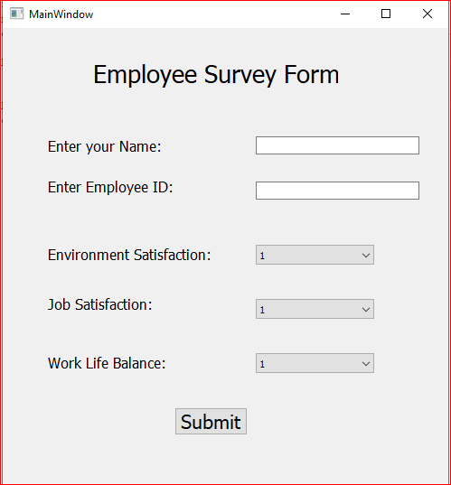

Fig.3 Employee Survey Form Window

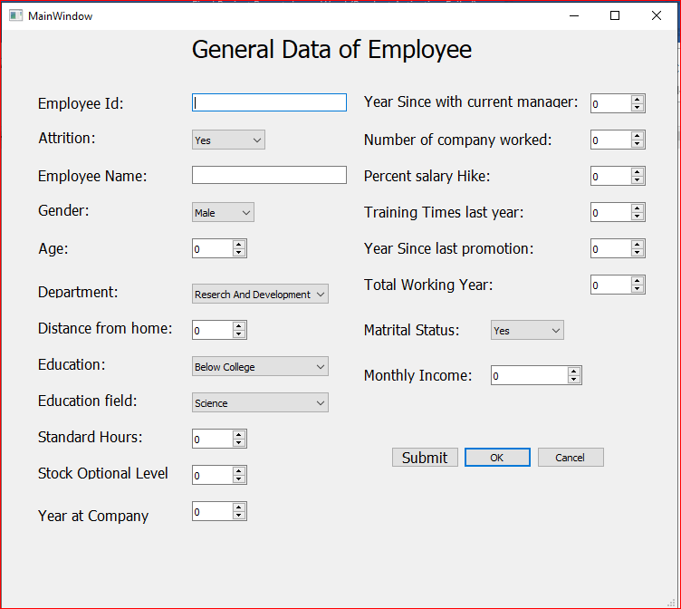

Fig.4 Employee General Data Form Window

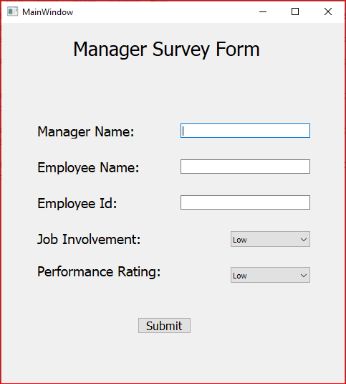

Fig.5 Manager Survey Form Window

**3.1.2 Flow Chart**

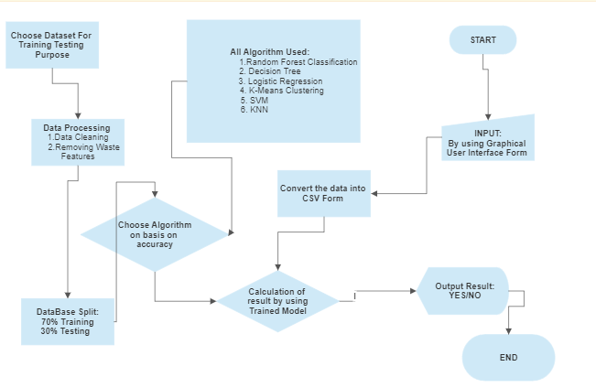

Fig.6 Data Flow Chart

* 1. **Algorithms**

Different models for prediction and classification using following machine-learning algorithms.

* Decision Tree
* Random forest Classification
* Logistic regression
* k-means clustering
* SVM
* KNN

* + 1. **Decision Tree**

The decision tree is a popular machine-learning algorithm that is used for both classification and regression tasks. It is a model that predicts a target variable based on a series of decisions and their outcomes. The tree structure consists of decision nodes, leaf nodes, and branches.

**3.2.2 Random Forest Classification**

Random Forest is a supervised machine-learning algorithm that is used for classification, regression, and other tasks. It is an ensemble learning method that combines multiple decision trees and produces a final output by aggregating the outputs of individual trees.

**3.2.3 Logistic regression**

Logistic Regression is a statistical method used for modeling the relationship between a binary dependent variable and one or more independent variables. It is commonly used for classification problems where the goal is to predict the probability of an event occurring.

**3.2.4 K-Mean Clustering**

K-means clustering is a popular unsupervised machine learning algorithm that is used to group or cluster data points into K clusters based on their similarity. The algorithm is based on the distance between data points and the centroid of the cluster to which the data point belongs.

**3.2.5 SVM**

Support Vector Machine (SVM) is a popular supervised machine-learning algorithm used for classification and regression tasks. The goal of SVM is to find the best hyperplane in a high-dimensional feature space that separates the data points into different classes.

**3.2.6 KNN**

K-Nearest Neighbors (KNN) is a popular machine-learning algorithm used for both classification and regression tasks. It is a non-parametric algorithm, which means it does not make any assumptions about the underlying data distribution.

**CHAPTER 4**

IMPLEMENTATION AND RESULTS

1. **Software and Hardware Requirements**

1.1 **Python:**

Python is a cross platform open source coding language which contains powerful libraries and modules. Major libraries used for project implementation:

1. **Pandas** is a python module used for reading data and data manipulation.
2. **Numpy** is a powerful python package used for computations and manipulating lists and tables of numerical data.
3. **Matplotlib**, **Seaborn**: is graphing tools used for data visualization.
4. **Scikit-Learn** is used for machine learning models.

5  **PyQt5** is used for building an interactive GUI.



Fig.7 Python Libraries

**2. Snapshots**

2.1 Employee and Manager Surveys Data Analysis Inferences

Table-1 Employee Survey Data.

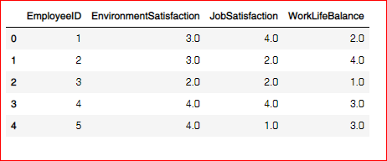

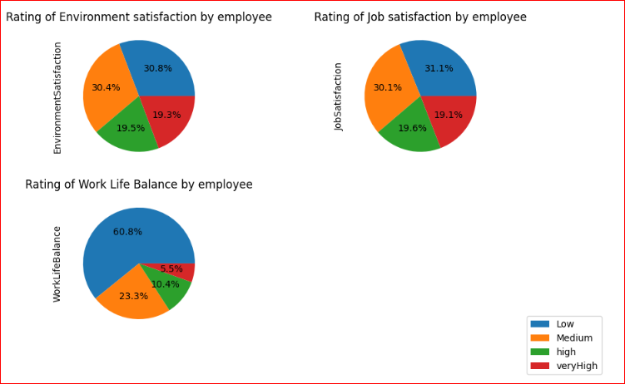

Fig.8 Employee survey data distribution.

Table-2 Manager Survey Data

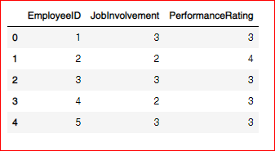

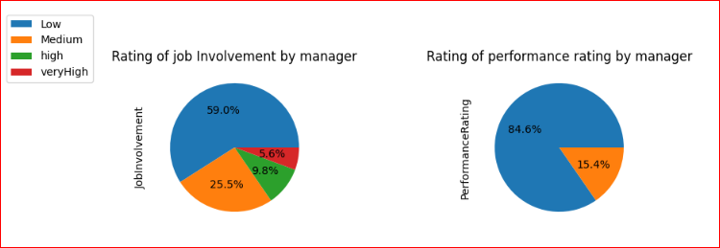

Fig.9 Manager Survey data distribution.

2.2 Employee general data analysis

Table-3 General Data

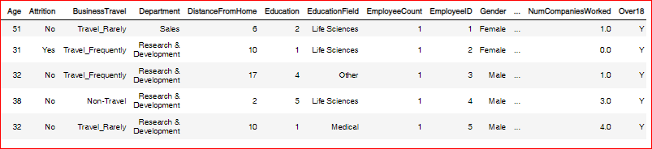

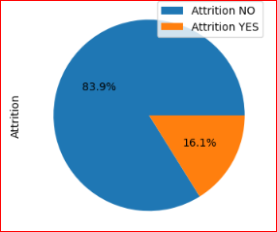

Fig.10 Distribution of employee attrition

## From the Pie Chart, we can infer that out of 4410 employees, 16.1% of the employees left their job due to some reasons whereas other 83.9% of the employees preferred to continue their job at the company.

## 

## Fig.11 Business Travel VS Attrition

## From the above data it is clear that Employees who travel rarely have more attrition rate followed by Employees who travel frequently

## 

## Fig.12 Attrition VS Working years of employee

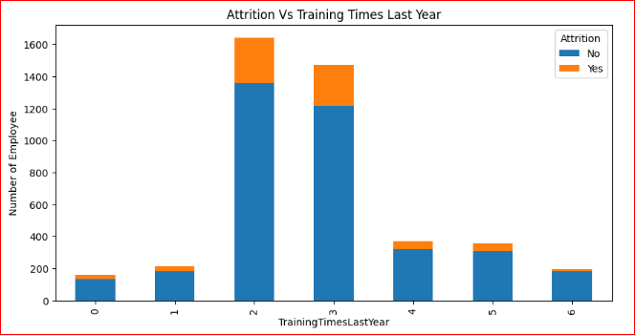

Fig.13 Attrition VS Training Time last year

#### It is observed that the employees who have two trainings last year quit their jobs most, followed by three trainings last year

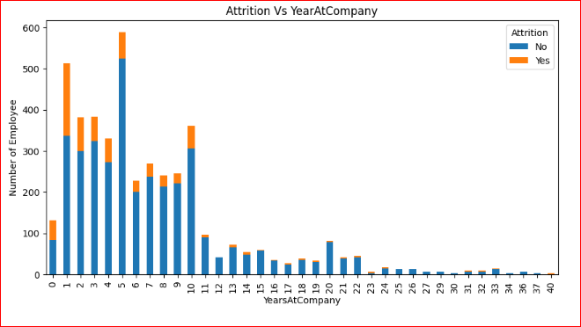

Fig.14 Attrition VS Year at company

It is observed that the newly arriving employees quit their jobs most, so more concern should be given to the freshers and their cause of leaving the company should be figured out.

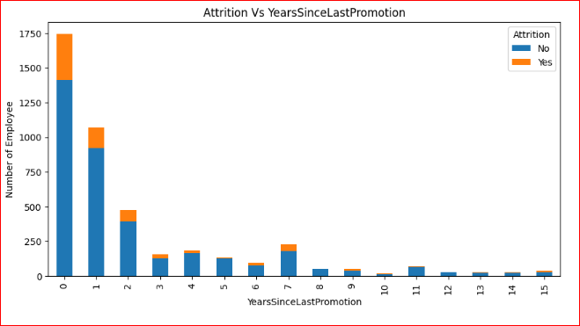

Fig.15 Attrition VS Year since last promotion

#### It is very clear that Employees who are in same post or not getting promoted tend to leave the company most

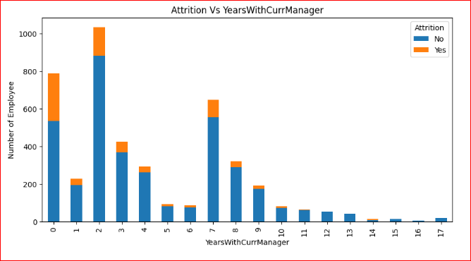

Fig.16 Attrition VS Year with current manager

#### From the above plot it is observed that attrition rate is higher in initial years

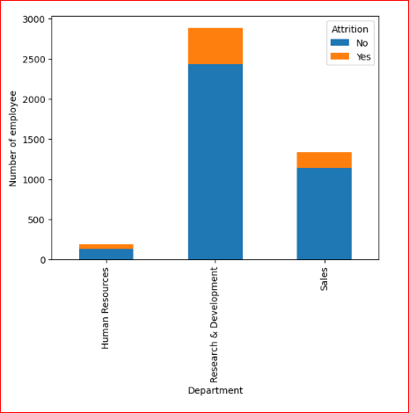

Fig.17 Distribution of Attrition in department

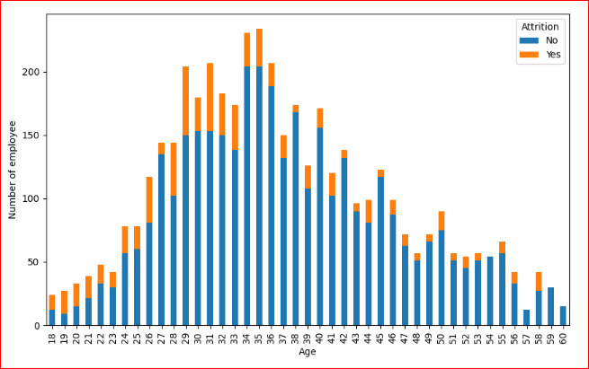

Fig.18 Distribution of Attrition in different age

#### In the above bar graph we observe that employee of age between 34-36 has higher attrition rate.

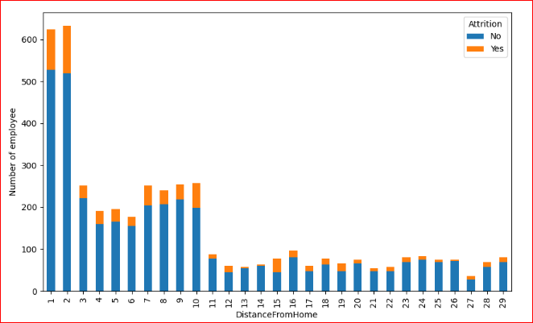

Fig.18 Distribution of Attrition for employee distance from home

It is observed that employee who lives closer to the office are more likely to have attrition in yes.

2.3 Model Evaluation Results

Table-4 Test and Train score of different models

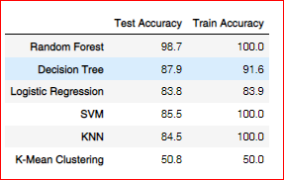

Logistic Regression has the highest test score. Logistic Regression is used

**CHAPTER 5**

**CONCLUSION**

In conclusion, employee attrition have a significant concussion on an organization success and long term viability. The purpose of this study was to search factors which influence mass exodue and develop a predictive model to determine which employees are most likely to left. The analysis of employee characteristics revealed that age, job level, education, monthly income, distance from home, percent salary increase, total working hours, training time in the previous year, yearsAtTheCompany, yearsSinceLast promotion, and years with exsisting manager are significant predictors of employee attrition. The developed prediction model accurately identifies employees who are at risk of quitting, providing employers with valuable information for retention.

**5.1 Performance Evaluation**

We applied six models to our dataset, including random forest classification, decision trees, logistic regression, SVM, KNN, and K-means clustering. Among these models, random forest classification had the highest test accuracy (98.715%), and we integrated it into our GUI.These predictive models can be integrated into existing HR procedures to proactively address retention challenges and enhance corporate success with further refinement and implementation.

**5.2 Future Direction**

* + In future, we includes more features to our GUI to make it more user friendly.
  + It will also predict the performance of employee with their historical data.
  + It will give suggestion to reduce employee attrition in organization.

**References**

[1]. Sindi Fatika Sari, Kemas Muslim Lhaksmana. Employee Attrition Prediction Using Feature Selection with information Gain and Random Forest Classification.

 [2].Elham Mohammed Thabit A. Alsaadi; Sameerah Faris Khlebus, Ashwak Alabaichi. Identification of human resource analytics using machine learning algorithms.

 [3]. Vinston Raja R; Srinath Doss; Ashok Kumar K. Analytics Approach of predicting Employee Attrition using data science techniques.

 [4]. Evanthia Faliagka, Kostas Ramantas, Athanasios Tsakalidis Application of Machine Learning Algorithms to an online Recruitment System.

 [5]. Ali A. Mahmoud, Tahini AL Shawabkeh, Walid A. Salameh, Ibrahim Al Amro Performance predicting in hiring process and performance appraisals using machine learning.

 [6].Ananya Sarker, S.M. Shamim, Dr. Md. Shahiduz Zama & Md. Mustafizur Rahman Employee’s Performance Analysis and prediction using K-means Clustering & Decision Tree Algorithm.

 [7]. Francesca Fallucchi, Marco Coladangelo, Romeo Giuliano and Ernesto William De Luca. Predicting Attrition Using Machine Learning Techniques.

[8]. Sarah S. Alduayj, Kashif Rajpoot Predicting Employee Attrition Using Machine Learning.