**Grievance Redressal Portal for IET Campus**

**Software Design Specifications**

**Department of Computer Engineering Institute of Engineering & Technology Devi Ahilya Vishwavidyalaya,**

**Indore (M.P.)**

**Guided By: Submitted By:**

Dr. Bhawna Nigam 19C7181- Ghanshyam Lodha(CSB)

18C7132- Nishant Sironjiya(CSB)

19C7186 - Sunil(CSB)

**Table of Contents**

1. Introduction 3
   1. Problem Domain: 3
   2. Solution Domain: 3
2. Literature Survey 4
3. Analysis 5
   1. Software Requirements 5-6
   2. Hardware Requirements 7
   3. Use Case Model 7
   4. Use Case Description: 8-9
4. Technology Selection 9
5. Conclusion 9
6. References 9

# Introduction:

E-Complaint Portal is a Web and Android application In which any Collage Member (Student , Faculty, Other) can complaint about any issue.

For doing user have to create their account on app and verify their account since this application is made specially for IET-DAVV college so the student and faculty member can only create their account with that email id that is provided by college (with @ietdavv.in domain) .

So there will be more security and nobody can complaint in bulk because every college member has their unique college id.

When user create their account he/ she have to select their role like student, faculty or other. It may be possible that some of the college member doesn’t have college ID for that.

we have added other option. After creating and verify their account they can login successfully and can submit their complaint if any.

In E-Complaint admin application admin can see all the complaints of user with user details like photo, role ,enrollment etc. and can change the status of the user complaint and after completion admin can delete complaint that will store in history for future reference.

## Problem Domain:

Our college education system is very well but we analyze some problem regarding

to complaint management. In our college, complaint management system is slow

due to which the problem seems to be more time consuming student required paper

work also due to this student were afraid they feel that his name would come. We

analyze this entire problem and we designed a portal which is GRIEVANCE

REDRESSAL PORTAL.

In this portal students and faculty members can complaint easily, and their

complaint will be redressed by the cell member (Principal Sir, HOD sir). Cell

members will give feedback to students and faculty member’s problem. It is very

easy and fast way for complaint management.

## Solution Domain:

The system registers the complaints of the student through an integrated interface. Whenever a student has got any complaint related to the Campus, regarding Library, Labs or college Infrastructure then they can make online complaints. Their complaints are being taken care by the respective authorities. The student can track the progress of their complaint being solved through a given Complaint ID.

When user create their account he/ she have to select their role like student ,faculty or other. It may be possible that some of the college member doesn’t have college ID for that. we have added other option. After creating and verify their account they can login successfully and can submit their complaint if any. In admin section admin can see all the complaints of user with user details like photo, role, enrollment etc. and can change the status of the user complaint and after completion admin can delete complaint that will store in history for future reference.

# Literature Survey:

There are many Student Complaint Portal available in the colleges. On studying some of them we find out that we have not any grievance portal like given below:-

1. University Grant Commission(Grievance Redressal Portal): UGC grievance portal have facilities online registration of students' grievances, send reminders and check action-taken status in connection with their concerns.  
   A student can register complaints regarding admission process, reservation policy, discrimination on the basis of caste and even non-declaration of results through the portal — www.ugc.ac.in.
2. All India Council of Technical Education(AICTE): Redressal of all types of Grievances, Complaints and Malpractices received from Individuals, Institutions, Government and Statutory & Professional bodies - <https://www.aicte-india.org/bureaus/grievance-redressal>.

After visiting these websites we have found that for our IET campus we have not any grievance portal so we are decided to develop a grievance portal which can helpful for students and staff as well and taking reference from these websites we are going to implement our own grievance portal, where:-

To design a web based complaint system record and information system to replace some extent of human role in cases of unavailability of job.

To provide quick responds to students complains on campus.

Also, the purpose of this application is to model a computerized complain system to enable proper complain submitting and control.

# Analysis:

## Software Requirements:

**What is Flutter ?**

Flutter is a free and open-source mobile UI framework created by Google and released in May 2017. In a few words, it allows you to create a native mobile application with only one codebase. This means that you can use one programming language and one codebase to create two different apps (for iOS and Android).

Flutter consists of two important parts:

* An SDK (Software Development Kit): A collection of tools that are going to help you develop your applications. This includes tools to compile your code into native machine code (code for iOS and Android).
* A Framework (UI Library based on widgets): A collection of reusable UI elements (buttons, text inputs, sliders, and so on) that you can personalize for your own needs.

To develop with Flutter, you will use a programming language called Dart. The language was created by Google in October 2011, but it has improved a lot over these past years.

Dart focuses on front-end development, and you can use it to create mobile and web applications.

If you know a bit of programming, Dart is a typed object programming language. You can compare Dart's syntax to JavaScript.

“Flutter is Google’s UI toolkit for building beautiful, natively compiled applications for mobile, web, and desktop from a single codebase.” - Google, [flutter.dev](https://flutter.dev/)

# What is Dart :-

# Dart is a client-optimized language for developing fast apps on any platform. Its goal is to offer the most productive programming language for multi-platform development, paired with a [flexible execution runtime platform](https://dart.dev/overview#platform) for app frameworks.

Languages are defined by their technical envelope — the choices made during development that shape the capabilities and strengths of a language. Dart is designed for a technical envelope that is particularly suited to client development, prioritizing both development (sub-second stateful hot reload) and high-quality production experiences across a wide variety of compilation targets (web, mobile, and desktop).

Dart also forms the foundation of [Flutter](https://flutter.dev/). Dart provides the language and runtimes that power Flutter apps, but Dart also supports many core developer tasks like formatting, analyzing, and testing code.

## Dart: The language

The Dart language is type safe; it uses static type checking to ensure that a variable’s value always matches the variable’s static type. Sometimes, this is referred to as sound typing. Although types are mandatory, type annotations are optional because of type inference. The Dart typing system is also flexible, allowing the use of a dynamic type combined with runtime checks, which can be useful during experimentation or for code that needs to be especially dynamic.

Dart offers [sound null safety](https://dart.dev/null-safety), meaning that values can’t be null unless you say they can be. With sound null safety, Dart can protect you from null exceptions at runtime through static code analysis. Unlike many other null-safe languages, when Dart determines that a variable is non-nullable, that variable is always non-nullable. If you inspect your running code in the debugger, you’ll see that non-nullability is retained at runtime (hence sound null safety).

# What is Firebase :-

Firebase is a Backend-as-a-Service (BaaS) app development platform that provides hosted backend services such as a realtime database, cloud storage, authentication, crash reporting, machine learning, remote configuration, and hosting for your static files.

Firebase is Google’s mobile application development platform that helps you build, improve, and grow your app.

# What is Android Studio :-

# Android Studio is the official Integrated Development Environment (IDE) for Android app development, based on [IntelliJ IDEA](https://www.jetbrains.com/idea/). On top of IntelliJ's powerful code editor and developer tools, Android Studio offers even more features that enhance your productivity when building Android apps, such as:

* A flexible Gradle-based build system
* A fast and feature-rich emulator
* A unified environment where you can develop for all Android devices
* Apply Changes to push code and resource changes to your running app without restarting your app
* Code templates and GitHub integration to help you build common app features and import sample code
* Extensive testing tools and frameworks
* Lint tools to catch performance, usability, version compatibility, and other problems
* C++ and NDK support

## What is Visual Studio Code :-

## Visual Studio Code is a lightweight but powerful source code editor which runs on your desktop and is available for Windows, macOS and Linux. It comes with built-in support for JavaScript, TypeScript and Node.js and has a rich ecosystem of extensions for other languages (such as C++, C#, Java, Python, PHP, Go) and runtimes (such as .NET and Unity).

## Hardware Requirements:

• Ram: 4 GB – 8 GB

• Processor: Intel(R) Core(TM) i3-4005U CPU @ 1.70GHz

• HDD: 1 TB

• Monitor: VGA (800 x 600) Software Requirement

• Operating System: Windows 7, 10.

• Browser: Google Chrome

## Use Case Model:

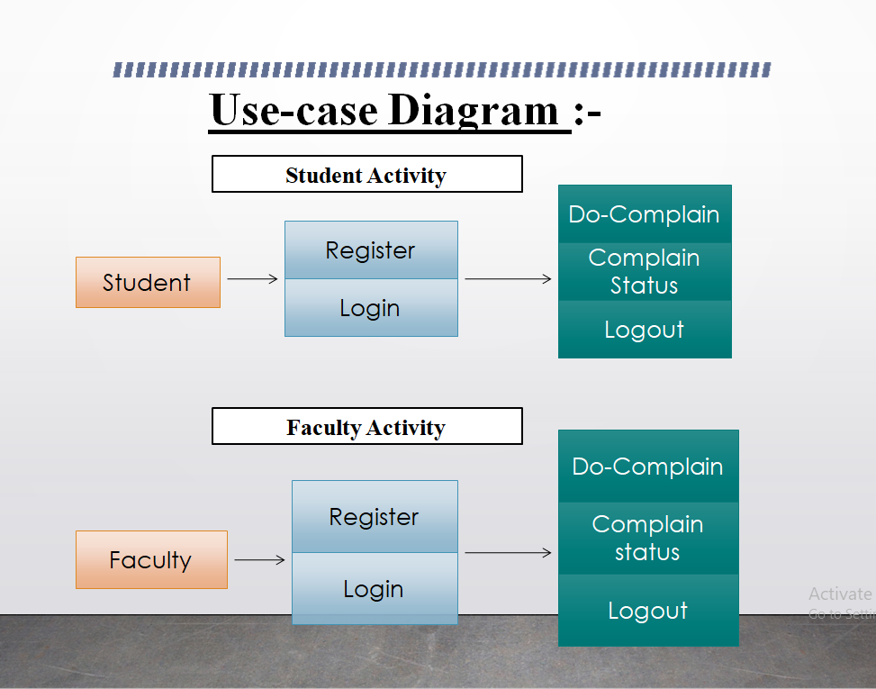

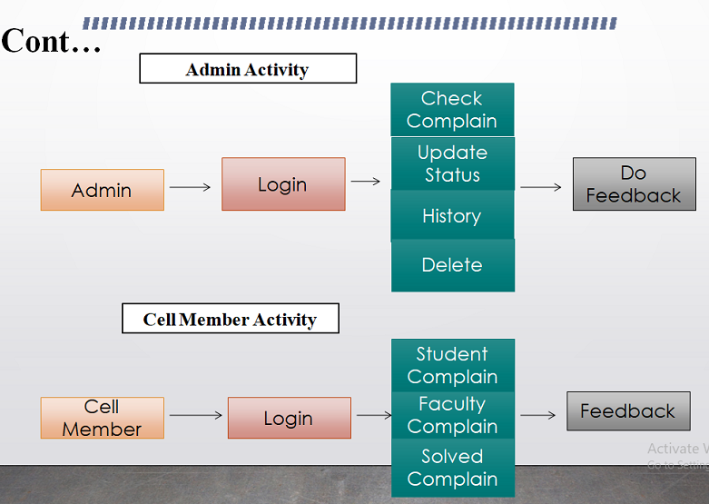

## Use Case Description:

## Login :-

Users need to sign up and login to the app. User will be able to see there complaint status and new complaints.

* The student will type subject and some comment regarding his Grievance
* The system displays complaint status through unique complaint ID.
* The student wrote his complaint by typing on the page.
* The system adds the grievance on the portal..
* On submit the system will add the info of student and the grievance into database.
* The system displays a confirmation message that complaint has been submitted
* The system returns to Home page

**Cannot login (User not Register):**

1. System show error message

2. Redirect to sign in page

**User ID and password Wrong**

1. System throw a message that ID or Password wrong

2. Please sign in or login with valid ID and Password

## Admin Login :-

## admin login allow to see all the grievance received on the portal

• Once the grievance is submitted ,the system shows the grievance to admin.

• The screen shows the grievance status of the complaint.

# Technology Selection –

IDE :- Android Studio&VS Code

Frame Work :- Flutter

Data Base :- Firebase

Language :- Dart

Environment :- Windows family,linux&unix and Mac

# Conclusion:

The system has the benefits of easy access because it is be developed as a platform independent web application, so the admin can maintain a proper contact with their student, which may be access anywhere . All communications between the student/user and administrator has done through the online, so this communication cost is also be free.

With the help of this project anyone can raise their issue securely and can check the status of their issue anytime.

# References:

[1] <https://flutter.dev/docs> Flutter Docs (Online) available at.

[2] <https://firebase.flutter.dev/> FlutterFire (Online) available at.

[3] <https://pub.dev/> Pub.dev (Online) available at.

[4] <https://firebase.google.com/docs?authuser=0> Firebase Docs(Online) available at.