Institute of Engineering and Technology, DAVV



B.E. 4th yr Project

Computer Engineering

Grievance Redressal Portal for IET Campus

Project guide: Team Members :

Dr. Bhawna Nigam 19C7186 - Sunil(CSB)

19C7181- Ghanshyam Lodha(CSB)

18C7132- Nishant Sironjiya(CSB)

**Keywords:** Online, Complaint, Management, Respond, Student, Staff.

**INTRODUCTION :**

Academic growth can be of various concerns in an academic environment to promote social and functioning educational system. For an effective educational system to take place there are some issues in an academic environment that should be properly addressed, take for instance issue of complaints management system in the university. This issue had created a lot of problems for an academic growth in the various aspects of the educational system.

To support this approach, this project identifies a range of options that can be used to manage and resolve Academic complaints. This includes, where the opportunity presents itself, the need for an administrator to make every effort to resolve potential or actual academic complaints as informally as possible in the first instance.

Design and implementation of online complaint management system is to maintain an effective, timely, and equitable complaint handling system which is easily accessible and offered to complainants (students) at no charge. This project defines the policy and steps for handling and resolving complaints and also to appeal for an un-favored situation and for this process to take place there must be automation of the system that will handle the complaints process and appeal method of registration.

To allow student and staff to register their complaints related to the resources and infrastructure like hostel, mess and parking used by them within the campus through a simple single interface, which is an integration of several campus complaint registry systems.

**Literature Survey -**

There are many Student Complaint Portal available in the colleges. On studying some of them we find out that we have not any grievance portal like given below:-

1. University Grant Commission(Grievance Redressal Portal): UGC grievance portal have facilities online registration of students' grievances, send reminders and check action-taken status in connection with their concerns.  
   A student can register complaints regarding admission process, reservation policy, discrimination on the basis of caste and even non-declaration of results through the portal — www.ugc.ac.in.
2. All India Council of Technical Education(AICTE): Redressal of all types of Grievances, Complaints and Malpractices received from Individuals, Institutions, Government and Statutory & Professional bodies - <https://www.aicte-india.org/bureaus/grievance-redressal>.

After visiting these websites we have found that for our IET campus we have not any grievance portal so we are decided to develop a grievance portal which can helpful for students and staff as well and taking reference from these websites we are going to implement our own grievance portal, where:-

To design a web based complaint system record and information system to replace some extent of human role in cases of unavailability of job.

To provide quick responds to students complains on campus.

Also, the purpose of this application is to model a computerized complain system to enable proper complain submitting and control.

**PROBLEM DOMAIN:**

Our college education system is very well but we analyze some problem regarding

to complaint management. In our college, complaint management system is slow

due to which the problem seems to be more time consuming student required paper

work also due to this student were afraid they feel that his name would come. We

analyze this entire problem and we designed a portal which is GRIEVANCE

REDRESSAL PORTAL.

In this portal students and faculty members can complaint easily, and their

complaint will be redressed by the cell member (Principal Sir, HOD sir). Cell

members will give feedback to students and faculty member’s problem. It is very

easy and fast way for complaint management.

**SOLUTION DOMAIN**:

The system registers the complaints of the student through an integrated interface. Whenever a student has got any complaint related to the Campus, regarding Library, Labs or college Infrastructure then they can make online complaints. Their complaints are being taken care by the respective authorities. The student can track the progress of their complaint being solved through a given Complaint ID.

When user create their account he/ she have to select their role like student ,faculty or other. It may be possible that some of the college member doesn’t have college ID for that. we have added other option. After creating and verify their account they can login successfully and can submit their complaint if any. In admin section admin can see all the complaints of user with user details like photo, role, enrollment etc. and can change the status of the user complaint and after completion admin can delete complaint that will store in history for future reference.

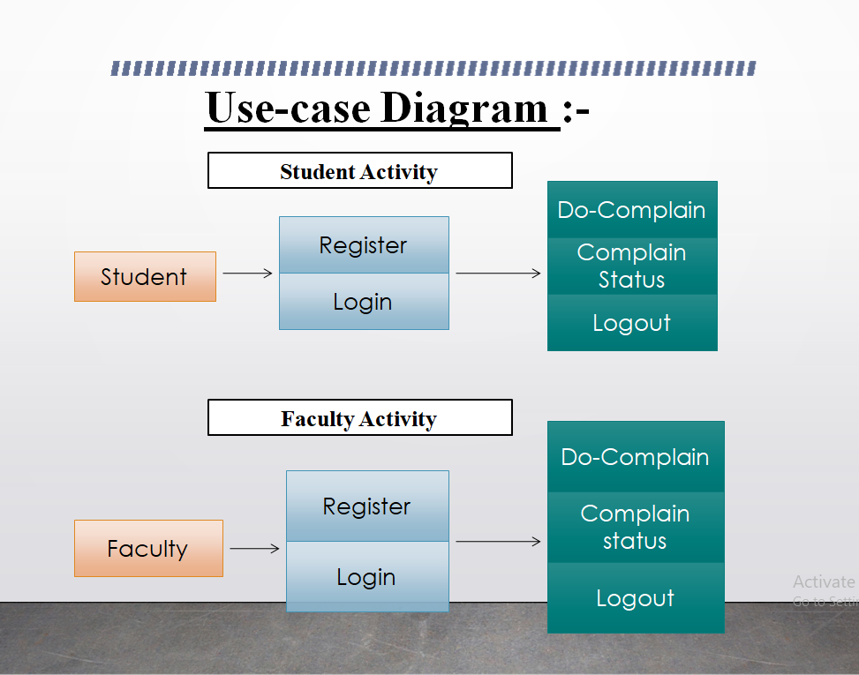

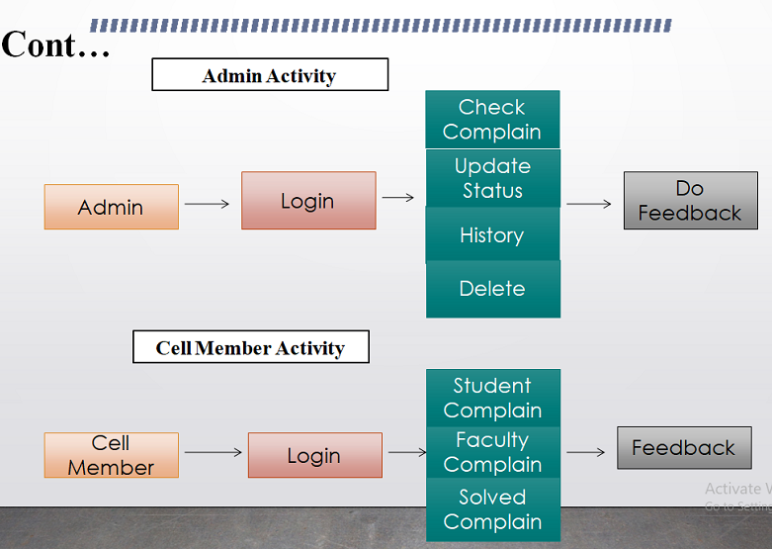

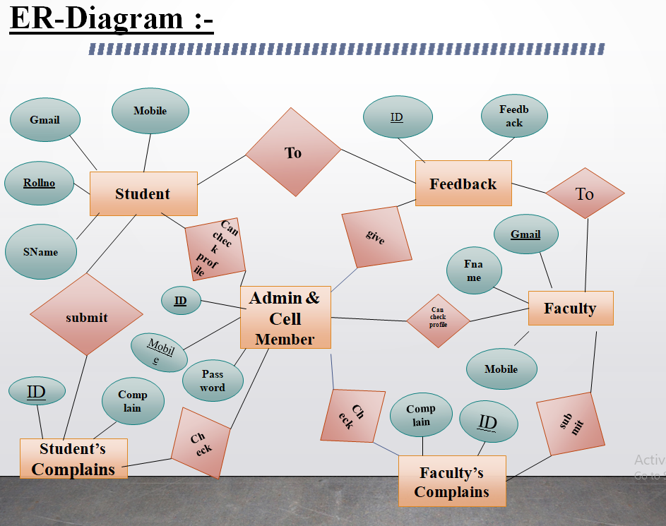

**SYSTEM DOMAIN:**

Minimum Hardware Requirements

• Ram: 4 GB – 8 GB

• Processor: Intel(R) Core(TM) i3-4005U CPU @ 1.70GHz

• HDD: 1 TB

• Monitor: VGA (800 x 600) Software Requirement

• Operating System: Windows 7, 10.

• Browser: Google Chrome

Tools and Technology

* IDE :- Android Studio & VS Code
* Frame Work :- Flutter
* Data Base :- Firebase
* Language :- Dart
* Environment :- Windows family, linux & Mac.
* Architecture :- Data center architecture
* Modeling :- V- Model
* Testing :- Unit testing , Integration testing , Beta testing , Object Oriented Testing

**APPLICATION DOMAIN:**

Complaint Portal is a Web and Android application In which any Collage Member (Student, Faculty, Other) can complaint about any issue. For doing user have to create their account on app and verify their account since this application is made specially for IET college so the student and

faculty member can only create their account with that email id that is provided by college (with @ietdavv.edu.in domain) . So there will be more security and nobody can complaint in bulk because

every college member has their unique college id.

**EXPECTED OUTCOME:**

* With the help of this project anyone can raise their issue securely and can check the status of their issue anytime.
* Every complaint is given a specific Complaint ID, from which the student would be able to track his complaint’s progress
* The administrator will deal with the overall maintenance of the system.
* Admin can search and validate Complaint with the help of Gmail and Mobile Number.
* The Center Admin also monitor the satisfaction percentage by the following considerations
  + How many complaints escalate within a day ?
* How many complaints are pending for escalation ?

**References :**

[1] <https://flutter.dev/docs> Flutter Docs (Online) available at.

[2] <https://firebase.flutter.dev/> FlutterFire (Online) available at.

[3] <https://pub.dev/> Pub.dev (Online) available at.

[4] <https://firebase.google.com/docs?authuser=0> Firebase Docs(Online) available at.