Grievance Redressal Portal for IET Campus



B.E. 4th year Project

Software requirements specification

Project guide: Team Members :

Dr. Bhawna Nigam 19C7186 – Sunil (CSB)
19C7181- Ghanshyam Lodha (CSB)
18C7132- Nishant Sironjiya (CSB)

Department of Computer Engineering / Information Technology
Institute of Engineering & Technology
Devi Ahilya Vishwavidyalaya, Indore(M.P.)
(www.iet.dauniv.ac.in)
September - 2021

Table of Contents
Table of Contents ii
1. Introduction 1
1.1 Purpose 1
1.2 Document Conventions 1
1.3 Intended Audience and Reading Suggestions 1
1.4 Product Scope 1
1.5 References 1-2
2. Overall Description 2
2.1 Product Perspective 2
2.2 Product Functions 2
2.3 User Classes and Characteristics 2
2.4 Operating Environment 3
2.5 Design and Implementation Constraints 3
2.6 User Documentation 3
2.7 Assumptions and Dependencies 3
3. External Interface Requirements 4
3.1 User Interfaces 4
3.2 Hardware Interfaces 4
3.3 Software Interfaces 4
3.4 Communications Interfaces 4
4. System Features 4
4.1 System Feature 1 4-5
4.2 System Feature 2 (and so on) 5
5. Other Nonfunctional Requirements 5
5.1 Performance Requirements 5
5.2 Safety Requirements 6
5.3 Security Requirements 6
5.4 Software Quality Attributes 6
5.5 Business Rules 6
6. Other Requirements 6
Appendix A: Glossary 7
Appendix B: Analysis Models 8

Introduction

Purpose
The purpose of an Online Grievance Redressal System is to provide a platform for students to lodge their complaints related to various services they receive from the institute. It bridges the communication gap between the college and the student, and provides student a platform through which they can get their grievances addressed in a timely and transparent manner.

Document Conventions
When user create their account he/ she have to select their role like student , faculty or other. It may be possible that some of the college member doesn’t have college ID for that.

We have added other option. After creating and verify their account they can login successfully and can submit their complaint if any.

In Complaint admin application admin can see all the complaints of user with user details like photo, role, enrollment etc. and can change the status of the user complaint and after completion admin can delete complaint that will store in history for future reference

Intended Audience and Reading Suggestions
The SRS document is intended for all the stakeholders to confirm on all the requirements and features before initiating development. Our team Design and implementation of online complaint management system is to maintain an effective, timely, and equitable complaint handling system which is easily accessible and offered to complainants (students) at no charge. This project defines the policy and steps for handling and resolving complaints and also to appeal for an un-favored situation and for this process to take place there must be automation of the system that will handle the complaints process and appeal method of registration.

Product Scope
The system registers the complaints of the student through an integrated interface. Whenever a student has got any complaint related to the Campus, regarding Library, Labs or college Infrastructure then they can make online complaints. Their complaints are being taken care by the respective authorities. The student can track the progress of their complaint being solved through a given Complaint ID.

References
- https://flutter.dev/docs Flutter Docs (Online) available at.
- https://firebase.flutter.dev/ Flutter Fire(Online) available at.
- https://pub.dev/ Pub.dev (Online) available at.

- https://firebase.google.com/docs?authuser=0 Firebase Docs(Online) available at.

Overall Description

Product Perspective
The "Online Grievance Redressal Portal" software is an independent application. It is a self -contained product. The System interfaces, user interfaces and hardware interfaces related with this software are defined as follows.

Product Functions

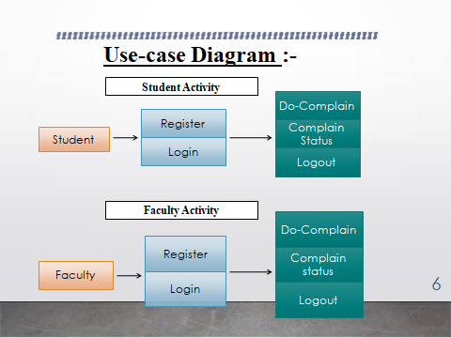

User Classes and Characteristics
There are four basic users – STUDENTS, ADMIN, FACULTY, and OTHER. These all can submit their grievance to a particular department, and get a track id. Grievance will be forwarded to concern department. Once the complaint is rectified, the department officer updates the grievance status. It will be notified to the user. User can view grievance status (Seen, In-Progress, Solved). Admin can add department, view all the reports

Operating Environment
Client on Internet
Web Browser, Operating System (any)

Web Server
Operating System (any)

Data Base Server
Firebase, Operating System (any)

Development End
Flutter, Dart, OS (Windows)

Design and Implementation Constraints
GUI is only in English.
Only Registered people can use this system

User Documentation

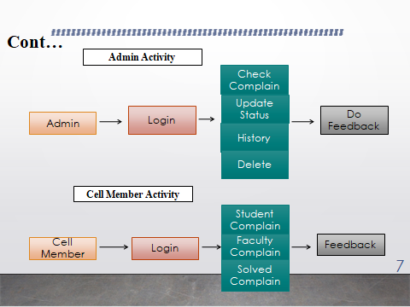

Assumptions and Dependencies
Network and server problems- These problems may reduce the function of the product. Communication – When a user does not know the language to communicate(i.e. English) Negligence – When any user character(actors) do not care about the grievances the system may fail.

External Interface Requirements

User Interfaces
The screen formats and menu structure should be in such a way that even have users will find it easy to use. The product must be use-friendly and very inter-active . The functionality provided by the system like displaying complaint status is very attractive.

Hardware Interfaces
Recommended Requirements:
Client Side Browser:
Chrome, Firefox Processor:
All Intel or AMD - 1 GHZ RAM:
256 MB Disk Space: 200MB

Server Side Processor:
All Intel or AMD - 1 GHZ RAM:
2GB Disk Space: 3GB

Software Interfaces
Operating System: Any Windows OS. Client Software : Any Web Browser(Internet Explorer).
Communication Network: Internet.

Communications Interfaces.
Client (system user) on Internet will be using HTTP/HTTPS protocol.
Admin on Internet will be using HTTP/HTTPS protocol.

System Features
Following are the major features of the system. The detail description of each feature is given below:

System Feature - Login
4.1.1 Description and Priority
The feature will allow users to sign up and login to the app. User will be able to see there complaint status and new complaints.
4.1.2 Stimulus/Response Sequences
- The student will type subject and some comment regarding his Grievance
- The system displays complaint status through unique complaint ID.
- The student wrote his complaint by typing on the page.
- The system adds the grievance on the portal..
- On submit the system will add the info of student and the grievance into database.
- The system displays a confirmation message that complaint has been submitted
- The system returns to Home page
4.1.3 Functional Requirements
FE1: Cannot login (User not Register):
1. System show error message
2. Redirect to sign in page
FE3: User ID and password Wrong
1. System throw a message that ID or Password wrong
2. Please sign in or login with valid ID and Password

System Feature - Admin Login
4.2.1. Description and Priority
The feature allows admin to see all the grievance received on the portal

4.2.2 Response Sequence
• Once the grievance is submitted ,the system shows the grievance to admin.
• The screen shows the grievance status of the complaint.

Other Nonfunctional Requirements

Performance Requirements
Performance is measured in terms of the output provided by the application. Requirement specification plays an important part in the analysis of a system. Only when the requirement specifications are properly given, it is possible to design a system, which will fit into required environment. It rests largely in the part of the users of the existing system to give the requirement specifications because they are the people who finally use the system. This is because the requirements have to be known during the initial stages so that the system can be designed according to those requirements. It is very difficult to change the system once it has been designed and on the other hand designing a system, which does not cater to the requirements of the user, is of no use.
The requirement specification for any system can be broadly stated as given below:
- The system should be able to interface with the existing system.
- The system should be accurate.
- The system should be better than the existing system.
The existing system is completely dependent on the user to perform all the duties.

Safety Requirements
This describes the safety-related H/W and high level S/W architecture. It decomposes the design of the safety functions and specifies the associated safety integrity functions such as self-tests and safety support functions such as operating and communication systems and justifies the partitioning.

Security Requirements
All the details in this system must be secured. It must be confidential.

Software Quality Attributes
Adaptability, Availability, Correctness, Flexibility, Interoperability, Maintainability, Portability, Reliability, Reusability, Robustness, Testability and Usability.

Business Rules

Contact the students to find out if they were satisfied with how their complaint was handled. Let them know what we are doing to avoid the same problem in the future.

Make sure staff are trained to following the procedure when handling complaints and that they have the power to resolve issues as quickly as possible.

Encourage the students to provide feedback and complaints so that they let know when there is a problem and give us the opportunity to resolve it.

Other Requirements
Facility to upload photos of the complaint
Appendix A: Glossary
1.SRS- Software Requirements Specification
2.GRP- Grievance Redressal Portal
3.OS-Operating System
4.GB-Gigabyte
5.HTML-Hyper Text Markup Language
6.CSS-Cascade Styling Sheet
7.REQ-Requirement
8.PK-Primary Key
9. SName- Student Name
10. FName – First Name
Appendix B: Analysis Models
