G. Arrays
By Lt Col Tom Schorsch
Introduction
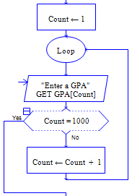
Prior to this reading we have been using variables that had a single memory location associated with them and that could store a single piece of information only. However, many computer programs process large groups of data that require a fundamentally different type of variable. These programs process data like the following: all employee social security numbers for a particular company, a set of grades for all students in a particular class, and the number of privileges remaining for each cadet in a squadron. Having individual variables for each separate value in one of the groups above would be cumbersome and impractical. For example, could you imagine writing a program that had 100+ individual variables to store and process the GPAs of all of the cadets in your squadron?

The RAPTOR code at the right has only 4 statements yet when executed it can read in and store 1,000 GPAs! The variable GPA will hold 1,000 GPAs after the code is executed. Any individual GPA of those 1000 can then be accessed by using an offset or index number to get at the particular one you are interested in..
Arrays and structured data
In order to simplify working with large amounts of information, programming languages provide the capability of storing a collection of data in a data structure. A data structure is literally a structure of data. The only data structure you will use in this class is the array data structure. A single dimensional array data structure can be thought of as a sequence of individual memory locations, like c c c c c c…c. Each memory location (box) contains a value of the same type, but not necessarily the same value. While each of those memory locations could have been declared so that it was associated with a unique variable identifier, sometimes it is convenient to declare a single variable that refers to all of them simultaneously. That variable is called an array variable. In the example code above, GPA is the array variable.

Data Structure |  | An approach for arranging data in a structured manner. As there are many different ways of arranging data in real life, most programming languages provide the capability of creating many different data structures.

The data structure that you are (probably) most familiar with is the matrix (the math structure not the movie). A single dimensional array can be thought of as a matrix with only one row of data. Each element of data in a 1-D array can be referred to by its position within the row. A two dimensional array can be thought of as an M by N matrix. Individual data elements in a 2-D array can be referenced by their row and column placement.

Programming languages use arrays to represent the structured data that is very common in real life. For example, the gates at an airport are often numbered consecutively. A 1-D array could hold the flight number of the plane that is arriving at that gate next. A second 1-D array could be used to hold the plane’s arrival time. Thus Flight_Number[1] could hold the flight number of the plane arriving at gate 1 and Arrival_Time[1] could hold that plane’s time of arrival. If you change the 1 to a 2 you are now referring to the flight number and arrival time for the plane at gate 2. As an example of a 2-D array, the points scored in a football game are often arranged by the team and quarter in which they were scored. The data is often displayed with Team 1 and Team 2 labeling the rows and Quarters 1-4 labeling the columns. A 2-D array could be used to represent that information. So Score[1,3] could be used to hold the number of points by the first team in the third quarter. For example, in Super Bowl XXXVII, Tampa Bay beat Oakland 48 to 21 the scoring by quarter is depicted visually below

 | Quarter 1 | Quarter 2 | Quarter 3 | Quarter 4
Team 1 | 3 | 0 | 6 | 12
Team 2 | 3 | 17 | 14 | 14

Thus Score[1,3] holds the value 6.

- 1.Come up with at least two more descriptions of 1-D data and at least one description of 2-D data that you encounter in real life:
1-D data:________________________________________________________________
________________________________________________________________________
2-D data:________________________________________________________________
________________________________________________________________________

Imagine that a sequence of 120 memory locations, …, is associated with an array variable called Squadron_GPAs. Assuming that there were enough memory locations, all of the GPAs of the cadets in your squadron could be stored in the memory locations referenced by the Squadron_GPAs array variable. Individual locations in the sequence are referred to as elements of the array (elements of the array data structure). The first location in the sequence is formally referred to as “the data element at index position 1 of the Squadron_GPAs array data structure”. As that is too lengthy, we often shorten it in a variety of ways: “the element at position 1 of the Squadron_GPAs array”, “the first element of the Squadron_GPAs array”, or simply “element 1 of Squadron_GPAs”. If we actually want to use the data at that location or assign a value to that location we have to index the array variable with the numeric offset of the location we want. Thus Squadron_GPAs[1] is how you would reference that data element location in your program. The second, third, etc. through last data elements in the array could be referred to in a similar fashion.

Each array variable that you use has 2 main properties. The size and shape of the array, and the type of data that is stored in each element of the array. We will address the size and shape first. A single-dimension array of size 20 could be thought of as a sequence of 20 memory locations. Each of those 20 locations could store a (possibly different) value of the same type. Any specific location in that array could be referenced by its index number (between 1 and 20). A two-dimensional array can be thought of as having rows and columns, height and width, or that it is a grid having X and Y positions. A three-dimensional array can be thought of as having depth or having a Z component. Each dimension of the array has its own size. The picture below makes it easy to visualize the structure of 1, 2, and 3-dimensioned arrays (RAPTOR only has 1 and 2-D arrays).

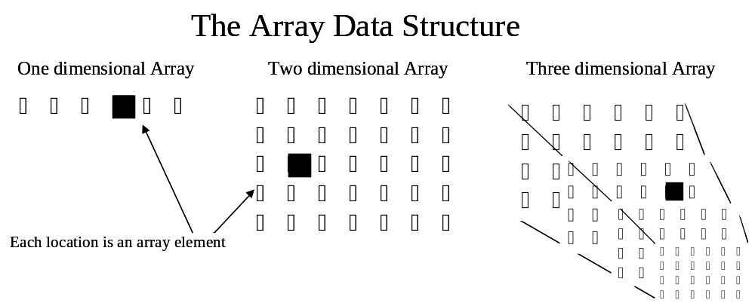
- Characterize each array data structure above by the size of its dimensions.
1-D _________, 2-D______________, 3-D___________________________.
- Refer back to how we speak of a given element in a single-dimensional array. Extend that method of reference and come up with your own way to describe where individual elements are located in the 2 and 3 dimensional arrays. Note: You don’t have to come up with the “right way” just an obvious extension. Now describe where each blackened-in array element is in the example array data structures above (use The_1D_Array, etc. as the names of the arrays).
The_1D_Array: ______________________________________________________________
The_2D_Array: ______________________________________________________________
The_3D_Array: ______________________________________________________________
Now that we have discussed the size and shape property of an array, and you can refer to the elements in an array in a logical manner, let’s examine the type property of an array. All the data that a single array can hold must be of the same type. Although RAPTOR has variables of type number and type string, RAPTOR arrays can only have element values of type “number”. Other programming languages have arrays that have elements of type String or even a Boolean type.

To characterize an array we will often refer to its size, shape, and type. Thus we often refer to an array of size 20, a 2-D array, or a number array. We also combine these and refer to a 20 by 30 number array or a number array of size 30.

- Several collections of data are described below. This data could be stored in an array data structure and processed by a program. The shape and names of the dimensions have been provided and they all have “number” as the element type; you describe the size of each dimension of the array. Note: use sizes that are appropriate for the data and/or round up to a convenient value as it is always better to have a little more space then you need than not enough.
The GPAs of the students in your CS110 class (1D).
The PFT score of every cadet in your graduation class (1D).
The minutes you slept during each hour of the last 24 hours (1D):
The course numbers of each of your classes in each of your 8 (projected) semesters here at USAFA (2D, semester # and course #).
The age of the cadets in your squadron (3D, Flight, Element, and Class).

Array |  | An array is used to group related data items of the same type into an ordered collection under a single name. Any particular element in the array can be indexed (referenced) by its numeric order within the dimension(s) of the array.

As an example, the GPAs of all students in a section could be stored in the array variable Section_GPAs. This variable could have a maximum of 24 memory locations associated with it because there could be a maximum of 24 students in a section. The Section_GPAs variable can be depicted as shown below:

Section_GPAs
1 | 2 | 3 | … |  |  |  |  |  |  |  |  |  |  |  |  |  |  |  | 24
c | c | c | c | c | c | c | c | c | c | c | c | c | c | c | c | c | c | c | c

A 20 by 20 Matrix variable is associated with 400 memory locations that can be depicted as shown below:

Matrix
 | 1 | 2 | 3 | … |  |  |  |  |  |  |  |  |  |  |  |  |  |  |  | 20
1 | c | c | c | c | c | c | c | c | c | c | c | c | c | c | c | c | c | c | c | c
2 | c | c | c | c | c | c | c | c | c | c | c | c | c | c | c | c | c | c | c | c
…
20 | c | c | c | c | c | c | c | c | c | c | c | c | c | c | c | c | c | c | c | c

Array Dimensions |  | The dimensions, 1-D, 2-D, 3-D of the array.

Array Size |  | The size of each of the array dimensions. Ex 20, 20x30, 100x100x100.

Referencing a Data Element of an Array Variable in RAPTOR
The data stored in an array variable cannot be accessed as readily as the data of a normal variable. If I used Section_GPAs in an expression, I would be referring to the entire structure of 24 values that are in the array. To reference an individual data element in an array, I must determine its location and use that location in the reference.

Recall the earlier question that asked you to indicate the location of the ’s in the three example array data structures. If you did it correctly you described the location based upon the number of dimensions of the array data structure and the ’s numerical location within those dimensions. The way you reference a data element of an array in RAPTOR is very similar.

By adding an index (position) after the array variable name you can reference any specific value in the array. As an example, Section_GPAs[20] refers to the 20th position in the array. The Section_GPAs part tells the computer to start at the (structured) memory location associated with the Section_GPAs variable at the time it was declared. The [20] part says move from that starting position over to the 20th position in the array and use the data located there.

Syntax for accessing an element of an array variable:
Array_Variable_Name [Integer_Expression] or
Array_Variable_Name [Integer_Expression, Integer_Expression]
Depending on the number of dimensions in the array

Examples
Section_GPAs[20]
Section_GPAs[I]
Matrix[10,7]
Matrix[X, 3 * Y]

Note, that the indices to get at the element could be literals, variables, or expressions. Note also that the above syntax is not that of a complete RAPTOR statement. Instead, accessing an array element is accomplished in the context of some activity such as assignment. Thus you can access an array element to use its value in a computation or to assign that element a value.

Array Element |  | One of the many data elements associated with the array variable. The size of the array determines how many elements an array has.

Array Index |  | The position used to find a particular element of an array. Each element has a certain position in the array and the index is used to specify that position. Multi-dimensioned arrays require multiple indices.

The following assignment statement, Section_GPAs[20] ← 4.0;, would place the value 4.0 into the 20th position of the array, i.e.

1 | 2 | 3 | … |  |  |  |  |  |  |  |  |  |  |  | 20 | … |  |  | 24
c | c | c | c | c | c | c | c | c | c | c | c | c | c | c | 4.0 | c | c | c | c

If, after that statement, we had the following additional assignment statement,
Section_GPAs[9] ← Section_GPAs[20];
it would copy the 4.0 in position 20 in the array over to 9th position of the array as well, i.e.

1 | 2 | 3 | … |  |  |  |  | 9 | … |  |  |  |  |  | 20 | … |  |  | 24
c | c | c | c | c | c | c | c | 4.0 | c | c | c | c | c | c | 4.0 | c | c | c | c

A two dimensional array requires two indices, one for each of the dimensions. The following assignment statement places a 0.0 in row 20, column 3 of the Matrix variable:
Matrix[20,3] ← 3.3;

That assignment statement has the following (miniscule) effect on the memory locations associated with the Matrix variable.

 | 1 | 2 | 3 | … |  |  |  |  |  |  |  |  |  |  |  |  |  |  |  | 20
1 | c | c | c | c | c | c | c | c | c | c | c | c | c | c | c | c | c | c | c | c
2 | c | c | c | c | c | c | c | c | c | c | c | c | c | c | c | c | c | c | c | c
…
20 | c | c | 3.3 | c | c | c | c | c | c | c | c | c | c | c | c | c | c | c | c | c

All of the other memory locations remain unchanged. In the following RAPTOR statement a value will be read in from the user and placed in the very first data element of the Matrix:
GET Matrix[1,1]. So one assignment statement and one GET statement managed to change the memory locations of 2 out of the 400 (20x20) that are associated with the Matrix variable. I would hate to have to write an additional 398 statements to change the other values. There is an easier way to change the values of the data elements of an array, which we will cover in the next section.

When they are fully indexed, array variables can be treated just like the variables that we are used to. Array variables can be referenced in an expression, they can be passed as parameters to some procedure, and they can be assigned in an assignment statement but they must be fully indexed in all of those places.

The examples above show literals being used as indices to access individual array elements. This is actually something that is only rarely done while programming. Usually an integer variable, say X, is used to index into array variable. Thus the assignment statement,
Section_GPAs[X] ← 4.0;
will assign the value 4.0 to some memory location associated with variable Section_GPAs. I say, “attempt” because there may be a run-time error. At the time of the assignment statement variable X will have a value. If that value is a whole number value then that associated position within variable Section_GPAs will be assigned the value 4.0. However, variable X could hold some real value such as 3.14159. If that happens then a run-time error occurs as you are asking RAPTOR to do something it cannot. RAPTOR cannot store 4.0 in a position that does not exist. Position 3 exists, and position 4 exists, but position 3.14159 does not exist.
Processing Array Variables using loops
So far you have seen examples of individual data elements in an array being referenced or being assigned. It doesn’t seem like you are accomplishing much. When working with arrays it is often desirable to access all of the elements sequentially a single element at a time. This could take a lot of code if done using literal values as the index to get at the elements. However, a loop control structure is best suited for traversing the elements of an array. In 98.9% of the cases if you are not using a loop to process the elements of an array, you are WRONG!

The following examples are all snippets of code from the middle of programs. Between them they cover most of the “classic” tasks you do with arrays.

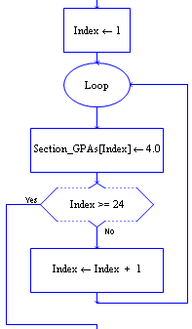
Assigning values to an array variable

This example, like the rest, uses a loop control variable to stop the loop and as an index into a position in an array. The loop will execute 24 times and the Loop control variable, Index, will take on the values 1 through 24. The assignment statement in the loop uses the Index variable to access a position within the array. Each time the assignment statement executes Index has a different value and a different memory location within the array Section_GPAs is assigned the value 4.0.

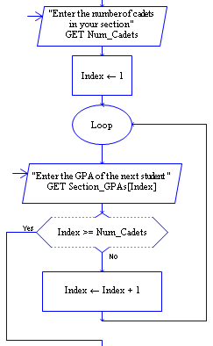

Reading values into an array variable

This example determines how many cadets are in the section before starting the loop. If (say) there are 22 students in the section then the user types in a 22 and Num_Cadets holds that value. Then the loop executes 22 times. At the end of the loop the 22 GPAs will be stored in the Section_GPAs array variable.

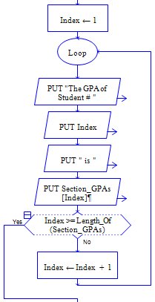

Writing array variable values out

This example displays the student index number and that students GPA to the screen. The function Length_Of, when given an array, will return the number of elements in the array. Thus the statement Index >= Length_Of(Section_GPAs) will be true when the index is at the last position in the array.

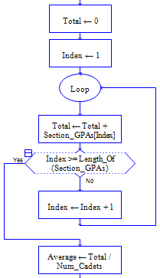

Totaling and computing the average of the values in an array variable

In order to determine an average GPA you need to sum up the GPAs to get a total and then divide that total by the number of GPAs. The first statement assigns the total to 0. Inside the loop, the assignment statement increases that total by the GPA of a single student. Each time the loop executes the next student’s GPA is added to the running total. At the end of the loop all of the GPAs have been added in. The total is then divided by the number of cadets in the section resulting in the average GPA of the section. This average could be written to the screen or used in a later statement.
Finding the largest value of all the values in an array variable
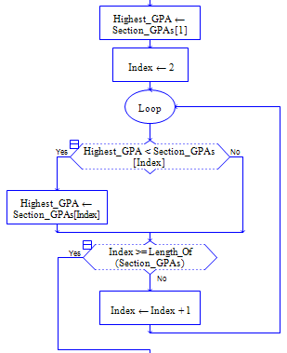
Searching for a particular element in an array is a common activity. In the example, it is the highest element that is being searched for.

Initially, Highest_GPA is assumed to be the first element in the array. The loop then examines the second through last GPA in sequence. In each case the Highest_GPA (found so far) is compared with the next element in the array. If a higher GPA is found, the new value becomes the Highest_GPA and the search continues. After examining all of the GPAs in the array the variable Highest_GPA will necessarily contain the highest one. At which point the loop ends and the value can be displayed or used in some other computation.

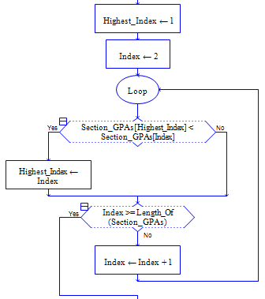

Finding the INDEX of the largest value in an array variable

This last 1-D example is very similar to the previous one. Instead of the highest value being remembered, the index position of the highest value is remembered. Thus initially we assume that the highest value is in the first position of the array. If, during the course of the loop we find a higher value, the index of that higher value is remembered. After examining all of the GPAs in the array the variable Highest_Index necessarily contains the index of the highest GPA. At which point the variable Highest_Index can be used directly or to be used to access the Highest GPA in the array.

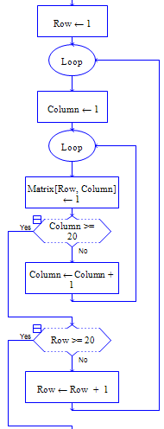
Processing multi-dimensional arrays

When processing a multi-dimension array, it is typical to have a loop for each dimension of the array. Each loop control variable becomes one of the indices of the array. above, Row and Column represent the row and column numbers. As the inner loop executes 20 times for each execution of the outer loop, the assignment statement will execute 400 times and all 400 elements of the Matrix_Array will be assigned the value 1. This is quite a lot of work for 7 “statements”.

Each of the 1-D examples could be extended in the obvious way so that it could be used to process a multi-dimensioned array.

Some things to note concerning the previous examples

In the examples, the index variable was inevitably called Index (or Row and Column). There is nothing magical about these names. The index variable could be called something else. Your instructor, for example, may use the name Counter, or the names I, and J,

The examples all contained similar elements concerning the loop control variable (LCV). In each case, the loop control variable(s) had an Initialization statement, a Test statement, and a Modify statement. (See the description if I.T.E.M. in the control structures reading.) This collection of statements is a pattern that you should use when processing arrays. Examples of these statements are depicted below:

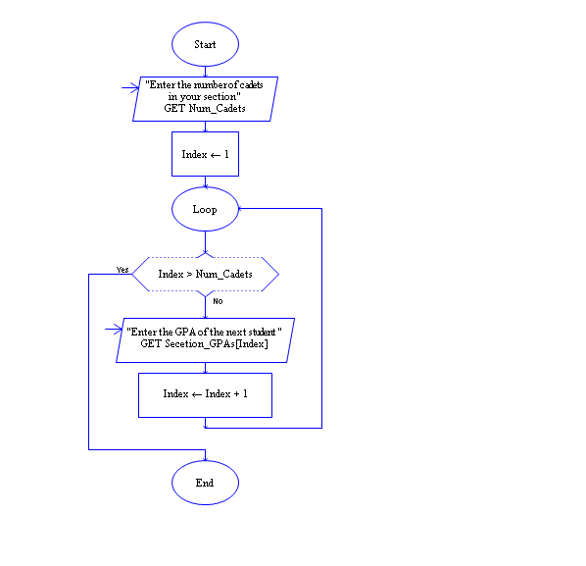
LCV Initialization

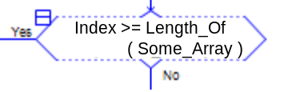 LCV Test

LCV modification
Persistent Storage
Arrays enable a program to deal with large amounts of data without large amounts of code. For example, any of the previous programs could easily be modified to deal with the GPAs of every cadet in a course or class year instead of the GPAs of cadets in a particular course section. The code for processing 1,000 GPAs is essentially the same for dealing with 24 GPAs as the array size and loop control variable account for the differences. Unfortunately, the user would have to enter 1,000 GPAs instead of 24 every time the program was used.

When dealing with large amounts of data, it is inconvenient to continue to type in the data by hand every time it is needed. Rather than have a user type in all the data, a persistent data file could be created that contains all of the data, and then that file could be used as input for a program. RAPTOR has special commands that enable a data file to be the source of data for a program. RAPTOR also has commands that redirect output to go to a data file rather than the Master Console.

Redirecting Output
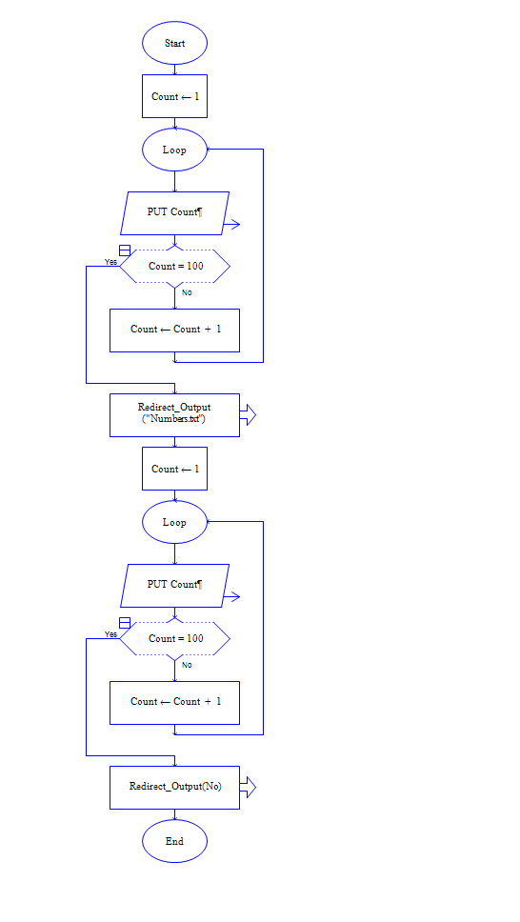
Writing code that redirects output is very simple. In the example on the left below, Output statements work normally and the code will cause the numbers 1 through 100 to be written to the Master Console. In the example on the right below, the code has been changed by adding two additional calls that effectively surround the statements whose output you want redirected. The first call statement, Redirect_Output("Numbers.txt"), changes the default output so that it is redirected to a file named “Numbers.txt” instead of being sent to the Master Console. The last call statement, Redirect_Output(No), turns off the redirection and once again enables output statements to go to the Master Console. Between the two calls, all of the Put statements which normally would display data in the Master Console, write the data to the given file instead.

Redirecting Input
Redirected input is only slightly harder to understand. Again, a few examples with and without redirected input should suffice. In the example on the left below input has not been redirected and the code works as is expected: the user is required to type in 100 numbers and they get stored in successive positions in the Numbers array. In the middle, input has been redirected to come from the file “Numbers.txt”. In the middle example exactly 100 numbers will be read from the file “Numbers.txt” and placed into the array Numbers. If there are fewer numbers in the file a run time error will occur when the code is executed. If there are more than 100 numbers in the file those latter numbers will not be read into the array. Finally, in the example at the right the numbers will also be from the file “Numbers.txt” and placed in the array “Numbers.txt”. Because of the decision test End_of_Input, however, more or fewer than 100 numbers can be read in. The loop will continue until no more numbers occur in the file whether that occurs after 10 numbers are read in or 1,000 numbers are read in. As soon as all the numbers in the file are read in, the example on the right will finish as End_of_Input will then be true..

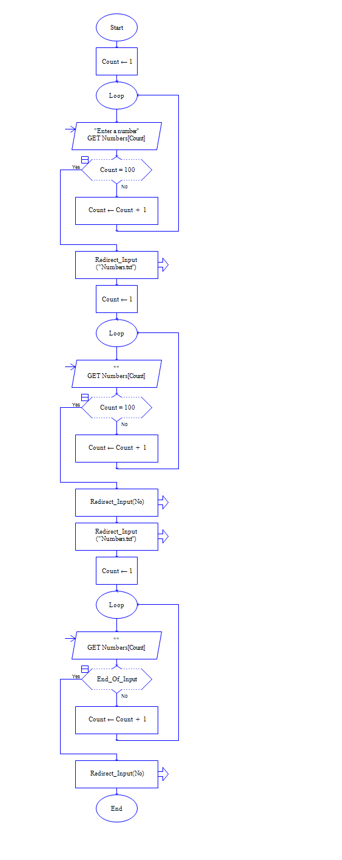

As a final note on persistent storage, the commands Redirect_Input(Yes) and Redirect_Output(Yes) will prompt the user for the name of the file.
What we have learned…

We understand that it is often necessary for programs to process large amounts of data and that a data structure, arrays, is needed to hold that large amount of data.

We can determine the array type (dimensionality, size,) required to store a given collection of data.

We can recognize situations where the use of an array variable is appropriate.

We can use indices to access individual elements of an array.

We can use loops to process the elements of an array sequentially and accomplish the following tasks: Assign, read in, write out, total, and search all of the elements in an array.
Reading Self-Check
Draw a pictorial representation of the memory associated with an array named Student_Grades containing 10 grades.

Write the code necessary to read in grades from the user to fill all of the elements in the Student_Grades array.

Write the code necessary to count the number of ‘100’s in the Student_Grades array.

Write the RAPTOR code necessary to search for any ‘0’s in the Student_Grades array. If at least one ‘0’ is found , display the message “Someone Flunked”, otherwise display the message “All OK”

