SOLUTION DOCUMENT
Uzbekistan Trade Platform
Agentic Layer — Approach, Technology and Architecture
Version 1.0 · 29 September 2026

Executive summary
The agentic layer takes an exporter or importer from a plain-language request (“export 20 tonnes of tea from Tashkent to Almaty by train”) to a completed trade procedure. Five cooperating agents match the request to one of 243 published Uzbek procedures, open a case, and run it one step at a time: they read and verify documents, check compliance and risk, plan the movement of the goods, and file online applications with 12 government-entity APIs. The trader is asked only for what the current step needs, and keeps every decision that commits money or carries a legal signature.

1. Approach

1.1 Grounded in the published procedures
Agents do not improvise a process. Every case follows an official procedure parsed from the government’s procedure documents: 243 procedures, 1,334 blocks, 5,539 steps and 44 issuing entities. Each parse is checked against the procedure’s own summary (block count, step count, timeframe), and goods or routes outside the published scope are declined by name.

1.2 Orchestrator-led, step-level execution
A single Orchestrator owns progress. A step becomes ready only when every step it depends on is complete. For each ready step, it asks only for that step’s inputs and marks the step complete only when those inputs are satisfied. Conversation can answer questions and collect information, but it never completes a step on its own.

1.3 Delegation model: Trader, Agent or Physical
Each step is assigned to one of three lanes by three questions asked in order:
- Must the goods be present? Loading, sampling, inspection and sealing are Physical.
- Does it move money or commit the company? Payments, signed declarations and agreements stay with the Trader; the agent prepares them.
- Does the platform have access to the portal? Integrated portals (Single Window, railway, customs, Uzexpertiza, Assalom Agro) are Agent steps; identity-bound portals (e-signature, personal cabinets, bank) stay with the Trader.
Across the corpus this yields 2,524 trader steps, 1,825 agent steps and 1,190 physical steps: about one step in three is fully automated.

1.4 Rules first, AI where it adds value
Workflow logic, procedure matching, readiness and step gates are deterministic, so the same case always behaves the same way. Language models are used where rules fall short: understanding free-text messages, reading scanned documents and ranking HS-code candidates. Every model answer is validated against a schema, and the platform still runs on rules alone when no model is available.

1.5 Human in the loop and verifiable AI
A value read from a document is accepted only when the model quotes the line it came from and that quote is found in the page transcript. Confidence gates decide what happens next: ≥ 0.80 accepted, 0.50–0.79 pre-filled for the trader to confirm, < 0.50 requested again. Where a figure cannot be derived reliably (for example duty rates), the agent states the gap instead of estimating.

1.6 Transparent and auditable
Every agent run, entity filing, status change and document decision is written as an audit event with its actor. The agent status panel reads each agent’s state (Working, Needs you, Idle) directly from case data, never from decoration.

2. Technology
The layer is written in TypeScript end to end, with a Python service for heavy document processing.
Layer | Technology | Role in the agentic layer
Application | TypeScript 5.9, React 19, Next.js 16 on Vite 8 (vinext), Node.js 22 | Chat workspace, step card, API route handlers that the agents run behind
Agent orchestration | LangGraph 1.4 (StateGraph), LangChain Core 1.2, Zod 4 | Orchestrator loop, specialist dispatch, schema-validated model output
Language model | Groq API, openai/gpt-oss-20b (default); optional local model (Qwen 2.5 7B via Ollama) | Intent and routing, slot extraction from free text, HS-code re-ranking, procedure Q&A
Vision model | Groq: Llama 4 Scout → Llama 4 Maverick → Qwen, first available | Reads each document page into a transcript plus field values with quotes
Document AI service | Python on a Hugging Face Inference Endpoint: EasyOCR (Russian + English), LayoutLM document QA, PyMuPDF | PDF rasterising, fallback reader, keeps documents off third-party models when required
Data | PostgreSQL (Neon in production, local cluster in development), Drizzle ORM | Cases, workflow runs, nodes, edges, work items, agent runs, artifacts, audit events
File storage | Vercel Blob | Original uploaded documents
Entity integrations | 12 REST services (Node.js) hosted on Render | Single Window, Railway, Customs, Payments and 8 more; submit, review, approve or request changes
Hosting | Vercel (web and agents), Render (entity APIs), Hugging Face (document AI) | Serverless functions with a 60-second ceiling; orchestrator runs within a 45-second budget
Quality | Evaluation harness (6 suites), unit tests, end-to-end API tests | Deterministic suites must score 100%; model suites are measured against an 80% threshold

3. Architecture

3.1 Layered view
The layer is organised in six tiers. Requests flow down from the trader’s screen; state and results flow back up.
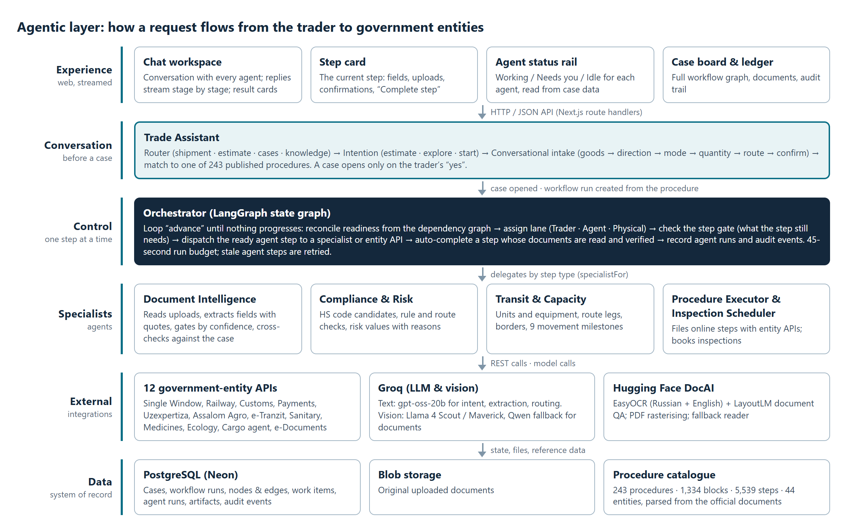
Figure 1. Architecture of the agentic layer

3.2 The agents and their responsibilities
Agent | Responsibility | Key behaviour
Trade Assistant | Understands the request, asks for missing details one at a time, matches the published procedure | Routes each message (shipment, estimate, cases, knowledge); opens a case only on the trader’s confirmation
Orchestrator | Runs the case: readiness, lanes, step gates, hand-offs to specialists and entities | LangGraph loop that advances until no step can progress; retries stalled agent steps
Document Intelligence | Reads uploads, extracts required fields, verifies each against the case | Quote-checked values, confidence gates, auto-completes a step when every field is verified
Compliance & Risk | HS classification, rule and route checks, risk values with reasons | HS candidates drawn only from the nomenclature; states gaps rather than inventing duty rates
Transit & Capacity | Transport units, route legs, borders, movement state | Tracks nine milestones from planned to arrived; flags over-limit loads and gauge breaks
Procedure Executor, Inspection Scheduler | Files agent-lane steps with entity APIs; books inspections | Submits, polls applications under review, resubmits when an entity requests changes

3.3 Life of a case
- Intake. The trader describes the shipment. The Trade Assistant fills goods, direction, mode, quantity and route, validating each against what is published.
- Match and confirm. The request is matched to a procedure and shown as a summary. The trader confirms, and a case and workflow run are created.
- Plan. Compliance & Risk and Transit & Capacity run immediately: HS heading, risk flags, transport units and route.
- Execute step by step. The Orchestrator presents the current step. Trader steps collect values, documents and confirmations; agent steps are filed with the entity API; physical steps are scheduled.
- Verify and advance. Uploaded documents are read and checked. When a step’s needs are met it completes, and the next ready step opens.
- Close. When every step is complete the case closes, with a full audit trail and document pack.

3.4 State and integration model
Case state is persisted as workflow nodes (one per step) and edges (dependencies), with every change logged as an audit event. The step gate is one function shared by the Orchestrator and the API, so the conversation and the engine can never disagree about what is missing. Entity APIs follow one contract: publish required fields, reject incomplete submissions with the missing or invalid fields, hold an application under review, then approve or request changes. The Orchestrator polls applications under review and re-files after corrections.

4. Features and limitations

4.1 Features
- Conversational intake: plain-language requests in English or Russian, one question at a time, no forms.
- Full procedure coverage: all 243 published procedures, import, export and transit, by train, road and air.
- Step-level guidance: each step shows who acts, where, what it needs and what is already provided.
- Automated filing: every one of the 1,825 agent-lane steps maps to an entity API service.
- Document reading: field extraction from invoices, railway bills and certificates; for example 14 of 14 invoice fields in about 5 seconds.
- Risk and transit insight: HS suggestions, risk values with reasons, capacity sizing, route legs and movement milestones.
- Live agent status and audit: each agent’s current state and a complete ledger of actions per case.

4.2 Current limitations
- No duty or tariff calculation: the Uzbek tariff schedule is not available, so duty is reported as a gap.
- No signing or payment by agents: e-signature, bank payment and identity-bound portals remain with the trader.
- Sandbox entity APIs: the 12 integrations are sandboxes that mirror the entities; production access requires agreements with each entity.
- Model throughput: on the current free Groq tier, document reading is limited to about one page per minute; production needs a paid tier.
- Demo documents: sample document packs exist for 10 procedures; the remaining 233 procedures have workflows only.
- Chat and step values: chat answers questions about a step, but values and uploads are still provided through the step card.
- Physical steps are tracked, not performed: inspections, loading and sealing happen outside the platform and are confirmed by the trader.

5. Assumptions for the agents to work
- Procedure data is current: the published procedures reflect the rules in force; a change requires re-extraction of the corpus.
- Entity access is granted: the platform holds API access to each integrated portal, and entities keep the published request and response contract.
- The trader holds their own credentials: e-signature key, bank account and personal cabinet access for identity-bound steps.
- Documents are legible: uploads are clear images or PDFs in Russian, Uzbek or English, with the required fields visible.
- AI services are available: a valid Groq API key with sufficient quota; the document AI endpoint is reachable for PDFs and as a fallback.
- One consignment per case: each case covers one shipment under one procedure, direction and transport mode.
- Information is truthful: the trader’s declared goods, quantities and parties are accurate; agents verify documents against them but cannot detect deliberate misstatement.
- Connectivity and hosting: the web application, database, entity APIs and model endpoints are reachable within the serverless time limits.

