Uzbekistan Trade Info — Procedure Automation
Procedure 161: Clearance of fruit and vegetable juices by road
As-is process map — the procedure exactly as it runs today. Source: uztradeinfo.uz/procedure/161
Blocks | Steps | Entities | Online | Optional | Alternative
2 | 13 | 4 | 4 | 1 | 2
End-to-end published timeframe: 2–12 hours.
1. Process flow
Columns group the entity in charge, so every move between columns is a handoff. The specific body is named in grey inside each box. Dashed border = optional (conditional) step. Boxes side by side = alternative routes, where the trader takes one. Heavy border = the step can be done online.
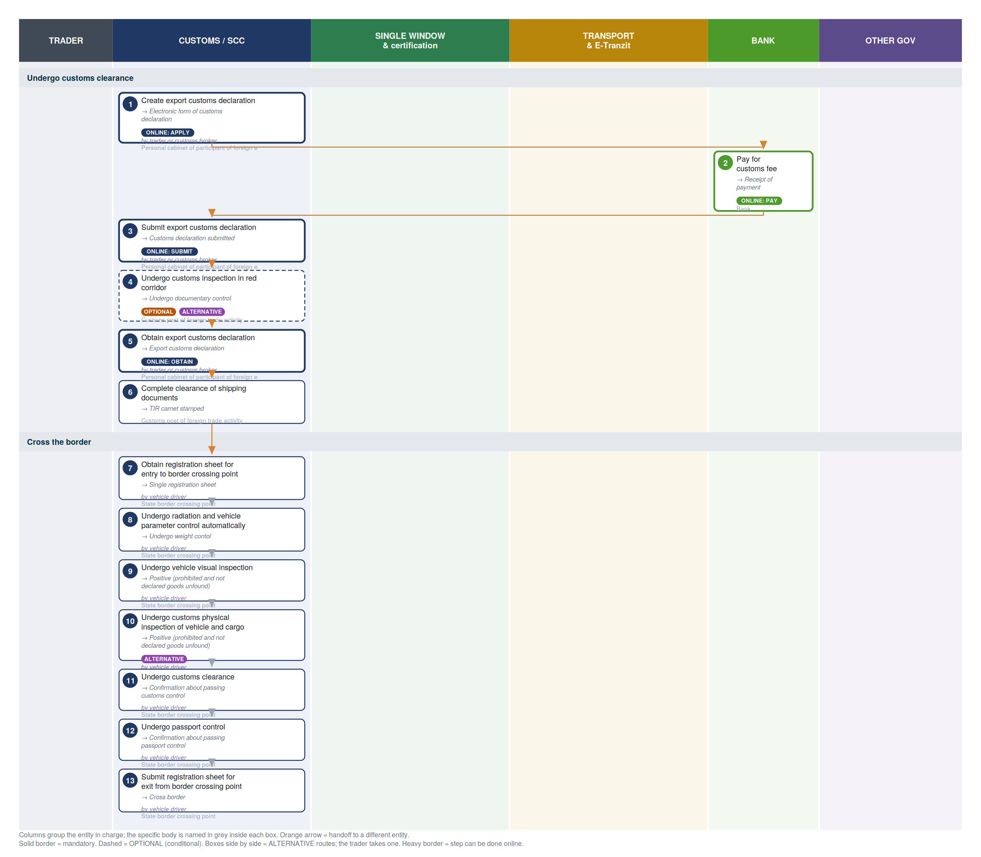

2. Where each step happens
Every step classified by channel. Online steps are performed on an external government service (the exact URL is in section 6). In-person steps happen at a physical counter, named in the “where” column.
Channel | Steps | Detail
Online — external service | 4 | Customs e-declaration cabinet (SCC) (3), Trade info portal (1)
In person — physical counter | 9 | Customs post of foreign trade activity, State border crossing point

3. Entities in charge & contact channels
Entity | Steps | Lane | Contact channels
Personal cabinet of participant of foreign economic activity | 1, 3, 5 | Customs / SCC | 🌐 http://ed1.customs.uz, http://ed2.customs.uz
Bank | 2 | Bank | — none published —
Customs post of foreign trade activity | 4, 6 | Customs / SCC | — none published —
State border crossing point | 7, 8, 9, 10, 11, 12, 13 | Customs / SCC | — none published —

4. Step-by-step breakdown
Full sequence. Channel shows online vs in-person; Where / service names the exact website for online steps or the physical location for in-person ones; Performed by is who carries the step out. Optional and alternative steps are flagged.
# | Step | Entity in charge | Channel | Where / service | Performed by
Undergo customs clearance
1 | Create export customs declaration  → Electronic form of customs declaration | Personal cabinet of participant of foreign economic activity | Online: apply | Customs e-declaration cabinet (SCC)  ed1.customs.uz | trader or customs broker
2 | Pay for customs fee  → Receipt of payment | Bank | Online: pay | Trade info portal  uztradeinfo.uz | —
3 | Submit export customs declaration  → Customs declaration submitted | Personal cabinet of participant of foreign economic activity | Online: submit | Customs e-declaration cabinet (SCC)  ed1.customs.uz | trader or customs broker
4 | Undergo customs inspection in red corridor  optional · alternative  → Undergo documentary control | Customs post of foreign trade activity | In person | Group of customs control and customs clearance | —
5 | Obtain export customs declaration  → Export customs declaration | Personal cabinet of participant of foreign economic activity | Online: obtain | Customs e-declaration cabinet (SCC)  ed1.customs.uz | trader or customs broker
6 | Complete clearance of shipping documents  → TIR carnet stamped | Customs post of foreign trade activity | In person | Group of customs control and customs clearance | —
Cross the border
7 | Obtain registration sheet for entry to border crossing point  → Single registration sheet | State border crossing point | In person | Border control | vehicle driver
8 | Undergo radiation and vehicle parameter control automatically  → Undergo weight contol | State border crossing point | In person | Weight and radiation control | vehicle driver
9 | Undergo vehicle visual inspection  → Positive (prohibited and not declared goods unfound) | State border crossing point | In person | Customs inspection area | vehicle driver
10 | Undergo customs physical inspection of vehicle and cargo  alternative  → Positive (prohibited and not declared goods unfound) | State border crossing point | In person | Inspection and screening station | vehicle driver
11 | Undergo customs clearance  → Confirmation about passing customs control | State border crossing point | In person | Customs control | vehicle driver
12 | Undergo passport control  → Confirmation about passing passport control | State border crossing point | In person | Passport control point | vehicle driver
13 | Submit registration sheet for exit from border crossing point  → Cross border | State border crossing point | In person | Border control | vehicle driver

5. Inputs required per step
Type 1 = the trader supplies it from outside the procedure. Type 2 = produced by an earlier step, so it is a dependency the agent can track.
1. Create export customs declaration
- Electronic digital signature [trader supplies]
- Identification number of foreign trade contract [trader supplies]
- Commercial invoice [trader supplies]
- Convention on the International Carriage of Goods by Road [trader supplies]
- Documents that are not obligatory to submit for export declaration [trader supplies]
- Certificate of origin [trader supplies]
- Certificate of origin form A [trader supplies]
- Certificate of origin General form [trader supplies]
2. Pay for customs fee
- Bank details of territorial customs departments [trader supplies]
- For physical payment [trader supplies]
- Physical presence [trader supplies]
- For online payment (without necessity to visit a bank) [trader supplies]
- Online banking account [trader supplies]
3. Submit export customs declaration
- Electronic digital signature [trader supplies]
- Electronic form of customs declaration [trader supplies]
4. Undergo customs inspection in red corridor
- Export customs declaration [trader supplies]
- Convention on the International Carriage of Goods by Road [trader supplies]
- Commercial invoice [trader supplies]
- Physical presence [trader supplies]
- Passport [trader supplies]
- Power of attorney [trader supplies]
5. Obtain export customs declaration
- Electronic digital signature [trader supplies]
6. Complete clearance of shipping documents
- Convention on the International Carriage of Goods by Road [trader supplies]
- Commercial invoice [trader supplies]
- For issuance of Cargo delivery control book [trader supplies]
- Vehicle registration certificate [trader supplies]
- Driver's license [trader supplies]
- For clearance of TIR carnet (when goods are transported under the Cover of TIR Carnet) [trader supplies]
- TIR Carnet - "Transport International Routier" [trader supplies]
7. Obtain registration sheet for entry to border crossing point
- Physical presence [trader supplies]
- International passport [trader supplies]
- Vehicle registration number [trader supplies]
8. Undergo radiation and vehicle parameter control automatically
- Physical presence [trader supplies]
9. Undergo vehicle visual inspection
- Physical presence [trader supplies]
10. Undergo customs physical inspection of vehicle and cargo
- Physical presence [trader supplies]
11. Undergo customs clearance
- Single registration sheet [trader supplies]
- Documents related to the vehicle [trader supplies]
- Vehicle registration certificate [trader supplies]
- Authorization for international carriage of goods [trader supplies]
- ATP certificate [trader supplies]
- Documents related to the cargo [trader supplies]
- Export customs declaration [trader supplies]
- Cargo delivery control book [trader supplies]
- TIR Carnet - "Transport International Routier" [trader supplies]
- Convention on the International Carriage of Goods by Road [trader supplies]
- Commercial invoice [trader supplies]
- Documents of the driver/hauler [trader supplies]
- International passport [trader supplies]
12. Undergo passport control
- Single registration sheet [trader supplies]
- International passport [trader supplies]
13. Submit registration sheet for exit from border crossing point
- Single registration sheet [trader supplies]
- Physical presence [trader supplies]

6. Online service redirects
Every online step in this procedure sends the trader to an external government service. These are the exact destinations — the redirect targets an agent (or a person) would need to reach.
# | Step | Action | Service URL
1 | Create export customs declaration | apply | Customs e-declaration cabinet (SCC)  http://ed1.customs.uz/PersonCabinet/template/property/ted_proper.jsp
2 | Pay for customs fee | pay | Trade info portal  https://uztradeinfo.uz/menu/22
3 | Submit export customs declaration | submit | Customs e-declaration cabinet (SCC)  http://ed1.customs.uz/PersonCabinet/template/property/ted_proper.jsp
5 | Obtain export customs declaration | obtain | Customs e-declaration cabinet (SCC)  http://ed1.customs.uz/PersonCabinet/template/property/ted_proper.jsp
Distinct services in this procedure: Customs e-declaration cabinet (SCC) (3); Trade info portal (1)

7. Document samples
Specimen images of the documents this procedure requires, published by the platform. Duplicates across steps are shown once. 19 distinct documents.
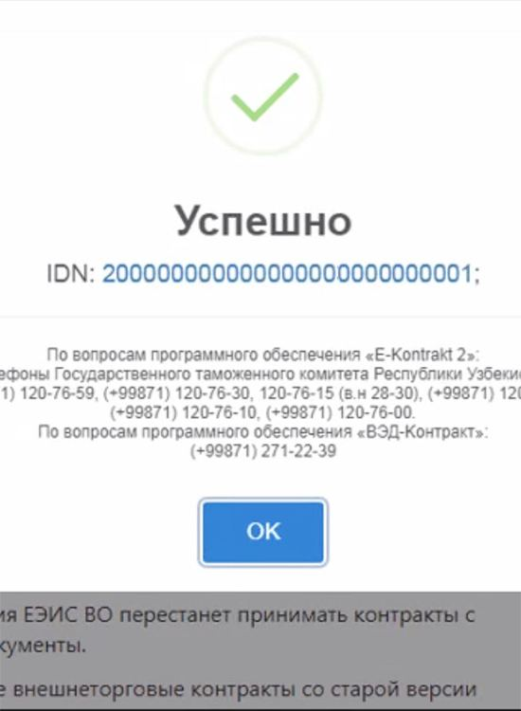  Identification number of foreign trade contract | 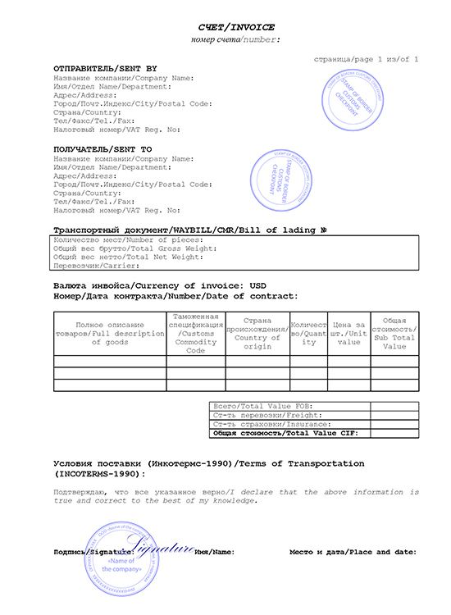  Commercial invoice | 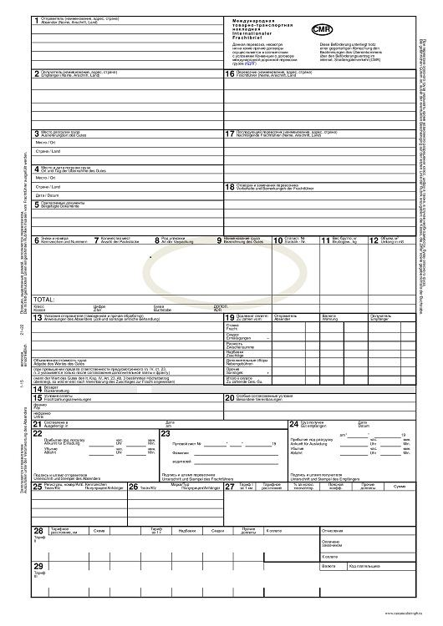  Convention on the International Carriage of Goods by Road
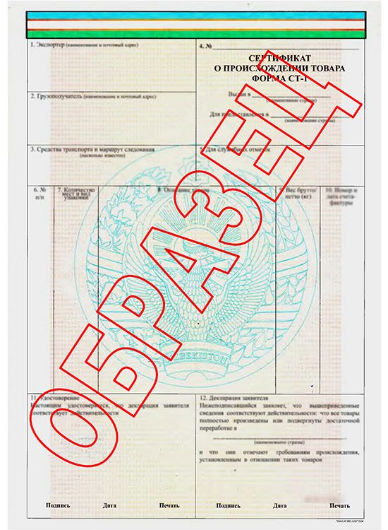  Certificate of origin | 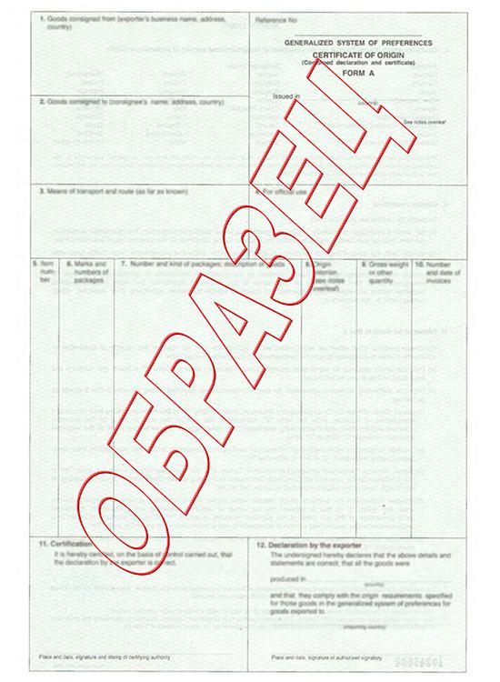  Certificate of origin form A | 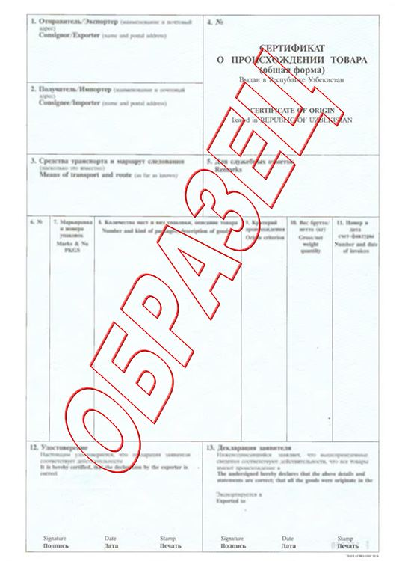  Certificate of origin General form
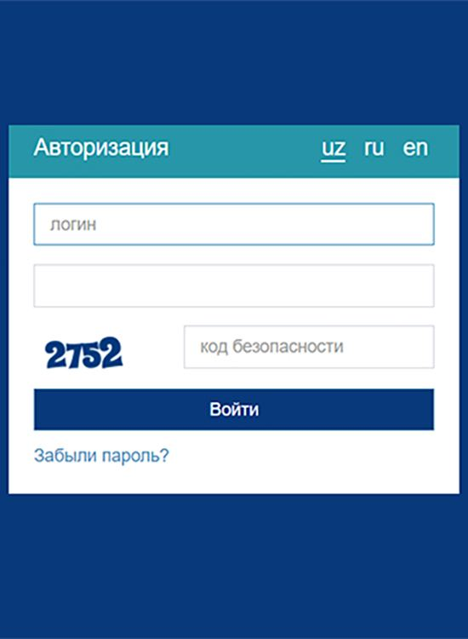  Online banking account | 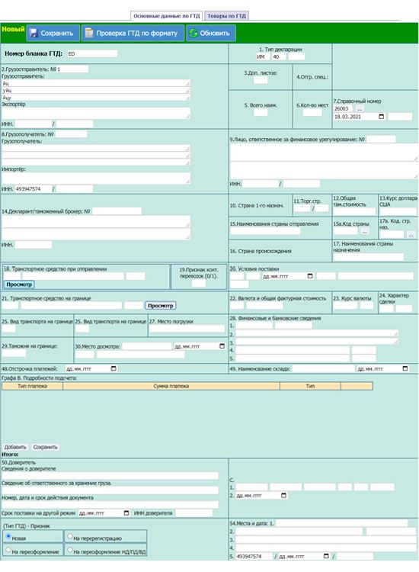  Electronic form of customs declaration | 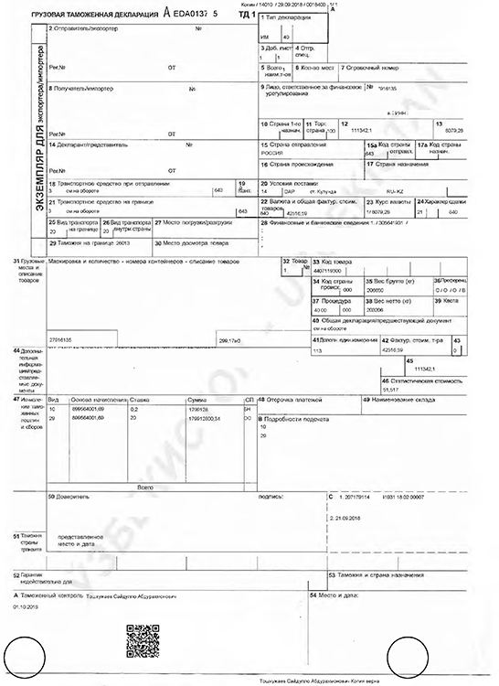  Export customs declaration
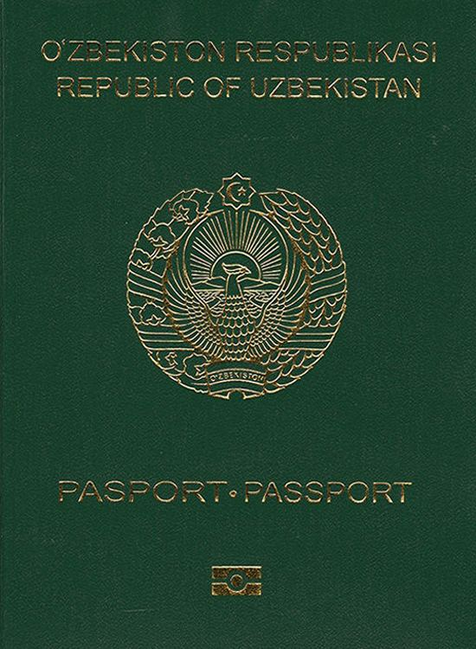  Passport | 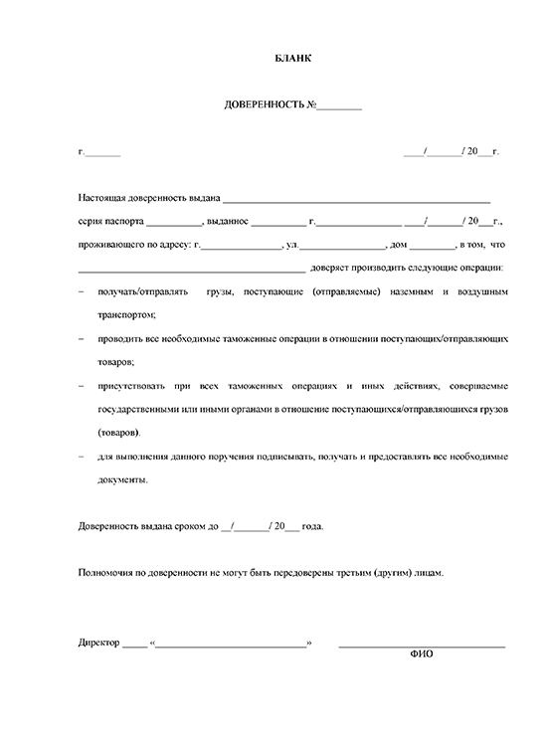  Power of attorney | 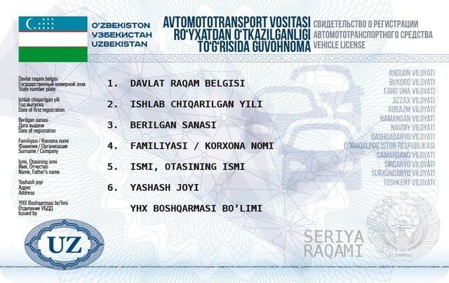  Vehicle registration certificate
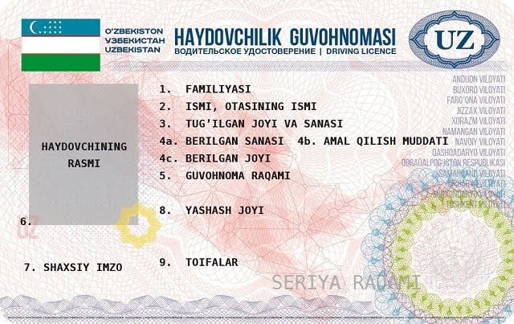  Driver's license | 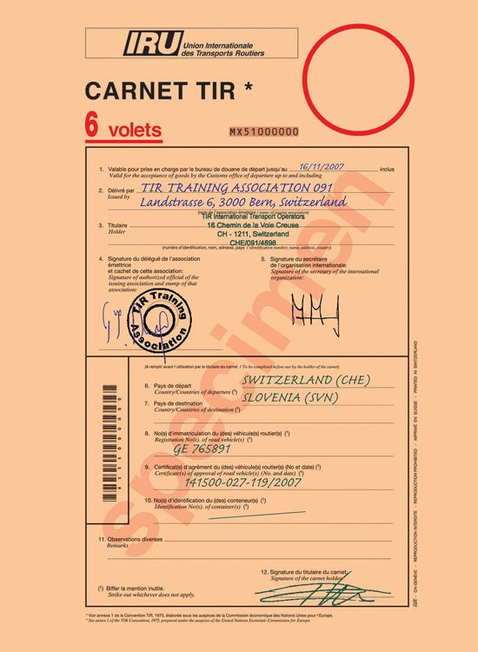  TIR Carnet - "Transport International Routier" | 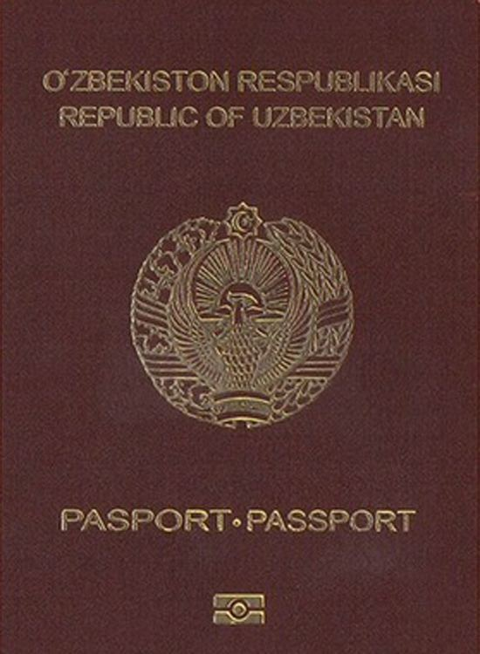  International passport
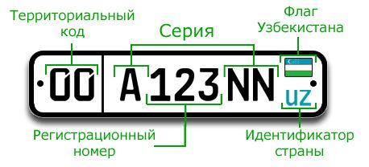  Vehicle registration number | 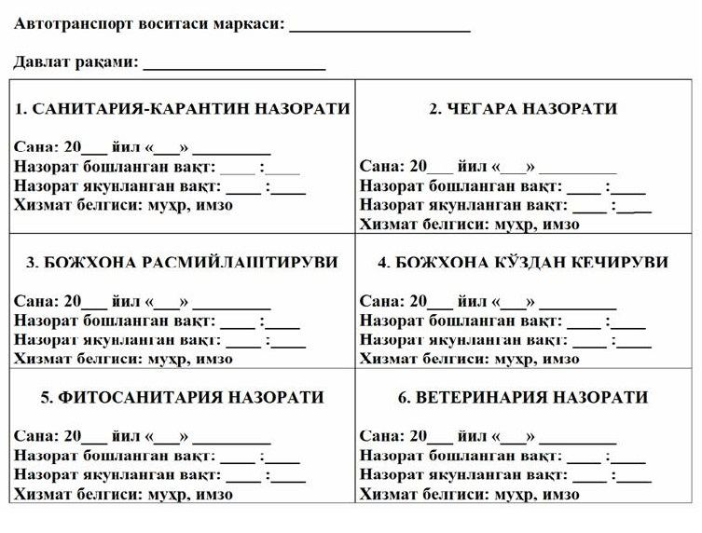  Single registration sheet | 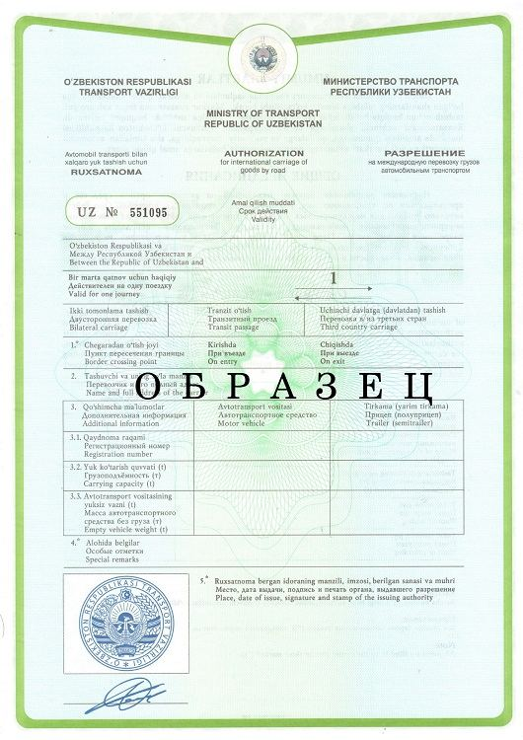  Authorization for international carriage of goods
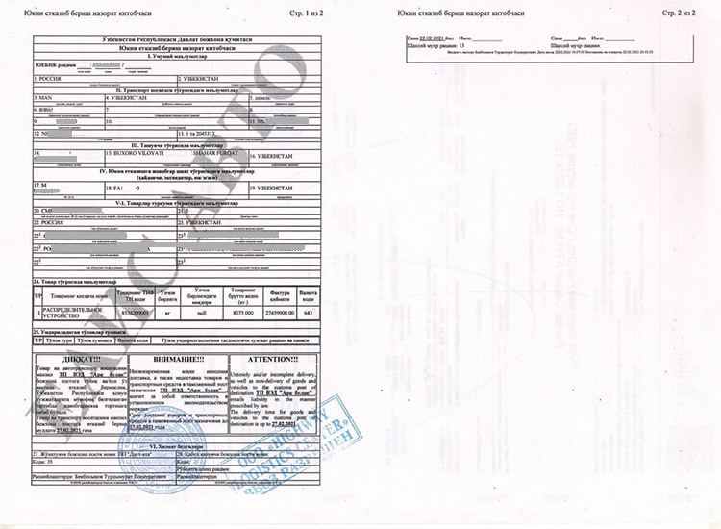
Cargo delivery control book

8. Step reference screenshots
The platform's own screen for each step, reproduced as published. These are screenshots of the eRegulations record (in Uzbek), showing contact details, expected result, requirements and price — not screenshots of the destination government service. They serve as visual provenance for the tables above.
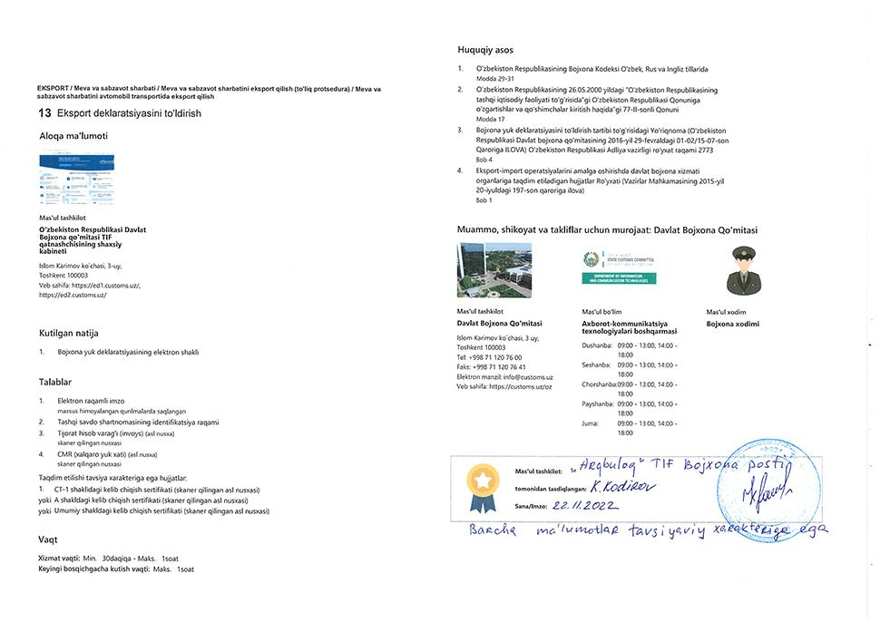  Step 1 — Create export customs declaration | 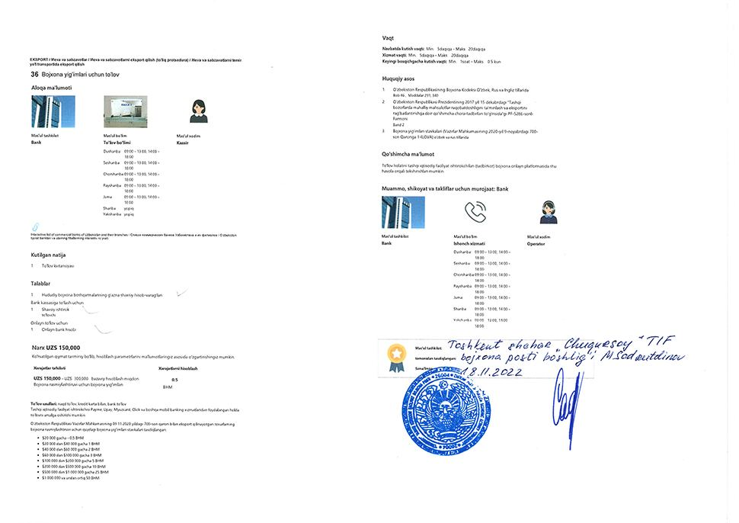  Step 2 — Pay for customs fee
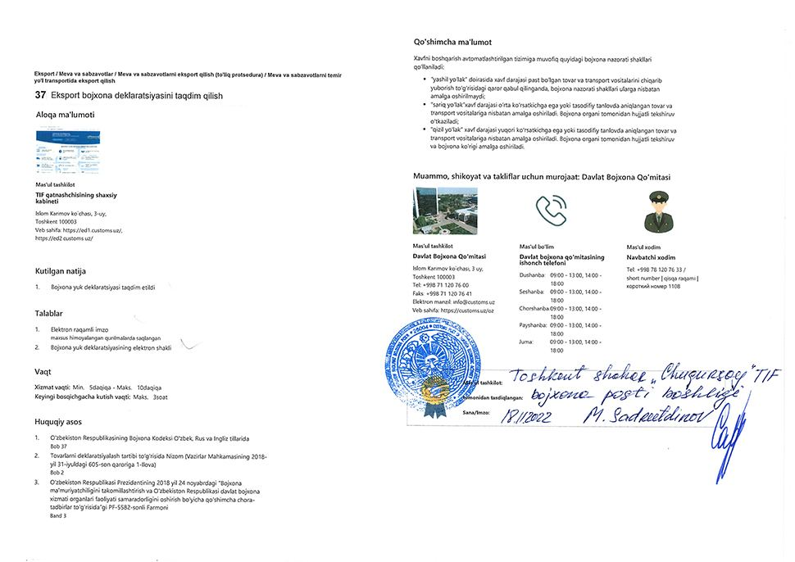  Step 3 — Submit export customs declaration | 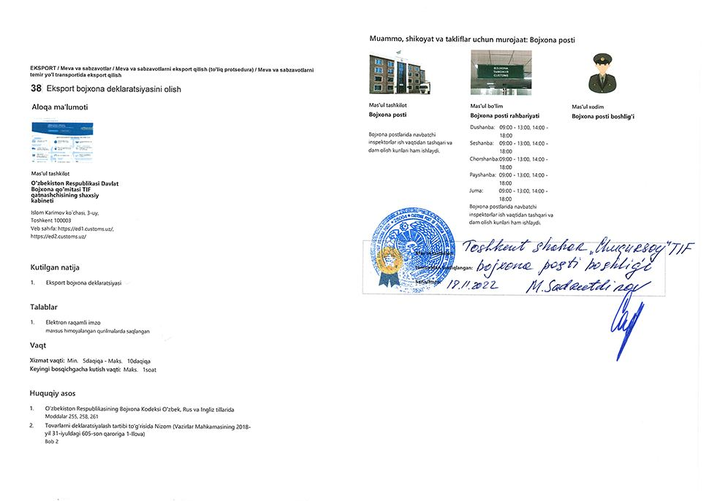  Step 5 — Obtain export customs declaration
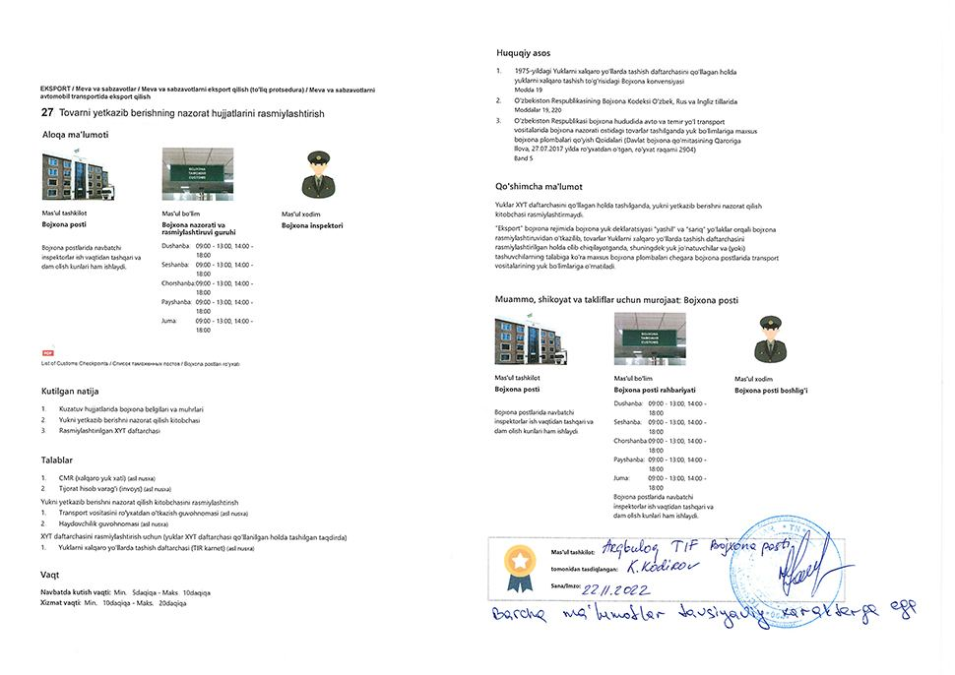  Step 6 — Complete clearance of shipping documents | 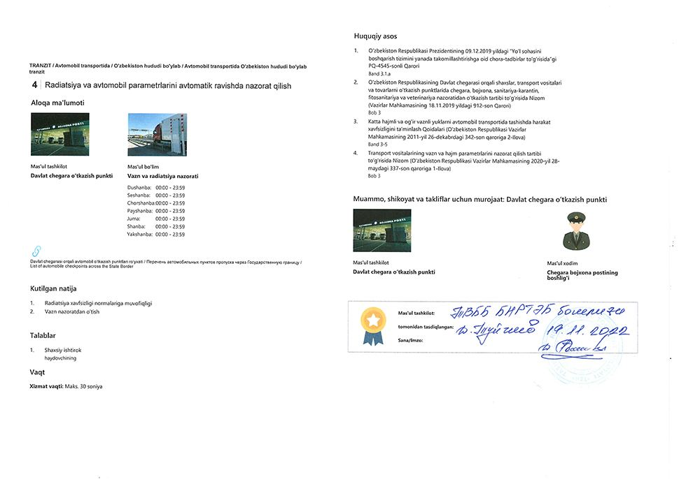  Step 8 — Undergo radiation and vehicle parameter control automatically
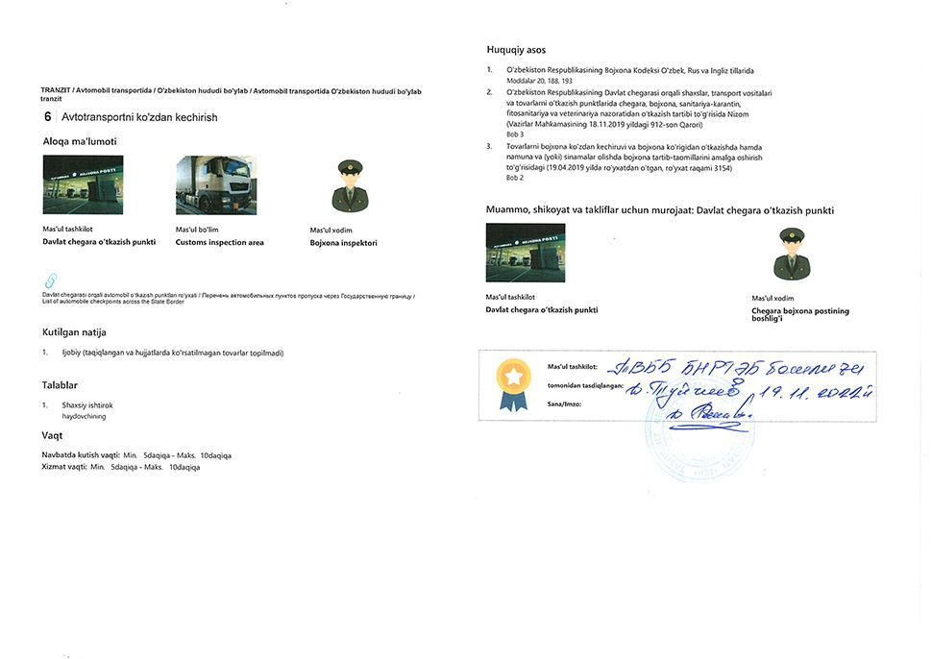  Step 9 — Undergo vehicle visual inspection | 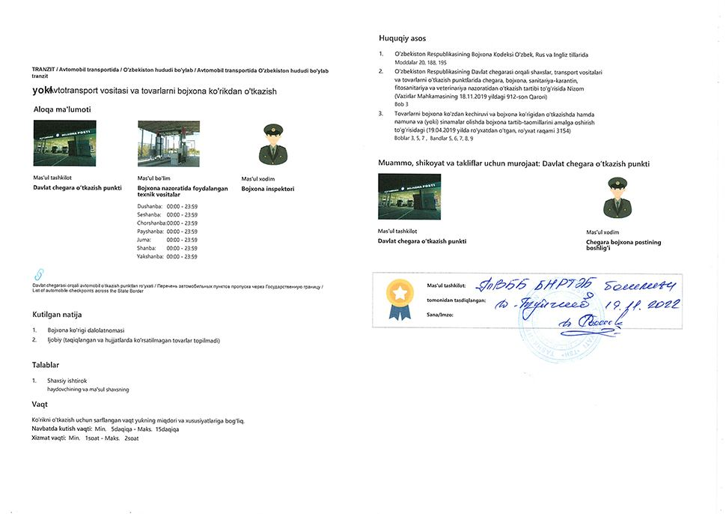  Step 10 — Undergo customs physical inspection of vehicle and cargo
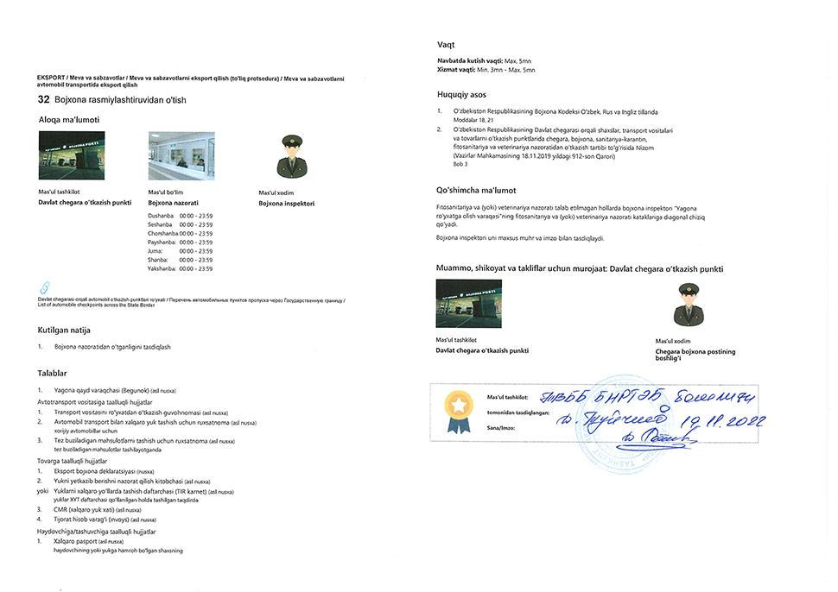
Step 11 — Undergo customs clearance

