Uzbekistan Trade Info — Procedure Automation
Procedure 325: Export of fresh fruits and vegetables by train
As-is process map — the procedure exactly as it runs today. Source: uztradeinfo.uz/procedure/325
Blocks | Steps | Entities | Online | Optional | Alternative
10 | 48 | 18 | 22 | 4 | 2
End-to-end published timeframe: 81–241 hours.
1. Process flow
Columns group the entity in charge, so every move between columns is a handoff. The specific body is named in grey inside each box. Dashed border = optional (conditional) step. Boxes side by side = alternative routes, where the trader takes one. Heavy border = the step can be done online.
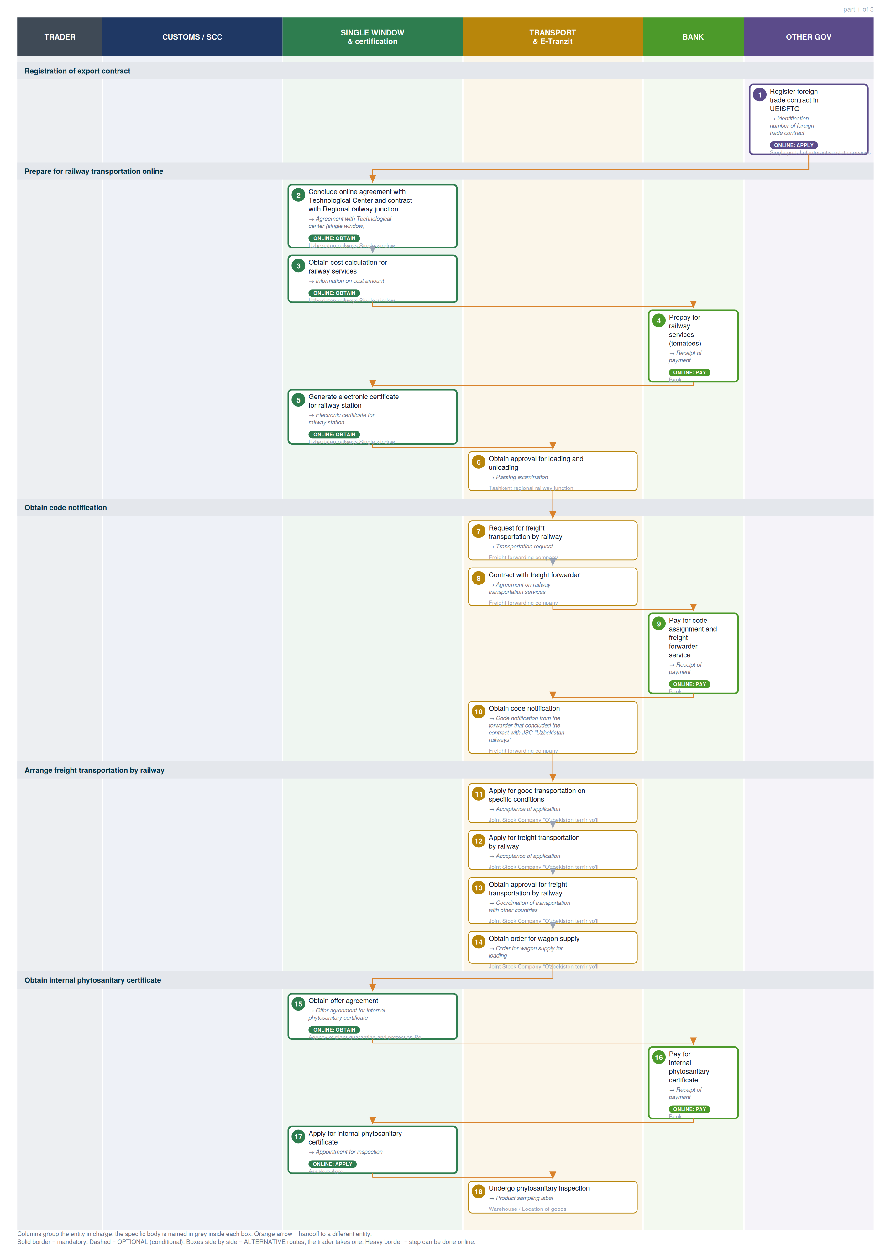

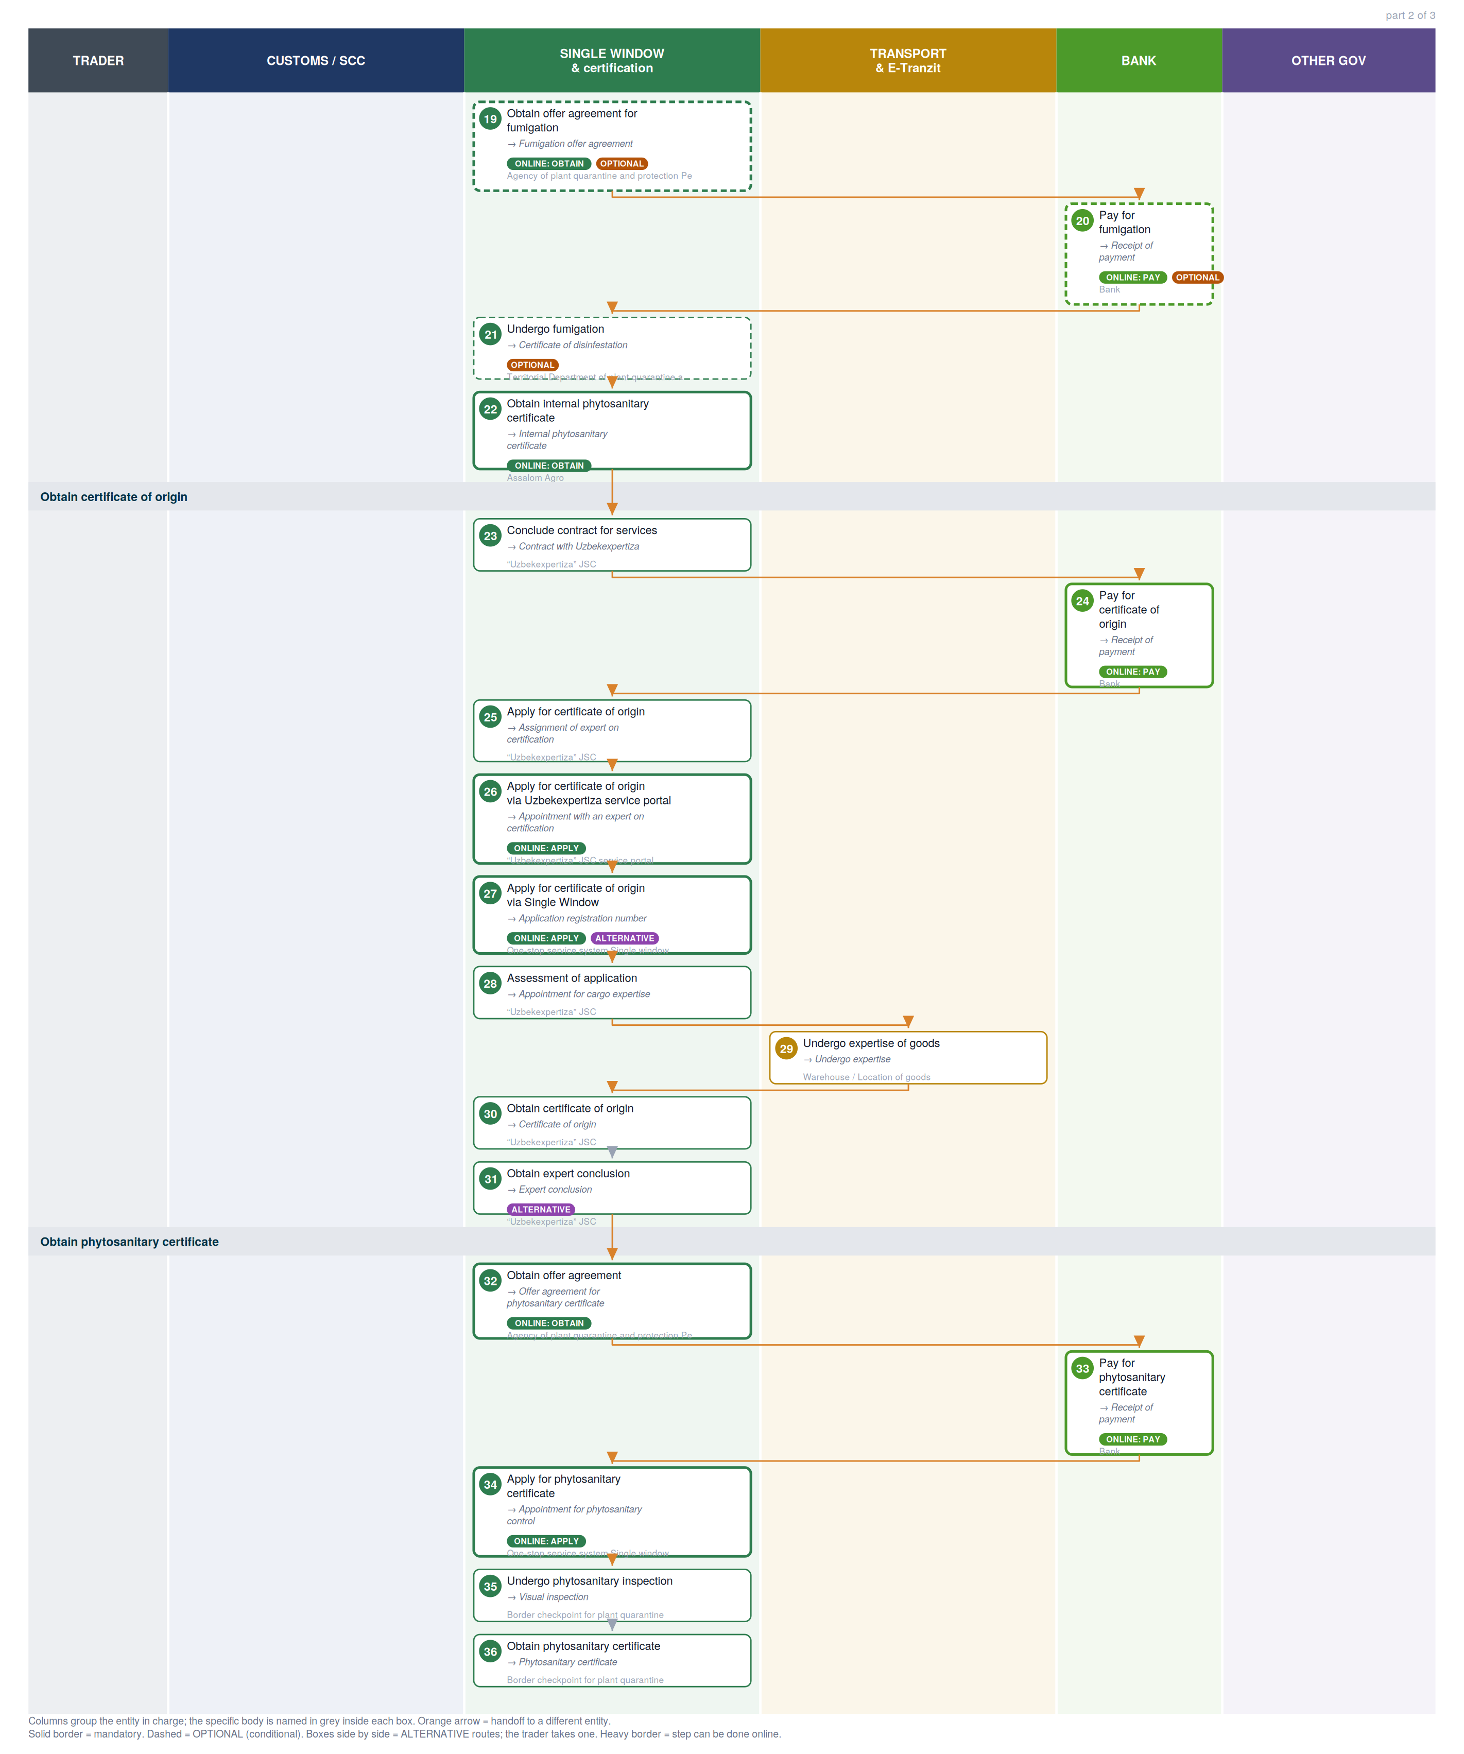

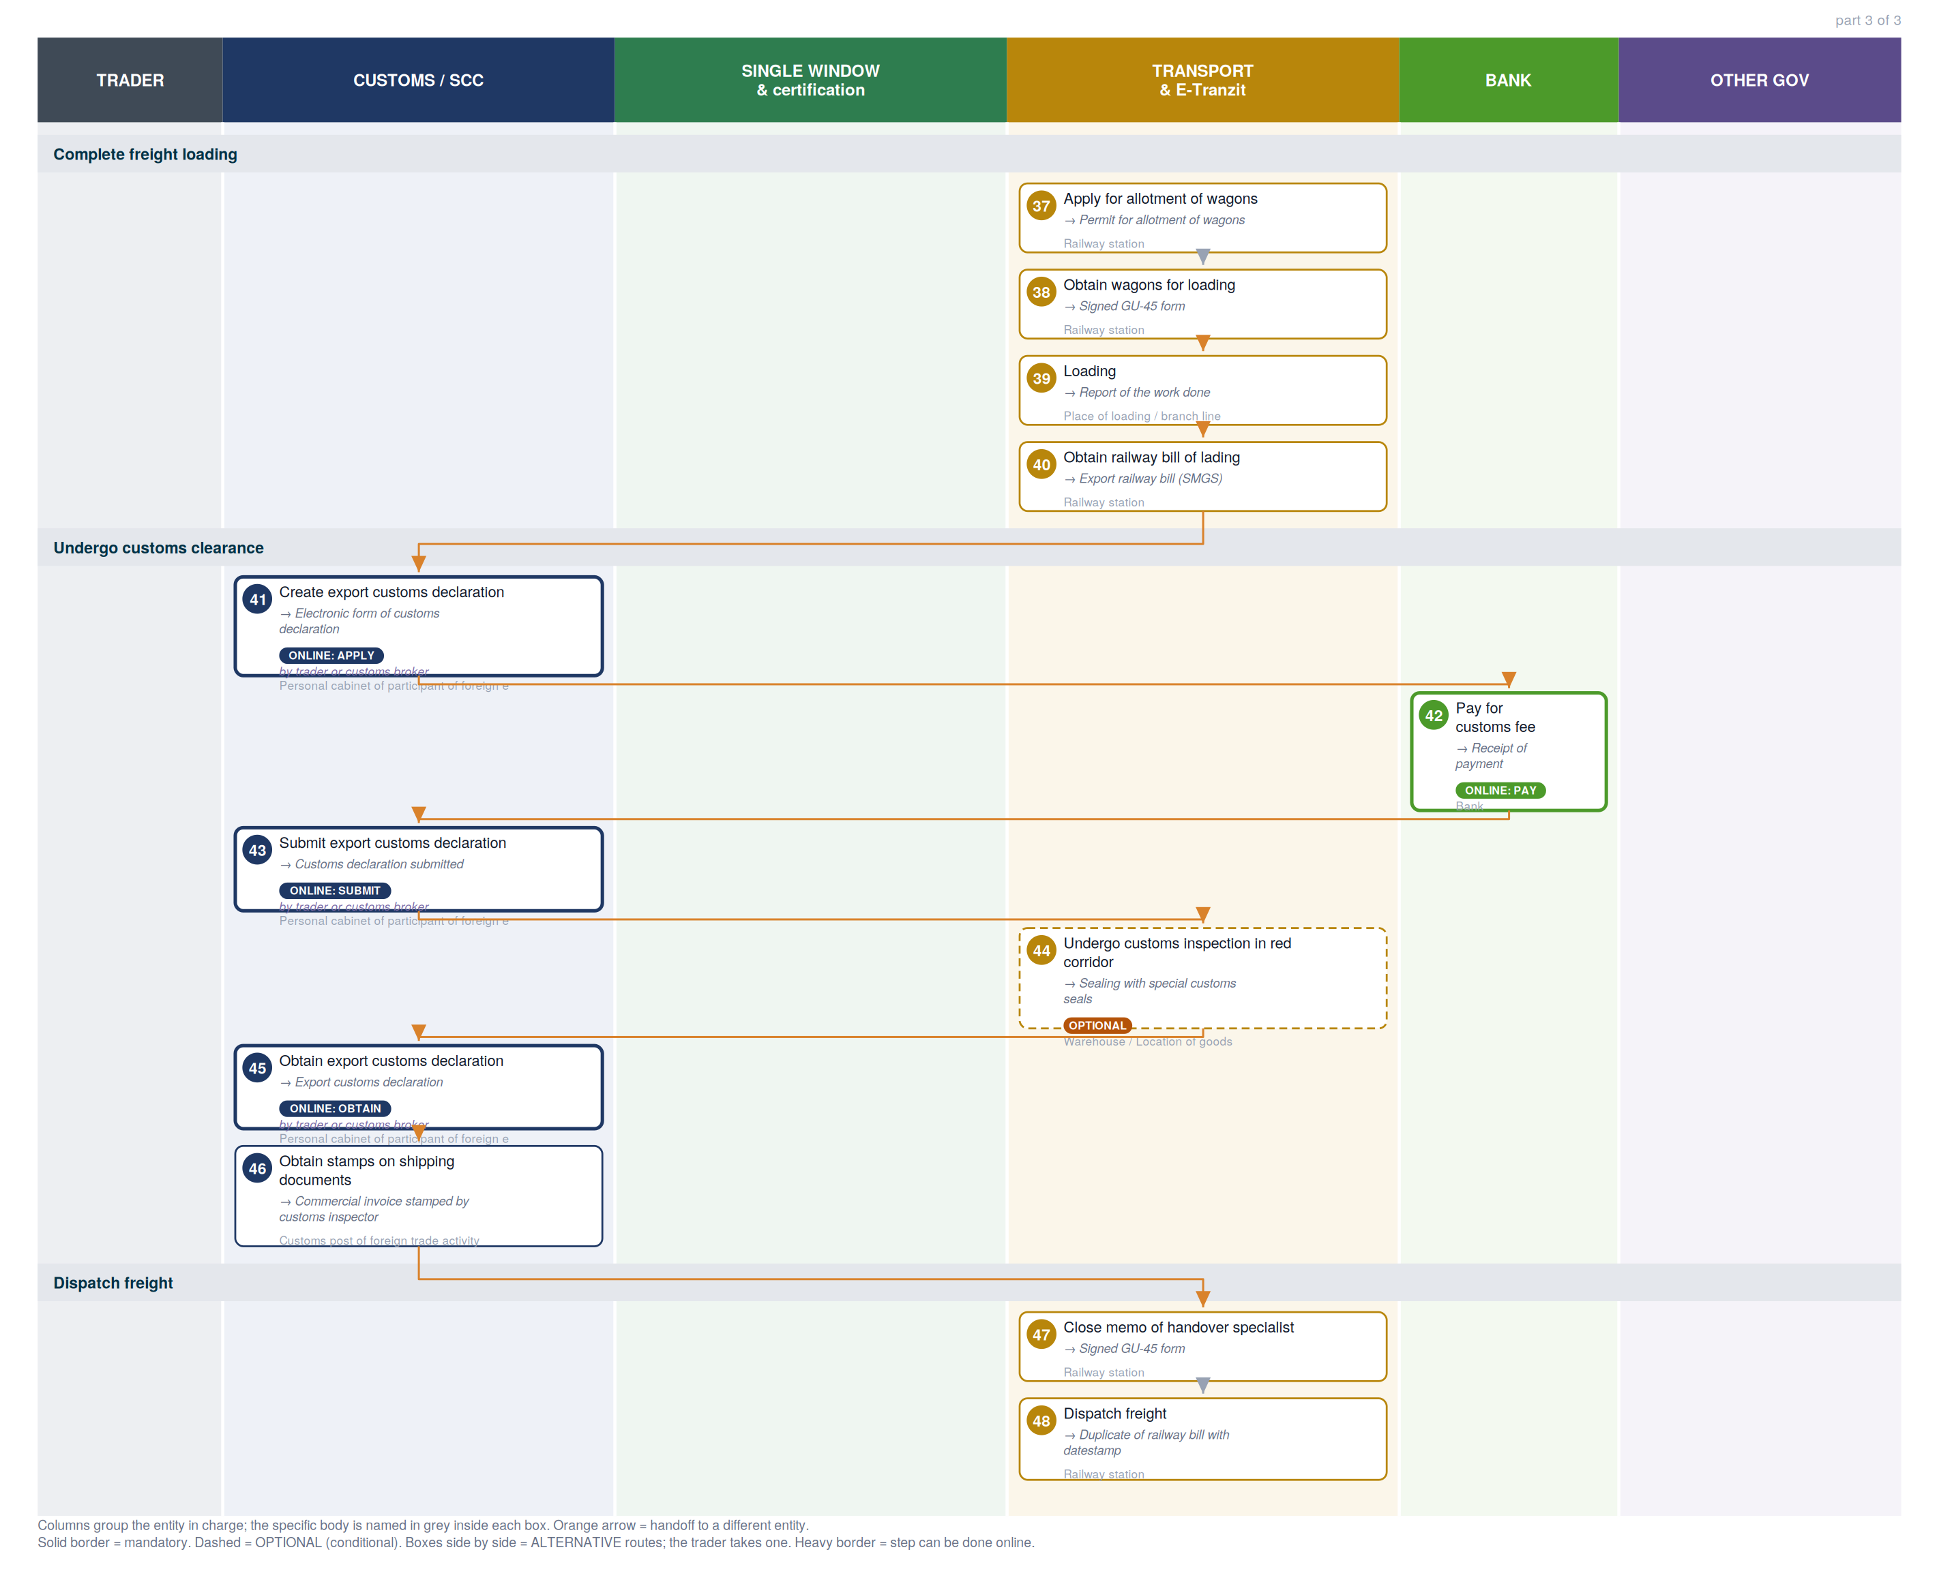

2. Where each step happens
Every step classified by channel. Online steps are performed on an external government service (the exact URL is in section 6). In-person steps happen at a physical counter, named in the “where” column.
Channel | Steps | Detail
Online — external service | 22 | Payment methods information page (6), Railway electronic waybill (3), Customs e-declaration cabinet (SCC) (3), eFito (phytosanitary) (2), assalomagro.uz (2), Single Window (2), my.gov.uz — unified state services (1), Uzbekexpertiza service portal (1), Quarantine cabinet (1), Trade info portal (1)
In person — physical counter | 26 | Tashkent regional railway junction, Freight forwarding company, Joint Stock Company "O'zbekiston temir yo'llari", Warehouse / Location of goods, Territorial Department of plant quarantine and protection, “Uzbekexpertiza” JSC, Border checkpoint for plant quarantine, Railway station, Place of loading / branch line, Customs post of foreign trade activity

3. Entities in charge & contact channels
Entity | Steps | Lane | Contact channels
Single portal of interactive state services | 1 | Other government | ✉ epigu@egov.uz  ☎ +998 55 501 36 19, +998 55 501 36 17  🌐 https://my.gov.uz/, https://my.gov.uz/ru/site/feedback
Uzbekistan railways Single window | 2, 3, 5 | Single Window & certification | ✉ git@railway.uz  ☎ +998 71 238 88 02  🌐 https://e-nakl.railway.uz/
Bank | 4, 9, 16, 20, 24, 33, 42 | Bank | — none published —
Tashkent regional railway junction | 6 | Transport & E-Tranzit | ✉ rju-1@railway.uz  ☎ +998 71 299 96 20  🌐 http://tashkent.railway.uz/en/
Freight forwarding company | 7, 8, 10 | Transport & E-Tranzit | — none published —
Joint Stock Company "O'zbekiston temir yo'llari" | 11, 12, 13, 14 | Transport & E-Tranzit | ✉ info@uzrailway.uz  ☎ +998 71 237 99 98, 1005  🌐 https://railway.uz/en/
Agency of plant quarantine and protection Personal cabinet (Oferta) | 15, 19, 32 | Single Window & certification | ✉ info@karantin.uz  🌐 https://efito.uz/invoice/, http://karantin.uz/
Assalom Agro | 17, 22 | Single Window & certification | ✉ assalomagro@gmail.com, info@5x5.uz  ☎ +998 55 502 55 75, +998 98 198 14 02  🌐 https://assalomagro.uz/en
Warehouse / Location of goods | 18, 29, 44 | Transport & E-Tranzit | — none published —
Territorial Department of plant quarantine and protection | 21 | Single Window & certification | — none published —
“Uzbekexpertiza” JSC | 23, 25, 28, 30, 31 | Single Window & certification | ✉ info1@expertiza.uz, expertiza@exat.uz  ☎ +998 71 230 23 64, +998 71 230 23 60  🌐 http://www.expertiza.uz/, http://t.me/uzbekexpertiza_bot
“Uzbekexpertiza” JSC service portal | 26 | Single Window & certification | 🌐 http://application.expertiza.uz/expertiza/#/, http://www.expertiza.uz/
One-stop service system Single window | 27, 34 | Single Window & certification | ☎ +998 78 120 76 08 (Int. 5603, 5646, 5606, 5885) , +998 78 120 76 00 (Int. 5603, 5646, 5606, 5885)  🌐 http://singlewindow.uz/index.jsp, http://sw2.customs.uz/
Border checkpoint for plant quarantine | 35, 36 | Single Window & certification | — none published —
Railway station | 37, 38, 40, 47, 48 | Transport & E-Tranzit | — none published —
Place of loading / branch line | 39 | Transport & E-Tranzit | — none published —
Personal cabinet of participant of foreign economic activity | 41, 43, 45 | Customs / SCC | 🌐 http://ed1.customs.uz, http://ed2.customs.uz
Customs post of foreign trade activity | 46 | Customs / SCC | — none published —

4. Step-by-step breakdown
Full sequence. Channel shows online vs in-person; Where / service names the exact website for online steps or the physical location for in-person ones; Performed by is who carries the step out. Optional and alternative steps are flagged.
# | Step | Entity in charge | Channel | Where / service | Performed by
Registration of export contract
1 | Register foreign trade contract in UEISFTO  → Identification number of foreign trade contract | Single portal of interactive state services | Online: apply | my.gov.uz — unified state services  my.gov.uz | —
Prepare for railway transportation online
2 | Conclude online agreement with Technological Center and contract with Regional railway junction  → Agreement with Technological center (single window) | Uzbekistan railways Single window | Online: obtain | Railway electronic waybill  e-nakl.railway.uz | —
3 | Obtain cost calculation for railway services  → Information on cost amount | Uzbekistan railways Single window | Online: obtain | Railway electronic waybill  e-nakl.railway.uz | —
4 | Prepay for railway services (tomatoes)  → Receipt of payment | Bank | Online: pay | Payment methods information page  uzbekistan.tradeportal.org | —
5 | Generate electronic certificate for railway station  → Electronic certificate for railway station | Uzbekistan railways Single window | Online: obtain | Railway electronic waybill  e-nakl.railway.uz | —
6 | Obtain approval for loading and unloading  → Passing examination | Tashkent regional railway junction | In person | Inspectors of the Department on freight and commerce Room 402, 4th floor" | —
Obtain code notification
7 | Request for freight transportation by railway  → Transportation request | Freight forwarding company | In person | Freight forwarding company | —
8 | Contract with freight forwarder  → Agreement on railway transportation services | Freight forwarding company | In person | Freight forwarding company | —
9 | Pay for code assignment and freight forwarder service  → Receipt of payment | Bank | Online: pay | Payment methods information page  uzbekistan.tradeportal.org | —
10 | Obtain code notification  → Code notification from the forwarder that concluded the contract with JSC "Uzbekistan railways" | Freight forwarding company | In person | Freight forwarding company | —
Arrange freight transportation by railway
11 | Apply for good transportation on specific conditions  → Acceptance of application | Joint Stock Company "O'zbekiston temir yo'llari" | In person | Department of carriage conditions "Room 313, 3rd Floor" | —
12 | Apply for freight transportation by railway  → Acceptance of application | Joint Stock Company "O'zbekiston temir yo'llari" | In person | Transportation Unit "Room 128, 1st Floor" | —
13 | Obtain approval for freight transportation by railway  → Coordination of transportation with other countries | Joint Stock Company "O'zbekiston temir yo'llari" | In person | Transportation Unit "Room 128, 1st Floor" | —
14 | Obtain order for wagon supply  → Order for wagon supply for loading | Joint Stock Company "O'zbekiston temir yo'llari" | In person | Transportation Unit "Room 128, 1st Floor" | —
Obtain internal phytosanitary certificate
15 | Obtain offer agreement  → Offer agreement for internal phytosanitary certificate | Agency of plant quarantine and protection Personal cabinet (Oferta) | Online: obtain | eFito (phytosanitary)  efito.uz | —
16 | Pay for internal phytosanitary certificate  → Receipt of payment | Bank | Online: pay | Payment methods information page  uzbekistan.tradeportal.org | —
17 | Apply for internal phytosanitary certificate  → Appointment for inspection | Assalom Agro | Online: apply | assalomagro.uz  assalomagro.uz | —
18 | Undergo phytosanitary inspection  → Product sampling label | Warehouse / Location of goods | In person | Warehouse / Location of goods | —
19 | Obtain offer agreement for fumigation  optional  → Fumigation offer agreement | Agency of plant quarantine and protection Personal cabinet (Oferta) | Online: obtain | eFito (phytosanitary)  efito.uz | —
20 | Pay for fumigation  optional  → Receipt of payment | Bank | Online: pay | Payment methods information page  uzbekistan.tradeportal.org | —
21 | Undergo fumigation  optional  → Certificate of disinfestation | Territorial Department of plant quarantine and protection | In person | Fumigation (disinfection) division | —
22 | Obtain internal phytosanitary certificate  → Internal phytosanitary certificate | Assalom Agro | Online: obtain | assalomagro.uz  assalomagro.uz | —
Obtain certificate of origin
23 | Conclude contract for services  → Contract with Uzbekexpertiza | “Uzbekexpertiza” JSC | In person | Deputy Chief of the Department of examination of preferential goods "Room 36, 3rd floor" | —
24 | Pay for certificate of origin  → Receipt of payment | Bank | Online: pay | Payment methods information page  uzbekistan.tradeportal.org | —
25 | Apply for certificate of origin  → Assignment of expert on certification | “Uzbekexpertiza” JSC | In person | Deputy Chief of the Department of examination of preferential goods "Room 36, 3rd floor" | —
26 | Apply for certificate of origin via Uzbekexpertiza service portal  → Appointment with an expert on certification | “Uzbekexpertiza” JSC service portal | Online: apply | Uzbekexpertiza service portal  application.expertiza.uz | —
27 | Apply for certificate of origin via Single Window  alternative  → Application registration number | One-stop service system Single window | Online: apply | Single Window  singlewindow.uz | —
28 | Assessment of application  → Appointment for cargo expertise | “Uzbekexpertiza” JSC | In person | Department of Examination of Preferential Goods "3rd floor" | —
29 | Undergo expertise of goods  → Undergo expertise | Warehouse / Location of goods | In person | Warehouse / Location of goods | —
30 | Obtain certificate of origin  → Certificate of origin | “Uzbekexpertiza” JSC | In person | Department of Examination of Preferential Goods "3rd floor" | —
31 | Obtain expert conclusion  alternative  → Expert conclusion | “Uzbekexpertiza” JSC | In person | Department of Examination of Preferential Goods "3rd floor" | —
Obtain phytosanitary certificate
32 | Obtain offer agreement  → Offer agreement for phytosanitary certificate | Agency of plant quarantine and protection Personal cabinet (Oferta) | Online: obtain | Quarantine cabinet  cabinet.karantin.uz | —
33 | Pay for phytosanitary certificate  → Receipt of payment | Bank | Online: pay | Payment methods information page  uzbekistan.tradeportal.org | —
34 | Apply for phytosanitary certificate  → Appointment for phytosanitary control | One-stop service system Single window | Online: apply | Single Window  singlewindow.uz | —
35 | Undergo phytosanitary inspection  → Visual inspection | Border checkpoint for plant quarantine | In person | Office of the inspector on the border checkpoint for plant quarantine | —
36 | Obtain phytosanitary certificate  → Phytosanitary certificate | Border checkpoint for plant quarantine | In person | Office of the inspector on the border checkpoint for plant quarantine | —
Complete freight loading
37 | Apply for allotment of wagons  → Permit for allotment of wagons | Railway station | In person | Commodity cash desk | —
38 | Obtain wagons for loading  → Signed GU-45 form | Railway station | In person | Freight acceptance and handover Room | —
39 | Loading  → Report of the work done | Place of loading / branch line | In person | Place of loading / branch line | —
40 | Obtain railway bill of lading  → Export railway bill (SMGS) | Railway station | In person | Commodity cash desk | —
Undergo customs clearance
41 | Create export customs declaration  → Electronic form of customs declaration | Personal cabinet of participant of foreign economic activity | Online: apply | Customs e-declaration cabinet (SCC)  ed1.customs.uz | trader or customs broker
42 | Pay for customs fee  → Receipt of payment | Bank | Online: pay | Trade info portal  uztradeinfo.uz | —
43 | Submit export customs declaration  → Customs declaration submitted | Personal cabinet of participant of foreign economic activity | Online: submit | Customs e-declaration cabinet (SCC)  ed1.customs.uz | trader or customs broker
44 | Undergo customs inspection in red corridor  optional  → Sealing with special customs seals | Warehouse / Location of goods | In person | Warehouse / Location of goods | —
45 | Obtain export customs declaration  → Export customs declaration | Personal cabinet of participant of foreign economic activity | Online: obtain | Customs e-declaration cabinet (SCC)  ed1.customs.uz | trader or customs broker
46 | Obtain stamps on shipping documents  → Commercial invoice stamped by customs inspector | Customs post of foreign trade activity | In person | Group of customs control and customs clearance | —
Dispatch freight
47 | Close memo of handover specialist  → Signed GU-45 form | Railway station | In person | Freight acceptance and handover Room | —
48 | Dispatch freight  → Duplicate of railway bill with datestamp | Railway station | In person | Commodity cash desk | —

5. Inputs required per step
Type 1 = the trader supplies it from outside the procedure. Type 2 = produced by an earlier step, so it is a dependency the agent can track.
1. Register foreign trade contract in UEISFTO
- Electronic digital signature [trader supplies]
- Electronic copy of foreign trade contract [trader supplies]
2. Conclude online agreement with Technological Center and contract with Regional railway junction
- Electronic digital signature [trader supplies]
- One ID account [trader supplies]
3. Obtain cost calculation for railway services
- Electronic digital signature [trader supplies]
- One ID account [trader supplies]
4. Prepay for railway services (tomatoes)
- Invoice for payment for railway services [trader supplies]
- Agreement with Technological center [trader supplies]
- For physical payment [trader supplies]
- Physical presence [trader supplies]
- For online payment (without necessity to visit a bank) [trader supplies]
- Online banking account [trader supplies]
5. Generate electronic certificate for railway station
- Electronic digital signature [trader supplies]
6. Obtain approval for loading and unloading
- Physical presence [trader supplies]
- Passport [trader supplies]
- Power of attorney [trader supplies]
7. Request for freight transportation by railway
- Foreign economic activity contract [trader supplies]
- Supply contract [trader supplies]
8. Contract with freight forwarder
- Passport [trader supplies]
- Power of attorney [trader supplies]
- Tax Identification Number of the organization or individual [trader supplies]
- Personal identification number of an individual [trader supplies]
- Bank details [trader supplies]
9. Pay for code assignment and freight forwarder service
- Invoice for payment [trader supplies]
- Agreement on railway transportation services [trader supplies]
- For physical payment [trader supplies]
- Physical presence [trader supplies]
- Passport [trader supplies]
- For online payment (without necessity to visit a bank) [trader supplies]
- Online banking account [trader supplies]
10. Obtain code notification
- Receipt of payment [trader supplies]
- Agreement on railway transportation services [trader supplies]
11. Apply for good transportation on specific conditions
- Application for good transportation on specific conditions [trader supplies]
12. Apply for freight transportation by railway
- For submitting application by emails mpo@uzrailway.uz, mpo1@uzrailway.uz, mpo2@uzrailway.uz [trader supplies]
- Application for cargo transportation GU-12 [trader supplies]
- Application for obtaining approval of cargo transportation [trader supplies]
- Islamic Republic of Iran approval letter [trader supplies]
- For submitting application physically [trader supplies]
- Application for cargo transportation GU-12 [trader supplies]
- Application for obtaining approval of cargo transportation [trader supplies]
- Islamic Republic of Iran approval letter [trader supplies]
13. Obtain approval for freight transportation by railway
- Availability by phone [trader supplies]
14. Obtain order for wagon supply
- For submitting application by emails mpo@uzrailway.uz, mpo1@uzrailway.uz, mpo2@uzrailway.uz [trader supplies]
- Application on letterhead [trader supplies]
- Application on letterhead (own wagons) [trader supplies]
- Code notification from the forwarder that concluded the contract with JSC "Uzbekistan railways" [trader supplies]
- For submitting application physically [trader supplies]
- Power of attorney for Transportation Unit [trader supplies]
- Passport [trader supplies]
- Application on letterhead [trader supplies]
- Application on letterhead (own wagons) [trader supplies]
- Code notification from the forwarder that concluded the contract with JSC "Uzbekistan railways" [trader supplies]
15. Obtain offer agreement
- Internet access [trader supplies]
- Data required to complete offer agreement [trader supplies]
- Tax Identification Number of the organization or individual [trader supplies]
- Name of the organization [trader supplies]
- Full name of an organization’s manager [trader supplies]
- Contact phone number [trader supplies]
- Agency region [trader supplies]
- Payment sum [trader supplies]
16. Pay for internal phytosanitary certificate
- Offer agreement for internal phytosanitary certificate [trader supplies]
- For physical payment [trader supplies]
- Physical presence [trader supplies]
- Passport [trader supplies]
- For online payment (without necessity to visit a bank) [trader supplies]
- Online banking account [trader supplies]
17. Apply for internal phytosanitary certificate
- To access the platform [trader supplies]
- One ID account [trader supplies]
- Contact phone number [trader supplies]
- Email [trader supplies]
18. Undergo phytosanitary inspection
- Physical presence [trader supplies]
19. Obtain offer agreement for fumigation
- Internet access [trader supplies]
- Data required to complete offer agreement [trader supplies]
- Tax Identification Number of the organization or individual [trader supplies]
- Name of the organization [trader supplies]
- Full name of an organization’s manager [trader supplies]
- Type of organization (business entity, budgetary) [trader supplies]
- Contact phone number [trader supplies]
- Agency region [trader supplies]
- Cost on the contract [trader supplies]
20. Pay for fumigation
- Fumigation offer agreement [trader supplies]
- For physical payment [trader supplies]
- Physical presence [trader supplies]
- Passport [trader supplies]
- For online payment (without necessity to visit a bank) [trader supplies]
- Online banking account [trader supplies]
21. Undergo fumigation
- Physical presence [trader supplies]
22. Obtain internal phytosanitary certificate
- One ID account [trader supplies]
- Contact phone number [trader supplies]
- Email [trader supplies]
23. Conclude contract for services
- Physical presence [trader supplies]
- Passport [trader supplies]
- Power of attorney [trader supplies]
24. Pay for certificate of origin
- Invoice for prepayment [trader supplies]
- For physical payment [trader supplies]
- Physical presence [trader supplies]
- Passport [trader supplies]
- For online payment (without necessity to visit a bank) [trader supplies]
- Online banking account [trader supplies]
25. Apply for certificate of origin
- Application for obtaining of Certificate of origin for exported goods [trader supplies]
- Application for obtaining of Certificate of origin for exported goods [trader supplies]
- Commercial invoice [trader supplies]
- Any document confirming the exporter's right to use a land plot [trader supplies]
- Any document confirming purchase of agricultural products [trader supplies]
26. Apply for certificate of origin via Uzbekexpertiza service portal
- Electronic digital signature [trader supplies]
- One ID account [trader supplies]
- Online application for certificate of origin [trader supplies]
- Commercial invoice [trader supplies]
- Any document confirming the exporter's right to use a land plot [trader supplies]
- Any document confirming purchase of agricultural products [trader supplies]
27. Apply for certificate of origin via Single Window
- Electronic digital signature [trader supplies]
- Online application for certificate of origin [trader supplies]
- Commercial invoice [trader supplies]
- Any document confirming the exporter's right to use a land plot [trader supplies]
- Any document confirming purchase of agricultural products [trader supplies]
28. Assessment of application
- Physical presence [trader supplies]
29. Undergo expertise of goods
- Physical presence [trader supplies]
30. Obtain certificate of origin
- Physical presence [trader supplies]
31. Obtain expert conclusion
- Physical presence [trader supplies]
32. Obtain offer agreement
- Electronic digital signature [trader supplies]
- Data required to complete offer agreement [trader supplies]
- Tax Identification Number of the organization or individual [trader supplies]
- Name of the organization [trader supplies]
- Full name of an organization’s manager [trader supplies]
- Type of organization (business entity, budgetary) [trader supplies]
- Contact phone number [trader supplies]
- Agency region [trader supplies]
- Payment sum [trader supplies]
- Quantity of transport units [trader supplies]
33. Pay for phytosanitary certificate
- Offer agreement for phytosanitary certificate [trader supplies]
- For physical payment [trader supplies]
- Physical presence [trader supplies]
- Passport [trader supplies]
- For online payment (without necessity to visit a bank) [trader supplies]
- Online banking account [trader supplies]
34. Apply for phytosanitary certificate
- Electronic digital signature [trader supplies]
- Online application for phytosanitary certificate [trader supplies]
35. Undergo phytosanitary inspection
- Physical presence [trader supplies]
36. Obtain phytosanitary certificate
- Physical presence [trader supplies]
37. Apply for allotment of wagons
- Physical presence [trader supplies]
- Application on letterhead for allotment of wagons [trader supplies]
- Order for wagon supply for loading [trader supplies]
- Certificate on availability of funds at client's account [trader supplies]
- Passport [trader supplies]
- Power of attorney for railway station [trader supplies]
- Certificate on passing examination [trader supplies]
38. Obtain wagons for loading
- Physical presence [trader supplies]
39. Loading
- Physical presence [trader supplies]
- Power of attorney [trader supplies]
40. Obtain railway bill of lading
- Commercial invoice [trader supplies]
41. Create export customs declaration
- Electronic digital signature [trader supplies]
- Identification number of foreign trade contract [trader supplies]
- Commercial invoice [trader supplies]
- Export railway bill (SMGS) [trader supplies]
- Documents that are not obligatory to submit for export declaration [trader supplies]
- Phytosanitary certificate [trader supplies]
- Certificate of origin [trader supplies]
- Certificate of origin form A [trader supplies]
- Certificate of origin General form [trader supplies]
42. Pay for customs fee
- Bank details of territorial customs departments [trader supplies]
- For physical payment [trader supplies]
- Physical presence [trader supplies]
- For online payment (without necessity to visit a bank) [trader supplies]
- Online banking account [trader supplies]
43. Submit export customs declaration
- Electronic digital signature [trader supplies]
- Electronic form of customs declaration [trader supplies]
44. Undergo customs inspection in red corridor
- Export customs declaration [trader supplies]
- Export railway bill (SMGS) [trader supplies]
- Commercial invoice [trader supplies]
- Physical presence [trader supplies]
- Passport [trader supplies]
- Power of attorney [trader supplies]
45. Obtain export customs declaration
- Electronic digital signature [trader supplies]
46. Obtain stamps on shipping documents
- Physical presence [trader supplies]
- Export railway bill (SMGS) [trader supplies]
- Commercial invoice [trader supplies]
- Export customs declaration [trader supplies]
47. Close memo of handover specialist
- Physical presence [trader supplies]
- Application for wagon handover [trader supplies]
48. Dispatch freight
- Export railway bill (SMGS) [trader supplies]
- Package of documents [trader supplies]

6. Online service redirects
Every online step in this procedure sends the trader to an external government service. These are the exact destinations — the redirect targets an agent (or a person) would need to reach.
# | Step | Action | Service URL
1 | Register foreign trade contract in UEISFTO | apply | my.gov.uz — unified state services  https://my.gov.uz/ru/service/96
2 | Conclude online agreement with Technological Center and contract with Regional railway junction | obtain | Railway electronic waybill  https://e-nakl.railway.uz/ru/Login
3 | Obtain cost calculation for railway services | obtain | Railway electronic waybill  https://e-nakl.railway.uz/ru/Home/Calculate
4 | Prepay for railway services (tomatoes) | pay | Payment methods information page  https://uzbekistan.tradeportal.org/menu/22
5 | Generate electronic certificate for railway station | obtain | Railway electronic waybill  https://e-nakl.railway.uz/ru/Customers/CreateSpravka
9 | Pay for code assignment and freight forwarder service | pay | Payment methods information page  https://uzbekistan.tradeportal.org/menu/22
15 | Obtain offer agreement | obtain | eFito (phytosanitary)  https://efito.uz/invoice/
16 | Pay for internal phytosanitary certificate | pay | Payment methods information page  https://uzbekistan.tradeportal.org/menu/22
17 | Apply for internal phytosanitary certificate | apply | assalomagro.uz  https://assalomagro.uz/en
19 | Obtain offer agreement for fumigation | obtain | eFito (phytosanitary)  https://efito.uz/invoice/
20 | Pay for fumigation | pay | Payment methods information page  https://uzbekistan.tradeportal.org/menu/22
22 | Obtain internal phytosanitary certificate | obtain | assalomagro.uz  https://assalomagro.uz/en
24 | Pay for certificate of origin | pay | Payment methods information page  https://uzbekistan.tradeportal.org/menu/22
26 | Apply for certificate of origin via Uzbekexpertiza service portal | apply | Uzbekexpertiza service portal  http://application.expertiza.uz/expertiza/#/
27 | Apply for certificate of origin via Single Window | apply | Single Window  http://singlewindow.uz/
32 | Obtain offer agreement | obtain | Quarantine cabinet  https://cabinet.karantin.uz/
33 | Pay for phytosanitary certificate | pay | Payment methods information page  https://uzbekistan.tradeportal.org/menu/22
34 | Apply for phytosanitary certificate | apply | Single Window  http://singlewindow.uz/
41 | Create export customs declaration | apply | Customs e-declaration cabinet (SCC)  http://ed1.customs.uz/PersonCabinet/template/property/ted_proper.jsp
42 | Pay for customs fee | pay | Trade info portal  https://uztradeinfo.uz/menu/22
43 | Submit export customs declaration | submit | Customs e-declaration cabinet (SCC)  http://ed1.customs.uz/PersonCabinet/template/property/ted_proper.jsp
45 | Obtain export customs declaration | obtain | Customs e-declaration cabinet (SCC)  http://ed1.customs.uz/PersonCabinet/template/property/ted_proper.jsp
Distinct services in this procedure: my.gov.uz — unified state services (1); Railway electronic waybill (3); Payment methods information page (6); eFito (phytosanitary) (2); assalomagro.uz (2); Uzbekexpertiza service portal (1); Single Window (2); Quarantine cabinet (1); Customs e-declaration cabinet (SCC) (3); Trade info portal (1)

7. Document samples
Specimen images of the documents this procedure requires, published by the platform. Duplicates across steps are shown once. 51 distinct documents.
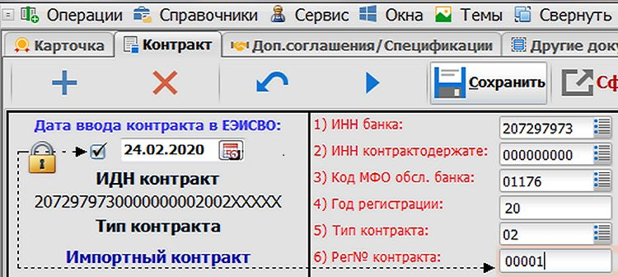  Electronic copy of foreign trade contract | 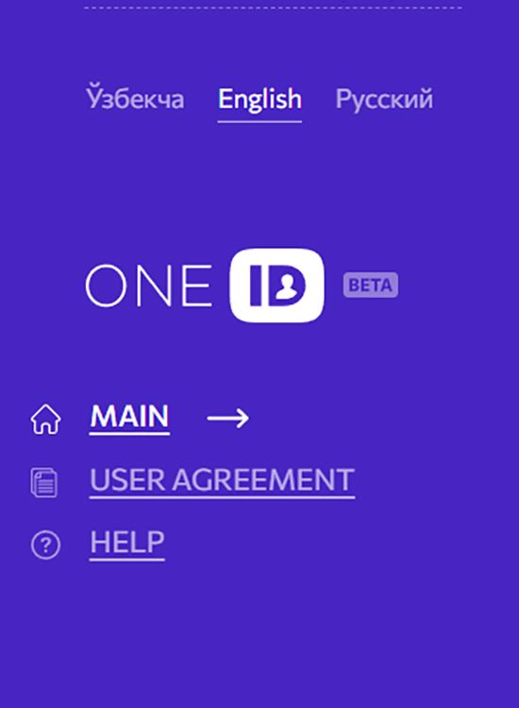  One ID account | 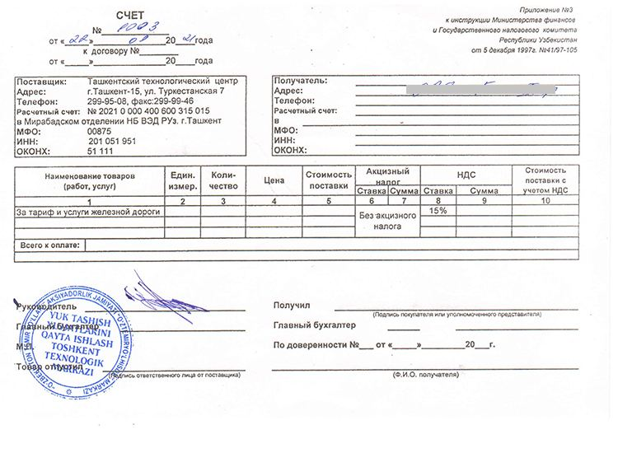  Invoice for payment for railway services
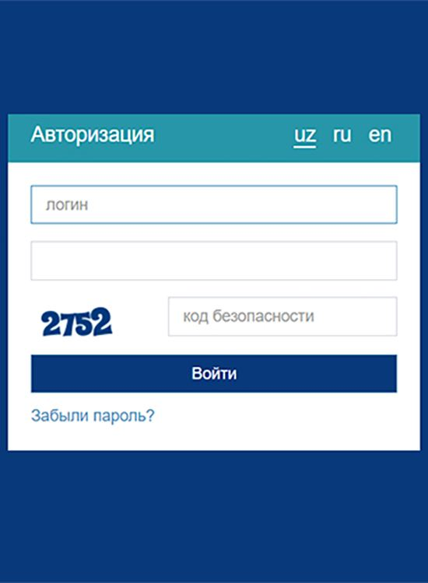  Online banking account | 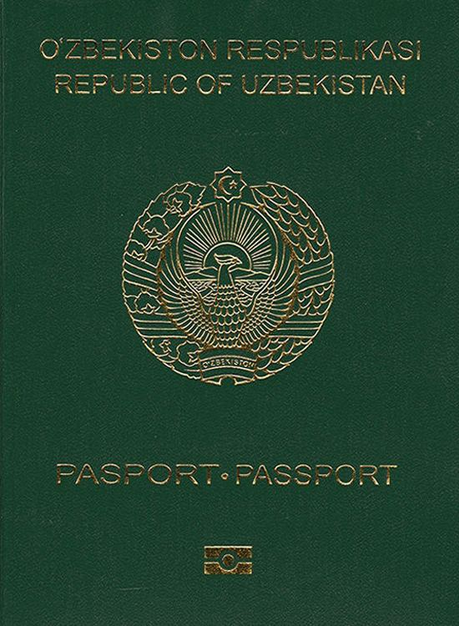  Passport | 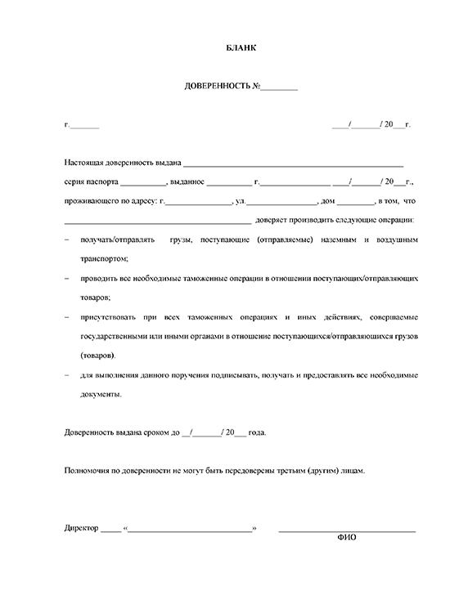  Power of attorney
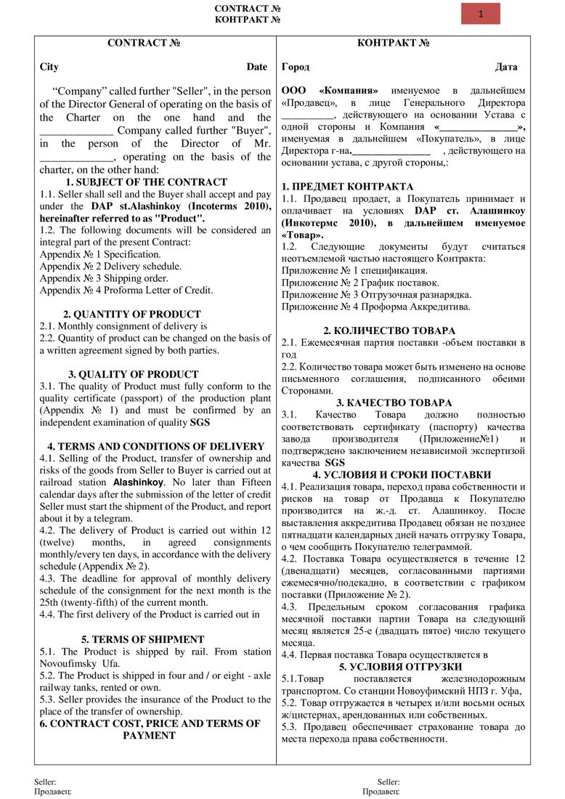  Foreign economic activity contract | Supply contract |   Tax Identification Number of the organization or individual
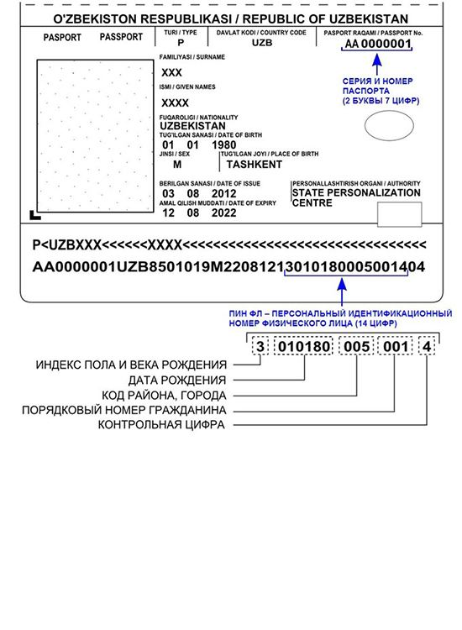  Personal identification number of an individual | 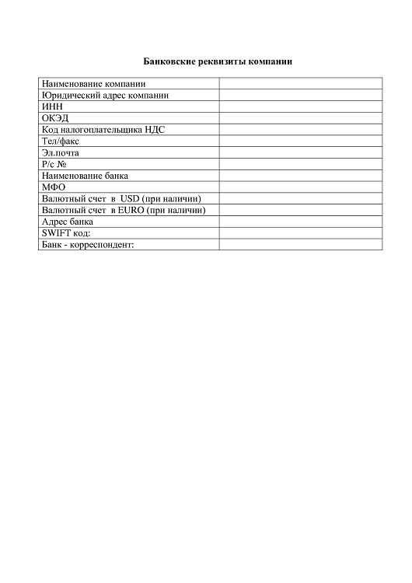  Bank details | 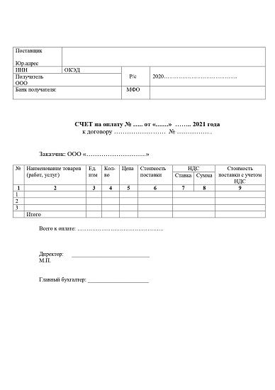  Invoice for payment
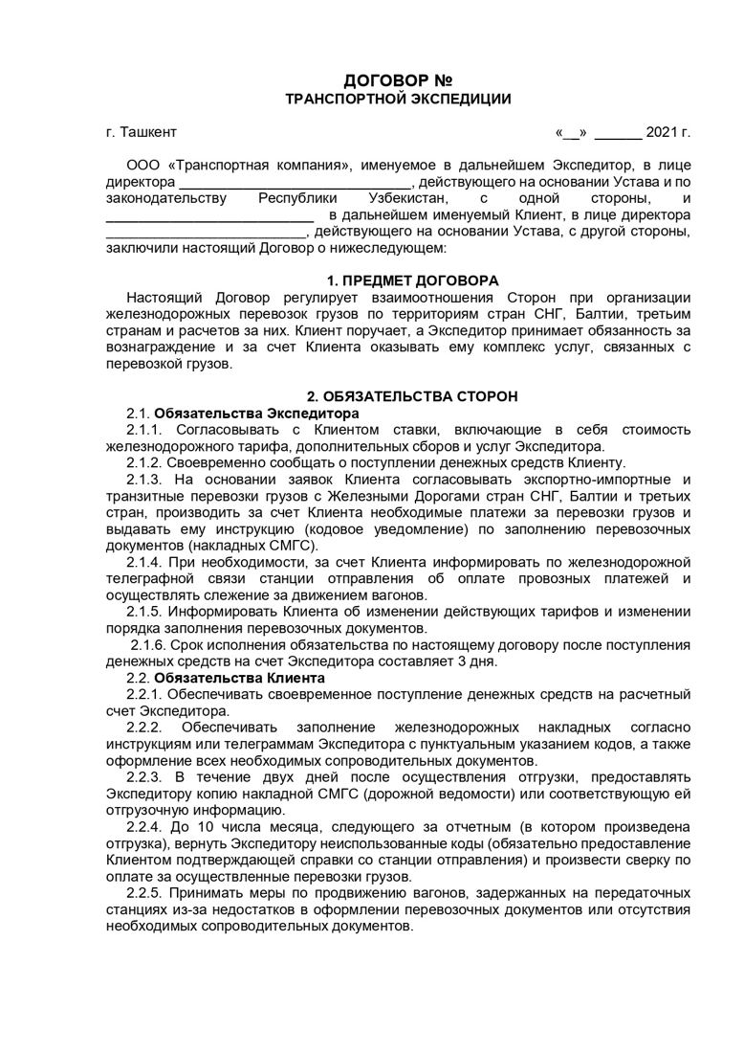  Agreement on railway transportation services | 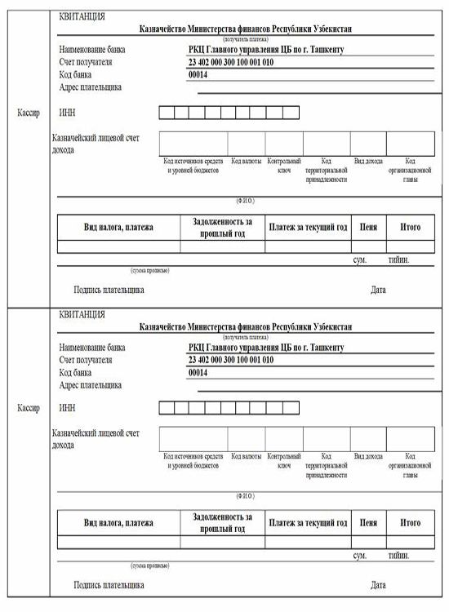  Receipt of payment | 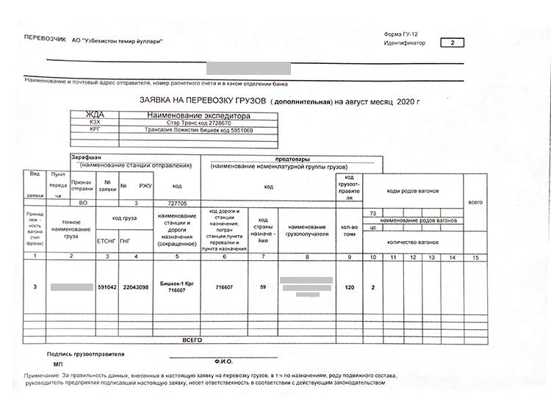  Application for cargo transportation GU-12
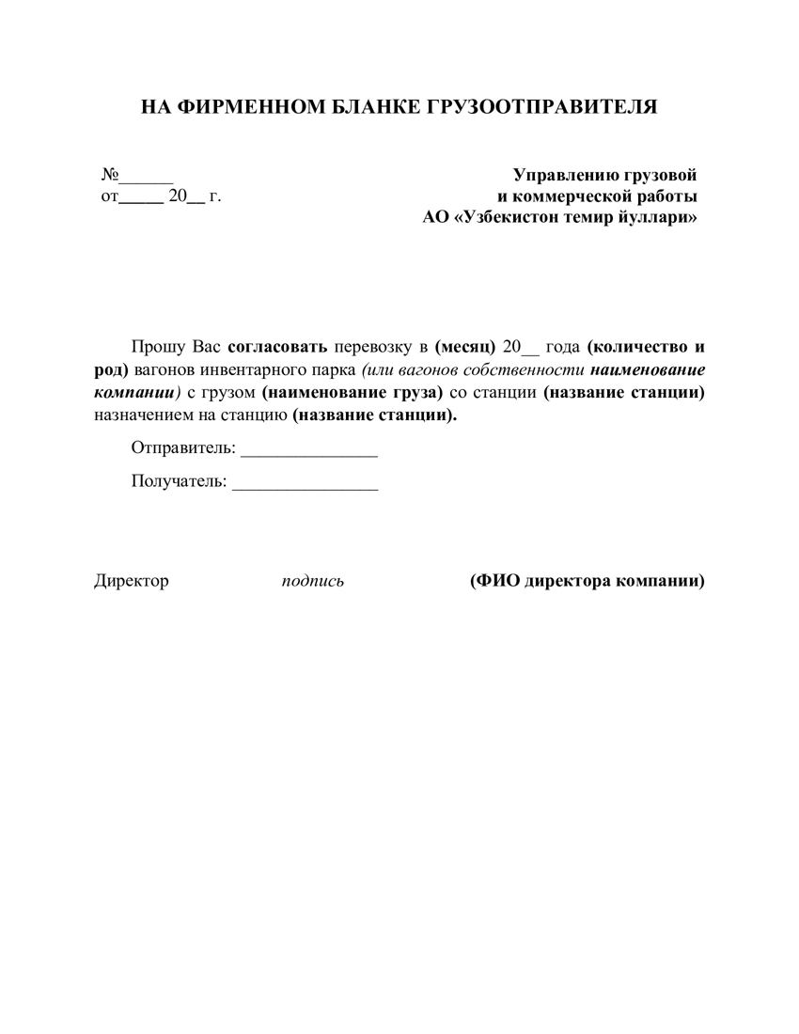  Application for obtaining approval of cargo transportation | 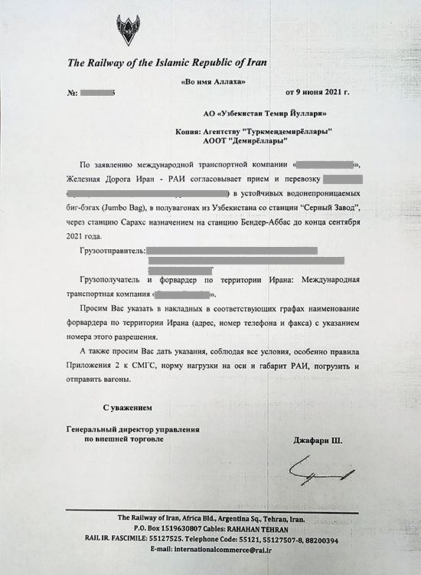  Islamic Republic of Iran approval letter |   Availability by phone
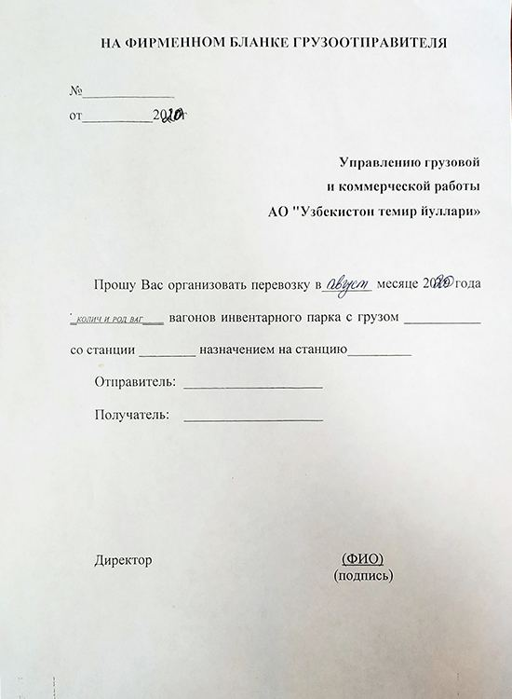  Application on letterhead | 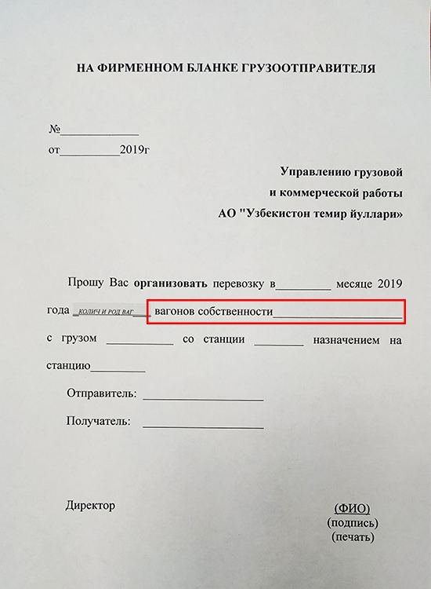  Application on letterhead (own wagons) | 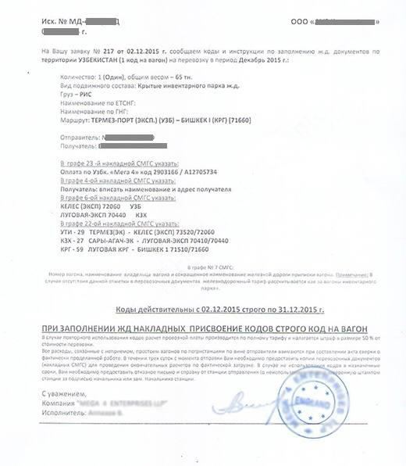  Code notification from the forwarder that concluded the contract with JSC "Uzbekistan railways"
  Internet access | Name of the organization | Full name of an organization’s manager
  Contact phone number | Agency region | Payment sum
Email | Type of organization (business entity, budgetary) | Cost on the contract
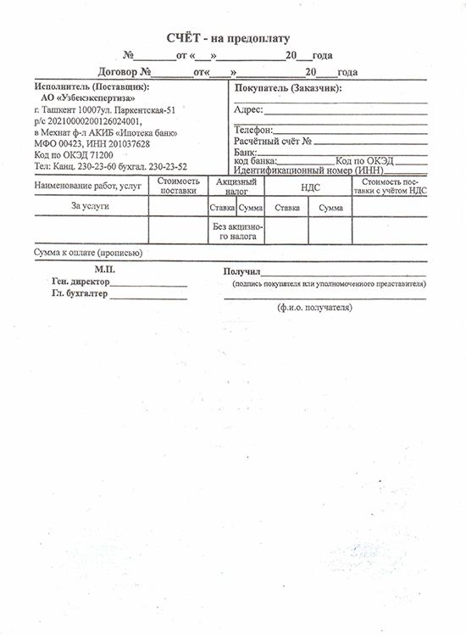  Invoice for prepayment | 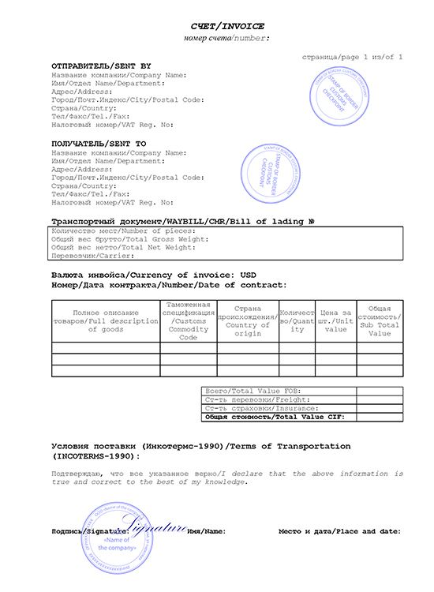  Commercial invoice |   Any document confirming the exporter's right to use a land plot
Any document confirming purchase of agricultural products | 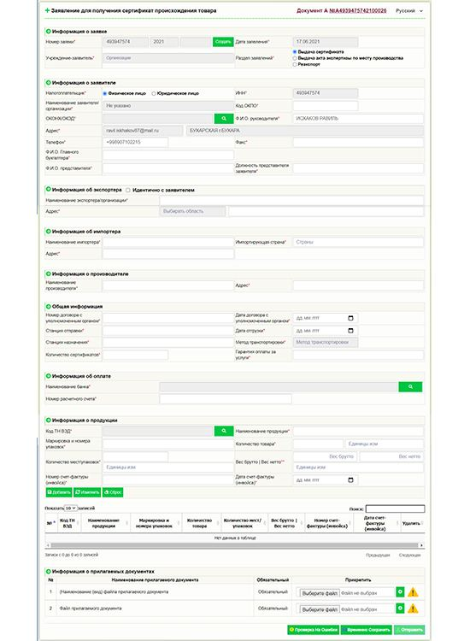  Online application for certificate of origin | Quantity of transport units
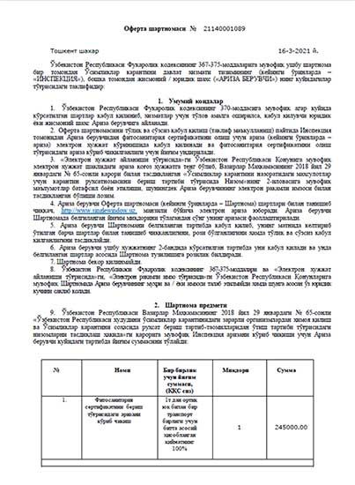  Offer agreement for phytosanitary certificate | 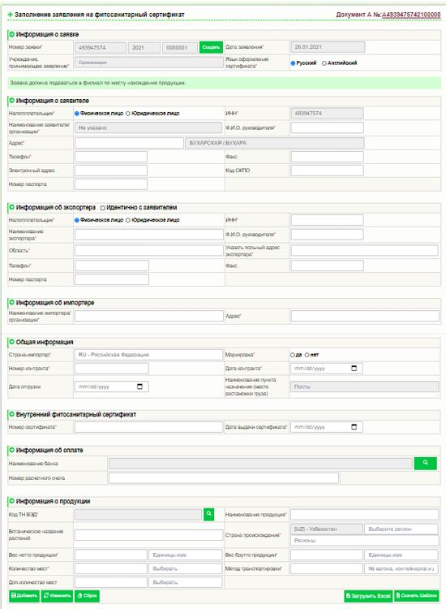  Online application for phytosanitary certificate | 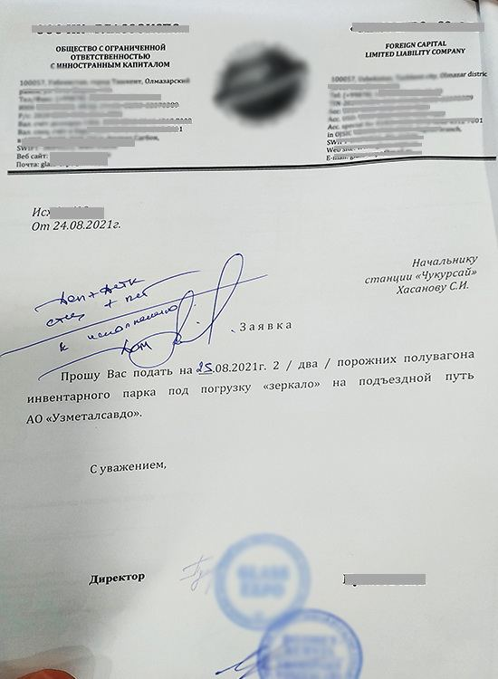  Application on letterhead for allotment of wagons
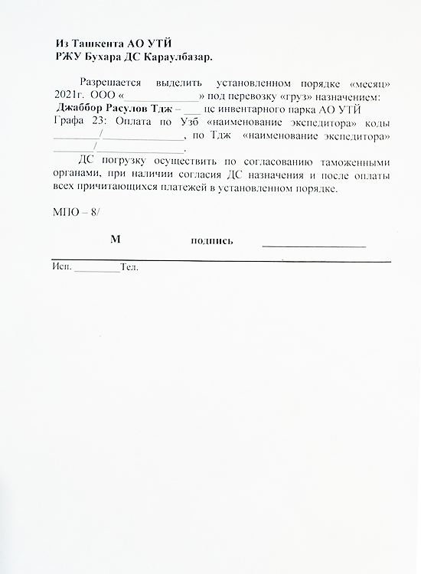  Order for wagon supply for loading | 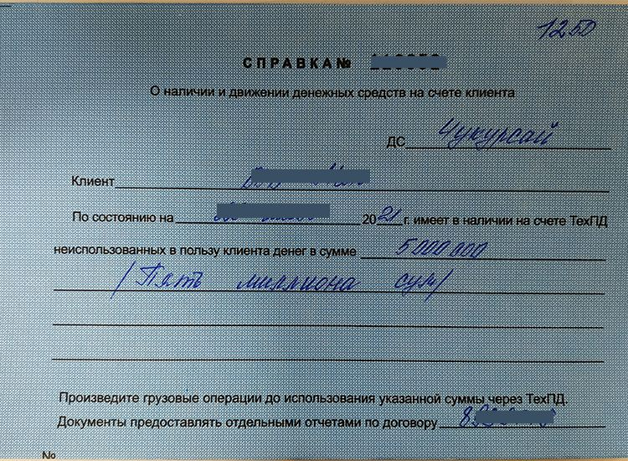  Certificate on availability of funds at client's account | 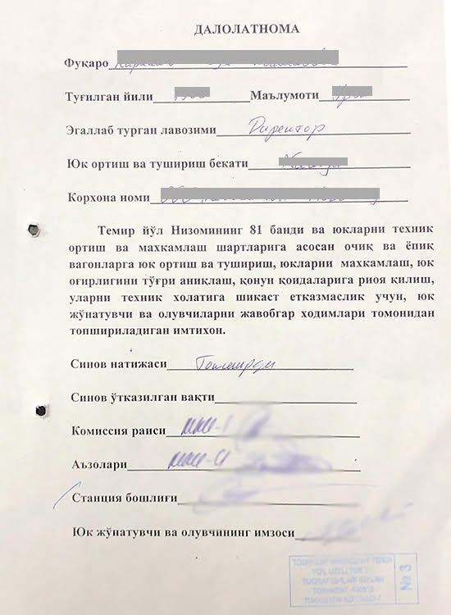  Certificate on passing examination
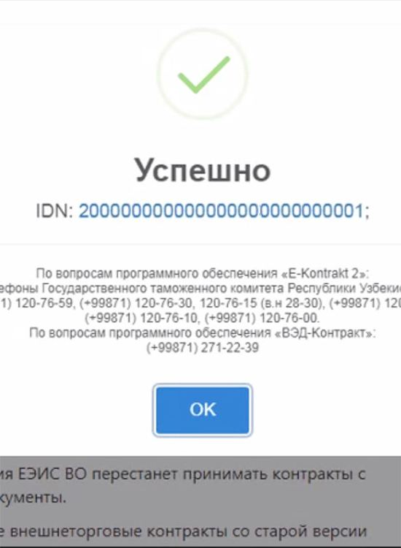  Identification number of foreign trade contract | 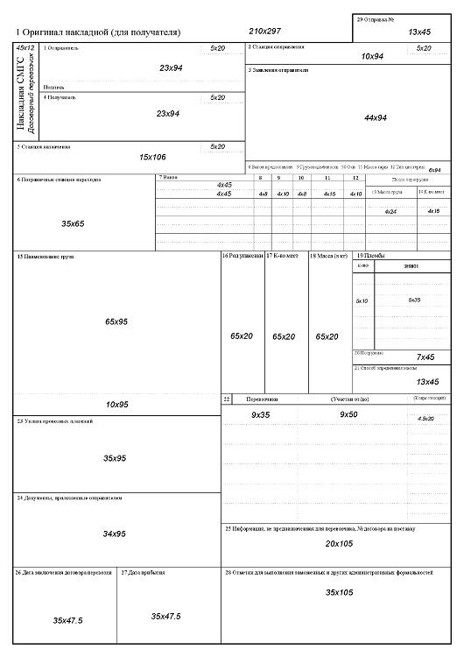  Export railway bill (SMGS) | 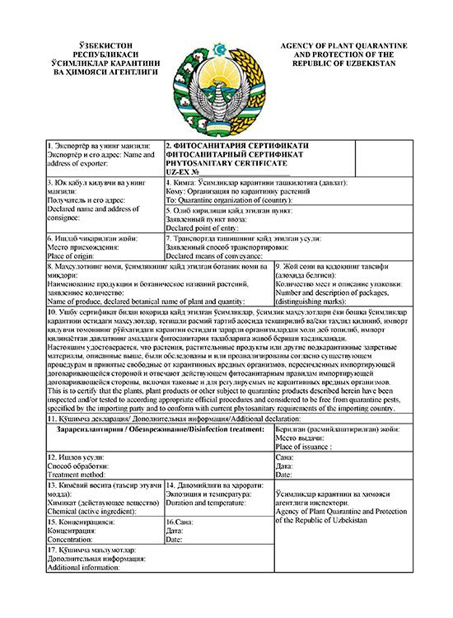  Phytosanitary certificate
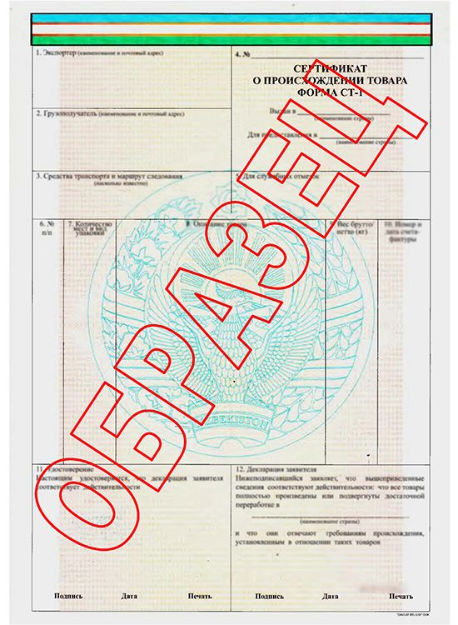  Certificate of origin | 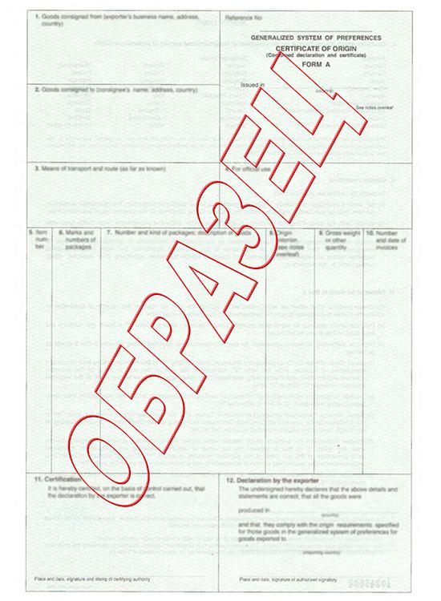  Certificate of origin form A | 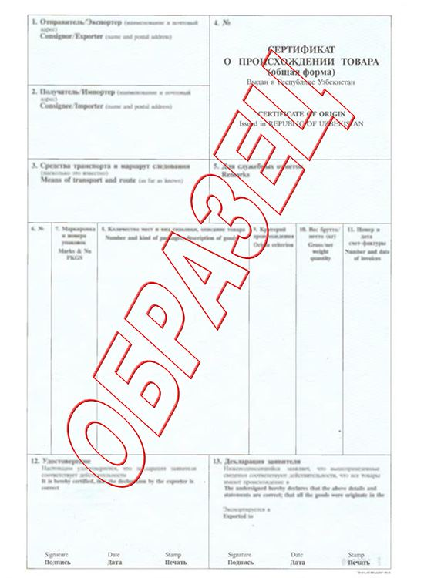  Certificate of origin General form
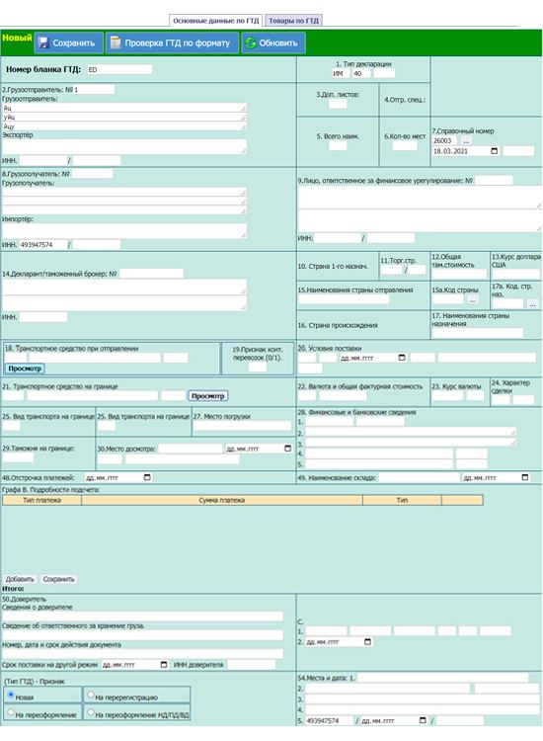  Electronic form of customs declaration | 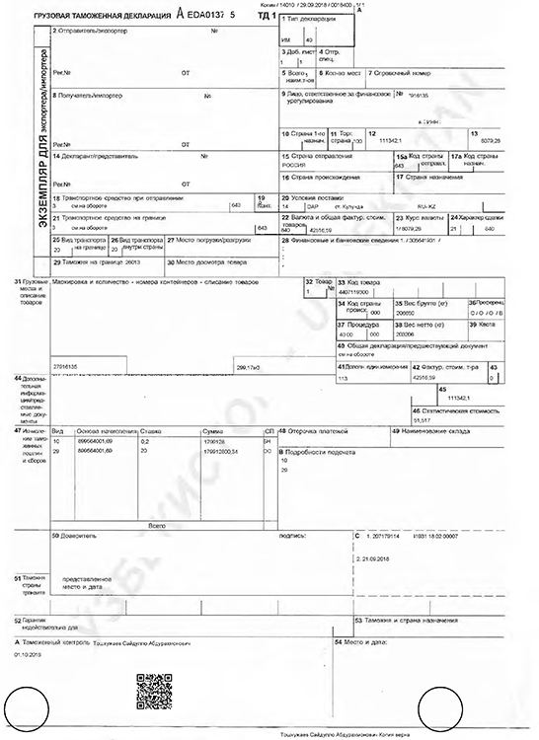  Export customs declaration | 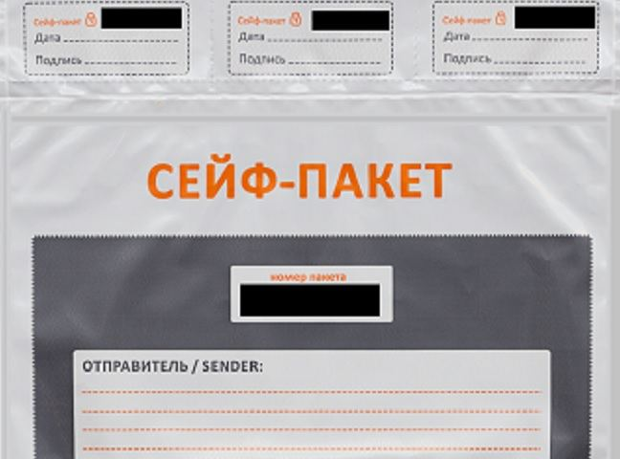  Package of documents

8. Step reference screenshots
The platform's own screen for each step, reproduced as published. These are screenshots of the eRegulations record (in Uzbek), showing contact details, expected result, requirements and price — not screenshots of the destination government service. They serve as visual provenance for the tables above.
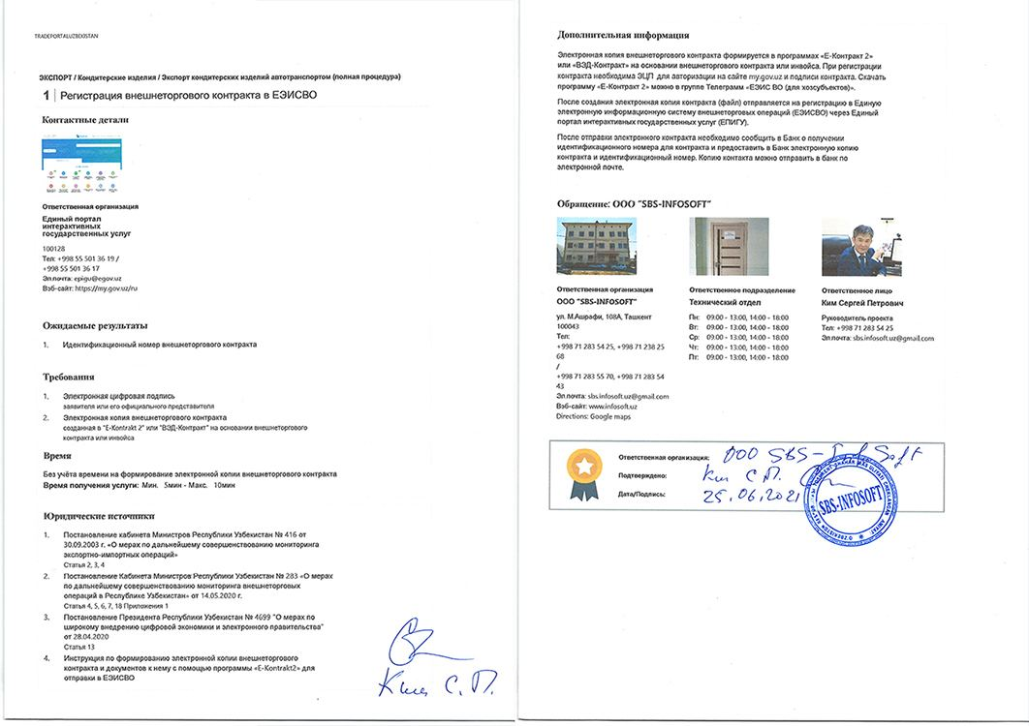  Step 1 — Register foreign trade contract in UEISFTO | 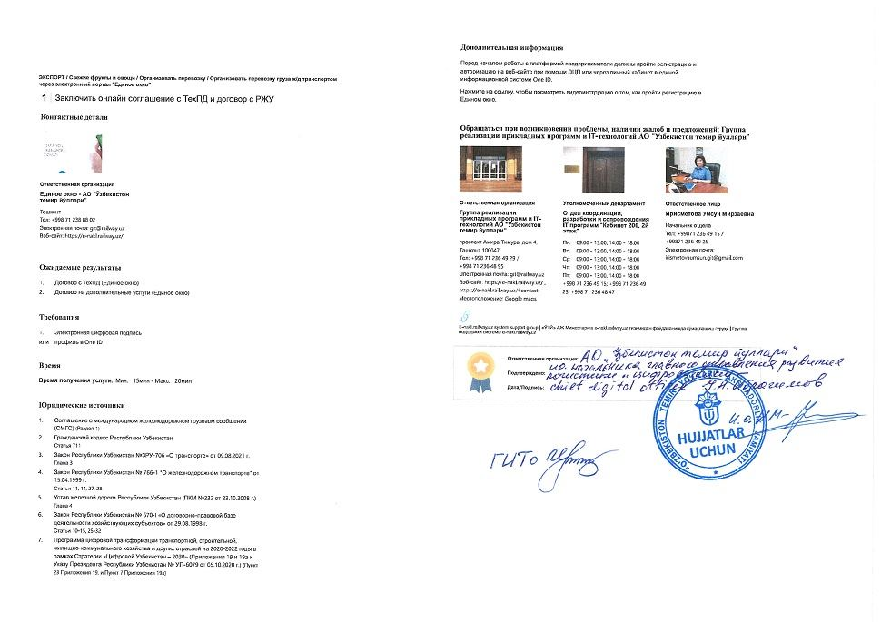  Step 2 — Conclude online agreement with Technological Center and contract with Regional railway junction
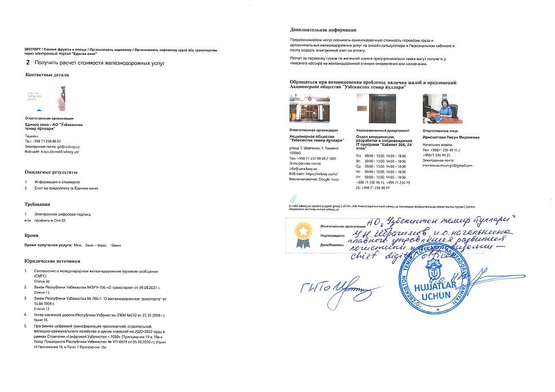  Step 3 — Obtain cost calculation for railway services | 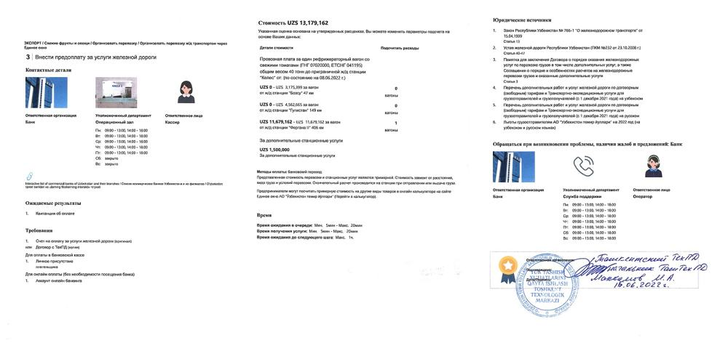  Step 4 — Prepay for railway services (tomatoes)
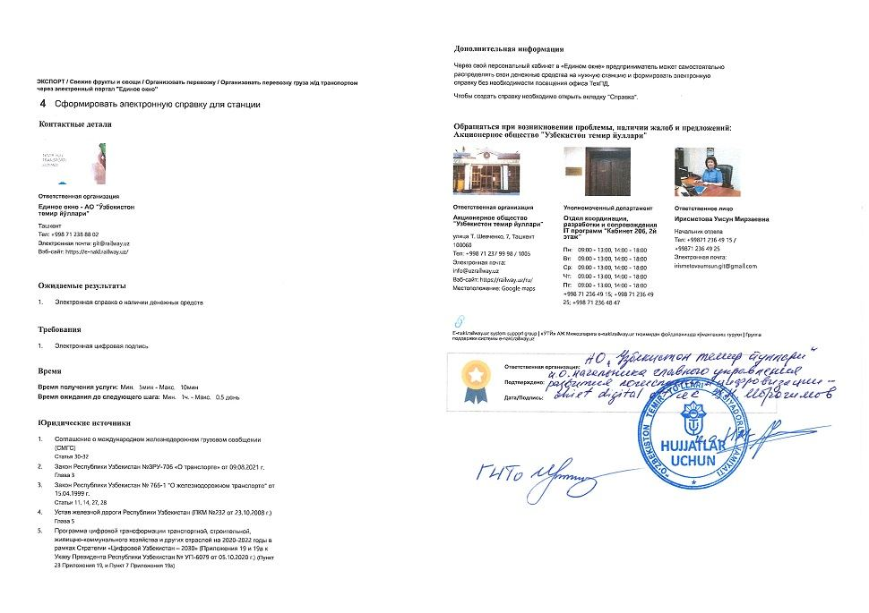  Step 5 — Generate electronic certificate for railway station | 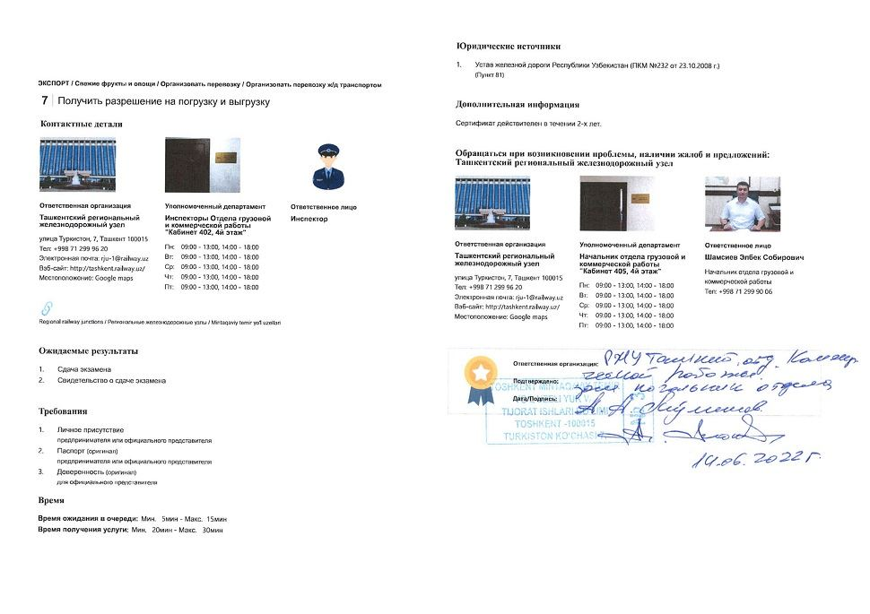  Step 6 — Obtain approval for loading and unloading
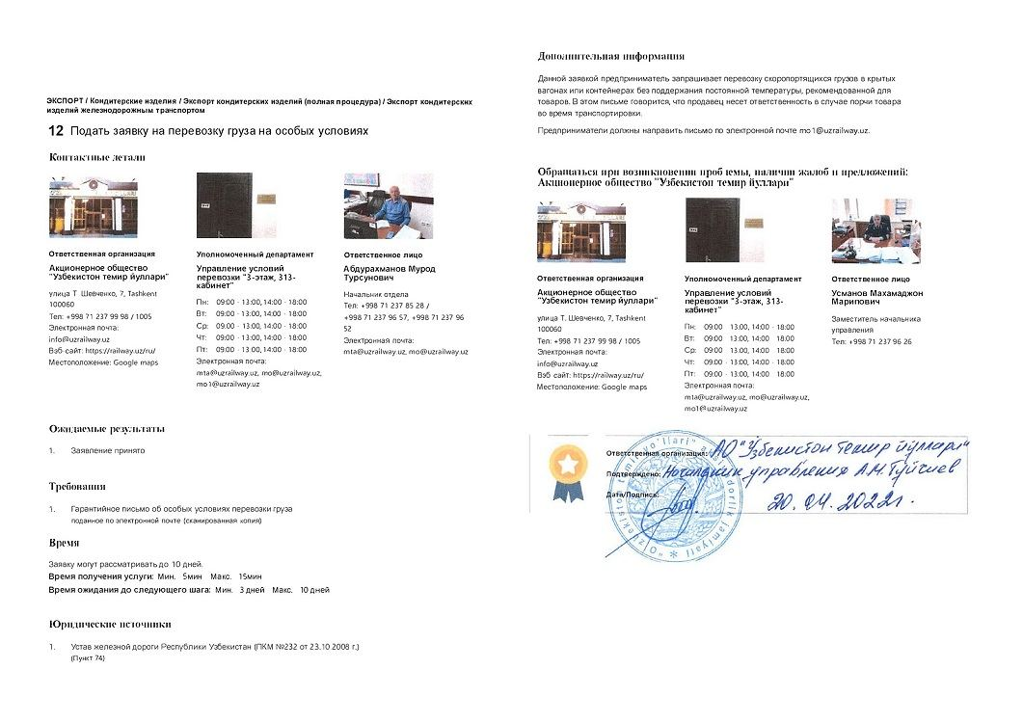  Step 11 — Apply for good transportation on specific conditions | 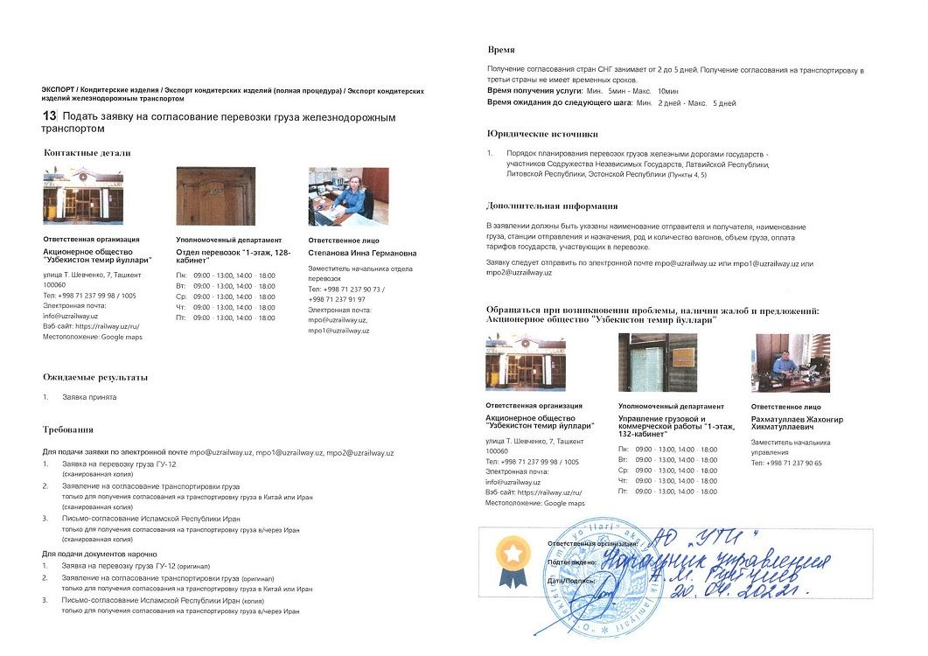  Step 12 — Apply for freight transportation by railway
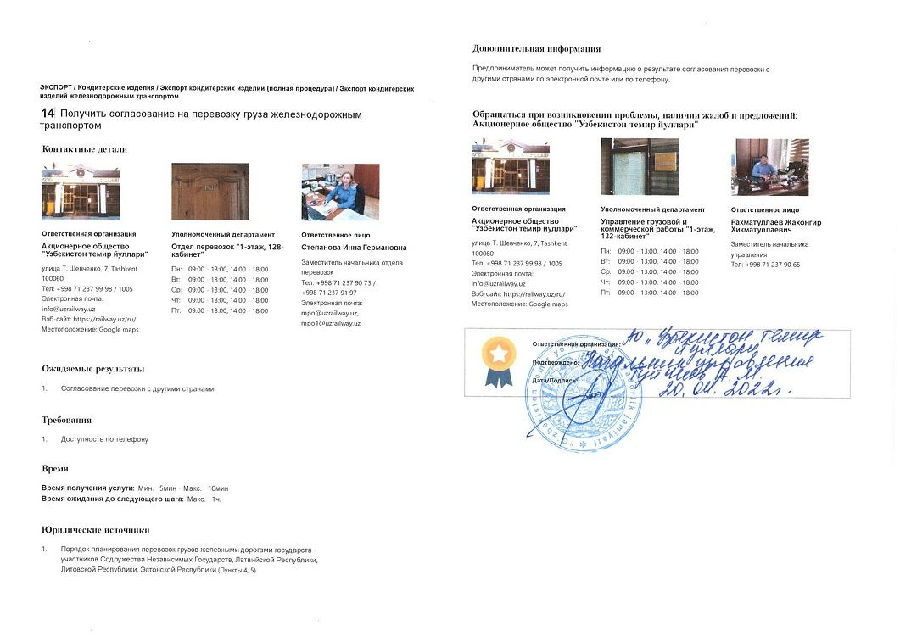  Step 13 — Obtain approval for freight transportation by railway | 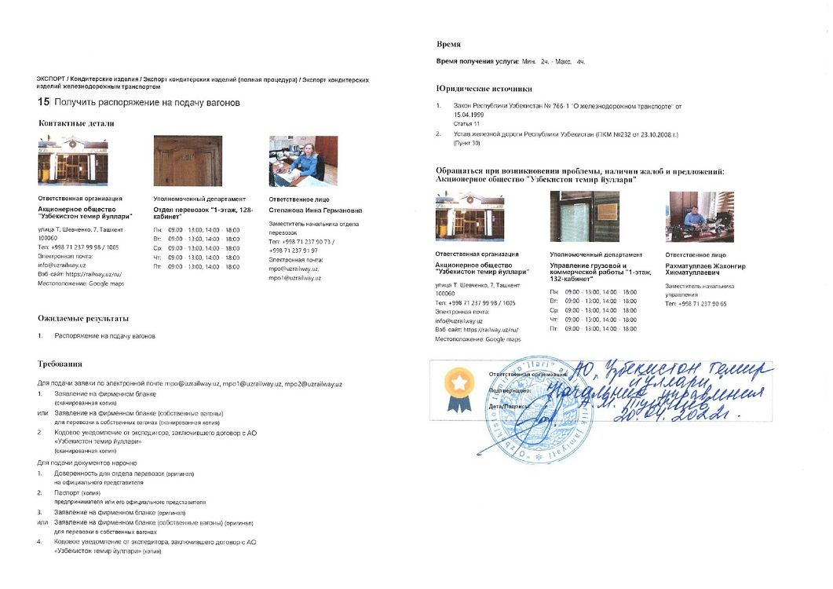  Step 14 — Obtain order for wagon supply
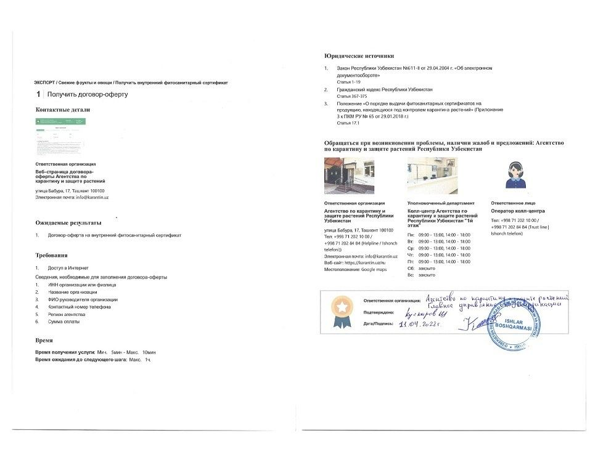  Step 15 — Obtain offer agreement | 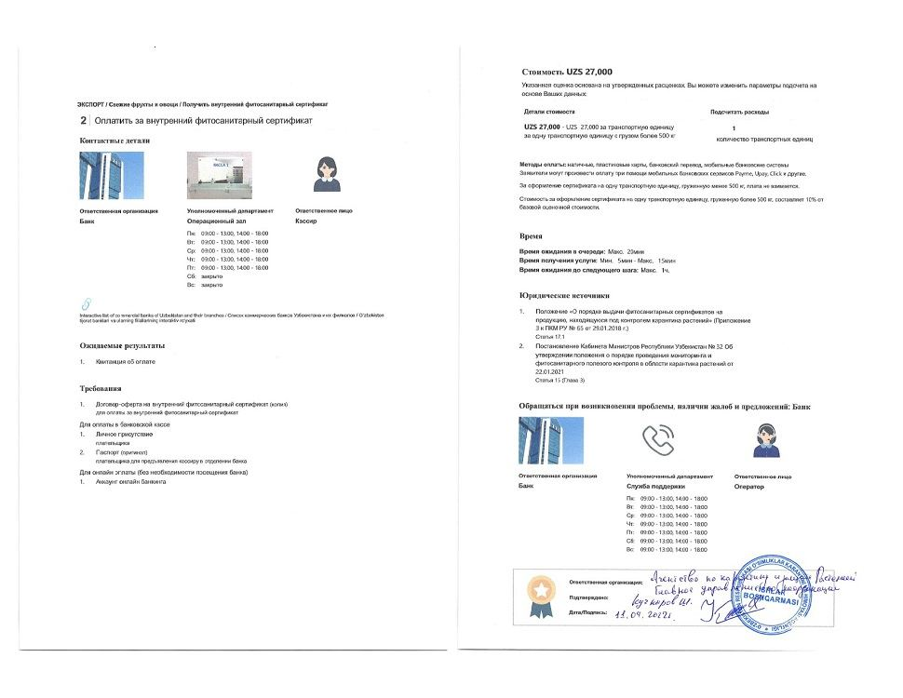  Step 16 — Pay for internal phytosanitary certificate
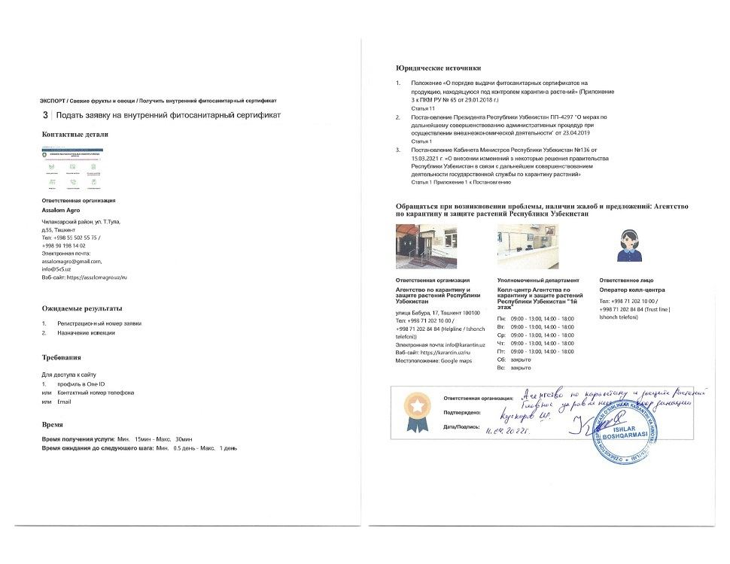  Step 17 — Apply for internal phytosanitary certificate | 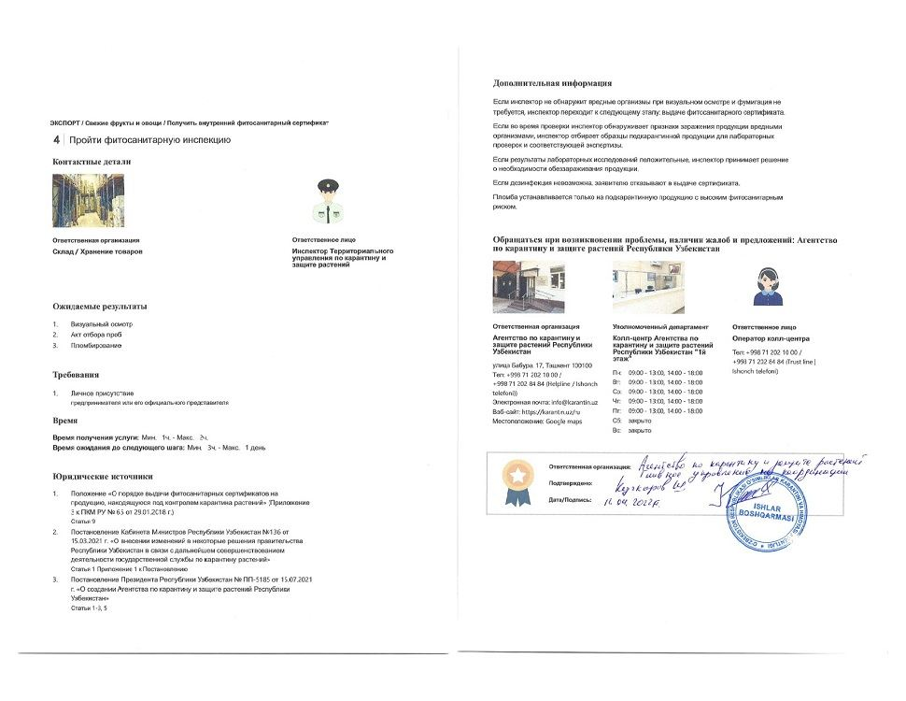  Step 18 — Undergo phytosanitary inspection
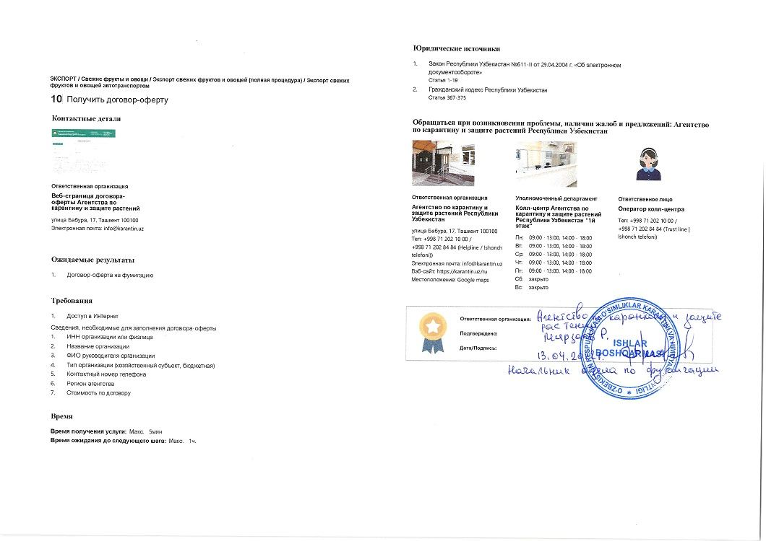  Step 19 — Obtain offer agreement for fumigation | 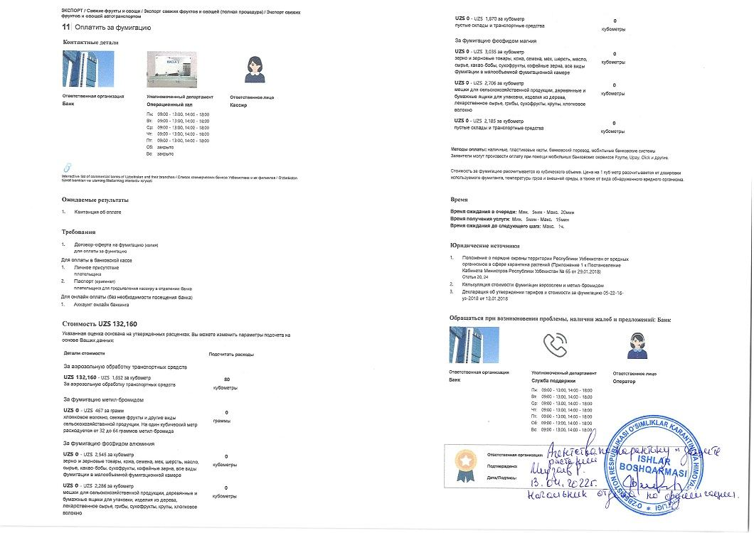  Step 20 — Pay for fumigation
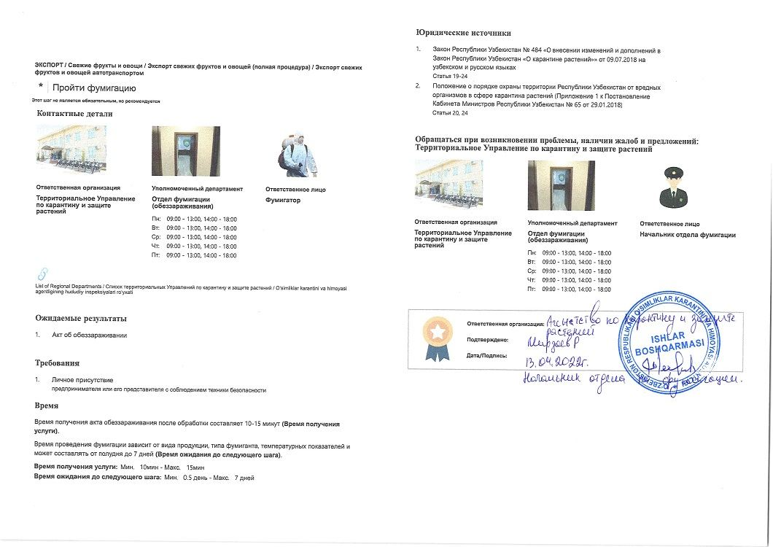  Step 21 — Undergo fumigation | 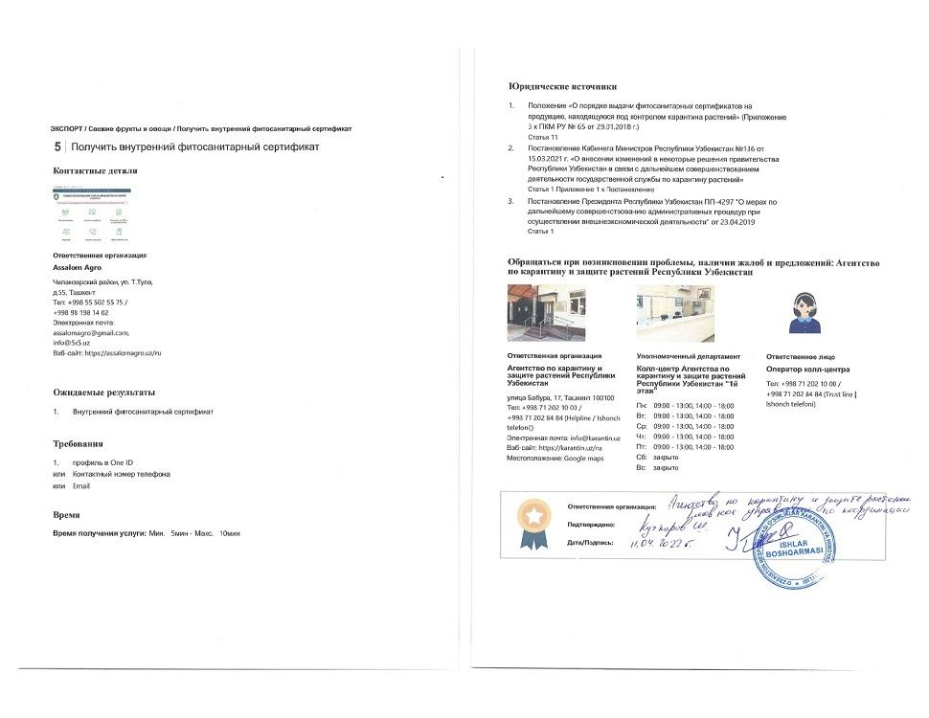  Step 22 — Obtain internal phytosanitary certificate
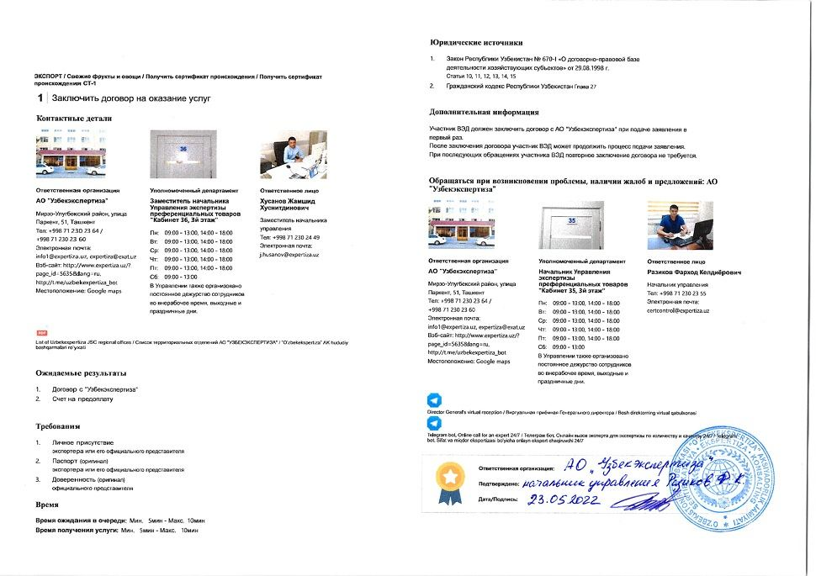  Step 23 — Conclude contract for services | 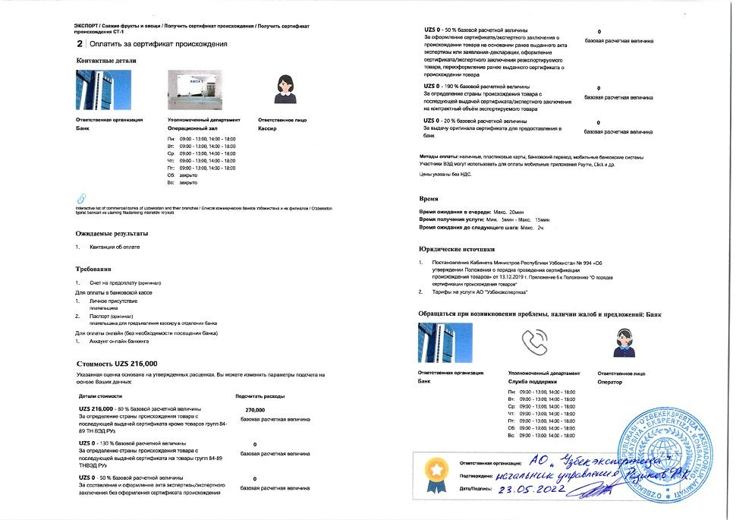  Step 24 — Pay for certificate of origin
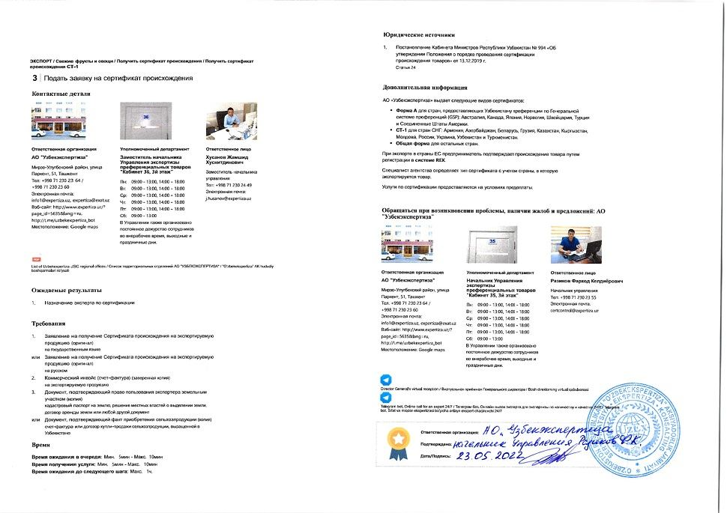  Step 25 — Apply for certificate of origin | 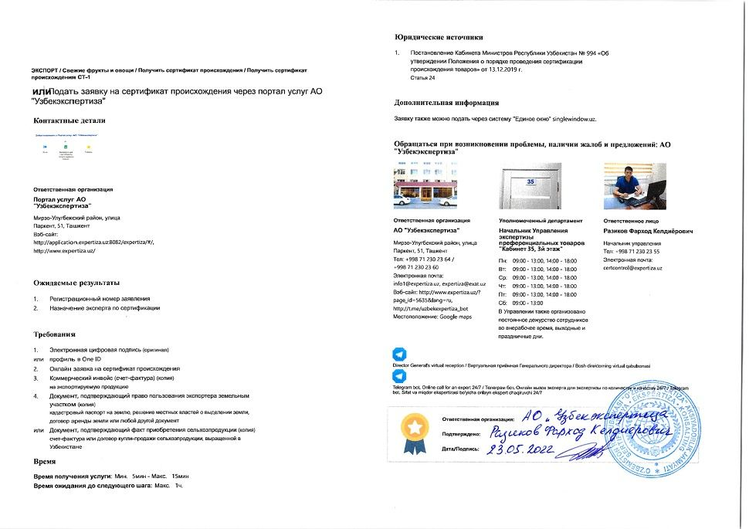  Step 26 — Apply for certificate of origin via Uzbekexpertiza service portal
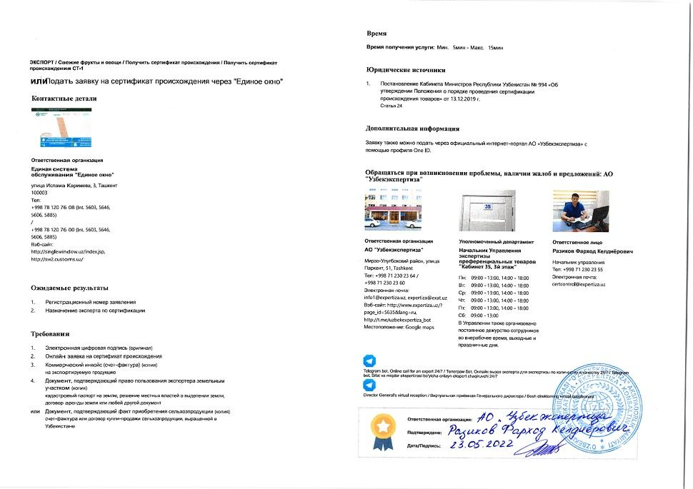  Step 27 — Apply for certificate of origin via Single Window | 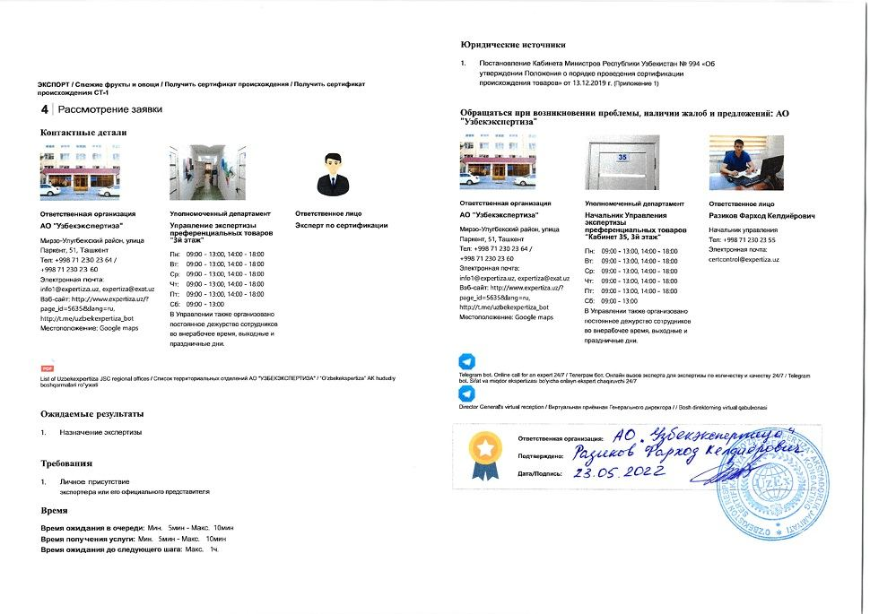  Step 28 — Assessment of application
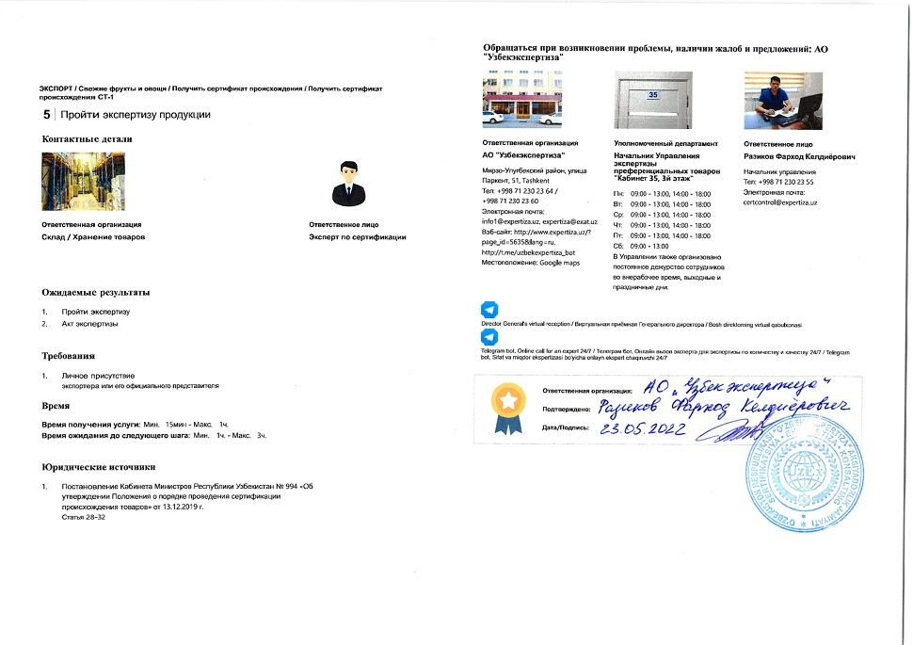  Step 29 — Undergo expertise of goods | 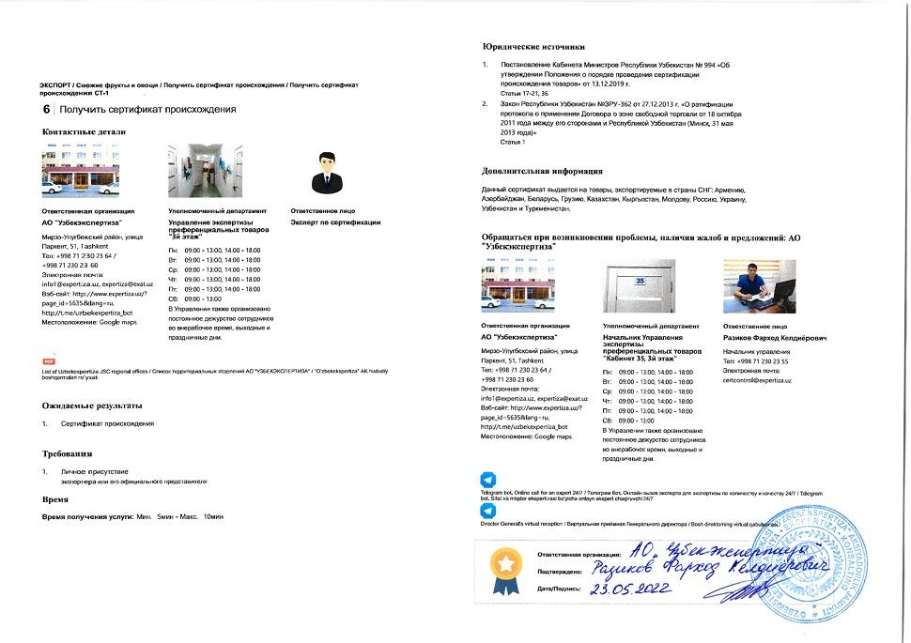  Step 30 — Obtain certificate of origin
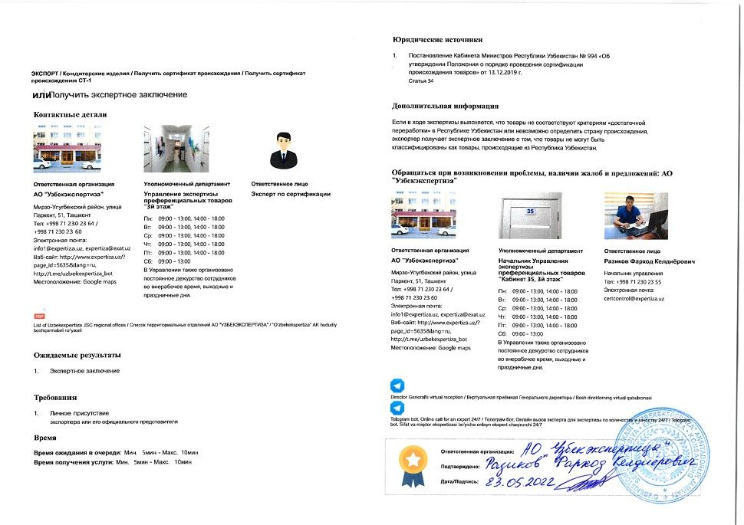  Step 31 — Obtain expert conclusion | 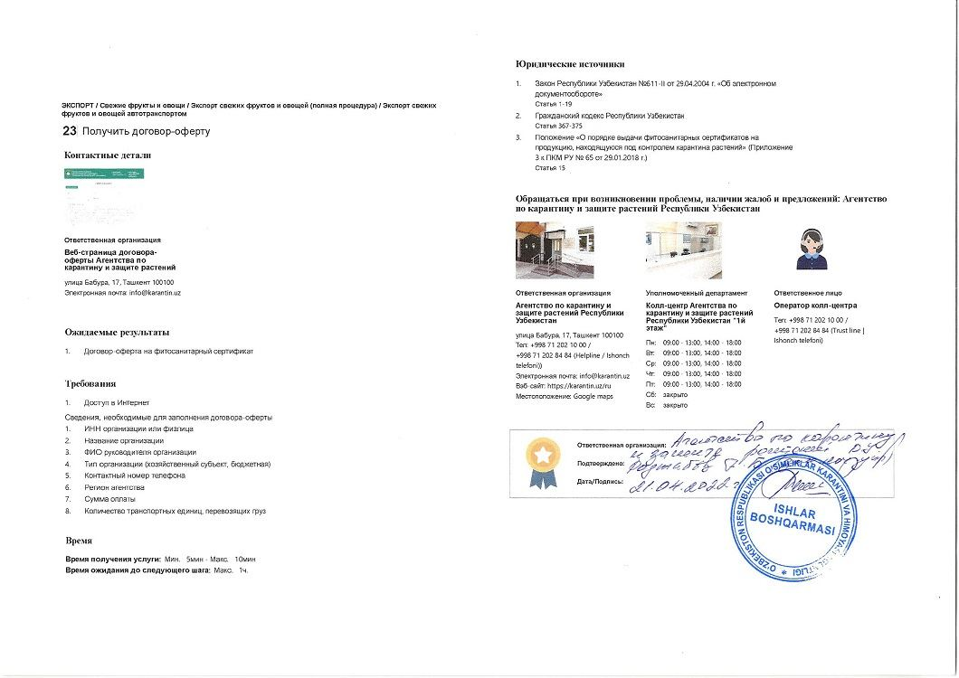  Step 32 — Obtain offer agreement
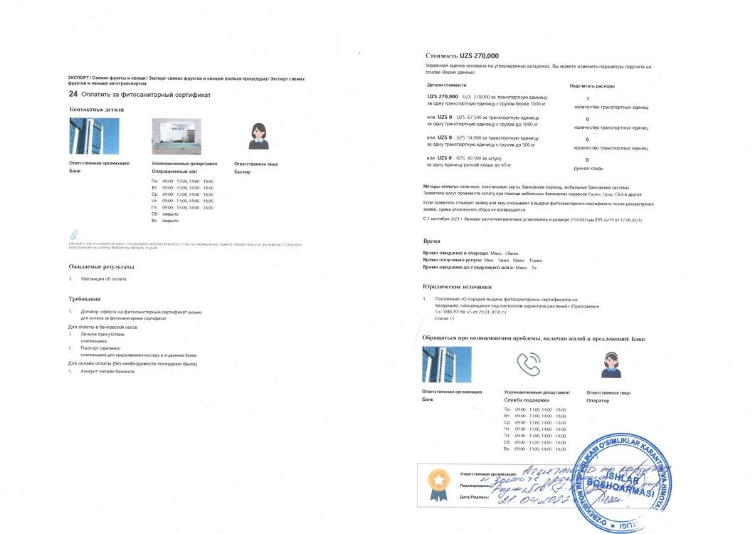  Step 33 — Pay for phytosanitary certificate | 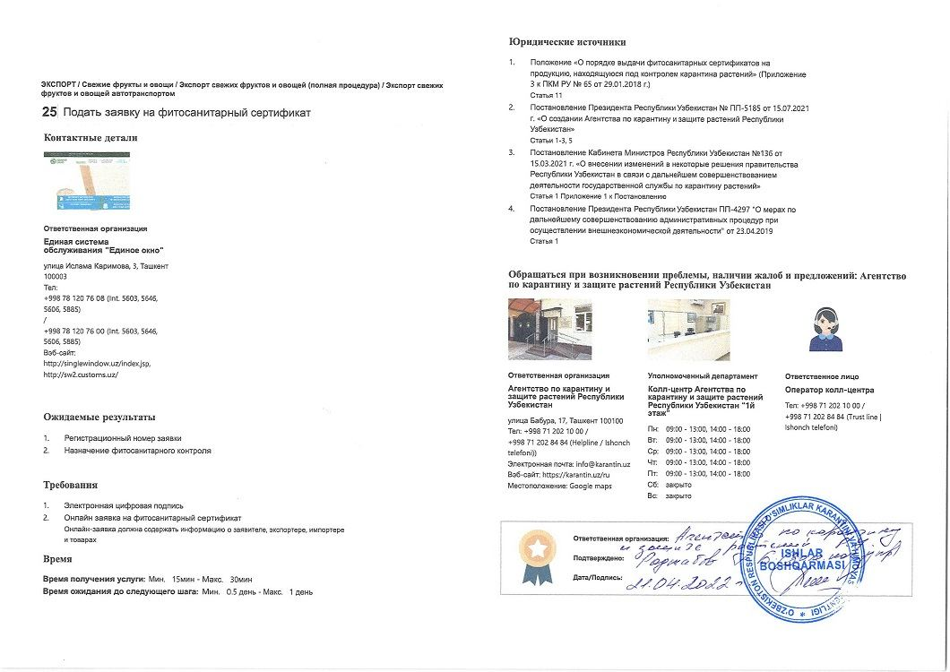  Step 34 — Apply for phytosanitary certificate
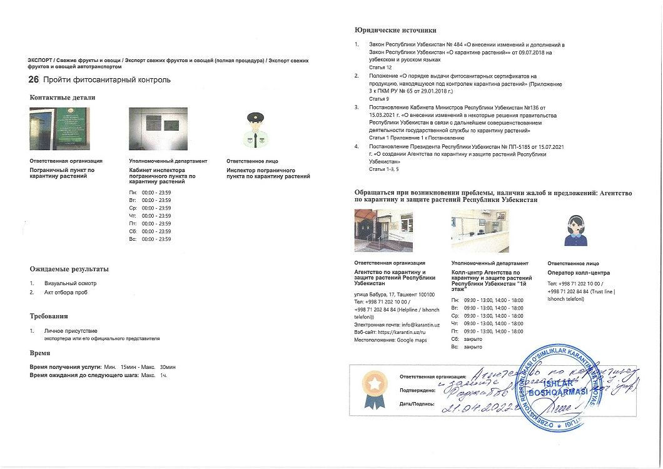  Step 35 — Undergo phytosanitary inspection | 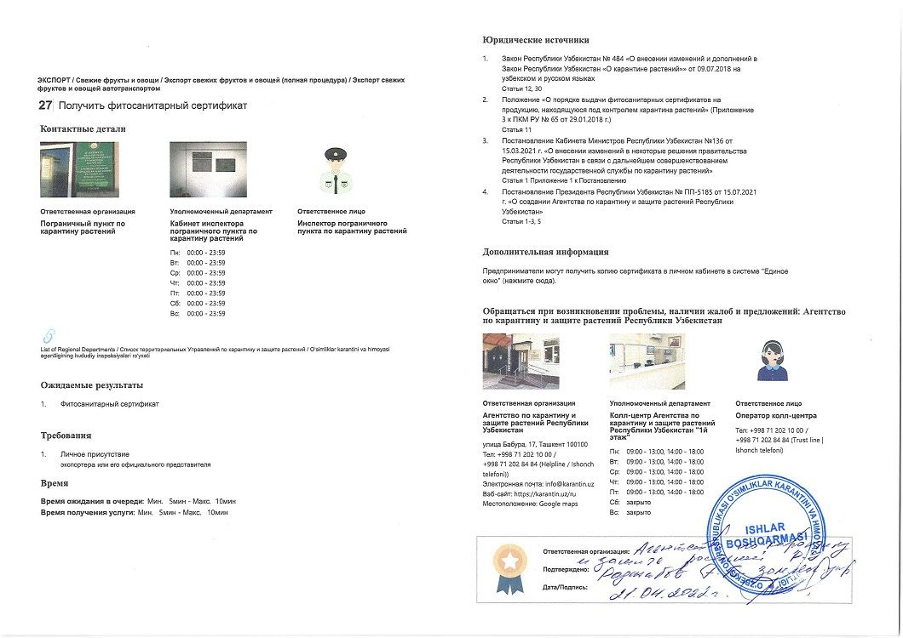  Step 36 — Obtain phytosanitary certificate
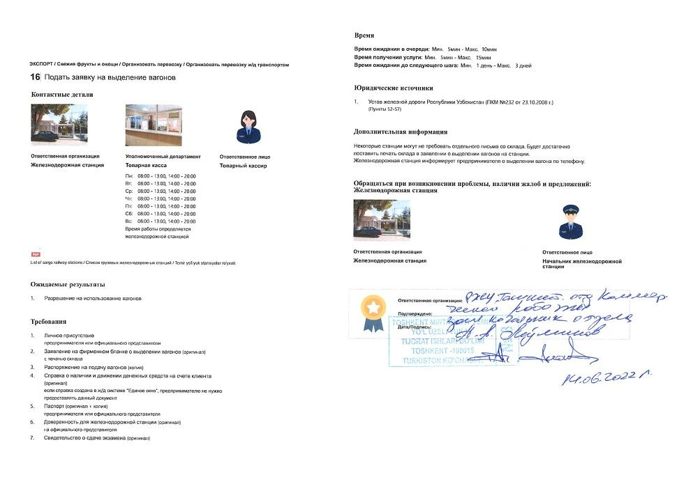  Step 37 — Apply for allotment of wagons | 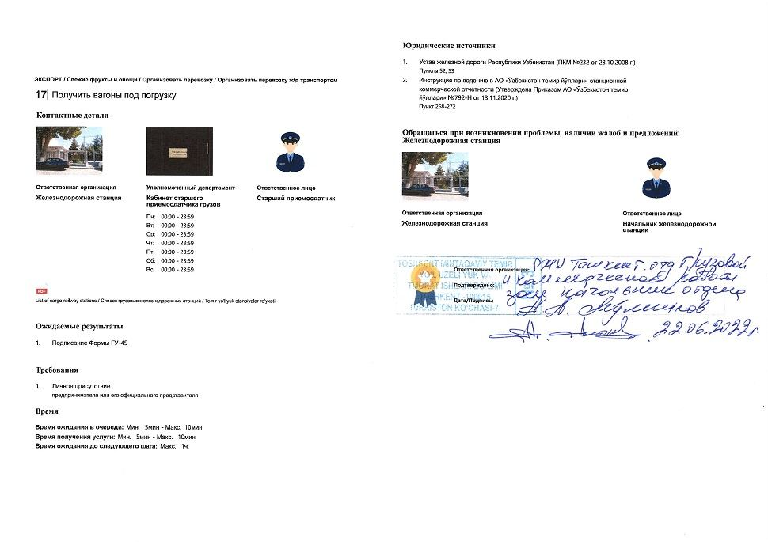  Step 38 — Obtain wagons for loading
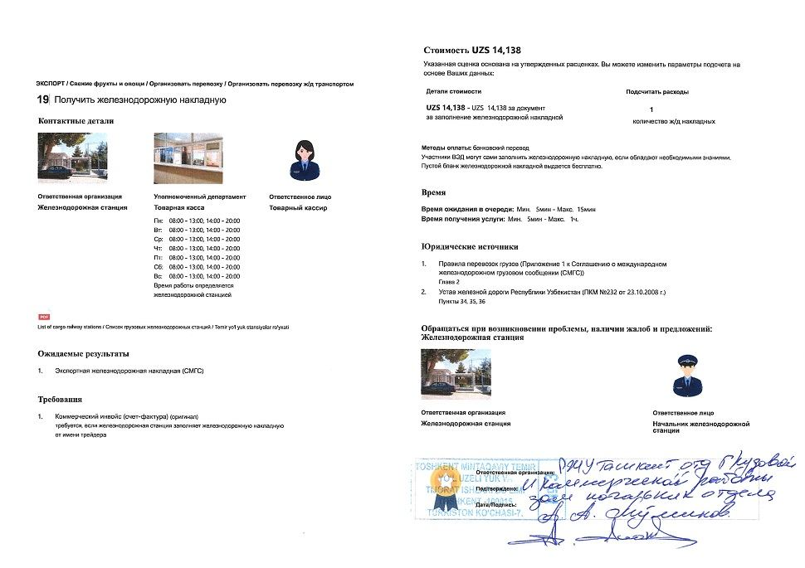  Step 40 — Obtain railway bill of lading | 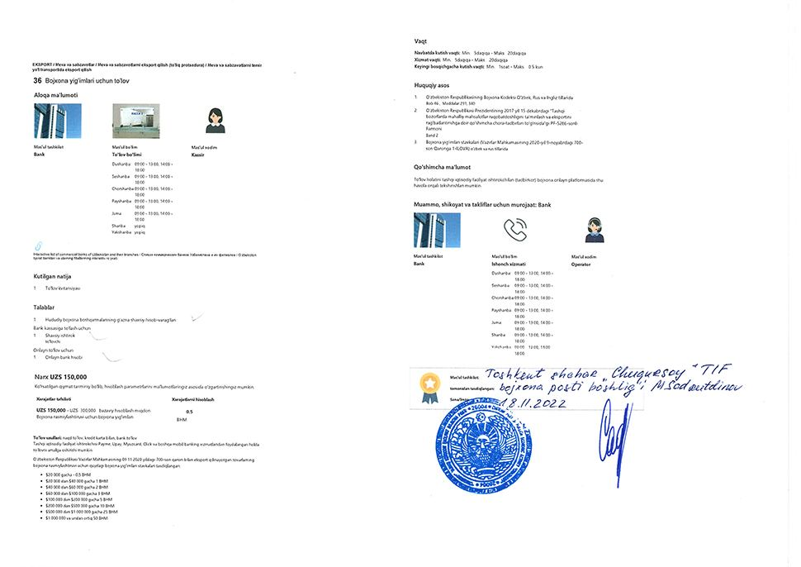  Step 42 — Pay for customs fee
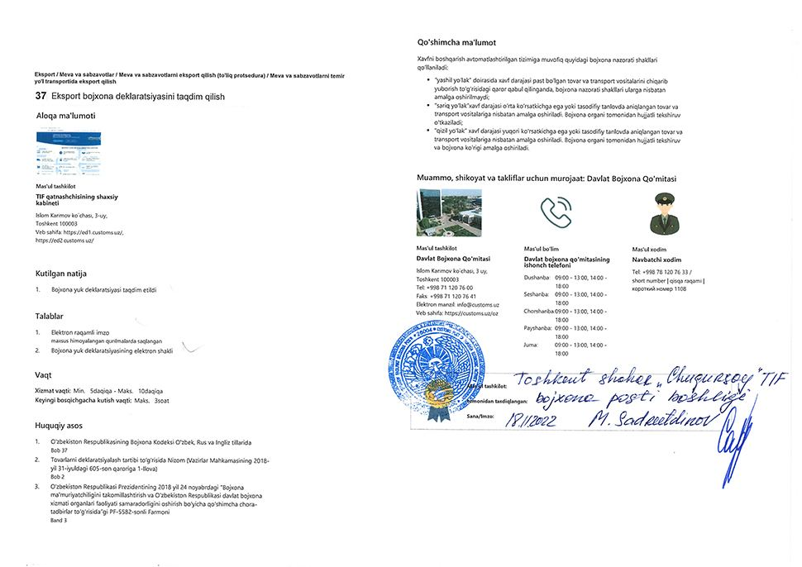  Step 43 — Submit export customs declaration | 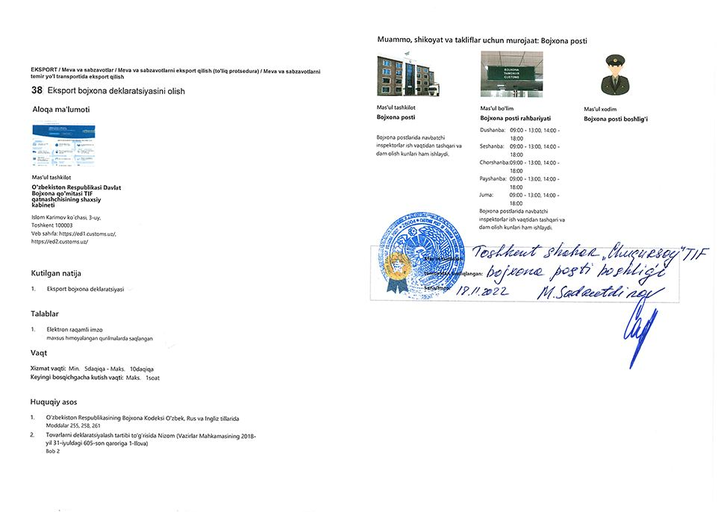  Step 45 — Obtain export customs declaration
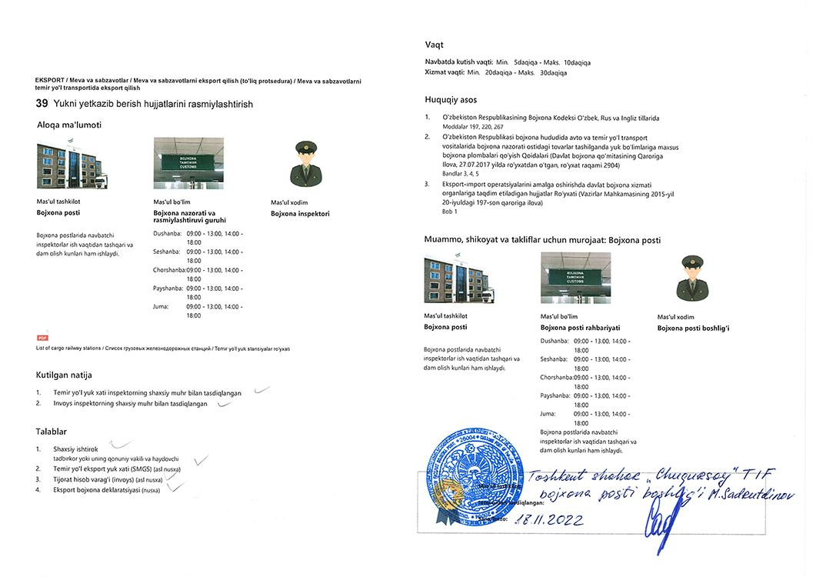  Step 46 — Obtain stamps on shipping documents | 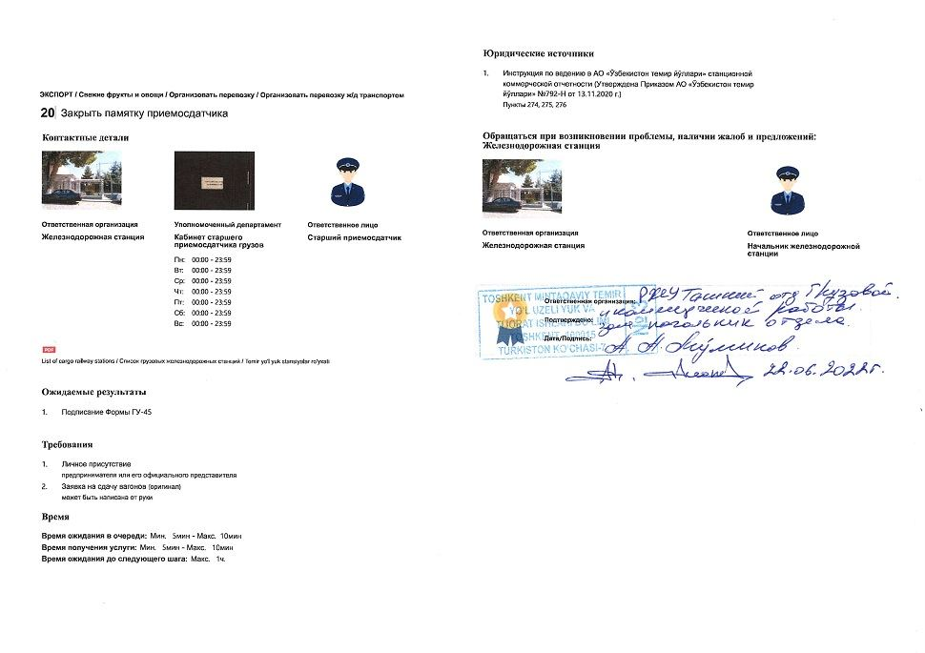  Step 47 — Close memo of handover specialist
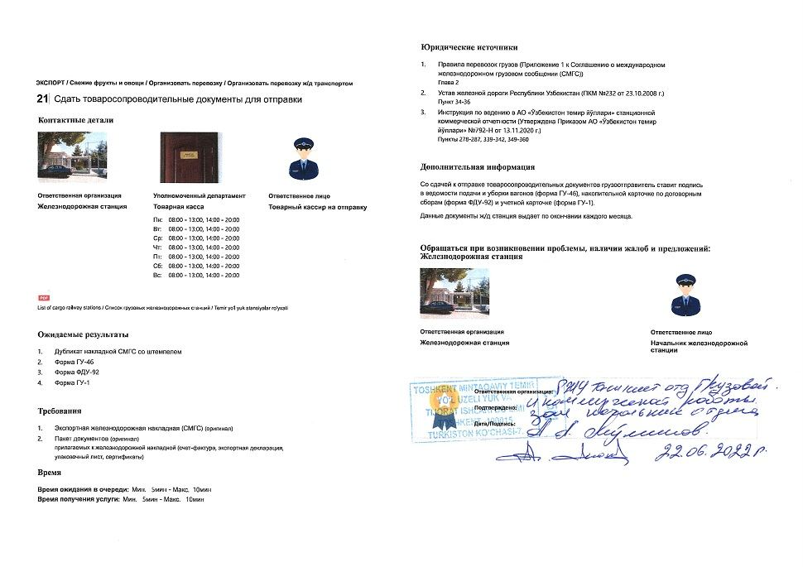
Step 48 — Dispatch freight

