Uzbekistan Trade Info — Procedure Automation
Procedure 540: Export of tea by air
As-is process map — the procedure exactly as it runs today. Source: uztradeinfo.uz/procedure/540
Blocks | Steps | Entities | Online | Optional | Alternative
9 | 47 | 14 | 19 | 4 | 2
End-to-end published timeframe: 30–108 hours.
1. Process flow
Columns group the entity in charge, so every move between columns is a handoff. The specific body is named in grey inside each box. Dashed border = optional (conditional) step. Boxes side by side = alternative routes, where the trader takes one. Heavy border = the step can be done online.
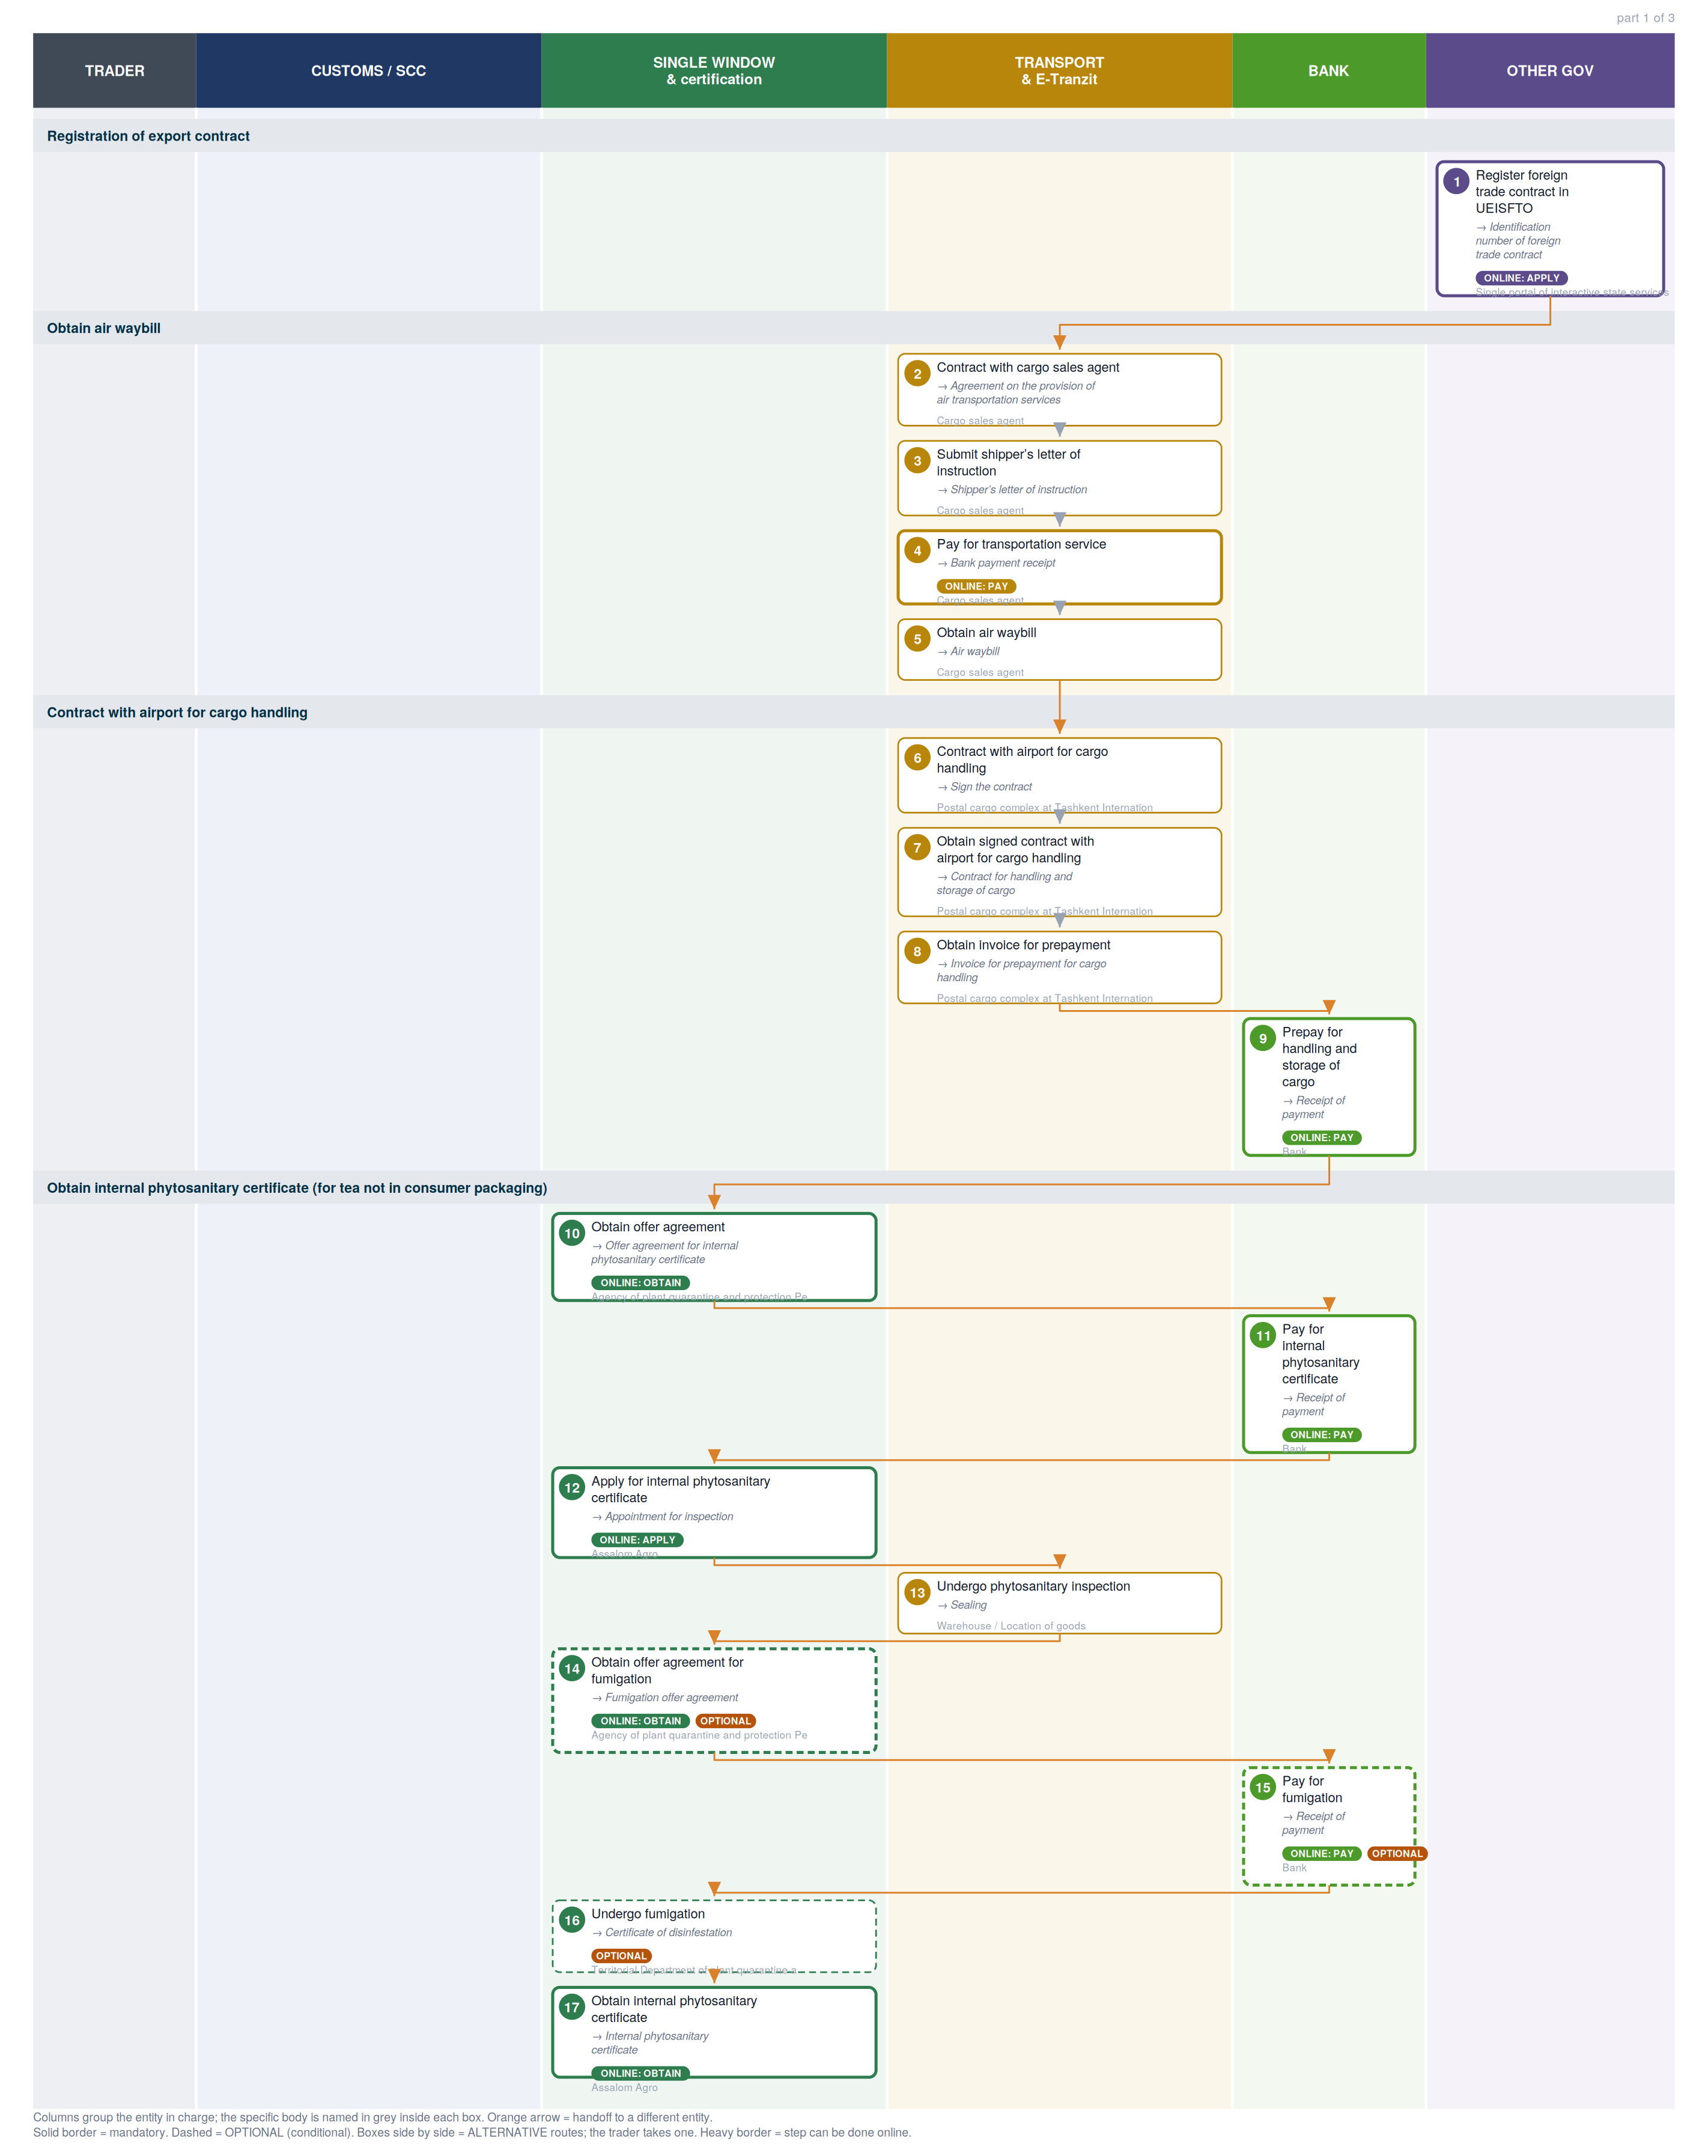

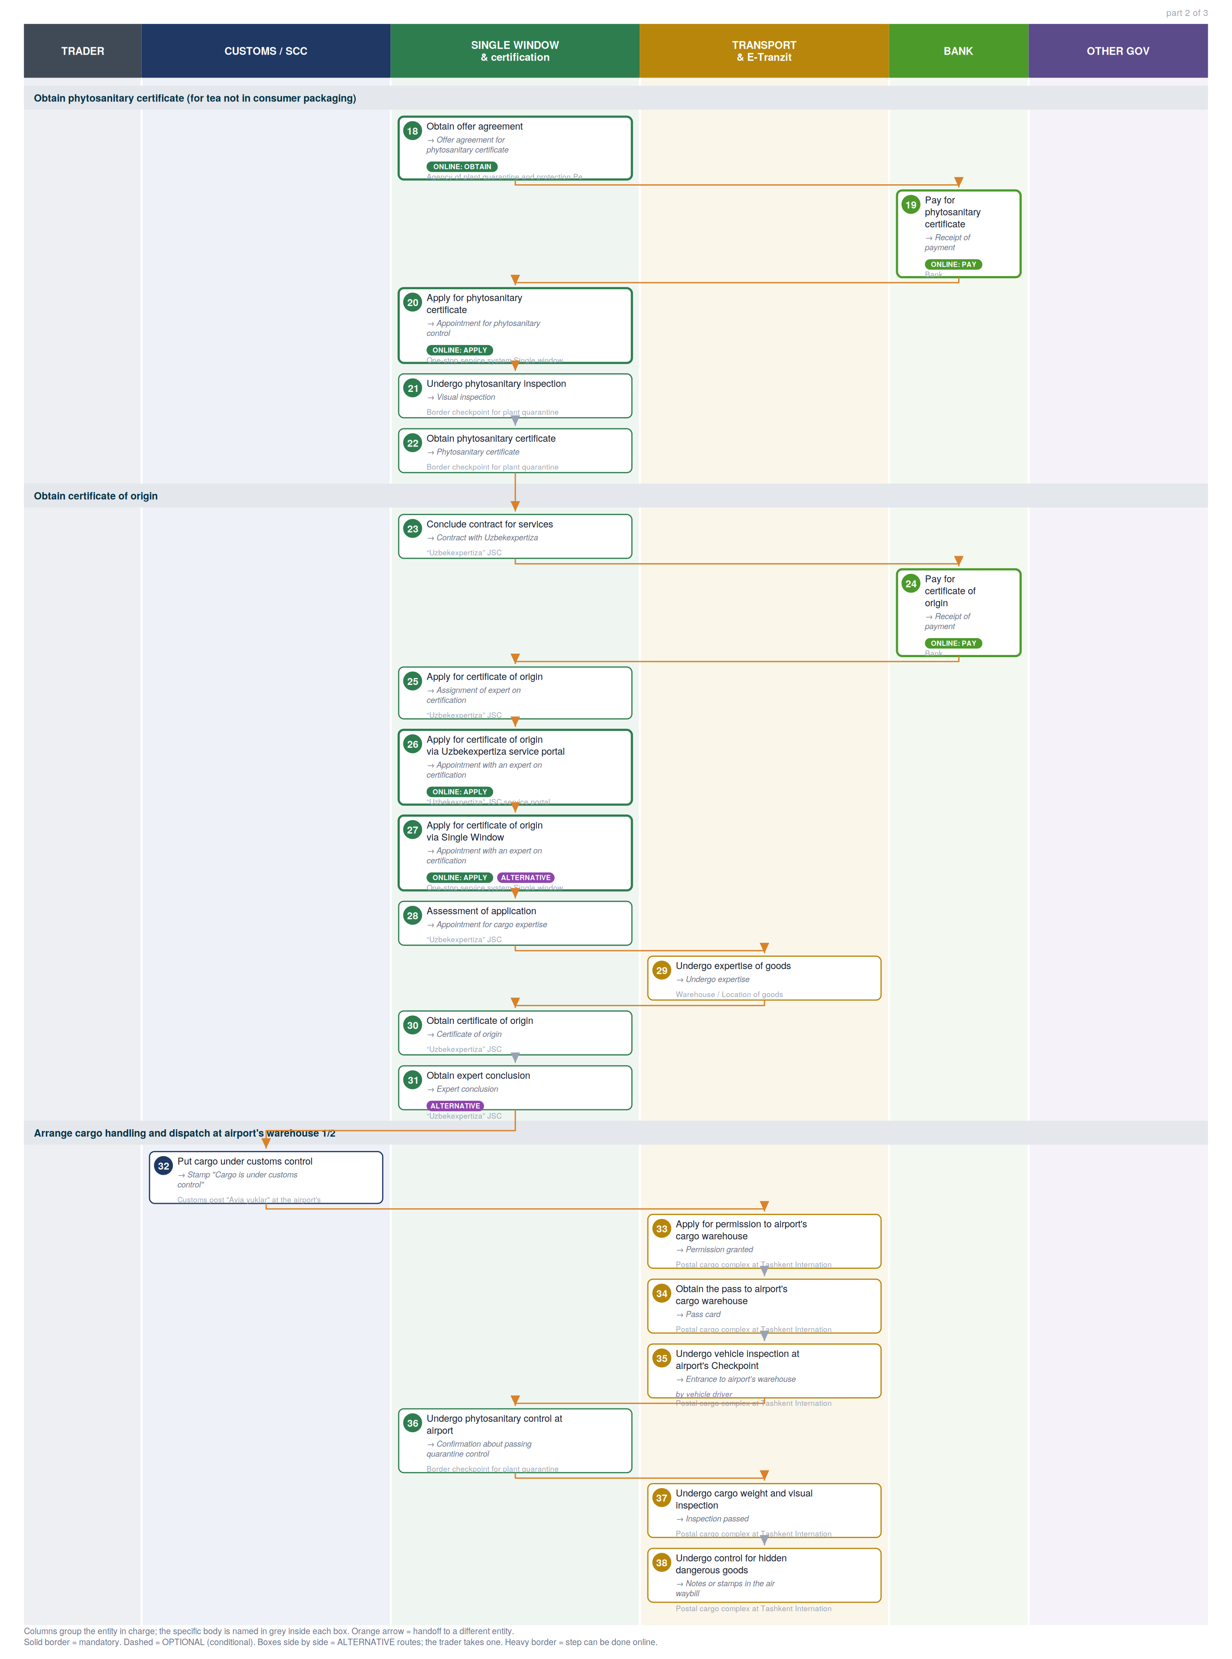

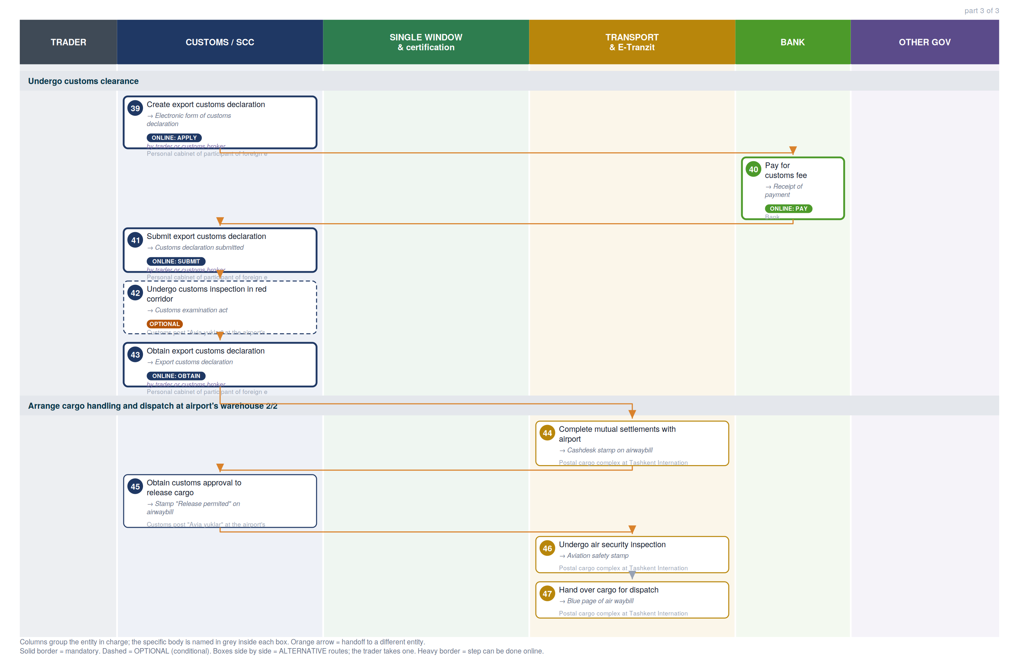

2. Where each step happens
Every step classified by channel. Online steps are performed on an external government service (the exact URL is in section 6). In-person steps happen at a physical counter, named in the “where” column.
Channel | Steps | Detail
Online — external service | 19 | Payment methods information page (6), Customs e-declaration cabinet (SCC) (3), eFito (phytosanitary) (2), assalomagro.uz (2), Single Window (2), my.gov.uz — unified state services (1), Quarantine cabinet (1), Uzbekexpertiza service portal (1), Trade info portal (1)
In person — physical counter | 28 | Cargo sales agent, Postal cargo complex at Tashkent International Airport named by Islam Karimov, Warehouse / Location of goods, Territorial Department of plant quarantine and protection, Border checkpoint for plant quarantine, “Uzbekexpertiza” JSC, Customs post "Avia yuklar" at the airport's warehouse

3. Entities in charge & contact channels
Entity | Steps | Lane | Contact channels
Single portal of interactive state services | 1 | Other government | ✉ epigu@egov.uz  ☎ +998 55 501 36 19, +998 55 501 36 17  🌐 https://my.gov.uz/, https://my.gov.uz/ru/site/feedback
Cargo sales agent | 2, 3, 4, 5 | Transport & E-Tranzit | — none published —
Postal cargo complex at Tashkent International Airport named by Islam Karimov | 6, 7, 8, 33, 34, 35, 37, 38, 44, 46, 47 | Transport & E-Tranzit | ✉ pkg.tas@uzairports.com, tashairkanc@uzairports.com  ☎ +990 78 140 28 25, +998 78 140 28 26  🌐 https://tashkent-airport.uz/
Bank | 9, 11, 15, 19, 24, 40 | Bank | — none published —
Agency of plant quarantine and protection Personal cabinet (Oferta) | 10, 14, 18 | Single Window & certification | ✉ info@karantin.uz  🌐 https://efito.uz/invoice/, http://karantin.uz/
Assalom Agro | 12, 17 | Single Window & certification | ✉ assalomagro@gmail.com, info@5x5.uz  ☎ +998 55 502 55 75, +998 98 198 14 02  🌐 https://assalomagro.uz/en
Warehouse / Location of goods | 13, 29 | Transport & E-Tranzit | — none published —
Territorial Department of plant quarantine and protection | 16 | Single Window & certification | — none published —
One-stop service system Single window | 20, 27 | Single Window & certification | ☎ +998 78 120 76 08 (Int. 5603, 5646, 5606, 5885) , +998 78 120 76 00 (Int. 5603, 5646, 5606, 5885)  🌐 http://singlewindow.uz/index.jsp, http://sw2.customs.uz/
Border checkpoint for plant quarantine | 21, 22, 36 | Single Window & certification | — none published —
“Uzbekexpertiza” JSC | 23, 25, 28, 30, 31 | Single Window & certification | ✉ info1@expertiza.uz, expertiza@exat.uz  ☎ +998 71 230 23 64, +998 71 230 23 60  🌐 http://www.expertiza.uz/, http://t.me/uzbekexpertiza_bot
“Uzbekexpertiza” JSC service portal | 26 | Single Window & certification | 🌐 http://application.expertiza.uz/expertiza/#/, http://www.expertiza.uz/
Customs post "Avia yuklar" at the airport's warehouse | 32, 42, 45 | Customs / SCC | ☎ +998 78 120 86 30, +998 71 255 83 89
Personal cabinet of participant of foreign economic activity | 39, 41, 43 | Customs / SCC | 🌐 http://ed1.customs.uz, http://ed2.customs.uz

4. Step-by-step breakdown
Full sequence. Channel shows online vs in-person; Where / service names the exact website for online steps or the physical location for in-person ones; Performed by is who carries the step out. Optional and alternative steps are flagged.
# | Step | Entity in charge | Channel | Where / service | Performed by
Registration of export contract
1 | Register foreign trade contract in UEISFTO  → Identification number of foreign trade contract | Single portal of interactive state services | Online: apply | my.gov.uz — unified state services  my.gov.uz | —
Obtain air waybill
2 | Contract with cargo sales agent  → Agreement on the provision of air transportation services | Cargo sales agent | In person | Cargo sales agent | —
3 | Submit shipper’s letter of instruction  → Shipper’s letter of instruction | Cargo sales agent | In person | Cargo sales agent | —
4 | Pay for transportation service  → Bank payment receipt | Cargo sales agent | Online: pay | Payment methods information page  uzbekistan.tradeportal.org | —
5 | Obtain air waybill  → Air waybill | Cargo sales agent | In person | Cargo sales agent | —
Contract with airport for cargo handling
6 | Contract with airport for cargo handling  → Sign the contract | Postal cargo complex at Tashkent International Airport named by Islam Karimov | In person | Contracting Department "Room 212, 2nd floor" | —
7 | Obtain signed contract with airport for cargo handling  → Contract for handling and storage of cargo | Postal cargo complex at Tashkent International Airport named by Islam Karimov | In person | Contracting Department "Room 212, 2nd floor" | —
8 | Obtain invoice for prepayment  → Invoice for prepayment for cargo handling | Postal cargo complex at Tashkent International Airport named by Islam Karimov | In person | Cash desk "First floor" | —
9 | Prepay for handling and storage of cargo  → Receipt of payment | Bank | Online: pay | Payment methods information page  uzbekistan.tradeportal.org | —
Obtain internal phytosanitary certificate (for tea not in consumer packaging)
10 | Obtain offer agreement  → Offer agreement for internal phytosanitary certificate | Agency of plant quarantine and protection Personal cabinet (Oferta) | Online: obtain | eFito (phytosanitary)  efito.uz | —
11 | Pay for internal phytosanitary certificate  → Receipt of payment | Bank | Online: pay | Payment methods information page  uzbekistan.tradeportal.org | —
12 | Apply for internal phytosanitary certificate  → Appointment for inspection | Assalom Agro | Online: apply | assalomagro.uz  assalomagro.uz | —
13 | Undergo phytosanitary inspection  → Sealing | Warehouse / Location of goods | In person | Warehouse / Location of goods | —
14 | Obtain offer agreement for fumigation  optional  → Fumigation offer agreement | Agency of plant quarantine and protection Personal cabinet (Oferta) | Online: obtain | eFito (phytosanitary)  efito.uz | —
15 | Pay for fumigation  optional  → Receipt of payment | Bank | Online: pay | Payment methods information page  uzbekistan.tradeportal.org | —
16 | Undergo fumigation  optional  → Certificate of disinfestation | Territorial Department of plant quarantine and protection | In person | Fumigation (disinfection) division | —
17 | Obtain internal phytosanitary certificate  → Internal phytosanitary certificate | Assalom Agro | Online: obtain | assalomagro.uz  assalomagro.uz | —
Obtain phytosanitary certificate (for tea not in consumer packaging)
18 | Obtain offer agreement  → Offer agreement for phytosanitary certificate | Agency of plant quarantine and protection Personal cabinet (Oferta) | Online: obtain | Quarantine cabinet  cabinet.karantin.uz | —
19 | Pay for phytosanitary certificate  → Receipt of payment | Bank | Online: pay | Payment methods information page  uzbekistan.tradeportal.org | —
20 | Apply for phytosanitary certificate  → Appointment for phytosanitary control | One-stop service system Single window | Online: apply | Single Window  singlewindow.uz | —
21 | Undergo phytosanitary inspection  → Visual inspection | Border checkpoint for plant quarantine | In person | Office of the inspector on the border checkpoint for plant quarantine | —
22 | Obtain phytosanitary certificate  → Phytosanitary certificate | Border checkpoint for plant quarantine | In person | Office of the inspector on the border checkpoint for plant quarantine | —
Obtain certificate of origin
23 | Conclude contract for services  → Contract with Uzbekexpertiza | “Uzbekexpertiza” JSC | In person | Deputy Chief of the Department of examination of preferential goods "Room 36, 3rd floor" | —
24 | Pay for certificate of origin  → Receipt of payment | Bank | Online: pay | Payment methods information page  uzbekistan.tradeportal.org | —
25 | Apply for certificate of origin  → Assignment of expert on certification | “Uzbekexpertiza” JSC | In person | Deputy Chief of the Department of examination of preferential goods "Room 36, 3rd floor" | —
26 | Apply for certificate of origin via Uzbekexpertiza service portal  → Appointment with an expert on certification | “Uzbekexpertiza” JSC service portal | Online: apply | Uzbekexpertiza service portal  application.expertiza.uz | —
27 | Apply for certificate of origin via Single Window  alternative  → Appointment with an expert on certification | One-stop service system Single window | Online: apply | Single Window  singlewindow.uz | —
28 | Assessment of application  → Appointment for cargo expertise | “Uzbekexpertiza” JSC | In person | Department of Examination of Preferential Goods "3rd floor" | —
29 | Undergo expertise of goods  → Undergo expertise | Warehouse / Location of goods | In person | Warehouse / Location of goods | —
30 | Obtain certificate of origin  → Certificate of origin | “Uzbekexpertiza” JSC | In person | Department of Examination of Preferential Goods "3rd floor" | —
31 | Obtain expert conclusion  alternative  → Expert conclusion | “Uzbekexpertiza” JSC | In person | Department of Examination of Preferential Goods "3rd floor" | —
Arrange cargo handling and dispatch at airport's warehouse 1/2
32 | Put cargo under customs control  → Stamp "Cargo is under customs control" | Customs post "Avia yuklar" at the airport's warehouse | In person | Group of customs control and customs clearance | —
33 | Apply for permission to airport's cargo warehouse  → Permission granted | Postal cargo complex at Tashkent International Airport named by Islam Karimov | In person | The agent in booking cargoes "Room 102, 1st floor" | —
34 | Obtain the pass to airport's cargo warehouse  → Pass card | Postal cargo complex at Tashkent International Airport named by Islam Karimov | In person | Pass issuance room "Room 109, 1st floor" | —
35 | Undergo vehicle inspection at airport's Checkpoint  → Entrance to airport's warehouse | Postal cargo complex at Tashkent International Airport named by Islam Karimov | In person | Airport's Checkpoint | vehicle driver
36 | Undergo phytosanitary control at airport  → Confirmation about passing quarantine control | Border checkpoint for plant quarantine | In person | Office of the inspector on the border checkpoint for plant quarantine | —
37 | Undergo cargo weight and visual inspection  → Inspection passed | Postal cargo complex at Tashkent International Airport named by Islam Karimov | In person | Cargo storage place | —
38 | Undergo control for hidden dangerous goods  → Notes or stamps in the air waybill | Postal cargo complex at Tashkent International Airport named by Islam Karimov | In person | Dangerous goods department "Room 101, 1st floor" | —
Undergo customs clearance
39 | Create export customs declaration  → Electronic form of customs declaration | Personal cabinet of participant of foreign economic activity | Online: apply | Customs e-declaration cabinet (SCC)  ed1.customs.uz | trader or customs broker
40 | Pay for customs fee  → Receipt of payment | Bank | Online: pay | Trade info portal  uztradeinfo.uz | —
41 | Submit export customs declaration  → Customs declaration submitted | Personal cabinet of participant of foreign economic activity | Online: submit | Customs e-declaration cabinet (SCC)  ed1.customs.uz | trader or customs broker
42 | Undergo customs inspection in red corridor  optional  → Customs examination act | Customs post "Avia yuklar" at the airport's warehouse | In person | Group of customs control and customs clearance | —
43 | Obtain export customs declaration  → Export customs declaration | Personal cabinet of participant of foreign economic activity | Online: obtain | Customs e-declaration cabinet (SCC)  ed1.customs.uz | trader or customs broker
Arrange cargo handling and dispatch at airport's warehouse 2/2
44 | Complete mutual settlements with airport  → Cashdesk stamp on airwaybill | Postal cargo complex at Tashkent International Airport named by Islam Karimov | In person | Cash desk "First floor" | —
45 | Obtain customs approval to release cargo  → Stamp "Release permited" on airwaybill | Customs post "Avia yuklar" at the airport's warehouse | In person | Department of customs clearance "First Window, 1st floor in secured zone" | —
46 | Undergo air security inspection  → Aviation safety stamp | Postal cargo complex at Tashkent International Airport named by Islam Karimov | In person | Aviation safety inspection department | —
47 | Hand over cargo for dispatch  → Blue page of air waybill | Postal cargo complex at Tashkent International Airport named by Islam Karimov | In person | Postal cargo complex at Tashkent International Airport named by Islam Karimov | —

5. Inputs required per step
Type 1 = the trader supplies it from outside the procedure. Type 2 = produced by an earlier step, so it is a dependency the agent can track.
1. Register foreign trade contract in UEISFTO
- Electronic digital signature [trader supplies]
- Electronic copy of foreign trade contract [trader supplies]
2. Contract with cargo sales agent
- Guarantees and fees [trader supplies]
- Bank details [trader supplies]
3. Submit shipper’s letter of instruction
- Commercial invoice [trader supplies]
- Packing list [trader supplies]
4. Pay for transportation service
- Invoice for payment [trader supplies]
- For physical payment [trader supplies]
- Physical presence [trader supplies]
- For online payment (without necessity to visit a bank) [trader supplies]
- Online banking account [trader supplies]
5. Obtain air waybill
- Shipper’s letter of instruction [trader supplies]
- Bank payment receipt [trader supplies]
6. Contract with airport for cargo handling
- Physical presence [trader supplies]
- Certificate of state registration [trader supplies]
- Stamp [trader supplies]
7. Obtain signed contract with airport for cargo handling
- Physical presence [trader supplies]
- Power of attorney [trader supplies]
8. Obtain invoice for prepayment
- Contract for handling and storage of cargo [trader supplies]
- Air waybill [trader supplies]
9. Prepay for handling and storage of cargo
- Invoice for prepayment for cargo handling [trader supplies]
- For physical payment [trader supplies]
- Physical presence [trader supplies]
- For online payment (without necessity to visit a bank) [trader supplies]
- Online banking account [trader supplies]
10. Obtain offer agreement
- Internet access [trader supplies]
- Data required to complete offer agreement [trader supplies]
- Tax Identification Number of the organization or individual [trader supplies]
- Name of the organization [trader supplies]
- Full name of an organization’s manager [trader supplies]
- Contact phone number [trader supplies]
- Agency region [trader supplies]
- Payment sum [trader supplies]
11. Pay for internal phytosanitary certificate
- Offer agreement for internal phytosanitary certificate [trader supplies]
- For physical payment [trader supplies]
- Physical presence [trader supplies]
- Passport [trader supplies]
- For online payment (without necessity to visit a bank) [trader supplies]
- Online banking account [trader supplies]
12. Apply for internal phytosanitary certificate
- To access the platform [trader supplies]
- One ID account [trader supplies]
- Contact phone number [trader supplies]
- Email [trader supplies]
13. Undergo phytosanitary inspection
- Physical presence [trader supplies]
14. Obtain offer agreement for fumigation
- Internet access [trader supplies]
- Data required to complete offer agreement [trader supplies]
- Tax Identification Number of the organization or individual [trader supplies]
- Name of the organization [trader supplies]
- Full name of an organization’s manager [trader supplies]
- Type of organization (business entity, budgetary) [trader supplies]
- Contact phone number [trader supplies]
- Agency region [trader supplies]
- Cost on the contract [trader supplies]
15. Pay for fumigation
- Fumigation offer agreement [trader supplies]
- For physical payment [trader supplies]
- Physical presence [trader supplies]
- Passport [trader supplies]
- For online payment (without necessity to visit a bank) [trader supplies]
- Online banking account [trader supplies]
16. Undergo fumigation
- Physical presence [trader supplies]
17. Obtain internal phytosanitary certificate
- One ID account [trader supplies]
- Contact phone number [trader supplies]
- Email [trader supplies]
18. Obtain offer agreement
- Electronic digital signature [trader supplies]
- Data required to complete offer agreement [trader supplies]
- Tax Identification Number of the organization or individual [trader supplies]
- Name of the organization [trader supplies]
- Full name of an organization’s manager [trader supplies]
- Type of organization (business entity, budgetary) [trader supplies]
- Contact phone number [trader supplies]
- Agency region [trader supplies]
- Payment sum [trader supplies]
- Quantity of transport units [trader supplies]
19. Pay for phytosanitary certificate
- Offer agreement for phytosanitary certificate [trader supplies]
- For physical payment [trader supplies]
- Physical presence [trader supplies]
- Passport [trader supplies]
- For online payment (without necessity to visit a bank) [trader supplies]
- Online banking account [trader supplies]
20. Apply for phytosanitary certificate
- Electronic digital signature [trader supplies]
- Online application for phytosanitary certificate [trader supplies]
21. Undergo phytosanitary inspection
- Physical presence [trader supplies]
22. Obtain phytosanitary certificate
- Physical presence [trader supplies]
23. Conclude contract for services
- Physical presence [trader supplies]
- Passport [trader supplies]
- Power of attorney [trader supplies]
24. Pay for certificate of origin
- Invoice for prepayment [trader supplies]
- For physical payment [trader supplies]
- Physical presence [trader supplies]
- Passport [trader supplies]
- For online payment (without necessity to visit a bank) [trader supplies]
- Online banking account [trader supplies]
25. Apply for certificate of origin
- Application for obtaining of Certificate of origin for exported goods [trader supplies]
- Application for obtaining of Certificate of origin for exported goods [trader supplies]
- Commercial invoice [trader supplies]
- Any document confirming the exporter's right to use a land plot [trader supplies]
- Any document confirming purchase of agricultural products [trader supplies]
26. Apply for certificate of origin via Uzbekexpertiza service portal
- Electronic digital signature [trader supplies]
- One ID account [trader supplies]
- Online application for certificate of origin [trader supplies]
- Commercial invoice [trader supplies]
- Any document confirming the exporter's right to use a land plot [trader supplies]
- Any document confirming purchase of agricultural products [trader supplies]
27. Apply for certificate of origin via Single Window
- Electronic digital signature [trader supplies]
- Online application for certificate of origin [trader supplies]
- Commercial invoice [trader supplies]
- Any document confirming the exporter's right to use a land plot [trader supplies]
- Any document confirming purchase of agricultural products [trader supplies]
28. Assessment of application
- Physical presence [trader supplies]
29. Undergo expertise of goods
- Physical presence [trader supplies]
30. Obtain certificate of origin
- Physical presence [trader supplies]
31. Obtain expert conclusion
- Physical presence [trader supplies]
32. Put cargo under customs control
- Shipper’s letter of instruction [trader supplies]
- Physical presence [trader supplies]
- Power of attorney [trader supplies]
33. Apply for permission to airport's cargo warehouse
- Air waybill [trader supplies]
- Shipper’s letter of instruction [trader supplies]
- Passport [trader supplies]
- Vehicle registration certificate [trader supplies]
- Commercial invoice [trader supplies]
34. Obtain the pass to airport's cargo warehouse
- Physical presence [trader supplies]
- Passport [trader supplies]
- Vehicle registration certificate [trader supplies]
35. Undergo vehicle inspection at airport's Checkpoint
- Physical presence [trader supplies]
- Vehicle entrance permit [trader supplies]
36. Undergo phytosanitary control at airport
- Phytosanitary certificate [trader supplies]
37. Undergo cargo weight and visual inspection
- Air waybill [trader supplies]
38. Undergo control for hidden dangerous goods
- Air waybill [trader supplies]
39. Create export customs declaration
- Electronic digital signature [trader supplies]
- Documents required to complete declaration [trader supplies]
- Identification number of foreign trade contract [trader supplies]
- Commercial invoice [trader supplies]
- Air waybill [trader supplies]
- Documents that are not obligatory to submit for export declaration [trader supplies]
- Phytosanitary certificate [trader supplies]
- Certificate of origin [trader supplies]
- Certificate of origin form A [trader supplies]
- Certificate of origin General form [trader supplies]
40. Pay for customs fee
- Bank details of territorial customs departments [trader supplies]
- For physical payment [trader supplies]
- Physical presence [trader supplies]
- For online payment (without necessity to visit a bank) [trader supplies]
- Online banking account [trader supplies]
41. Submit export customs declaration
- Electronic digital signature [trader supplies]
- Electronic form of customs declaration [trader supplies]
42. Undergo customs inspection in red corridor
- Export customs declaration [trader supplies]
- Air waybill [trader supplies]
- Commercial invoice [trader supplies]
- Physical presence [trader supplies]
- Passport [trader supplies]
- Power of attorney [trader supplies]
43. Obtain export customs declaration
- Electronic digital signature [trader supplies]
44. Complete mutual settlements with airport
- Air waybill [trader supplies]
- Contract for handling and storage of cargo [trader supplies]
45. Obtain customs approval to release cargo
- Air waybill [trader supplies]
- Commercial invoice [trader supplies]
46. Undergo air security inspection
- Air waybill [trader supplies]
- Physical presence [trader supplies]
47. Hand over cargo for dispatch
- Air waybill [trader supplies]
- Package of documents [trader supplies]

6. Online service redirects
Every online step in this procedure sends the trader to an external government service. These are the exact destinations — the redirect targets an agent (or a person) would need to reach.
# | Step | Action | Service URL
1 | Register foreign trade contract in UEISFTO | apply | my.gov.uz — unified state services  https://my.gov.uz/ru/service/96
4 | Pay for transportation service | pay | Payment methods information page  https://uzbekistan.tradeportal.org/menu/22
9 | Prepay for handling and storage of cargo | pay | Payment methods information page  https://uzbekistan.tradeportal.org/menu/22
10 | Obtain offer agreement | obtain | eFito (phytosanitary)  https://efito.uz/invoice/
11 | Pay for internal phytosanitary certificate | pay | Payment methods information page  https://uzbekistan.tradeportal.org/menu/22
12 | Apply for internal phytosanitary certificate | apply | assalomagro.uz  https://assalomagro.uz/en
14 | Obtain offer agreement for fumigation | obtain | eFito (phytosanitary)  https://efito.uz/invoice/
15 | Pay for fumigation | pay | Payment methods information page  https://uzbekistan.tradeportal.org/menu/22
17 | Obtain internal phytosanitary certificate | obtain | assalomagro.uz  https://assalomagro.uz/en
18 | Obtain offer agreement | obtain | Quarantine cabinet  https://cabinet.karantin.uz/
19 | Pay for phytosanitary certificate | pay | Payment methods information page  https://uzbekistan.tradeportal.org/menu/22
20 | Apply for phytosanitary certificate | apply | Single Window  http://singlewindow.uz/
24 | Pay for certificate of origin | pay | Payment methods information page  https://uzbekistan.tradeportal.org/menu/22
26 | Apply for certificate of origin via Uzbekexpertiza service portal | apply | Uzbekexpertiza service portal  http://application.expertiza.uz/expertiza/#/
27 | Apply for certificate of origin via Single Window | apply | Single Window  http://singlewindow.uz/
39 | Create export customs declaration | apply | Customs e-declaration cabinet (SCC)  http://ed1.customs.uz/PersonCabinet/template/property/ted_proper.jsp
40 | Pay for customs fee | pay | Trade info portal  https://uztradeinfo.uz/menu/22
41 | Submit export customs declaration | submit | Customs e-declaration cabinet (SCC)  http://ed1.customs.uz/PersonCabinet/template/property/ted_proper.jsp
43 | Obtain export customs declaration | obtain | Customs e-declaration cabinet (SCC)  http://ed1.customs.uz/PersonCabinet/template/property/ted_proper.jsp
Distinct services in this procedure: my.gov.uz — unified state services (1); Payment methods information page (6); eFito (phytosanitary) (2); assalomagro.uz (2); Quarantine cabinet (1); Single Window (2); Uzbekexpertiza service portal (1); Customs e-declaration cabinet (SCC) (3); Trade info portal (1)

7. Document samples
Specimen images of the documents this procedure requires, published by the platform. Duplicates across steps are shown once. 43 distinct documents.
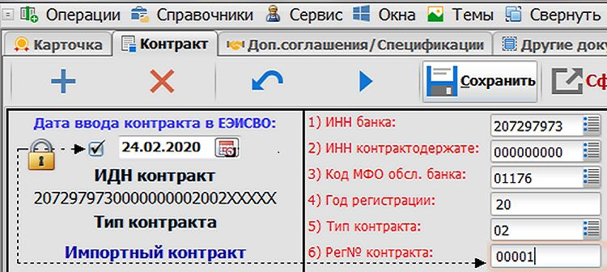  Electronic copy of foreign trade contract |   Guarantees and fees | 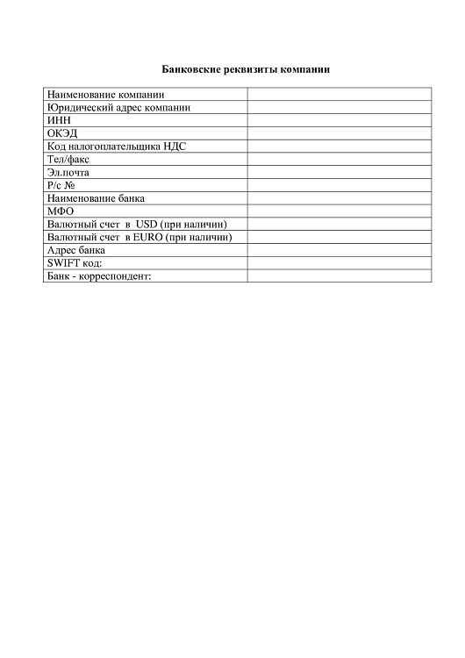  Bank details
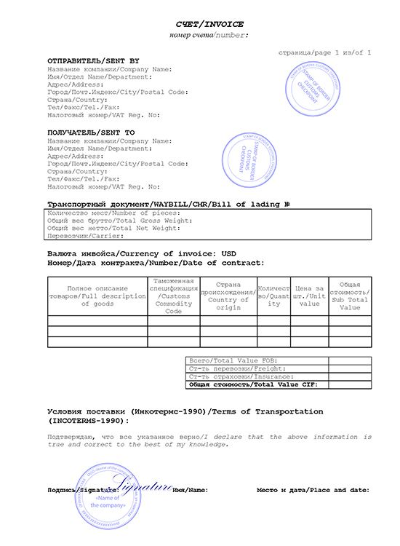  Commercial invoice | 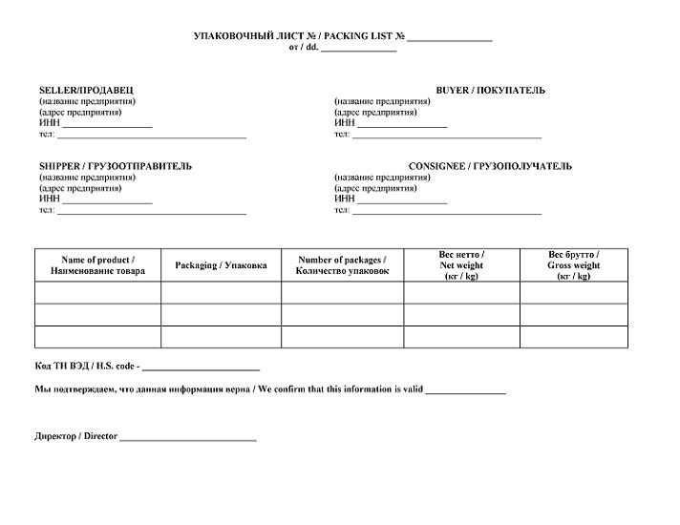  Packing list | 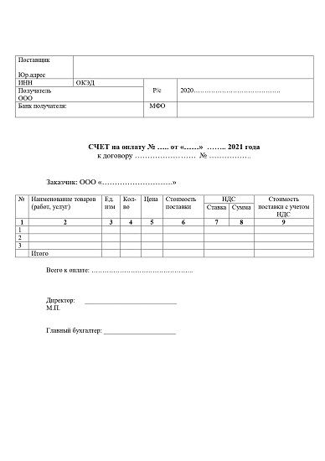  Invoice for payment
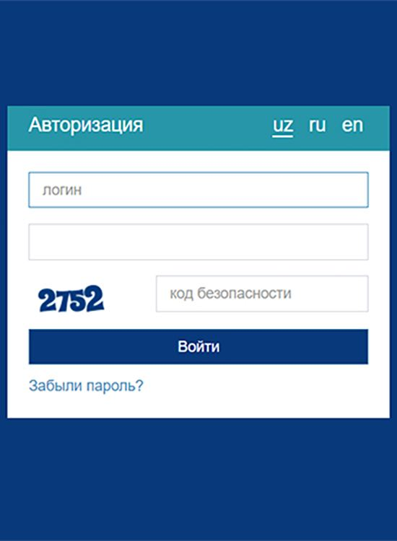  Online banking account | 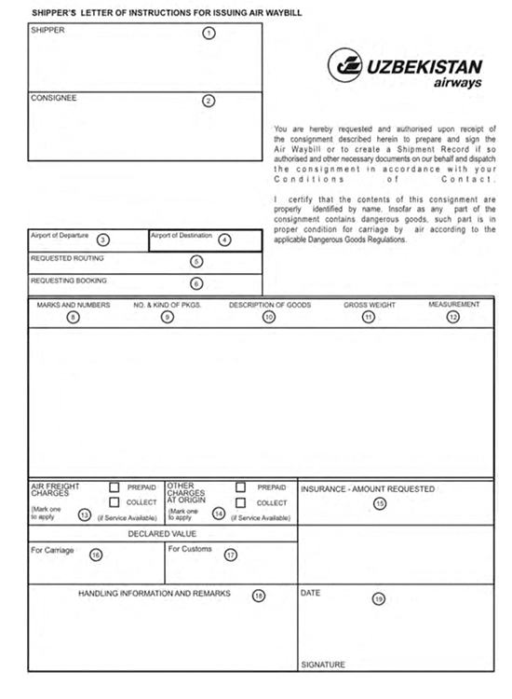  Shipper’s letter of instruction | 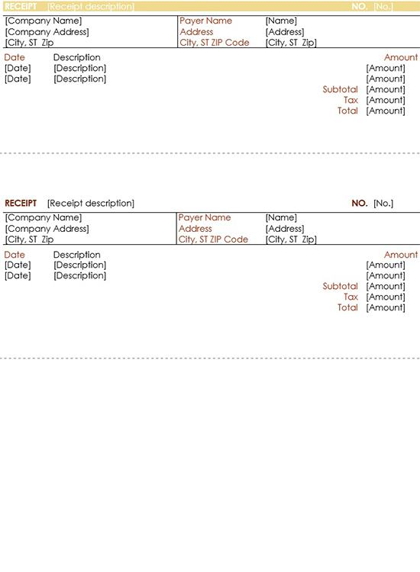  Bank payment receipt
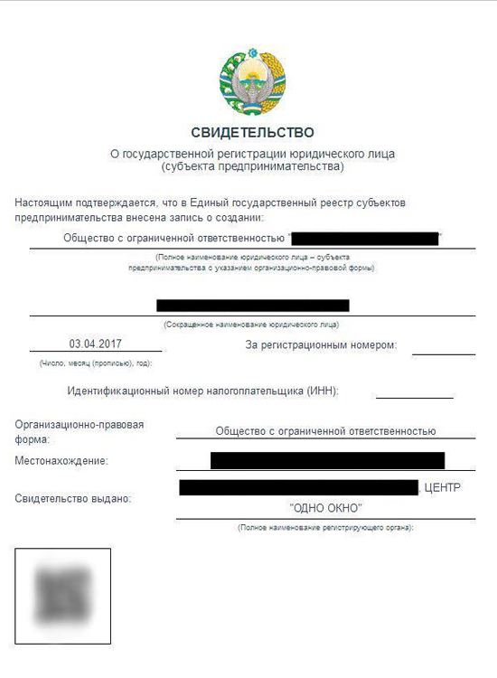  Certificate of state registration | 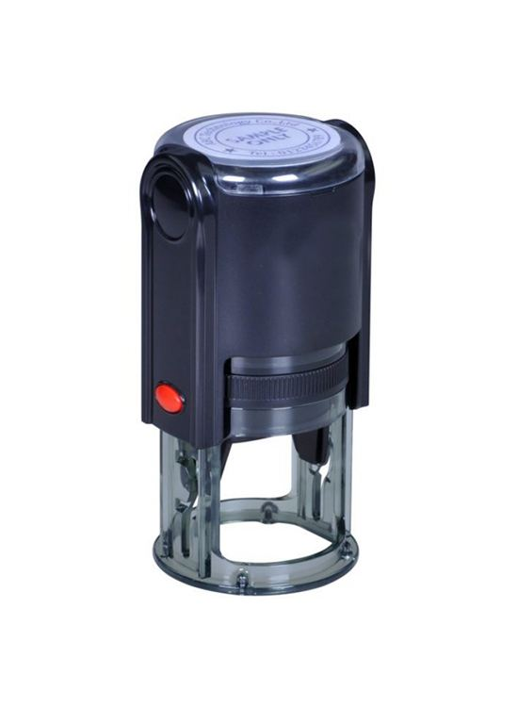  Stamp | 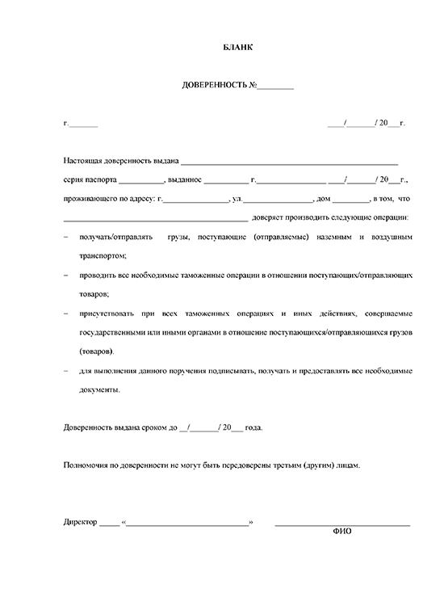  Power of attorney
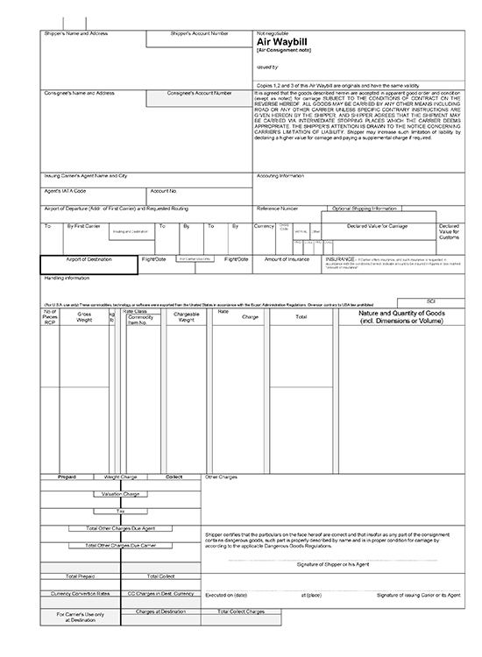  Air waybill | 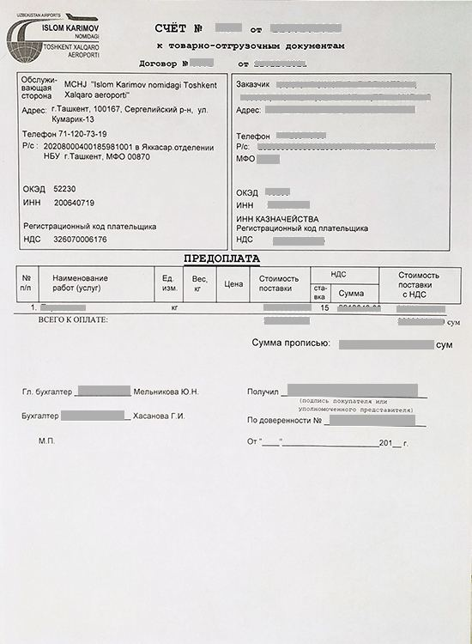  Invoice for prepayment for cargo handling |   Internet access
  Tax Identification Number of the organization or individual | Name of the organization | Full name of an organization’s manager
Contact phone number | Agency region | Payment sum
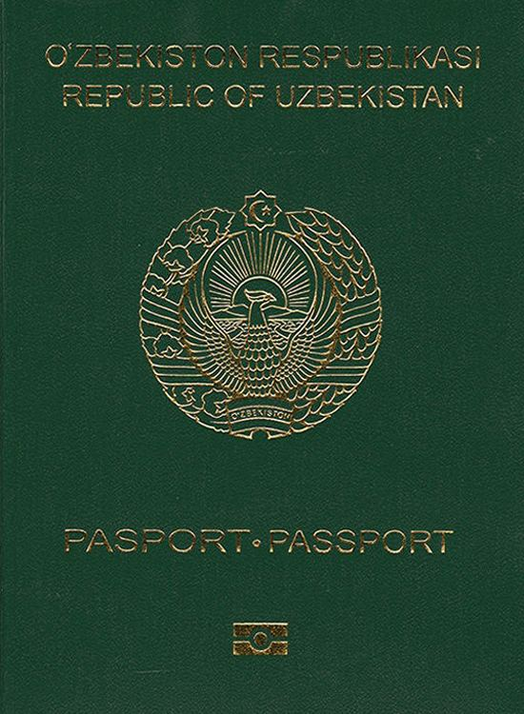  Passport | 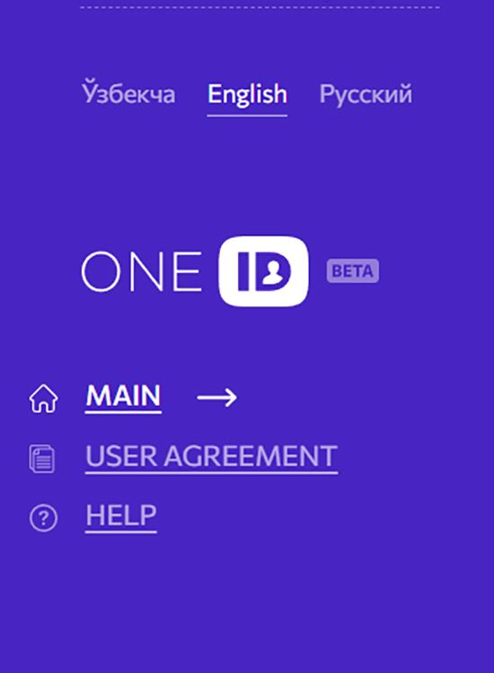  One ID account | Email
Type of organization (business entity, budgetary) | Cost on the contract | Quantity of transport units
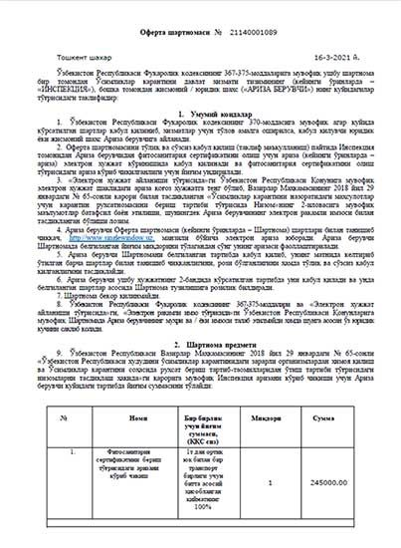  Offer agreement for phytosanitary certificate | 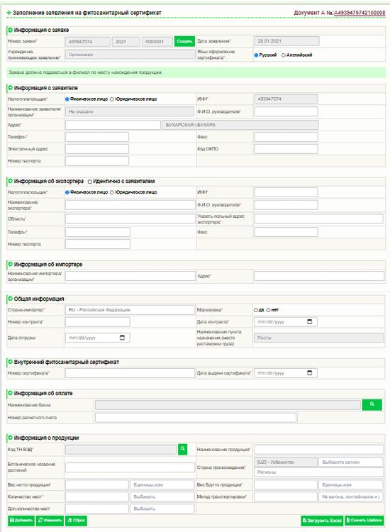  Online application for phytosanitary certificate | 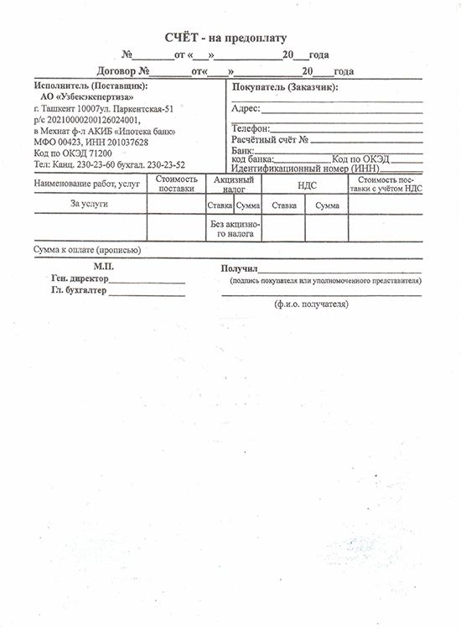  Invoice for prepayment
  Any document confirming the exporter's right to use a land plot | Any document confirming purchase of agricultural products | 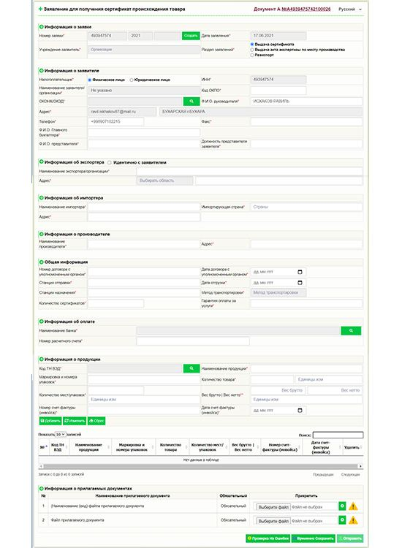  Online application for certificate of origin
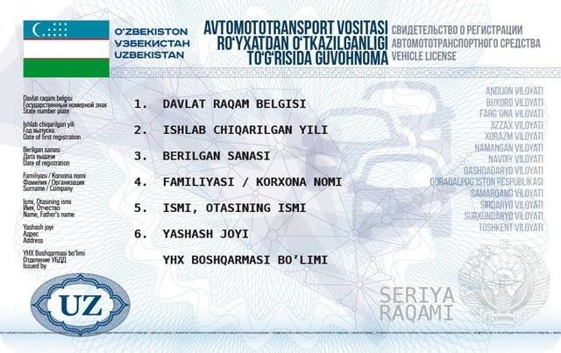  Vehicle registration certificate | 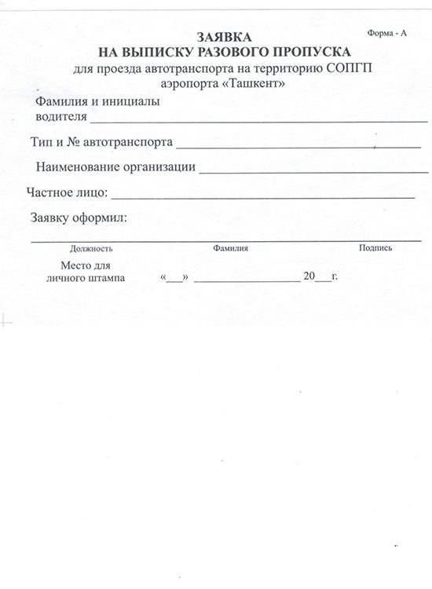  Vehicle entrance permit | 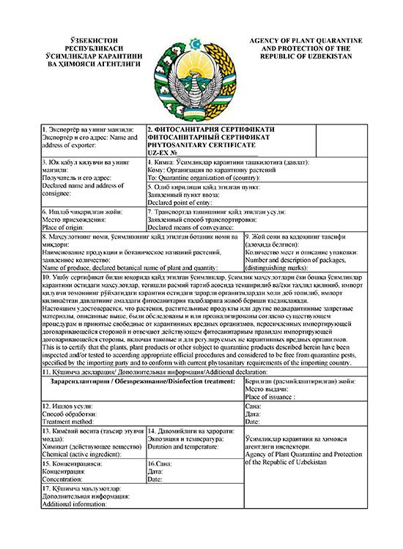  Phytosanitary certificate
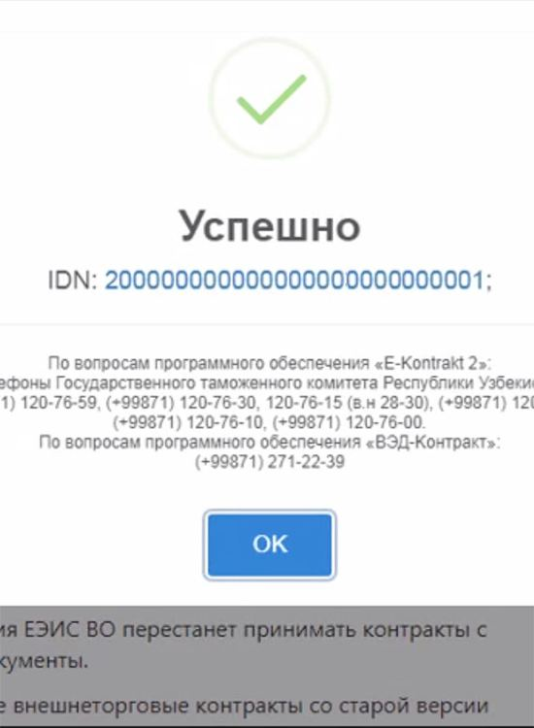  Identification number of foreign trade contract | 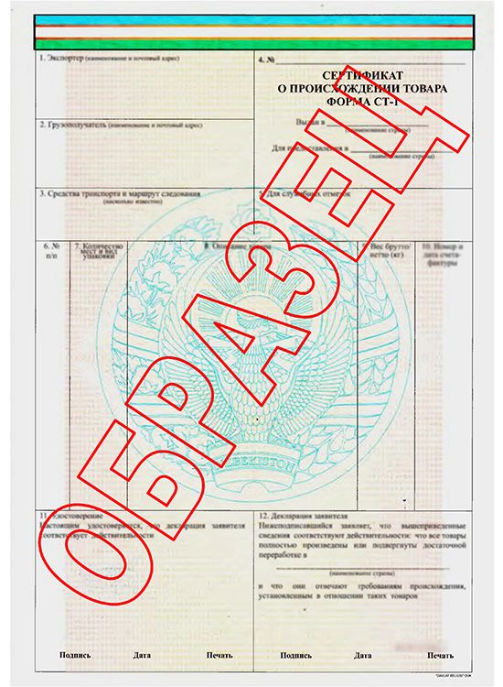  Certificate of origin | 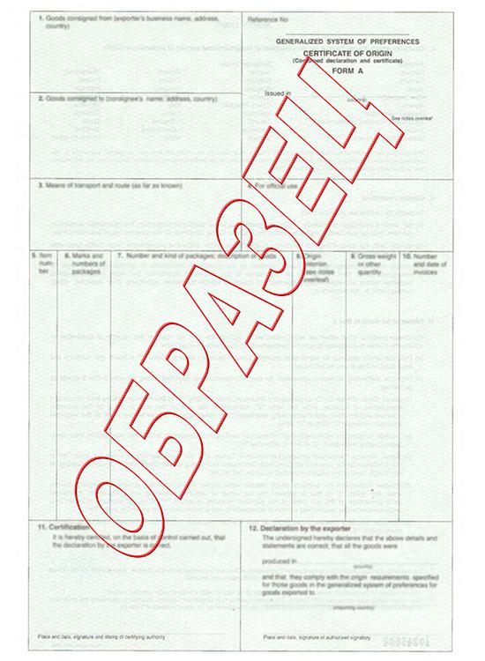  Certificate of origin form A
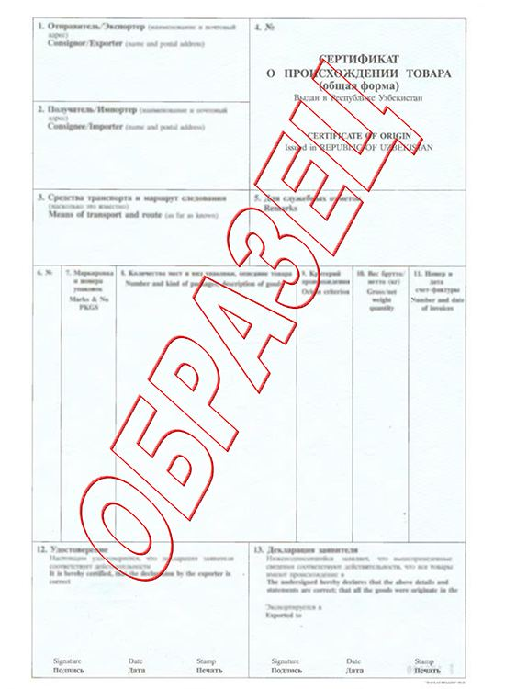  Certificate of origin General form | 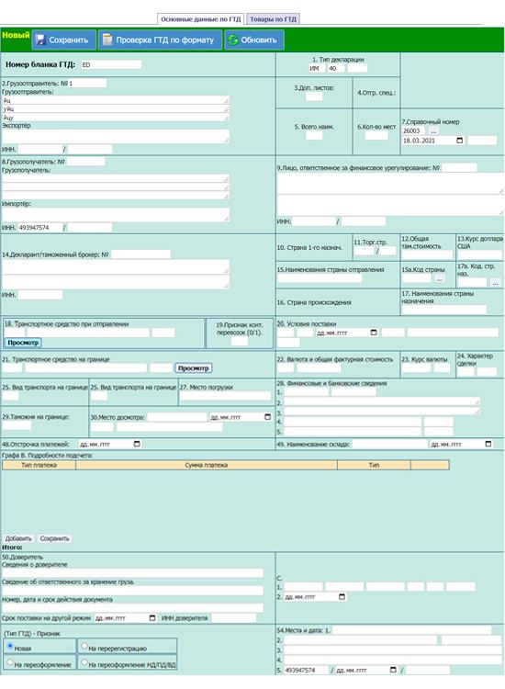  Electronic form of customs declaration | 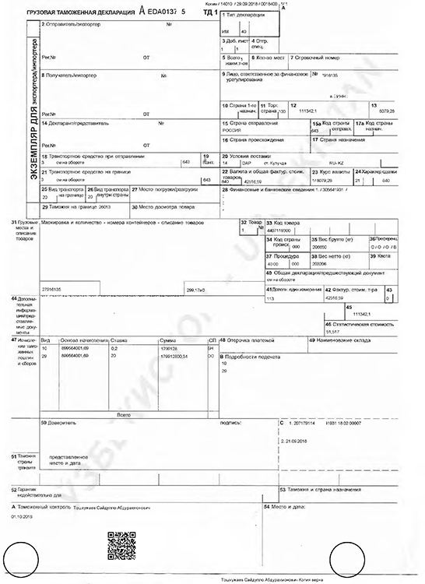  Export customs declaration
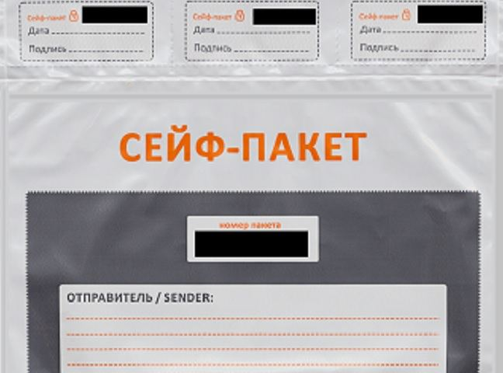
Package of documents

8. Step reference screenshots
The platform's own screen for each step, reproduced as published. These are screenshots of the eRegulations record (in Uzbek), showing contact details, expected result, requirements and price — not screenshots of the destination government service. They serve as visual provenance for the tables above.
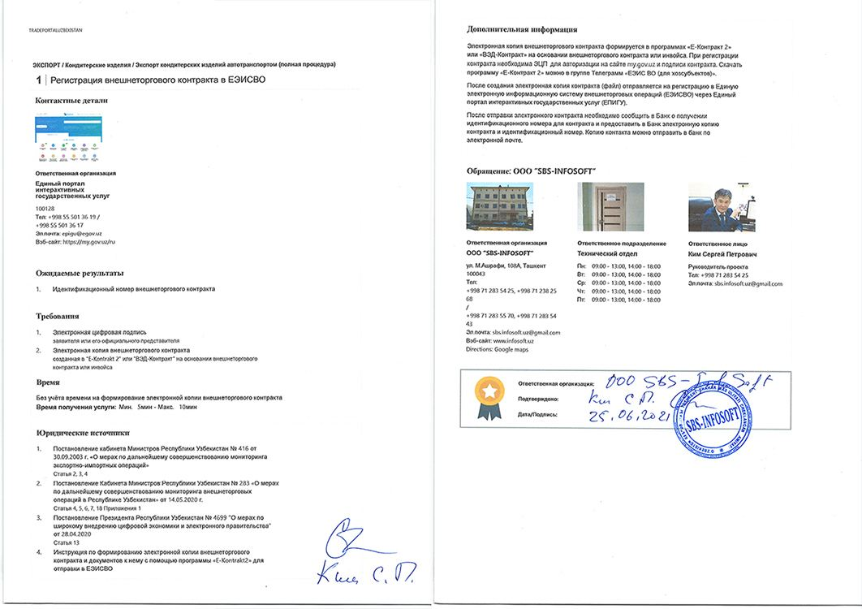  Step 1 — Register foreign trade contract in UEISFTO | 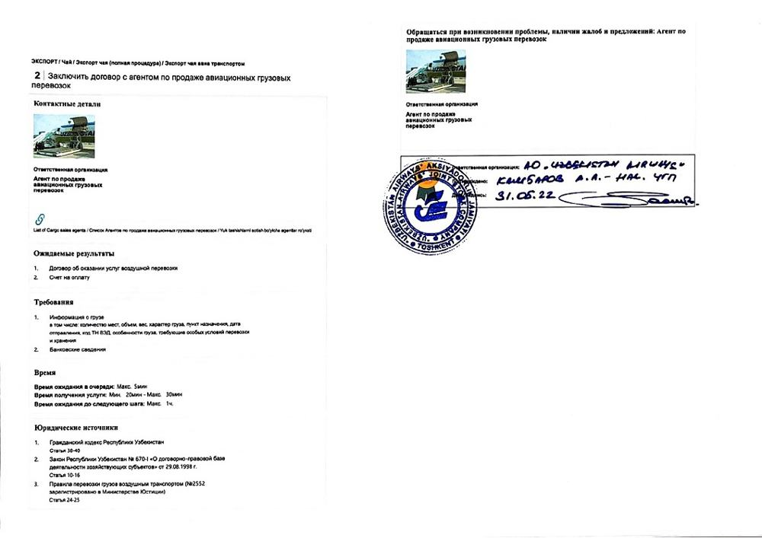  Step 2 — Contract with cargo sales agent
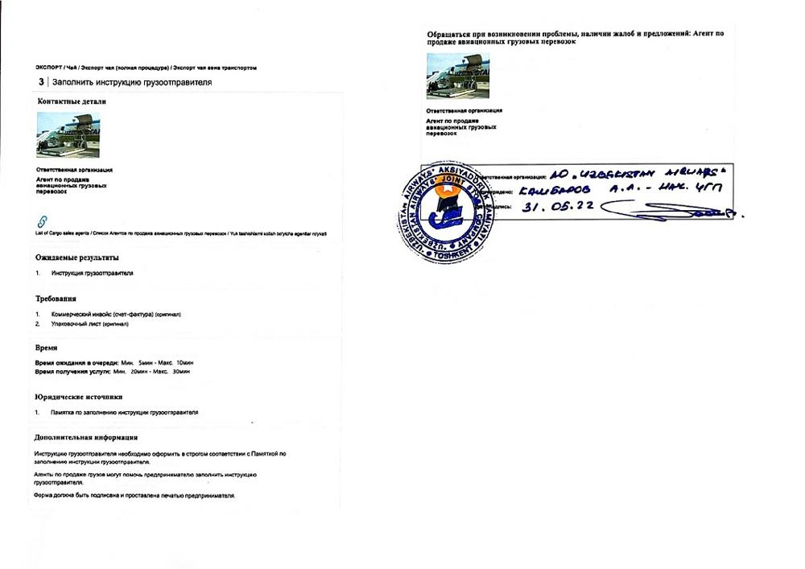  Step 3 — Submit shipper’s letter of instruction | 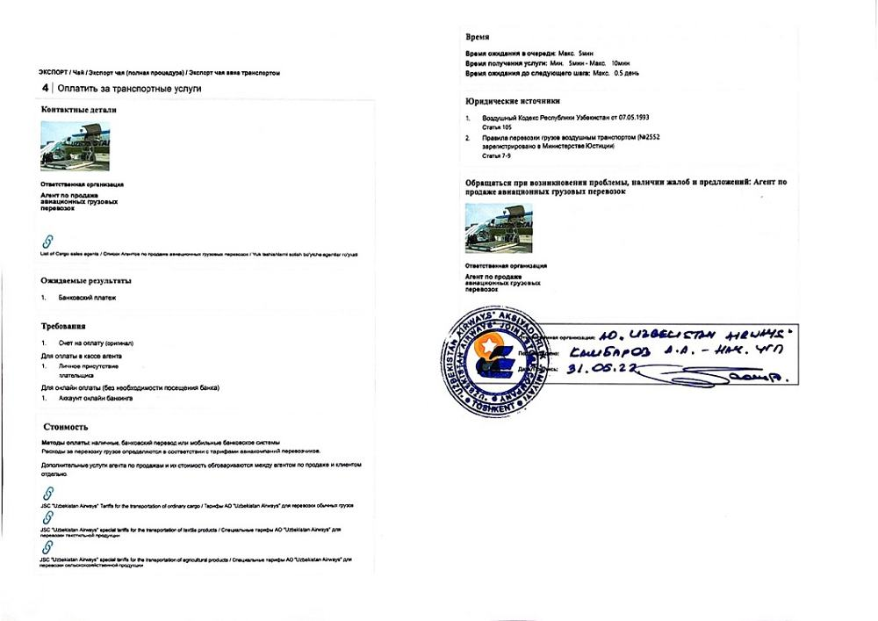  Step 4 — Pay for transportation service
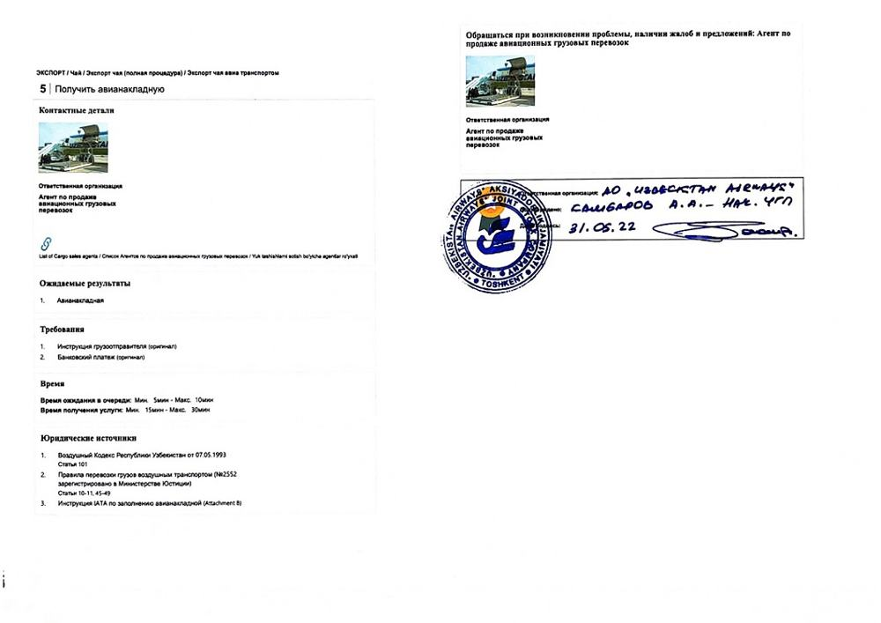  Step 5 — Obtain air waybill | 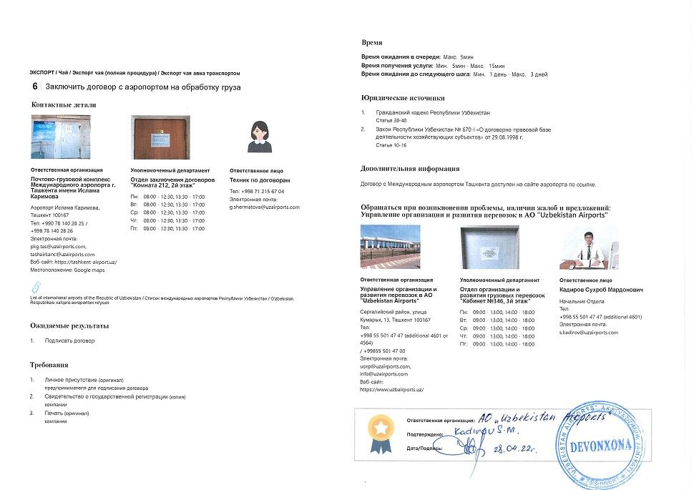  Step 6 — Contract with airport for cargo handling
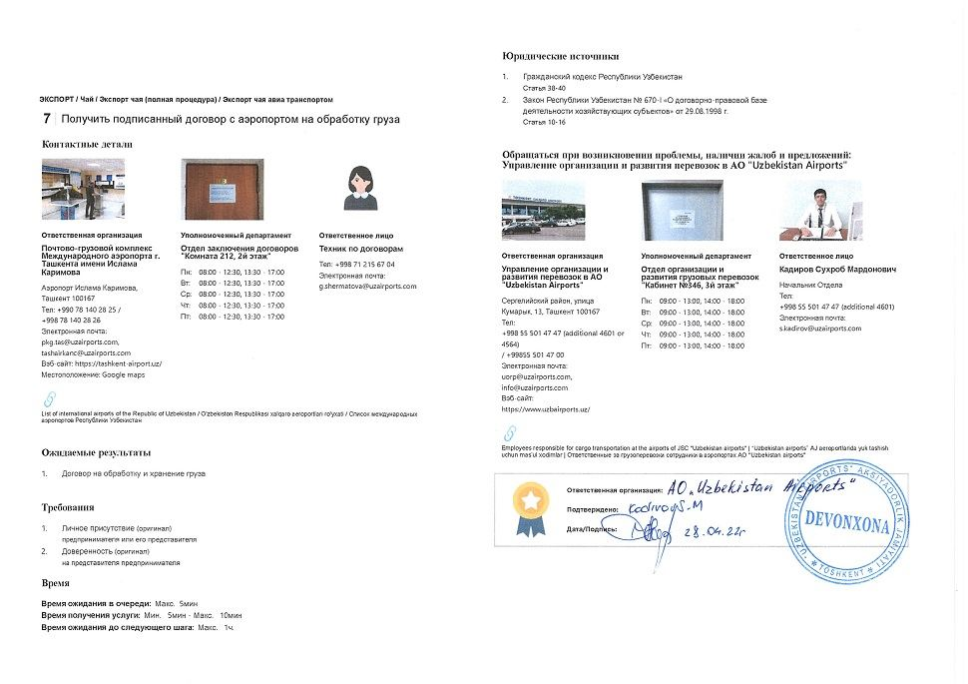  Step 7 — Obtain signed contract with airport for cargo handling | 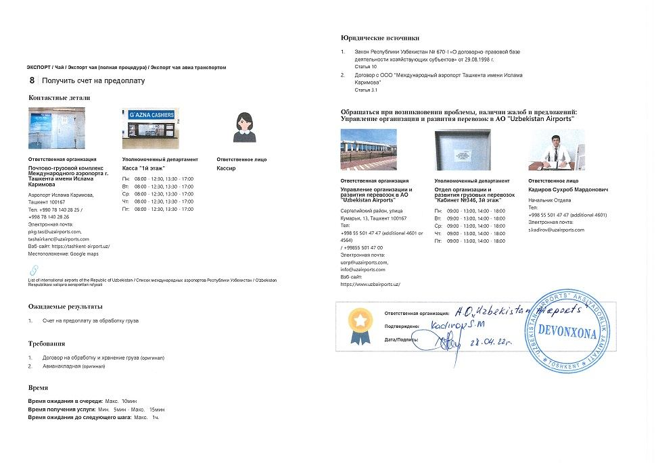  Step 8 — Obtain invoice for prepayment
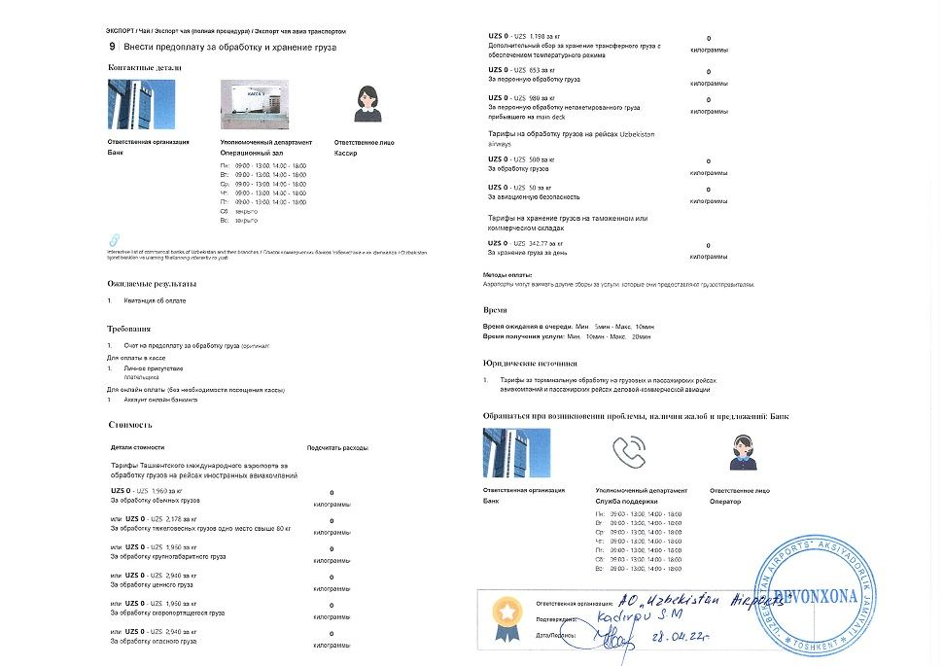  Step 9 — Prepay for handling and storage of cargo | 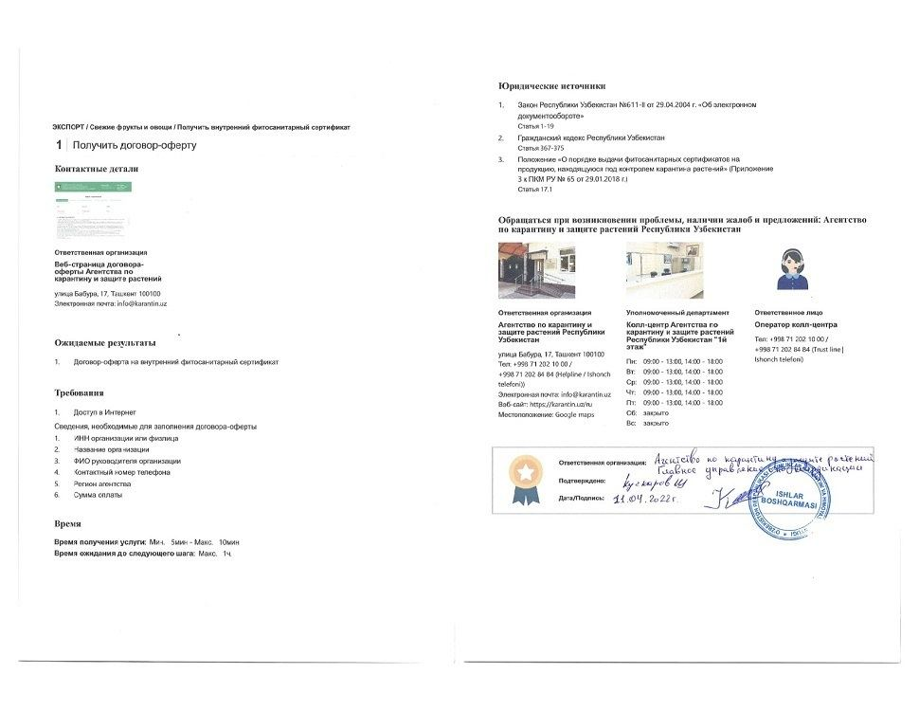  Step 10 — Obtain offer agreement
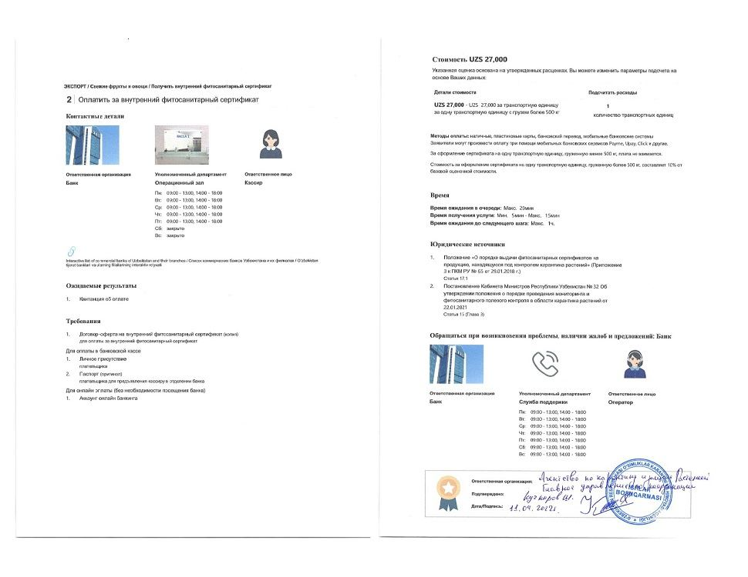  Step 11 — Pay for internal phytosanitary certificate | 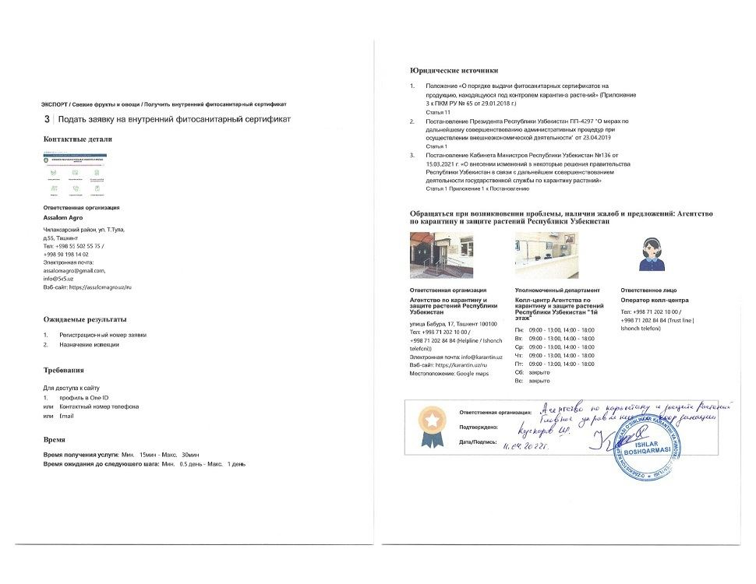  Step 12 — Apply for internal phytosanitary certificate
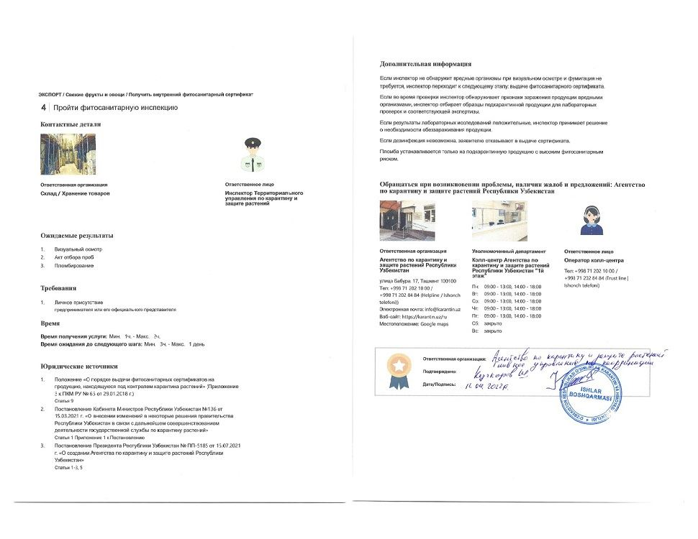  Step 13 — Undergo phytosanitary inspection | 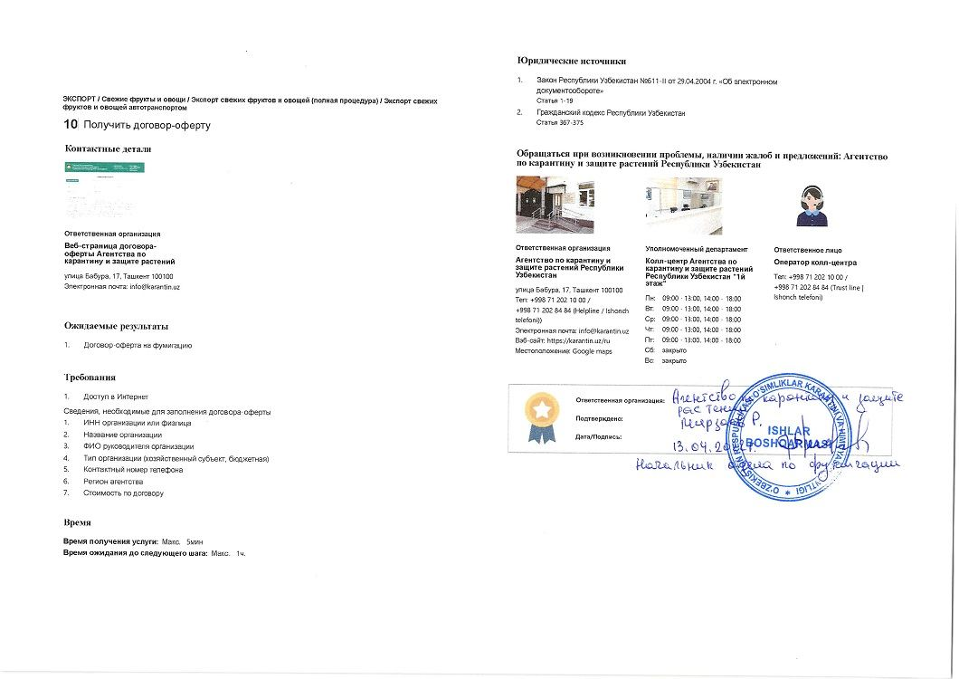  Step 14 — Obtain offer agreement for fumigation
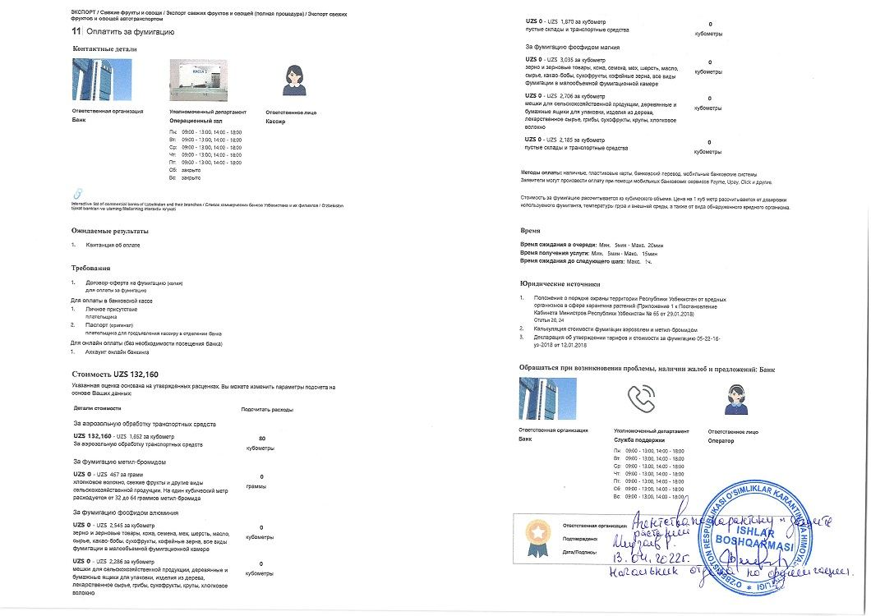  Step 15 — Pay for fumigation | 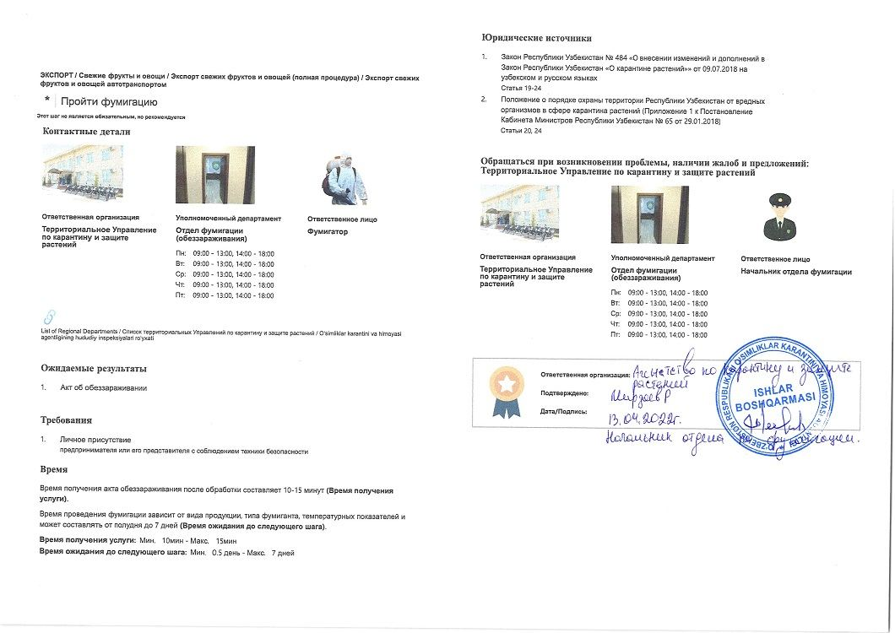  Step 16 — Undergo fumigation
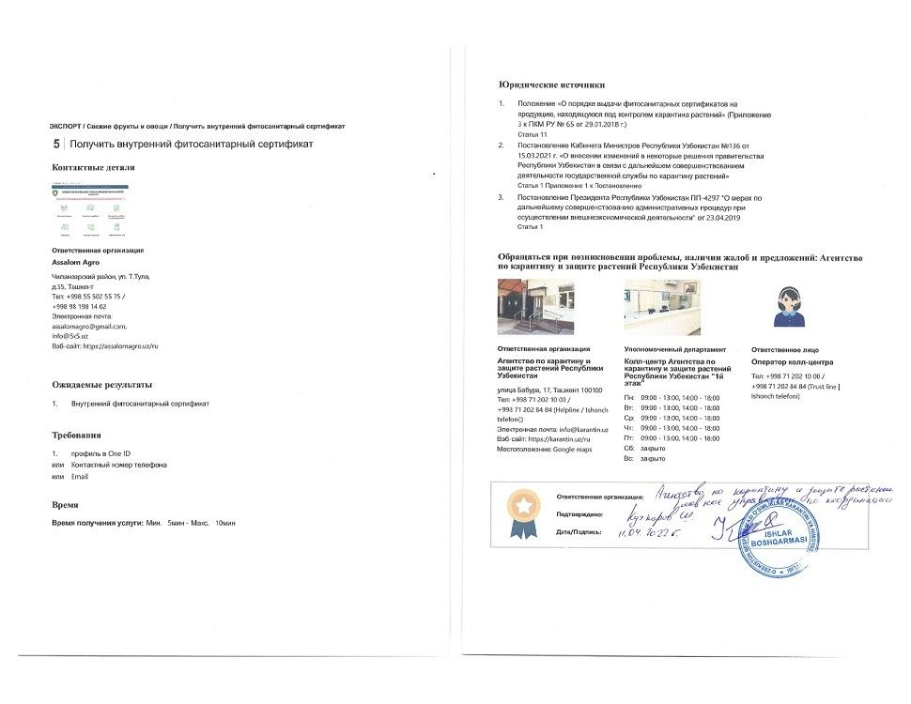  Step 17 — Obtain internal phytosanitary certificate | 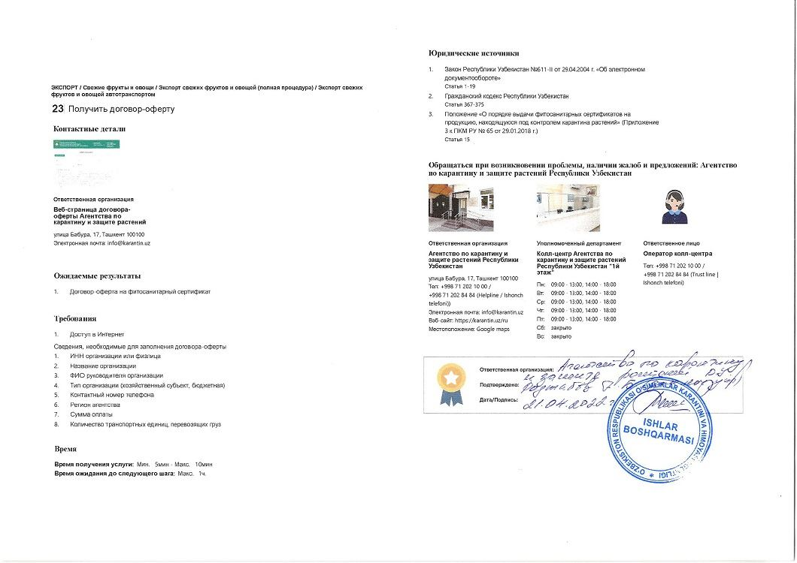  Step 18 — Obtain offer agreement
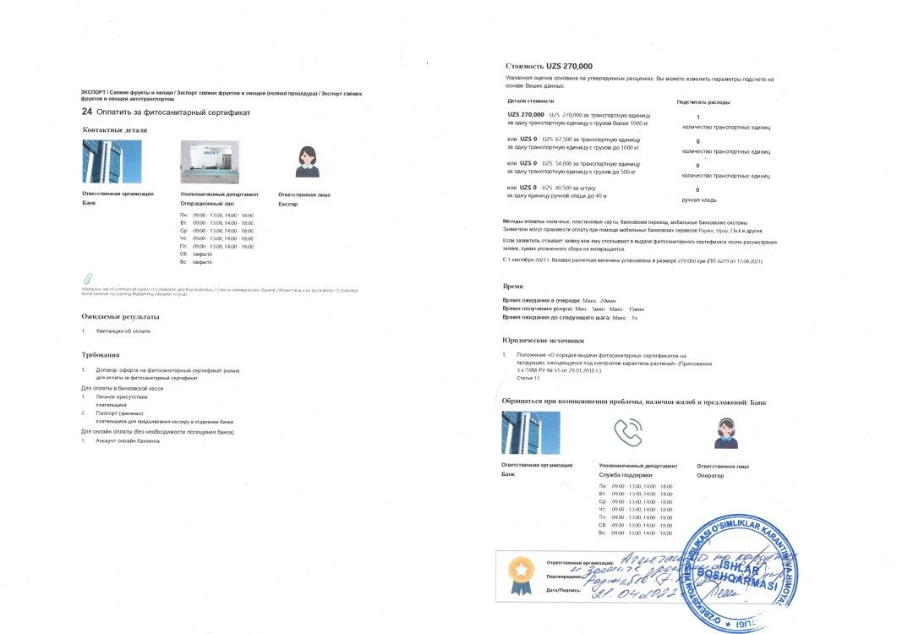  Step 19 — Pay for phytosanitary certificate | 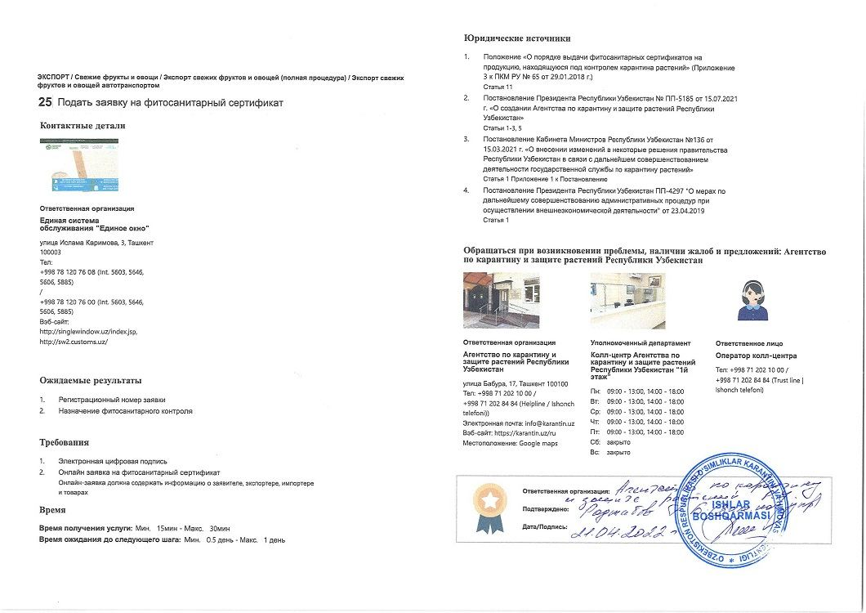  Step 20 — Apply for phytosanitary certificate
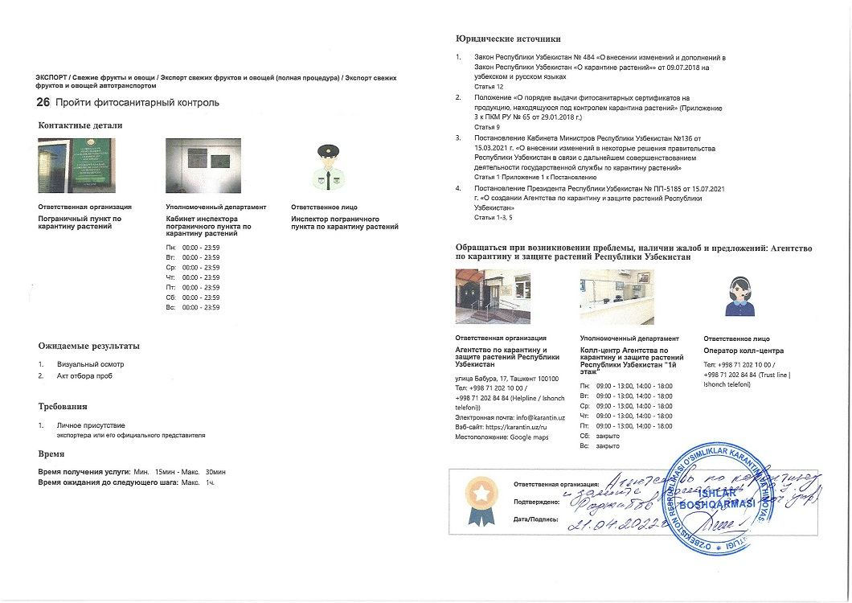  Step 21 — Undergo phytosanitary inspection | 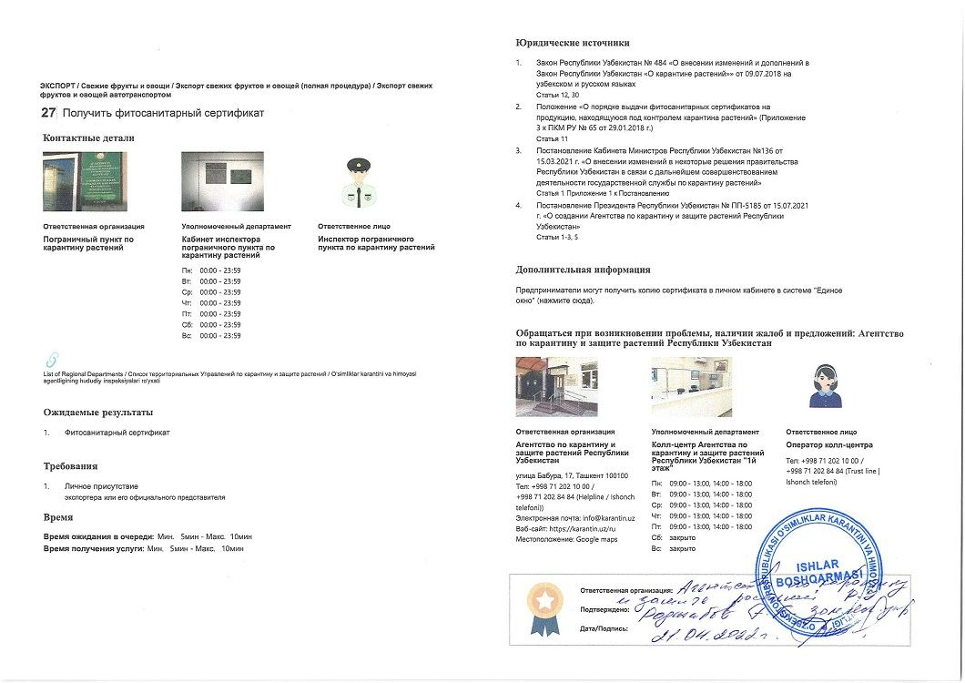  Step 22 — Obtain phytosanitary certificate
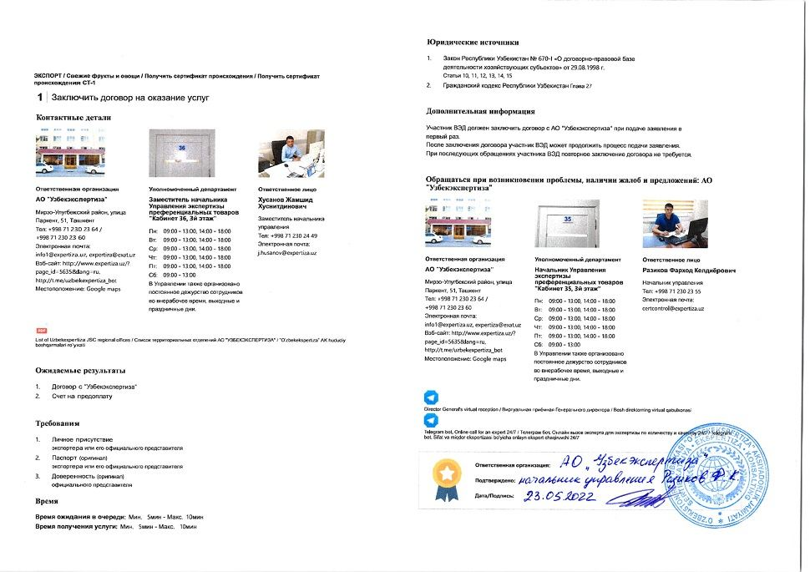  Step 23 — Conclude contract for services | 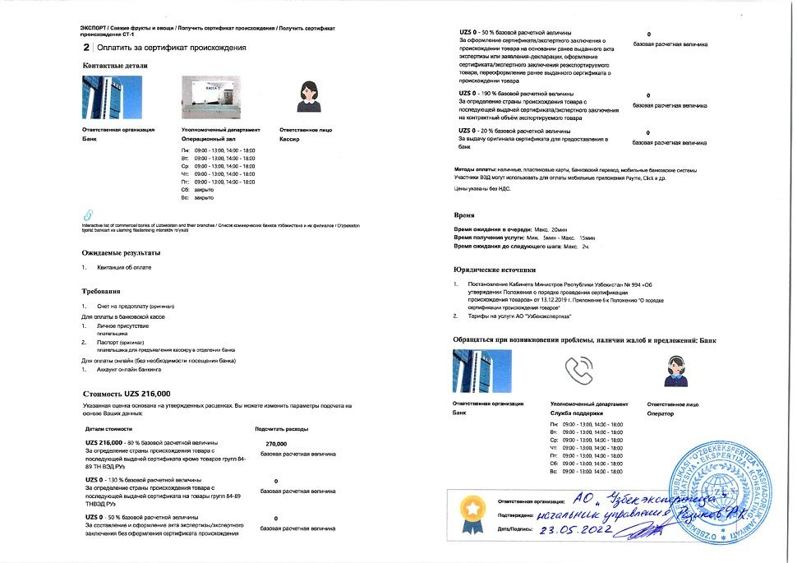  Step 24 — Pay for certificate of origin
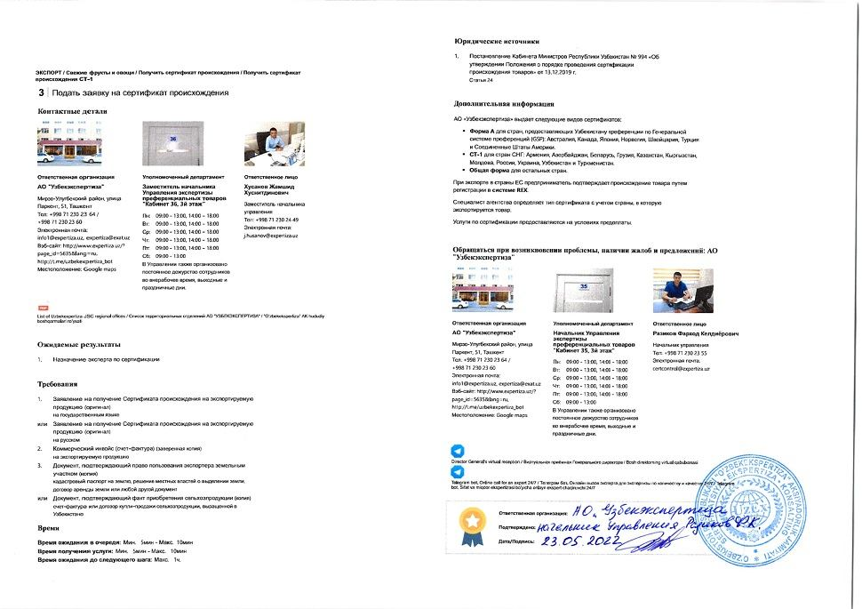  Step 25 — Apply for certificate of origin | 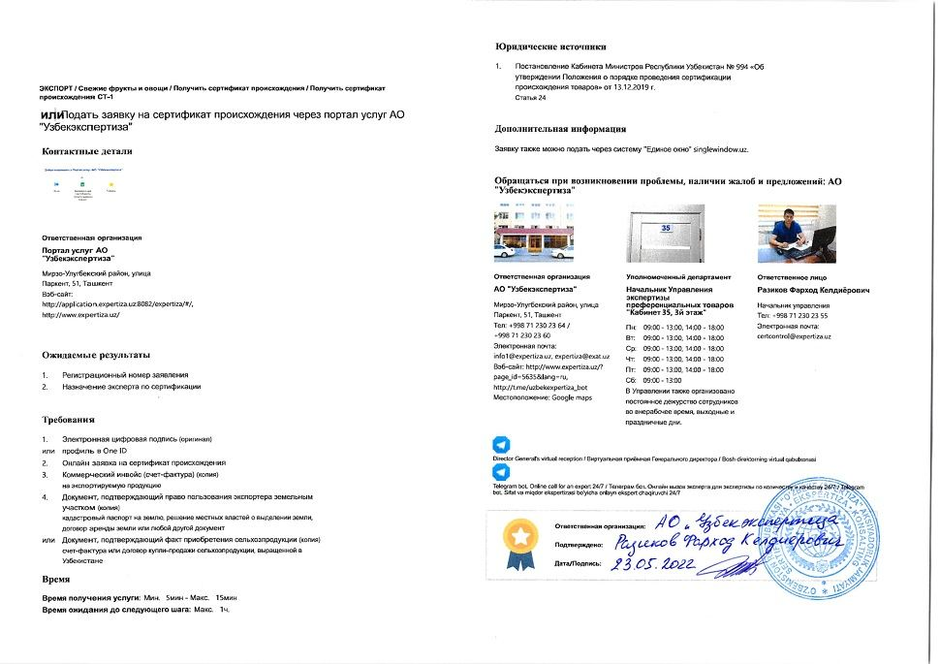  Step 26 — Apply for certificate of origin via Uzbekexpertiza service portal
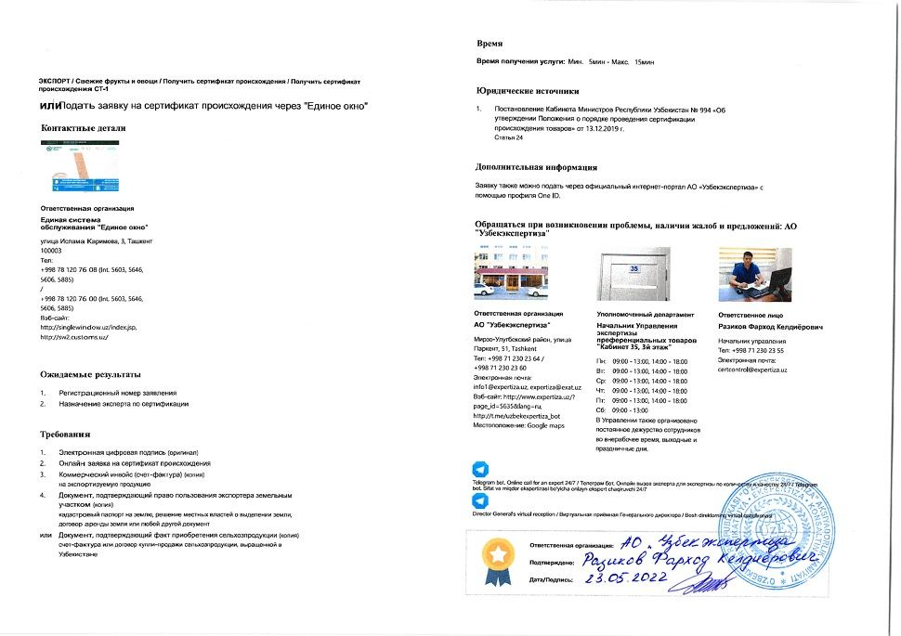  Step 27 — Apply for certificate of origin via Single Window | 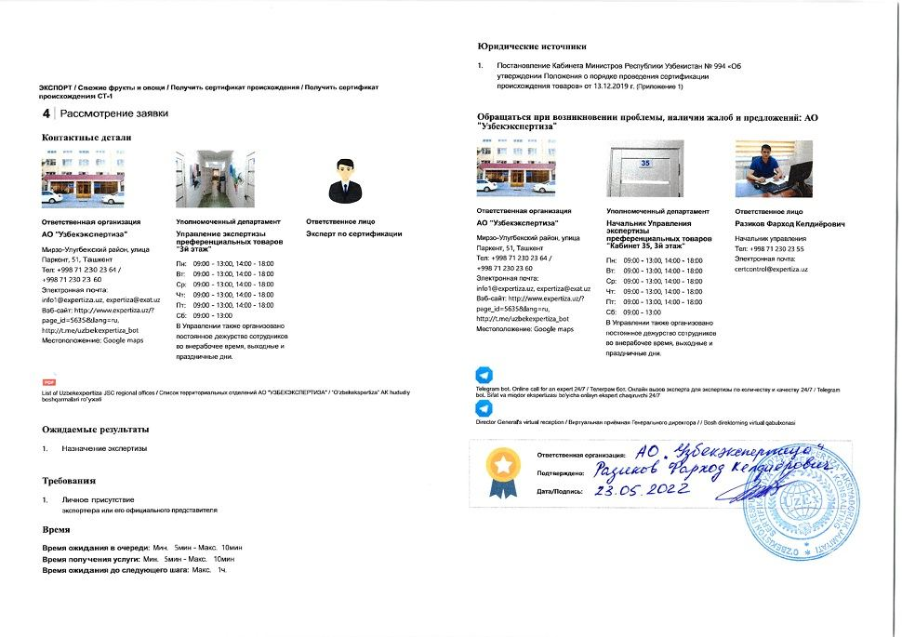  Step 28 — Assessment of application
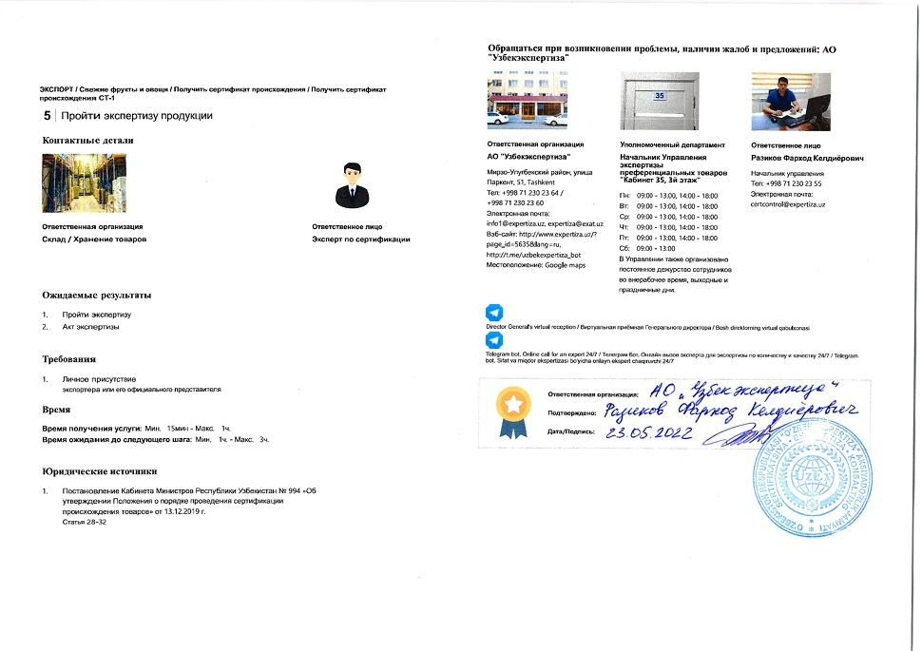  Step 29 — Undergo expertise of goods | 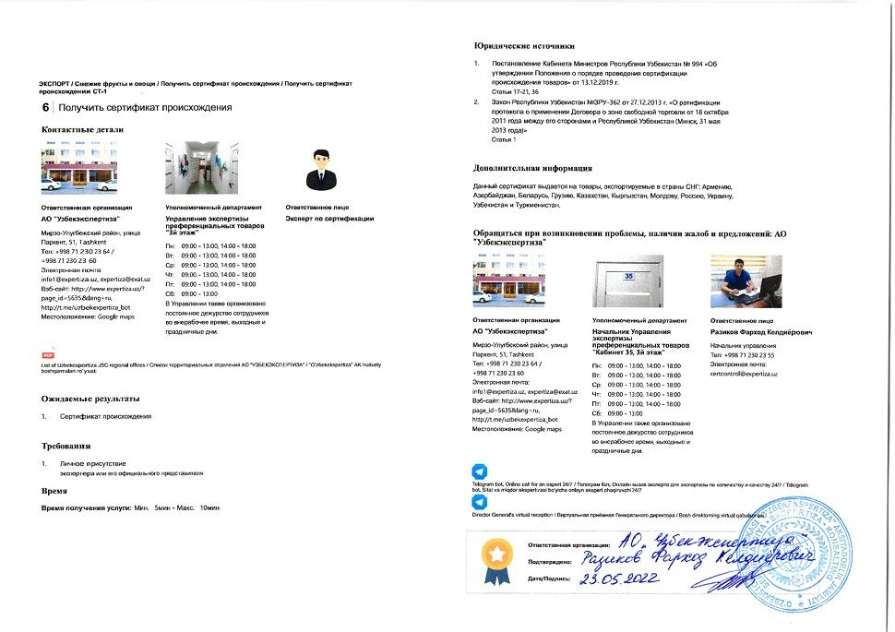  Step 30 — Obtain certificate of origin
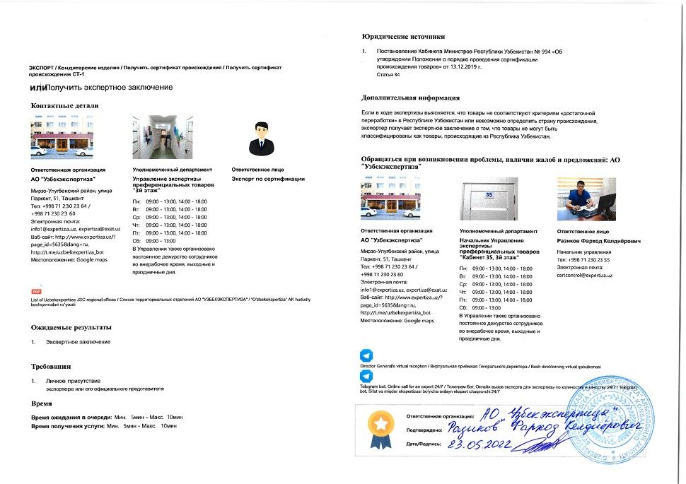  Step 31 — Obtain expert conclusion | 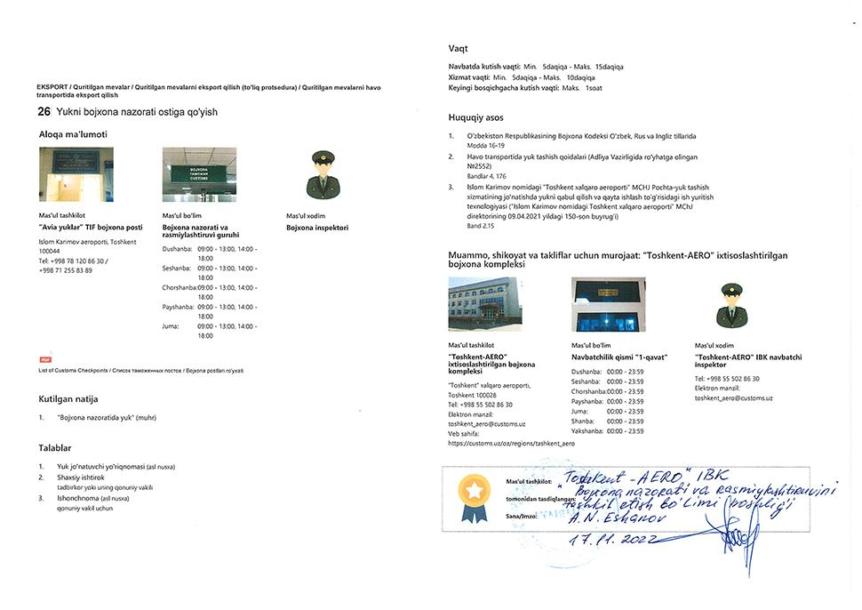  Step 32 — Put cargo under customs control
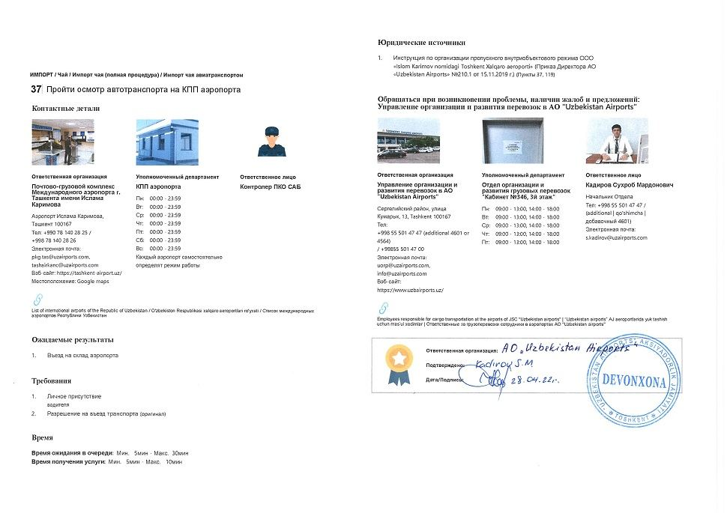  Step 35 — Undergo vehicle inspection at airport's Checkpoint | 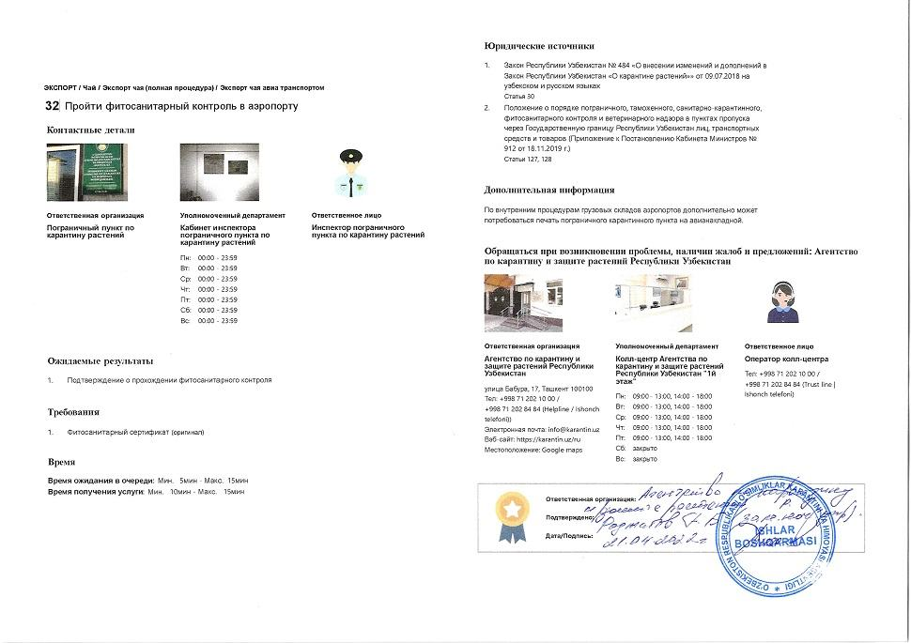  Step 36 — Undergo phytosanitary control at airport
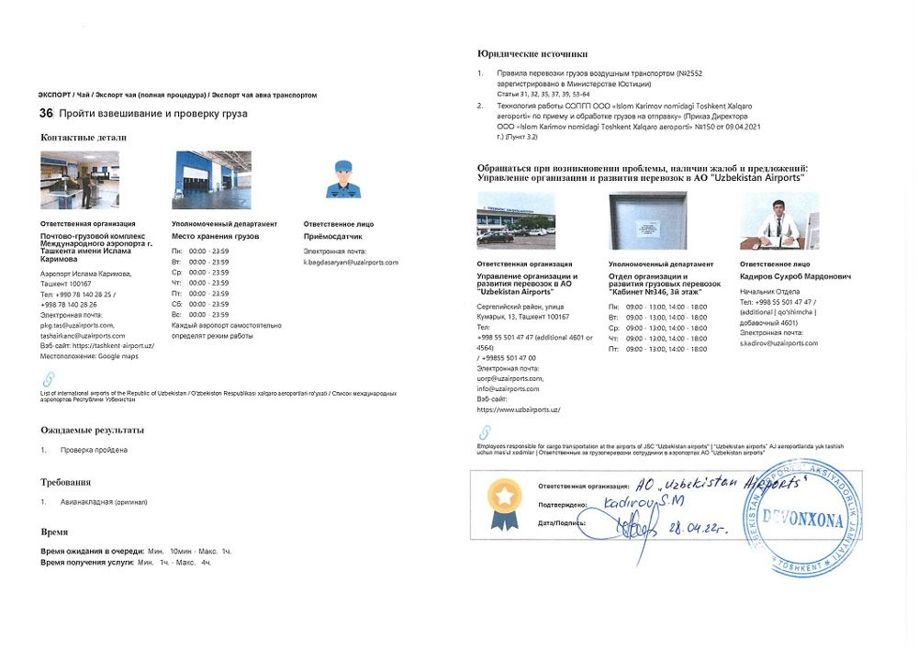  Step 37 — Undergo cargo weight and visual inspection | 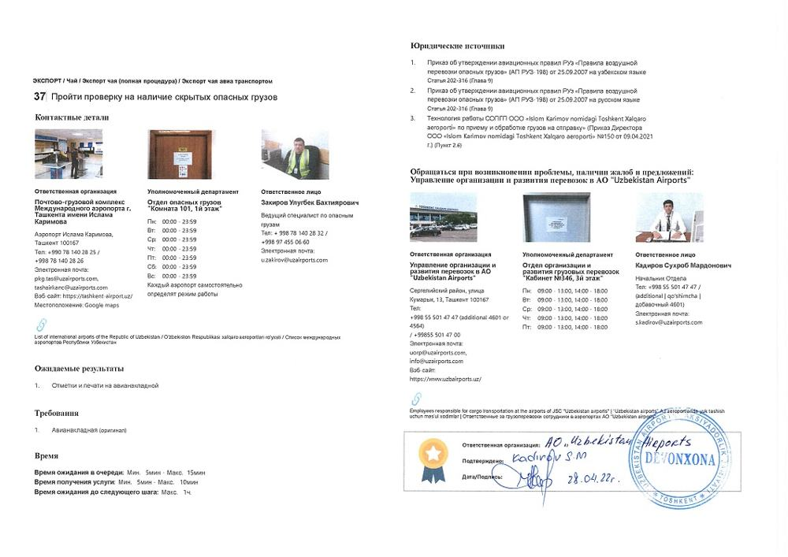  Step 38 — Undergo control for hidden dangerous goods
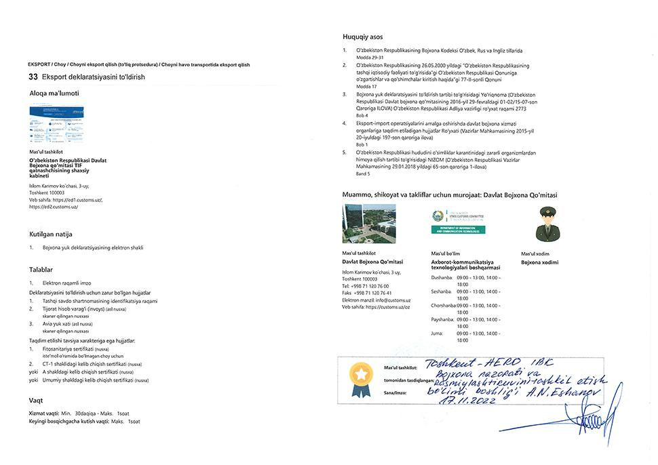  Step 39 — Create export customs declaration | 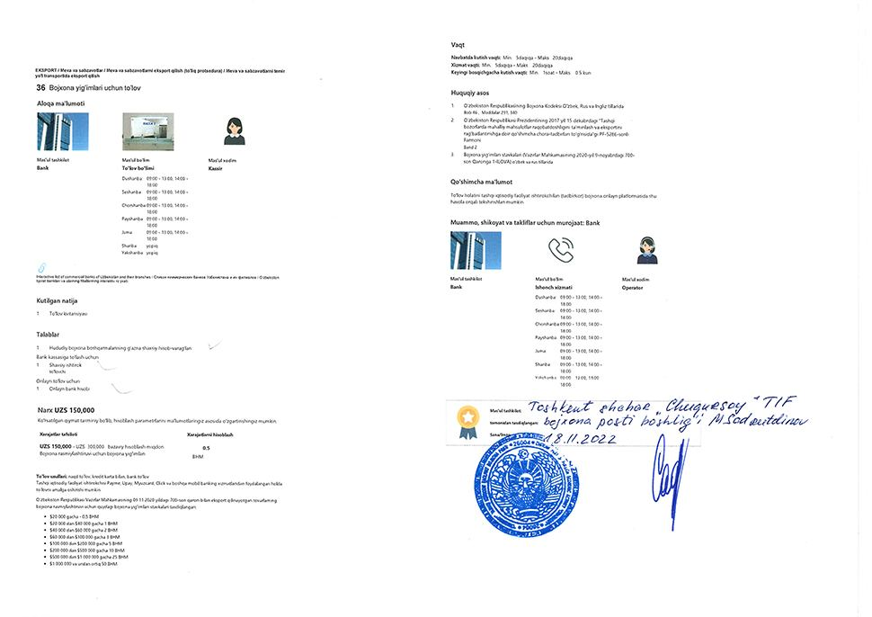  Step 40 — Pay for customs fee
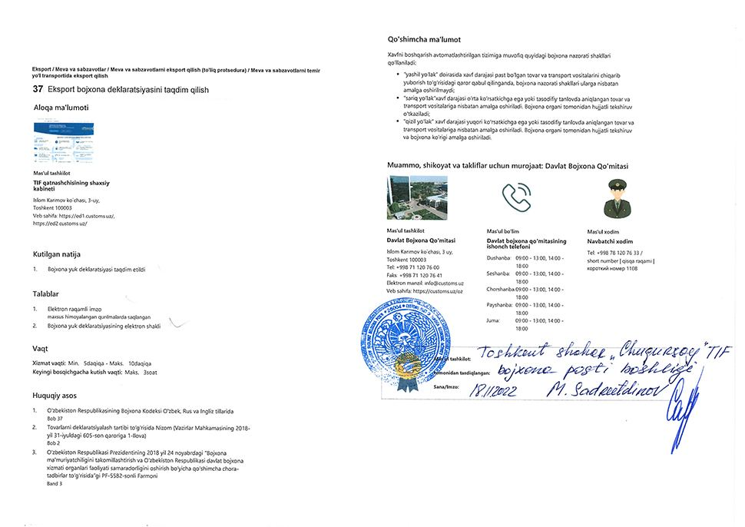  Step 41 — Submit export customs declaration | 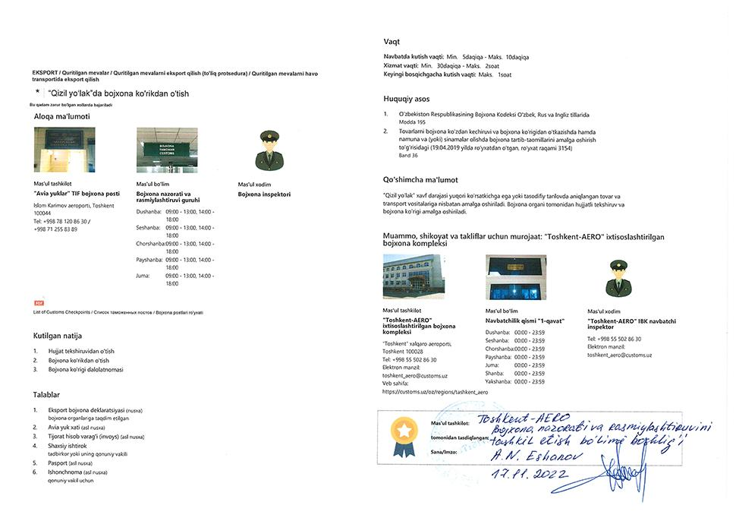  Step 42 — Undergo customs inspection in red corridor
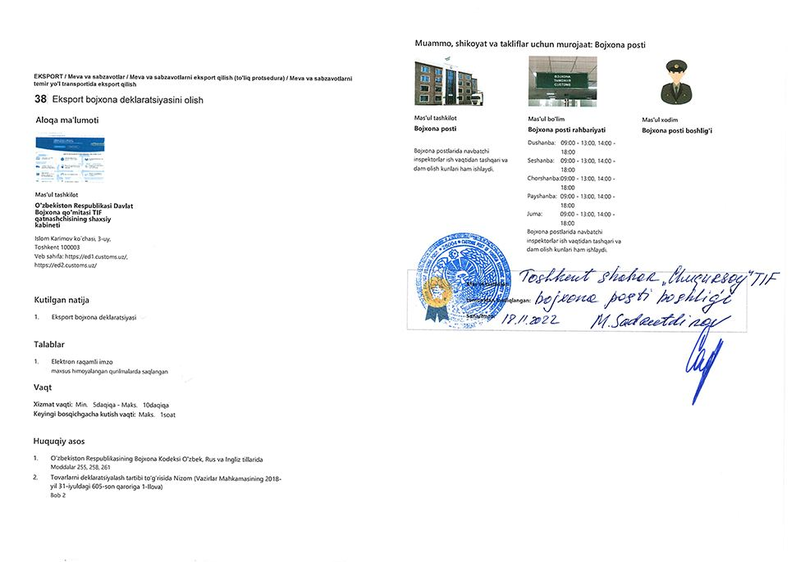  Step 43 — Obtain export customs declaration | 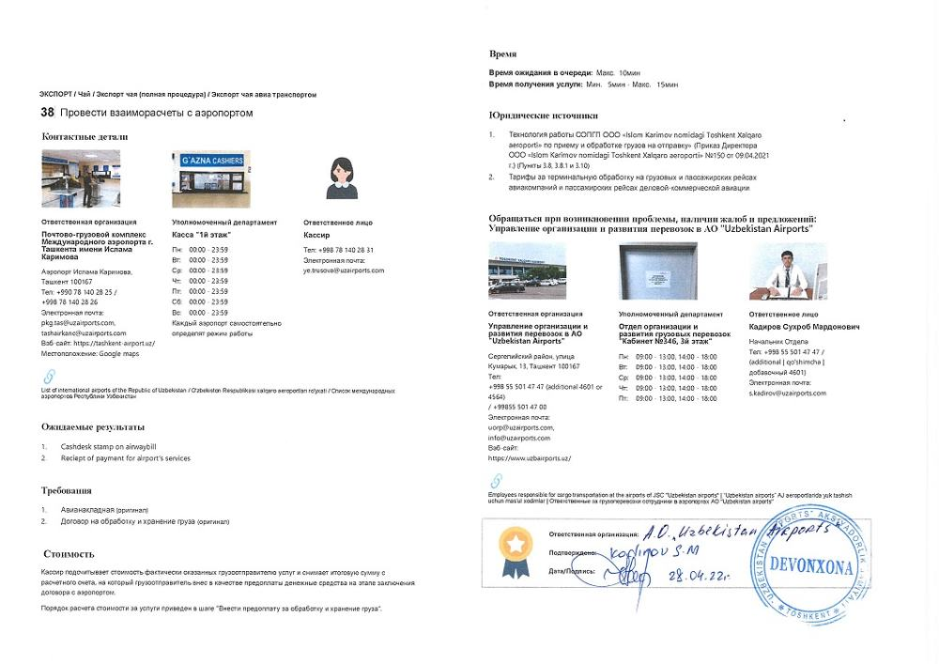  Step 44 — Complete mutual settlements with airport
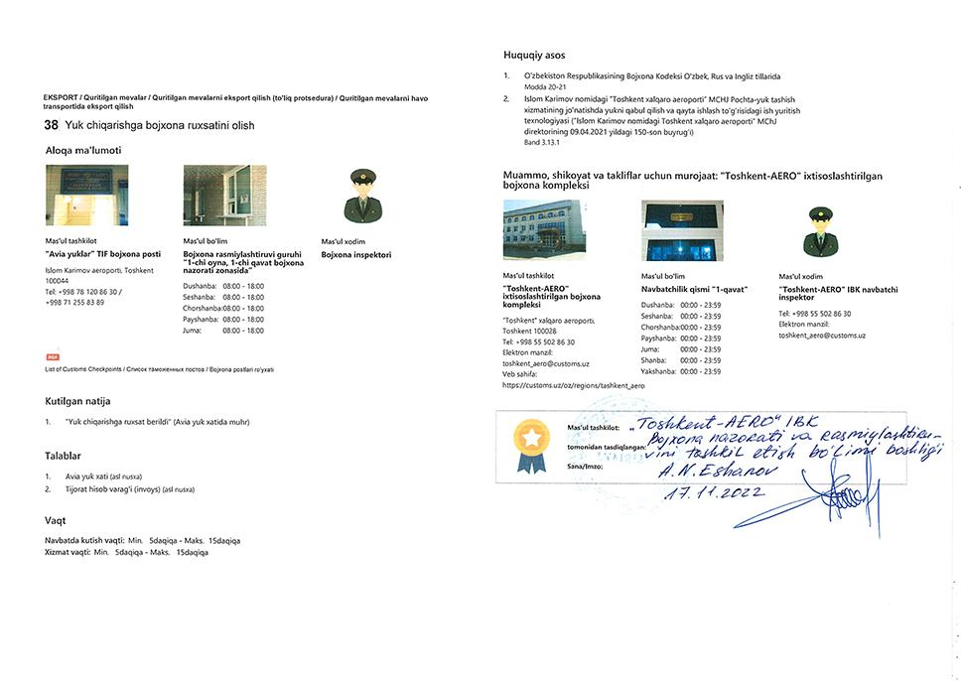  Step 45 — Obtain customs approval to release cargo | 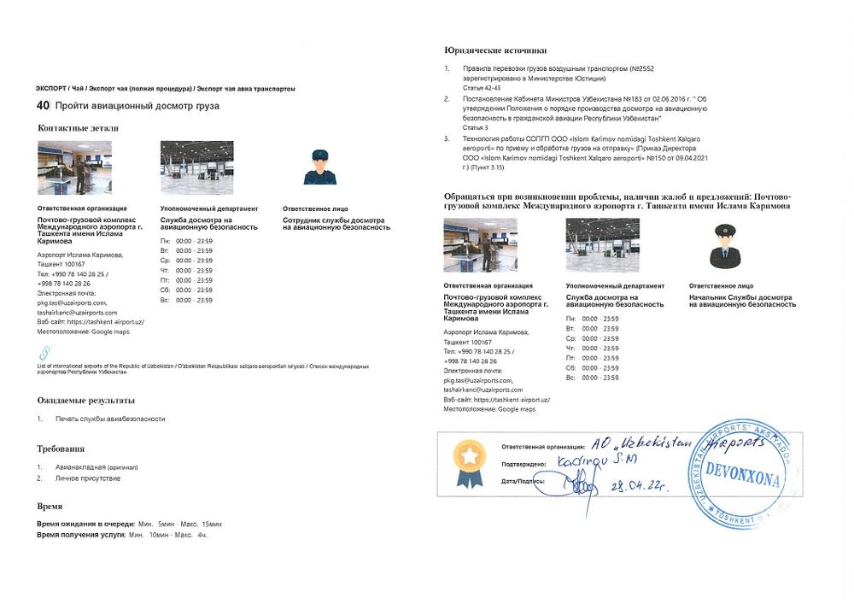  Step 46 — Undergo air security inspection
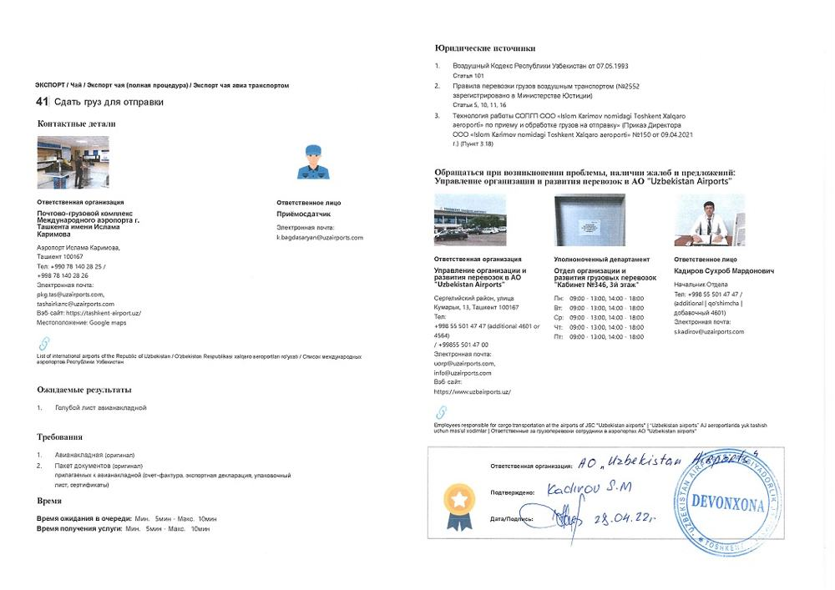
Step 47 — Hand over cargo for dispatch

