Uzbekistan Trade Info — Procedure Automation
Procedure 57: Import of animal or vegetable fertilizers by road
As-is process map — the procedure exactly as it runs today. Source: uztradeinfo.uz/procedure/57
Blocks | Steps | Entities | Online | Optional | Alternative
12 | 58 | 13 | 33 | 8 | 1
End-to-end published timeframe: 45–517 hours.
1. Process flow
Columns group the entity in charge, so every move between columns is a handoff. The specific body is named in grey inside each box. Dashed border = optional (conditional) step. Boxes side by side = alternative routes, where the trader takes one. Heavy border = the step can be done online.
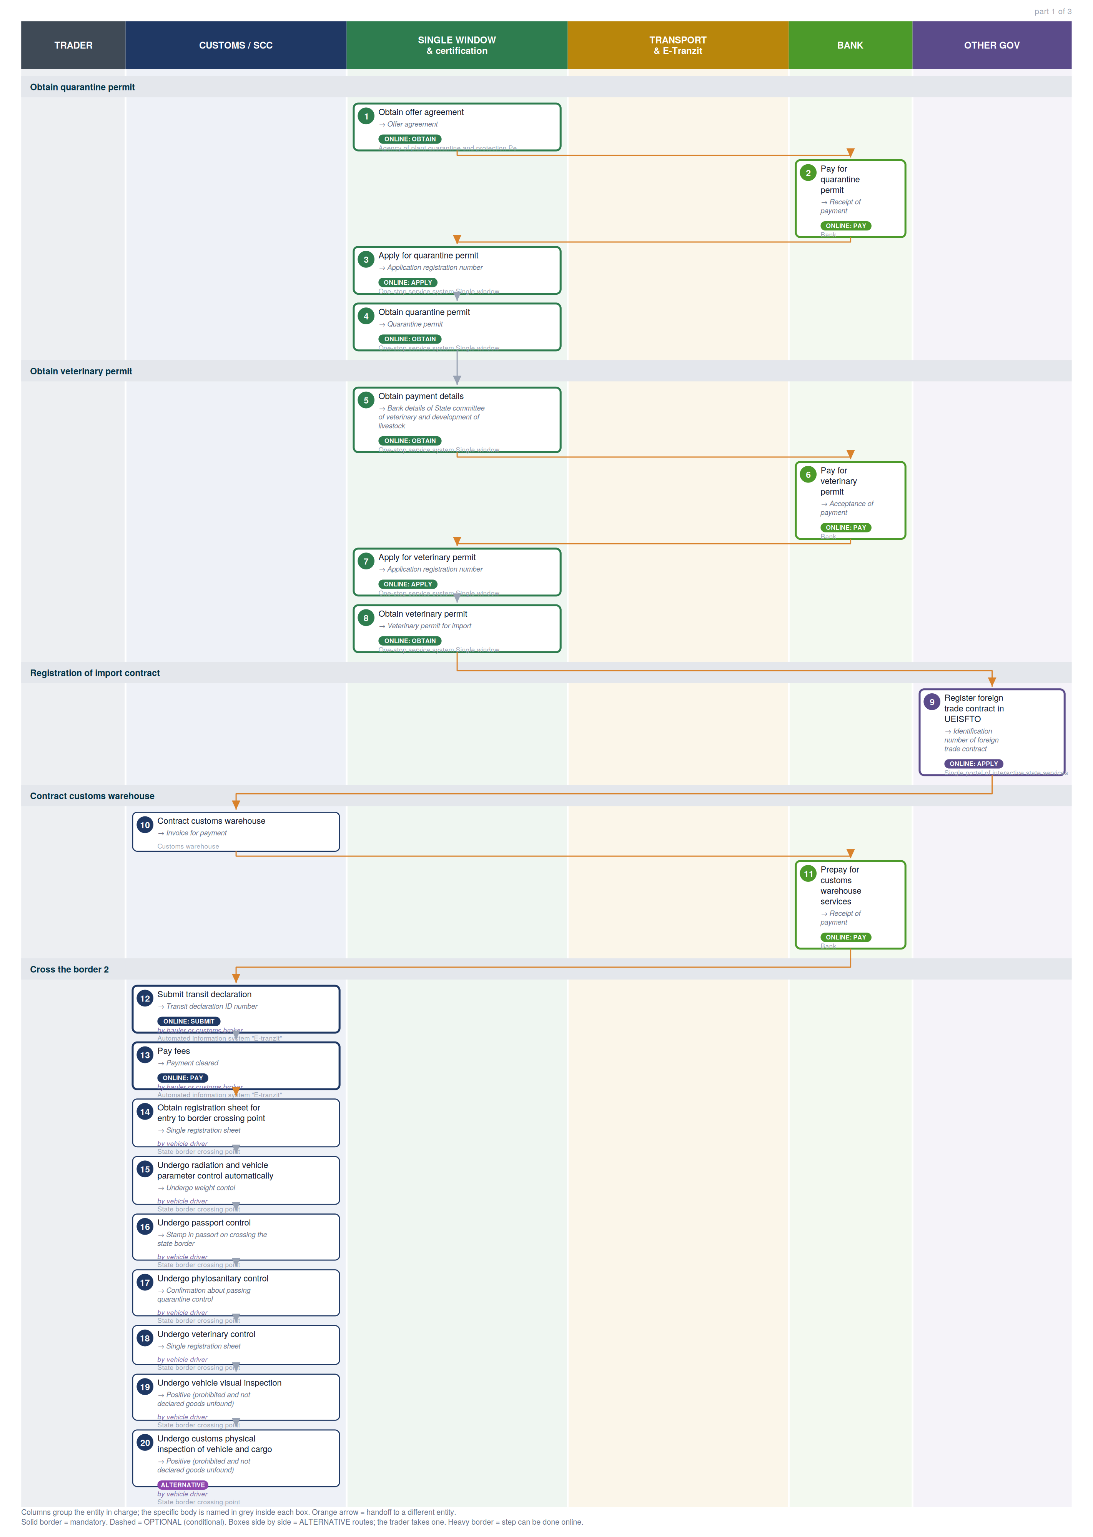

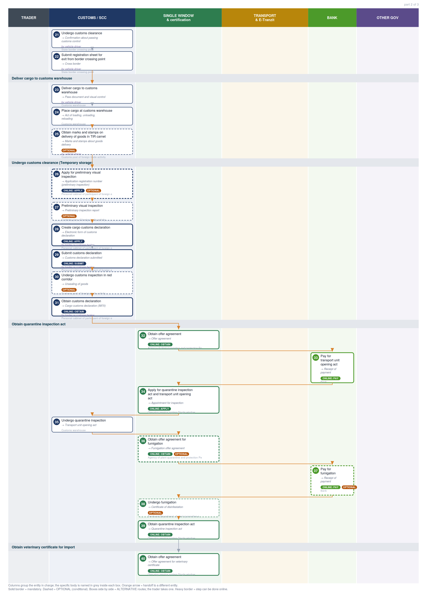

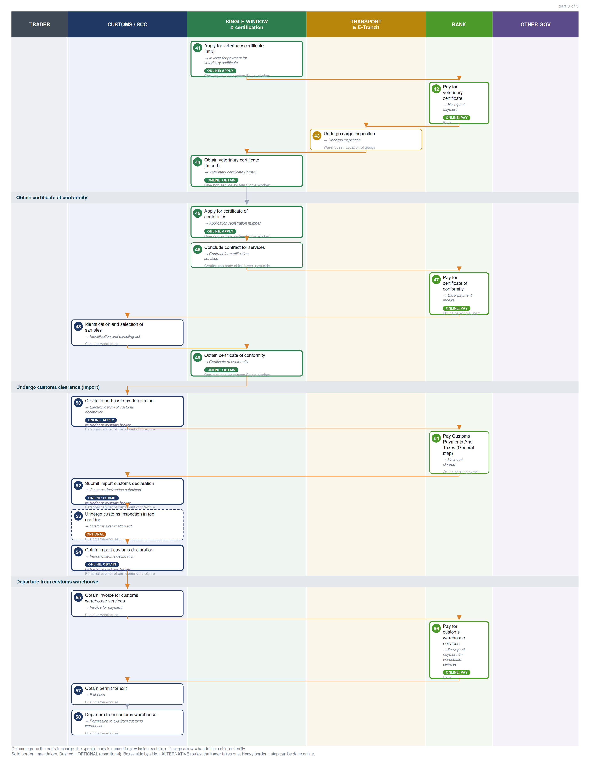

2. Where each step happens
Every step classified by channel. Online steps are performed on an external government service (the exact URL is in section 6). In-person steps happen at a physical counter, named in the “where” column.
Channel | Steps | Detail
Online — external service | 33 | Single Window (12), Payment methods information page (8), Customs e-declaration cabinet (SCC) (7), eFito (phytosanitary) (3), E-Tranzit (customs cargo) (2), my.gov.uz — unified state services (1)
In person — physical counter | 25 | Customs warehouse, State border crossing point, Customs post of foreign trade activity, Territorial Department of plant quarantine and protection, Warehouse / Location of goods, Certification body of fertilizers, pesticides and chemical protection of plants, Online banking system

3. Entities in charge & contact channels
Entity | Steps | Lane | Contact channels
Agency of plant quarantine and protection Personal cabinet (Oferta) | 1, 32, 36 | Single Window & certification | ✉ info@karantin.uz  🌐 https://efito.uz/invoice/, http://karantin.uz/
Bank | 2, 6, 11, 33, 37, 42, 56 | Bank | — none published —
One-stop service system Single window | 3, 4, 5, 7, 8, 34, 39, 40, 41, 44, 45, 49 | Single Window & certification | ☎ +998 78 120 76 08 (Int. 5603, 5646, 5606, 5885) , +998 78 120 76 00 (Int. 5603, 5646, 5606, 5885)  🌐 http://singlewindow.uz/index.jsp, http://sw2.customs.uz/
Single portal of interactive state services | 9 | Other government | ✉ epigu@egov.uz  ☎ +998 55 501 36 19, +998 55 501 36 17  🌐 https://my.gov.uz/, https://my.gov.uz/ru/site/feedback
Customs warehouse | 10, 23, 24, 35, 48, 53, 55, 57, 58 | Customs / SCC | — none published —
Automated information system "E-tranzit" | 12, 13 | Customs / SCC | ☎ +998 78 120 76 15 (7412)  🌐 http://cargo.customs.uz/
State border crossing point | 14, 15, 16, 17, 18, 19, 20, 21, 22 | Customs / SCC | — none published —
Customs post of foreign trade activity | 25, 27, 30 | Customs / SCC | — none published —
Personal cabinet of participant of foreign economic activity | 26, 28, 29, 31, 50, 52, 54 | Customs / SCC | 🌐 http://ed1.customs.uz, http://ed2.customs.uz
Territorial Department of plant quarantine and protection | 38 | Single Window & certification | — none published —
Warehouse / Location of goods | 43 | Transport & E-Tranzit | — none published —
Certification body of fertilizers, pesticides and chemical protection of plants | 46 | Single Window & certification | ✉ fpccp1999@gmail.com  ☎ + 998 71 262 74 76 , + 998 71 262 72 95  🌐 https://akkred.uz/reestr/060080
Online banking system | 47, 51 | Bank | — none published —

4. Step-by-step breakdown
Full sequence. Channel shows online vs in-person; Where / service names the exact website for online steps or the physical location for in-person ones; Performed by is who carries the step out. Optional and alternative steps are flagged.
# | Step | Entity in charge | Channel | Where / service | Performed by
Obtain quarantine permit
1 | Obtain offer agreement  → Offer agreement | Agency of plant quarantine and protection Personal cabinet (Oferta) | Online: obtain | eFito (phytosanitary)  efito.uz | —
2 | Pay for quarantine permit  → Receipt of payment | Bank | Online: pay | Payment methods information page  uzbekistan.tradeportal.org | —
3 | Apply for quarantine permit  → Application registration number | One-stop service system Single window | Online: apply | Single Window  singlewindow.uz | —
4 | Obtain quarantine permit  → Quarantine permit | One-stop service system Single window | Online: obtain | Single Window  singlewindow.uz | —
Obtain veterinary permit
5 | Obtain payment details  → Bank details of State committee of veterinary and development of livestock | One-stop service system Single window | Online: obtain | Single Window  singlewindow.uz | —
6 | Pay for veterinary permit  → Acceptance of payment | Bank | Online: pay | Payment methods information page  uzbekistan.tradeportal.org | —
7 | Apply for veterinary permit  → Application registration number | One-stop service system Single window | Online: apply | Single Window  singlewindow.uz | —
8 | Obtain veterinary permit  → Veterinary permit for import | One-stop service system Single window | Online: obtain | Single Window  singlewindow.uz | —
Registration of import contract
9 | Register foreign trade contract in UEISFTO  → Identification number of foreign trade contract | Single portal of interactive state services | Online: apply | my.gov.uz — unified state services  my.gov.uz | —
Contract customs warehouse
10 | Contract customs warehouse  → Invoice for payment | Customs warehouse | In person | Administration department | —
11 | Prepay for customs warehouse services  → Receipt of payment | Bank | Online: pay | Payment methods information page  uzbekistan.tradeportal.org | —
Cross the border 2
12 | Submit transit declaration  → Transit declaration ID number | Automated information system "E-tranzit" | Online: submit | E-Tranzit (customs cargo)  cargo.customs.uz | hauler or customs broker
13 | Pay fees  → Payment cleared | Automated information system "E-tranzit" | Online: pay | E-Tranzit (customs cargo)  cargo.customs.uz | hauler or customs broker
14 | Obtain registration sheet for entry to border crossing point  → Single registration sheet | State border crossing point | In person | Border control | vehicle driver
15 | Undergo radiation and vehicle parameter control automatically  → Undergo weight contol | State border crossing point | In person | Weight and radiation control | vehicle driver
16 | Undergo passport control  → Stamp in passort on crossing the state border | State border crossing point | In person | Passport control point | vehicle driver
17 | Undergo phytosanitary control  → Confirmation about passing quarantine control | State border crossing point | In person | Border checkpoint for plant quarantine | vehicle driver
18 | Undergo veterinary control  → Single registration sheet | State border crossing point | In person | Border veterinary control checkpoint | vehicle driver
19 | Undergo vehicle visual inspection  → Positive (prohibited and not declared goods unfound) | State border crossing point | In person | Customs inspection area | vehicle driver
20 | Undergo customs physical inspection of vehicle and cargo  alternative  → Positive (prohibited and not declared goods unfound) | State border crossing point | In person | Inspection and screening station | vehicle driver
21 | Undergo customs clearance  → Confirmation about passing customs control | State border crossing point | In person | Customs control | vehicle driver
22 | Submit registration sheet for exit from border crossing point  → Cross border | State border crossing point | In person | Border control | vehicle driver
Deliver cargo to customs warehouse
23 | Deliver cargo to customs warehouse  → Pass document and visual control | Customs warehouse | In person | Customs warehouse checkpoint | vehicle driver
24 | Place cargo at customs warehouse  → Act of loading, unloading, reloading | Customs warehouse | In person | Storage | —
25 | Obtain marks and stamps on delivery of goods in TIR carnet  optional  → Marks and stamps about goods delivery | Customs post of foreign trade activity | In person | Group of customs control and customs clearance | vehicle driver
Undergo customs clearance (Temporary storage)
26 | Apply for preliminary visual inspection  optional  → Application registration number (preliminary inspection) | Personal cabinet of participant of foreign economic activity | Online: apply | Customs e-declaration cabinet (SCC)  ed1.customs.uz | —
27 | Preliminary visual inspection  optional  → Preliminary inspection report | Customs post of foreign trade activity | In person | Customs control zone | —
28 | Create cargo customs declaration  → Electronic form of customs declaration | Personal cabinet of participant of foreign economic activity | Online: apply | Customs e-declaration cabinet (SCC)  ed1.customs.uz | trader or customs broker
29 | Submit customs declaration  → Customs declaration submitted | Personal cabinet of participant of foreign economic activity | Online: submit | Customs e-declaration cabinet (SCC)  ed1.customs.uz | trader or customs broker
30 | Undergo customs inspection in red corridor  optional  → Unsealing of goods | Customs post of foreign trade activity | In person | Customs control zone | —
31 | Obtain customs declaration  → Cargo customs declaration (IM70) | Personal cabinet of participant of foreign economic activity | Online: obtain | Customs e-declaration cabinet (SCC)  ed1.customs.uz | trader or customs broker
Obtain quarantine inspection act
32 | Obtain offer agreement  → Offer agreement | Agency of plant quarantine and protection Personal cabinet (Oferta) | Online: obtain | eFito (phytosanitary)  efito.uz | —
33 | Pay for transport unit opening act  → Receipt of payment | Bank | Online: pay | Payment methods information page  uzbekistan.tradeportal.org | —
34 | Apply for quarantine inspection act and transport unit opening act  → Appointment for inspection | One-stop service system Single window | Online: apply | Single Window  singlewindow.uz | —
35 | Undergo quarantine inspection  → Transport unit opening act | Customs warehouse | In person | Customs warehouse | —
36 | Obtain offer agreement for fumigation  optional  → Fumigation offer agreement | Agency of plant quarantine and protection Personal cabinet (Oferta) | Online: obtain | eFito (phytosanitary)  efito.uz | —
37 | Pay for fumigation  optional  → Receipt of payment | Bank | Online: pay | Payment methods information page  uzbekistan.tradeportal.org | —
38 | Undergo fumigation  optional  → Certificate of disinfestation | Territorial Department of plant quarantine and protection | In person | Fumigation (disinfection) division | —
39 | Obtain quarantine inspection act  → Quarantine inspection act | One-stop service system Single window | Online: obtain | Single Window  singlewindow.uz | —
Obtain veterinary certificate for import
40 | Obtain offer agreement  → Offer agreement for veterinary certificate | One-stop service system Single window | Online: obtain | Single Window  singlewindow.uz | —
41 | Apply for veterinary certificate (imp)  → Invoice for payment for veterinary certificate | One-stop service system Single window | Online: apply | Single Window  singlewindow.uz | —
42 | Pay for veterinary certificate  → Receipt of payment | Bank | Online: pay | Payment methods information page  uzbekistan.tradeportal.org | —
43 | Undergo cargo inspection  → Undergo inspection | Warehouse / Location of goods | In person | Warehouse / Location of goods | —
44 | Obtain veterinary certificate (import)  → Veterinary certificate Form-3 | One-stop service system Single window | Online: obtain | Single Window  singlewindow.uz | —
Obtain certificate of conformity
45 | Apply for certificate of conformity  → Application registration number | One-stop service system Single window | Online: apply | Single Window  singlewindow.uz | —
46 | Conclude contract for services  → Contract for certification services | Certification body of fertilizers, pesticides and chemical protection of plants | In person | Department for certification FPCCP "427 room, 4th floor" | —
47 | Pay for certificate of conformity  → Bank payment receipt | Online banking system | Online: pay | Payment methods information page  uzbekistan.tradeportal.org | —
48 | Identification and selection of samples  → Identification and sampling act | Customs warehouse | In person | Customs warehouse | —
49 | Obtain certificate of conformity  → Certificate of conformity | One-stop service system Single window | Online: obtain | Single Window  singlewindow.uz | —
Undergo customs clearance (Import)
50 | Create import customs declaration  → Electronic form of customs declaration | Personal cabinet of participant of foreign economic activity | Online: apply | Customs e-declaration cabinet (SCC)  ed1.customs.uz | trader or customs broker
51 | Pay Customs Payments And Taxes (General step)  → Payment cleared | Online banking system | In person | Online banking system | —
52 | Submit import customs declaration  → Customs declaration submitted | Personal cabinet of participant of foreign economic activity | Online: submit | Customs e-declaration cabinet (SCC)  ed1.customs.uz | trader or customs broker
53 | Undergo customs inspection in red corridor  optional  → Customs examination act | Customs warehouse | In person | Storage | —
54 | Obtain import customs declaration  → Import customs declaration | Personal cabinet of participant of foreign economic activity | Online: obtain | Customs e-declaration cabinet (SCC)  ed1.customs.uz | trader or customs broker
Departure from customs warehouse
55 | Obtain invoice for customs warehouse services  → Invoice for payment | Customs warehouse | In person | Commodity cash desk | —
56 | Pay for customs warehouse services  → Receipt of payment for warehouse services | Bank | Online: pay | Payment methods information page  uzbekistan.tradeportal.org | —
57 | Obtain permit for exit  → Exit pass | Customs warehouse | In person | Storage | —
58 | Departure from customs warehouse  → Permission to exit from customs warehouse | Customs warehouse | In person | Customs warehouse checkpoint | —

5. Inputs required per step
Type 1 = the trader supplies it from outside the procedure. Type 2 = produced by an earlier step, so it is a dependency the agent can track.
1. Obtain offer agreement
- Internet access [trader supplies]
- Data required to complete offer agreement [trader supplies]
- Tax Identification Number of the organization or individual [trader supplies]
- Name of the organization [trader supplies]
- Full name of an organization’s manager [trader supplies]
- Type of organization (business entity, budgetary) [trader supplies]
- Contact phone number [trader supplies]
- Amount of consignment [trader supplies]
2. Pay for quarantine permit
- Offer agreement for quarantine permit [trader supplies]
- For physical payment [trader supplies]
- Physical presence [trader supplies]
- Passport [trader supplies]
- For online payment (without necessity to visit a bank) [trader supplies]
- Online banking account [trader supplies]
3. Apply for quarantine permit
- Electronic digital signature [trader supplies]
- Quarantine permit application [trader supplies]
- Data required to complete application [trader supplies]
- Information about applicant [trader supplies]
- Information about importer [trader supplies]
- Information about exporter [trader supplies]
- General information [trader supplies]
- Information about product [trader supplies]
4. Obtain quarantine permit
- Electronic digital signature [trader supplies]
5. Obtain payment details
- Electronic digital signature [trader supplies]
6. Pay for veterinary permit
- Bank details of State committee of veterinary and development of livestock [trader supplies]
- For physical payment [trader supplies]
- Physical presence [trader supplies]
- For online payment (without necessity to visit a bank) [trader supplies]
- Online banking account [trader supplies]
7. Apply for veterinary permit
- Electronic digital signature [trader supplies]
8. Obtain veterinary permit
- Electronic digital signature [trader supplies]
9. Register foreign trade contract in UEISFTO
- Electronic digital signature [trader supplies]
- Electronic copy of foreign trade contract [trader supplies]
10. Contract customs warehouse
- Physical presence [trader supplies]
- Passport [trader supplies]
- Power of attorney [trader supplies]
- Certificate of state registration [trader supplies]
11. Prepay for customs warehouse services
- Invoice for payment [trader supplies]
- For physical payment [trader supplies]
- Physical presence [trader supplies]
- For online payment (without necessity to visit a bank) [trader supplies]
- Online banking account [trader supplies]
12. Submit transit declaration
- Electronic digital signature [trader supplies]
- Information required to complete transit declaration [trader supplies]
- General Information [trader supplies]
- Information about carrier (for legal entities) [trader supplies]
- Information about the carrier (for physical entities) [trader supplies]
- Vehicle Information [trader supplies]
- Information about driver [trader supplies]
- Information about shipping documents [trader supplies]
- Description of goods [trader supplies]
- Non-tariff measures [trader supplies]
- Guarantees and fees [trader supplies]
- Documents attached to the transit declaration [trader supplies]
- Vehicle registration certificate [trader supplies]
- International passport [trader supplies]
- Convention on the International Carriage of Goods by Road [trader supplies]
- Commercial invoice [trader supplies]
- Authorization for international carriage of goods [trader supplies]
13. Pay fees
- Invoice for payment for entrance and transit [trader supplies]
- Bank card number [trader supplies]
14. Obtain registration sheet for entry to border crossing point
- Physical presence [trader supplies]
- International passport [trader supplies]
- Vehicle registration number [trader supplies]
15. Undergo radiation and vehicle parameter control automatically
- Physical presence [trader supplies]
16. Undergo passport control
- Single registration sheet [trader supplies]
- International passport [trader supplies]
17. Undergo phytosanitary control
- Single registration sheet [trader supplies]
- Phytosanitary certificate of the exporter's country [trader supplies]
- Quarantine permit [trader supplies]
18. Undergo veterinary control
- Veterinary permit for import [trader supplies]
- Veterinary certificate from the exporter's country [trader supplies]
- Not obligatory documents [trader supplies]
- Commercial invoice [trader supplies]
- Convention on the International Carriage of Goods by Road [trader supplies]
19. Undergo vehicle visual inspection
- Physical presence [trader supplies]
20. Undergo customs physical inspection of vehicle and cargo
- Physical presence [trader supplies]
21. Undergo customs clearance
- Single registration sheet [trader supplies]
- Documents related to the vehicle [trader supplies]
- Vehicle registration certificate [trader supplies]
- TIR Carnet - "Transport International Routier" [trader supplies]
- Authorization for international carriage of goods [trader supplies]
- ATP certificate [trader supplies]
- Documents related to the cargo [trader supplies]
- Export declaration of the exporter's country [trader supplies]
- Convention on the International Carriage of Goods by Road [trader supplies]
- Commercial invoice [trader supplies]
- Documents of the driver/hauler [trader supplies]
- International passport [trader supplies]
22. Submit registration sheet for exit from border crossing point
- Single registration sheet [trader supplies]
- Physical presence [trader supplies]
23. Deliver cargo to customs warehouse
- Convention on the International Carriage of Goods by Road [trader supplies]
- TIR Carnet - "Transport International Routier" [trader supplies]
24. Place cargo at customs warehouse
- Physical presence [trader supplies]
- Power of attorney [trader supplies]
- Commercial invoice [trader supplies]
- Convention on the International Carriage of Goods by Road [trader supplies]
- If cargo operatoion are completed under customs contol [trader supplies]
- Physical presence [trader supplies]
25. Obtain marks and stamps on delivery of goods in TIR carnet
- TIR Carnet - "Transport International Routier" [trader supplies]
26. Apply for preliminary visual inspection
- Electronic application for preliminary visual inspection [trader supplies]
- Documents required to fill the Application [trader supplies]
- Application for preliminary visual inspection [trader supplies]
- Warehouse license number [trader supplies]
- Convention on the International Carriage of Goods by Road [trader supplies]
- Commercial invoice [trader supplies]
27. Preliminary visual inspection
- Physical presence [trader supplies]
- Power of attorney [trader supplies]
- Physical presence [trader supplies]
- Physical presence [trader supplies]
- Required documents [trader supplies]
- Convention on the International Carriage of Goods by Road [trader supplies]
- Commercial invoice [trader supplies]
- Packing list [trader supplies]
- Application for preliminary visual inspection [trader supplies]
28. Create cargo customs declaration
- Electronic digital signature [trader supplies]
- Documents requried to complete declaration [trader supplies]
- Commercial invoice [trader supplies]
- Convention on the International Carriage of Goods by Road [trader supplies]
- Transit declaration [trader supplies]
- Cargo delivery control book [trader supplies]
- TIR Carnet - "Transport International Routier" [trader supplies]
- Contract for customs warehouse services [trader supplies]
- Passport [trader supplies]
- Power of attorney [trader supplies]
- Application for preliminary visual inspection [trader supplies]
29. Submit customs declaration
- Electronic digital signature [trader supplies]
- Electronic form of customs declaration [trader supplies]
30. Undergo customs inspection in red corridor
- Cargo customs declaration (IM70) [trader supplies]
- Convention on the International Carriage of Goods by Road [trader supplies]
- Commercial invoice [trader supplies]
- Physical presence [trader supplies]
- Passport [trader supplies]
- Power of attorney [trader supplies]
31. Obtain customs declaration
- Electronic digital signature [trader supplies]
32. Obtain offer agreement
- Electronic digital signature [trader supplies]
- Data required to complete offer agreement [trader supplies]
- Tax Identification Number of the organization or individual [trader supplies]
- Name of the organization [trader supplies]
- Full name of an organization’s manager [trader supplies]
- Type of organization (business entity, budgetary) [trader supplies]
- Contact phone number [trader supplies]
- Amount of consignment [trader supplies]
33. Pay for transport unit opening act
- Offer agreement for transport unit opening act [trader supplies]
- For physical payment [trader supplies]
- Physical presence [trader supplies]
- Passport [trader supplies]
- For online payment (without necessity to visit a bank) [trader supplies]
- Online banking account [trader supplies]
34. Apply for quarantine inspection act and transport unit opening act
- Electronic digital signature [trader supplies]
- Online application for quarantine inspection certificate [trader supplies]
- Quarantine permit [trader supplies]
- Phytosanitary certificate of the exporter's country [trader supplies]
- Data required to complete application [trader supplies]
- Information about applicant [trader supplies]
- Information about importer [trader supplies]
- Information about exporter [trader supplies]
- General information [trader supplies]
- Information about product [trader supplies]
35. Undergo quarantine inspection
- Physical presence [trader supplies]
- Physical presence [trader supplies]
- Phytosanitary certificate of the exporter's country [trader supplies]
- Quarantine permit [trader supplies]
36. Obtain offer agreement for fumigation
- Internet access [trader supplies]
- Data required to complete offer agreement [trader supplies]
- Tax Identification Number of the organization or individual [trader supplies]
- Name of the organization [trader supplies]
- Full name of an organization’s manager [trader supplies]
- Type of organization (business entity, budgetary) [trader supplies]
- Contact phone number [trader supplies]
- Agency region [trader supplies]
- Cost on the contract [trader supplies]
37. Pay for fumigation
- Fumigation offer agreement [trader supplies]
- For physical payment [trader supplies]
- Physical presence [trader supplies]
- Passport [trader supplies]
- For online payment (without necessity to visit a bank) [trader supplies]
- Online banking account [trader supplies]
38. Undergo fumigation
- Physical presence [trader supplies]
39. Obtain quarantine inspection act
- Electronic digital signature [trader supplies]
40. Obtain offer agreement
- Electronic digital signature [trader supplies]
- Data required to complete offer agreement [trader supplies]
- Tax Identification Number of the organization or individual [trader supplies]
- Name of the organization [trader supplies]
- Full name of an organization’s manager [trader supplies]
- Type of organization (business entity, budgetary) [trader supplies]
- Contact phone number [trader supplies]
41. Apply for veterinary certificate (imp)
- Electronic digital signature [trader supplies]
- Online application for veterinary certificate [trader supplies]
- Veterinary certificate from the exporter's country [trader supplies]
- Veterinary permit for import [trader supplies]
- Not obligatory documents [trader supplies]
- Commercial invoice [trader supplies]
- Convention on the International Carriage of Goods by Road [trader supplies]
42. Pay for veterinary certificate
- Invoice for payment for veterinary certificate [trader supplies]
- For physical payment [trader supplies]
- Physical presence [trader supplies]
- Passport [trader supplies]
- For online payment (without necessity to visit a bank) [trader supplies]
- Online banking account [trader supplies]
43. Undergo cargo inspection
- Physical presence [trader supplies]
- Physical presence [trader supplies]
44. Obtain veterinary certificate (import)
- Electronic digital signature [trader supplies]
45. Apply for certificate of conformity
- Electronic digital signature [trader supplies]
- Commercial invoice [trader supplies]
- Registration certificate [trader supplies]
- Convention on the International Carriage of Goods by Road [trader supplies]
- Import railway bill [trader supplies]
- Air waybill [trader supplies]
- Normative documents on standardization (fertilizers) [trader supplies]
- Quality certificate [trader supplies]
- Certificate of analysis for fertilizers [trader supplies]
46. Conclude contract for services
- Application registration number [trader supplies]
- Bank details [trader supplies]
47. Pay for certificate of conformity
- Electronic invoice for payment [trader supplies]
- Online banking account [trader supplies]
48. Identification and selection of samples
- Physical presence [trader supplies]
- Physical presence [trader supplies]
49. Obtain certificate of conformity
- Electronic digital signature [trader supplies]
50. Create import customs declaration
- Electronic digital signature [trader supplies]
- Documents requried to complete declaration [trader supplies]
- Convention on the International Carriage of Goods by Road [trader supplies]
- Commercial invoice [trader supplies]
- Identification number of foreign trade contract [trader supplies]
- Export declaration of the exporter's country [trader supplies]
- Certificates and permits [trader supplies]
- Certificate of origin of the exporter's country [trader supplies]
- Certificate of conformity [trader supplies]
- Veterinary certificate [trader supplies]
- Quarantine permit [trader supplies]
51. Pay Customs Payments And Taxes (General step)
- Bank details of territorial customs departments [trader supplies]
- Online banking account [trader supplies]
52. Submit import customs declaration
- Electronic digital signature [trader supplies]
- Electronic form of customs declaration [trader supplies]
53. Undergo customs inspection in red corridor
- Import customs declaration [trader supplies]
- Convention on the International Carriage of Goods by Road [trader supplies]
- Commercial invoice [trader supplies]
- Physical presence [trader supplies]
- Passport [trader supplies]
- Power of attorney [trader supplies]
54. Obtain import customs declaration
- Electronic digital signature [trader supplies]
55. Obtain invoice for customs warehouse services
- Import customs declaration [trader supplies]
- Physical presence [trader supplies]
- Passport [trader supplies]
- Power of attorney [trader supplies]
56. Pay for customs warehouse services
- Invoice for payment [trader supplies]
- For physical payment [trader supplies]
- Physical presence [trader supplies]
- For online payment (without necessity to visit a bank) [trader supplies]
- Online banking account [trader supplies]
57. Obtain permit for exit
- Receipt of payment [trader supplies]
- Import customs declaration [trader supplies]
- Physical presence [trader supplies]
- Passport [trader supplies]
- Power of attorney [trader supplies]
58. Departure from customs warehouse
- Exit pass [trader supplies]
- Physical presence [trader supplies]

6. Online service redirects
Every online step in this procedure sends the trader to an external government service. These are the exact destinations — the redirect targets an agent (or a person) would need to reach.
# | Step | Action | Service URL
1 | Obtain offer agreement | obtain | eFito (phytosanitary)  https://efito.uz/invoice/
2 | Pay for quarantine permit | pay | Payment methods information page  https://uzbekistan.tradeportal.org/menu/22
3 | Apply for quarantine permit | apply | Single Window  http://singlewindow.uz/
4 | Obtain quarantine permit | obtain | Single Window  http://singlewindow.uz/
5 | Obtain payment details | obtain | Single Window  http://singlewindow.uz/
6 | Pay for veterinary permit | pay | Payment methods information page  https://uzbekistan.tradeportal.org/menu/22
7 | Apply for veterinary permit | apply | Single Window  http://singlewindow.uz/
8 | Obtain veterinary permit | obtain | Single Window  http://singlewindow.uz/
9 | Register foreign trade contract in UEISFTO | apply | my.gov.uz — unified state services  https://my.gov.uz/ru/service/96
11 | Prepay for customs warehouse services | pay | Payment methods information page  https://uzbekistan.tradeportal.org/menu/22
12 | Submit transit declaration | submit | E-Tranzit (customs cargo)  http://cargo.customs.uz/
13 | Pay fees | pay | E-Tranzit (customs cargo)  http://cargo.customs.uz/user/auth/auth-signin
26 | Apply for preliminary visual inspection | apply | Customs e-declaration cabinet (SCC)  http://ed1.customs.uz/mainFrame.jsp
28 | Create cargo customs declaration | apply | Customs e-declaration cabinet (SCC)  http://ed1.customs.uz/PersonCabinet/template/property/ted_proper.jsp
29 | Submit customs declaration | submit | Customs e-declaration cabinet (SCC)  http://ed1.customs.uz/PersonCabinet/template/property/ted_proper.jsp
31 | Obtain customs declaration | obtain | Customs e-declaration cabinet (SCC)  http://ed1.customs.uz/PersonCabinet/template/PCabinet_en.jsp
32 | Obtain offer agreement | obtain | eFito (phytosanitary)  https://efito.uz/invoice/
33 | Pay for transport unit opening act | pay | Payment methods information page  https://uzbekistan.tradeportal.org/menu/22
34 | Apply for quarantine inspection act and transport unit opening act | apply | Single Window  http://singlewindow.uz/
36 | Obtain offer agreement for fumigation | obtain | eFito (phytosanitary)  https://efito.uz/invoice/
37 | Pay for fumigation | pay | Payment methods information page  https://uzbekistan.tradeportal.org/menu/22
39 | Obtain quarantine inspection act | obtain | Single Window  http://singlewindow.uz/
40 | Obtain offer agreement | obtain | Single Window  http://singlewindow.uz
41 | Apply for veterinary certificate (imp) | apply | Single Window  http://www.singlewindow.uz
42 | Pay for veterinary certificate | pay | Payment methods information page  https://uzbekistan.tradeportal.org/menu/22
44 | Obtain veterinary certificate (import) | obtain | Single Window  http://www.singlewindow.uz
45 | Apply for certificate of conformity | apply | Single Window  http://singlewindow.uz/
47 | Pay for certificate of conformity | pay | Payment methods information page  https://uzbekistan.tradeportal.org/menu/22
49 | Obtain certificate of conformity | obtain | Single Window  http://singlewindow.uz/#
50 | Create import customs declaration | apply | Customs e-declaration cabinet (SCC)  http://ed1.customs.uz/PersonCabinet/template/property/ted_proper.jsp
52 | Submit import customs declaration | submit | Customs e-declaration cabinet (SCC)  http://ed1.customs.uz/PersonCabinet/template/property/ted_proper.jsp
54 | Obtain import customs declaration | obtain | Customs e-declaration cabinet (SCC)  http://ed1.customs.uz/PersonCabinet/template/PCabinet_en.jsp
56 | Pay for customs warehouse services | pay | Payment methods information page  https://uzbekistan.tradeportal.org/menu/22
Distinct services in this procedure: eFito (phytosanitary) (3); Payment methods information page (8); Single Window (12); my.gov.uz — unified state services (1); E-Tranzit (customs cargo) (2); Customs e-declaration cabinet (SCC) (7)

7. Document samples
Specimen images of the documents this procedure requires, published by the platform. Duplicates across steps are shown once. 76 distinct documents.
  Internet access |   Tax Identification Number of the organization or individual | Name of the organization
Full name of an organization’s manager | Type of organization (business entity, budgetary) |   Contact phone number
  Amount of consignment | 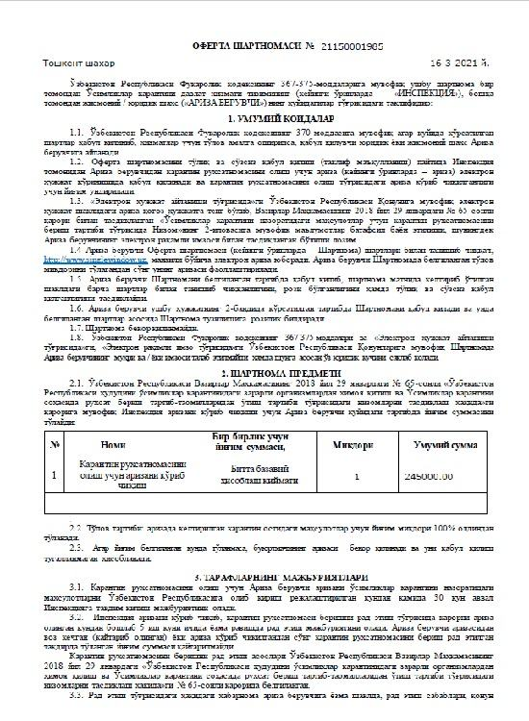  Offer agreement for quarantine permit | 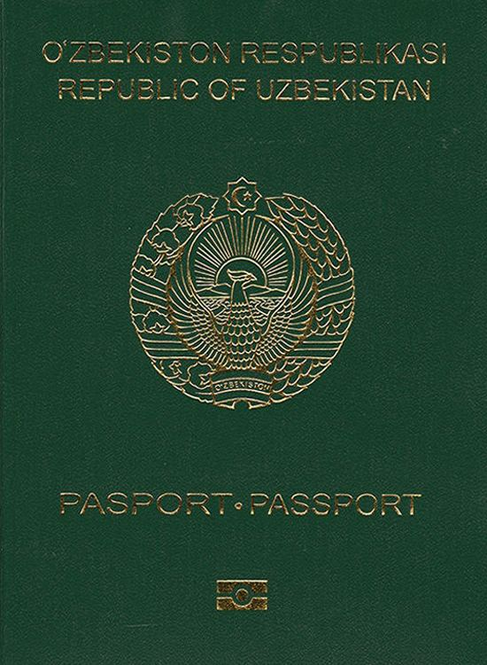  Passport
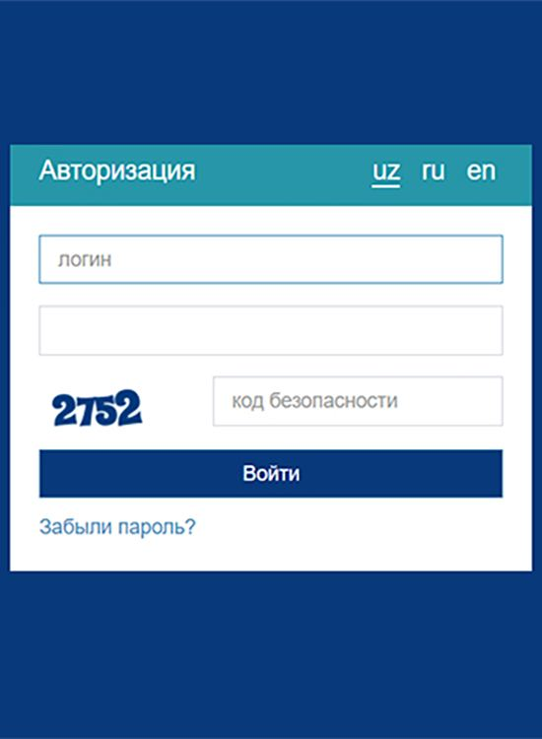  Online banking account | 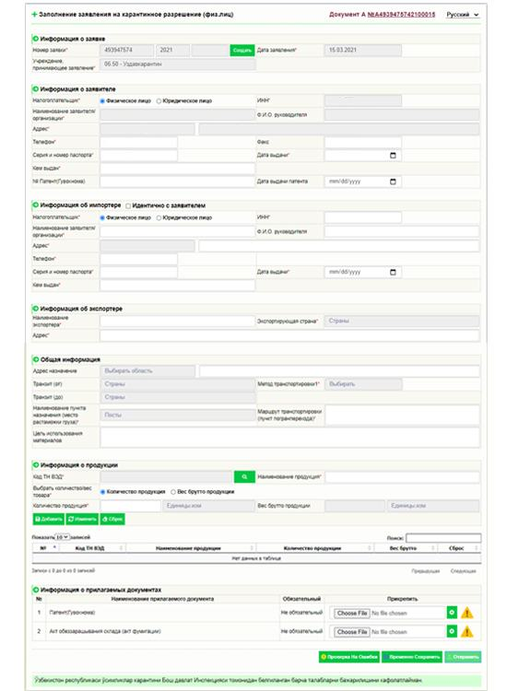  Quarantine permit application | Information about applicant
Information about importer | Information about exporter | General information
Information about product | 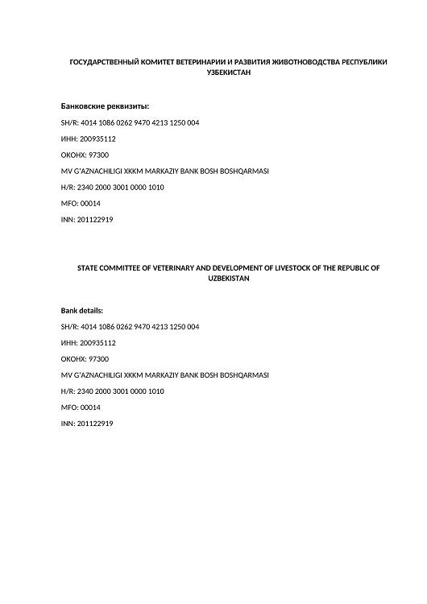  Bank details of State committee of veterinary and development of livestock | 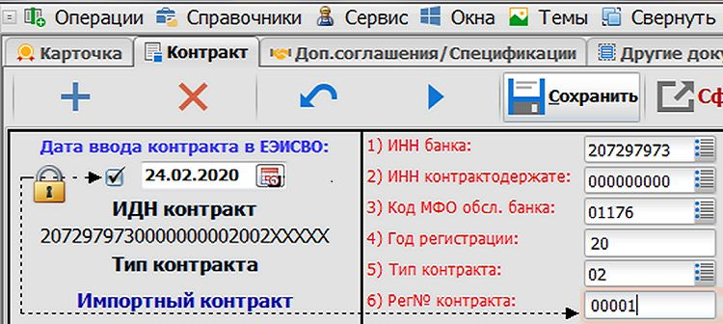  Electronic copy of foreign trade contract
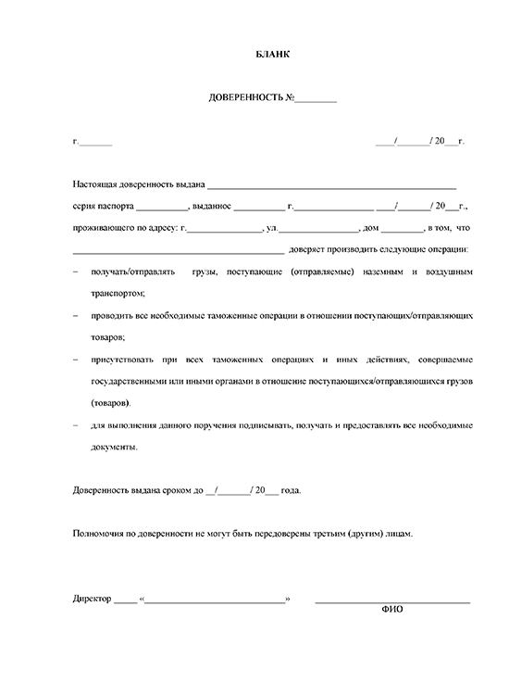  Power of attorney | 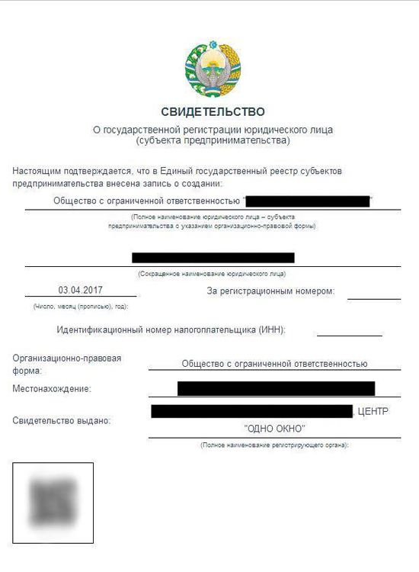  Certificate of state registration | 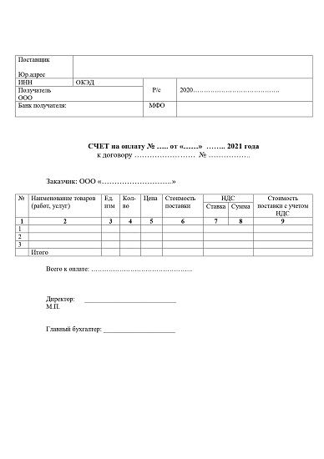  Invoice for payment
General Information | Information about carrier (for legal entities) | Information about the carrier (for physical entities)
Vehicle Information | Information about driver | Information about shipping documents
Description of goods | Non-tariff measures | Guarantees and fees
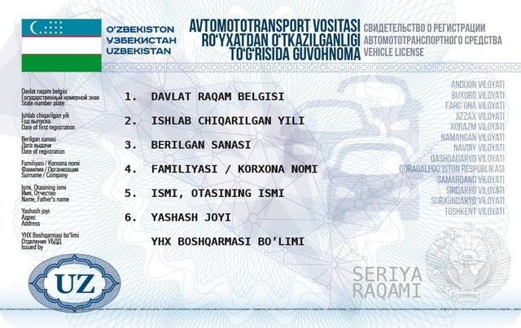  Vehicle registration certificate | 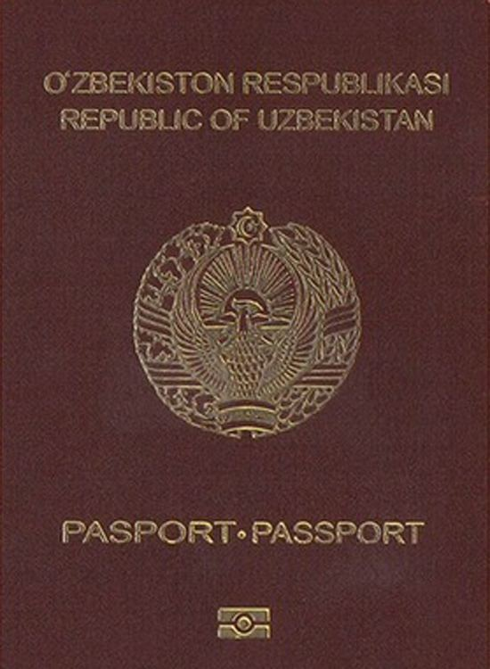  International passport | 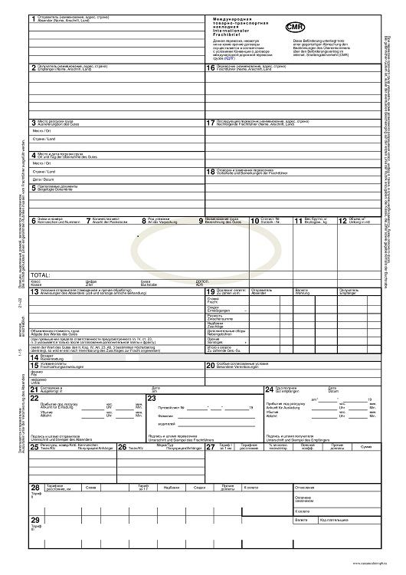  Convention on the International Carriage of Goods by Road
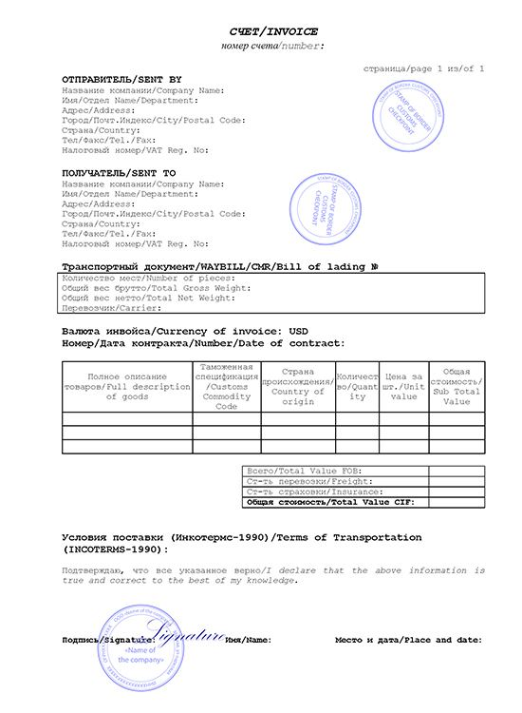  Commercial invoice | 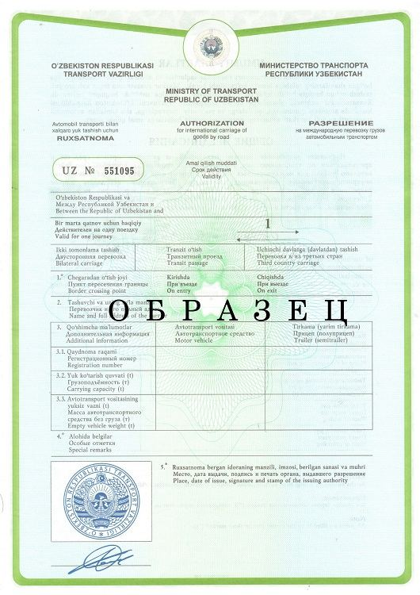  Authorization for international carriage of goods | 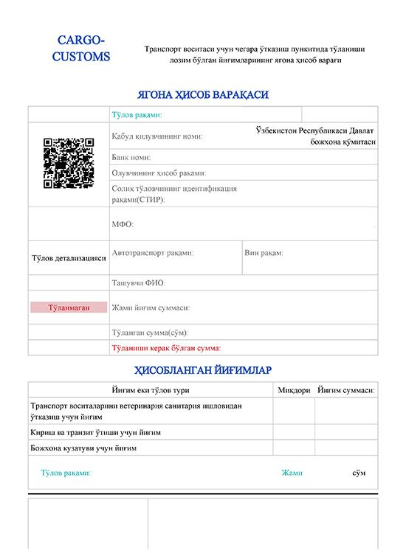  Invoice for payment for entrance and transit
Bank card number | 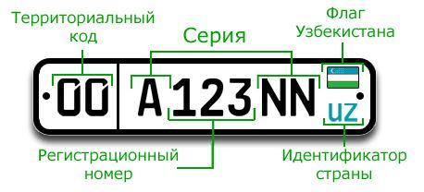  Vehicle registration number | 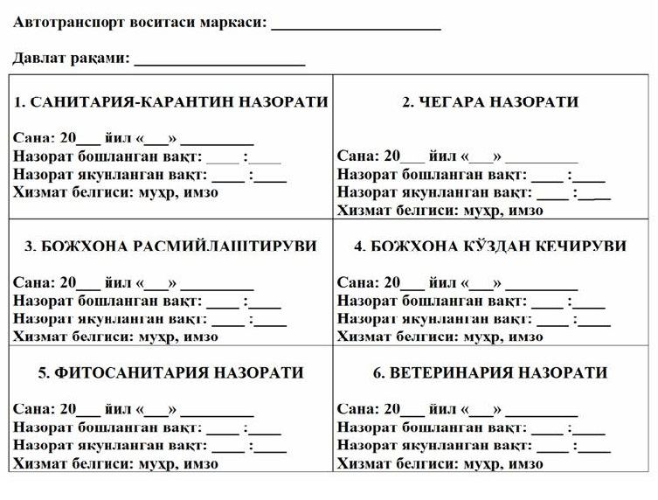  Single registration sheet
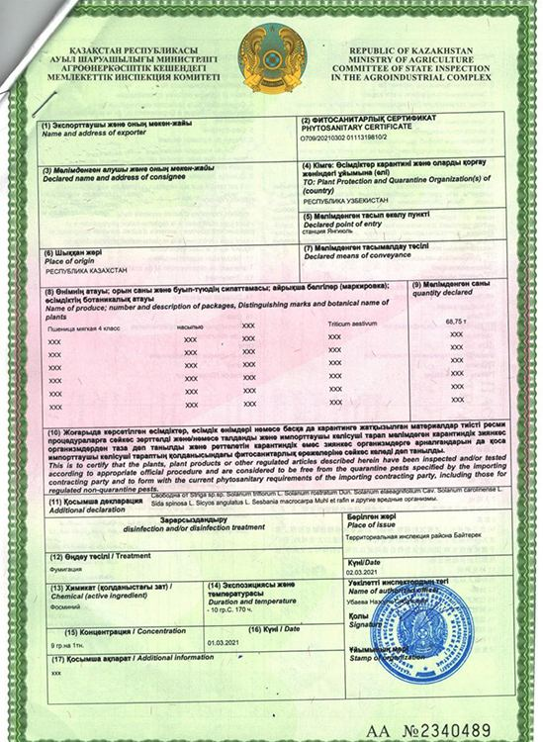  Phytosanitary certificate of the exporter's country | 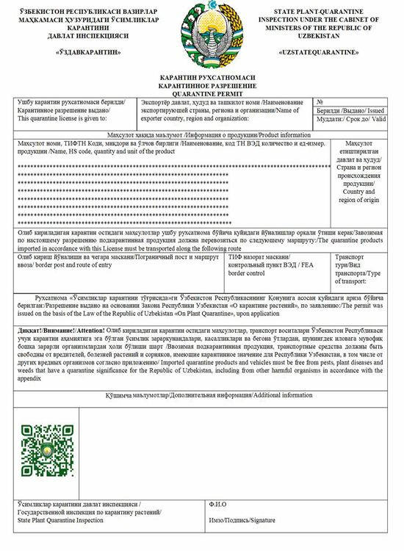  Quarantine permit | 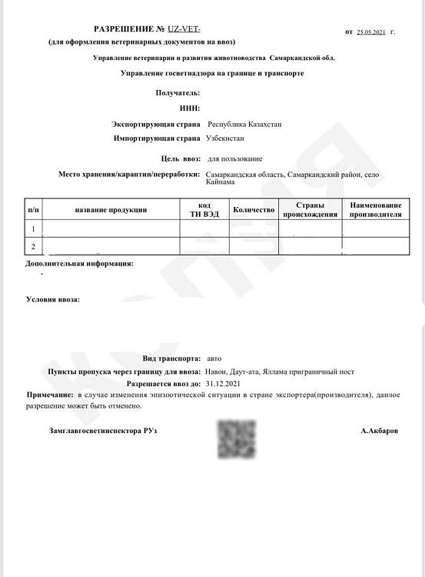  Veterinary permit for import
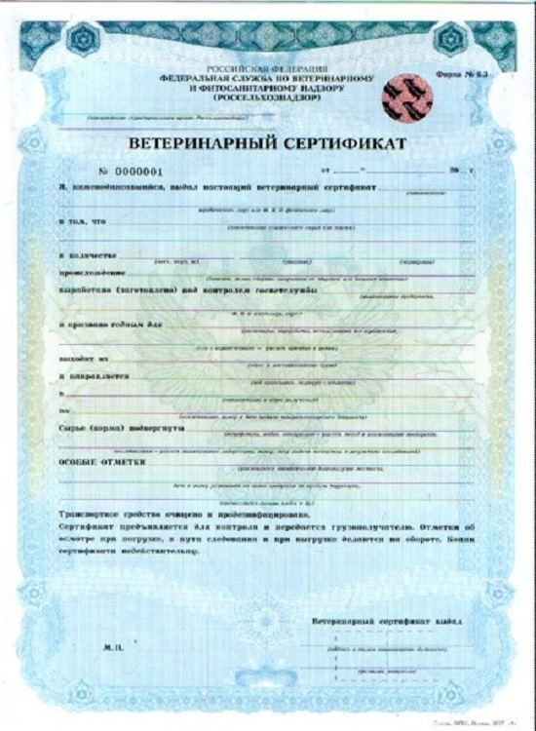  Veterinary certificate from the exporter's country | 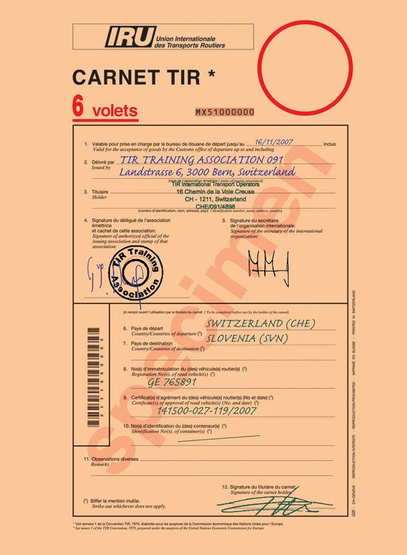  TIR Carnet - "Transport International Routier" | 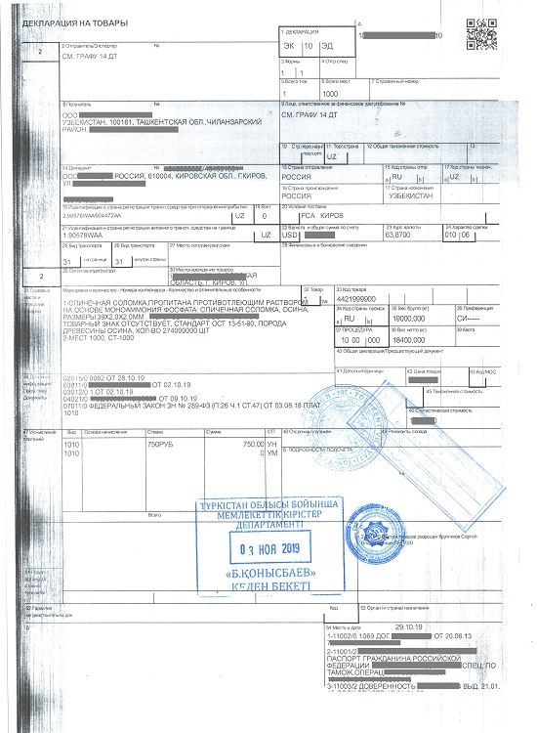  Export declaration of the exporter's country
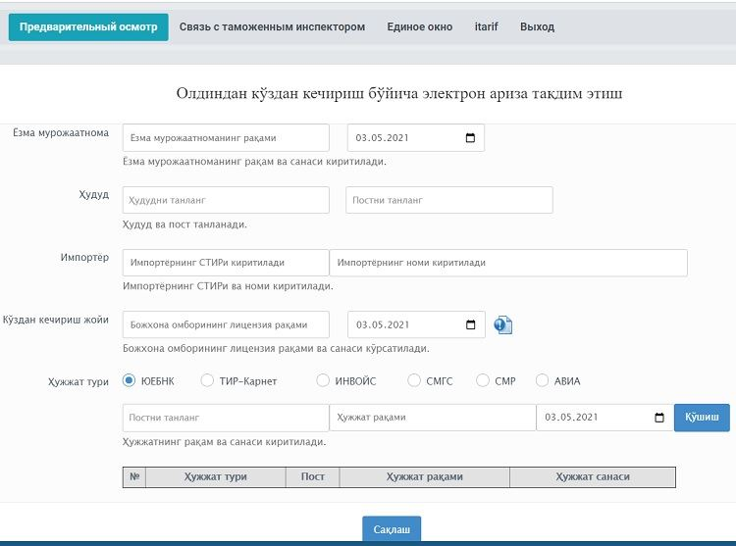  Electronic application for preliminary visual inspection | 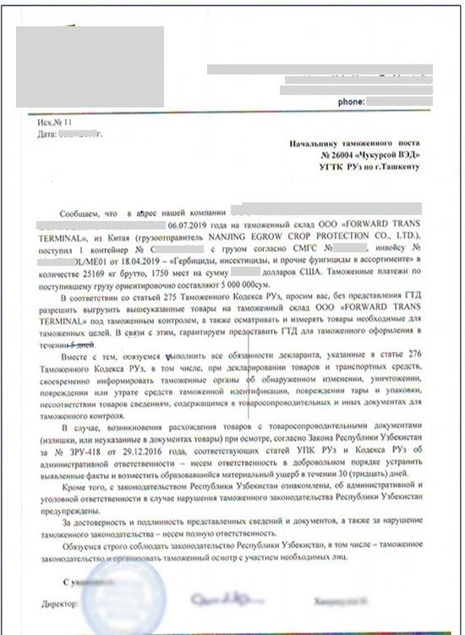  Application for preliminary visual inspection | Warehouse license number
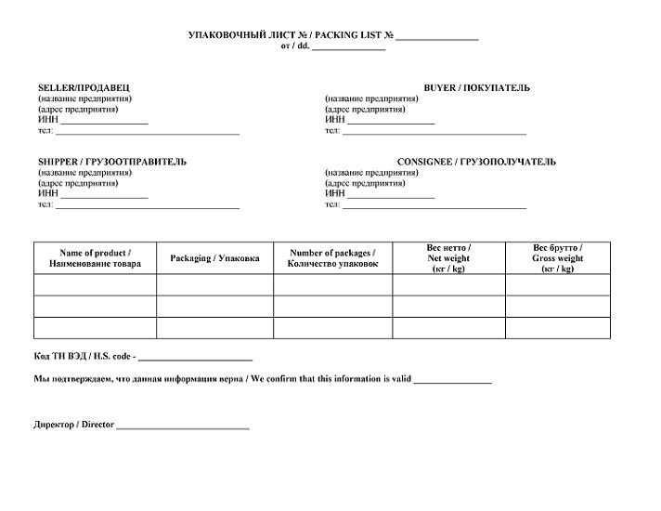  Packing list | 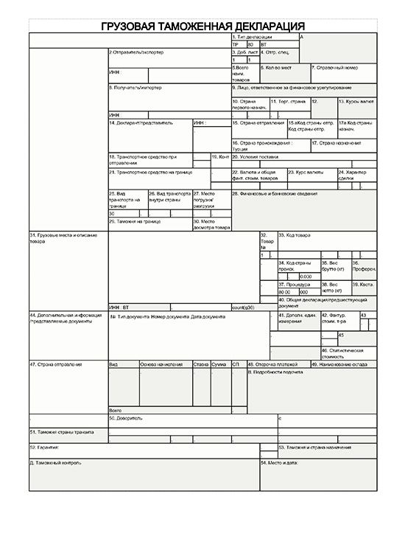  Transit declaration | 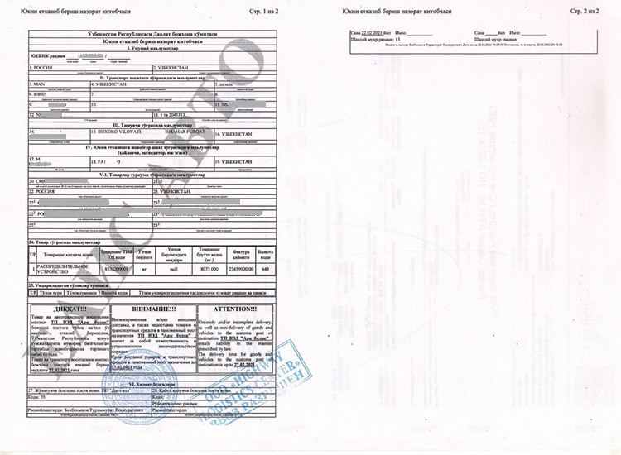  Cargo delivery control book
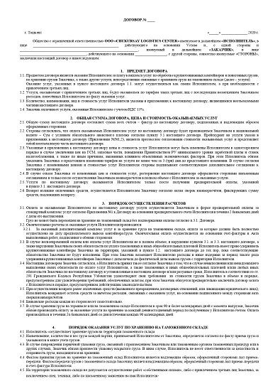  Contract for customs warehouse services | 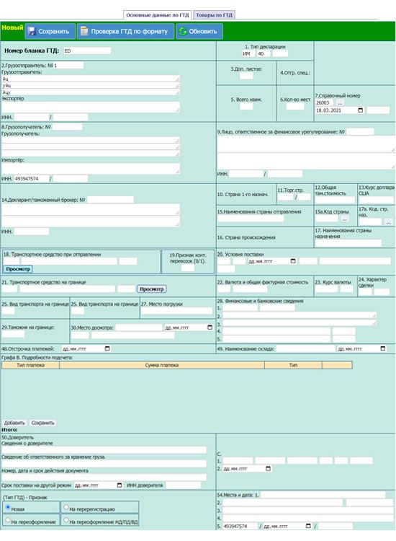  Electronic form of customs declaration | 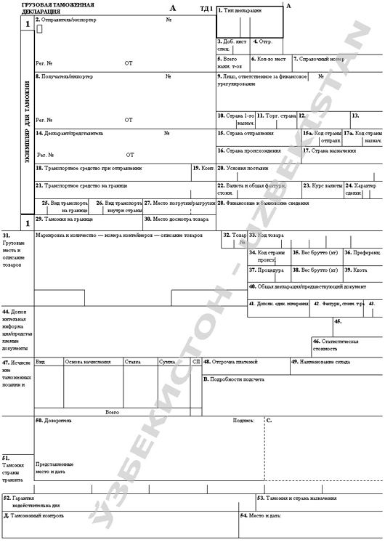  Cargo customs declaration (IM70)
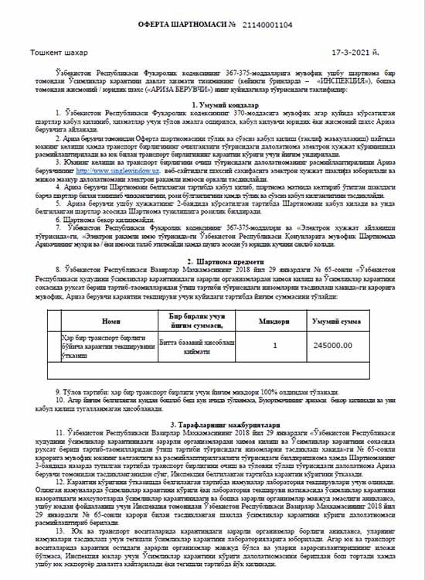  Offer agreement for transport unit opening act | 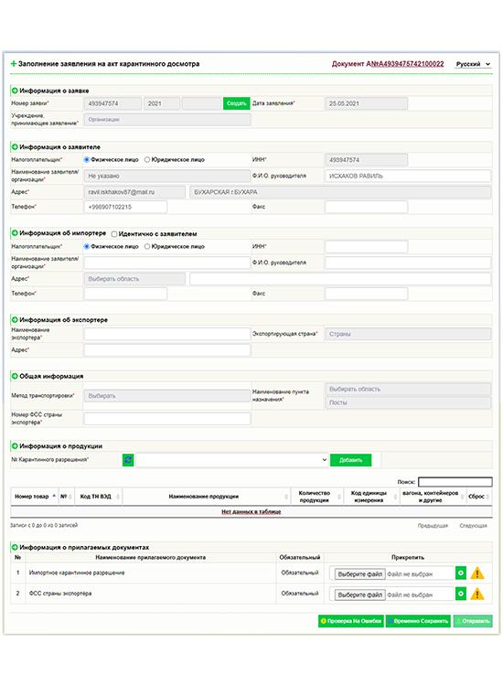  Online application for quarantine inspection certificate | Agency region
Cost on the contract | 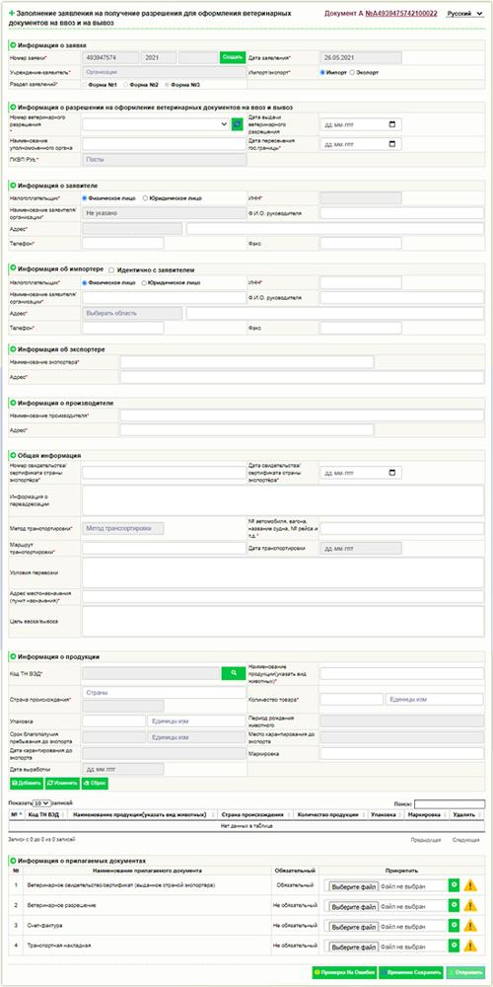  Online application for veterinary certificate | 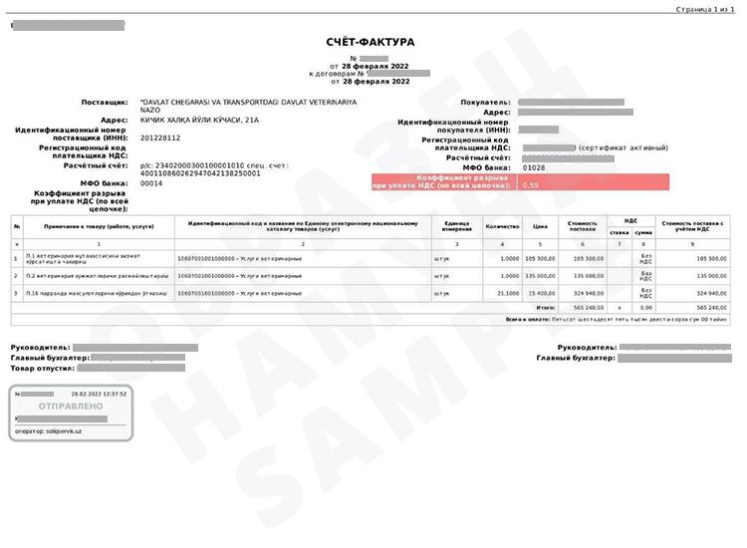  Invoice for payment for veterinary certificate
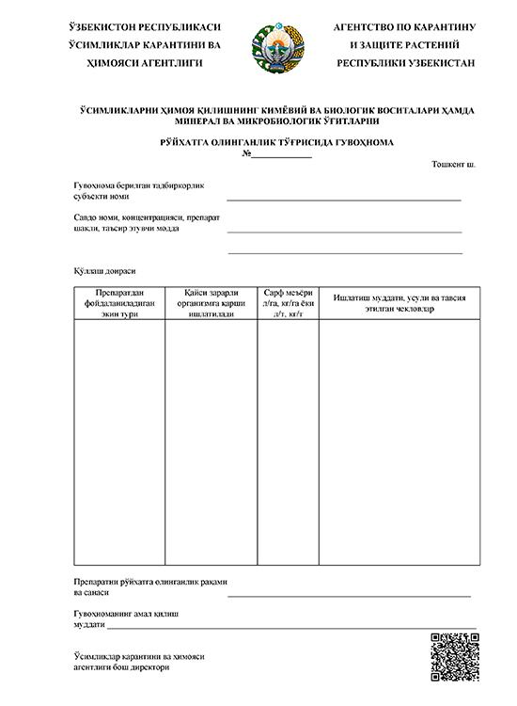  Registration certificate | 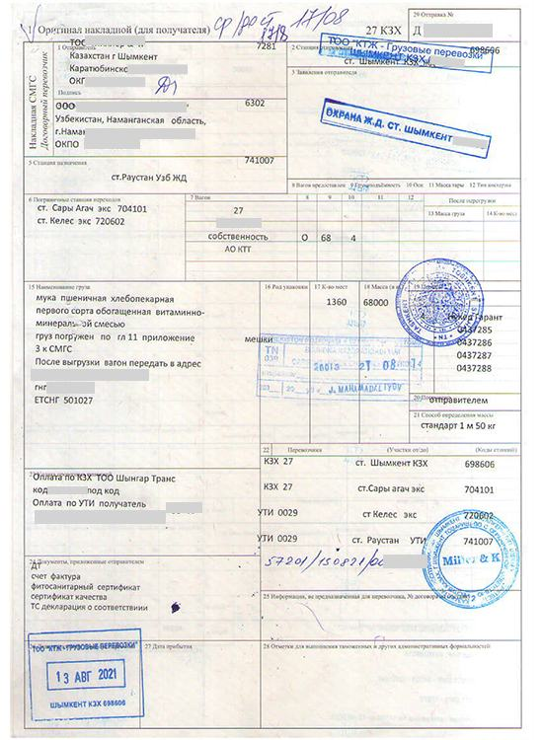  Import railway bill | 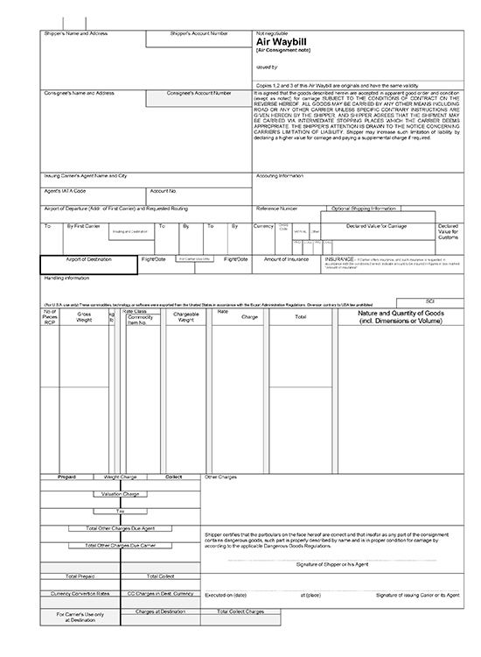  Air waybill
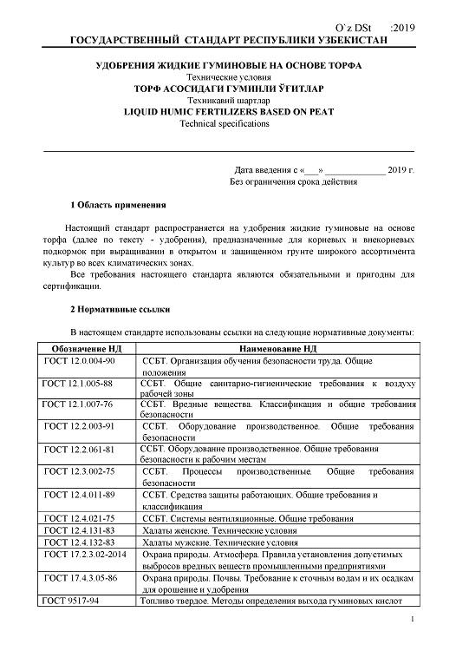  Normative documents on standardization (fertilizers) | 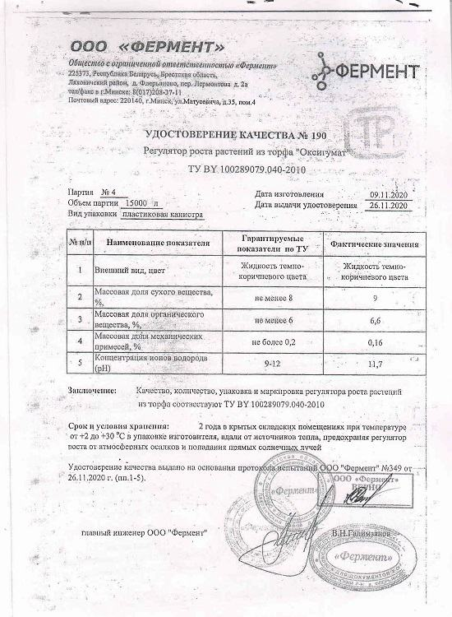  Quality certificate | 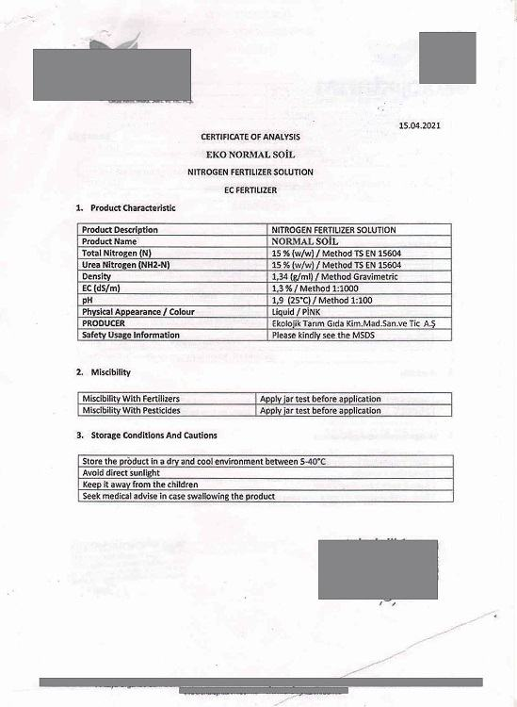  Certificate of analysis for fertilizers
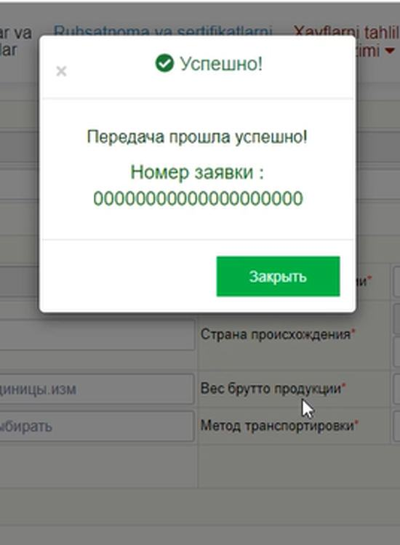  Application registration number | 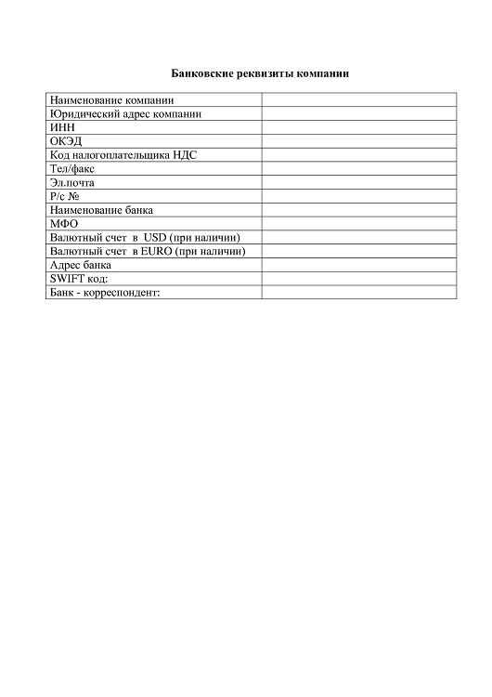  Bank details | 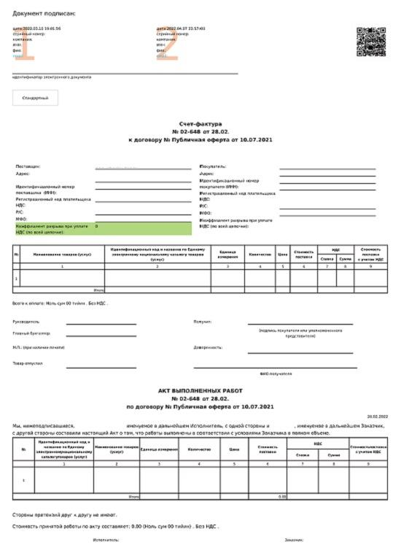  Electronic invoice for payment
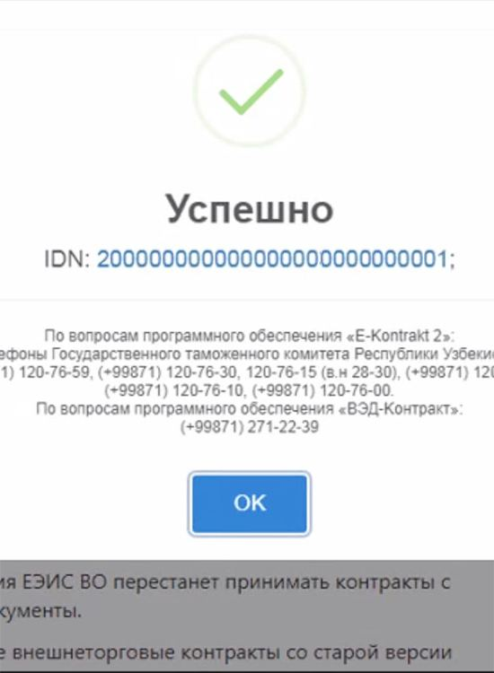  Identification number of foreign trade contract | 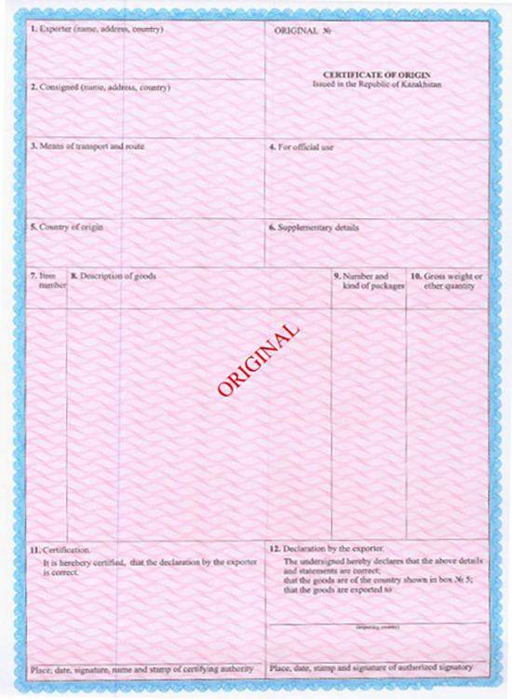  Certificate of origin of the exporter's country | 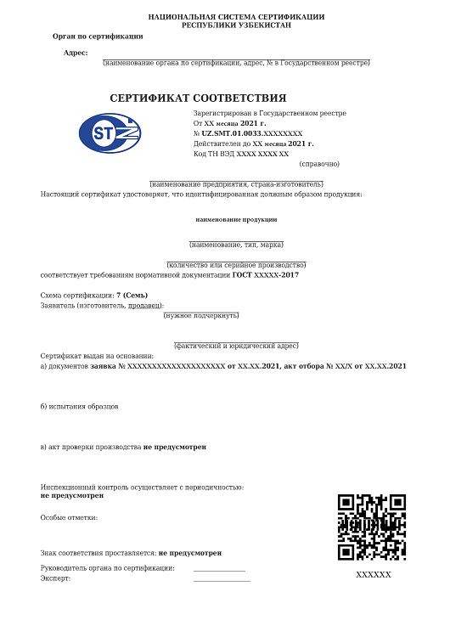  Certificate of conformity
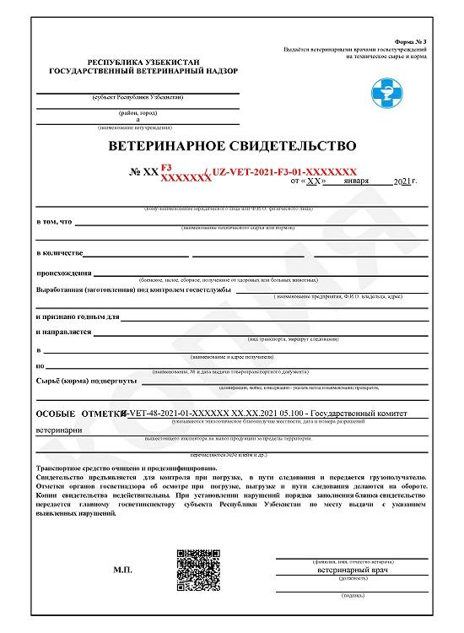  Veterinary certificate | 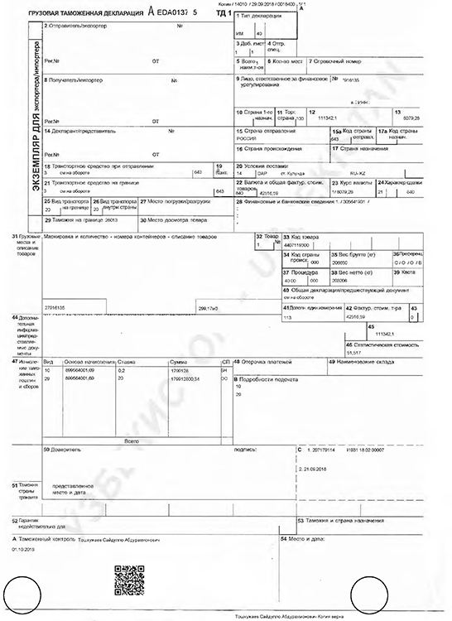  Import customs declaration | 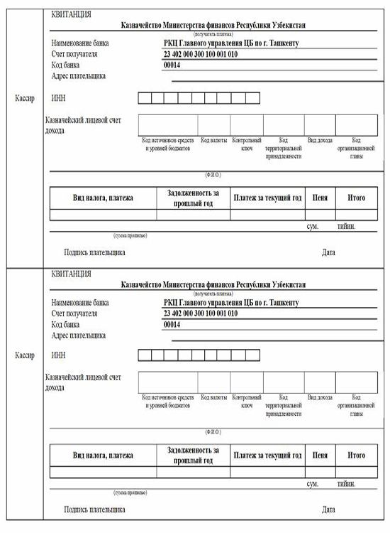  Receipt of payment
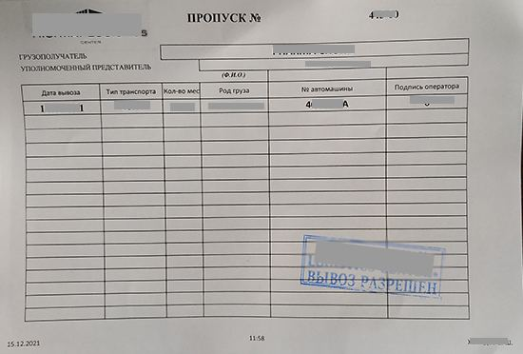
Exit pass

8. Step reference screenshots
The platform's own screen for each step, reproduced as published. These are screenshots of the eRegulations record (in Uzbek), showing contact details, expected result, requirements and price — not screenshots of the destination government service. They serve as visual provenance for the tables above.
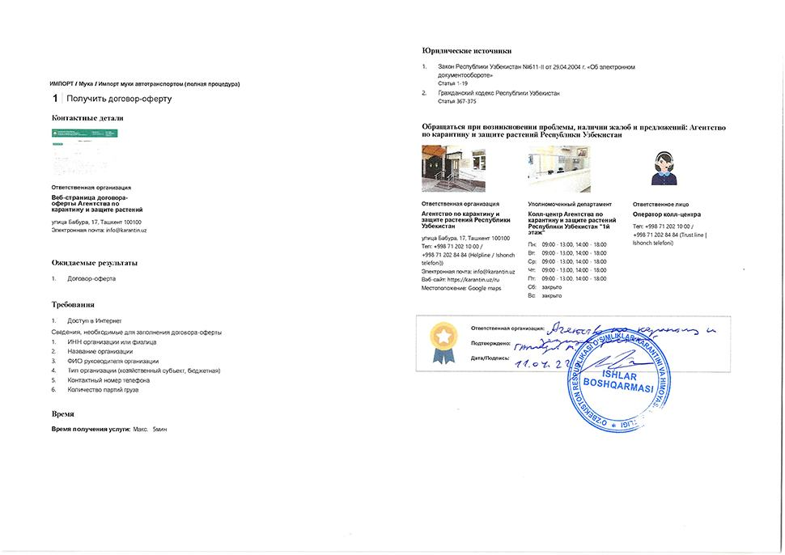  Step 1 — Obtain offer agreement | 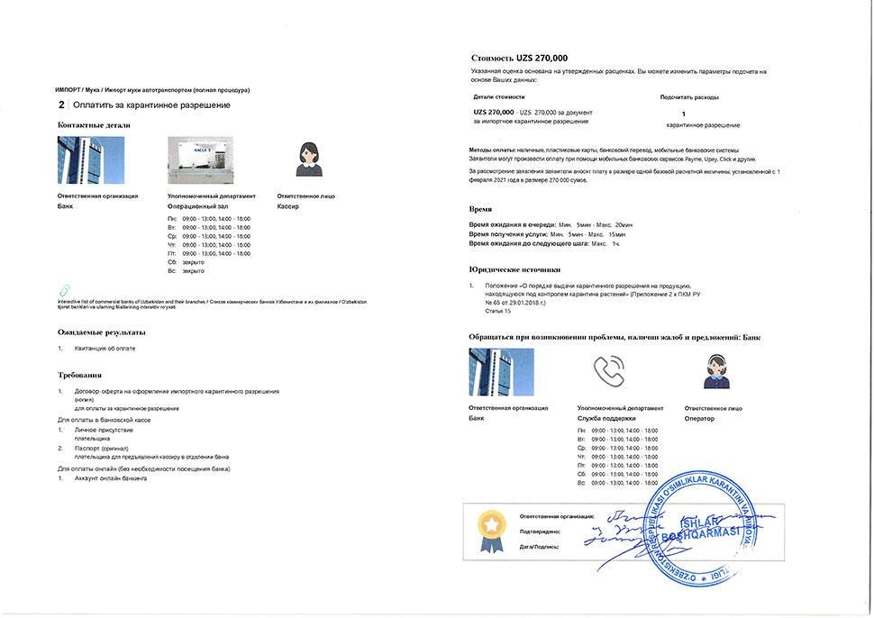  Step 2 — Pay for quarantine permit
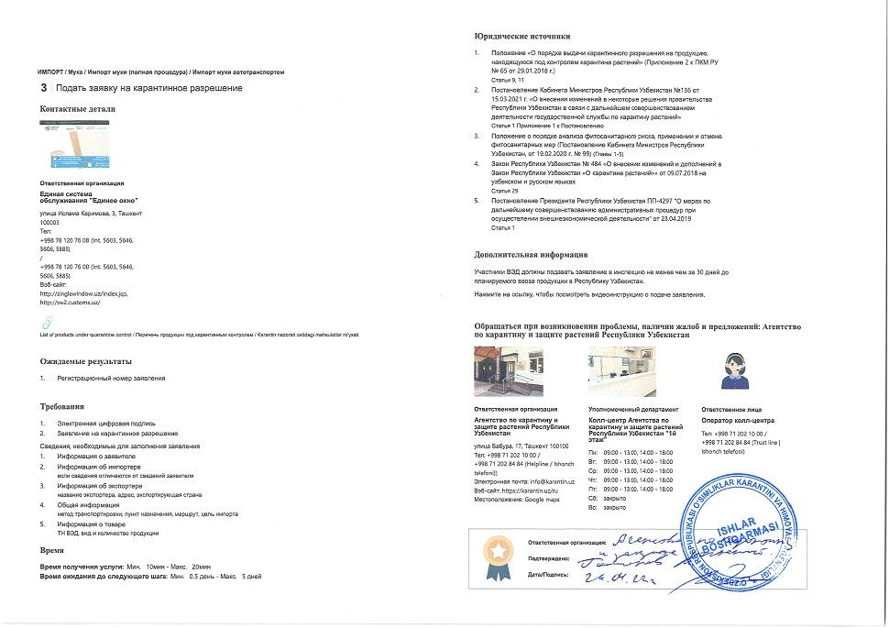  Step 3 — Apply for quarantine permit | 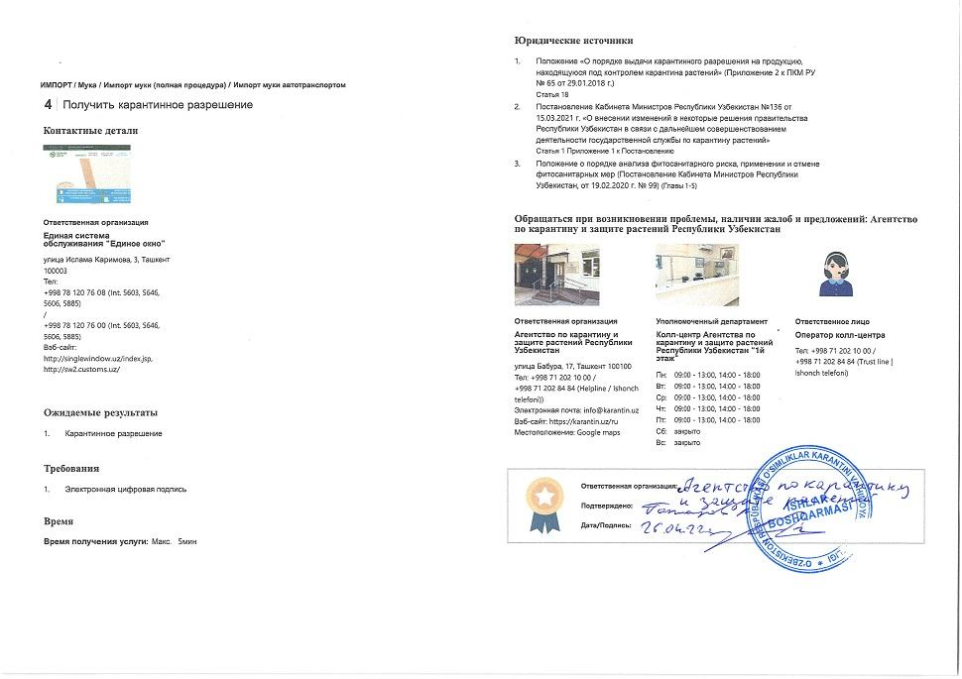  Step 4 — Obtain quarantine permit
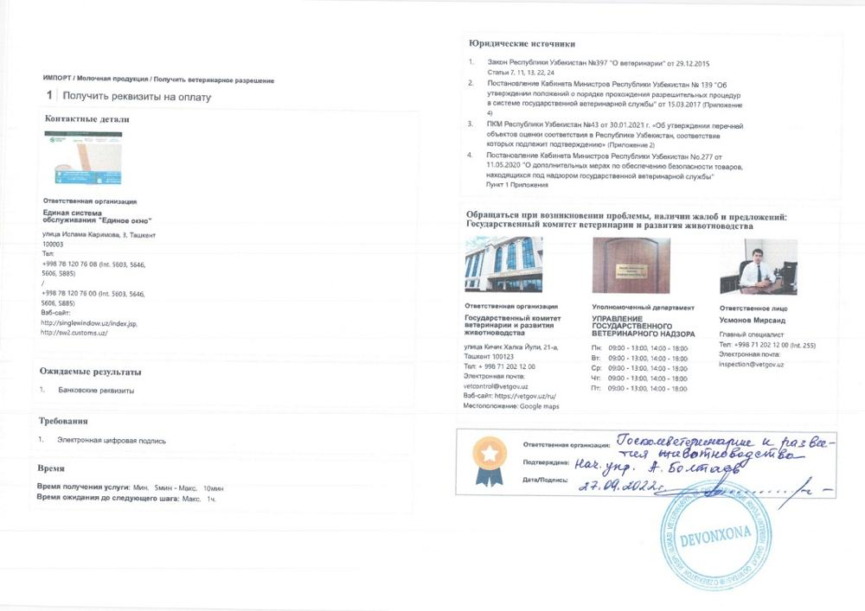  Step 5 — Obtain payment details | 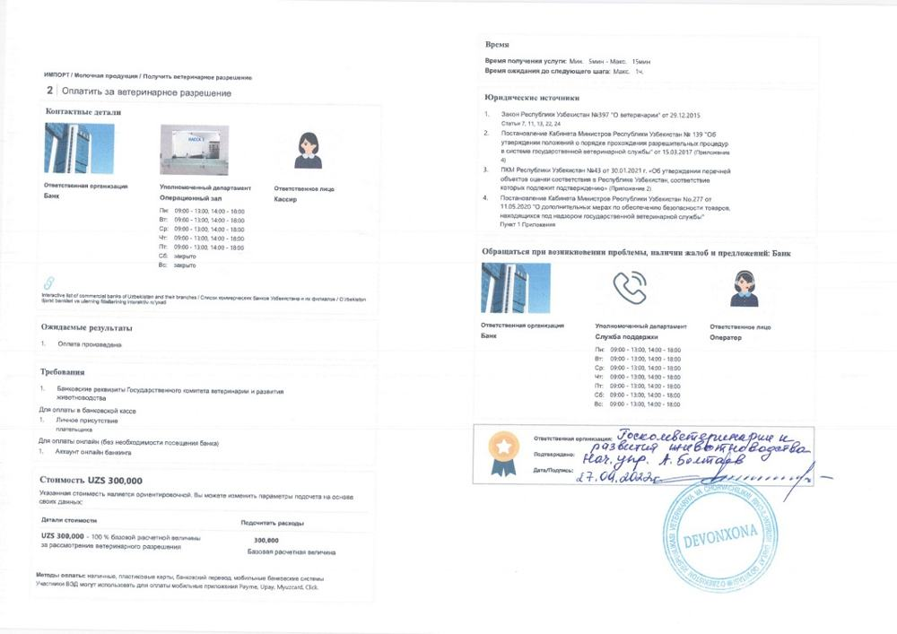  Step 6 — Pay for veterinary permit
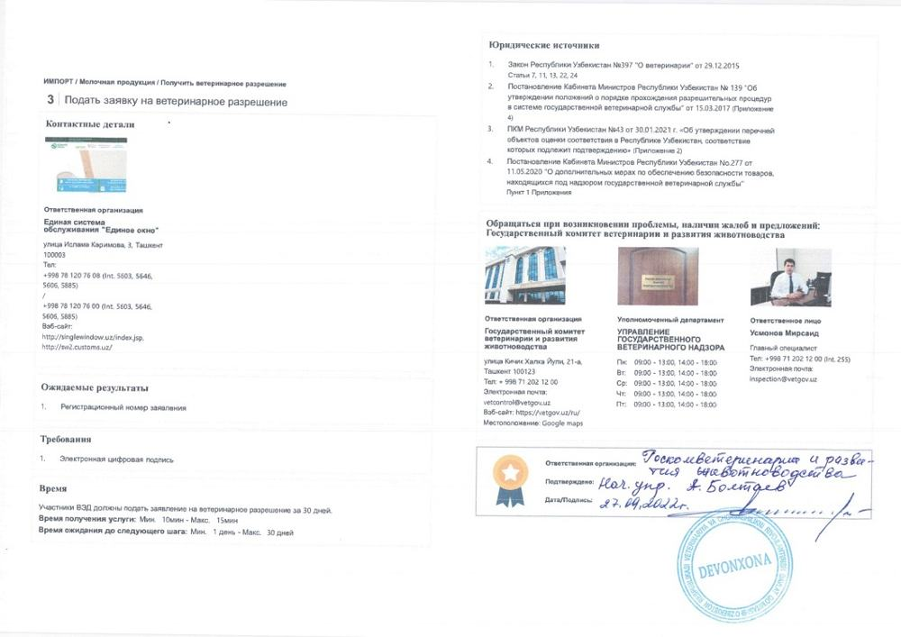  Step 7 — Apply for veterinary permit | 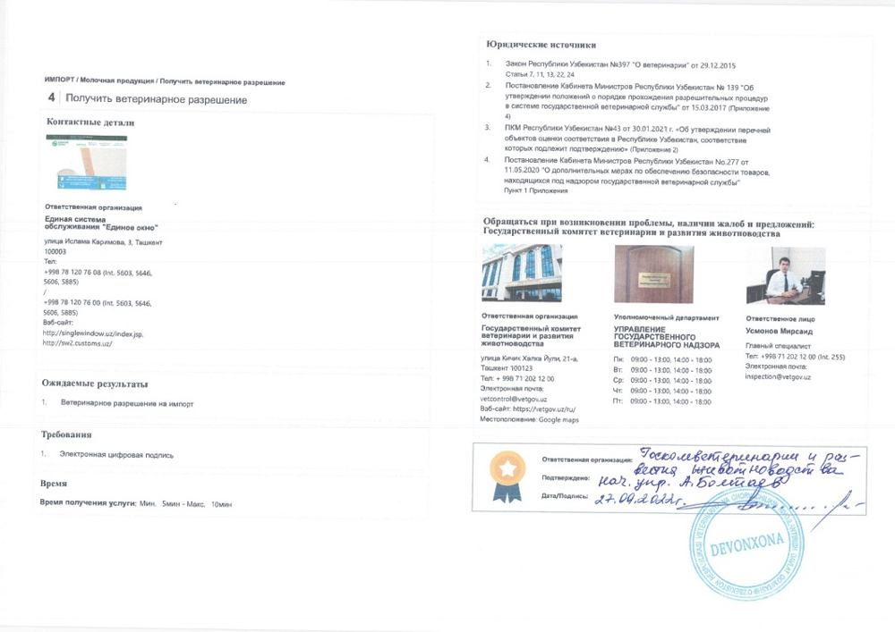  Step 8 — Obtain veterinary permit
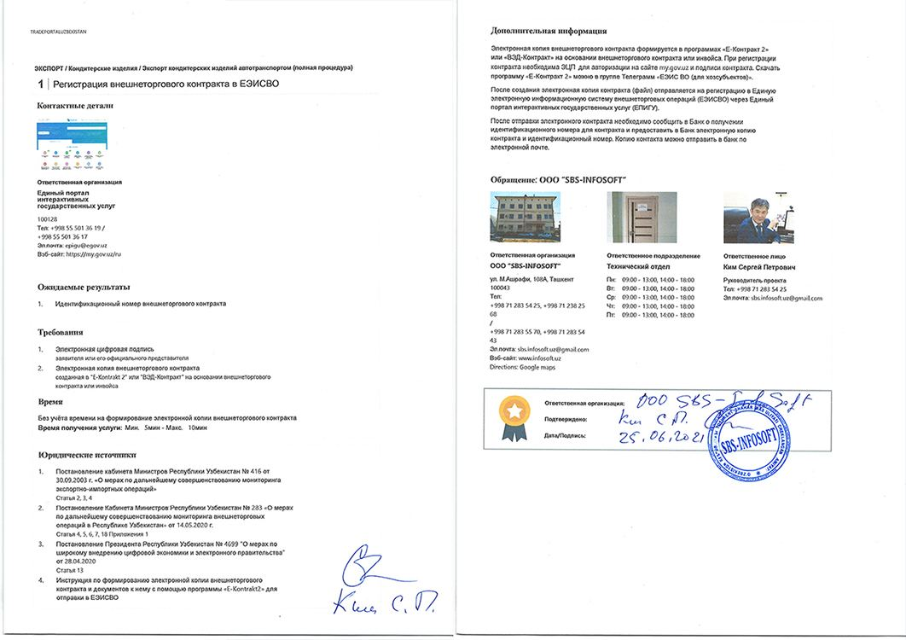  Step 9 — Register foreign trade contract in UEISFTO | 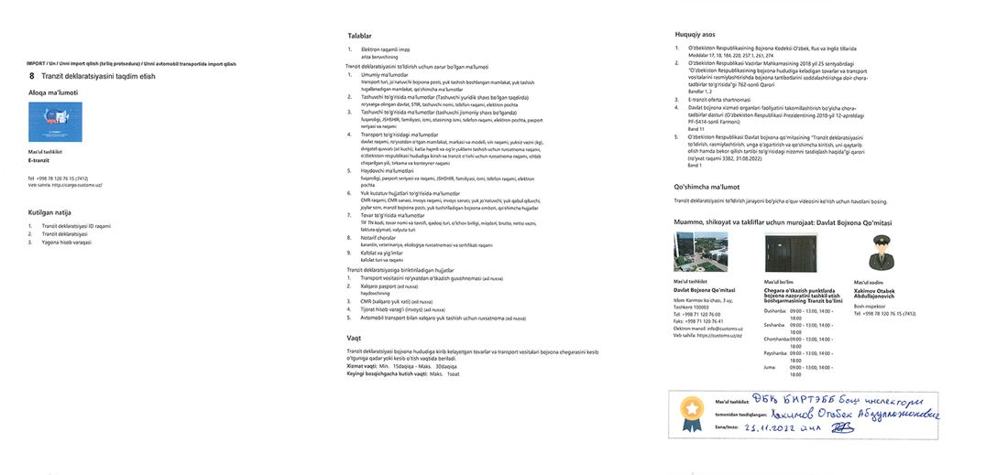  Step 12 — Submit transit declaration
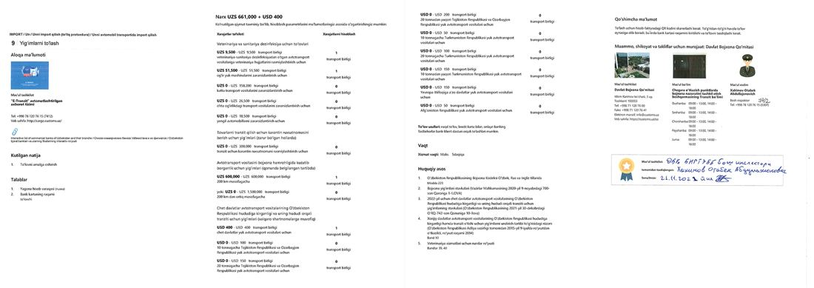  Step 13 — Pay fees | 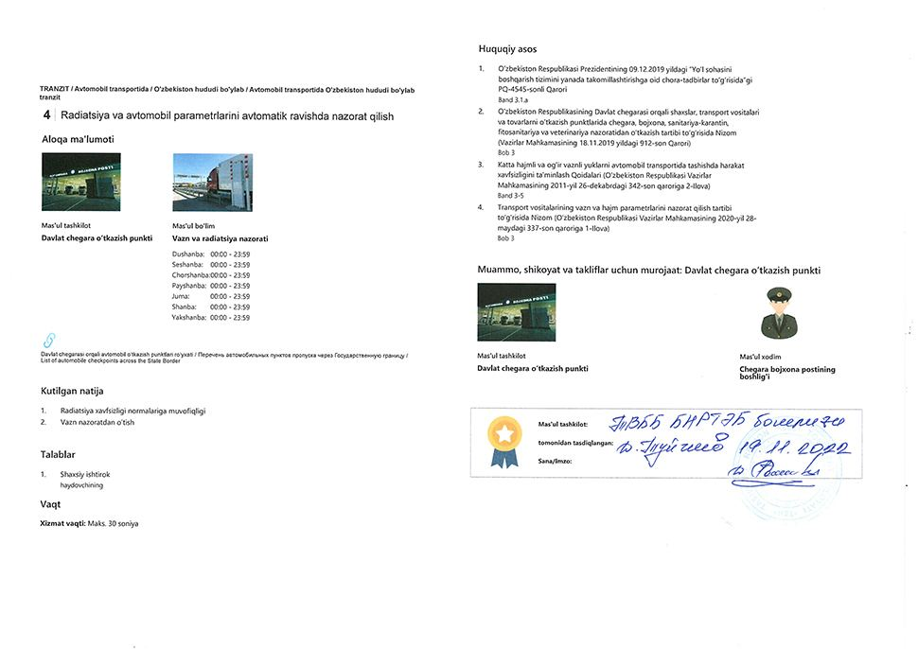  Step 15 — Undergo radiation and vehicle parameter control automatically
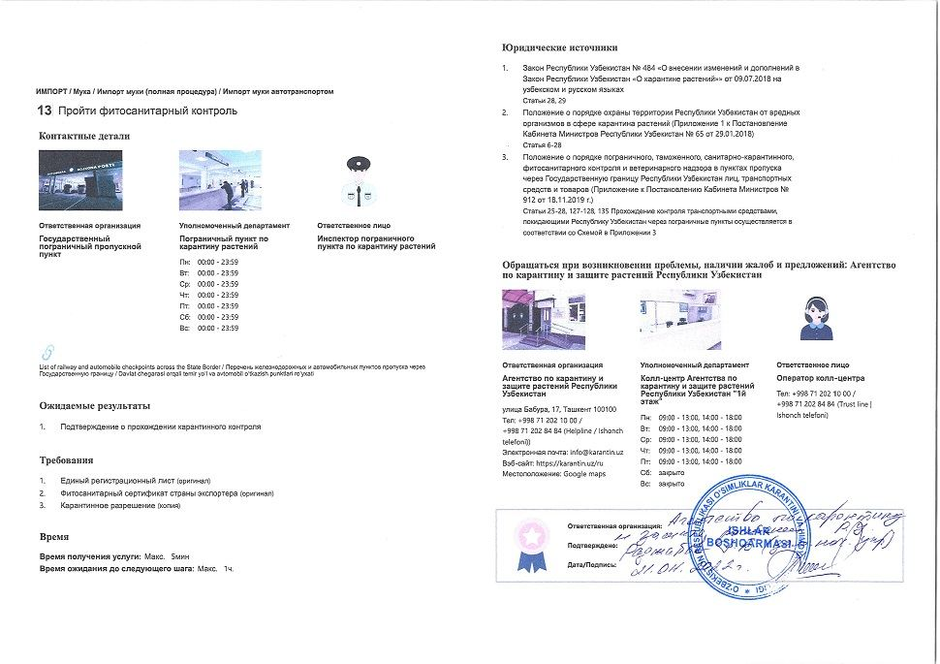  Step 17 — Undergo phytosanitary control | 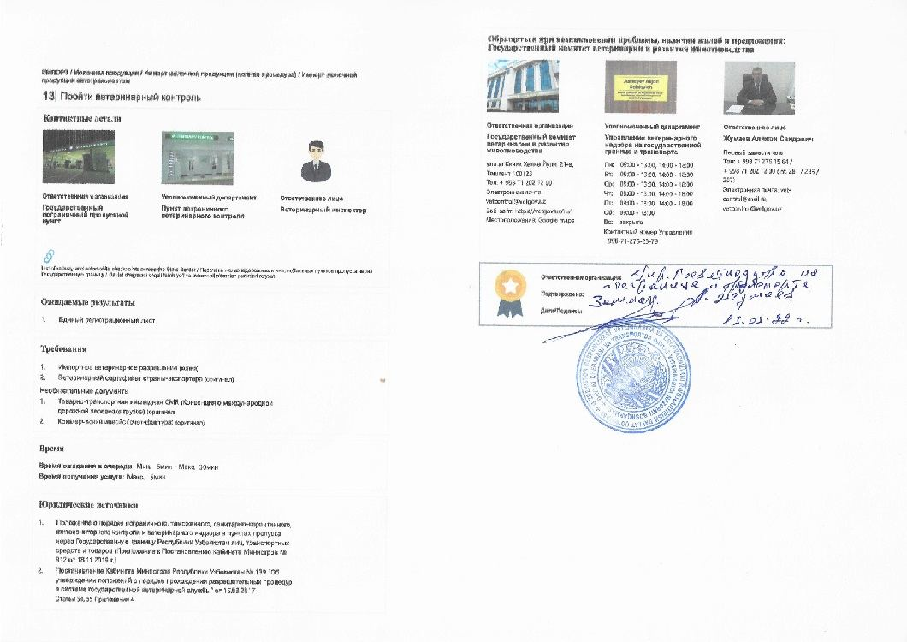  Step 18 — Undergo veterinary control
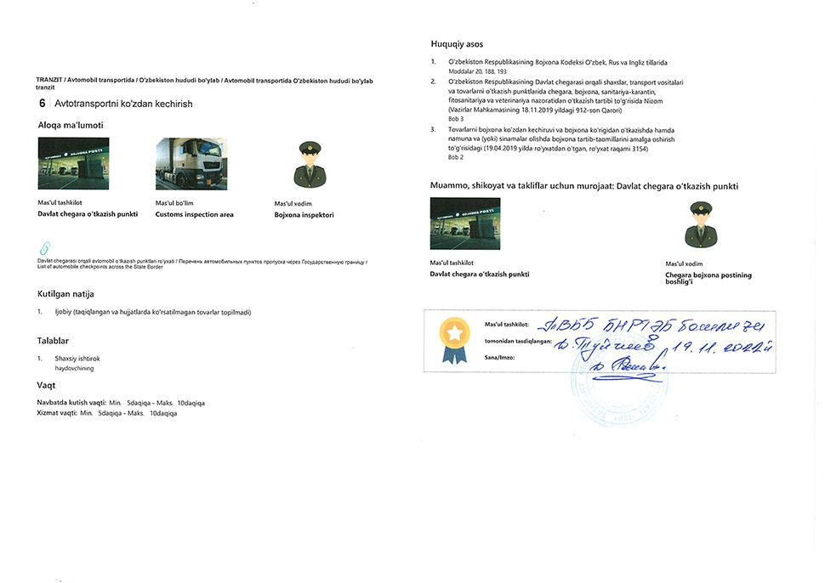  Step 19 — Undergo vehicle visual inspection | 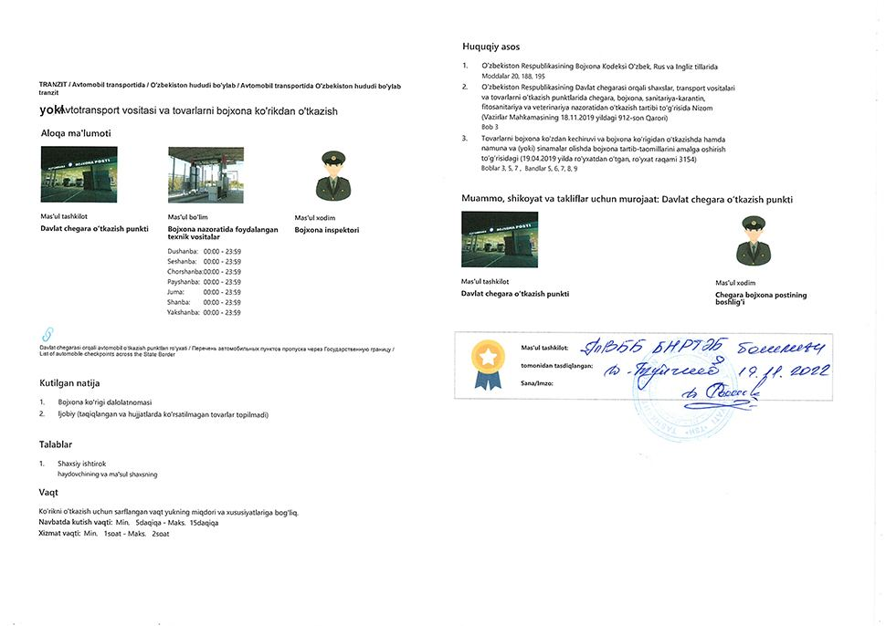  Step 20 — Undergo customs physical inspection of vehicle and cargo
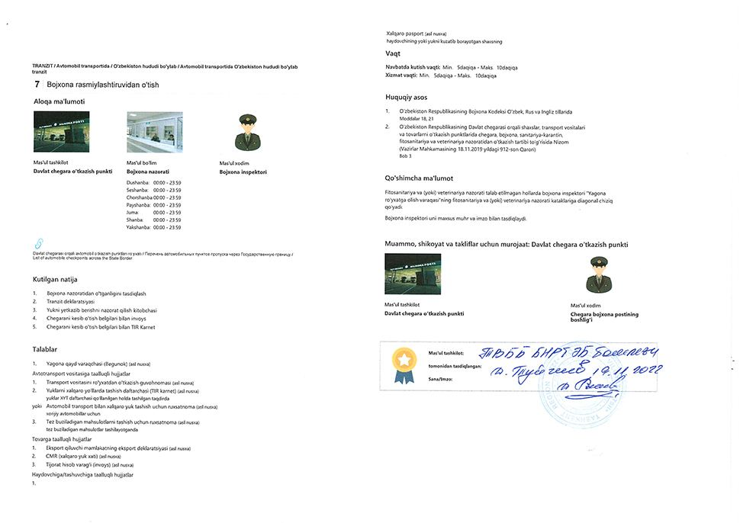  Step 21 — Undergo customs clearance | 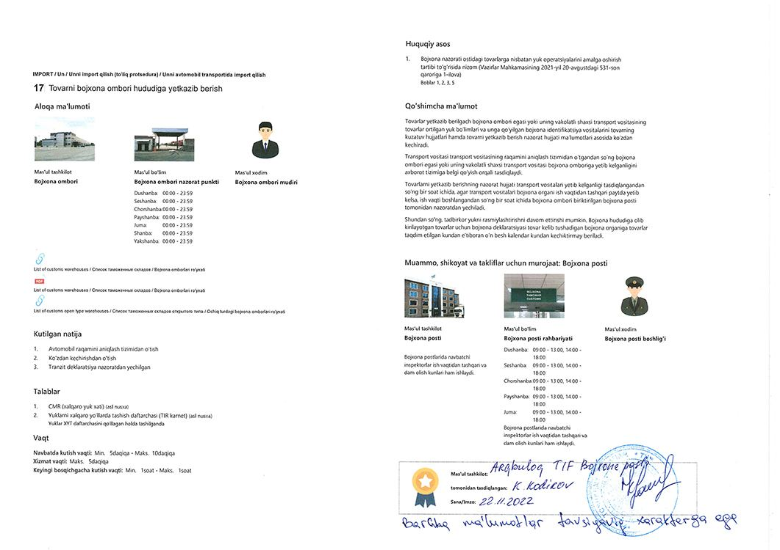  Step 23 — Deliver cargo to customs warehouse
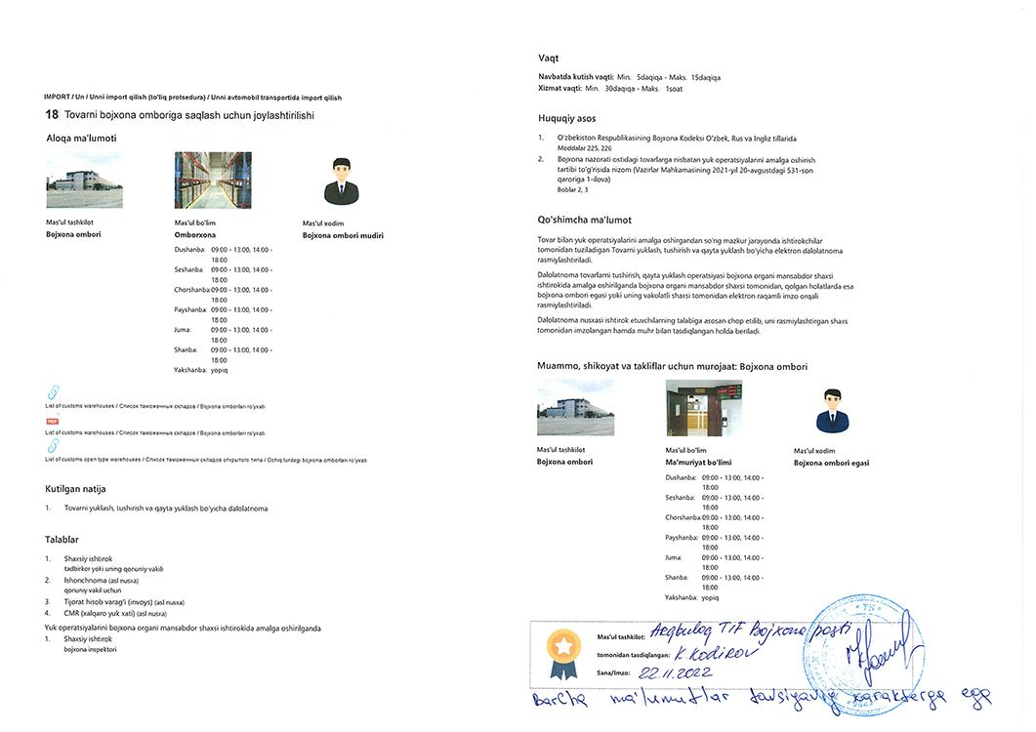  Step 24 — Place cargo at customs warehouse | 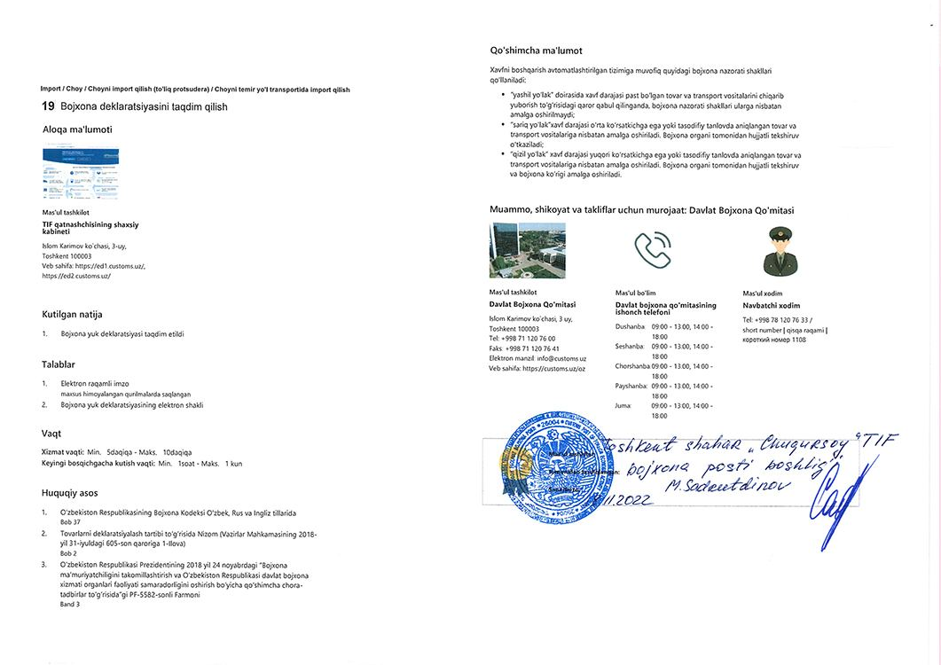  Step 29 — Submit customs declaration
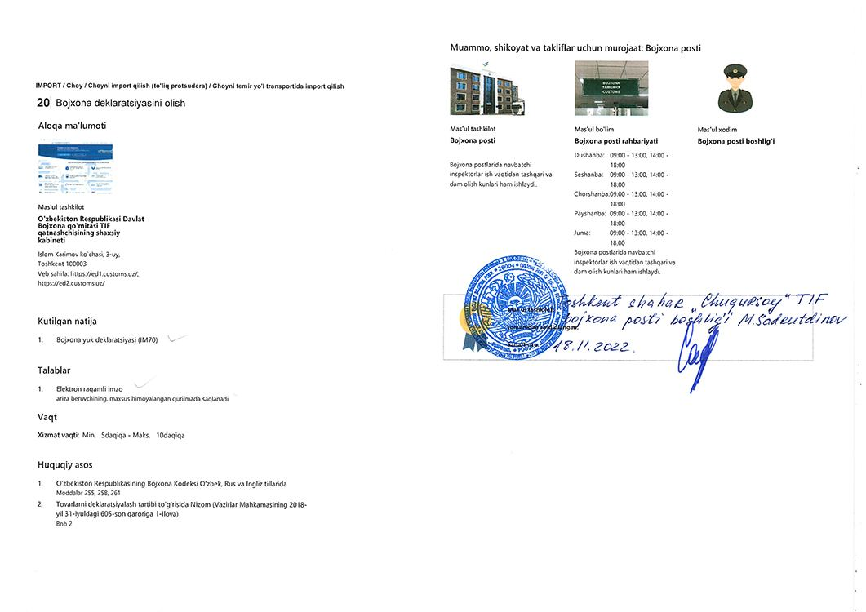  Step 31 — Obtain customs declaration | 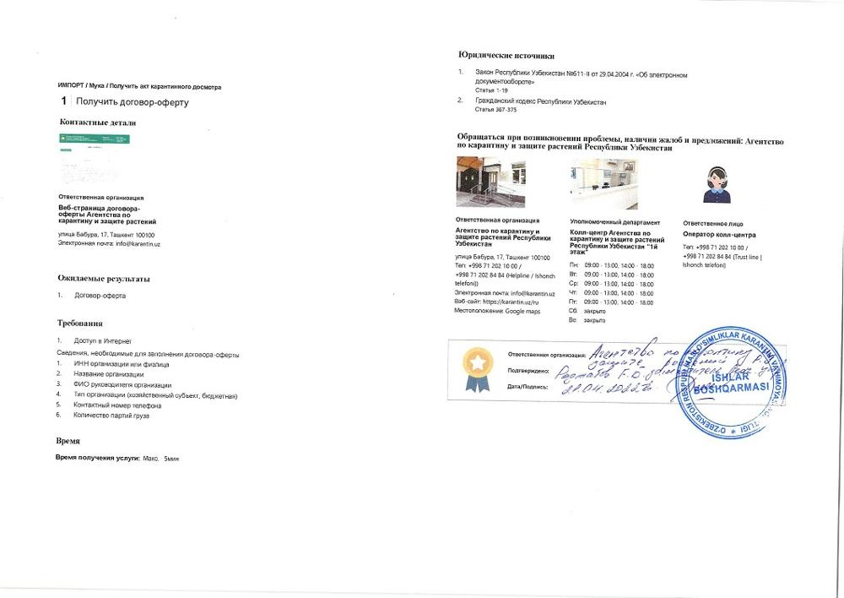  Step 32 — Obtain offer agreement
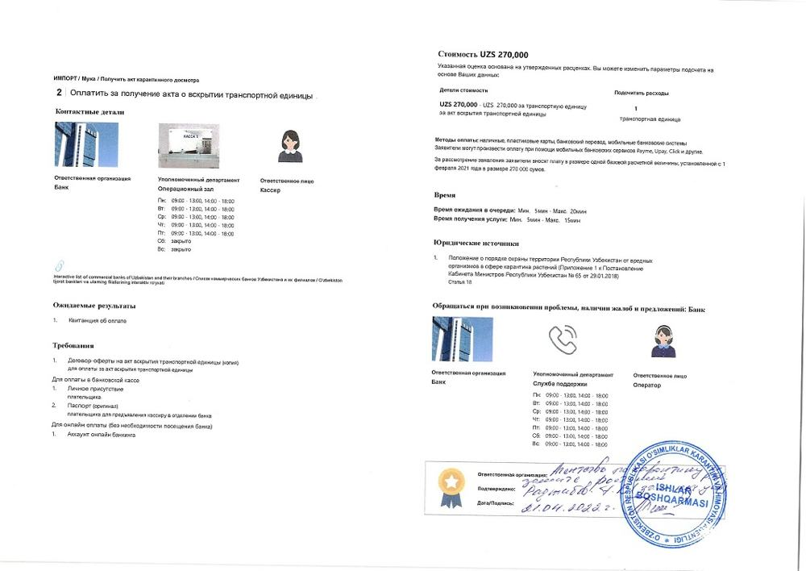  Step 33 — Pay for transport unit opening act | 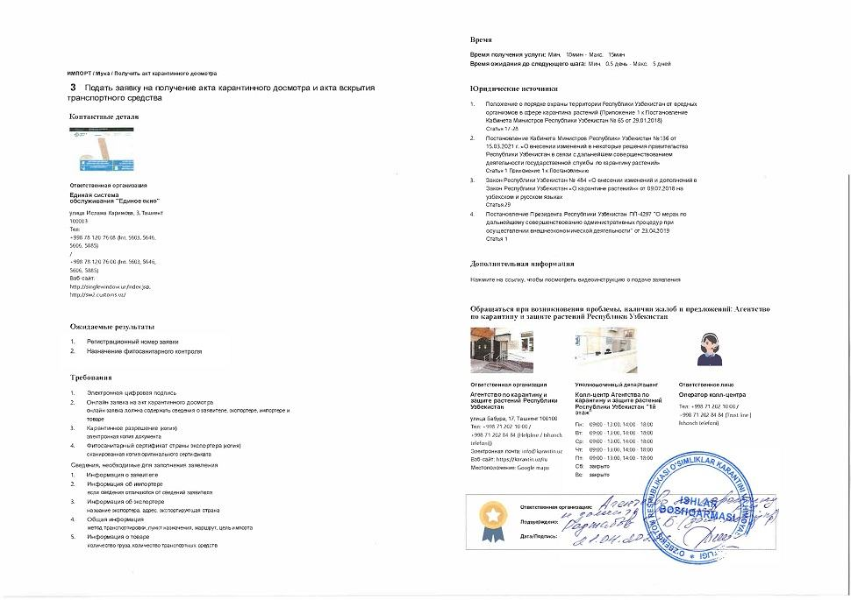  Step 34 — Apply for quarantine inspection act and transport unit opening act
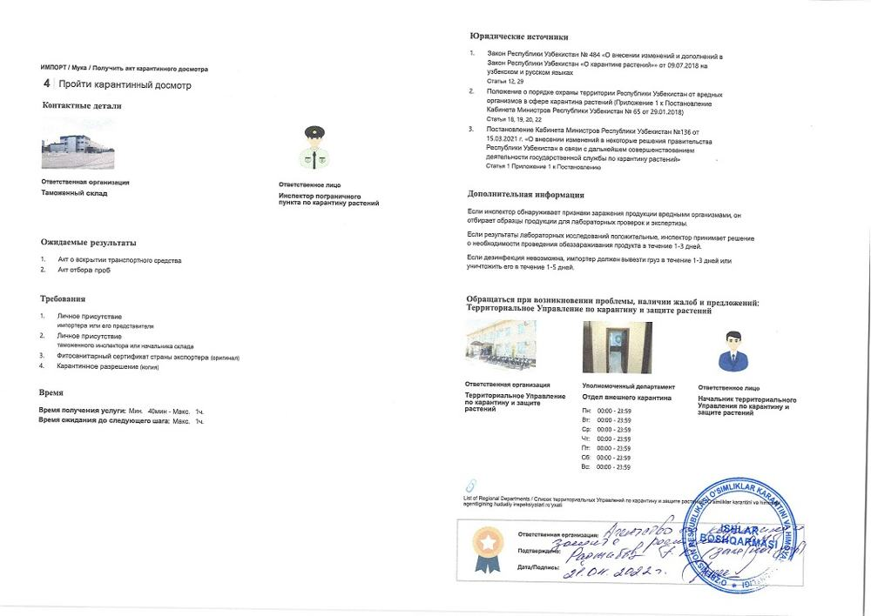  Step 35 — Undergo quarantine inspection | 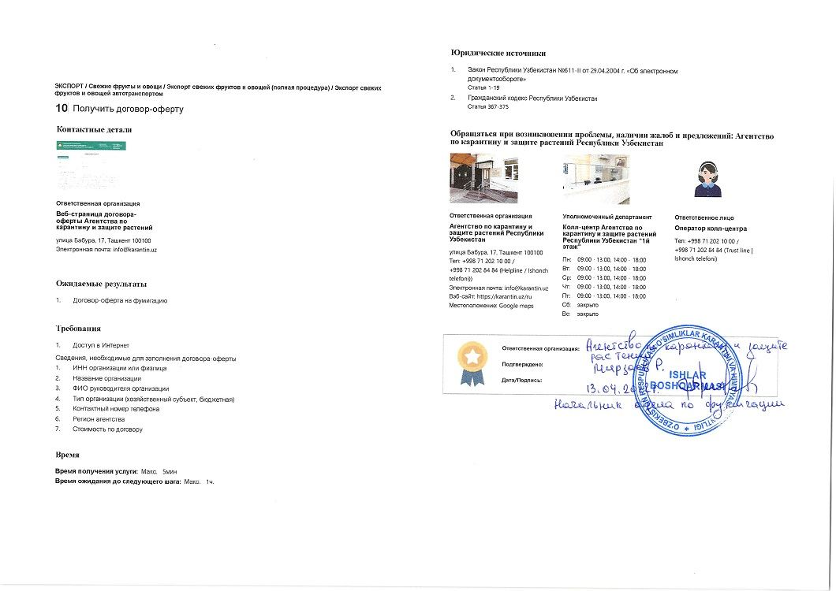  Step 36 — Obtain offer agreement for fumigation
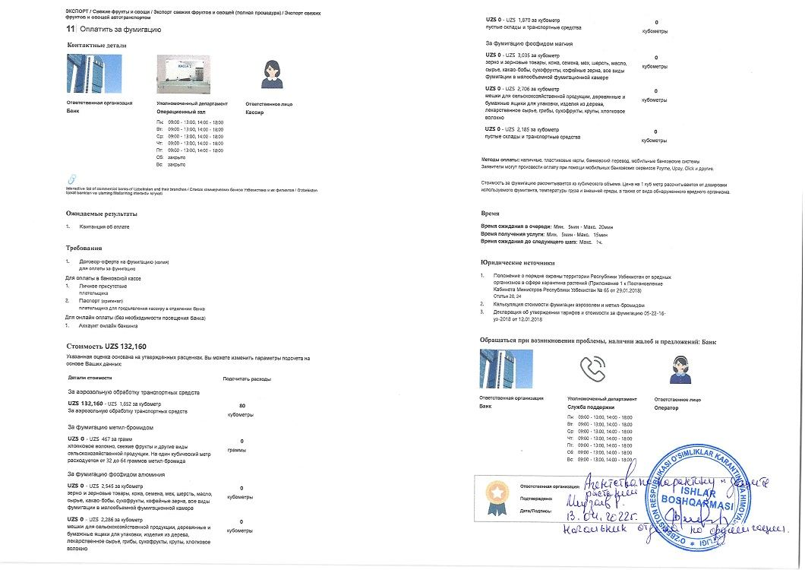  Step 37 — Pay for fumigation | 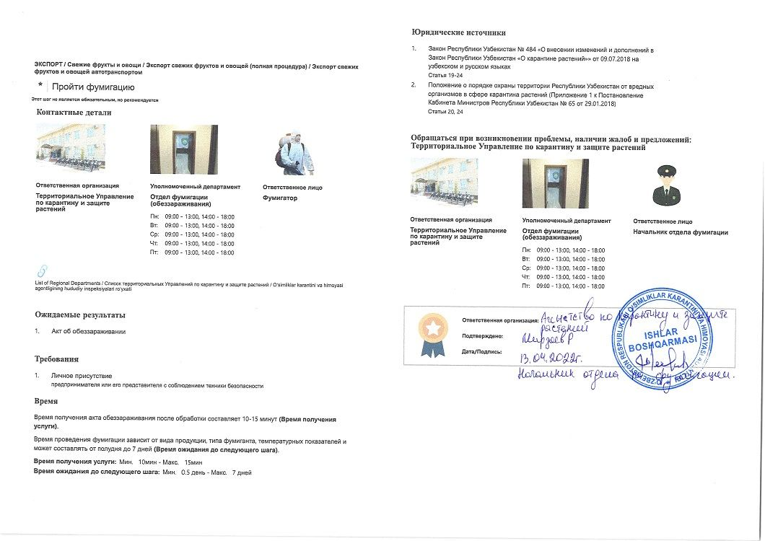  Step 38 — Undergo fumigation
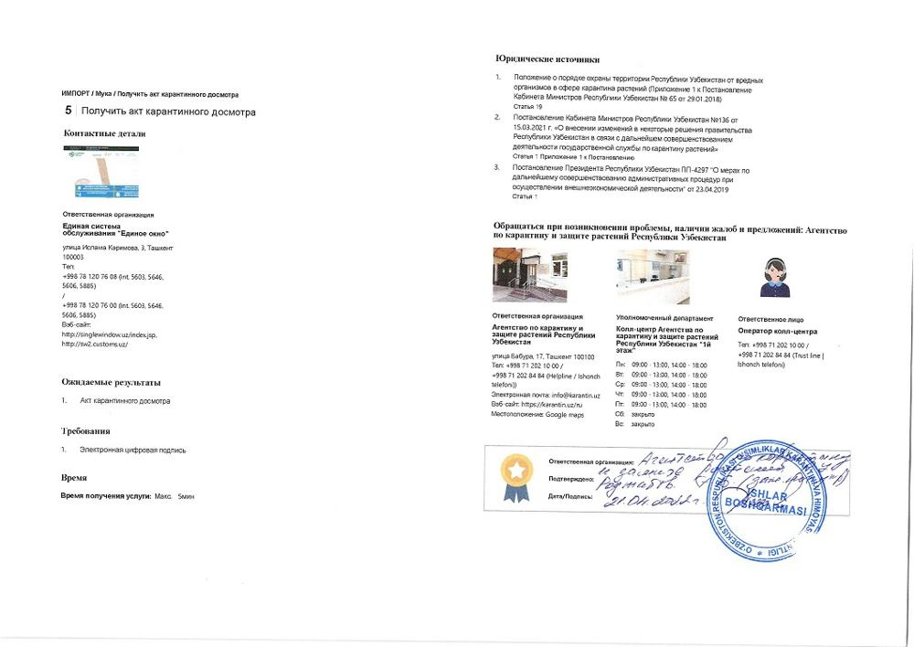  Step 39 — Obtain quarantine inspection act | 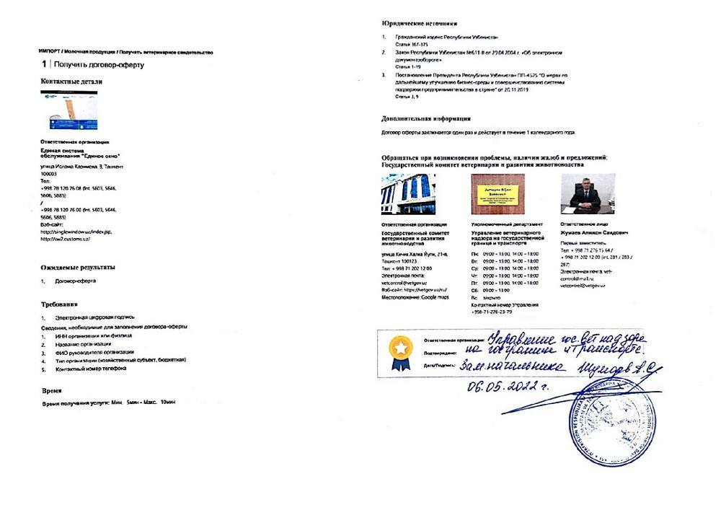  Step 40 — Obtain offer agreement
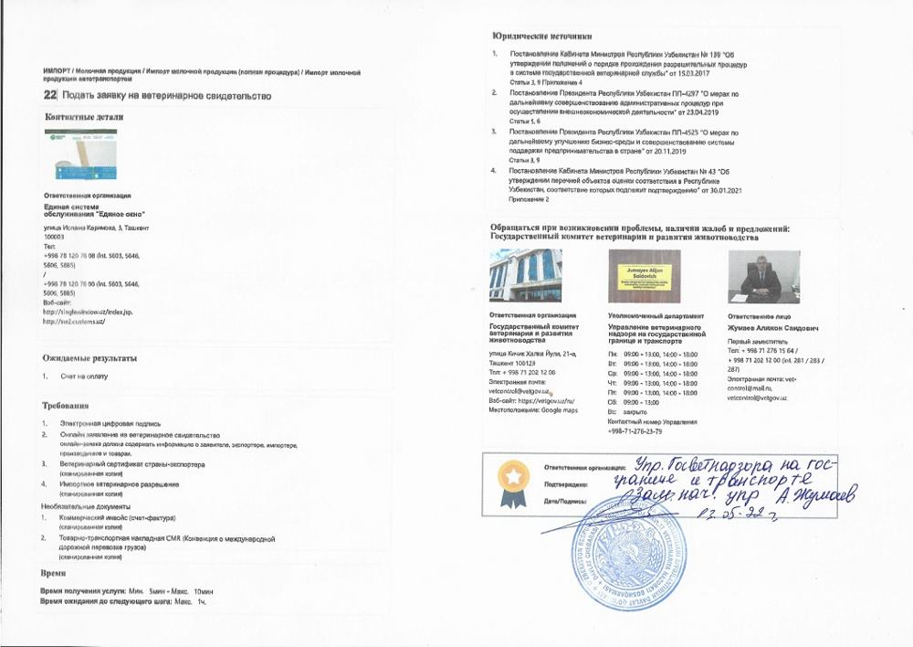  Step 41 — Apply for veterinary certificate (imp) | 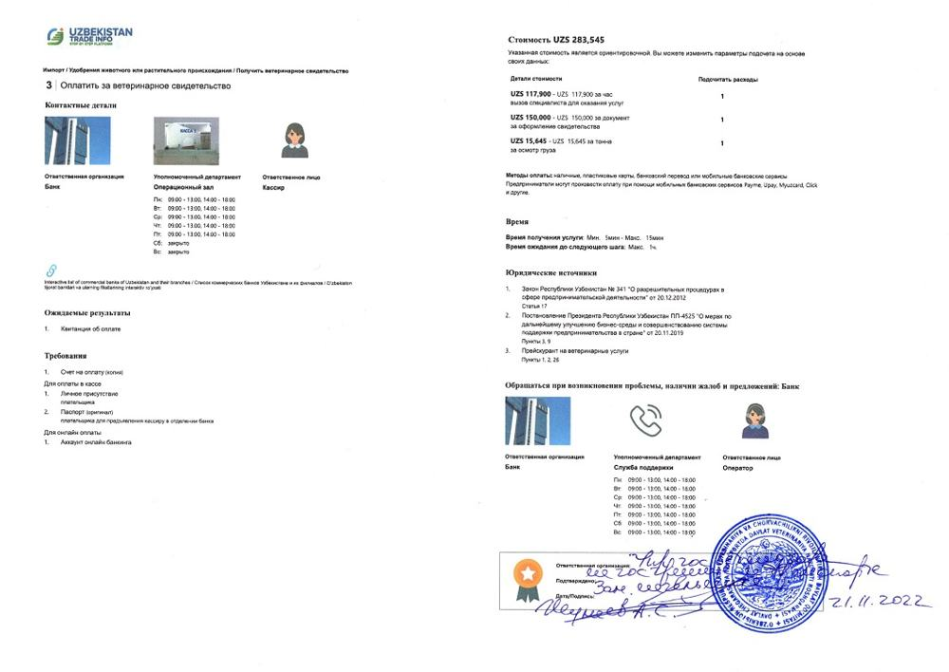  Step 42 — Pay for veterinary certificate
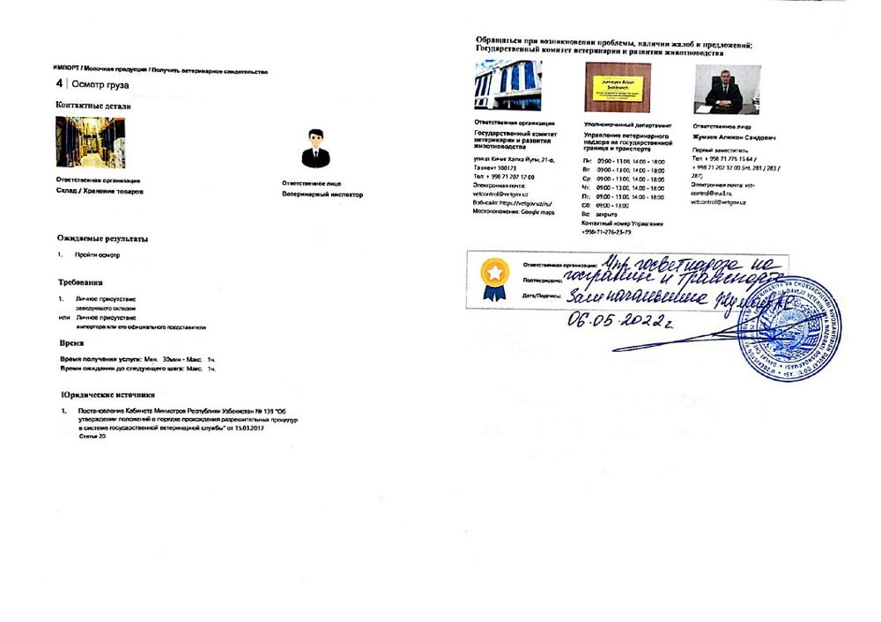  Step 43 — Undergo cargo inspection | 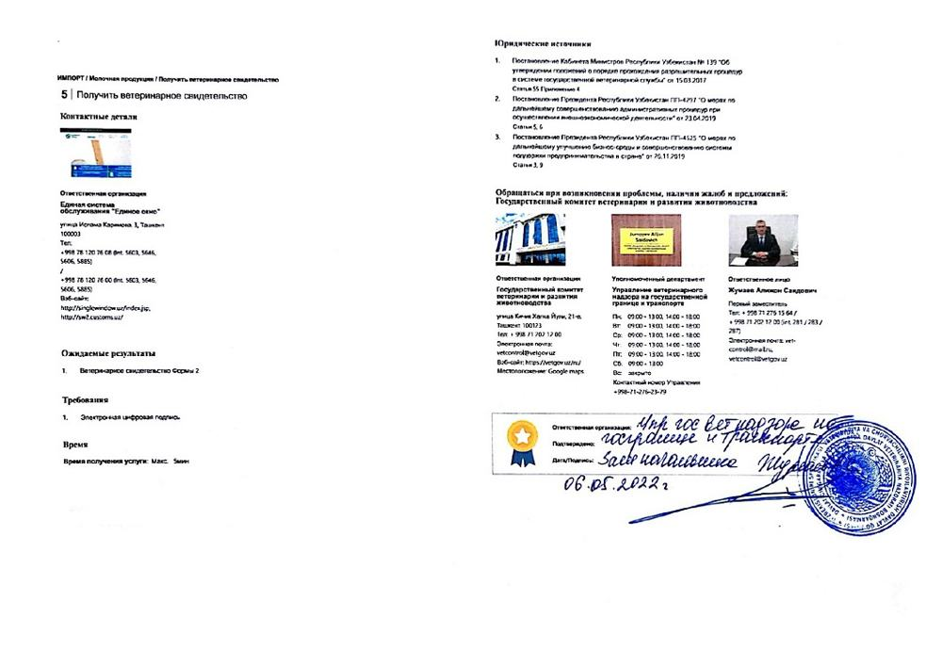  Step 44 — Obtain veterinary certificate (import)
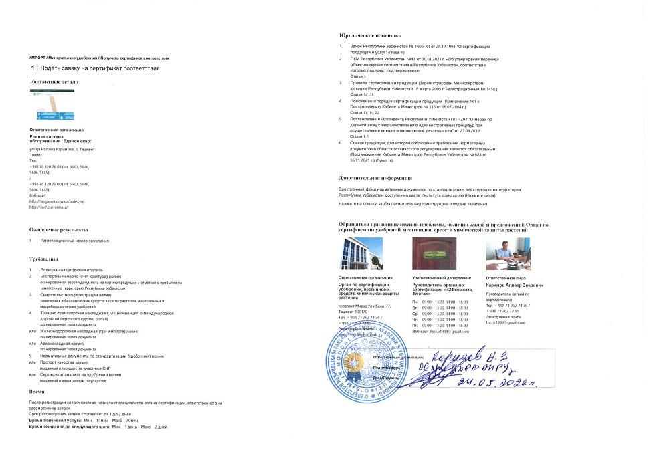  Step 45 — Apply for certificate of conformity | 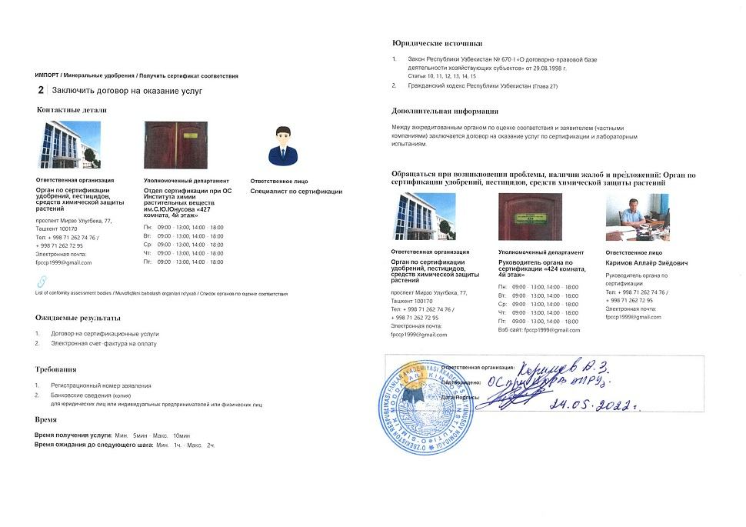  Step 46 — Conclude contract for services
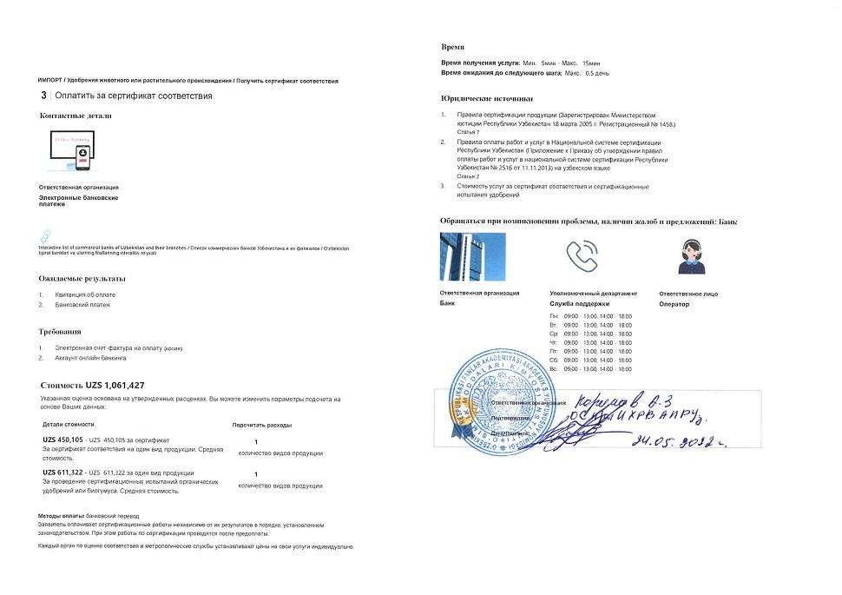  Step 47 — Pay for certificate of conformity | 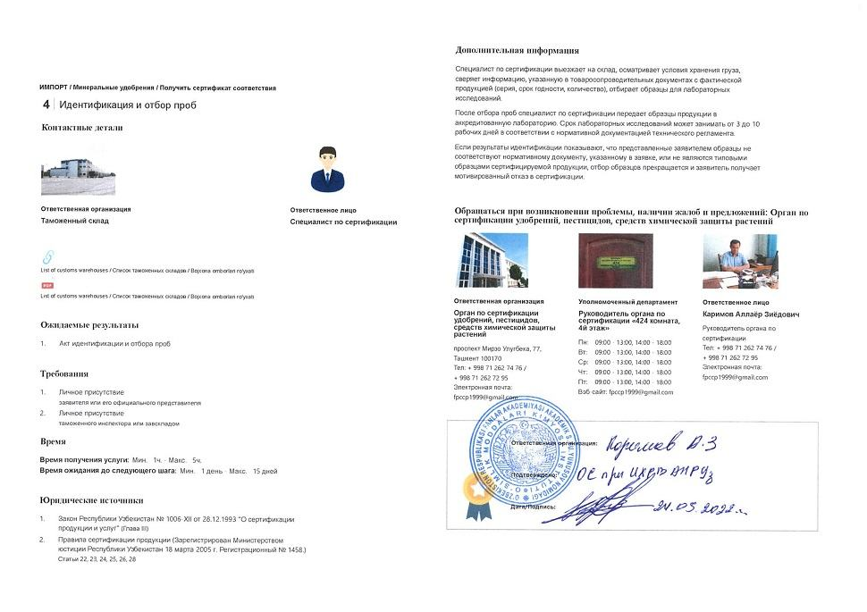  Step 48 — Identification and selection of samples
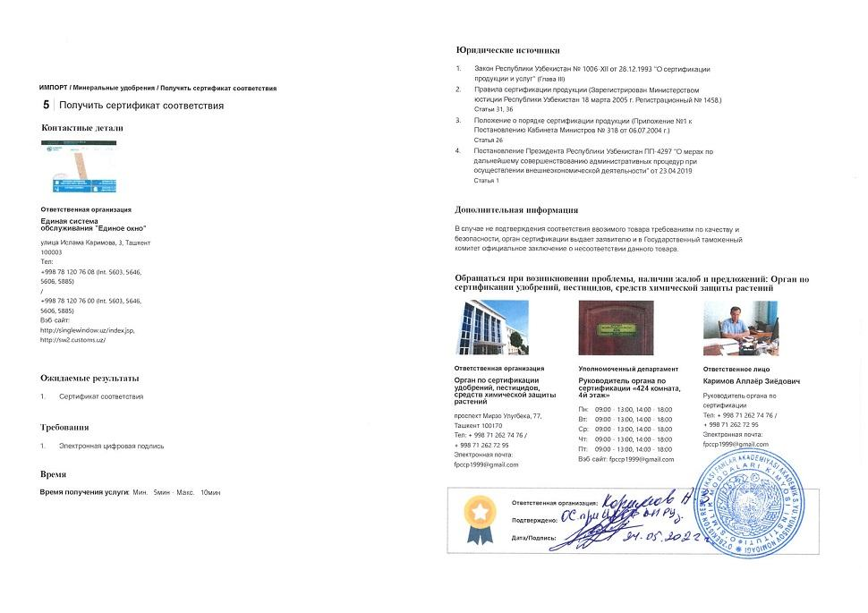  Step 49 — Obtain certificate of conformity | 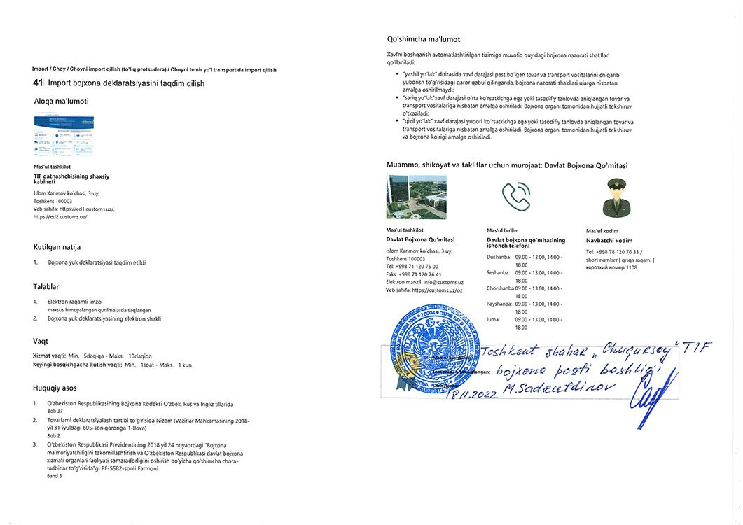  Step 52 — Submit import customs declaration
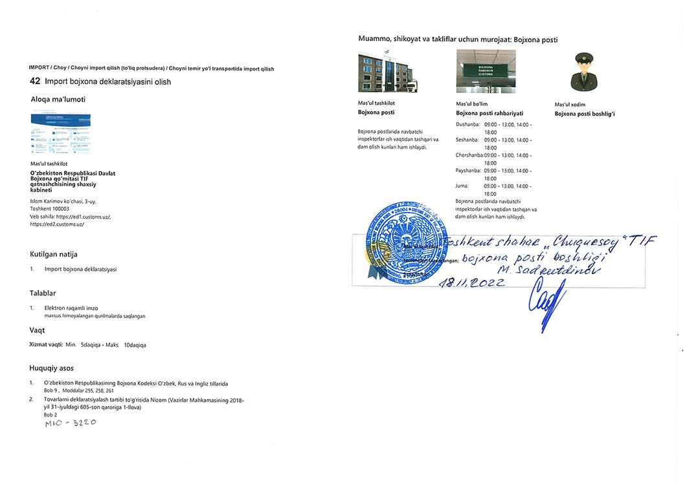
Step 54 — Obtain import customs declaration

