Uzbekistan Trade Info — Procedure Automation
Procedure 707: Import of animal or vegetable fertilizers by train
As-is process map — the procedure exactly as it runs today. Source: uztradeinfo.uz/procedure/707
Blocks | Steps | Entities | Online | Optional | Alternative
17 | 60 | 14 | 35 | 7 | 0
End-to-end published timeframe: 49–531 hours.
1. Process flow
Columns group the entity in charge, so every move between columns is a handoff. The specific body is named in grey inside each box. Dashed border = optional (conditional) step. Boxes side by side = alternative routes, where the trader takes one. Heavy border = the step can be done online.
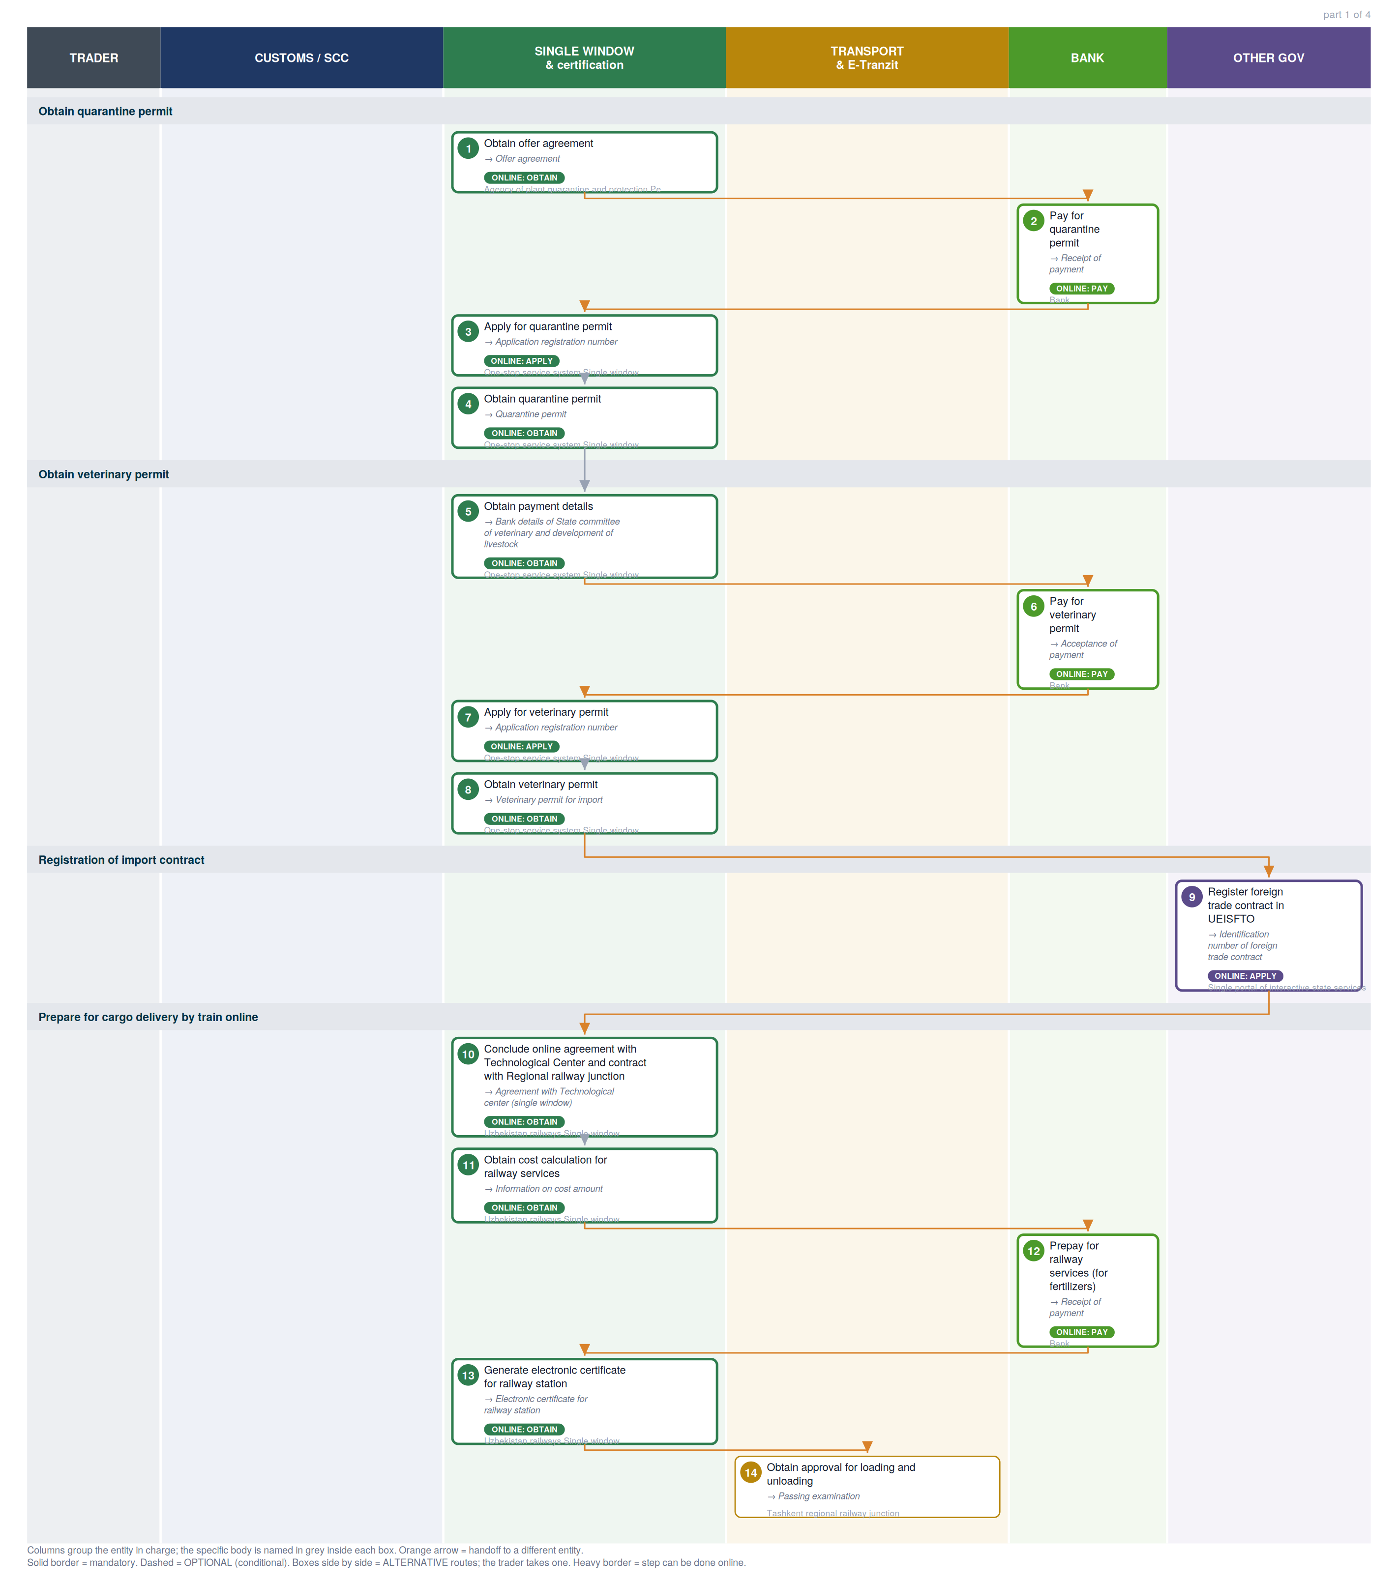

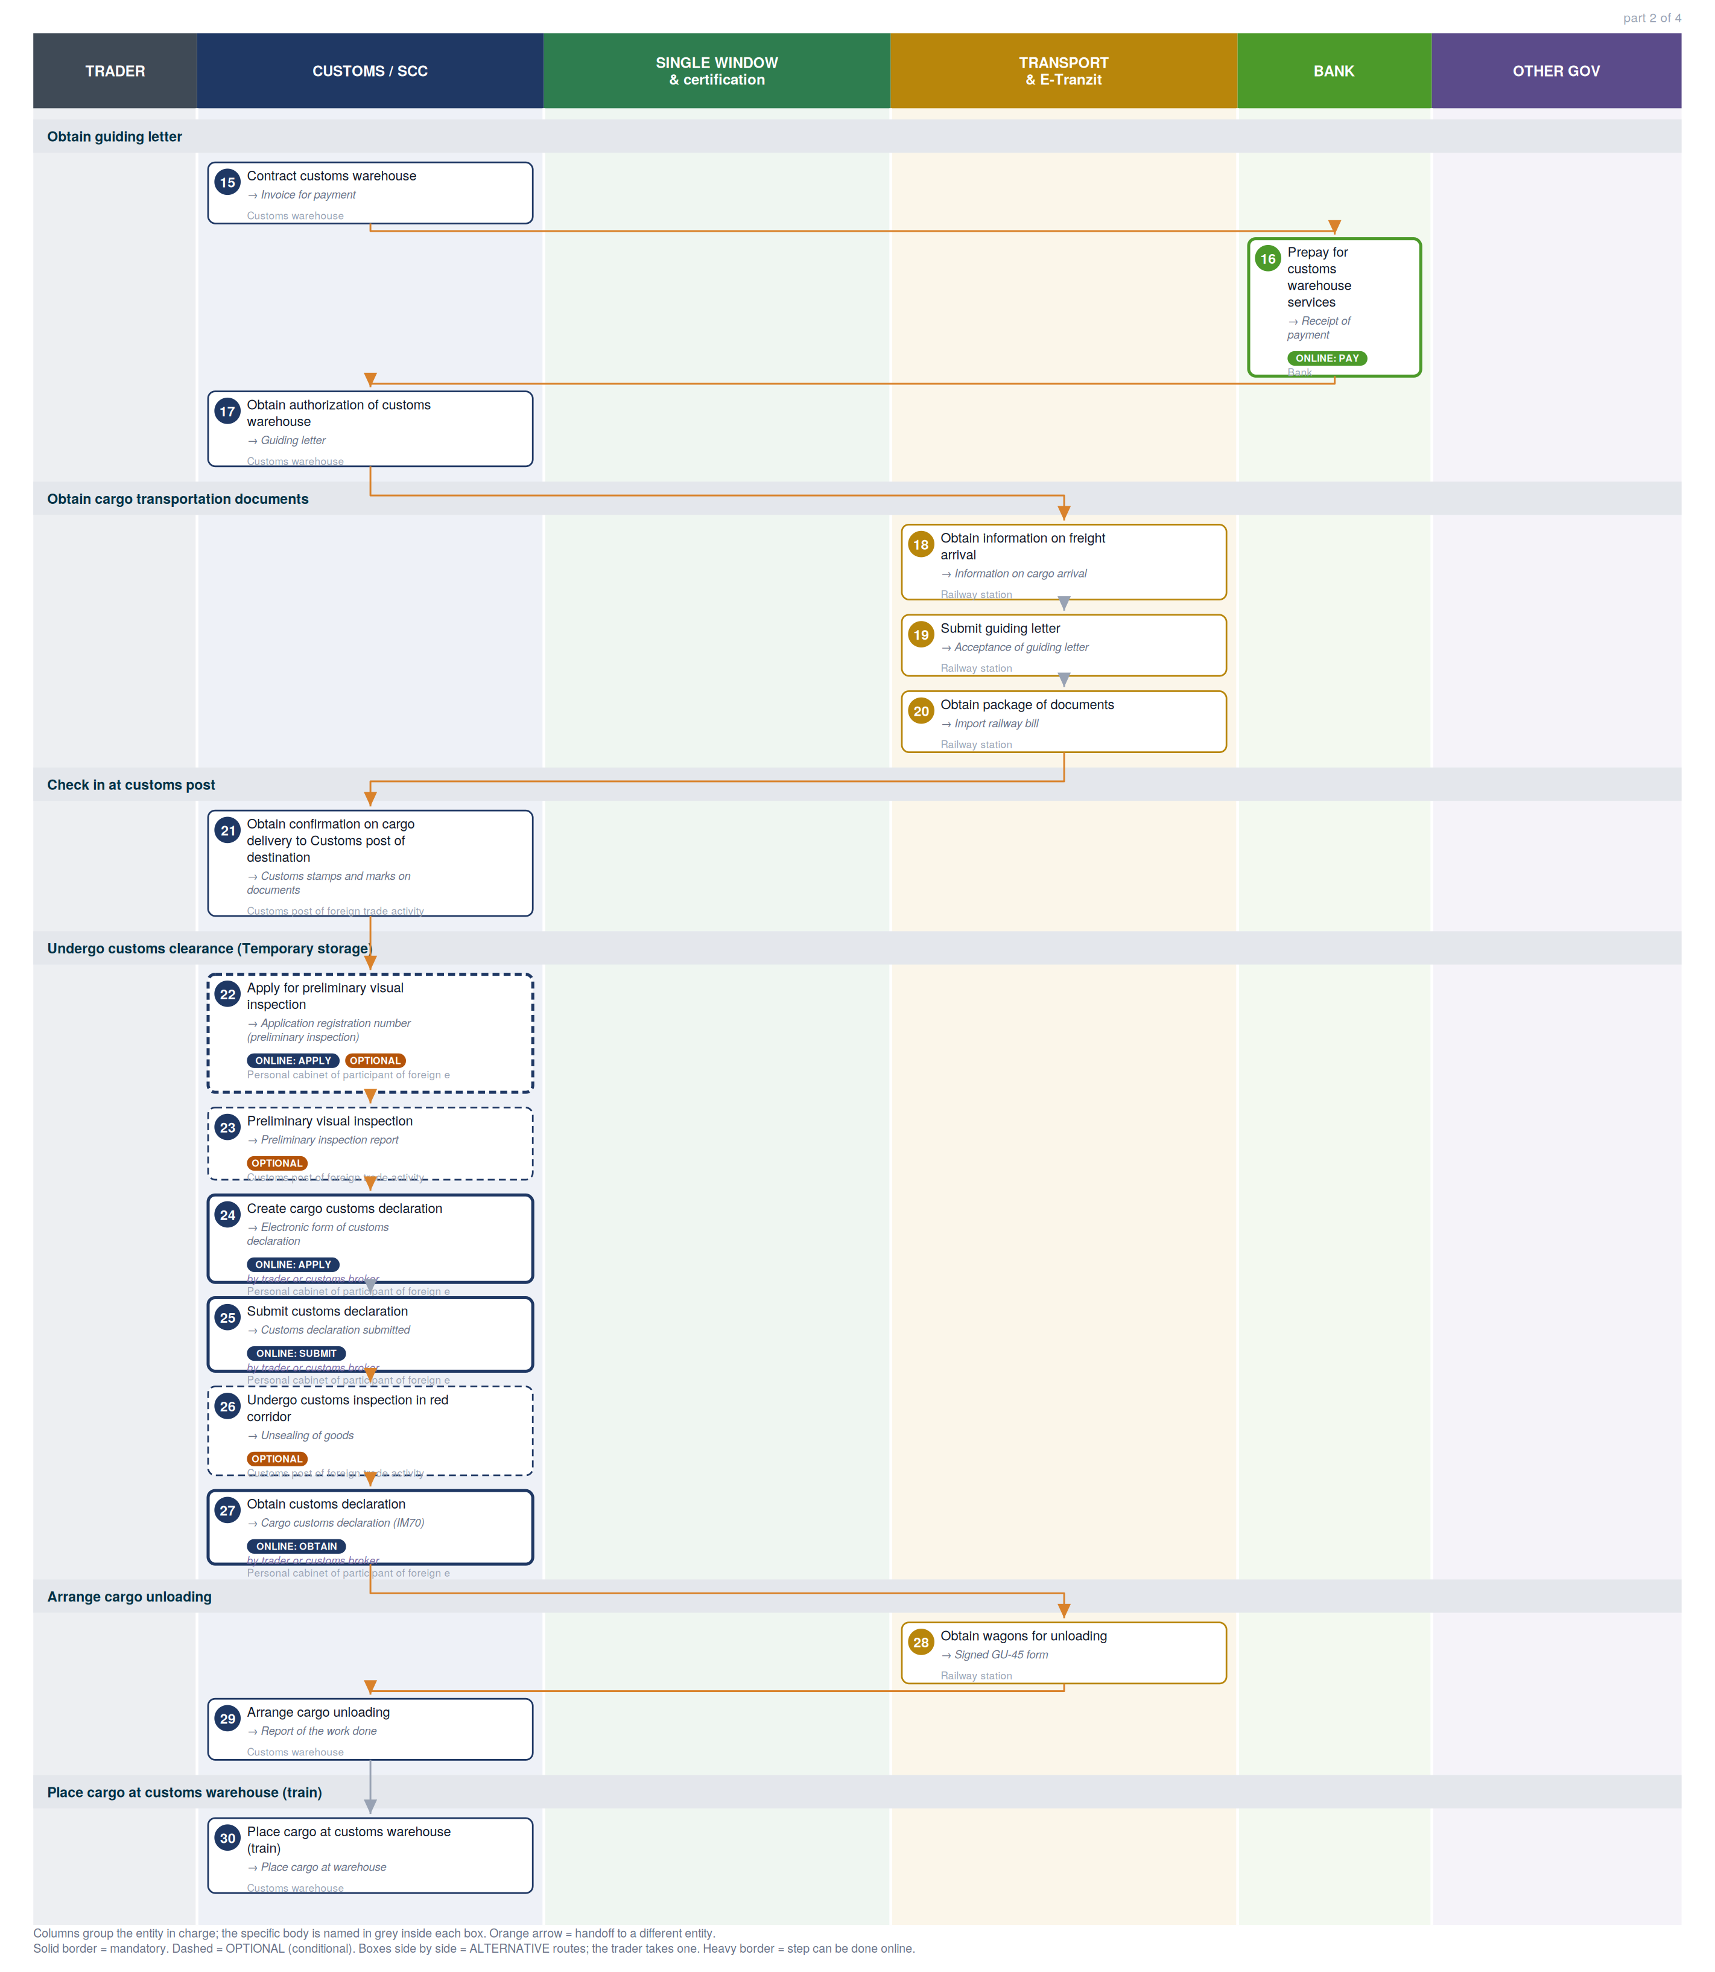

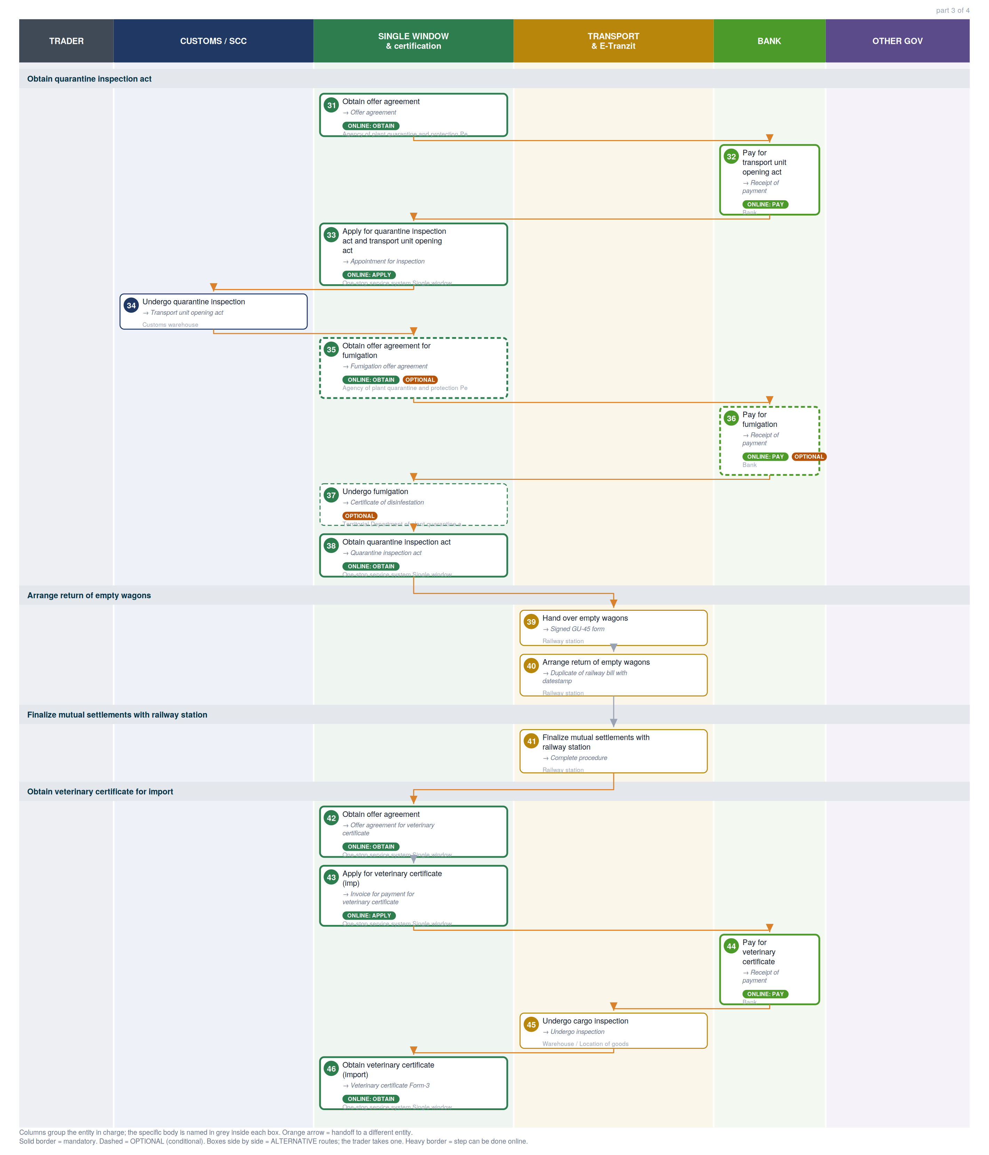

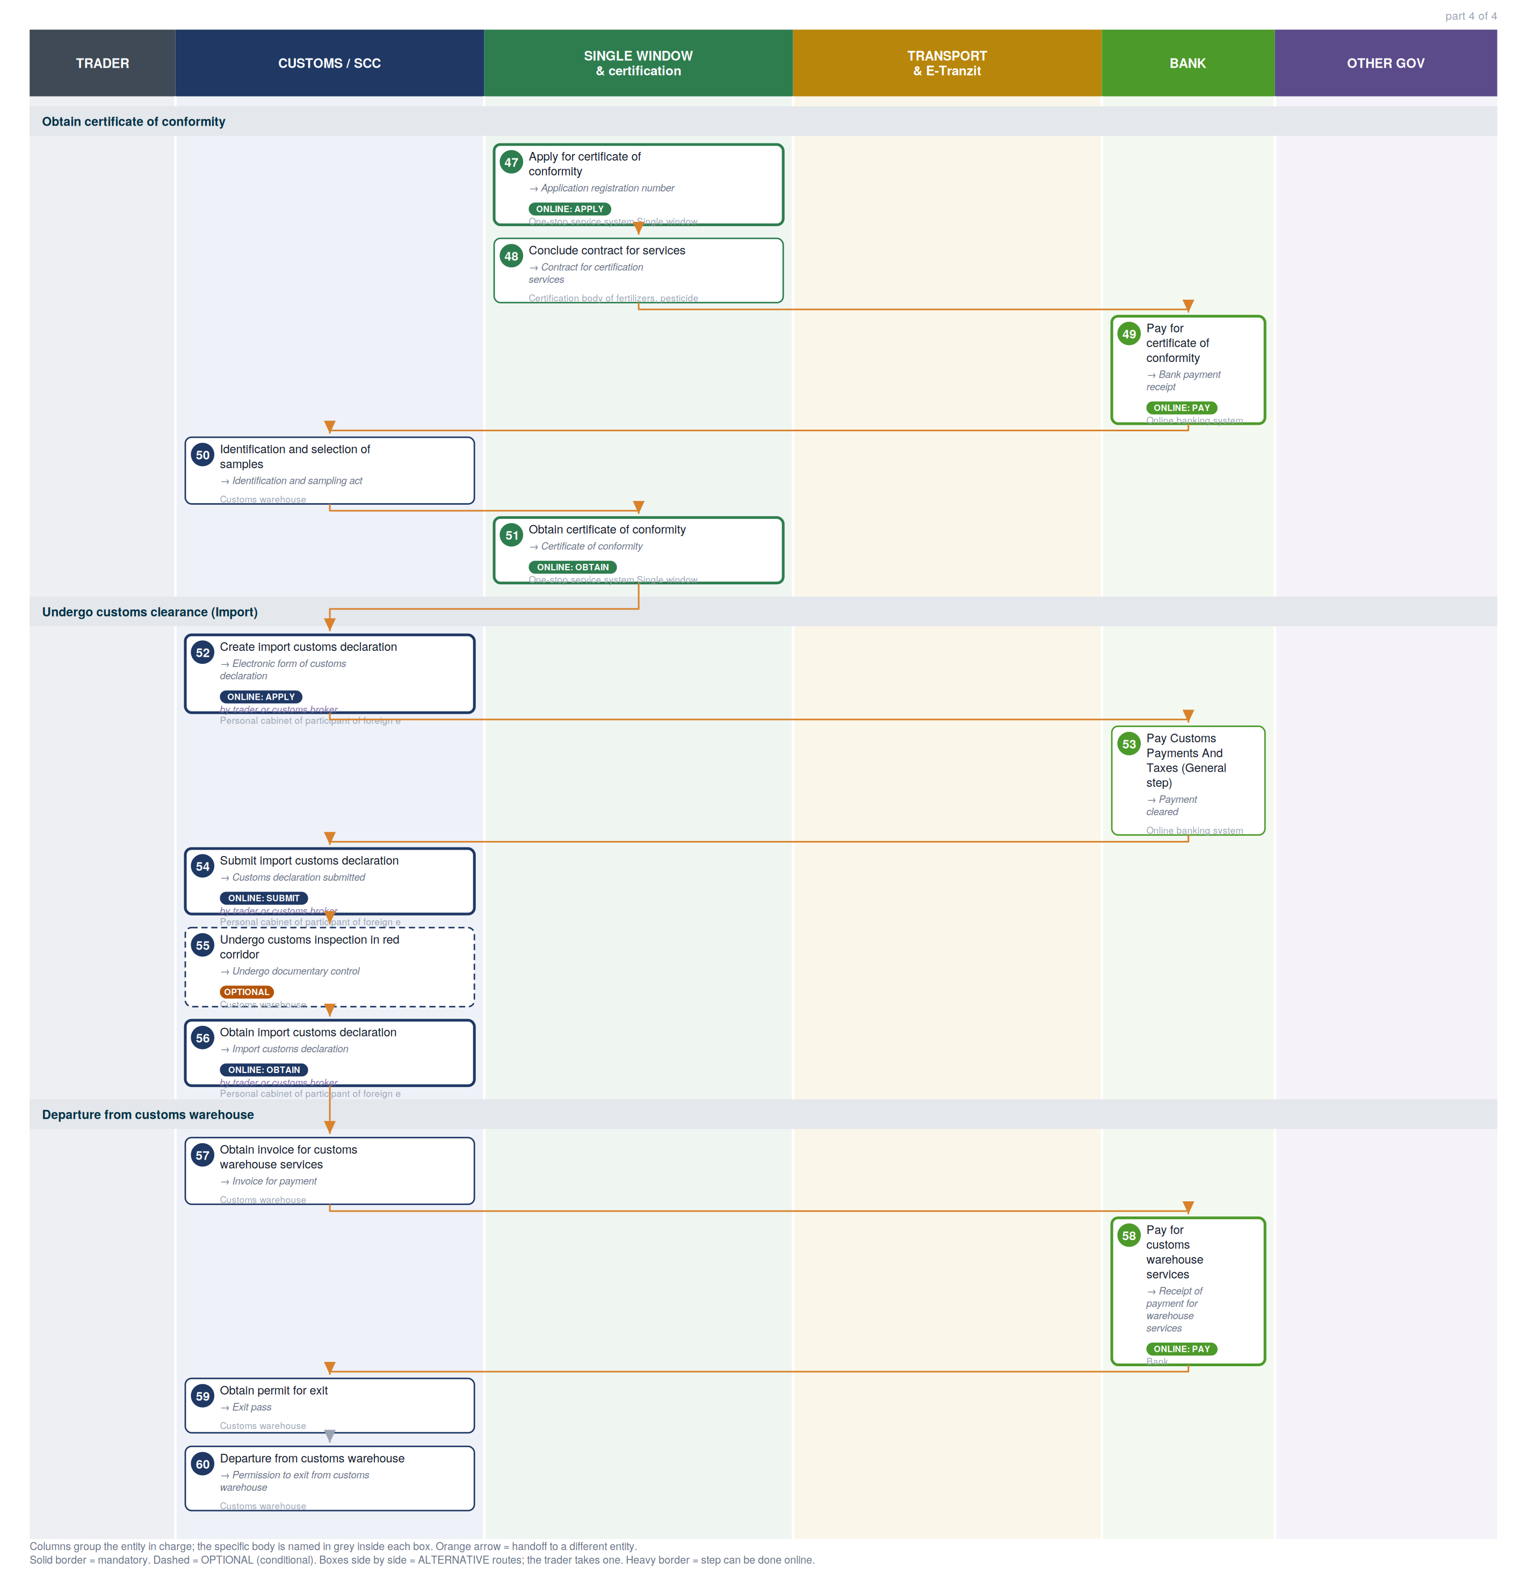

2. Where each step happens
Every step classified by channel. Online steps are performed on an external government service (the exact URL is in section 6). In-person steps happen at a physical counter, named in the “where” column.
Channel | Steps | Detail
Online — external service | 35 | Single Window (12), Payment methods information page (9), Customs e-declaration cabinet (SCC) (7), eFito (phytosanitary) (3), Railway electronic waybill (3), my.gov.uz — unified state services (1)
In person — physical counter | 25 | Tashkent regional railway junction, Customs warehouse, Railway station, Customs post of foreign trade activity, Territorial Department of plant quarantine and protection, Warehouse / Location of goods, Certification body of fertilizers, pesticides and chemical protection of plants, Online banking system

3. Entities in charge & contact channels
Entity | Steps | Lane | Contact channels
Agency of plant quarantine and protection Personal cabinet (Oferta) | 1, 31, 35 | Single Window & certification | ✉ info@karantin.uz  🌐 https://efito.uz/invoice/, http://karantin.uz/
Bank | 2, 6, 12, 16, 32, 36, 44, 58 | Bank | — none published —
One-stop service system Single window | 3, 4, 5, 7, 8, 33, 38, 42, 43, 46, 47, 51 | Single Window & certification | ☎ +998 78 120 76 08 (Int. 5603, 5646, 5606, 5885) , +998 78 120 76 00 (Int. 5603, 5646, 5606, 5885)  🌐 http://singlewindow.uz/index.jsp, http://sw2.customs.uz/
Single portal of interactive state services | 9 | Other government | ✉ epigu@egov.uz  ☎ +998 55 501 36 19, +998 55 501 36 17  🌐 https://my.gov.uz/, https://my.gov.uz/ru/site/feedback
Uzbekistan railways Single window | 10, 11, 13 | Single Window & certification | ✉ git@railway.uz  ☎ +998 71 238 88 02  🌐 https://e-nakl.railway.uz/
Tashkent regional railway junction | 14 | Transport & E-Tranzit | ✉ rju-1@railway.uz  ☎ +998 71 299 96 20  🌐 http://tashkent.railway.uz/en/
Customs warehouse | 15, 17, 29, 30, 34, 50, 55, 57, 59, 60 | Customs / SCC | — none published —
Railway station | 18, 19, 20, 28, 39, 40, 41 | Transport & E-Tranzit | — none published —
Customs post of foreign trade activity | 21, 23, 26 | Customs / SCC | — none published —
Personal cabinet of participant of foreign economic activity | 22, 24, 25, 27, 52, 54, 56 | Customs / SCC | 🌐 http://ed1.customs.uz, http://ed2.customs.uz
Territorial Department of plant quarantine and protection | 37 | Single Window & certification | — none published —
Warehouse / Location of goods | 45 | Transport & E-Tranzit | — none published —
Certification body of fertilizers, pesticides and chemical protection of plants | 48 | Single Window & certification | ✉ fpccp1999@gmail.com  ☎ + 998 71 262 74 76 , + 998 71 262 72 95  🌐 https://akkred.uz/reestr/060080
Online banking system | 49, 53 | Bank | — none published —

4. Step-by-step breakdown
Full sequence. Channel shows online vs in-person; Where / service names the exact website for online steps or the physical location for in-person ones; Performed by is who carries the step out. Optional and alternative steps are flagged.
# | Step | Entity in charge | Channel | Where / service | Performed by
Obtain quarantine permit
1 | Obtain offer agreement  → Offer agreement | Agency of plant quarantine and protection Personal cabinet (Oferta) | Online: obtain | eFito (phytosanitary)  efito.uz | —
2 | Pay for quarantine permit  → Receipt of payment | Bank | Online: pay | Payment methods information page  uzbekistan.tradeportal.org | —
3 | Apply for quarantine permit  → Application registration number | One-stop service system Single window | Online: apply | Single Window  singlewindow.uz | —
4 | Obtain quarantine permit  → Quarantine permit | One-stop service system Single window | Online: obtain | Single Window  singlewindow.uz | —
Obtain veterinary permit
5 | Obtain payment details  → Bank details of State committee of veterinary and development of livestock | One-stop service system Single window | Online: obtain | Single Window  singlewindow.uz | —
6 | Pay for veterinary permit  → Acceptance of payment | Bank | Online: pay | Payment methods information page  uzbekistan.tradeportal.org | —
7 | Apply for veterinary permit  → Application registration number | One-stop service system Single window | Online: apply | Single Window  singlewindow.uz | —
8 | Obtain veterinary permit  → Veterinary permit for import | One-stop service system Single window | Online: obtain | Single Window  singlewindow.uz | —
Registration of import contract
9 | Register foreign trade contract in UEISFTO  → Identification number of foreign trade contract | Single portal of interactive state services | Online: apply | my.gov.uz — unified state services  my.gov.uz | —
Prepare for cargo delivery by train online
10 | Conclude online agreement with Technological Center and contract with Regional railway junction  → Agreement with Technological center (single window) | Uzbekistan railways Single window | Online: obtain | Railway electronic waybill  e-nakl.railway.uz | —
11 | Obtain cost calculation for railway services  → Information on cost amount | Uzbekistan railways Single window | Online: obtain | Railway electronic waybill  e-nakl.railway.uz | —
12 | Prepay for railway services (for fertilizers)  → Receipt of payment | Bank | Online: pay | Payment methods information page  uzbekistan.tradeportal.org | —
13 | Generate electronic certificate for railway station  → Electronic certificate for railway station | Uzbekistan railways Single window | Online: obtain | Railway electronic waybill  e-nakl.railway.uz | —
14 | Obtain approval for loading and unloading  → Passing examination | Tashkent regional railway junction | In person | Inspectors of the Department on freight and commerce Room 402, 4th floor" | —
Obtain guiding letter
15 | Contract customs warehouse  → Invoice for payment | Customs warehouse | In person | Administration department | —
16 | Prepay for customs warehouse services  → Receipt of payment | Bank | Online: pay | Payment methods information page  uzbekistan.tradeportal.org | —
17 | Obtain authorization of customs warehouse  → Guiding letter | Customs warehouse | In person | Administration department | —
Obtain cargo transportation documents
18 | Obtain information on freight arrival  → Information on cargo arrival | Railway station | In person | Freight acceptance and handover Room | —
19 | Submit guiding letter  → Acceptance of guiding letter | Railway station | In person | Freight acceptance and handover Room | —
20 | Obtain package of documents  → Import railway bill | Railway station | In person | Commodity cash desk | —
Check in at customs post
21 | Obtain confirmation on cargo delivery to Customs post of destination  → Customs stamps and marks on documents | Customs post of foreign trade activity | In person | Group of customs control and customs clearance | —
Undergo customs clearance (Temporary storage)
22 | Apply for preliminary visual inspection  optional  → Application registration number (preliminary inspection) | Personal cabinet of participant of foreign economic activity | Online: apply | Customs e-declaration cabinet (SCC)  ed1.customs.uz | —
23 | Preliminary visual inspection  optional  → Preliminary inspection report | Customs post of foreign trade activity | In person | Customs control zone | —
24 | Create cargo customs declaration  → Electronic form of customs declaration | Personal cabinet of participant of foreign economic activity | Online: apply | Customs e-declaration cabinet (SCC)  ed1.customs.uz | trader or customs broker
25 | Submit customs declaration  → Customs declaration submitted | Personal cabinet of participant of foreign economic activity | Online: submit | Customs e-declaration cabinet (SCC)  ed1.customs.uz | trader or customs broker
26 | Undergo customs inspection in red corridor  optional  → Unsealing of goods | Customs post of foreign trade activity | In person | Customs control zone | —
27 | Obtain customs declaration  → Cargo customs declaration (IM70) | Personal cabinet of participant of foreign economic activity | Online: obtain | Customs e-declaration cabinet (SCC)  ed1.customs.uz | trader or customs broker
Arrange cargo unloading
28 | Obtain wagons for unloading  → Signed GU-45 form | Railway station | In person | Freight acceptance and handover Room | —
29 | Arrange cargo unloading  → Report of the work done | Customs warehouse | In person | Customs warehouse | —
Place cargo at customs warehouse (train)
30 | Place cargo at customs warehouse (train)  → Place cargo at warehouse | Customs warehouse | In person | Storage | —
Obtain quarantine inspection act
31 | Obtain offer agreement  → Offer agreement | Agency of plant quarantine and protection Personal cabinet (Oferta) | Online: obtain | eFito (phytosanitary)  efito.uz | —
32 | Pay for transport unit opening act  → Receipt of payment | Bank | Online: pay | Payment methods information page  uzbekistan.tradeportal.org | —
33 | Apply for quarantine inspection act and transport unit opening act  → Appointment for inspection | One-stop service system Single window | Online: apply | Single Window  singlewindow.uz | —
34 | Undergo quarantine inspection  → Transport unit opening act | Customs warehouse | In person | Customs warehouse | —
35 | Obtain offer agreement for fumigation  optional  → Fumigation offer agreement | Agency of plant quarantine and protection Personal cabinet (Oferta) | Online: obtain | eFito (phytosanitary)  efito.uz | —
36 | Pay for fumigation  optional  → Receipt of payment | Bank | Online: pay | Payment methods information page  uzbekistan.tradeportal.org | —
37 | Undergo fumigation  optional  → Certificate of disinfestation | Territorial Department of plant quarantine and protection | In person | Fumigation (disinfection) division | —
38 | Obtain quarantine inspection act  → Quarantine inspection act | One-stop service system Single window | Online: obtain | Single Window  singlewindow.uz | —
Arrange return of empty wagons
39 | Hand over empty wagons  → Signed GU-45 form | Railway station | In person | Freight acceptance and handover Room | —
40 | Arrange return of empty wagons  → Duplicate of railway bill with datestamp | Railway station | In person | Commodity cash desk | —
Finalize mutual settlements with railway station
41 | Finalize mutual settlements with railway station  → Complete procedure | Railway station | In person | Commodity cash desk | —
Obtain veterinary certificate for import
42 | Obtain offer agreement  → Offer agreement for veterinary certificate | One-stop service system Single window | Online: obtain | Single Window  singlewindow.uz | —
43 | Apply for veterinary certificate (imp)  → Invoice for payment for veterinary certificate | One-stop service system Single window | Online: apply | Single Window  singlewindow.uz | —
44 | Pay for veterinary certificate  → Receipt of payment | Bank | Online: pay | Payment methods information page  uzbekistan.tradeportal.org | —
45 | Undergo cargo inspection  → Undergo inspection | Warehouse / Location of goods | In person | Warehouse / Location of goods | —
46 | Obtain veterinary certificate (import)  → Veterinary certificate Form-3 | One-stop service system Single window | Online: obtain | Single Window  singlewindow.uz | —
Obtain certificate of conformity
47 | Apply for certificate of conformity  → Application registration number | One-stop service system Single window | Online: apply | Single Window  singlewindow.uz | —
48 | Conclude contract for services  → Contract for certification services | Certification body of fertilizers, pesticides and chemical protection of plants | In person | Department for certification FPCCP "427 room, 4th floor" | —
49 | Pay for certificate of conformity  → Bank payment receipt | Online banking system | Online: pay | Payment methods information page  uzbekistan.tradeportal.org | —
50 | Identification and selection of samples  → Identification and sampling act | Customs warehouse | In person | Customs warehouse | —
51 | Obtain certificate of conformity  → Certificate of conformity | One-stop service system Single window | Online: obtain | Single Window  singlewindow.uz | —
Undergo customs clearance (Import)
52 | Create import customs declaration  → Electronic form of customs declaration | Personal cabinet of participant of foreign economic activity | Online: apply | Customs e-declaration cabinet (SCC)  ed1.customs.uz | trader or customs broker
53 | Pay Customs Payments And Taxes (General step)  → Payment cleared | Online banking system | In person | Online banking system | —
54 | Submit import customs declaration  → Customs declaration submitted | Personal cabinet of participant of foreign economic activity | Online: submit | Customs e-declaration cabinet (SCC)  ed1.customs.uz | trader or customs broker
55 | Undergo customs inspection in red corridor  optional  → Undergo documentary control | Customs warehouse | In person | Storage | —
56 | Obtain import customs declaration  → Import customs declaration | Personal cabinet of participant of foreign economic activity | Online: obtain | Customs e-declaration cabinet (SCC)  ed1.customs.uz | trader or customs broker
Departure from customs warehouse
57 | Obtain invoice for customs warehouse services  → Invoice for payment | Customs warehouse | In person | Commodity cash desk | —
58 | Pay for customs warehouse services  → Receipt of payment for warehouse services | Bank | Online: pay | Payment methods information page  uzbekistan.tradeportal.org | —
59 | Obtain permit for exit  → Exit pass | Customs warehouse | In person | Storage | —
60 | Departure from customs warehouse  → Permission to exit from customs warehouse | Customs warehouse | In person | Customs warehouse checkpoint | —

5. Inputs required per step
Type 1 = the trader supplies it from outside the procedure. Type 2 = produced by an earlier step, so it is a dependency the agent can track.
1. Obtain offer agreement
- Internet access [trader supplies]
- Data required to complete offer agreement [trader supplies]
- Tax Identification Number of the organization or individual [trader supplies]
- Name of the organization [trader supplies]
- Full name of an organization’s manager [trader supplies]
- Type of organization (business entity, budgetary) [trader supplies]
- Contact phone number [trader supplies]
- Amount of consignment [trader supplies]
2. Pay for quarantine permit
- Offer agreement for quarantine permit [trader supplies]
- For physical payment [trader supplies]
- Physical presence [trader supplies]
- Passport [trader supplies]
- For online payment (without necessity to visit a bank) [trader supplies]
- Online banking account [trader supplies]
3. Apply for quarantine permit
- Electronic digital signature [trader supplies]
- Quarantine permit application [trader supplies]
- Data required to complete application [trader supplies]
- Information about applicant [trader supplies]
- Information about importer [trader supplies]
- Information about exporter [trader supplies]
- General information [trader supplies]
- Information about product [trader supplies]
4. Obtain quarantine permit
- Electronic digital signature [trader supplies]
5. Obtain payment details
- Electronic digital signature [trader supplies]
6. Pay for veterinary permit
- Bank details of State committee of veterinary and development of livestock [trader supplies]
- For physical payment [trader supplies]
- Physical presence [trader supplies]
- For online payment (without necessity to visit a bank) [trader supplies]
- Online banking account [trader supplies]
7. Apply for veterinary permit
- Electronic digital signature [trader supplies]
8. Obtain veterinary permit
- Electronic digital signature [trader supplies]
9. Register foreign trade contract in UEISFTO
- Electronic digital signature [trader supplies]
- Electronic copy of foreign trade contract [trader supplies]
10. Conclude online agreement with Technological Center and contract with Regional railway junction
- Electronic digital signature [trader supplies]
- One ID account [trader supplies]
11. Obtain cost calculation for railway services
- Electronic digital signature [trader supplies]
- One ID account [trader supplies]
12. Prepay for railway services (for fertilizers)
- Invoice for payment for railway services [trader supplies]
- Agreement with Technological center [trader supplies]
- For physical payment [trader supplies]
- Physical presence [trader supplies]
- For online payment (without necessity to visit a bank) [trader supplies]
- Online banking account [trader supplies]
13. Generate electronic certificate for railway station
- Electronic digital signature [trader supplies]
14. Obtain approval for loading and unloading
- Physical presence [trader supplies]
- Passport [trader supplies]
- Power of attorney [trader supplies]
15. Contract customs warehouse
- Physical presence [trader supplies]
- Passport [trader supplies]
- Power of attorney [trader supplies]
- Certificate of state registration [trader supplies]
16. Prepay for customs warehouse services
- Invoice for payment [trader supplies]
- For physical payment [trader supplies]
- Physical presence [trader supplies]
- For online payment (without necessity to visit a bank) [trader supplies]
- Online banking account [trader supplies]
17. Obtain authorization of customs warehouse
- Guiding letter (template) [trader supplies]
- Letter to railway station [trader supplies]
18. Obtain information on freight arrival
- Availability by phone [trader supplies]
19. Submit guiding letter
- Guiding letter [trader supplies]
- Letter to railway station [trader supplies]
20. Obtain package of documents
- Guiding letter [trader supplies]
- Certificate on availability of funds at client's account [trader supplies]
- Passport [trader supplies]
- Power of attorney for railway station [trader supplies]
21. Obtain confirmation on cargo delivery to Customs post of destination
- Import railway bill [trader supplies]
- Commercial invoice [trader supplies]
- Packing list [trader supplies]
22. Apply for preliminary visual inspection
- Electronic application for preliminary visual inspection [trader supplies]
- Documents required to fill the Application [trader supplies]
- Application for preliminary visual inspection [trader supplies]
- Warehouse license number [trader supplies]
- Import railway bill [trader supplies]
- Commercial invoice [trader supplies]
23. Preliminary visual inspection
- Physical presence [trader supplies]
- Power of attorney [trader supplies]
- Physical presence [trader supplies]
- Physical presence [trader supplies]
- Required documents [trader supplies]
- Import railway bill [trader supplies]
- Commercial invoice [trader supplies]
- Packing list [trader supplies]
- Application for preliminary visual inspection [trader supplies]
24. Create cargo customs declaration
- Electronic digital signature [trader supplies]
- Documents requried to complete declaration [trader supplies]
- Commercial invoice [trader supplies]
- Import railway bill [trader supplies]
- Contract for customs warehouse services [trader supplies]
- Passport [trader supplies]
- Power of attorney [trader supplies]
- Application for preliminary visual inspection [trader supplies]
25. Submit customs declaration
- Electronic digital signature [trader supplies]
- Electronic form of customs declaration [trader supplies]
26. Undergo customs inspection in red corridor
- Cargo customs declaration (IM70) [trader supplies]
- Import railway bill [trader supplies]
- Commercial invoice [trader supplies]
- Physical presence [trader supplies]
- Passport [trader supplies]
- Power of attorney [trader supplies]
27. Obtain customs declaration
- Electronic digital signature [trader supplies]
28. Obtain wagons for unloading
- Physical presence [trader supplies]
29. Arrange cargo unloading
- Physical presence [trader supplies]
- Power of attorney [trader supplies]
- Certificate on passing examination [trader supplies]
30. Place cargo at customs warehouse (train)
- Import railway bill [trader supplies]
- Commercial invoice [trader supplies]
- Packing list [trader supplies]
- Cargo customs declaration (IM70) [trader supplies]
- Cargo delivery control book (railway) [trader supplies]
31. Obtain offer agreement
- Electronic digital signature [trader supplies]
- Data required to complete offer agreement [trader supplies]
- Tax Identification Number of the organization or individual [trader supplies]
- Name of the organization [trader supplies]
- Full name of an organization’s manager [trader supplies]
- Type of organization (business entity, budgetary) [trader supplies]
- Contact phone number [trader supplies]
- Amount of consignment [trader supplies]
32. Pay for transport unit opening act
- Offer agreement for transport unit opening act [trader supplies]
- For physical payment [trader supplies]
- Physical presence [trader supplies]
- Passport [trader supplies]
- For online payment (without necessity to visit a bank) [trader supplies]
- Online banking account [trader supplies]
33. Apply for quarantine inspection act and transport unit opening act
- Electronic digital signature [trader supplies]
- Online application for quarantine inspection certificate [trader supplies]
- Quarantine permit [trader supplies]
- Phytosanitary certificate of the exporter's country [trader supplies]
- Data required to complete application [trader supplies]
- Information about applicant [trader supplies]
- Information about importer [trader supplies]
- Information about exporter [trader supplies]
- General information [trader supplies]
- Information about product [trader supplies]
34. Undergo quarantine inspection
- Physical presence [trader supplies]
- Physical presence [trader supplies]
- Phytosanitary certificate of the exporter's country [trader supplies]
- Quarantine permit [trader supplies]
35. Obtain offer agreement for fumigation
- Internet access [trader supplies]
- Data required to complete offer agreement [trader supplies]
- Tax Identification Number of the organization or individual [trader supplies]
- Name of the organization [trader supplies]
- Full name of an organization’s manager [trader supplies]
- Type of organization (business entity, budgetary) [trader supplies]
- Contact phone number [trader supplies]
- Agency region [trader supplies]
- Cost on the contract [trader supplies]
36. Pay for fumigation
- Fumigation offer agreement [trader supplies]
- For physical payment [trader supplies]
- Physical presence [trader supplies]
- Passport [trader supplies]
- For online payment (without necessity to visit a bank) [trader supplies]
- Online banking account [trader supplies]
37. Undergo fumigation
- Physical presence [trader supplies]
38. Obtain quarantine inspection act
- Electronic digital signature [trader supplies]
39. Hand over empty wagons
- Physical presence [trader supplies]
- Application for wagon handover [trader supplies]
40. Arrange return of empty wagons
- Physical presence [trader supplies]
- Application for returning empty wagons [trader supplies]
- Instruction on completing railway bill [trader supplies]
- Export railway bill (SMGS) [trader supplies]
41. Finalize mutual settlements with railway station
- Physical presence [trader supplies]
- Import railway bill [trader supplies]
42. Obtain offer agreement
- Electronic digital signature [trader supplies]
- Data required to complete offer agreement [trader supplies]
- Tax Identification Number of the organization or individual [trader supplies]
- Name of the organization [trader supplies]
- Full name of an organization’s manager [trader supplies]
- Type of organization (business entity, budgetary) [trader supplies]
- Contact phone number [trader supplies]
43. Apply for veterinary certificate (imp)
- Electronic digital signature [trader supplies]
- Online application for veterinary certificate [trader supplies]
- Veterinary certificate from the exporter's country [trader supplies]
- Veterinary permit for import [trader supplies]
- Not obligatory documents [trader supplies]
- Commercial invoice [trader supplies]
- Import railway bill [trader supplies]
44. Pay for veterinary certificate
- Invoice for payment for veterinary certificate [trader supplies]
- For physical payment [trader supplies]
- Physical presence [trader supplies]
- Passport [trader supplies]
- For online payment (without necessity to visit a bank) [trader supplies]
- Online banking account [trader supplies]
45. Undergo cargo inspection
- Physical presence [trader supplies]
- Physical presence [trader supplies]
46. Obtain veterinary certificate (import)
- Electronic digital signature [trader supplies]
47. Apply for certificate of conformity
- Electronic digital signature [trader supplies]
- Commercial invoice [trader supplies]
- Registration certificate [trader supplies]
- Convention on the International Carriage of Goods by Road [trader supplies]
- Import railway bill [trader supplies]
- Air waybill [trader supplies]
- Normative documents on standardization (fertilizers) [trader supplies]
- Quality certificate [trader supplies]
- Certificate of analysis for fertilizers [trader supplies]
48. Conclude contract for services
- Application registration number [trader supplies]
- Bank details [trader supplies]
49. Pay for certificate of conformity
- Electronic invoice for payment [trader supplies]
- Online banking account [trader supplies]
50. Identification and selection of samples
- Physical presence [trader supplies]
- Physical presence [trader supplies]
51. Obtain certificate of conformity
- Electronic digital signature [trader supplies]
52. Create import customs declaration
- Electronic digital signature [trader supplies]
- Documents requried to complete declaration [trader supplies]
- Import railway bill [trader supplies]
- Commercial invoice [trader supplies]
- Identification number of foreign trade contract [trader supplies]
- Export declaration of the exporter's country [trader supplies]
- Certificates and permits [trader supplies]
- Certificate of origin of the exporter's country [trader supplies]
- Quarantine permit [trader supplies]
- Veterinary certificate Form-2 [trader supplies]
- Certificate of conformity [trader supplies]
53. Pay Customs Payments And Taxes (General step)
- Bank details of territorial customs departments [trader supplies]
- Online banking account [trader supplies]
54. Submit import customs declaration
- Electronic digital signature [trader supplies]
- Electronic form of customs declaration [trader supplies]
55. Undergo customs inspection in red corridor
- Import customs declaration [trader supplies]
- Import railway bill [trader supplies]
- Commercial invoice [trader supplies]
- Physical presence [trader supplies]
- Passport [trader supplies]
- Power of attorney [trader supplies]
56. Obtain import customs declaration
- Electronic digital signature [trader supplies]
57. Obtain invoice for customs warehouse services
- Import customs declaration [trader supplies]
- Physical presence [trader supplies]
- Passport [trader supplies]
- Power of attorney [trader supplies]
58. Pay for customs warehouse services
- Invoice for payment [trader supplies]
- For physical payment [trader supplies]
- Physical presence [trader supplies]
- For online payment (without necessity to visit a bank) [trader supplies]
- Online banking account [trader supplies]
59. Obtain permit for exit
- Receipt of payment [trader supplies]
- Import customs declaration [trader supplies]
- Physical presence [trader supplies]
- Passport [trader supplies]
- Power of attorney [trader supplies]
60. Departure from customs warehouse
- Exit pass [trader supplies]
- Physical presence [trader supplies]

6. Online service redirects
Every online step in this procedure sends the trader to an external government service. These are the exact destinations — the redirect targets an agent (or a person) would need to reach.
# | Step | Action | Service URL
1 | Obtain offer agreement | obtain | eFito (phytosanitary)  https://efito.uz/invoice/
2 | Pay for quarantine permit | pay | Payment methods information page  https://uzbekistan.tradeportal.org/menu/22
3 | Apply for quarantine permit | apply | Single Window  http://singlewindow.uz/
4 | Obtain quarantine permit | obtain | Single Window  http://singlewindow.uz/
5 | Obtain payment details | obtain | Single Window  http://singlewindow.uz/
6 | Pay for veterinary permit | pay | Payment methods information page  https://uzbekistan.tradeportal.org/menu/22
7 | Apply for veterinary permit | apply | Single Window  http://singlewindow.uz/
8 | Obtain veterinary permit | obtain | Single Window  http://singlewindow.uz/
9 | Register foreign trade contract in UEISFTO | apply | my.gov.uz — unified state services  https://my.gov.uz/ru/service/96
10 | Conclude online agreement with Technological Center and contract with Regional railway junction | obtain | Railway electronic waybill  https://e-nakl.railway.uz/ru/Login
11 | Obtain cost calculation for railway services | obtain | Railway electronic waybill  https://e-nakl.railway.uz/ru/Home/Calculate
12 | Prepay for railway services (for fertilizers) | pay | Payment methods information page  https://uzbekistan.tradeportal.org/menu/22
13 | Generate electronic certificate for railway station | obtain | Railway electronic waybill  https://e-nakl.railway.uz/ru/Customers/CreateSpravka
16 | Prepay for customs warehouse services | pay | Payment methods information page  https://uzbekistan.tradeportal.org/menu/22
22 | Apply for preliminary visual inspection | apply | Customs e-declaration cabinet (SCC)  http://ed1.customs.uz/mainFrame.jsp
24 | Create cargo customs declaration | apply | Customs e-declaration cabinet (SCC)  http://ed1.customs.uz/PersonCabinet/template/property/ted_proper.jsp
25 | Submit customs declaration | submit | Customs e-declaration cabinet (SCC)  http://ed1.customs.uz/PersonCabinet/template/property/ted_proper.jsp
27 | Obtain customs declaration | obtain | Customs e-declaration cabinet (SCC)  http://ed1.customs.uz/PersonCabinet/template/PCabinet_en.jsp
31 | Obtain offer agreement | obtain | eFito (phytosanitary)  https://efito.uz/invoice/
32 | Pay for transport unit opening act | pay | Payment methods information page  https://uzbekistan.tradeportal.org/menu/22
33 | Apply for quarantine inspection act and transport unit opening act | apply | Single Window  http://singlewindow.uz/
35 | Obtain offer agreement for fumigation | obtain | eFito (phytosanitary)  https://efito.uz/invoice/
36 | Pay for fumigation | pay | Payment methods information page  https://uzbekistan.tradeportal.org/menu/22
38 | Obtain quarantine inspection act | obtain | Single Window  http://singlewindow.uz/
42 | Obtain offer agreement | obtain | Single Window  http://singlewindow.uz
43 | Apply for veterinary certificate (imp) | apply | Single Window  http://www.singlewindow.uz
44 | Pay for veterinary certificate | pay | Payment methods information page  https://uzbekistan.tradeportal.org/menu/22
46 | Obtain veterinary certificate (import) | obtain | Single Window  http://www.singlewindow.uz
47 | Apply for certificate of conformity | apply | Single Window  http://singlewindow.uz/
49 | Pay for certificate of conformity | pay | Payment methods information page  https://uzbekistan.tradeportal.org/menu/22
51 | Obtain certificate of conformity | obtain | Single Window  http://singlewindow.uz/#
52 | Create import customs declaration | apply | Customs e-declaration cabinet (SCC)  http://ed1.customs.uz/PersonCabinet/template/property/ted_proper.jsp
54 | Submit import customs declaration | submit | Customs e-declaration cabinet (SCC)  http://ed1.customs.uz/PersonCabinet/template/property/ted_proper.jsp
56 | Obtain import customs declaration | obtain | Customs e-declaration cabinet (SCC)  http://ed1.customs.uz/PersonCabinet/template/PCabinet_en.jsp
58 | Pay for customs warehouse services | pay | Payment methods information page  https://uzbekistan.tradeportal.org/menu/22
Distinct services in this procedure: eFito (phytosanitary) (3); Payment methods information page (9); Single Window (12); my.gov.uz — unified state services (1); Railway electronic waybill (3); Customs e-declaration cabinet (SCC) (7)

7. Document samples
Specimen images of the documents this procedure requires, published by the platform. Duplicates across steps are shown once. 67 distinct documents.
  Internet access |   Tax Identification Number of the organization or individual | Name of the organization
Full name of an organization’s manager | Type of organization (business entity, budgetary) |   Contact phone number
  Amount of consignment | 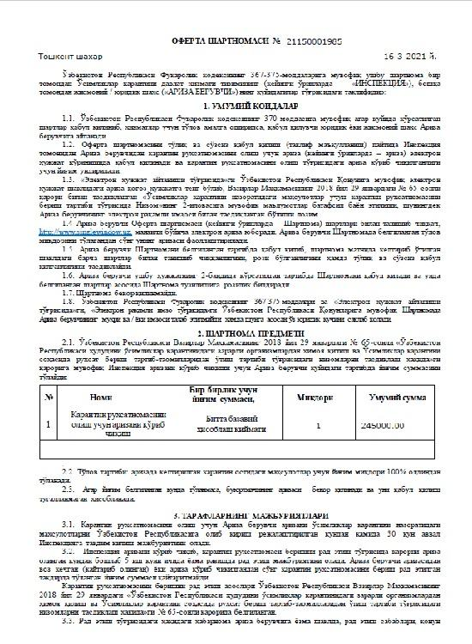  Offer agreement for quarantine permit | 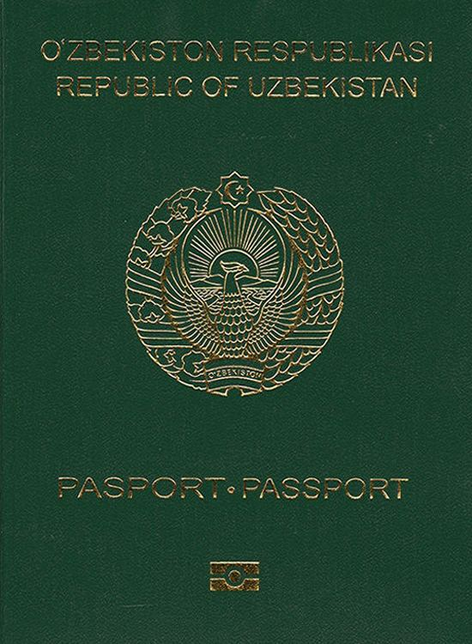  Passport
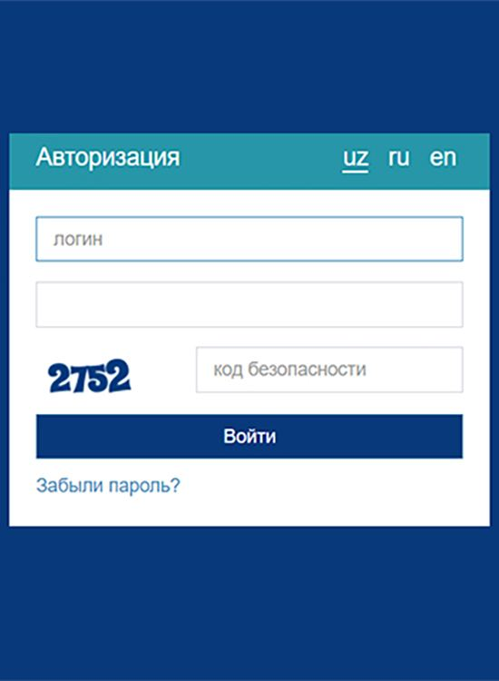  Online banking account | 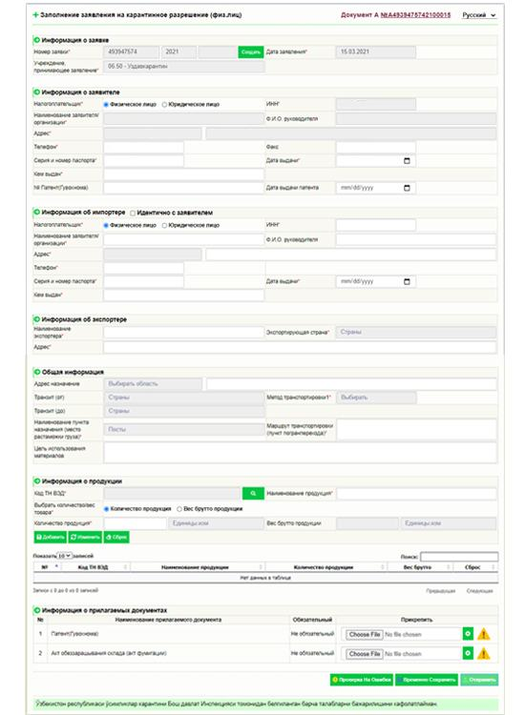  Quarantine permit application | Information about applicant
Information about importer | Information about exporter | General information
Information about product | 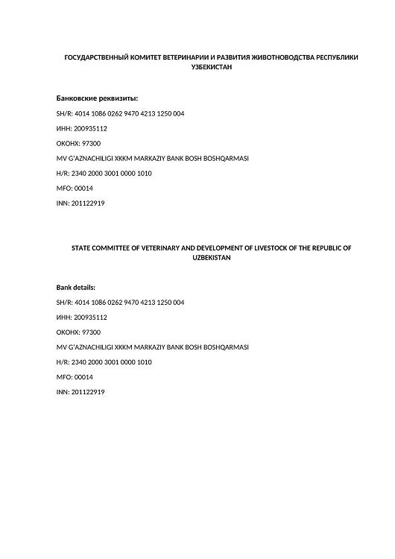  Bank details of State committee of veterinary and development of livestock | 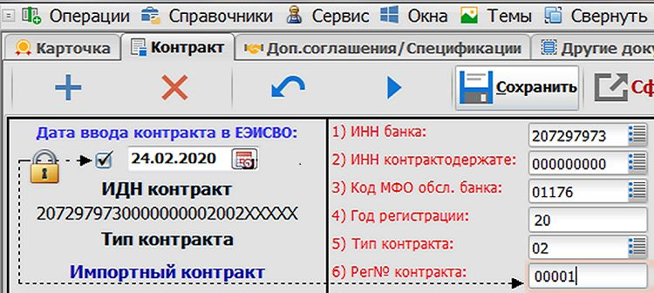  Electronic copy of foreign trade contract
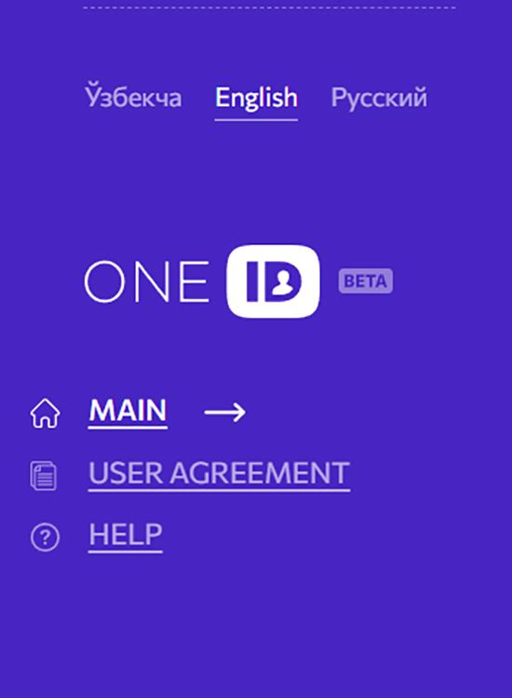  One ID account | 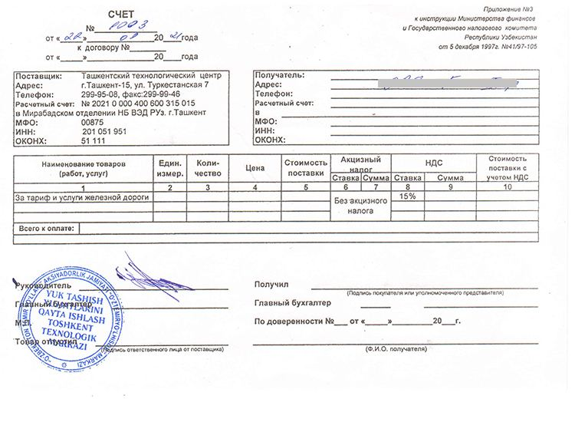  Invoice for payment for railway services | 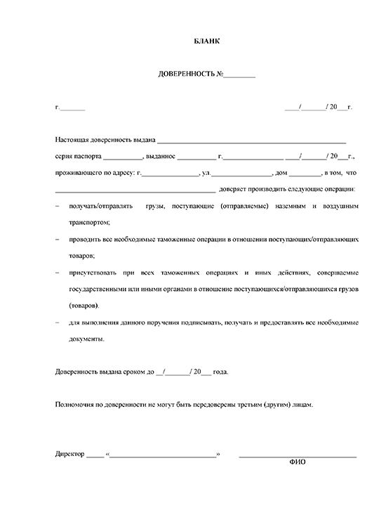  Power of attorney
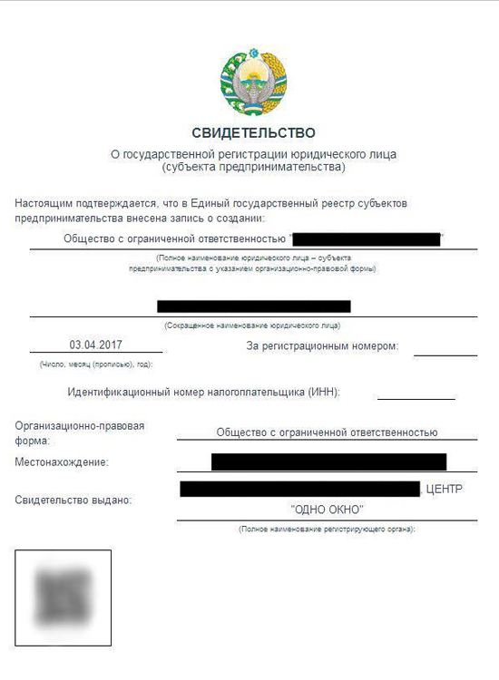  Certificate of state registration | 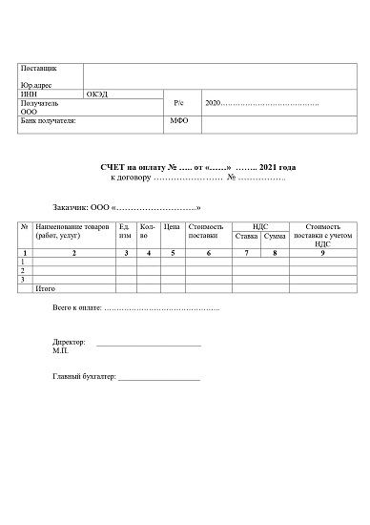  Invoice for payment |   Availability by phone
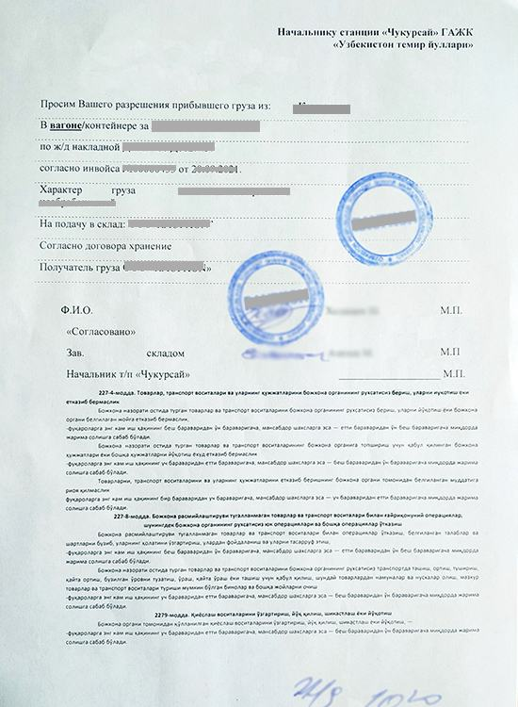  Guiding letter | 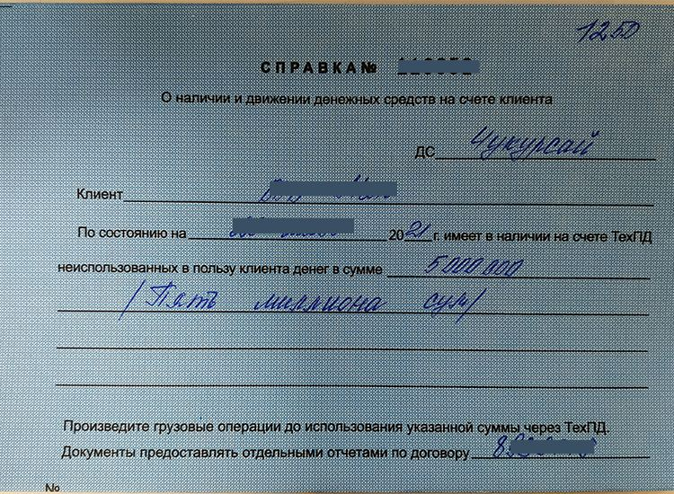  Certificate on availability of funds at client's account | 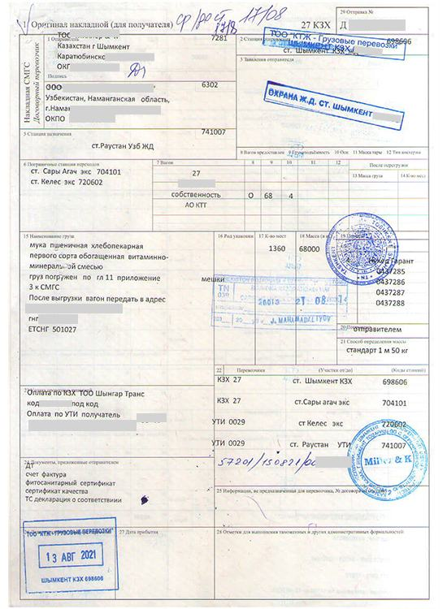  Import railway bill
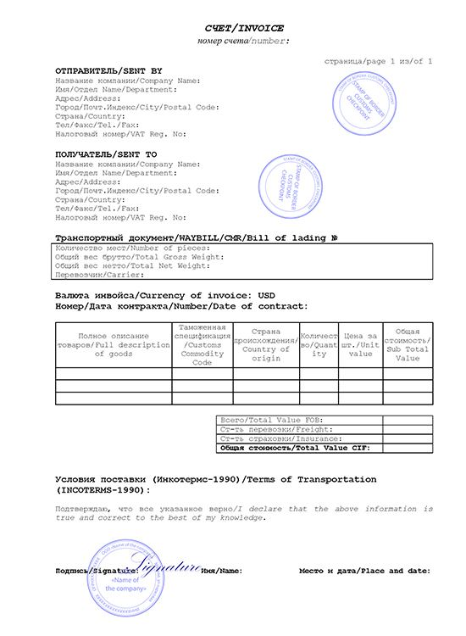  Commercial invoice | 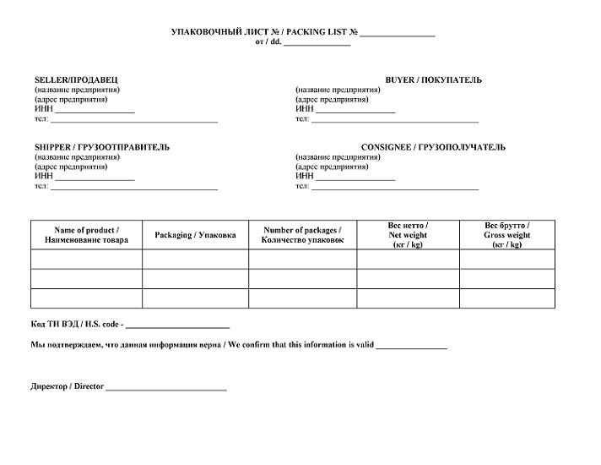  Packing list | 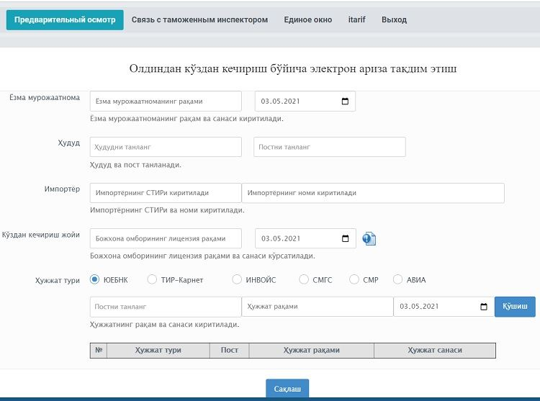  Electronic application for preliminary visual inspection
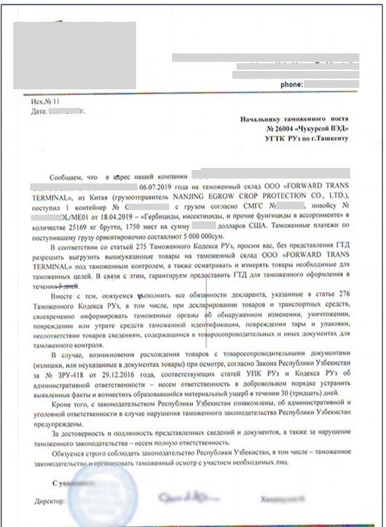  Application for preliminary visual inspection | Warehouse license number | 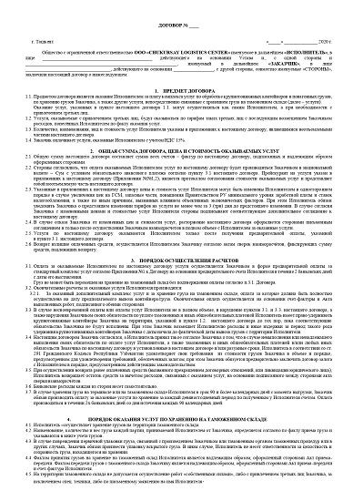  Contract for customs warehouse services
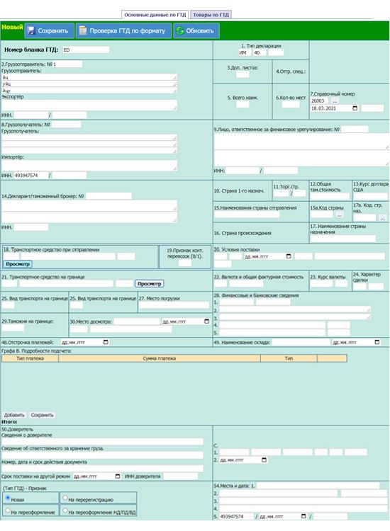  Electronic form of customs declaration | 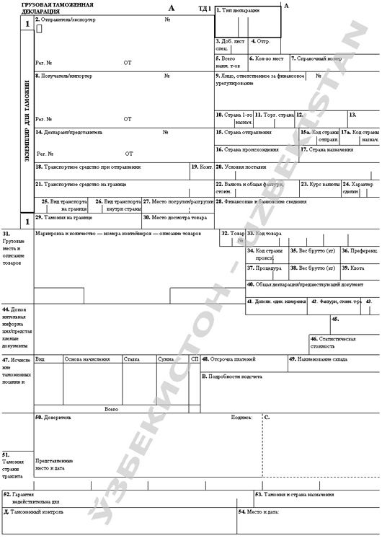  Cargo customs declaration (IM70) | 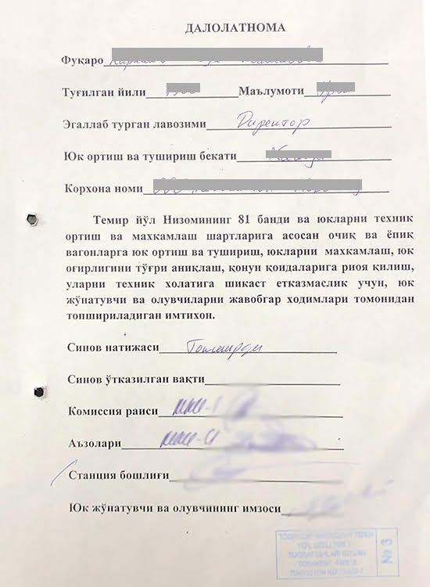  Certificate on passing examination
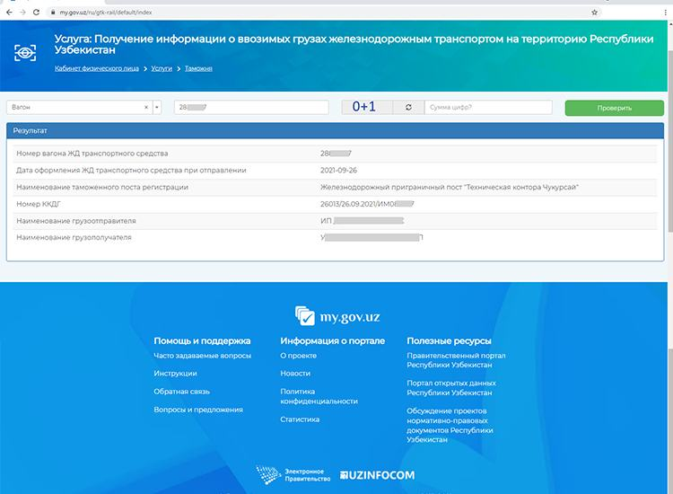  Cargo delivery control book (railway) | 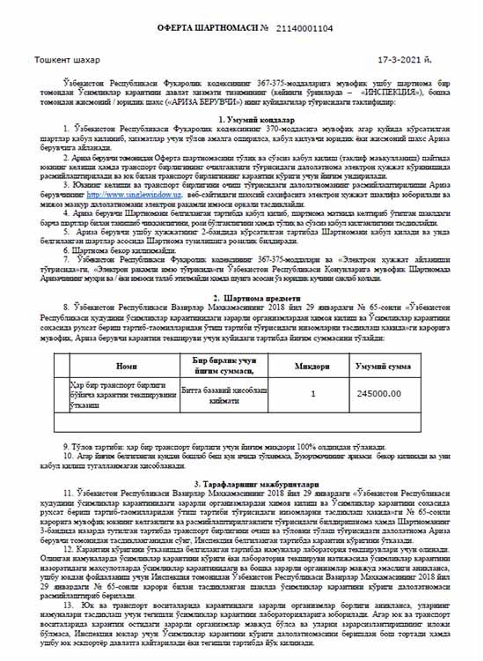  Offer agreement for transport unit opening act | 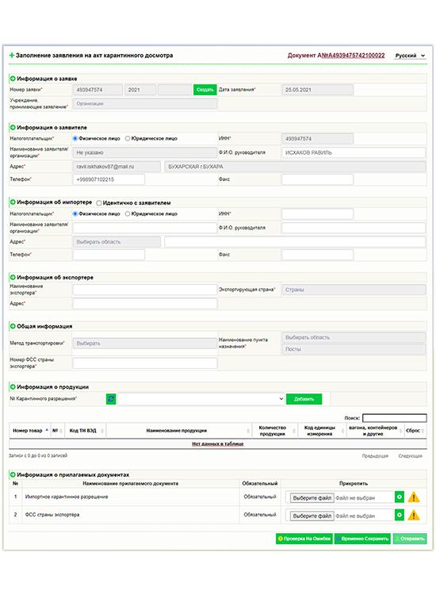  Online application for quarantine inspection certificate
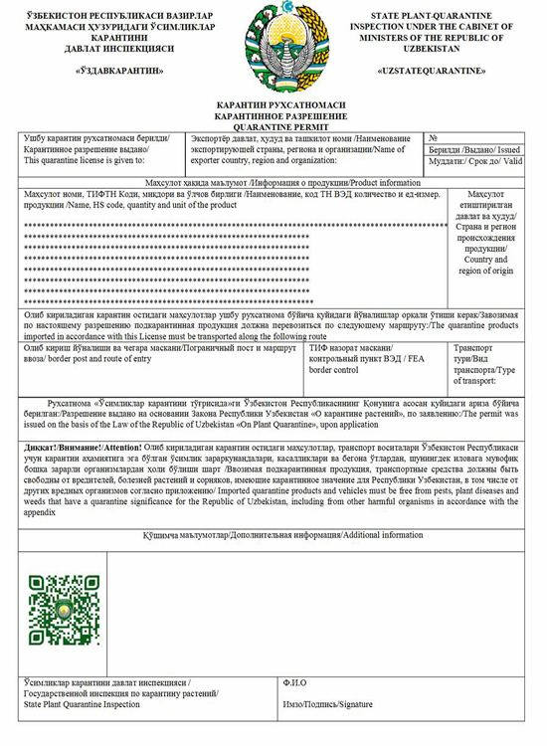  Quarantine permit | 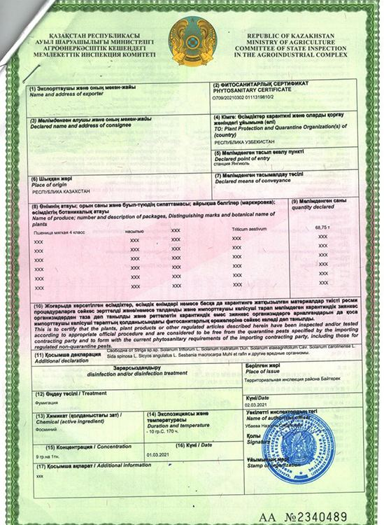  Phytosanitary certificate of the exporter's country | Agency region
Cost on the contract | 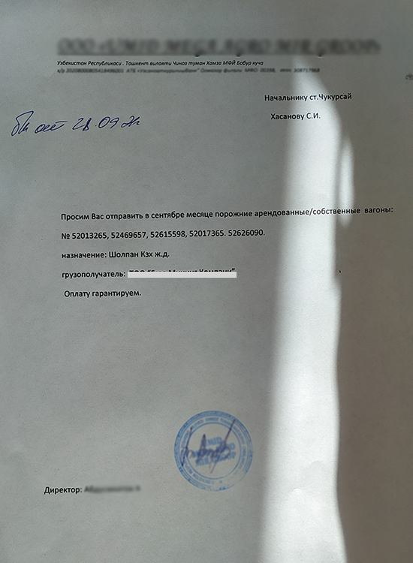  Application for returning empty wagons | 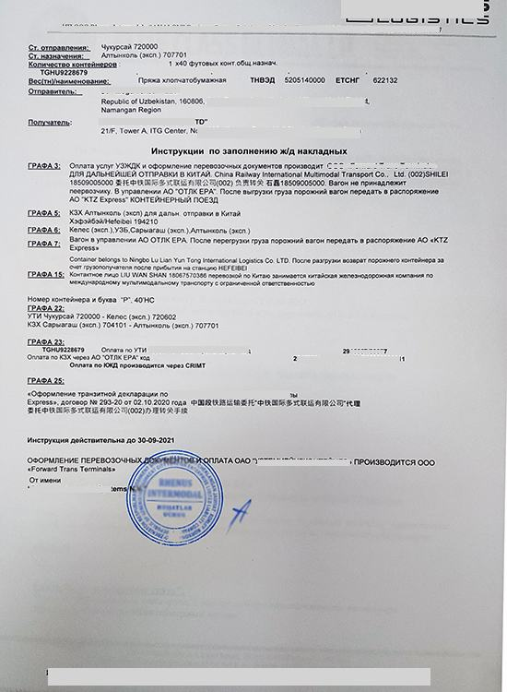  Instruction on completing railway bill
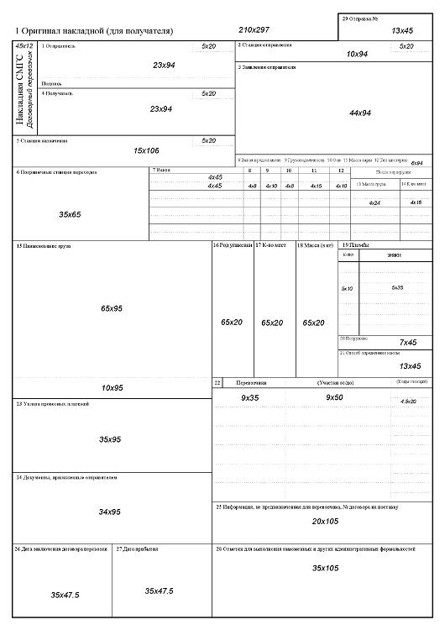  Export railway bill (SMGS) | 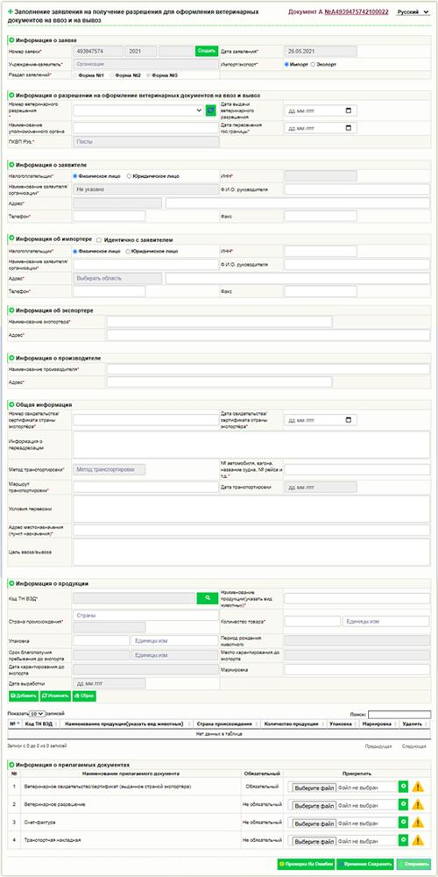  Online application for veterinary certificate | 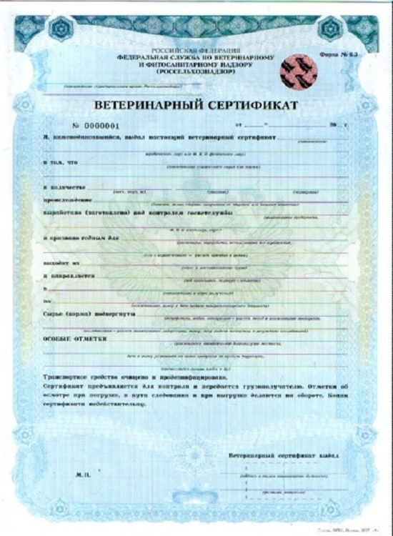  Veterinary certificate from the exporter's country
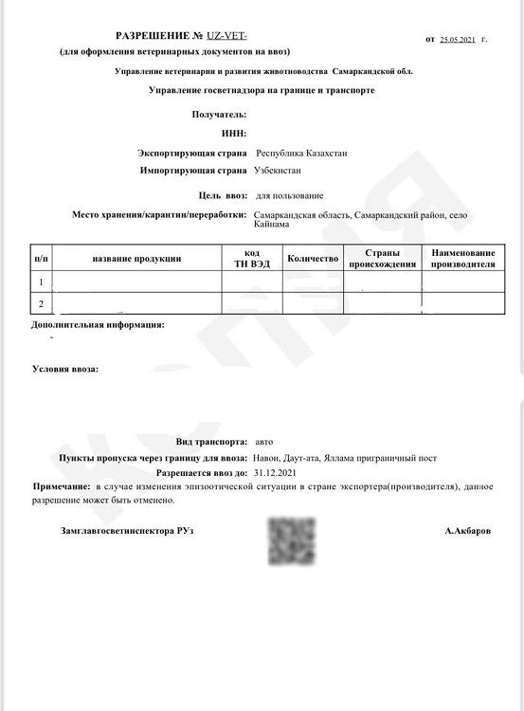  Veterinary permit for import | 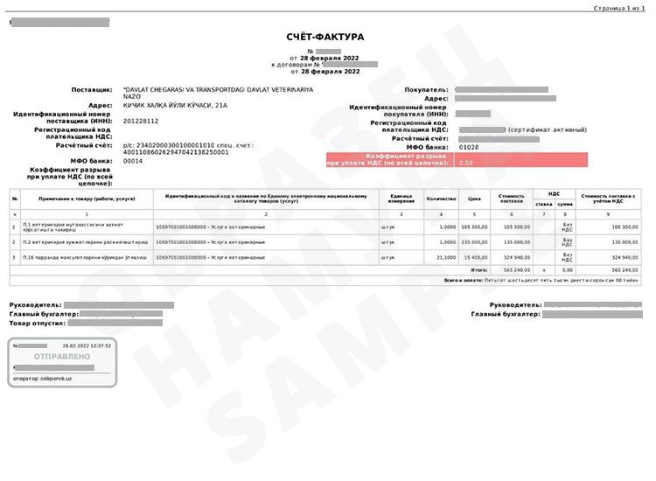  Invoice for payment for veterinary certificate | 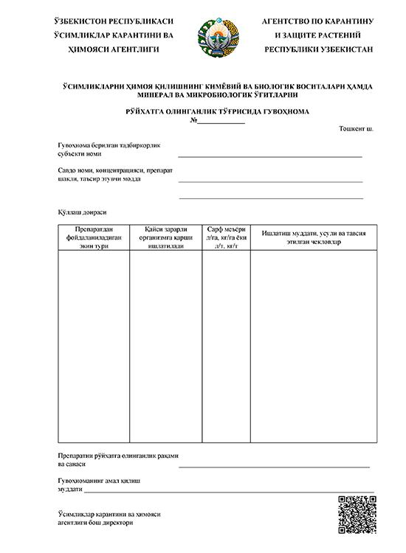  Registration certificate
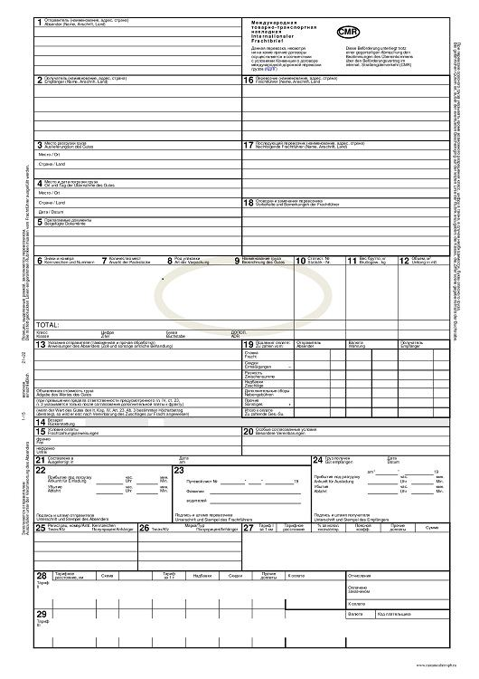  Convention on the International Carriage of Goods by Road | 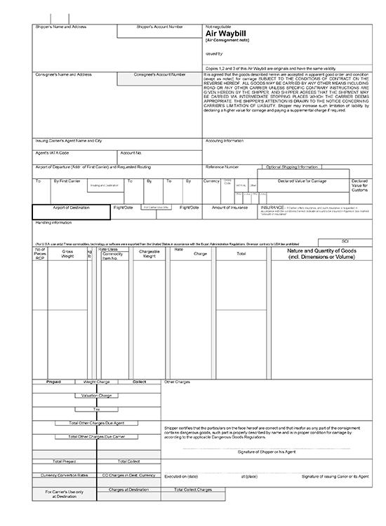  Air waybill | 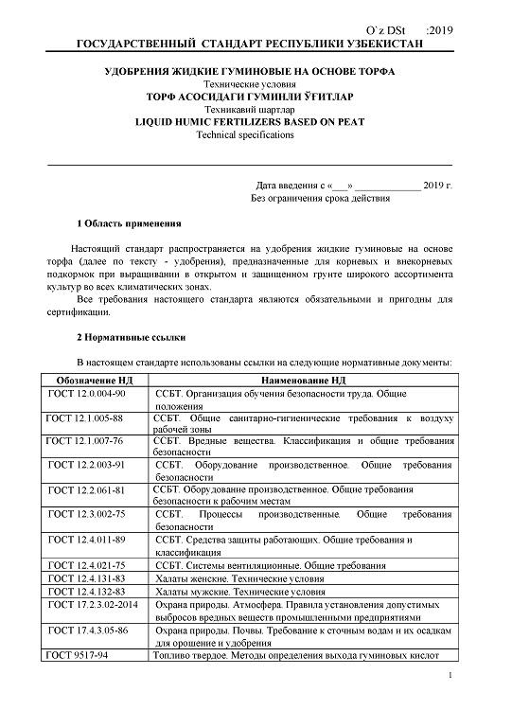  Normative documents on standardization (fertilizers)
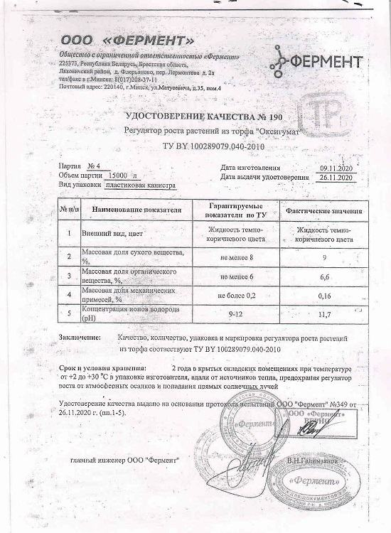  Quality certificate | 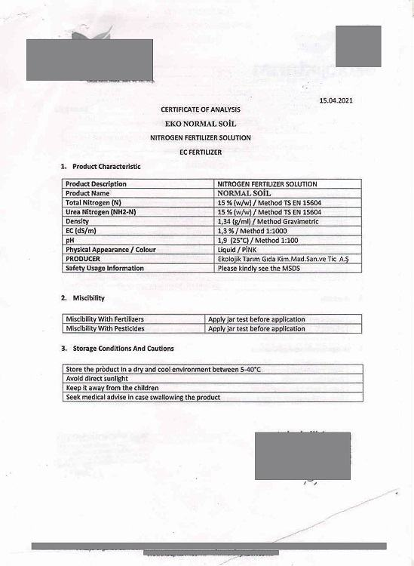  Certificate of analysis for fertilizers | 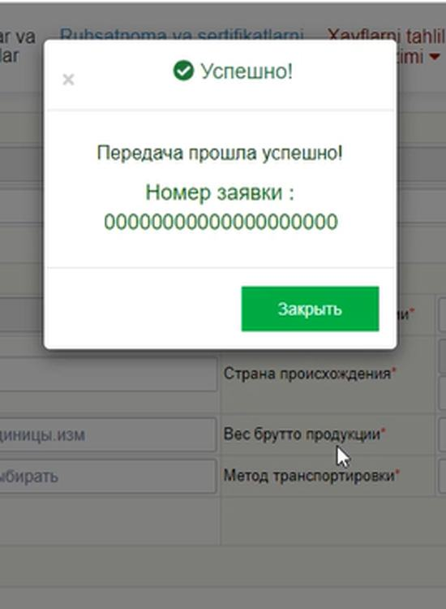  Application registration number
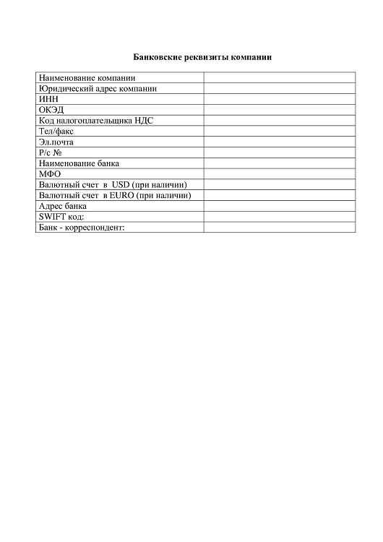  Bank details | 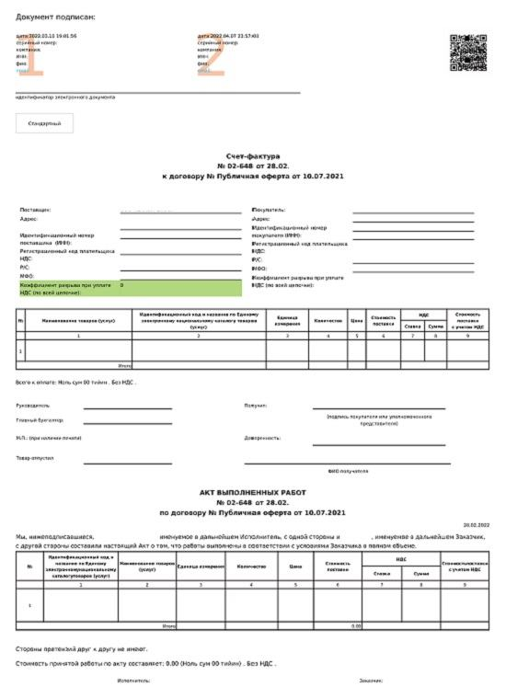  Electronic invoice for payment | 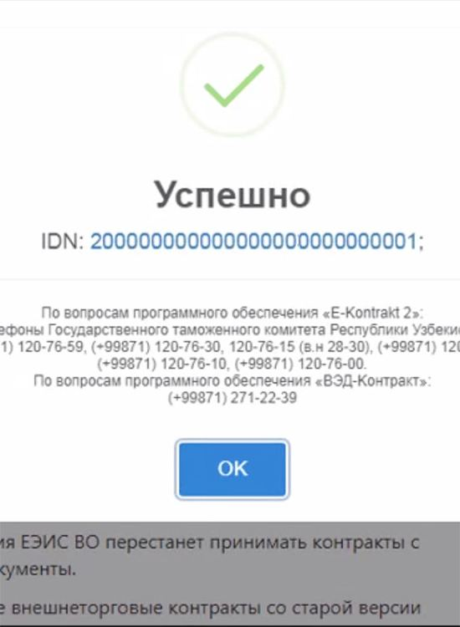  Identification number of foreign trade contract
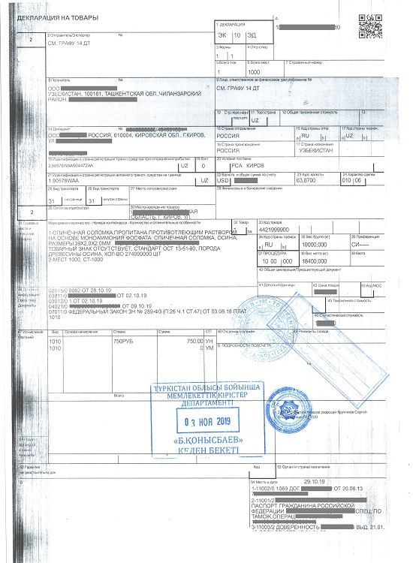  Export declaration of the exporter's country | 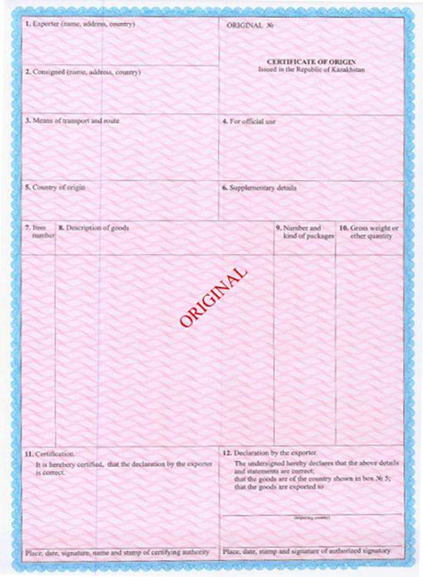  Certificate of origin of the exporter's country | 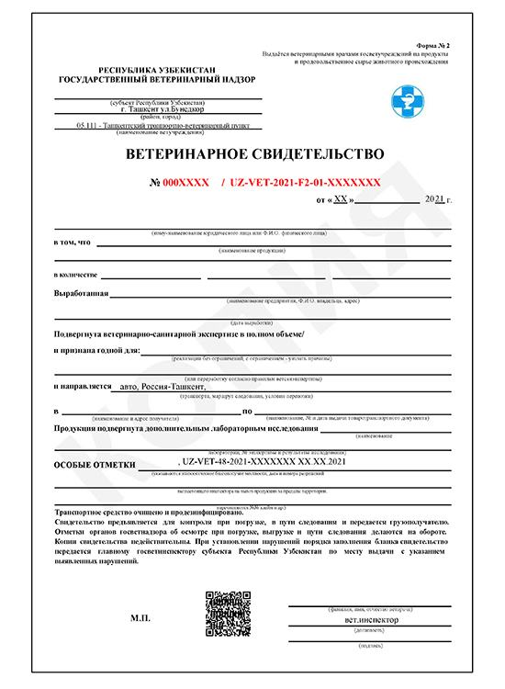  Veterinary certificate Form-2
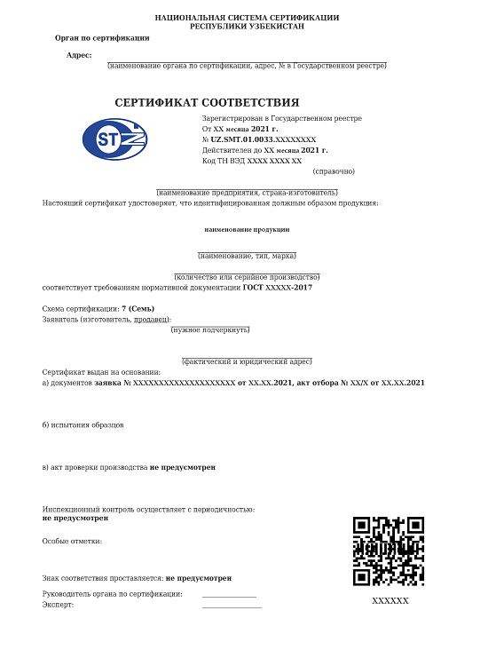  Certificate of conformity | 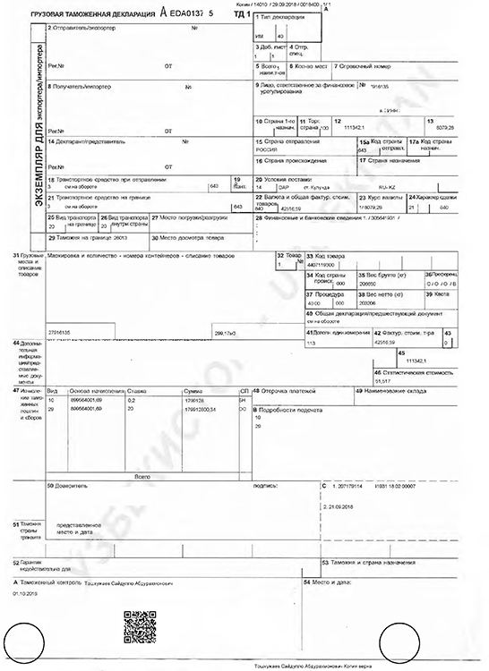  Import customs declaration | 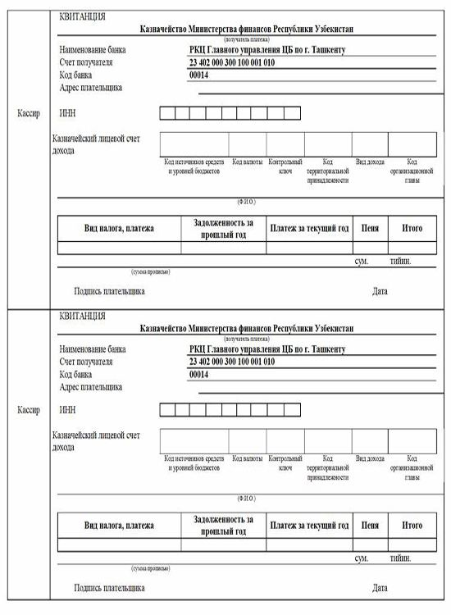  Receipt of payment
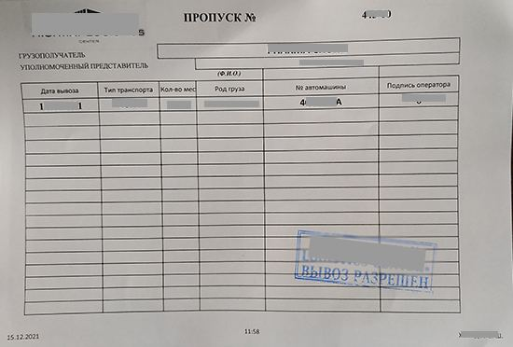
Exit pass

8. Step reference screenshots
The platform's own screen for each step, reproduced as published. These are screenshots of the eRegulations record (in Uzbek), showing contact details, expected result, requirements and price — not screenshots of the destination government service. They serve as visual provenance for the tables above.
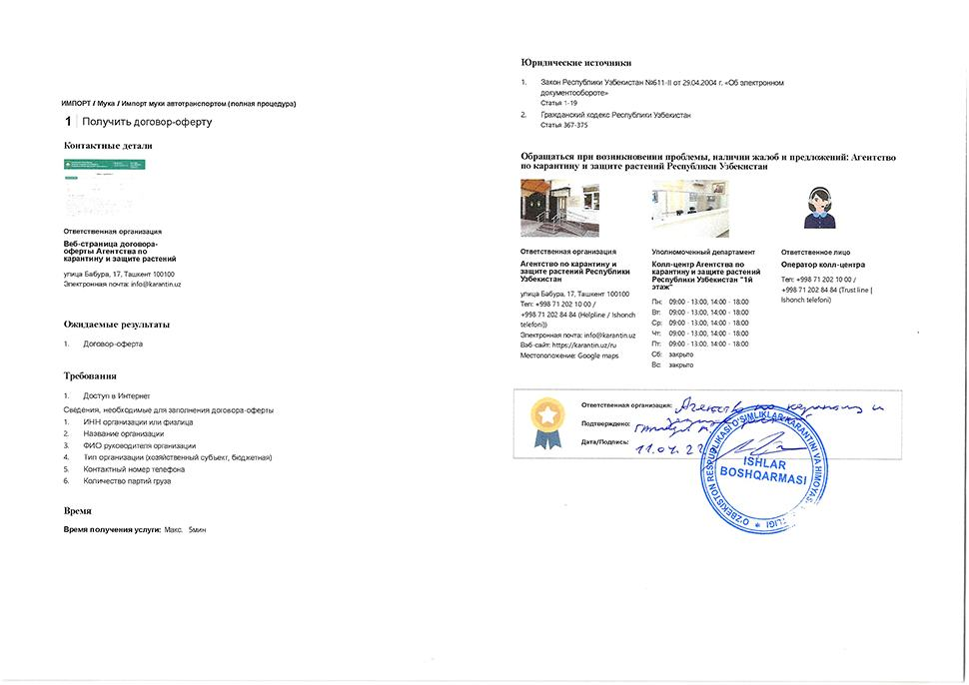  Step 1 — Obtain offer agreement | 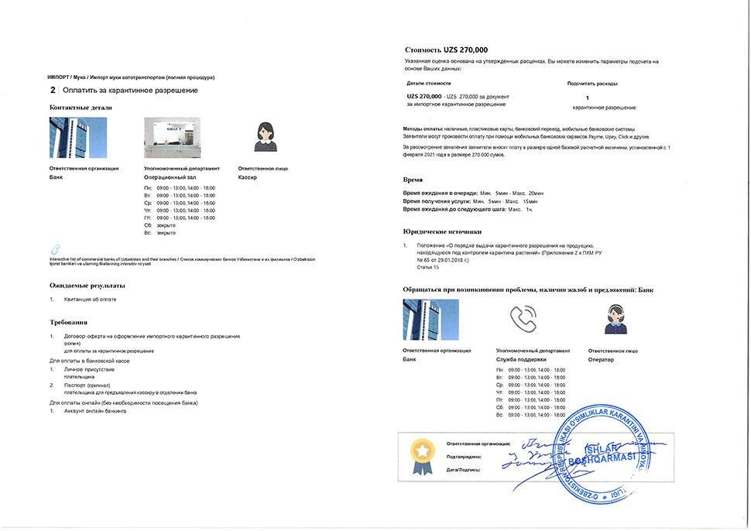  Step 2 — Pay for quarantine permit
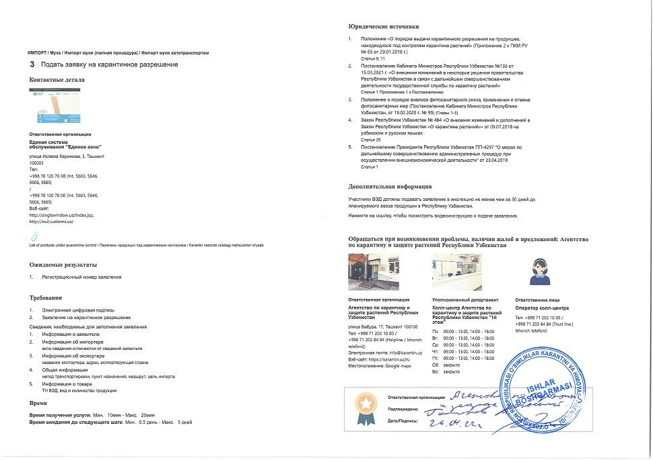  Step 3 — Apply for quarantine permit | 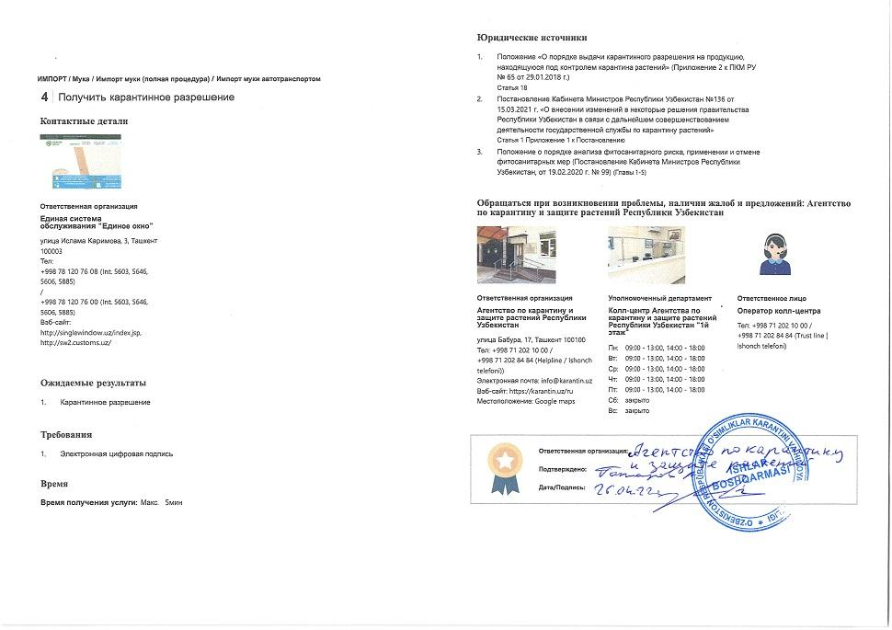  Step 4 — Obtain quarantine permit
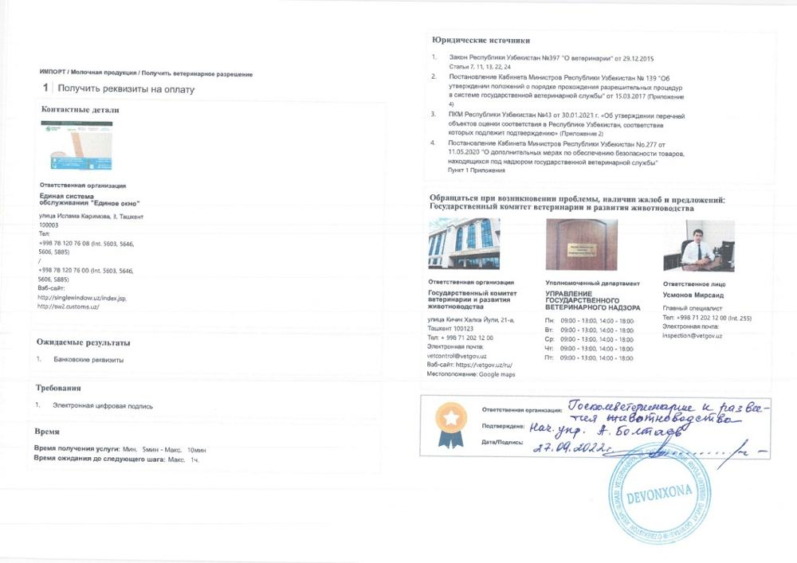  Step 5 — Obtain payment details | 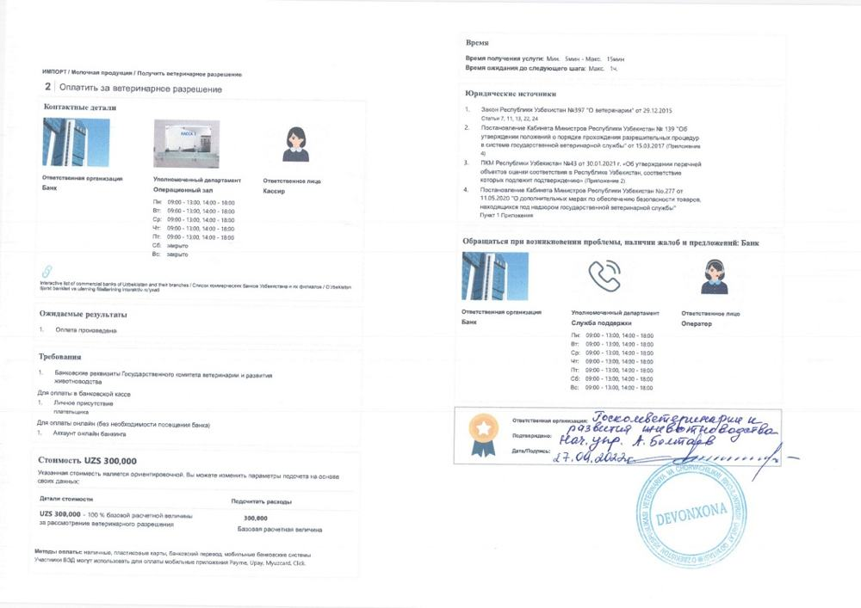  Step 6 — Pay for veterinary permit
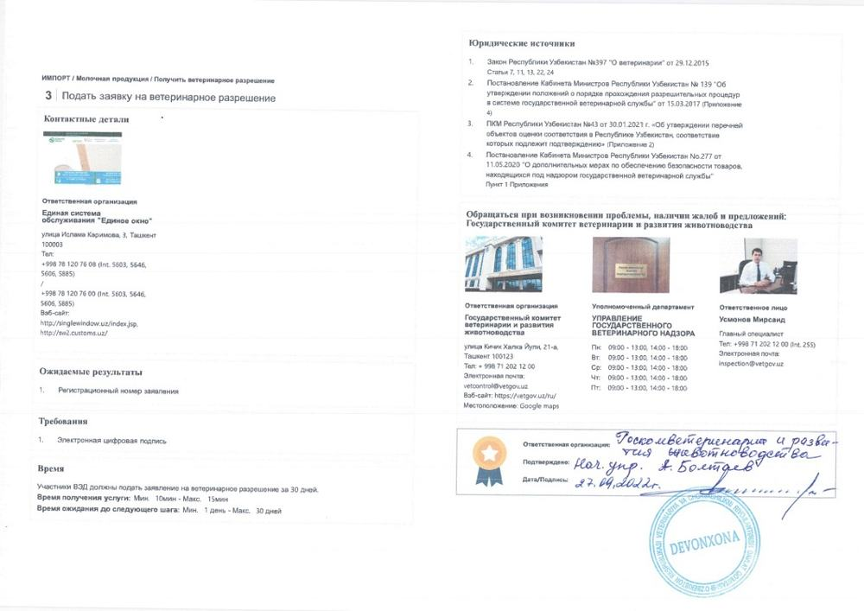  Step 7 — Apply for veterinary permit | 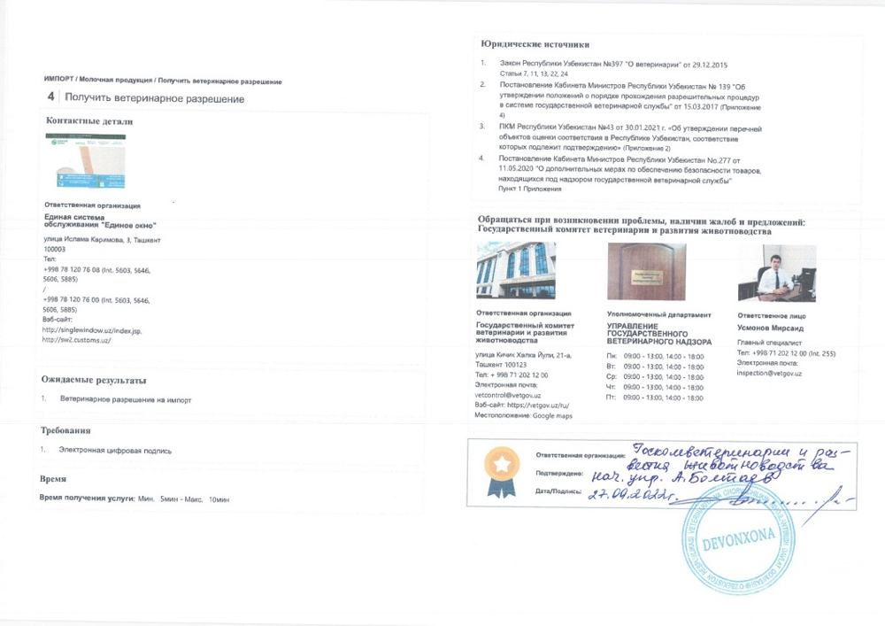  Step 8 — Obtain veterinary permit
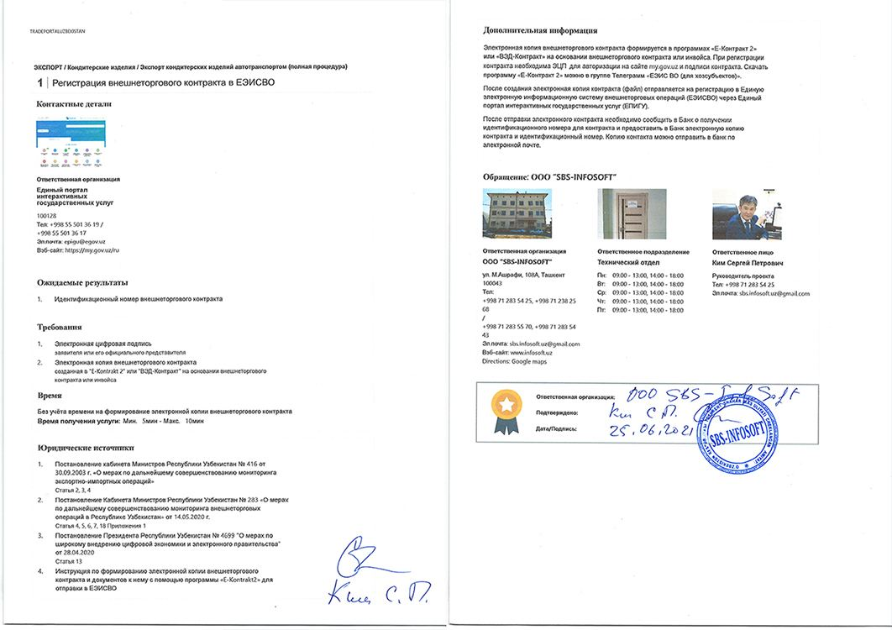  Step 9 — Register foreign trade contract in UEISFTO | 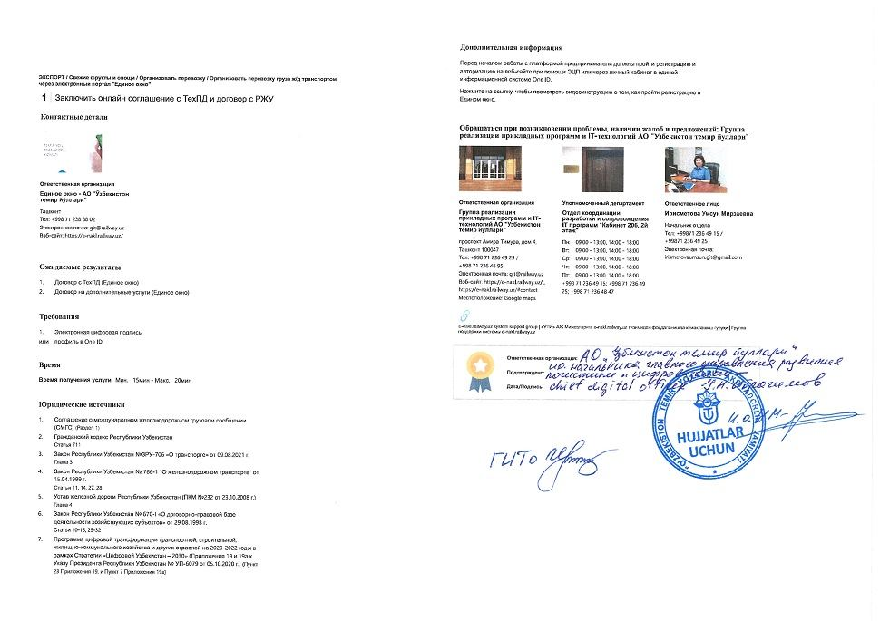  Step 10 — Conclude online agreement with Technological Center and contract with Regional railway junction
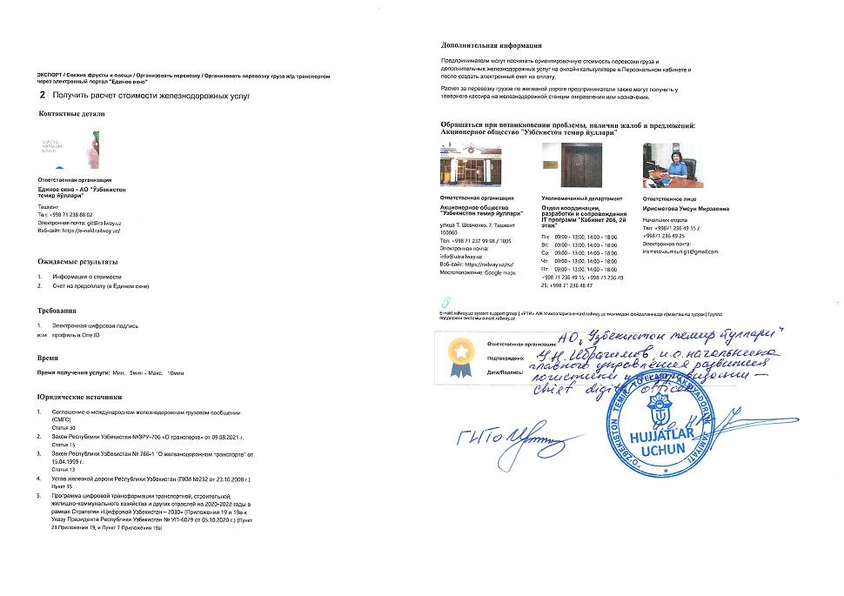  Step 11 — Obtain cost calculation for railway services | 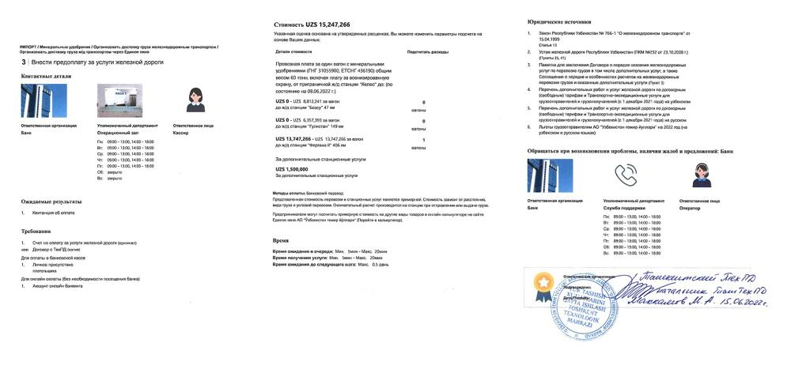  Step 12 — Prepay for railway services (for fertilizers)
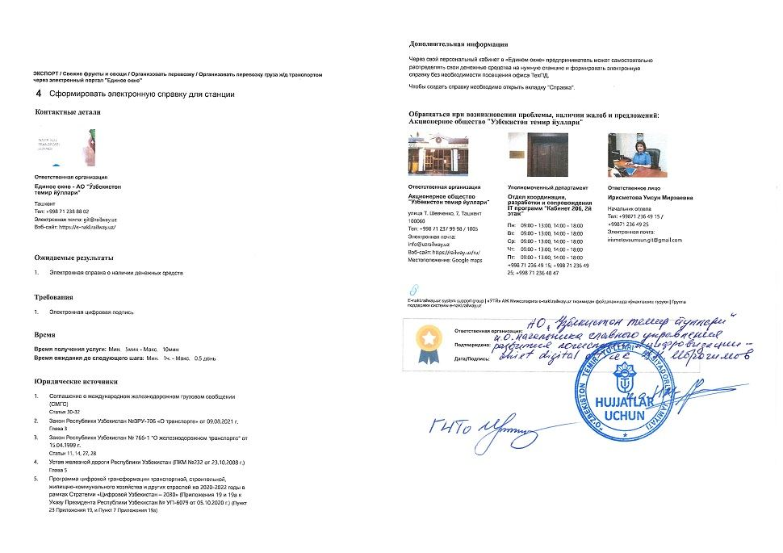  Step 13 — Generate electronic certificate for railway station | 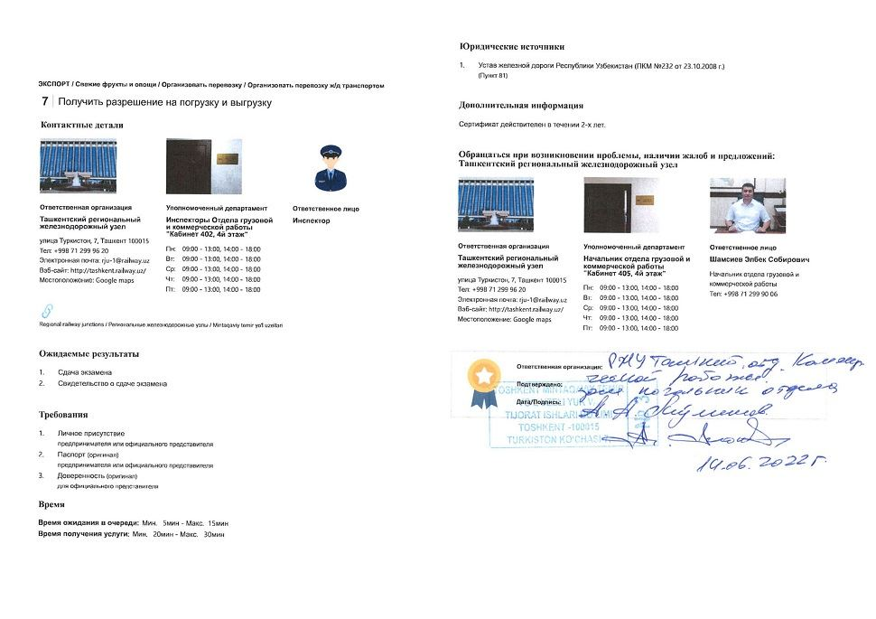  Step 14 — Obtain approval for loading and unloading
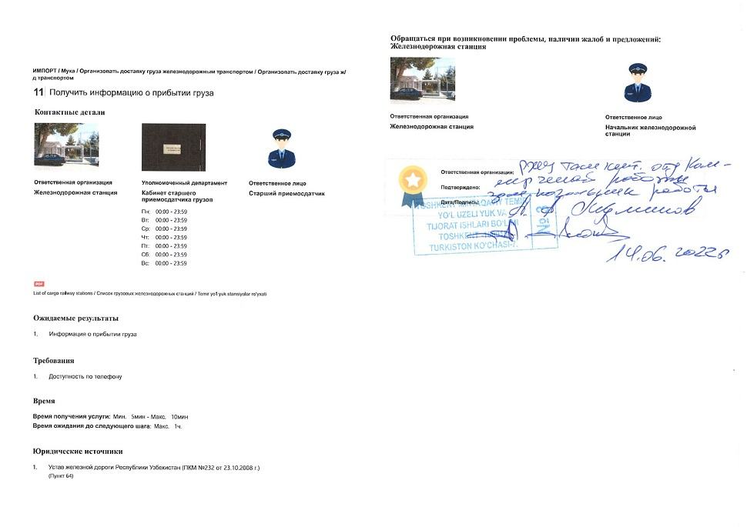  Step 18 — Obtain information on freight arrival | 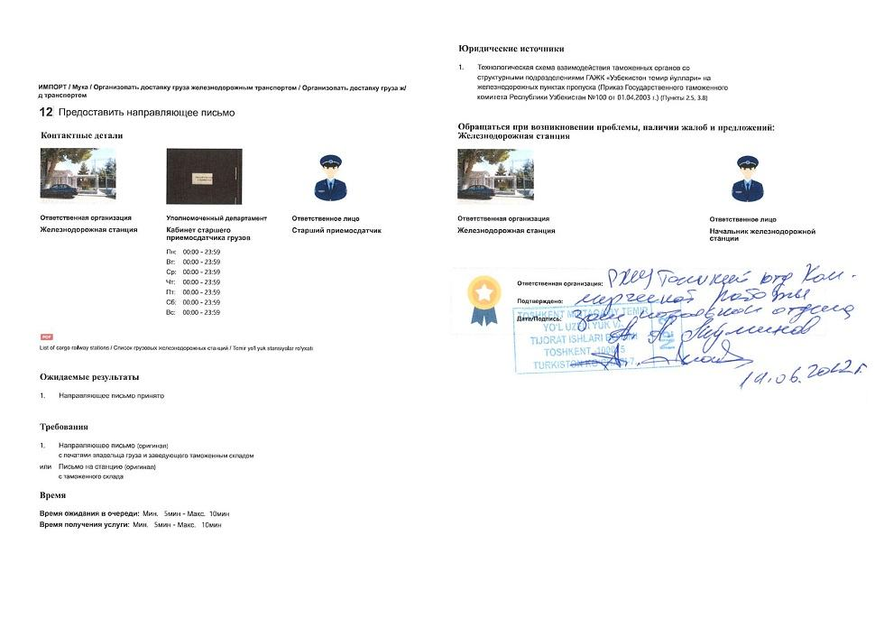  Step 19 — Submit guiding letter
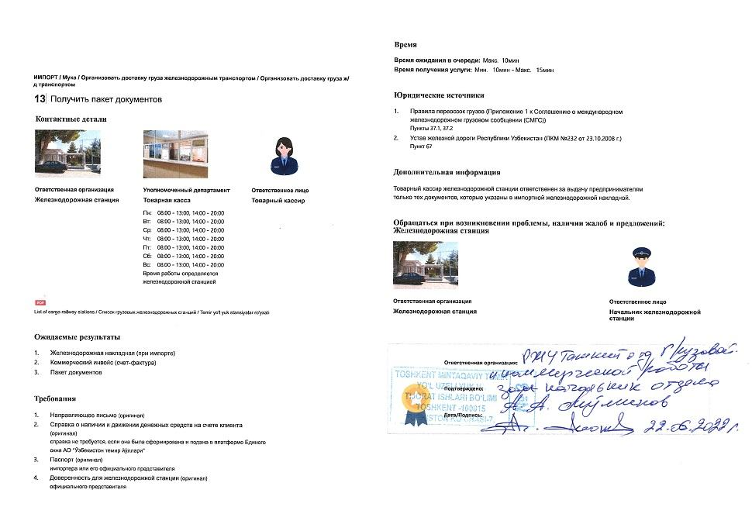  Step 20 — Obtain package of documents | 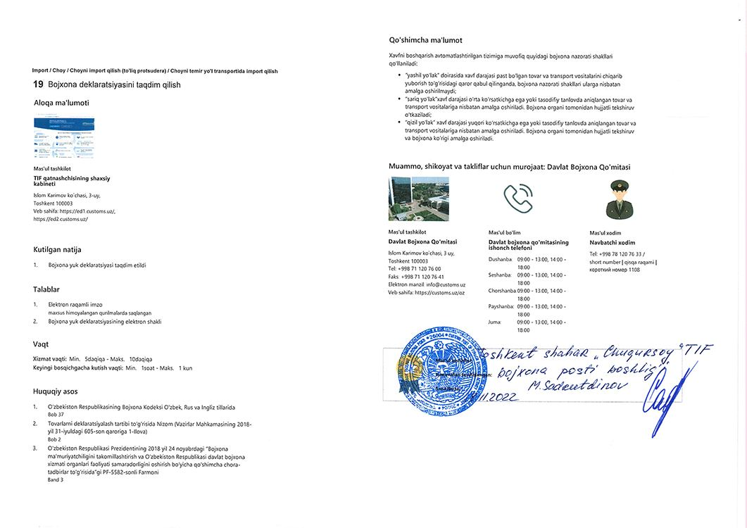  Step 25 — Submit customs declaration
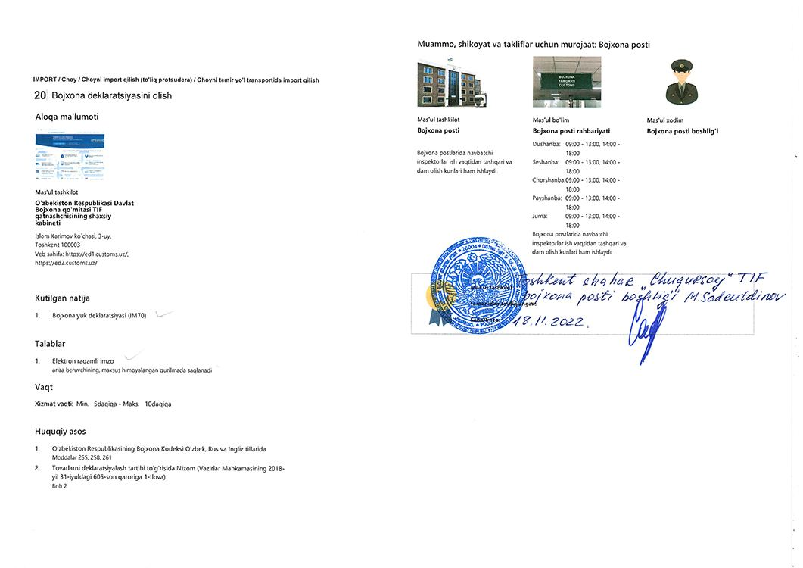  Step 27 — Obtain customs declaration | 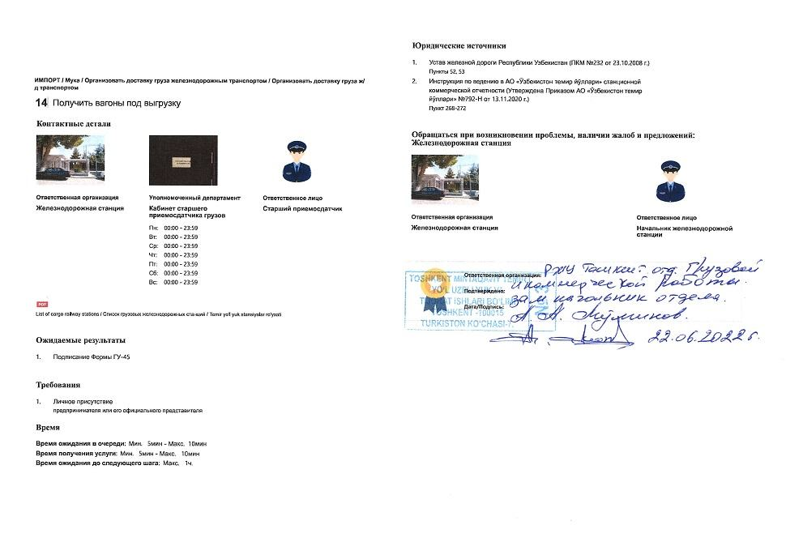  Step 28 — Obtain wagons for unloading
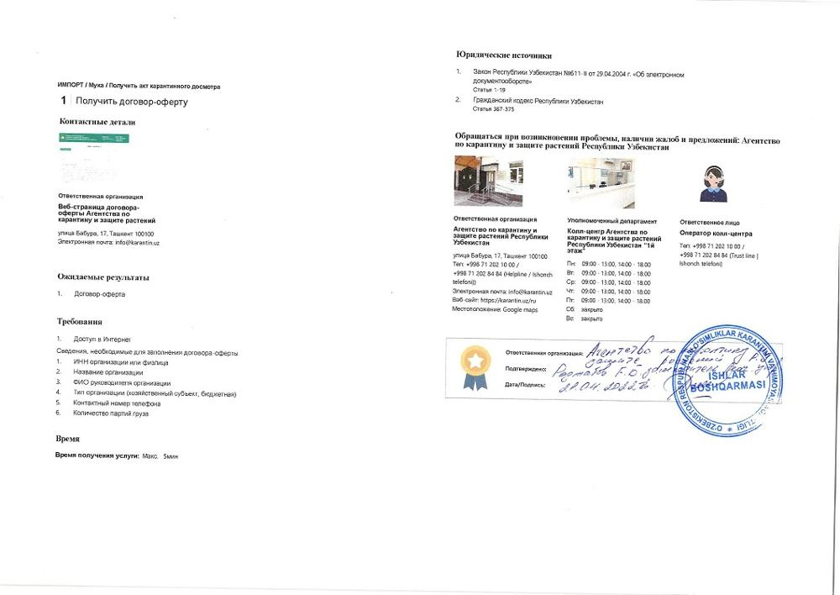  Step 31 — Obtain offer agreement | 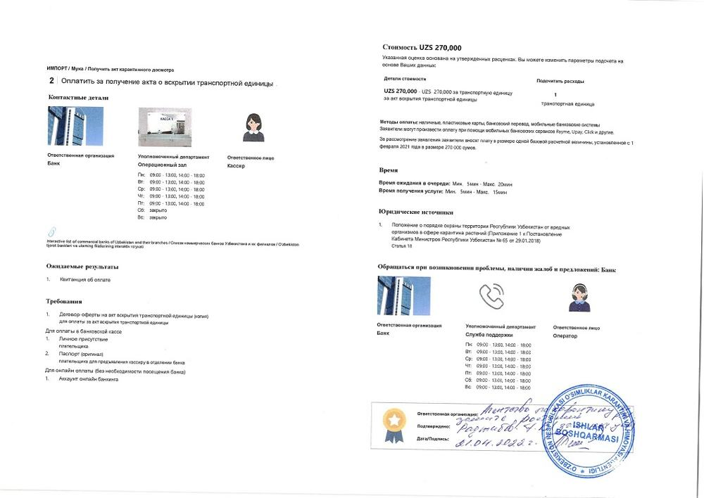  Step 32 — Pay for transport unit opening act
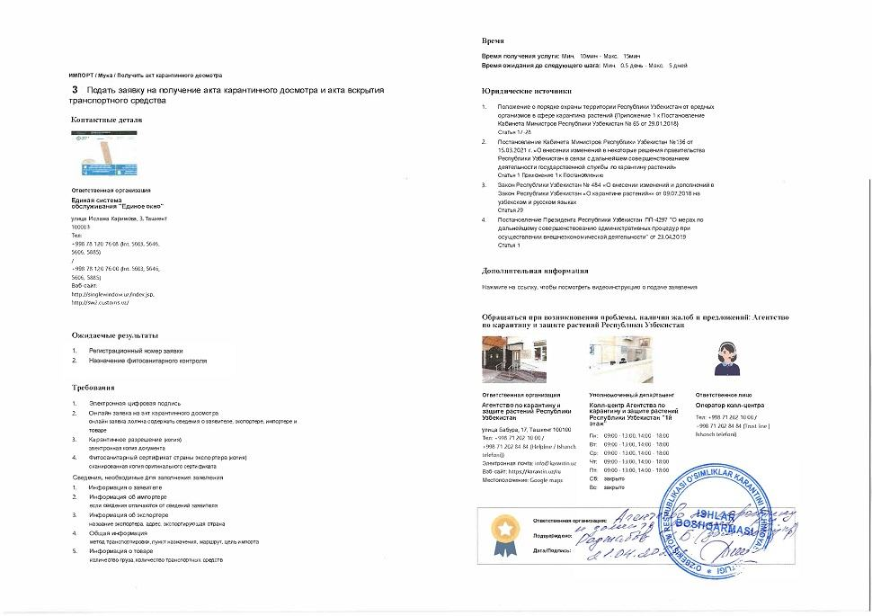  Step 33 — Apply for quarantine inspection act and transport unit opening act | 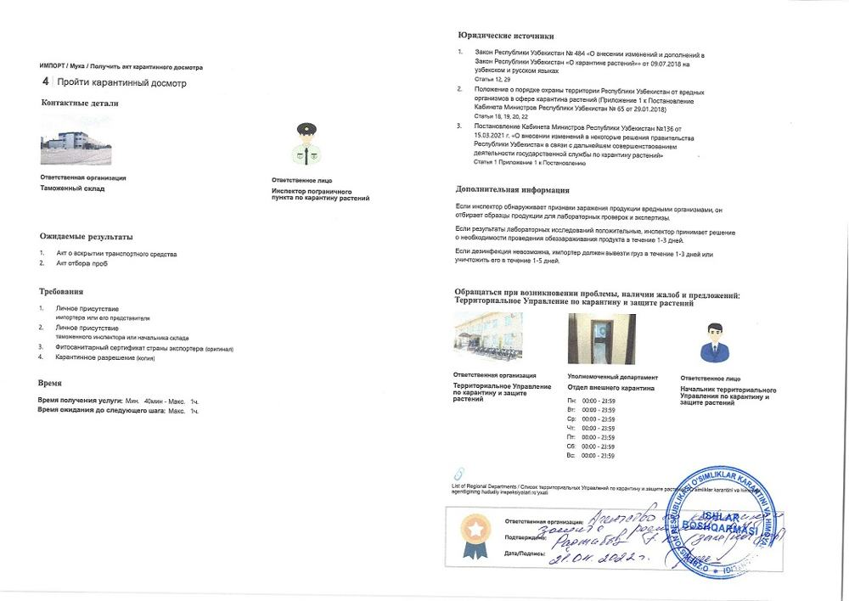  Step 34 — Undergo quarantine inspection
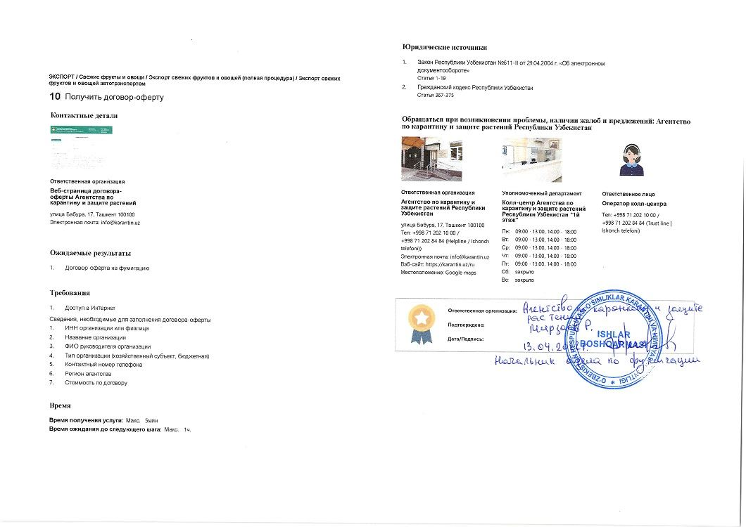  Step 35 — Obtain offer agreement for fumigation | 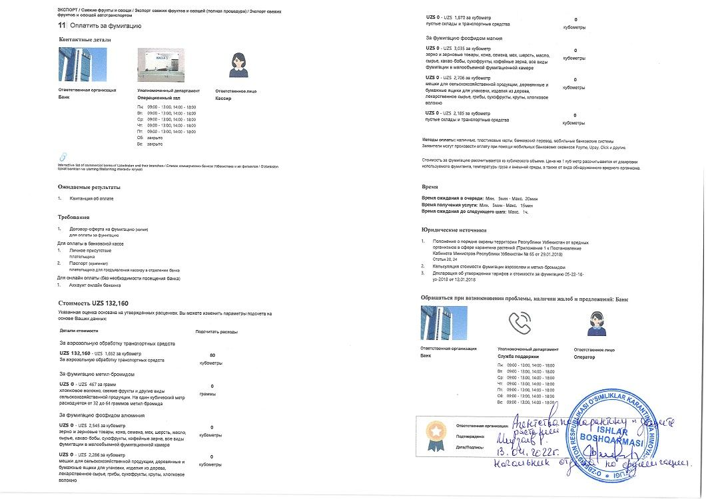  Step 36 — Pay for fumigation
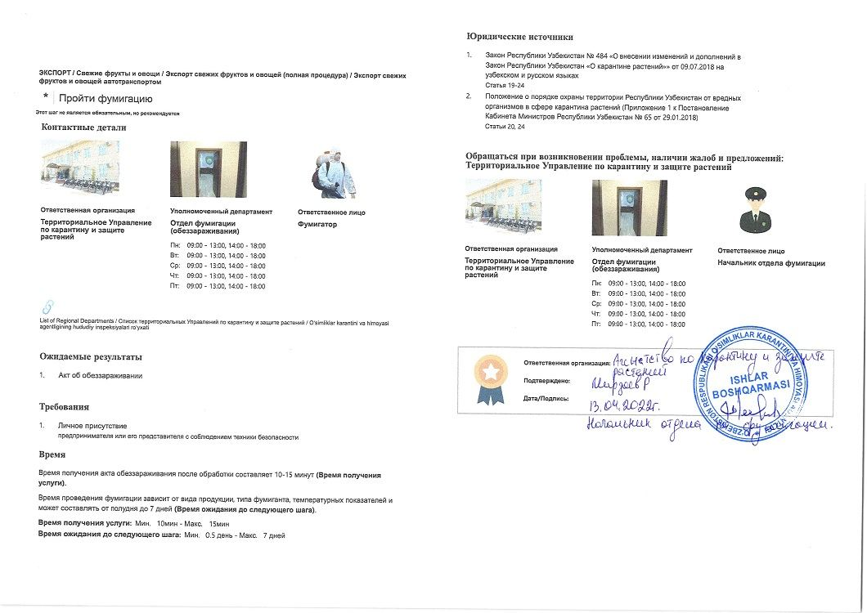  Step 37 — Undergo fumigation | 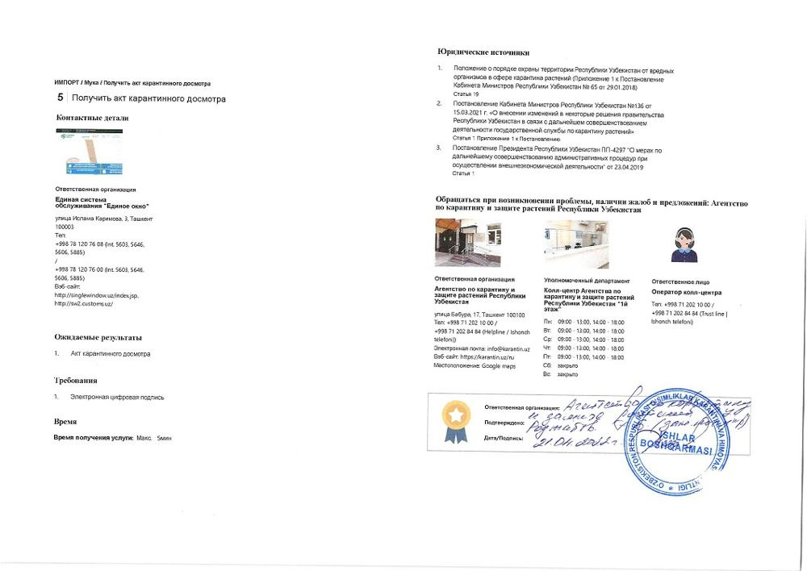  Step 38 — Obtain quarantine inspection act
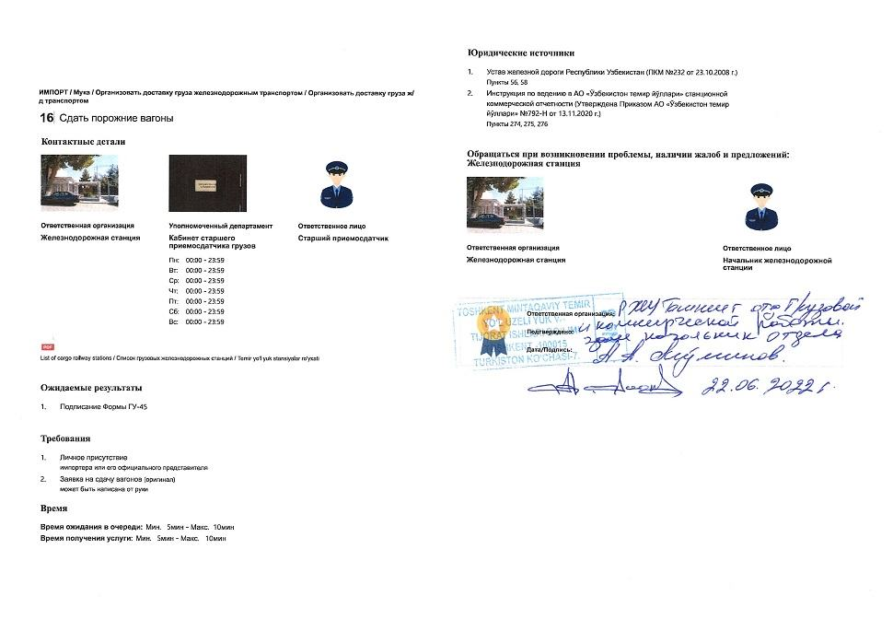  Step 39 — Hand over empty wagons | 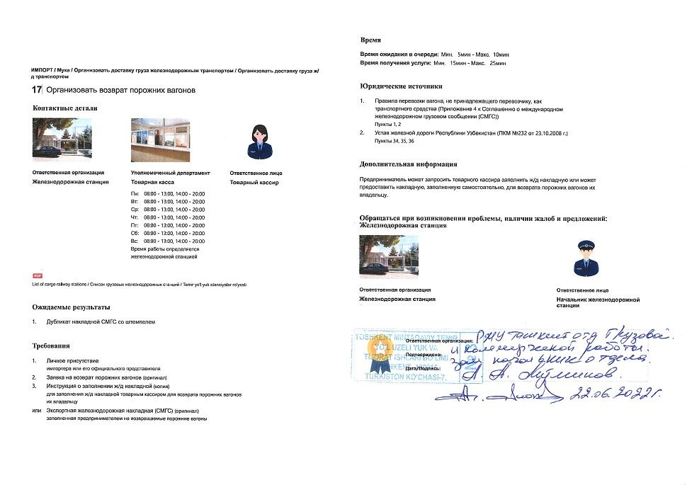  Step 40 — Arrange return of empty wagons
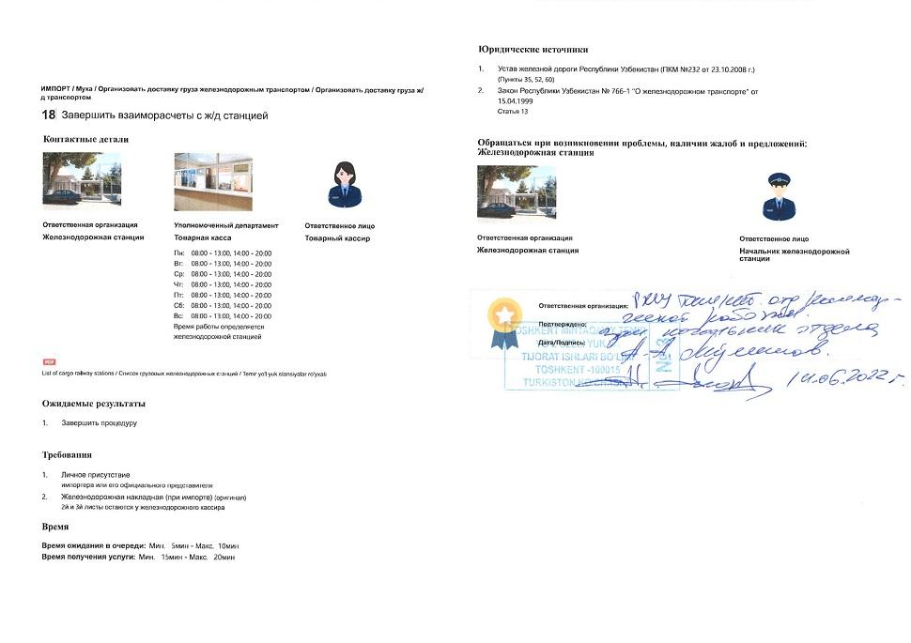  Step 41 — Finalize mutual settlements with railway station | 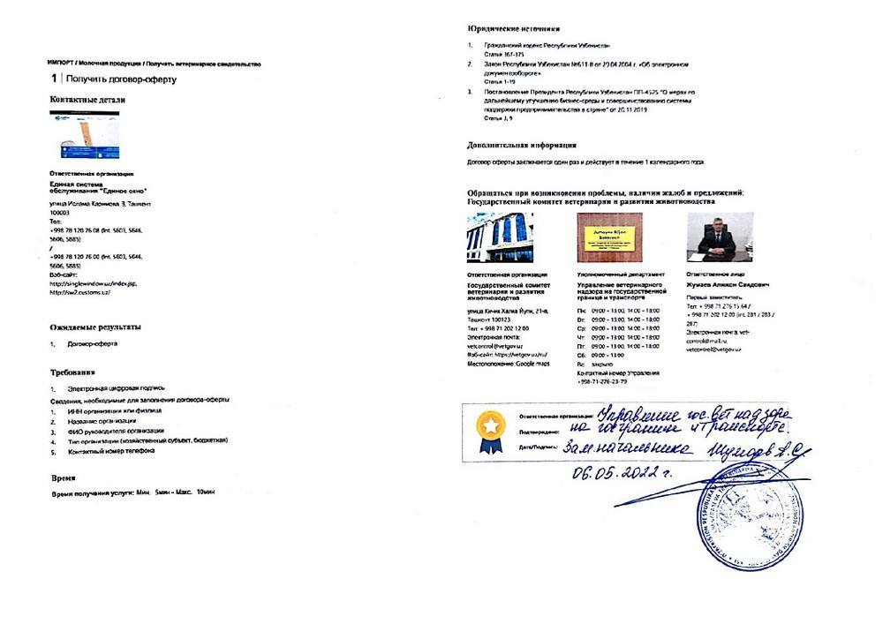  Step 42 — Obtain offer agreement
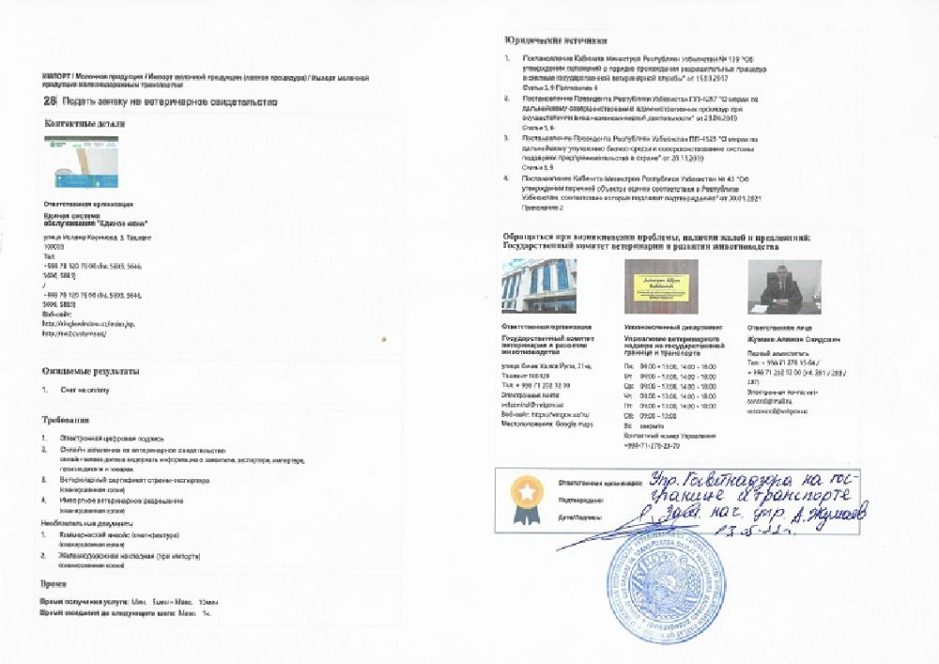  Step 43 — Apply for veterinary certificate (imp) | 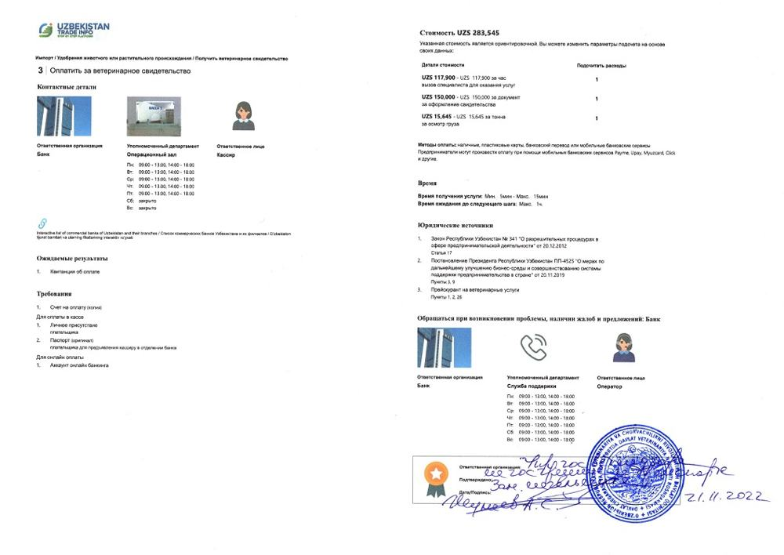  Step 44 — Pay for veterinary certificate
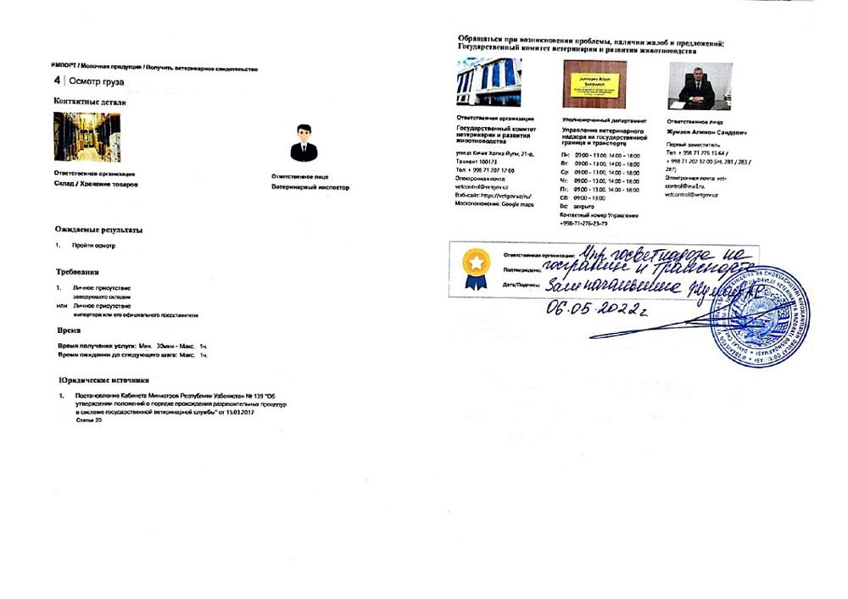  Step 45 — Undergo cargo inspection | 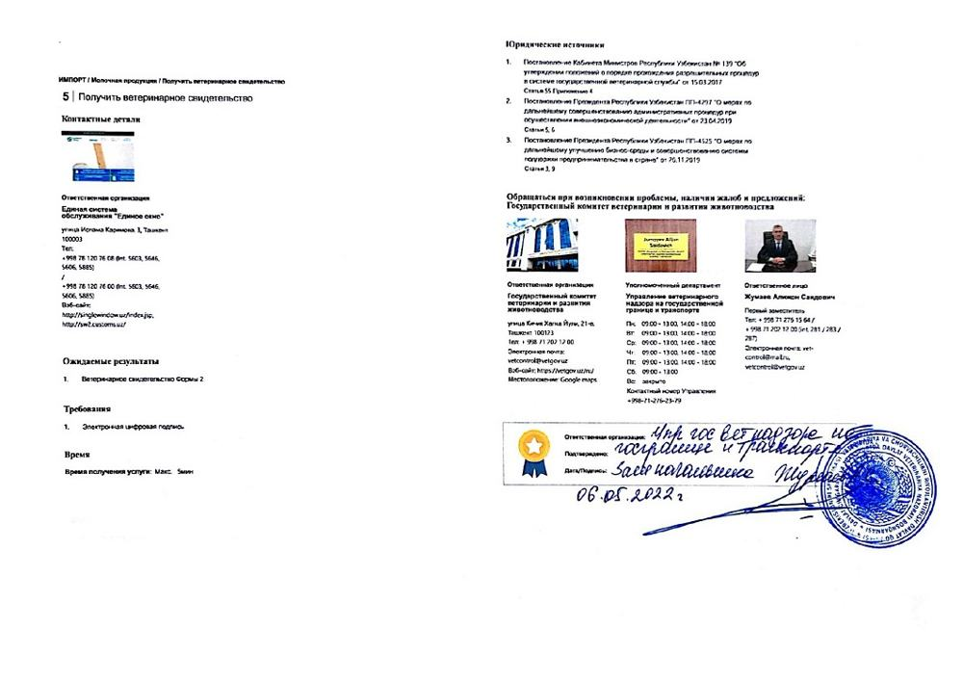  Step 46 — Obtain veterinary certificate (import)
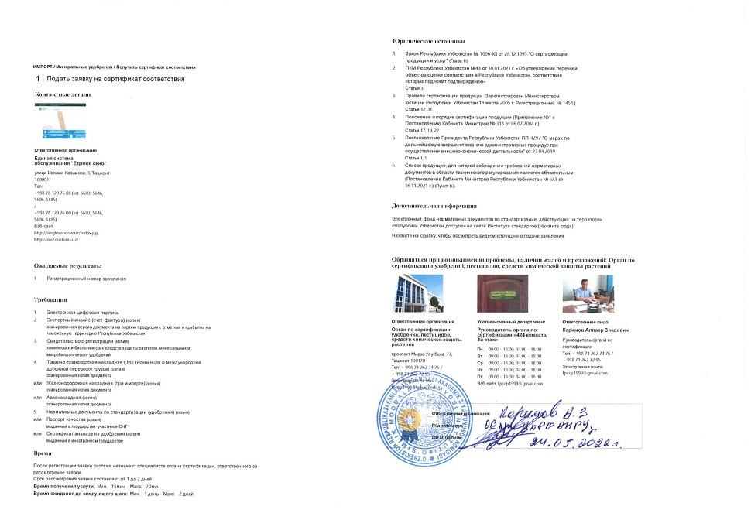  Step 47 — Apply for certificate of conformity | 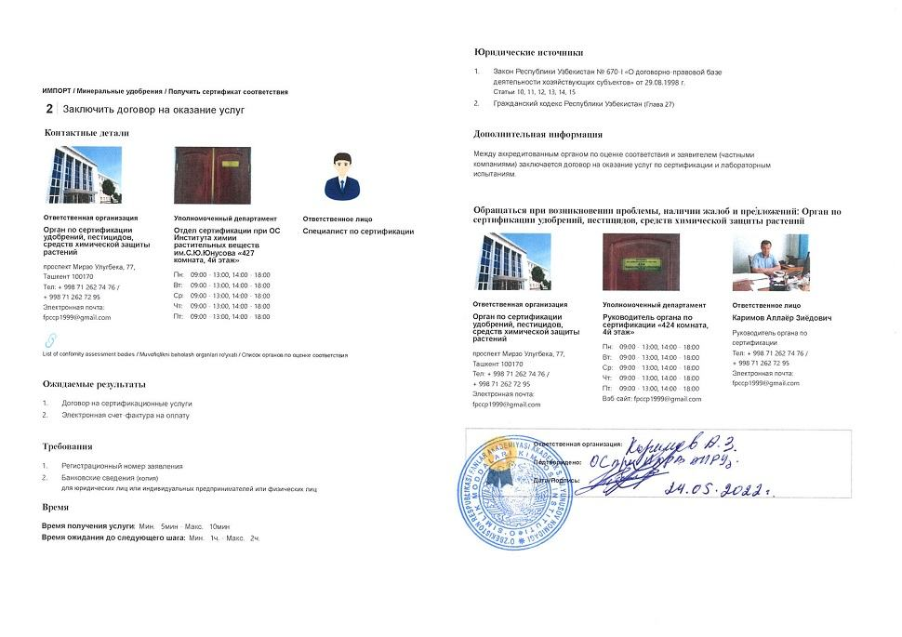  Step 48 — Conclude contract for services
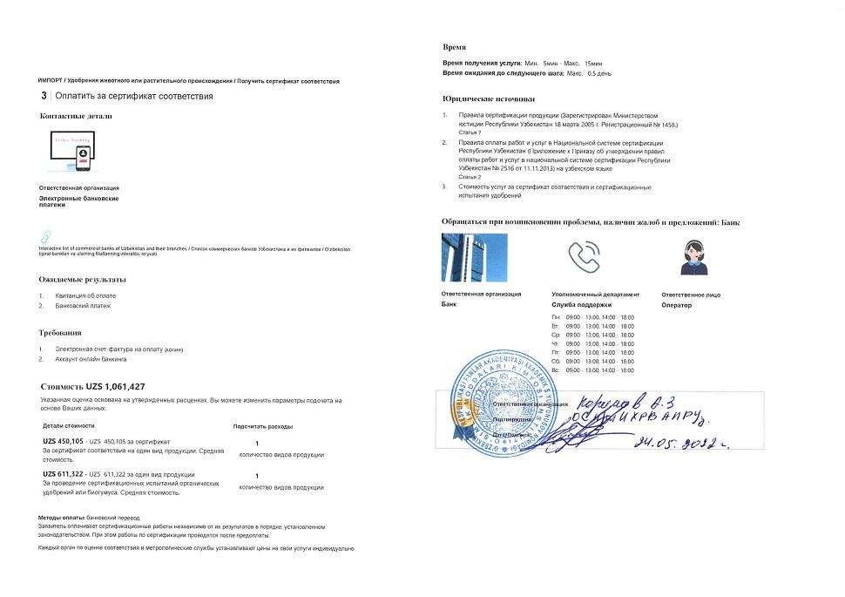  Step 49 — Pay for certificate of conformity | 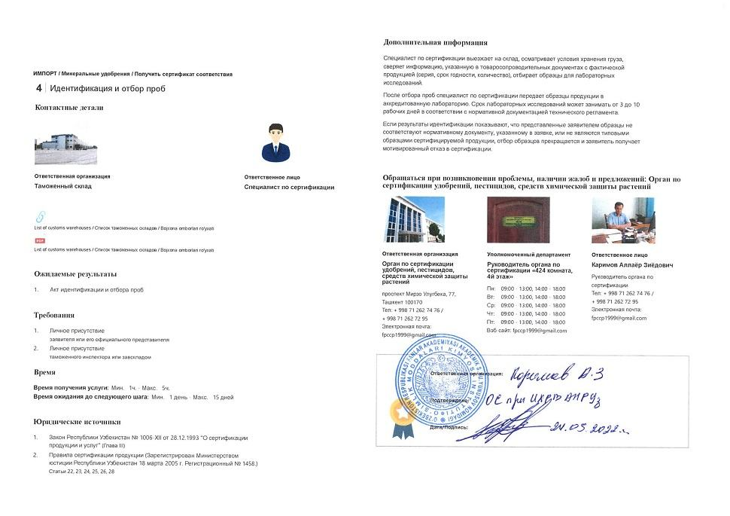  Step 50 — Identification and selection of samples
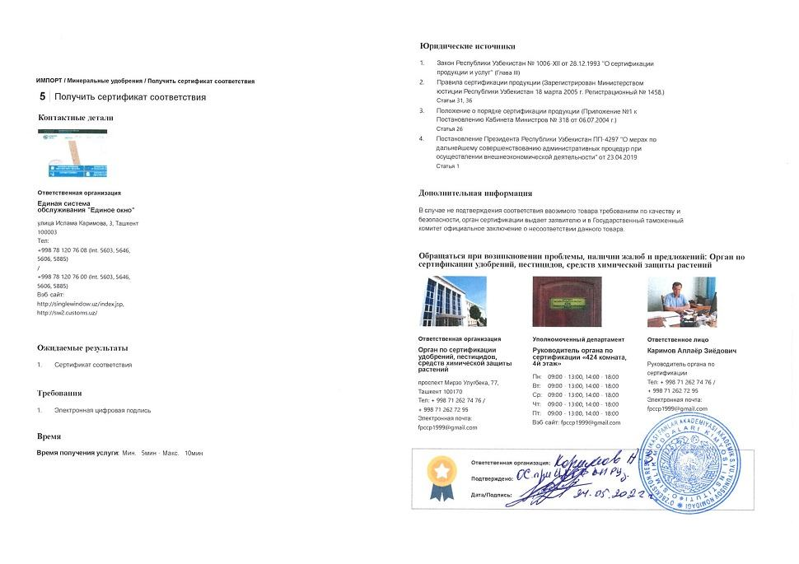  Step 51 — Obtain certificate of conformity | 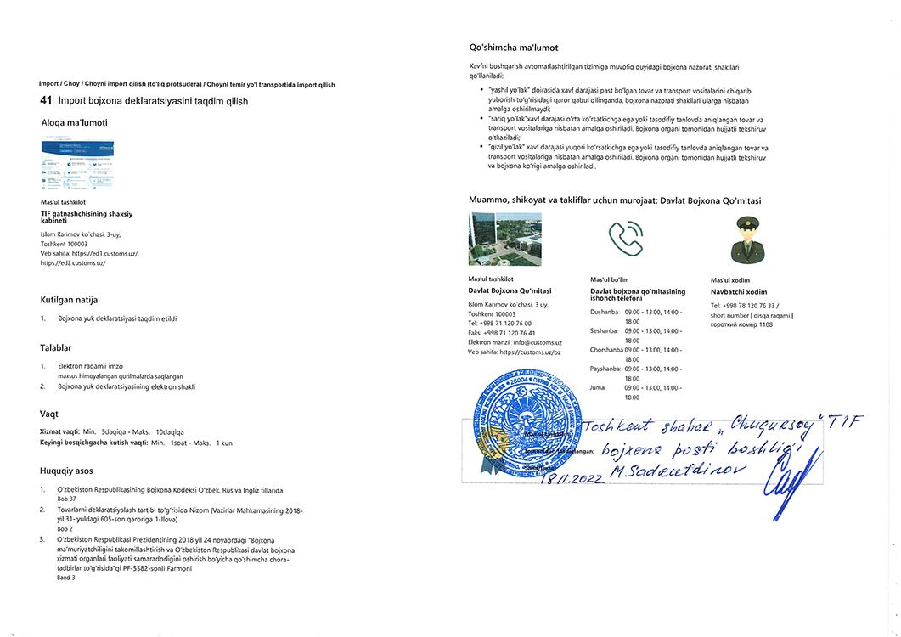  Step 54 — Submit import customs declaration
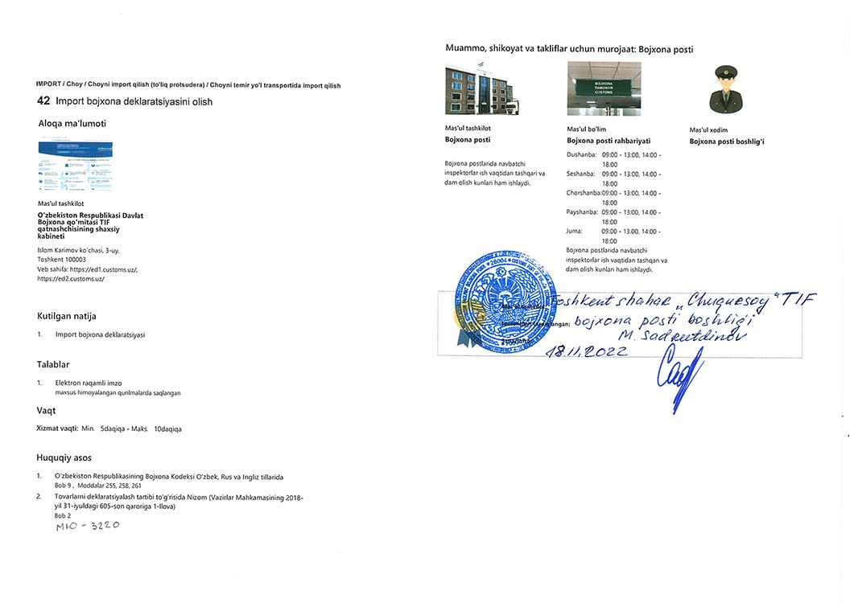
Step 56 — Obtain import customs declaration

