Uzbekistan Trade Info — Procedure Automation
Procedure 782: Arrange cargo transportation by train via "Single Window" online portal
As-is process map — the procedure exactly as it runs today. Source: uztradeinfo.uz/procedure/782
Blocks | Steps | Entities | Online | Optional | Alternative
5 | 20 | 6 | 14 | 0 | 0
End-to-end published timeframe: 33–87 hours.
1. Process flow
Columns group the entity in charge, so every move between columns is a handoff. The specific body is named in grey inside each box. Dashed border = optional (conditional) step. Boxes side by side = alternative routes, where the trader takes one. Heavy border = the step can be done online.
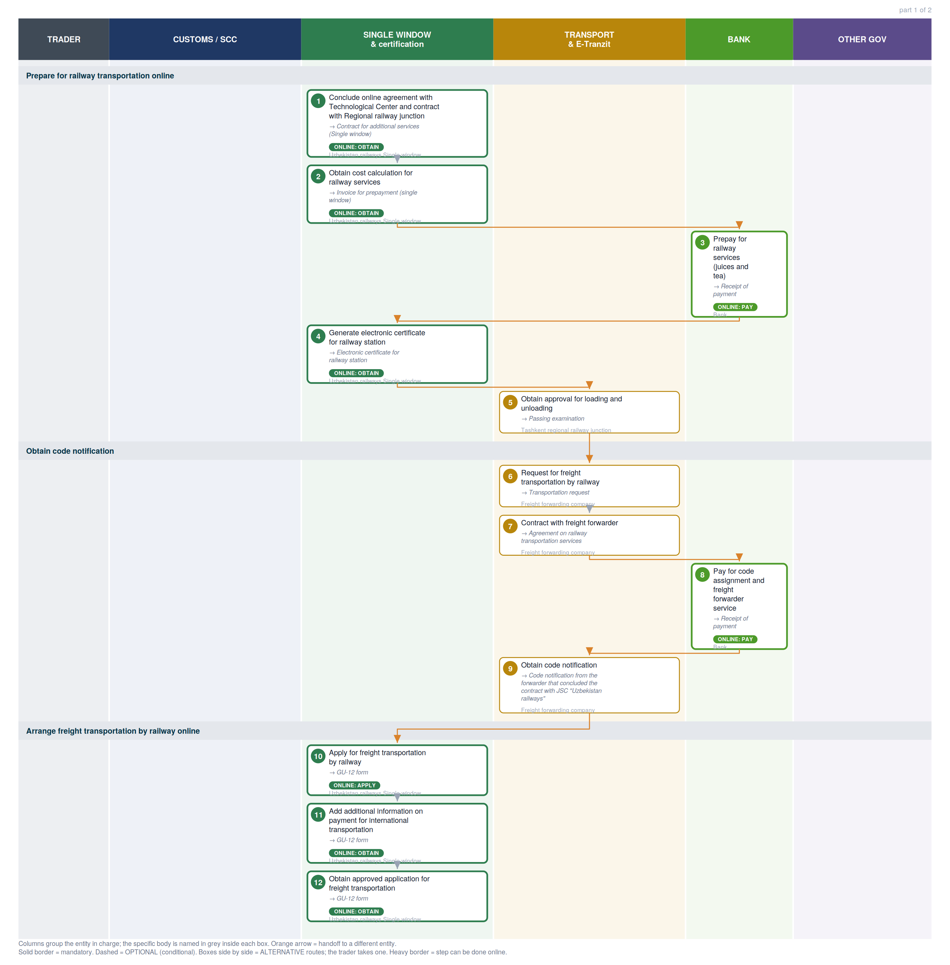

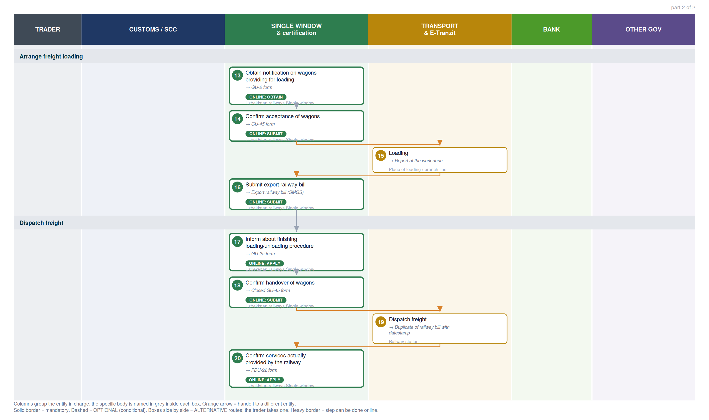

2. Where each step happens
Every step classified by channel. Online steps are performed on an external government service (the exact URL is in section 6). In-person steps happen at a physical counter, named in the “where” column.
Channel | Steps | Detail
Online — external service | 14 | Railway electronic waybill (12), Payment methods information page (2)
In person — physical counter | 6 | Tashkent regional railway junction, Freight forwarding company, Place of loading / branch line, Railway station

3. Entities in charge & contact channels
Entity | Steps | Lane | Contact channels
Uzbekistan railways Single window | 1, 2, 4, 10, 11, 12, 13, 14, 16, 17, 18, 20 | Single Window & certification | ✉ git@railway.uz  ☎ +998 71 238 88 02  🌐 https://e-nakl.railway.uz/
Bank | 3, 8 | Bank | — none published —
Tashkent regional railway junction | 5 | Transport & E-Tranzit | ✉ rju-1@railway.uz  ☎ +998 71 299 96 20  🌐 http://tashkent.railway.uz/en/
Freight forwarding company | 6, 7, 9 | Transport & E-Tranzit | — none published —
Place of loading / branch line | 15 | Transport & E-Tranzit | — none published —
Railway station | 19 | Transport & E-Tranzit | — none published —

4. Step-by-step breakdown
Full sequence. Channel shows online vs in-person; Where / service names the exact website for online steps or the physical location for in-person ones; Performed by is who carries the step out. Optional and alternative steps are flagged.
# | Step | Entity in charge | Channel | Where / service | Performed by
Prepare for railway transportation online
1 | Conclude online agreement with Technological Center and contract with Regional railway junction  → Contract for additional services (Single window) | Uzbekistan railways Single window | Online: obtain | Railway electronic waybill  e-nakl.railway.uz | —
2 | Obtain cost calculation for railway services  → Invoice for prepayment (single window) | Uzbekistan railways Single window | Online: obtain | Railway electronic waybill  e-nakl.railway.uz | —
3 | Prepay for railway services (juices and tea)  → Receipt of payment | Bank | Online: pay | Payment methods information page  uzbekistan.tradeportal.org | —
4 | Generate electronic certificate for railway station  → Electronic certificate for railway station | Uzbekistan railways Single window | Online: obtain | Railway electronic waybill  e-nakl.railway.uz | —
5 | Obtain approval for loading and unloading  → Passing examination | Tashkent regional railway junction | In person | Inspectors of the Department on freight and commerce Room 402, 4th floor" | —
Obtain code notification
6 | Request for freight transportation by railway  → Transportation request | Freight forwarding company | In person | Freight forwarding company | —
7 | Contract with freight forwarder  → Agreement on railway transportation services | Freight forwarding company | In person | Freight forwarding company | —
8 | Pay for code assignment and freight forwarder service  → Receipt of payment | Bank | Online: pay | Payment methods information page  uzbekistan.tradeportal.org | —
9 | Obtain code notification  → Code notification from the forwarder that concluded the contract with JSC "Uzbekistan railways" | Freight forwarding company | In person | Freight forwarding company | —
Arrange freight transportation by railway online
10 | Apply for freight transportation by railway  → GU-12 form | Uzbekistan railways Single window | Online: apply | Railway electronic waybill  e-nakl.railway.uz | —
11 | Add additional information on payment for international transportation  → GU-12 form | Uzbekistan railways Single window | Online: obtain | Railway electronic waybill  e-nakl.railway.uz | —
12 | Obtain approved application for freight transportation  → GU-12 form | Uzbekistan railways Single window | Online: obtain | Railway electronic waybill  e-nakl.railway.uz | —
Arrange freight loading
13 | Obtain notification on wagons providing for loading  → GU-2 form | Uzbekistan railways Single window | Online: obtain | Railway electronic waybill  e-nakl.railway.uz | —
14 | Confirm acceptance of wagons  → GU-45 form | Uzbekistan railways Single window | Online: submit | Railway electronic waybill  e-nakl.railway.uz | —
15 | Loading  → Report of the work done | Place of loading / branch line | In person | Place of loading / branch line | —
16 | Submit export railway bill  → Export railway bill (SMGS) | Uzbekistan railways Single window | Online: submit | Railway electronic waybill  e-nakl.railway.uz | —
Dispatch freight
17 | Inform about finishing loading/unloading procedure  → GU-2a form | Uzbekistan railways Single window | Online: apply | Railway electronic waybill  e-nakl.railway.uz | —
18 | Confirm handover of wagons  → Closed GU-45 form | Uzbekistan railways Single window | Online: submit | Railway electronic waybill  e-nakl.railway.uz | —
19 | Dispatch freight  → Duplicate of railway bill with datestamp | Railway station | In person | Commodity cash desk | —
20 | Confirm services actually provided by the railway  → FDU-92 form | Uzbekistan railways Single window | Online: apply | Railway electronic waybill  e-nakl.railway.uz | —

5. Inputs required per step
Type 1 = the trader supplies it from outside the procedure. Type 2 = produced by an earlier step, so it is a dependency the agent can track.
1. Conclude online agreement with Technological Center and contract with Regional railway junction
- Electronic digital signature [trader supplies]
- One ID account [trader supplies]
2. Obtain cost calculation for railway services
- Electronic digital signature [trader supplies]
- One ID account [trader supplies]
3. Prepay for railway services (juices and tea)
- Invoice for payment for railway services [trader supplies]
- Agreement with Technological center [trader supplies]
- For physical payment [trader supplies]
- Physical presence [trader supplies]
- For online payment (without necessity to visit a bank) [trader supplies]
- Online banking account [trader supplies]
4. Generate electronic certificate for railway station
- Electronic digital signature [trader supplies]
5. Obtain approval for loading and unloading
- Physical presence [trader supplies]
- Passport [trader supplies]
- Power of attorney [trader supplies]
6. Request for freight transportation by railway
- Foreign economic activity contract [trader supplies]
- Supply contract [trader supplies]
7. Contract with freight forwarder
- Passport [trader supplies]
- Power of attorney [trader supplies]
- Tax Identification Number of the organization or individual [trader supplies]
- Personal identification number of an individual [trader supplies]
- Bank details [trader supplies]
8. Pay for code assignment and freight forwarder service
- Invoice for payment [trader supplies]
- Agreement on railway transportation services [trader supplies]
- For physical payment [trader supplies]
- Physical presence [trader supplies]
- Passport [trader supplies]
- For online payment (without necessity to visit a bank) [trader supplies]
- Online banking account [trader supplies]
9. Obtain code notification
- Receipt of payment [trader supplies]
- Agreement on railway transportation services [trader supplies]
10. Apply for freight transportation by railway
- Electronic digital signature [trader supplies]
- Information from following documents is required to complete the application [trader supplies]
- Commercial invoice [trader supplies]
11. Add additional information on payment for international transportation
- Electronic digital signature [trader supplies]
- Information from following documents is required to complete the application [trader supplies]
- Telegram on payment for the railway tariff by telegraph [trader supplies]
12. Obtain approved application for freight transportation
- Electronic digital signature [trader supplies]
13. Obtain notification on wagons providing for loading
- Electronic digital signature [trader supplies]
14. Confirm acceptance of wagons
- Electronic digital signature [trader supplies]
15. Loading
- Physical presence [trader supplies]
- Power of attorney [trader supplies]
16. Submit export railway bill
- Electronic digital signature [trader supplies]
17. Inform about finishing loading/unloading procedure
- Electronic digital signature [trader supplies]
18. Confirm handover of wagons
- Electronic digital signature [trader supplies]
19. Dispatch freight
- Export railway bill (SMGS) [trader supplies]
- Package of documents [trader supplies]
20. Confirm services actually provided by the railway
- Electronic digital signature [trader supplies]

6. Online service redirects
Every online step in this procedure sends the trader to an external government service. These are the exact destinations — the redirect targets an agent (or a person) would need to reach.
# | Step | Action | Service URL
1 | Conclude online agreement with Technological Center and contract with Regional railway junction | obtain | Railway electronic waybill  https://e-nakl.railway.uz/ru/Login
2 | Obtain cost calculation for railway services | obtain | Railway electronic waybill  https://e-nakl.railway.uz/ru/Home/Calculate
3 | Prepay for railway services (juices and tea) | pay | Payment methods information page  https://uzbekistan.tradeportal.org/menu/22
4 | Generate electronic certificate for railway station | obtain | Railway electronic waybill  https://e-nakl.railway.uz/ru/Customers/CreateSpravka
8 | Pay for code assignment and freight forwarder service | pay | Payment methods information page  https://uzbekistan.tradeportal.org/menu/22
10 | Apply for freight transportation by railway | apply | Railway electronic waybill  https://e-nakl.railway.uz/ru/Customers
11 | Add additional information on payment for international transportation | obtain | Railway electronic waybill  https://e-nakl.railway.uz/ru/Customers
12 | Obtain approved application for freight transportation | obtain | Railway electronic waybill  https://e-nakl.railway.uz/ru/Customers
13 | Obtain notification on wagons providing for loading | obtain | Railway electronic waybill  https://e-nakl.railway.uz/ru/Customers/ListGu2
14 | Confirm acceptance of wagons | submit | Railway electronic waybill  https://e-nakl.railway.uz/ru/Customers
16 | Submit export railway bill | submit | Railway electronic waybill  https://e-nakl.railway.uz/ru/Customers/ListSmgsCustomer
17 | Inform about finishing loading/unloading procedure | apply | Railway electronic waybill  https://e-nakl.railway.uz/ru/Customers/UListGu2a
18 | Confirm handover of wagons | submit | Railway electronic waybill  https://e-nakl.railway.uz/ru/Customers
20 | Confirm services actually provided by the railway | apply | Railway electronic waybill  https://e-nakl.railway.uz/ru/Customers
Distinct services in this procedure: Railway electronic waybill (12); Payment methods information page (2)

7. Document samples
Specimen images of the documents this procedure requires, published by the platform. Duplicates across steps are shown once. 17 distinct documents.
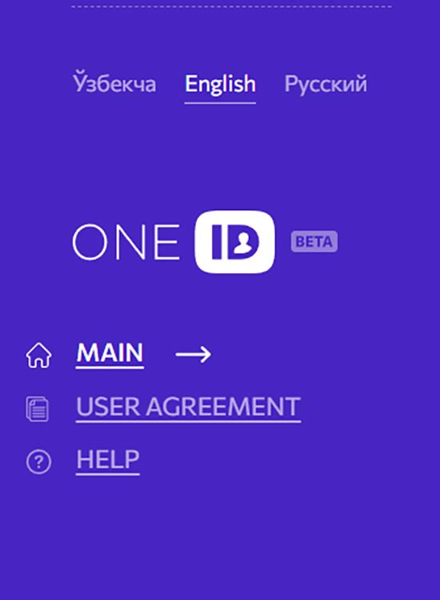  One ID account | 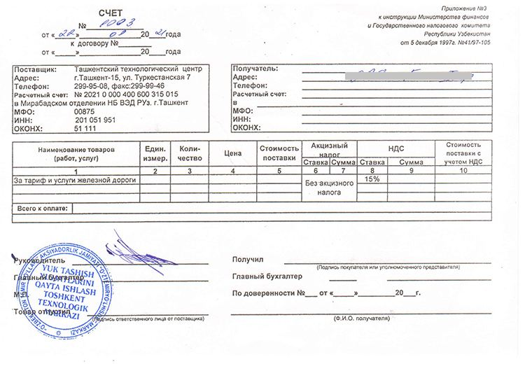  Invoice for payment for railway services | 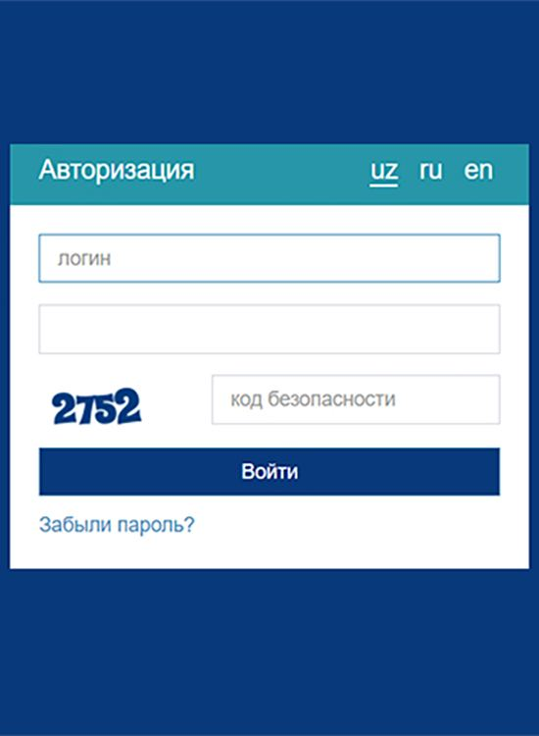  Online banking account
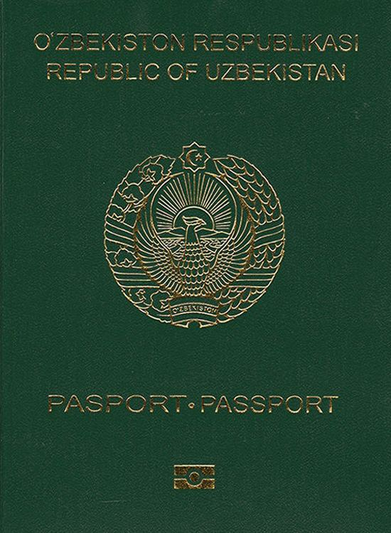  Passport | 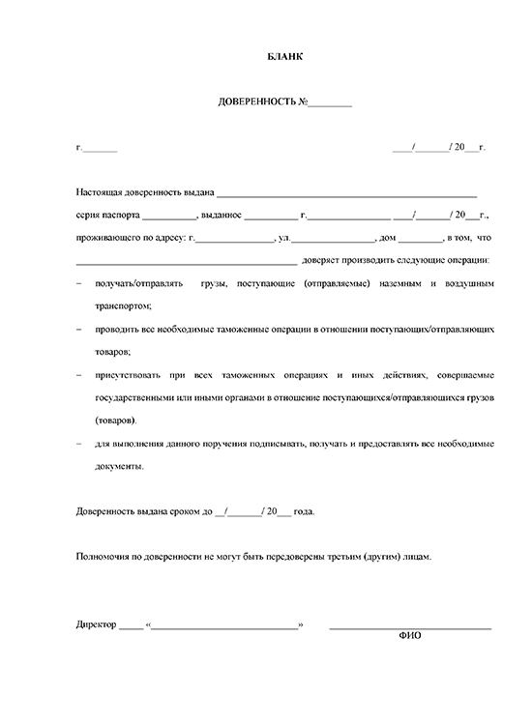  Power of attorney | 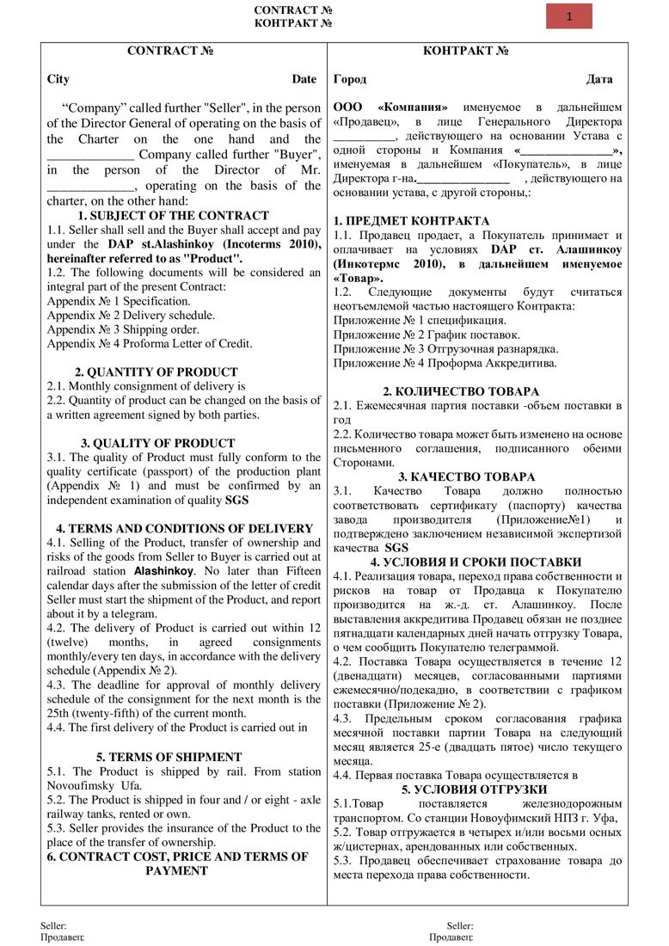  Foreign economic activity contract
Supply contract |   Tax Identification Number of the organization or individual | 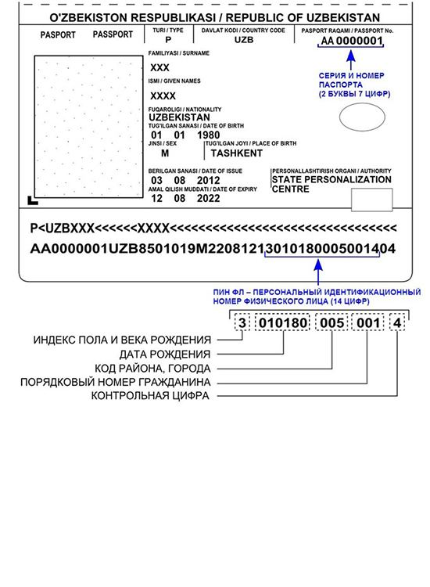  Personal identification number of an individual
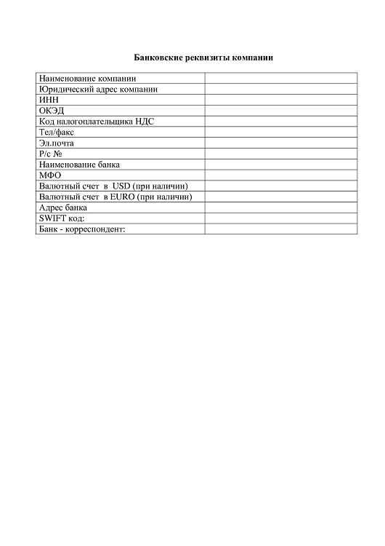  Bank details | 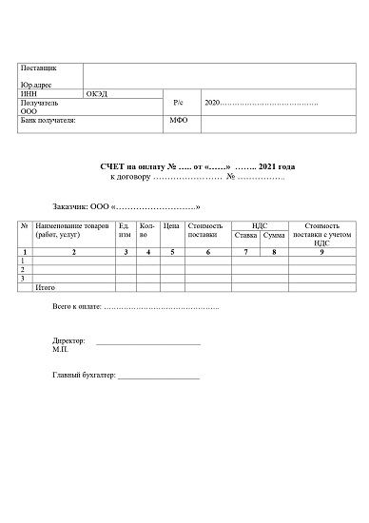  Invoice for payment | 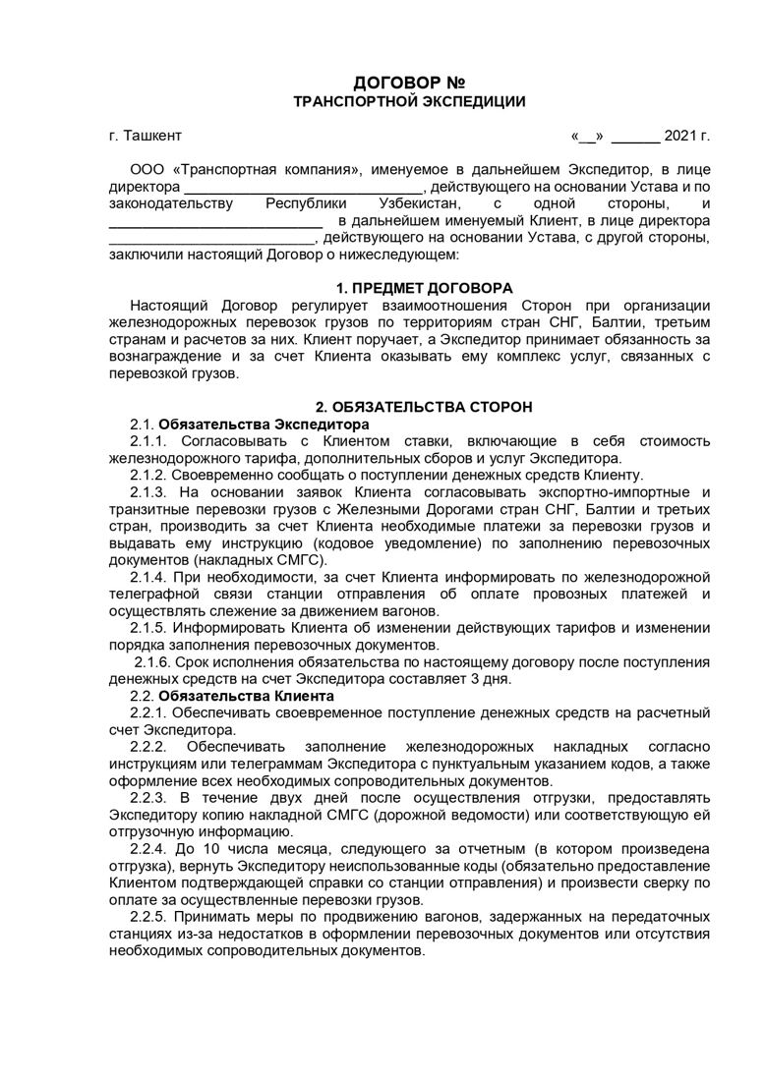  Agreement on railway transportation services
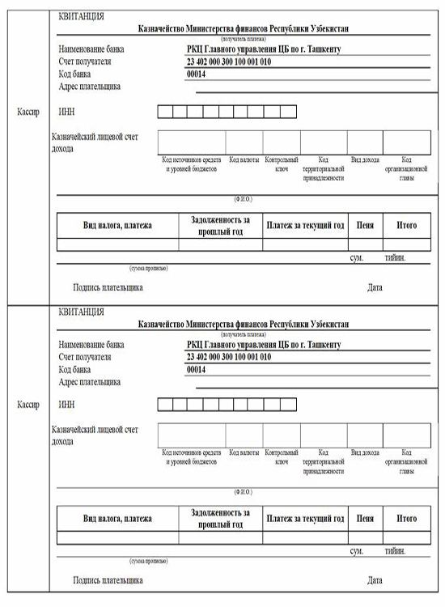  Receipt of payment | 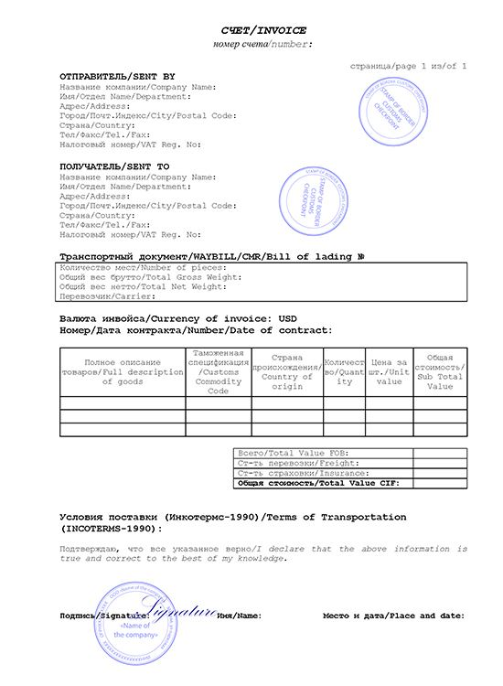  Commercial invoice | 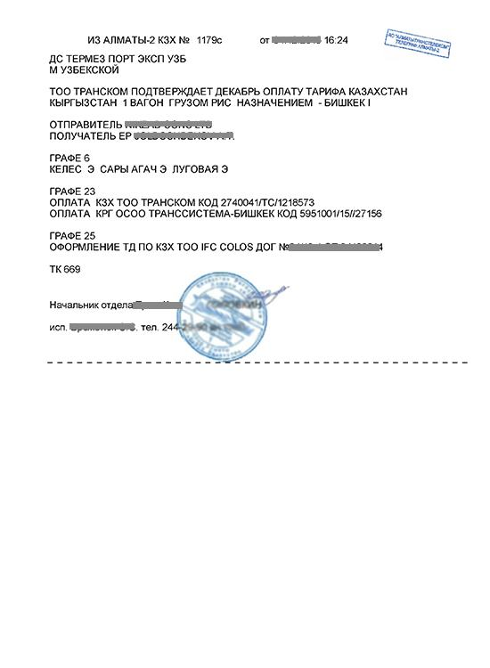  Telegram on payment for the railway tariff by telegraph
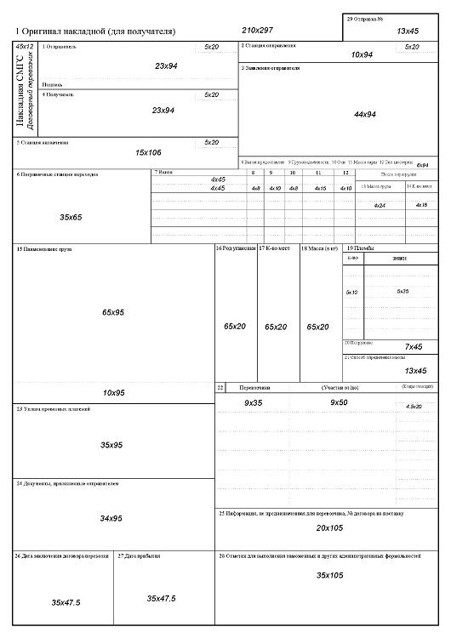  Export railway bill (SMGS) | 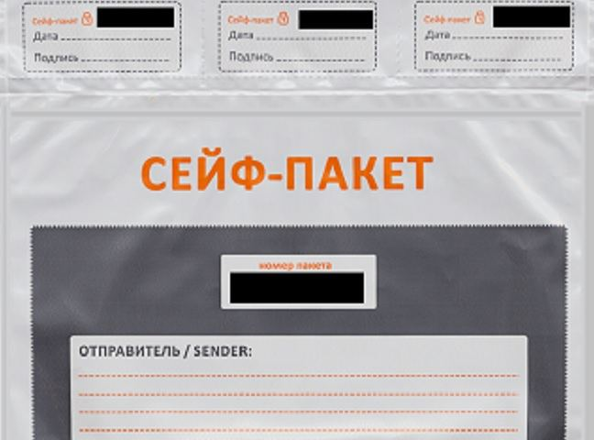  Package of documents

8. Step reference screenshots
The platform's own screen for each step, reproduced as published. These are screenshots of the eRegulations record (in Uzbek), showing contact details, expected result, requirements and price — not screenshots of the destination government service. They serve as visual provenance for the tables above.
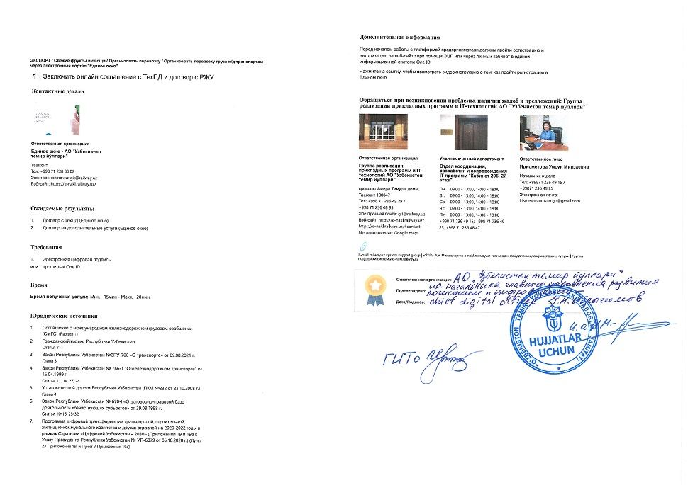  Step 1 — Conclude online agreement with Technological Center and contract with Regional railway junction | 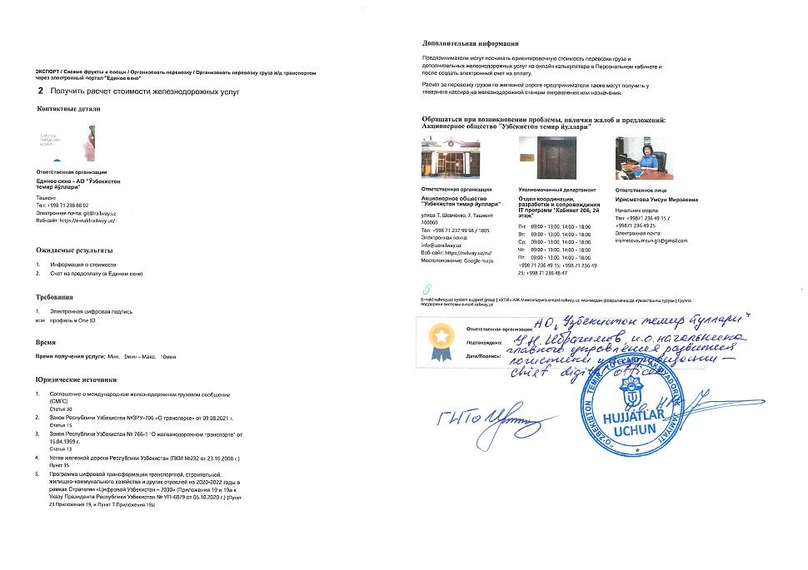  Step 2 — Obtain cost calculation for railway services
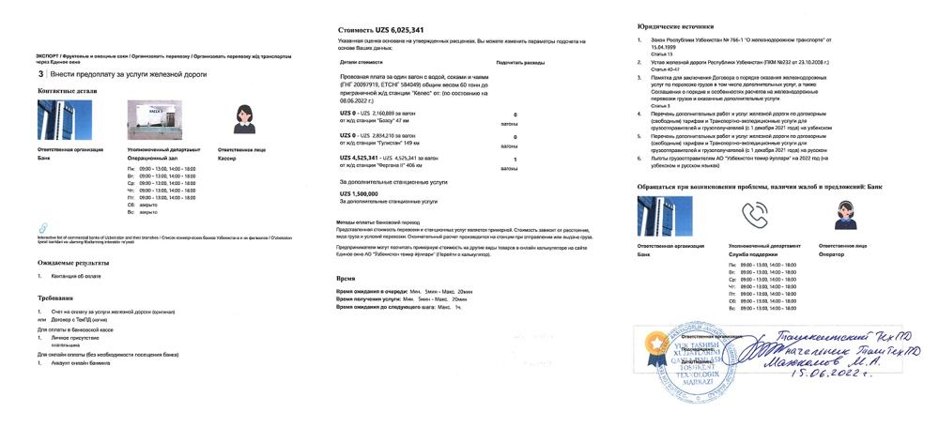  Step 3 — Prepay for railway services (juices and tea) | 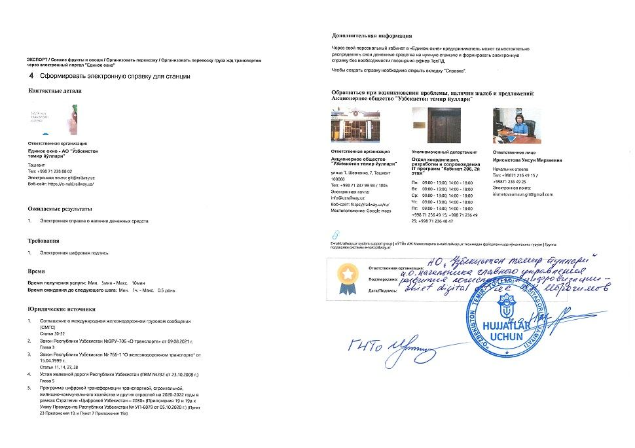  Step 4 — Generate electronic certificate for railway station
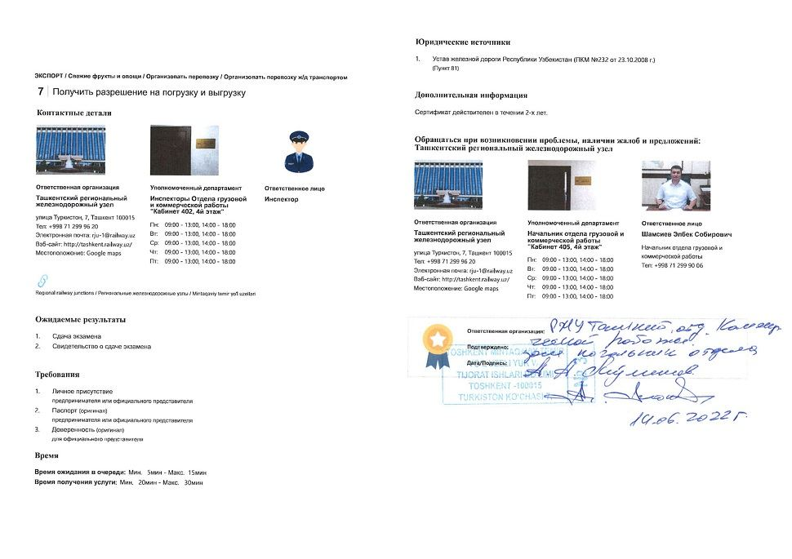  Step 5 — Obtain approval for loading and unloading | 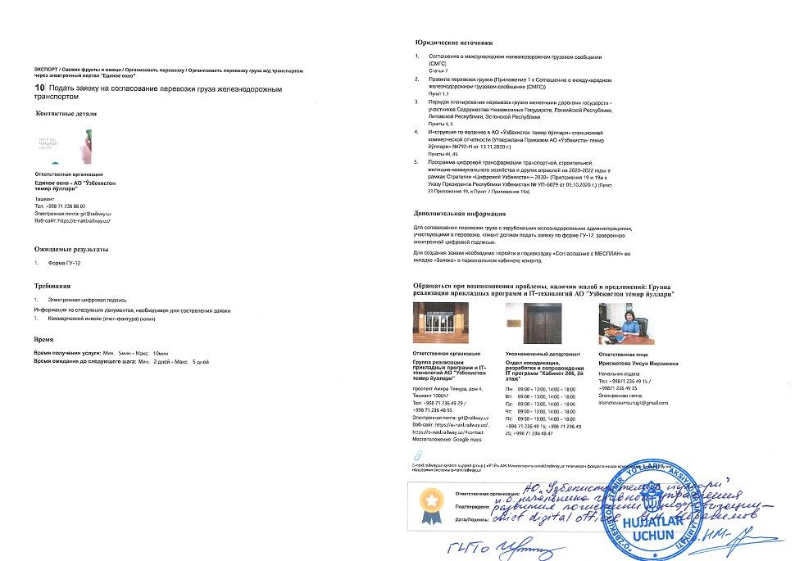  Step 10 — Apply for freight transportation by railway
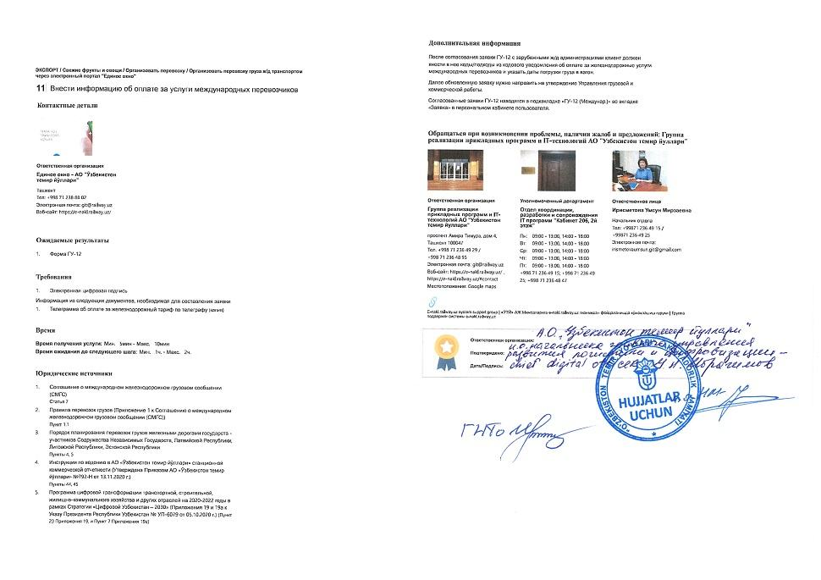  Step 11 — Add additional information on payment for international transportation | 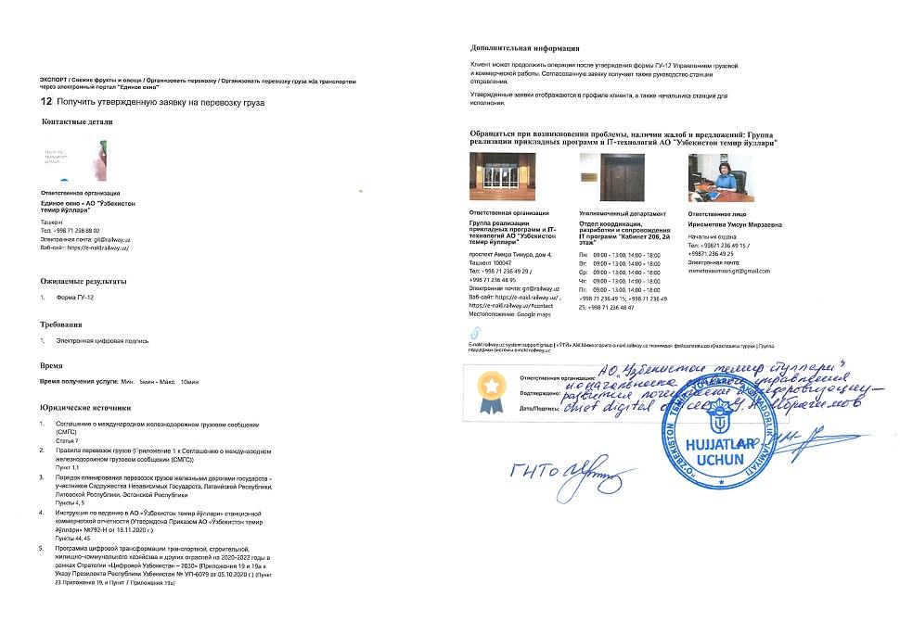  Step 12 — Obtain approved application for freight transportation
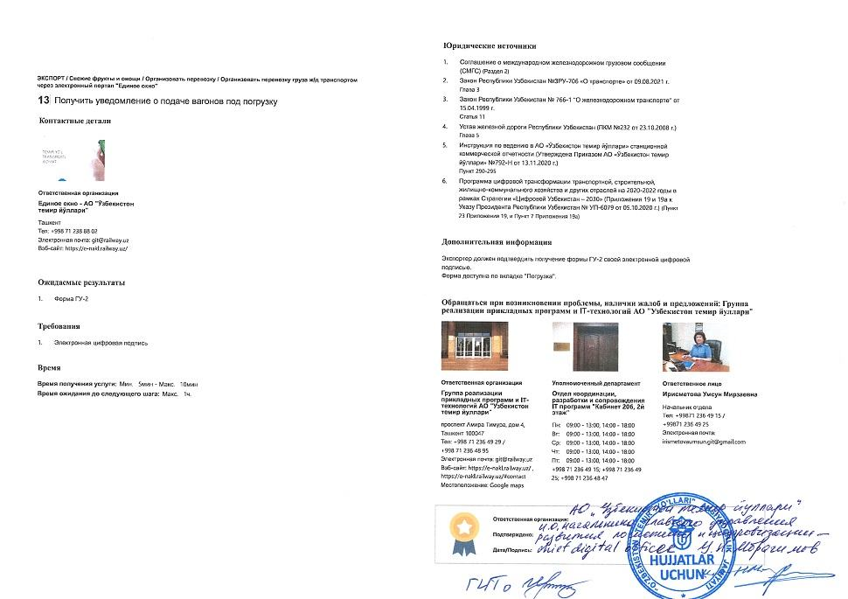  Step 13 — Obtain notification on wagons providing for loading | 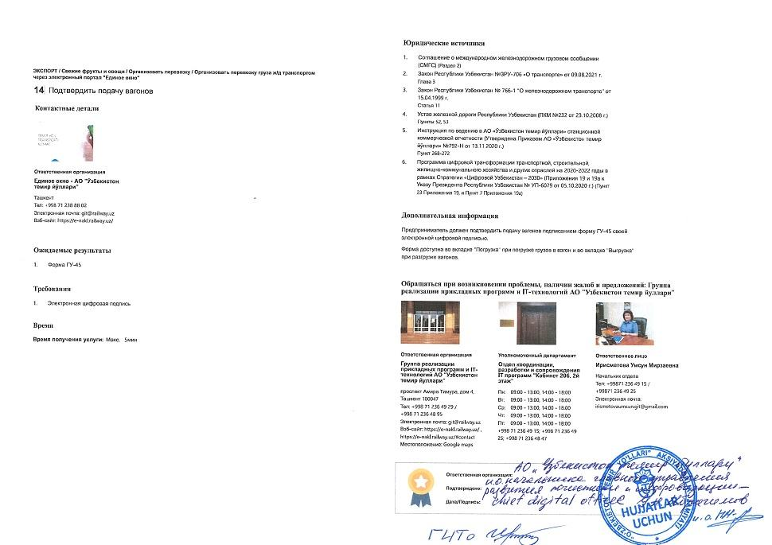  Step 14 — Confirm acceptance of wagons
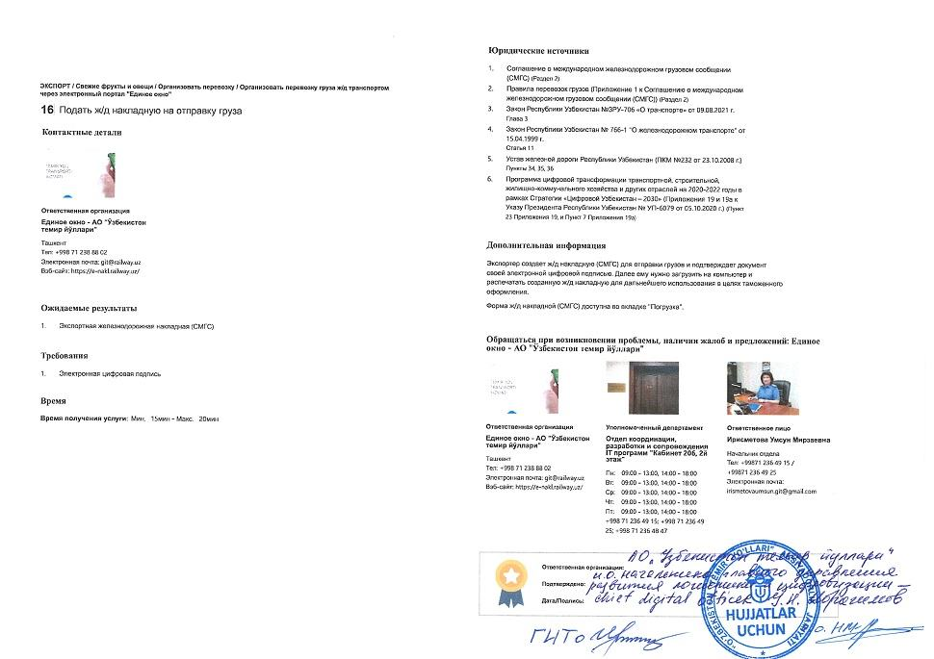  Step 16 — Submit export railway bill | 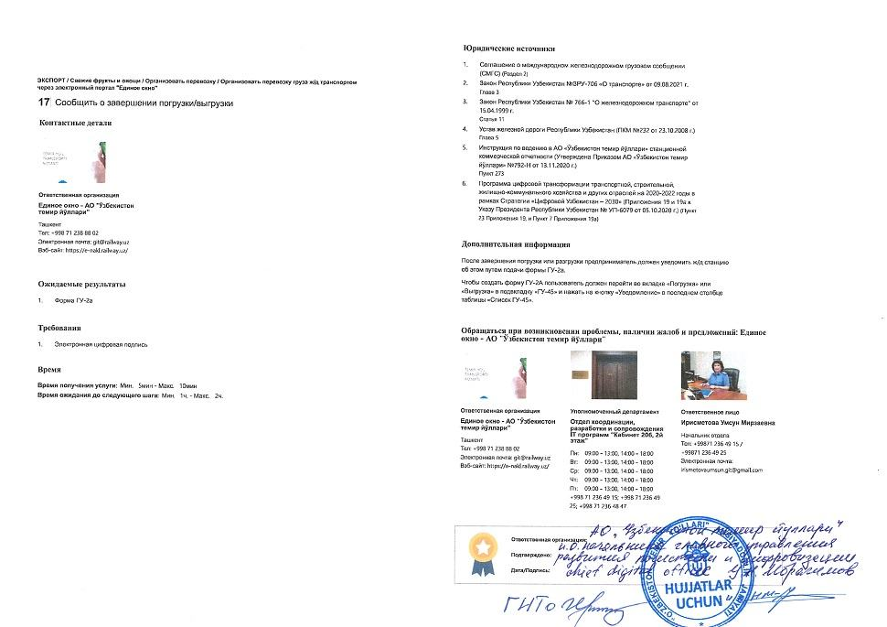  Step 17 — Inform about finishing loading/unloading procedure
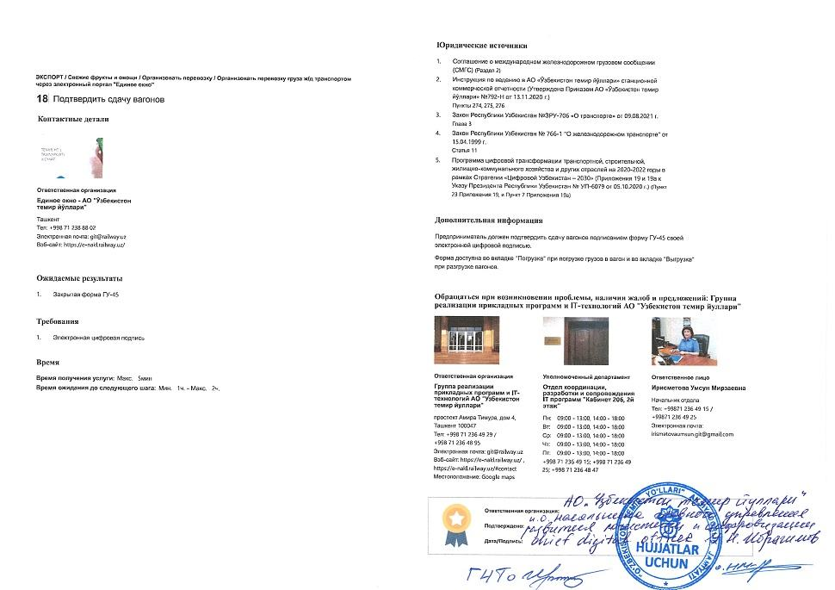  Step 18 — Confirm handover of wagons | 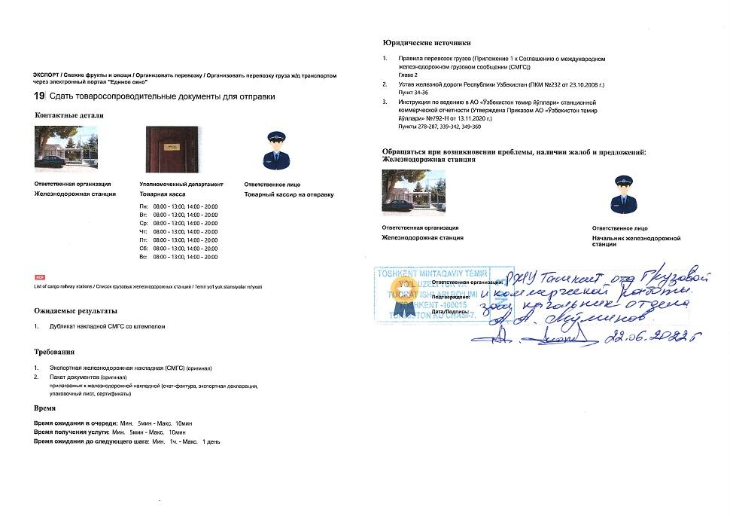  Step 19 — Dispatch freight
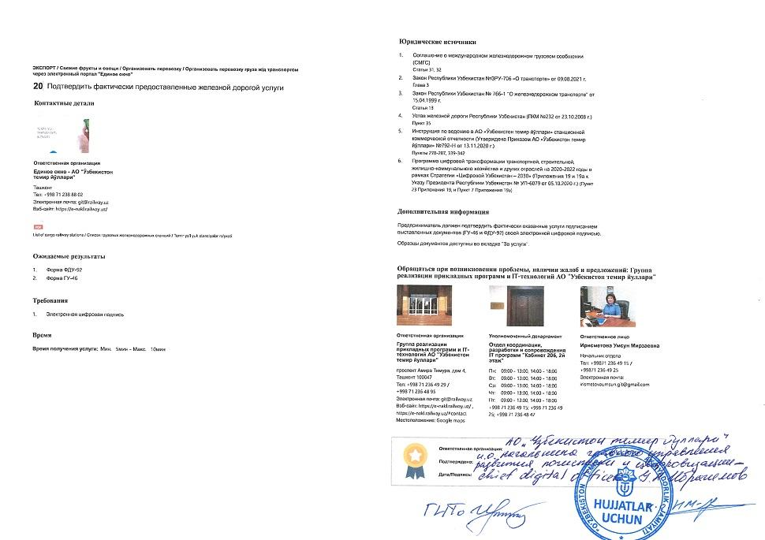
Step 20 — Confirm services actually provided by the railway

