Uzbekistan Trade Info — Procedure Automation
Procedure 924: Arrange cargo delivery by train physically
As-is process map — the procedure exactly as it runs today. Source: uztradeinfo.uz/procedure/924
Blocks | Steps | Entities | Online | Optional | Alternative
6 | 18 | 5 | 2 | 0 | 0
This process is shared by 4 published procedures — identical blocks, steps, online flags and routing. The variants differ only by commodity or contract type, so this document describes all of them.
924 — Arrange cargo delivery by train physically  1004 — Arrange cargo delivery by train physically | 1018 — Arrange cargo delivery by train physically  1034 — Arrange cargo delivery by train physically
End-to-end published timeframe: 7–27 hours.
1. Process flow
Columns group the entity in charge, so every move between columns is a handoff. The specific body is named in grey inside each box. Dashed border = optional (conditional) step. Boxes side by side = alternative routes, where the trader takes one. Heavy border = the step can be done online.
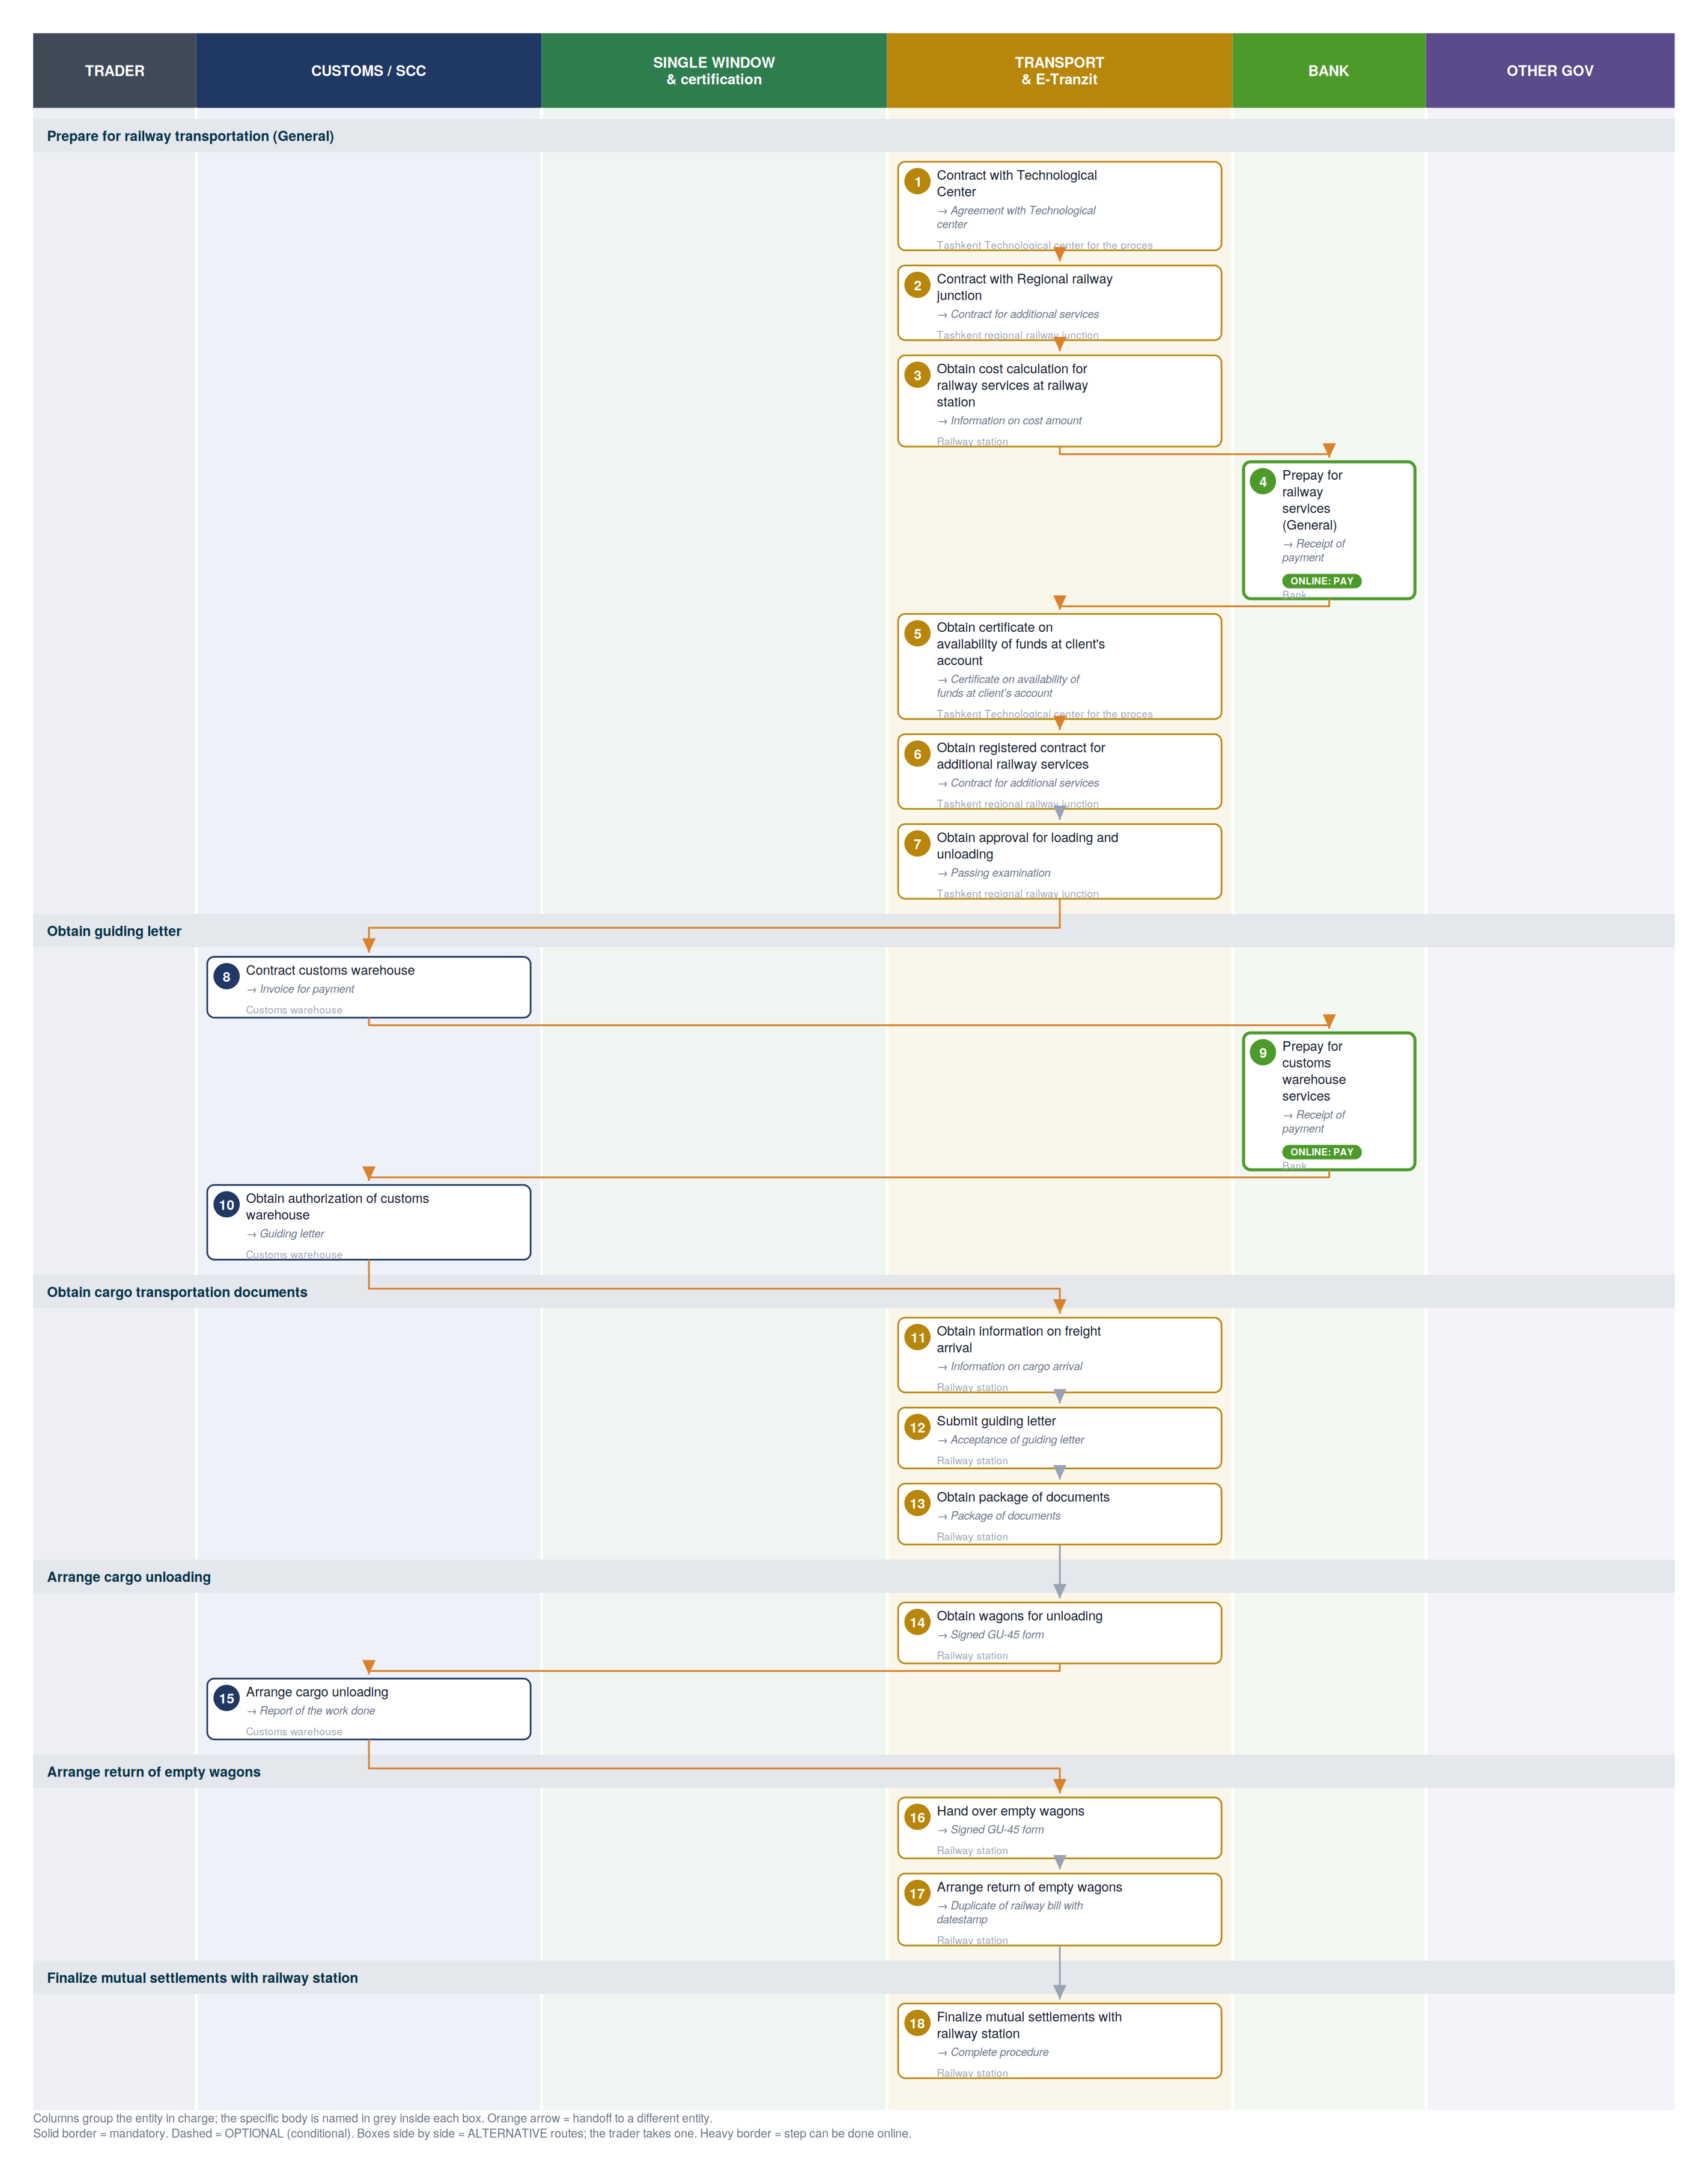

2. Where each step happens
Every step classified by channel. Online steps are performed on an external government service (the exact URL is in section 6). In-person steps happen at a physical counter, named in the “where” column.
Channel | Steps | Detail
Online — external service | 2 | Payment methods information page (2)
In person — physical counter | 16 | Tashkent Technological center for the processing of transport documents, Tashkent regional railway junction, Railway station, Customs warehouse

3. Entities in charge & contact channels
Entity | Steps | Lane | Contact channels
Tashkent Technological center for the processing of transport documents | 1, 5 | Transport & E-Tranzit | ☎ +998 71 299 97 73, +998 71 299 95 08  🌐 http://tashkent.railway.uz/uzzheldorraschet/
Tashkent regional railway junction | 2, 6, 7 | Transport & E-Tranzit | ✉ rju-1@railway.uz  ☎ +998 71 299 96 20  🌐 http://tashkent.railway.uz/en/
Railway station | 3, 11, 12, 13, 14, 16, 17, 18 | Transport & E-Tranzit | — none published —
Bank | 4, 9 | Bank | — none published —
Customs warehouse | 8, 10, 15 | Customs / SCC | — none published —

4. Step-by-step breakdown
Full sequence. Channel shows online vs in-person; Where / service names the exact website for online steps or the physical location for in-person ones; Performed by is who carries the step out. Optional and alternative steps are flagged.
# | Step | Entity in charge | Channel | Where / service | Performed by
Prepare for railway transportation (General)
1 | Contract with Technological Center  → Agreement with Technological center | Tashkent Technological center for the processing of transport documents | In person | Accounting department "Room 127, 1st Floor" | —
2 | Contract with Regional railway junction  → Contract for additional services | Tashkent regional railway junction | In person | Department on freight and commerce "Room 405, 4th Floor" | —
3 | Obtain cost calculation for railway services at railway station  → Information on cost amount | Railway station | In person | Commodity cash desk | —
4 | Prepay for railway services (General)  → Receipt of payment | Bank | Online: pay | Payment methods information page  uzbekistan.tradeportal.org | —
5 | Obtain certificate on availability of funds at client's account  → Certificate on availability of funds at client's account | Tashkent Technological center for the processing of transport documents | In person | Accounting department "Room 127, 1st Floor" | —
6 | Obtain registered contract for additional railway services  → Contract for additional services | Tashkent regional railway junction | In person | Department on freight and commerce "Room 405, 4th Floor" | —
7 | Obtain approval for loading and unloading  → Passing examination | Tashkent regional railway junction | In person | Inspectors of the Department on freight and commerce Room 402, 4th floor" | —
Obtain guiding letter
8 | Contract customs warehouse  → Invoice for payment | Customs warehouse | In person | Administration department | —
9 | Prepay for customs warehouse services  → Receipt of payment | Bank | Online: pay | Payment methods information page  uzbekistan.tradeportal.org | —
10 | Obtain authorization of customs warehouse  → Guiding letter | Customs warehouse | In person | Administration department | —
Obtain cargo transportation documents
11 | Obtain information on freight arrival  → Information on cargo arrival | Railway station | In person | Freight acceptance and handover Room | —
12 | Submit guiding letter  → Acceptance of guiding letter | Railway station | In person | Freight acceptance and handover Room | —
13 | Obtain package of documents  → Package of documents | Railway station | In person | Commodity cash desk | —
Arrange cargo unloading
14 | Obtain wagons for unloading  → Signed GU-45 form | Railway station | In person | Freight acceptance and handover Room | —
15 | Arrange cargo unloading  → Report of the work done | Customs warehouse | In person | Customs warehouse | —
Arrange return of empty wagons
16 | Hand over empty wagons  → Signed GU-45 form | Railway station | In person | Freight acceptance and handover Room | —
17 | Arrange return of empty wagons  → Duplicate of railway bill with datestamp | Railway station | In person | Commodity cash desk | —
Finalize mutual settlements with railway station
18 | Finalize mutual settlements with railway station  → Complete procedure | Railway station | In person | Commodity cash desk | —

5. Inputs required per step
Type 1 = the trader supplies it from outside the procedure. Type 2 = produced by an earlier step, so it is a dependency the agent can track.
1. Contract with Technological Center
- Physical presence [trader supplies]
2. Contract with Regional railway junction
- Physical presence [trader supplies]
3. Obtain cost calculation for railway services at railway station
- Physical presence [trader supplies]
- Commercial invoice [trader supplies]
4. Prepay for railway services (General)
- Invoice for payment for railway services [trader supplies]
- Agreement with Technological center [trader supplies]
- For physical payment [trader supplies]
- Physical presence [trader supplies]
- For online payment (without necessity to visit a bank) [trader supplies]
- Online banking account [trader supplies]
5. Obtain certificate on availability of funds at client's account
- For concluding agreement with the Technical Center [trader supplies]
- Agreement with Technological center [trader supplies]
- Application for conclusion of agreement with Technological Center [trader supplies]
- Certificate of state registration [trader supplies]
- Passport [trader supplies]
- Power of attorney for railway station [trader supplies]
- Passport [trader supplies]
6. Obtain registered contract for additional railway services
- Physical presence [trader supplies]
- Contract for additional services [trader supplies]
7. Obtain approval for loading and unloading
- Physical presence [trader supplies]
- Passport [trader supplies]
- Power of attorney [trader supplies]
8. Contract customs warehouse
- Physical presence [trader supplies]
- Passport [trader supplies]
- Power of attorney [trader supplies]
- Certificate of state registration [trader supplies]
9. Prepay for customs warehouse services
- Invoice for payment [trader supplies]
- For physical payment [trader supplies]
- Physical presence [trader supplies]
- For online payment (without necessity to visit a bank) [trader supplies]
- Online banking account [trader supplies]
10. Obtain authorization of customs warehouse
- Guiding letter (template) [trader supplies]
- Letter to railway station [trader supplies]
11. Obtain information on freight arrival
- Availability by phone [trader supplies]
12. Submit guiding letter
- Guiding letter [trader supplies]
- Letter to railway station [trader supplies]
13. Obtain package of documents
- Guiding letter [trader supplies]
- Certificate on availability of funds at client's account [trader supplies]
- Passport [trader supplies]
- Power of attorney for railway station [trader supplies]
14. Obtain wagons for unloading
- Physical presence [trader supplies]
15. Arrange cargo unloading
- Physical presence [trader supplies]
- Power of attorney [trader supplies]
- Certificate on passing examination [trader supplies]
16. Hand over empty wagons
- Physical presence [trader supplies]
- Application for wagon handover [trader supplies]
17. Arrange return of empty wagons
- Physical presence [trader supplies]
- Application for returning empty wagons [trader supplies]
- Instruction on completing railway bill [trader supplies]
- Export railway bill (SMGS) [trader supplies]
18. Finalize mutual settlements with railway station
- Physical presence [trader supplies]
- Import railway bill [trader supplies]

6. Online service redirects
Every online step in this procedure sends the trader to an external government service. These are the exact destinations — the redirect targets an agent (or a person) would need to reach.
# | Step | Action | Service URL
4 | Prepay for railway services (General) | pay | Payment methods information page  https://uzbekistan.tradeportal.org/menu/22
9 | Prepay for customs warehouse services | pay | Payment methods information page  https://uzbekistan.tradeportal.org/menu/22
Distinct services in this procedure: Payment methods information page (2)

7. Document samples
Specimen images of the documents this procedure requires, published by the platform. Duplicates across steps are shown once. 16 distinct documents.
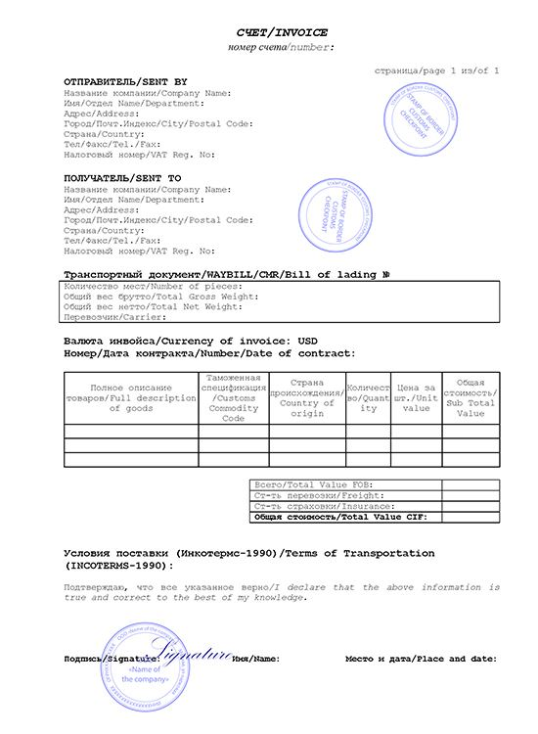  Commercial invoice | 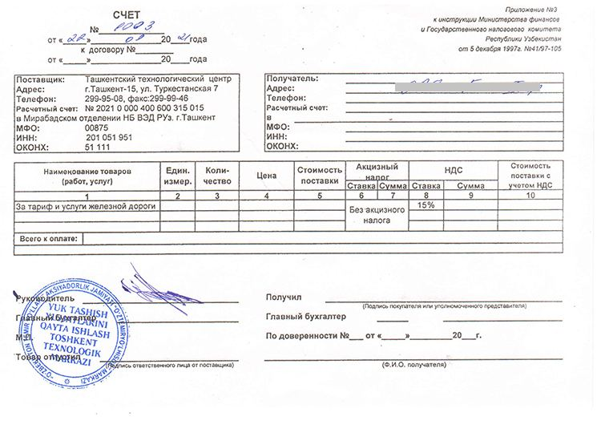  Invoice for payment for railway services | 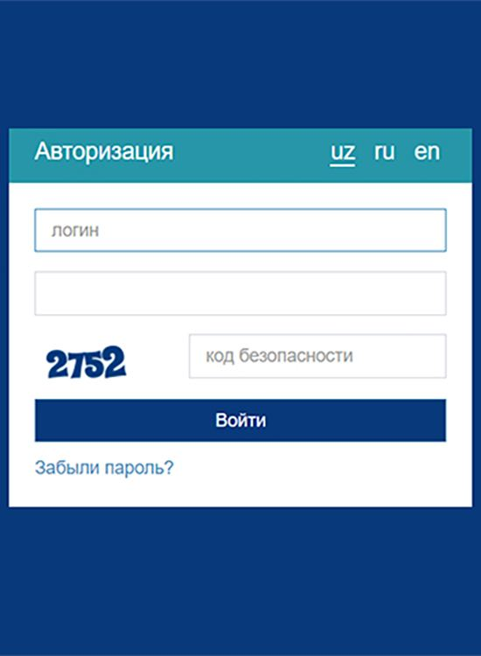  Online banking account
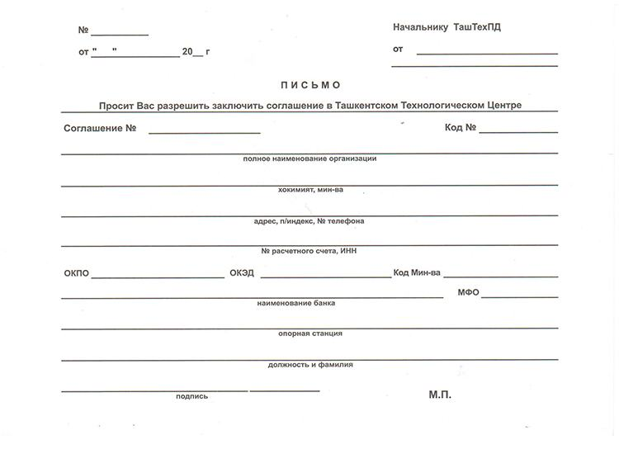  Application for conclusion of agreement with Technological Center | 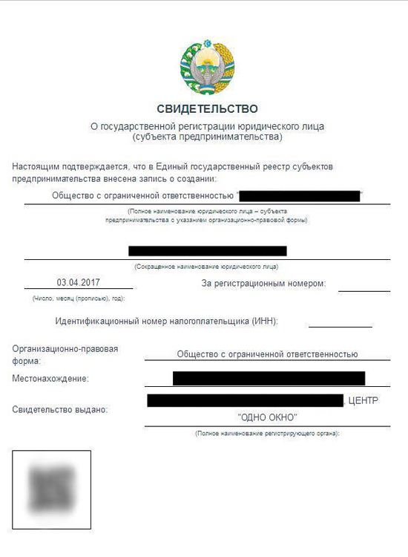  Certificate of state registration |   Passport
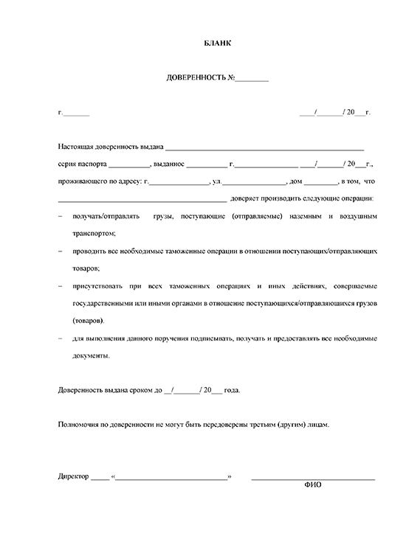  Power of attorney | 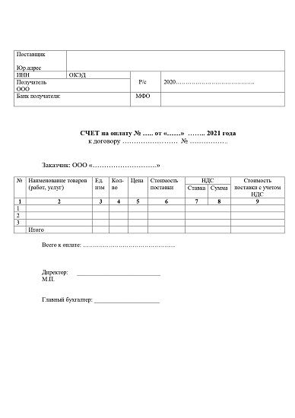  Invoice for payment |   Availability by phone
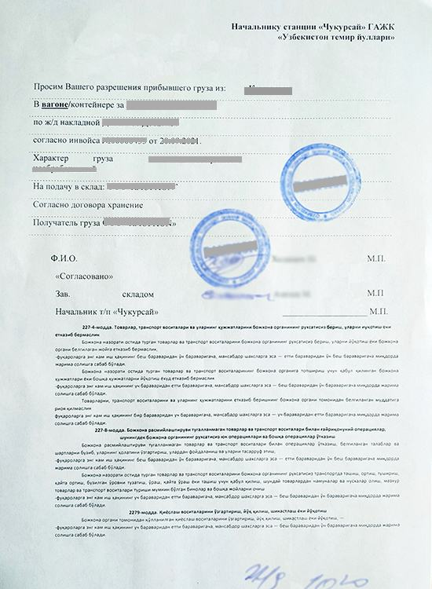  Guiding letter | 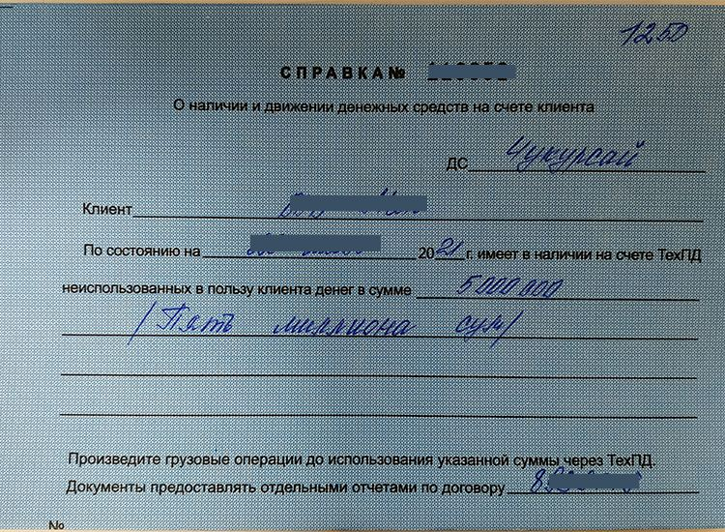  Certificate on availability of funds at client's account | 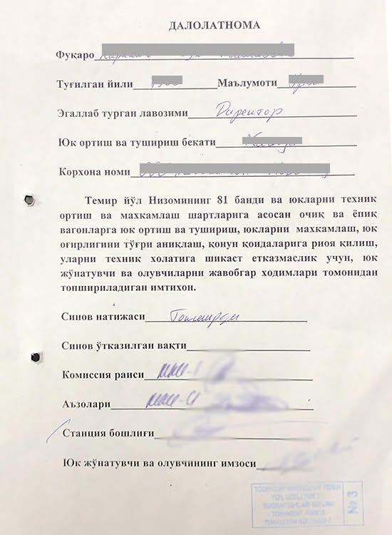  Certificate on passing examination
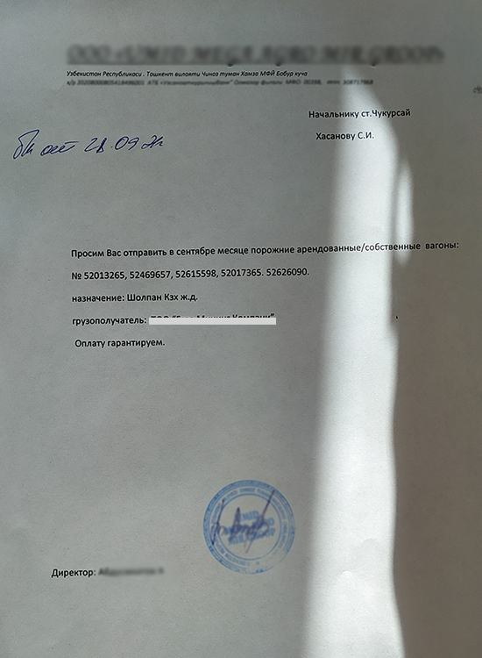  Application for returning empty wagons | 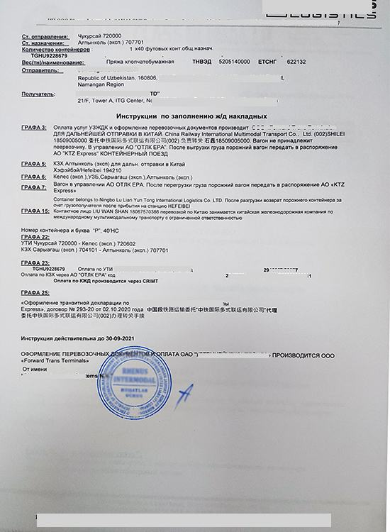  Instruction on completing railway bill | 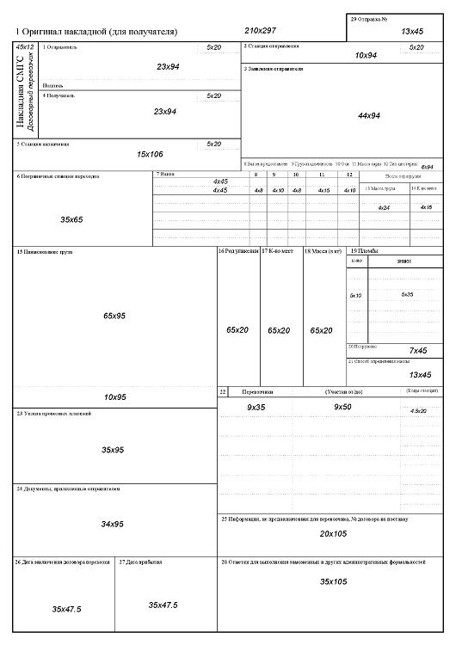  Export railway bill (SMGS)
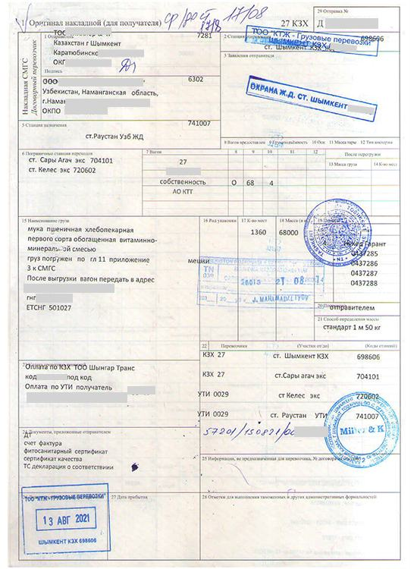
Import railway bill

8. Step reference screenshots
The platform's own screen for each step, reproduced as published. These are screenshots of the eRegulations record (in Uzbek), showing contact details, expected result, requirements and price — not screenshots of the destination government service. They serve as visual provenance for the tables above.
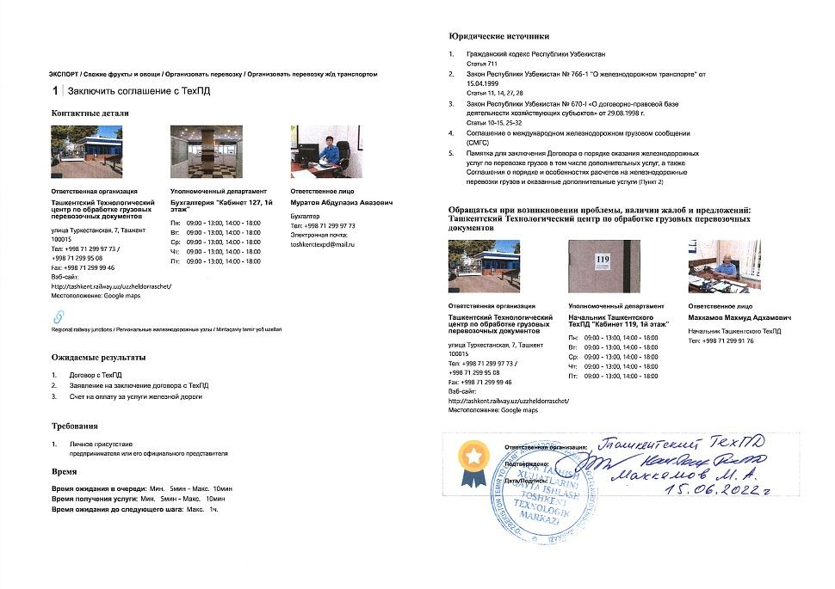  Step 1 — Contract with Technological Center | 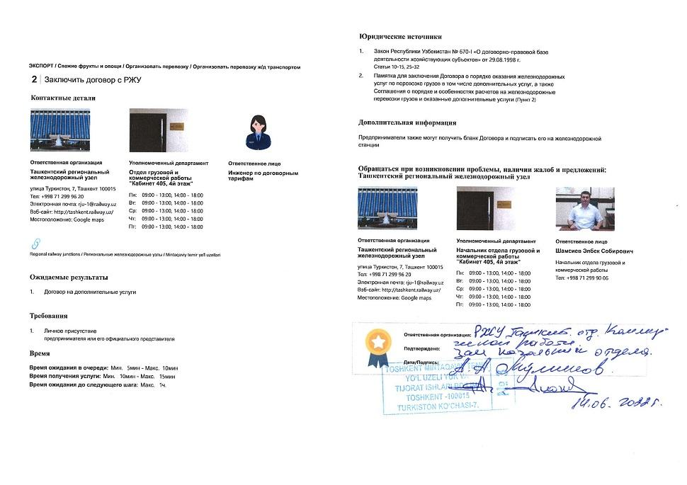  Step 2 — Contract with Regional railway junction
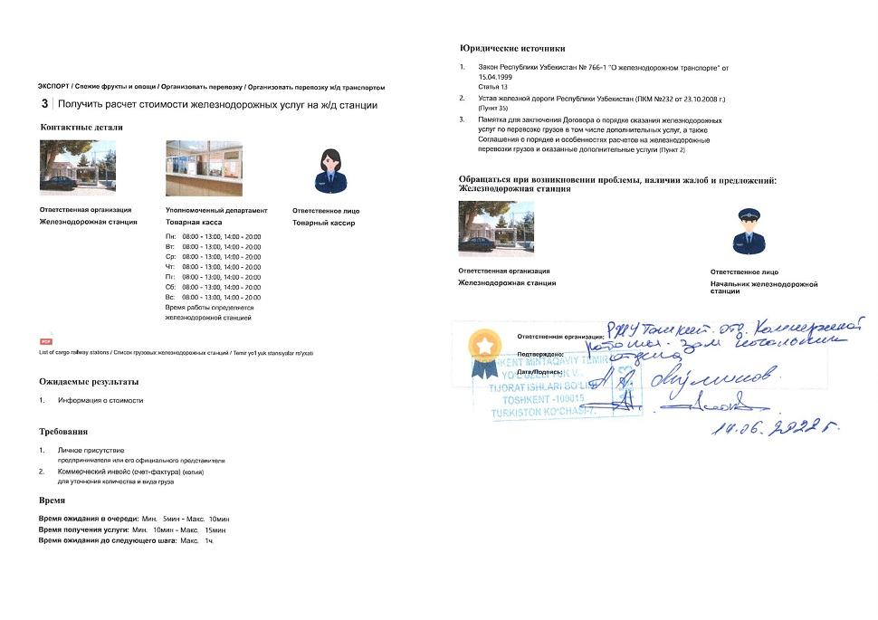  Step 3 — Obtain cost calculation for railway services at railway station | 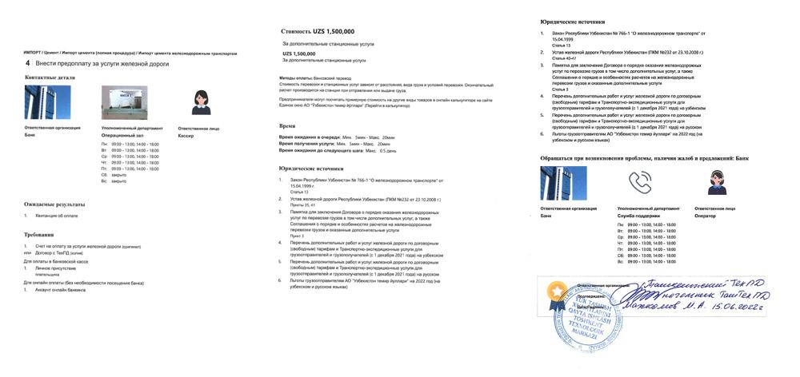  Step 4 — Prepay for railway services (General)
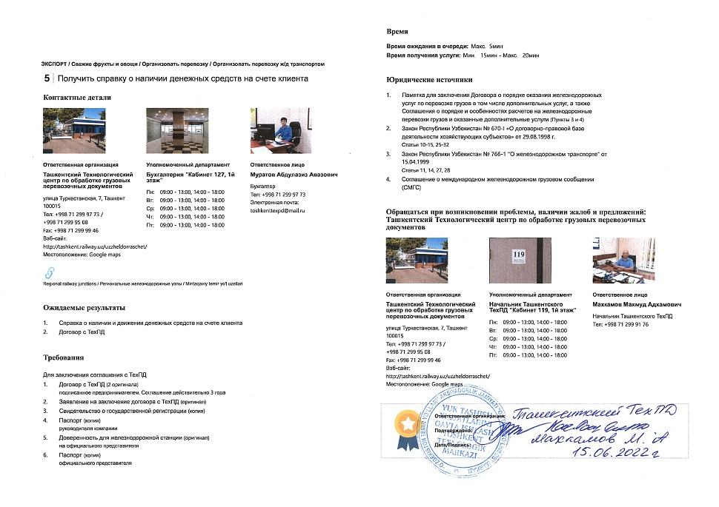  Step 5 — Obtain certificate on availability of funds at client's account | 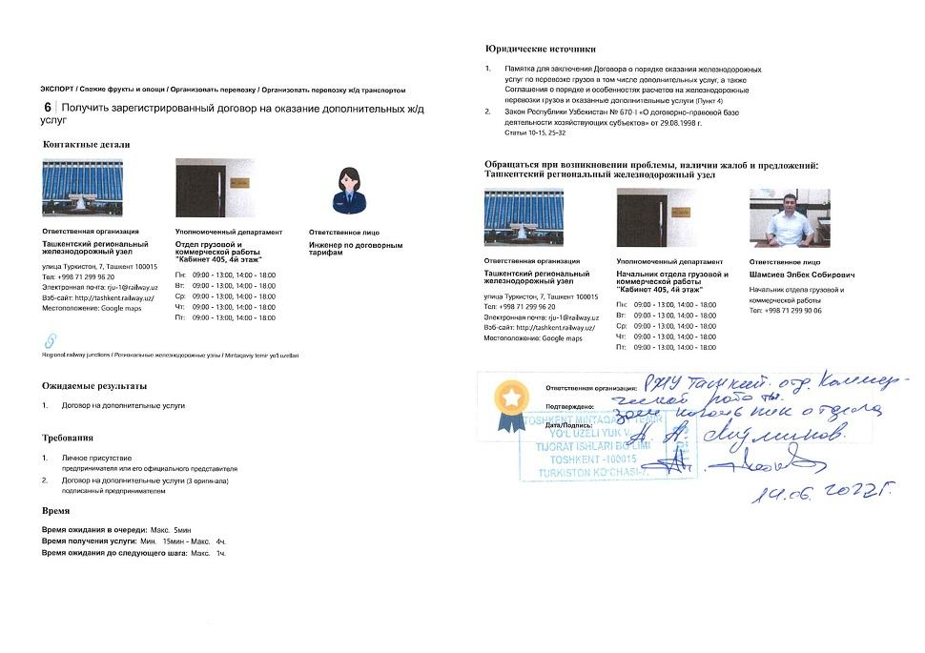  Step 6 — Obtain registered contract for additional railway services
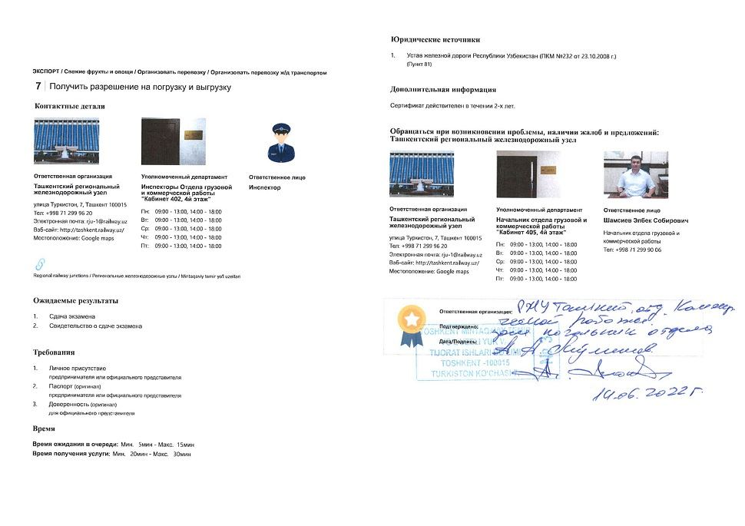  Step 7 — Obtain approval for loading and unloading | 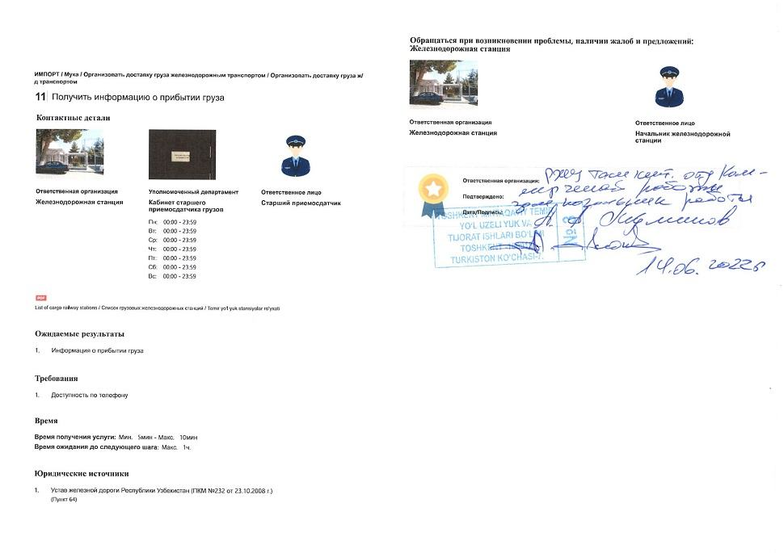  Step 11 — Obtain information on freight arrival
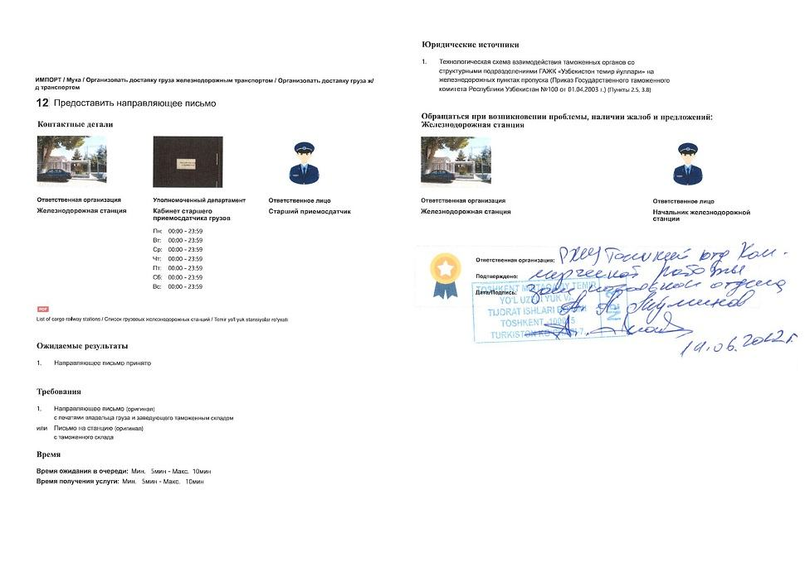  Step 12 — Submit guiding letter | 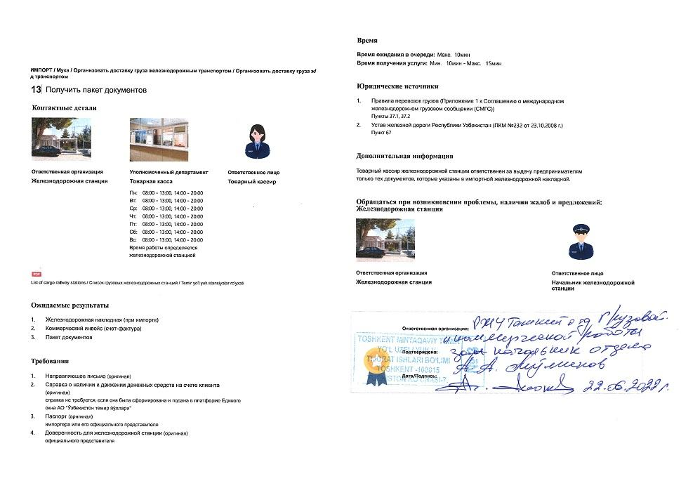  Step 13 — Obtain package of documents
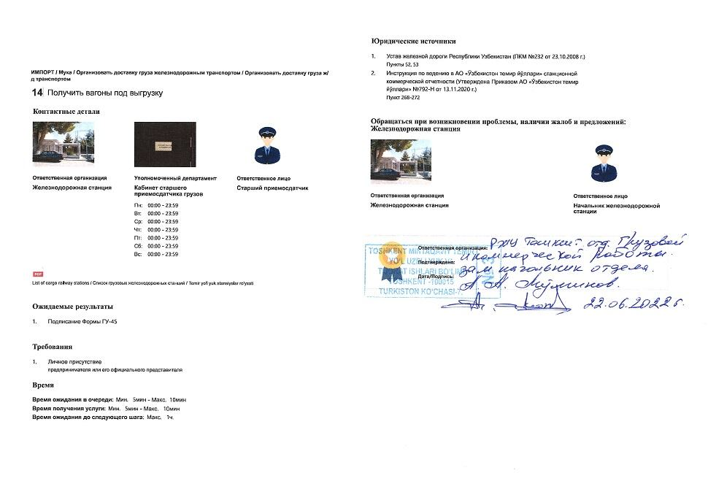  Step 14 — Obtain wagons for unloading | 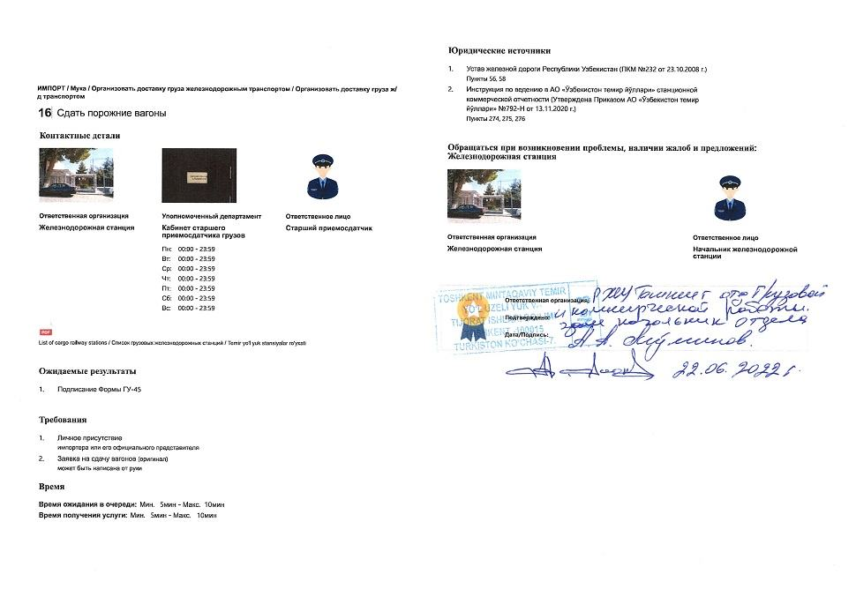  Step 16 — Hand over empty wagons
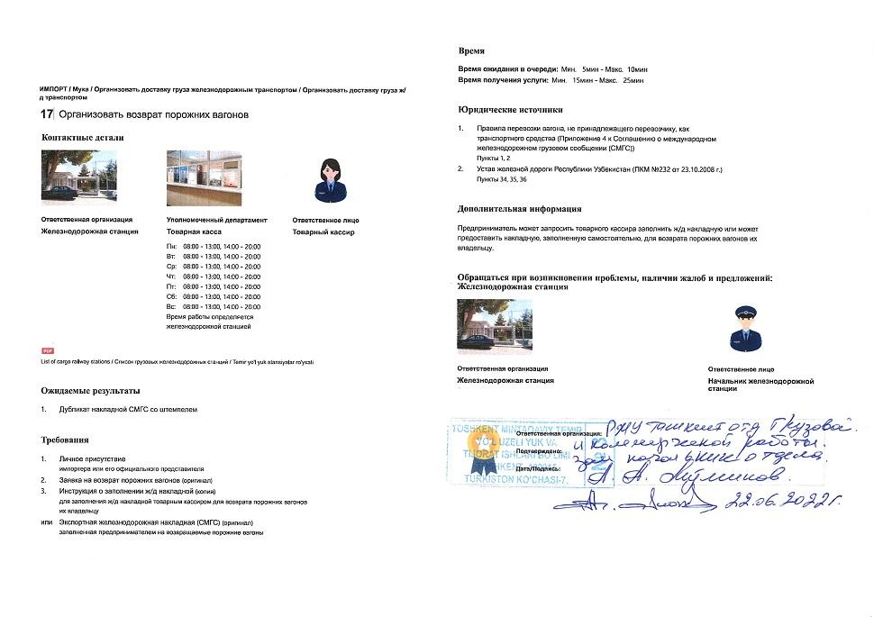  Step 17 — Arrange return of empty wagons | 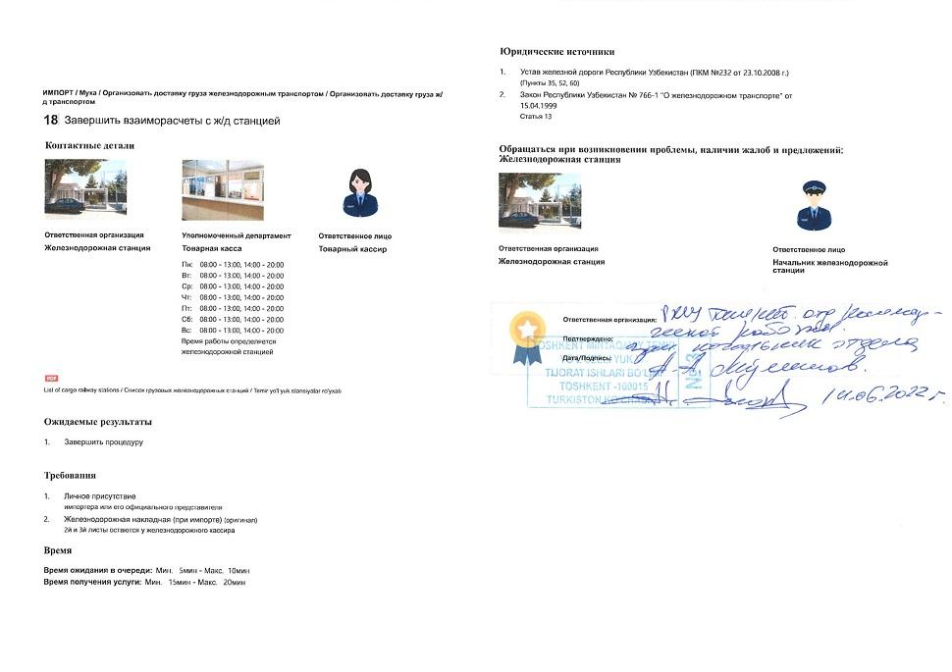  Step 18 — Finalize mutual settlements with railway station

