Deploying Flask App with NGINX
What we’ll Do
--------------

1. Create a simple Flask app

2. Dockerize the Flask app

3. Push the image (use local Minikube image)

4. Write Kubernetes manifests:
* Deployment for Flask app

* Deployment for NGINX as a reverse proxy

* Services to expose both

**Prerequisites:**

Before we begin, we should ensure that we have the following:
* A machine running Linux, macOS, or Windows.
* A hypervisor, such as VirtualBox or KVM, is installed on our machine. If we’re using Windows, we can use Hyper-V instead.
* A shell environment, such as Bash or PowerShell.
* curl installed on our machine.

Install Minikube:
For Linux run:
curl -Lo minikube https://storage.googleapis.com/minikube/releases/latest/minikube-linux-amd64
chmod +x minikube
sudo mv minikube /usr/local/bin/

Install VirtualBox:
for linux
sudo apt install virtualbox virtualbox-ext-pack

Install `kubectl`:
sudo apt install -y kubectl

**start minikube**
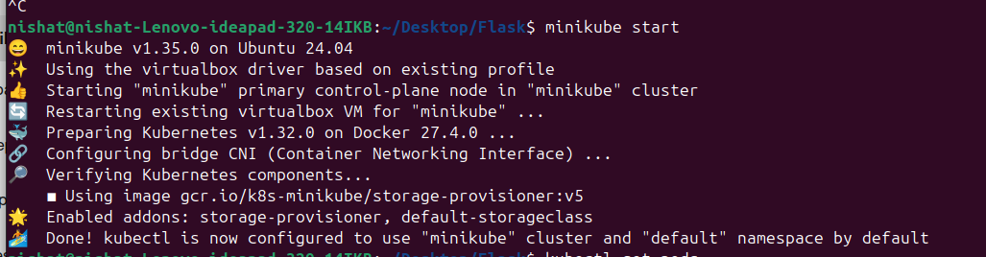

1.Create a Simple Flask App
-------------------------------

**`app.py`:**

from flask import Flask
app = Flask(__name__)

@app.route('/')
def hello():
return "Hello from Flask in Kubernetes!"

if __name__ == '__main__':
app.run(host='0.0.0.0', port=5000)

**`requirements.txt`:**

Flask==2.2.2

* * *

2.Dockerize the Flask App
-----------------------------

**`Dockerfile`:**

FROM python:3.9-slim

WORKDIR /app

COPY requirements.txt .
RUN pip install -r requirements.txt

COPY app.py .

CMD ["python", "app.py"]

### Build Docker Image in Minikube

Set your environment to Minikube:

eval $(minikube docker-env)

Then build the image:

docker build -t flask-app:latest .

Check that it's available:

docker images

* * *

3.Kubernetes Manifests
--------------------------

### A. Flask Deployment & Service

**`flask-deployment.yaml`:**

apiVersion: apps/v1
kind: Deployment
metadata:
name: flask-deployment
spec:
replicas: 1
selector:
matchLabels:
app: flask
template:
metadata:
labels:
app: flask
spec:
containers:
- name: flask
image: flask-app:latest
ports:
- containerPort: 5000
---
apiVersion: v1
kind: Service
metadata:
name: flask-service
spec:
selector:
app: flask
ports:
- protocol: TCP
port: 5000
targetPort: 5000

Apply:

kubectl apply -f flask-deployment.yaml

* * *

### B. NGINX ConfigMap

**`nginx-config.yaml`:**

apiVersion: v1
kind: ConfigMap
metadata:
name: nginx-config
data:
default.conf: |
server {
listen 80;
location / {
proxy_pass http://flask-service:5000;
}
}

Apply:

kubectl apply -f nginx-config.yaml

* * *

### C. NGINX Deployment & Service

**`nginx-deployment.yaml`:**

apiVersion: apps/v1
kind: Deployment
metadata:
name: nginx-deployment
spec:
replicas: 1
selector:
matchLabels:
app: nginx
template:
metadata:
labels:
app: nginx
spec:
containers:
- name: nginx
image: nginx:latest
ports:
- containerPort: 80
volumeMounts:
- name: nginx-config-volume
mountPath: /etc/nginx/conf.d
volumes:
- name: nginx-config-volume
configMap:
name: nginx-config
---
apiVersion: v1
kind: Service
metadata:
name: nginx-service
spec:
type: NodePort
selector:
app: nginx
ports:
- protocol: TCP
port: 80
targetPort: 80
nodePort: 30080

Apply:

kubectl apply -f nginx-deployment.yaml

* * *

4.Access the App
--------------------

Get the Minikube IP:

minikube ip

Visit the app in browser:

http://<minikube-ip>:30080

You should seethe result:

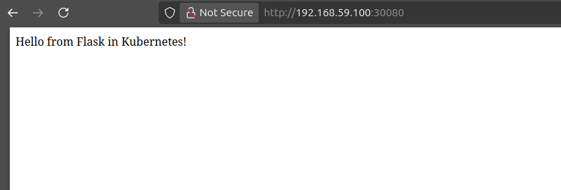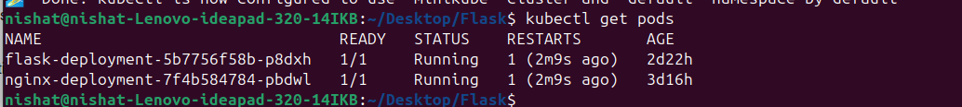
**Git Url:** https://dev.azure.com/fronturetech/Fronture%20ERP/_git/hands-on-lab-nishat?version=GBKubernetes&_a=contents

**references**:
https://www.baeldung.com/ops/minikube-getting-started
https://medium.com/@kadampritesh46/getting-started-with-kubernetes-a-step-by-step-guide-using-minikube-e88867296bcb
## **What is helm**
One of the key challenges of traditional deployment is repetition. Engineers are often required to duplicate YAML files for each environment and then manually modify values such as the number of replicas, image versions, or ports. This process is not only time-consuming but also error-prone, especially when changes must be applied consistently across different environments. Additionally, the traditional method lacks built-in version control for configuration changes, making it harder to track or roll back deployments if something goes wrong.

To address these limitations, Helm was introduced as a package manager for Kubernetes. Helm simplifies the deployment process by allowing engineers to use templated YAML files bundled together in what’s called a Helm chart. A Helm chart is a structured collection of files that can be reused and customized through a single `values.yaml` file. Instead of manually editing each YAML file, engineers can define key configuration values like image tags, replica counts, and service types in `values.yaml`, and Helm automatically applies those values to the templates during deployment.

## **Deploy flask app with helm using NodePort service**
## **Prerequisites**

Make sure the following are installed and configured:

- [ ] Docker

- [ ] Minikube

- [ ] Helm

- [ ] kubectl

**A Flask app already created and Dockerized** **and Minikube is started in previous part**
https://dev.azure.com/fronturetech/Fronture%20ERP/_wiki/wikis/Fronture-ERP.wiki/347/Deploying-flask-app-using-kubernetes

_Note:_ If you build docker image directly, the image will be registered to your computer local docker repository, which cannot be accessed by the Minikube. Therefore, we have to build the image into Minikube’s docker repository.

**Now A Helm chart was created using:**

>helm create flask-app-helm

This creates a directory structure like:

flask-app-helm/
├── charts/
├── templates/
│ ├── deployment.yaml
│ ├── service.yaml
│ ├── hpa.yaml (optional)
│ ├── ingress.yaml (optional)
│ └── serviceaccount.yaml
├── values.yaml
├── Chart.yaml

## **Customize Helm Chart**
_**in Chart.yaml file**_

Edit metadata fields like name and version.

>apiVersion: v2
name: flask-app-helm
description: A Helm chart for Flask application
version: 0.1.0

https://dev.azure.com/fronturetech/Fronture%20ERP/_git/hands-on-lab-nishat?path=/flask-app-helm/Chart.yaml

_**in values.yaml**_

Edit content of values.yaml:

>replicaCount: 1
image:
repository: flask-app
tag: latest
pullPolicy: Never
service:
type: NodePort
port: 5000
nodePort: 30088

https://dev.azure.com/fronturetech/Fronture%20ERP/_git/hands-on-lab-nishat?path=/flask-app-helm/values.yaml

_**in deployment.yaml**_

Ensure image and port match your Flask app Docker config.
https://dev.azure.com/fronturetech/Fronture%20ERP/_git/hands-on-lab-nishat?path=/flask-app-helm/templates/deployment.yaml

_**Install Helm Chart**_

Navigate to the directory containing the Helm chart:

cd ~/Desktop/Flask/flask-app-helm

_Now Install the Helm chart:_

>>helm install flask-app . --create-namespace --namespace flask-app

If successful, you’ll see output including deployment notes.

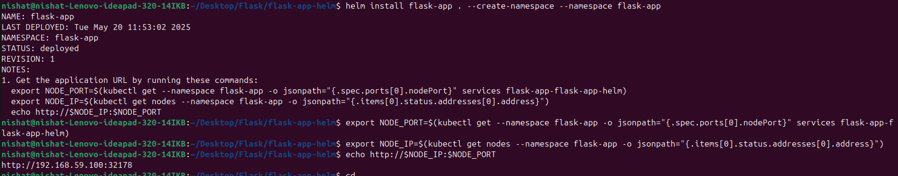Run the following to get the service IP and port:

>export NODE_PORT=$(kubectl get --namespace flask-app -o jsonpath="{.spec.ports[0].nodePort}" services flask-app-flask-app-helm)

>export NODE_IP=$(kubectl get nodes --namespace flask-app -o jsonpath="{.items[0].status.addresses[0].address}")

>echo http://NODE_IP:$NODE_PORT

Open the output URL in your browser. You should see the Flask app running.
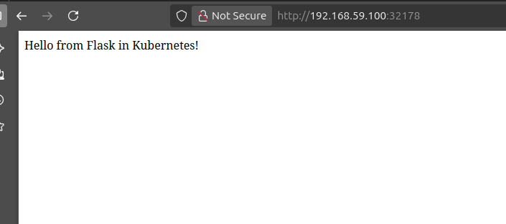
## Additional Test:
_**Helm Testing**_
Helm lets you write simple Kubernetes Jobs to verify your app after installation. This is useful for CI/CD and production readiness.
>helm test flask-app --namespace flask-app
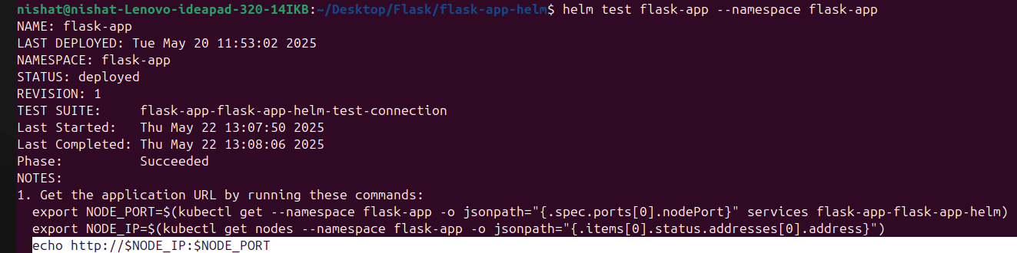
_**Multiple Environments (dev, staging, prod)**_
Helm enables us to just use one template for different environments like dev, test, prod etc. based to different _values.yaml_ for platform resources
Create files:
* `values-dev.yaml` : https://dev.azure.com/fronturetech/Fronture%20ERP/_git/hands-on-lab-nishat?path=/flask-app-helm/values-dev.yaml

* `values-staging.yaml` : https://dev.azure.com/fronturetech/Fronture%20ERP/_git/hands-on-lab-nishat?path=/flask-app-helm/values-staging.yaml

* `values-prod.yaml` : https://dev.azure.com/fronturetech/Fronture%20ERP/_git/hands-on-lab-nishat?path=/flask-app-helm/values-prod.yaml

**Install helm for each environment:**

`helm install flask-dev ./flask-app-helm --namespace dev --create-namespace -f values-dev.yaml`

`helm install flask-staging ./flask-app-helm --namespace staging --create-namespace -f values-staging.yaml`

`helm install flask-prod ./flask-app-helm --namespace prod --create-namespace -f values-prod.yaml`

**Check helm releases:**
`helm list -A`

**Verify They Are Working**
>kubectl get all -n dev
kubectl get all -n staging
kubectl get all -n prod

You can access each app using Minikube and its assigned NodePort:
>minikube service --url -n dev flask-dev
minikube service --url -n staging flask-staging
minikube service --url -n prod flask-prod

you can upgrade your helm release. for example here we are updating staging release.
>helm upgrade flask-staging . -n staging -f values-staging.yaml
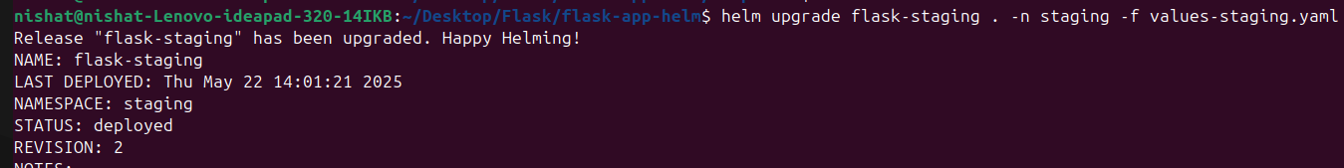

## **Summary**

Using Helm, you packaged your Flask application into a chart and deployed it to Minikube. This method abstracts the complexity of raw YAML files and provides better maintainability and environment flexibility through values.yaml.

Repo:https://dev.azure.com/fronturetech/Fronture%20ERP/_git/hands-on-lab-nishat?path=/flask-app-helm

reference: https://siweheee.medium.com/deploy-your-programs-onto-minikube-with-docker-and-helm-a68097e8d545

Deploy multiple Flask applications on Kubernetes using Helm chart-

first we used NodePort service. previous task: https://dev.azure.com/fronturetech/Fronture%20ERP/_wiki/wikis/Fronture-ERP.wiki/349/Helm

**Nodeport Limitations**
- Each app requires a unique port.

- Not scalable for many apps.

- No path-based routing.

now we are migrating to Ingress for better routing and scalability.
_**Ingress Service with Multiple Apps**_

Now we will-
- Deploy two Flask apps using a single Helm chart.

- Use Ingress for routing based on URL paths.

- Manage everything using variables in values.yaml.

**Structure**

**values.yaml:** https://dev.azure.com/fronturetech/Fronture%20ERP/_git/hands-on-lab-nishat?path=/flask-helloApp-chart/values.yaml

apps:
- name: hello1
image: flask-hello1:h1
containerPort: 5000
path: /hello1

- name: hello2
image: flask-hello2:h2
containerPort: 5000
path: /hello2

**Key Templates**

**deployment.yaml:** https://dev.azure.com/fronturetech/Fronture%20ERP/_git/hands-on-lab-nishat?path=/flask-helloApp-chart/templates/deployment.yaml

{{- range .Values.apps }} //loop through multiple app
apiVersion: apps/v1
kind: Deployment
metadata:
name: {{ .name }}
spec:
replicas: 1
selector:
matchLabels:
app: {{ .name }}
template:
metadata:
labels:
app: {{ .name }}
spec:
containers:
- name: {{ .name }}
image: {{ .image }}
ports:
- containerPort: {{ .containerPort }}

{{- end }}

**service.yaml:** https://dev.azure.com/fronturetech/Fronture%20ERP/_git/hands-on-lab-nishat?path=/flask-helloApp-chart/templates/service.yaml

{{- range .Values.apps }} //loop through multiple app
apiVersion: v1
kind: Service
metadata:
name: {{ .name }}
spec:
selector:
app: {{ .name }}
ports:
- protocol: TCP
port: 80
targetPort: {{ .containerPort }}

{{- end }}

**ingress.yaml:** https://dev.azure.com/fronturetech/Fronture%20ERP/_git/hands-on-lab-nishat?path=/flask-helloApp-chart/templates/ingress.yaml

apiVersion: networking.k8s.io/v1
kind: Ingress
metadata:
name: flask-ingress
spec:
rules:
- http:
paths:
{{- range .Values.apps }}
- path: {{ .path }}
pathType: Prefix
backend:
service:
name: {{ .name }}
port:
number: 80
{{- end }}

**_Now Apps Access Method_**

**Enable ingress:**

>minikube addons enable ingress

Our customized host name: hello-app.local
minikube Ip : 192.168.59.100
for setting customized host name :
Add the hosts entry:
echo "192.168.59.100 hello-app.local" | sudo tee -a /etc/hosts
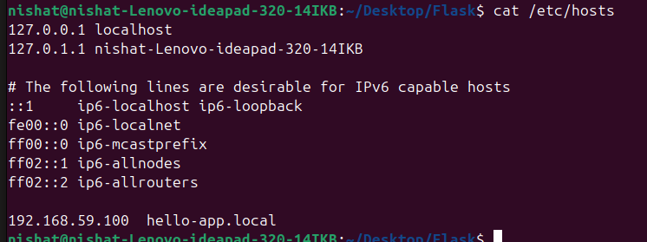
**Remember to add this host name at value.yaml file**
>ingress:
host: "hello-app-local.dev"

**Then access via:**

http://hello-app.local/hello1
http://hello-app.local/hello2
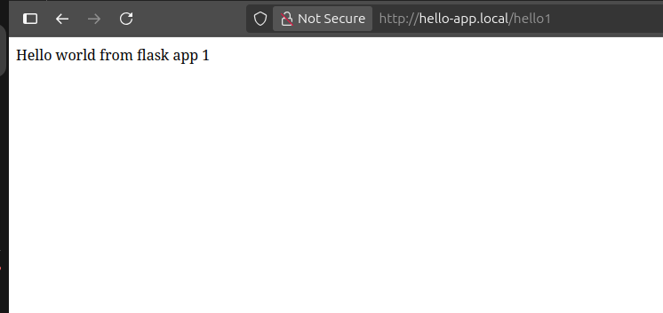

**Advantages**

- One Ingress handles multiple apps.

- Clean path-based routing.

- Easier to scale and manage.

