# **Ansible Hands-On Setup and Apache Install, uninstall**

Open a terminal and navigate to the directory where you want to set up your Ansible project.
Create a new directory for Ansible controller machiene by running the command mkdir ansible-controller

Make sure to authenticate with gcloud:
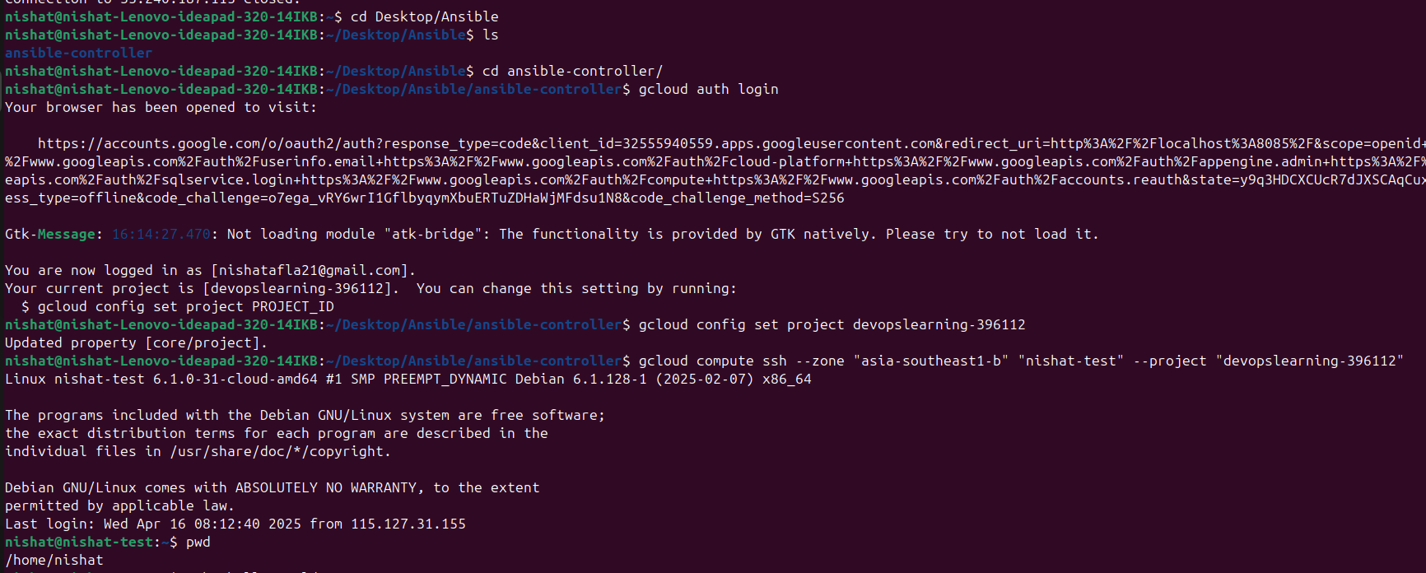
>>gcloud auth login

set the project:

>>gcloud config set project devopslearning-396112

Then run:

>>gcloud compute ssh --zone "asia-southeast1-b" "nishat-test" --project "devopslearning-396112"

Once the VM is up and running, connect to it using SSH
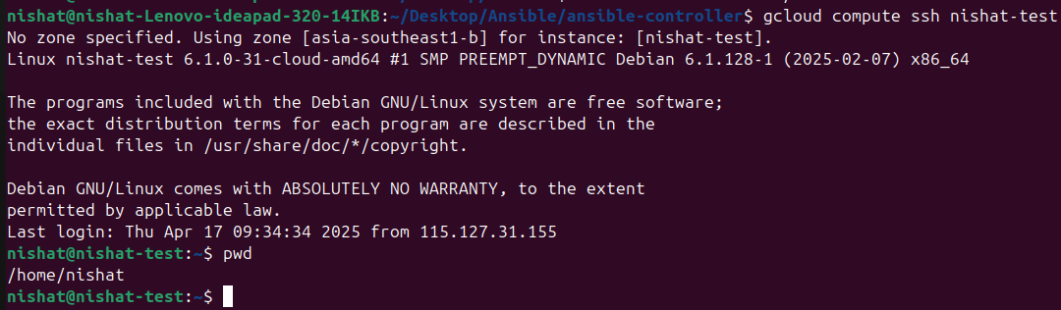>>gcloud compute ssh nishat-test --zone "asia-southeast1-b" --project "devopslearning-396112"

now install ansible in controller VM. check - ansible --version
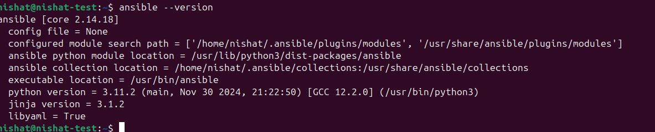
Update package list:

>>sudo apt update

Install Ansible:

>>sudo apt install -y ansible

Check installation:

>>ansible --version

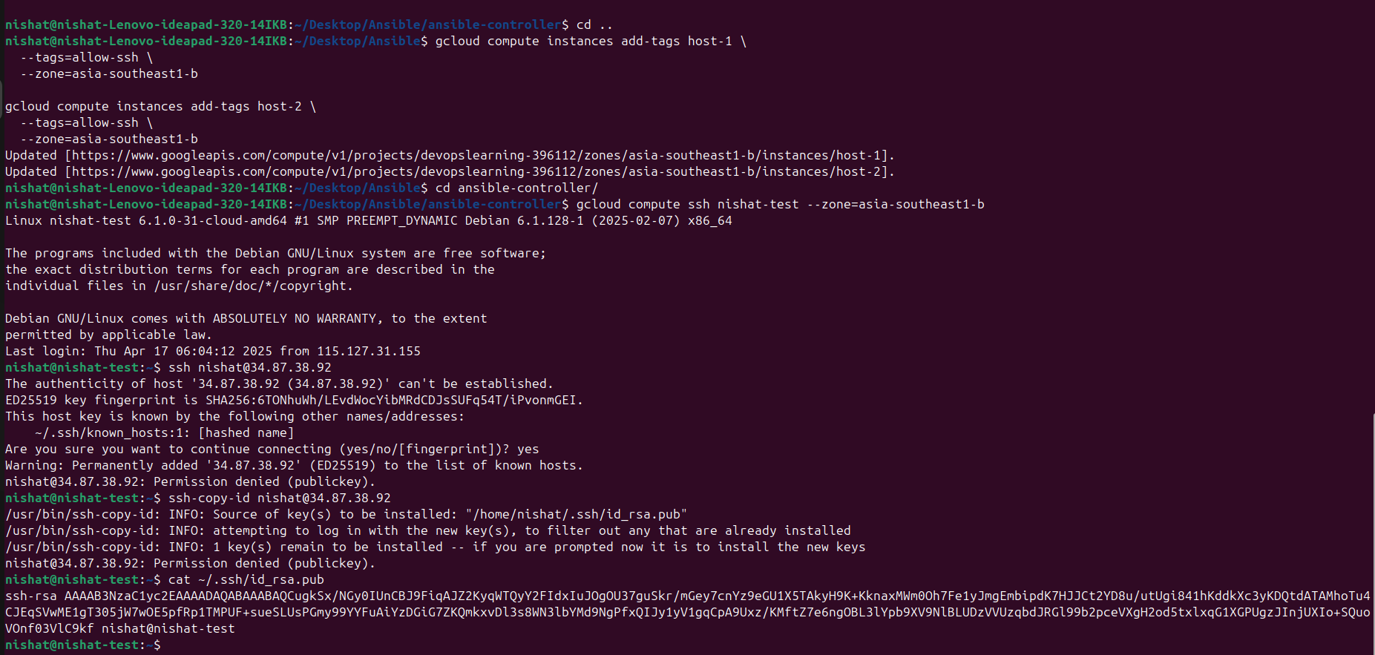
now for connecting controller to host machine
Generate SSH Key Pair for host vm

>>ssh-keygen -t rsa -b 2048

View and Copy the generate Public Key
>>cat ~/.ssh/id_rsa.pub

Then go to gcp, click on host vm , go to edit and in ssh key paste it
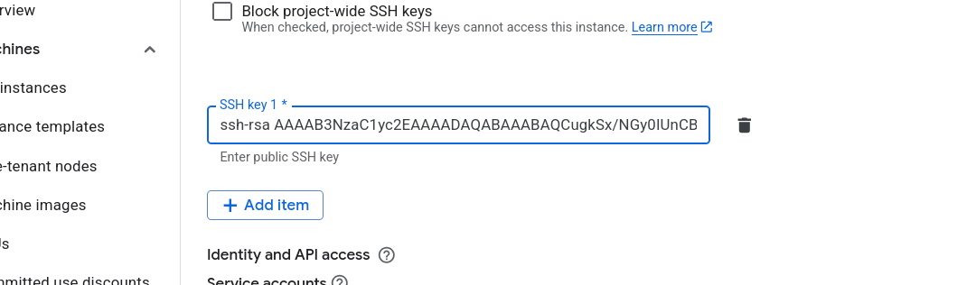
Now check both host vm got connected or not
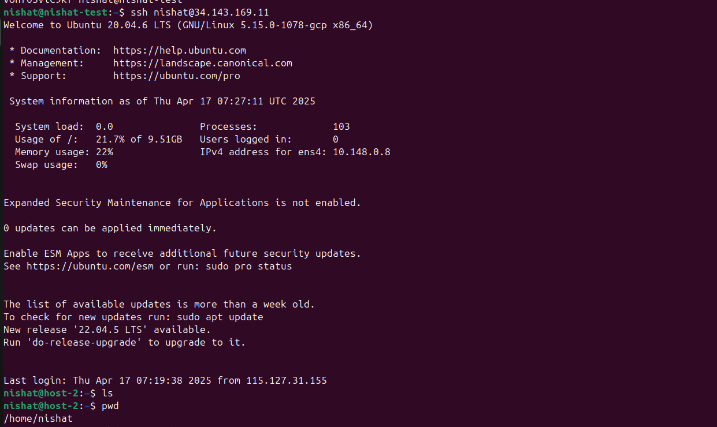command: ssh <your username>@<vm external ip address>

- [ ] Navigate to the controller host and create a ansible-project directory and create a new file called
-hosts by running the command touch hosts

- [ ] Create a new file called playbook.yml. This file will contain the tasks
you want to perform on your managed hosts.
As of now the hosts and the playbook file are empty
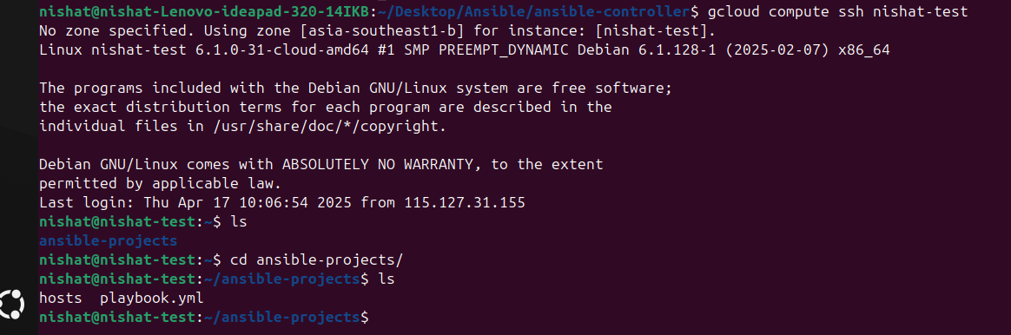
Connect to the ansible controller VM
write in the hosts file to add the IP addresses or hostnames of
the machines you want to control. For example:
Ansible hosts file
[host-1]
10.148.0.7

[host-2]
10.148.0.8
**But The efficient way to handle all the hosts at once is using one variable name.
example:
[host_VMs]
10.148.0.7
10.148.0.8
10.148.0.9**

Finally Run the command ansible all -m ping -i hosts to test the connection
to the host machines.

## For installing apache to host machine**
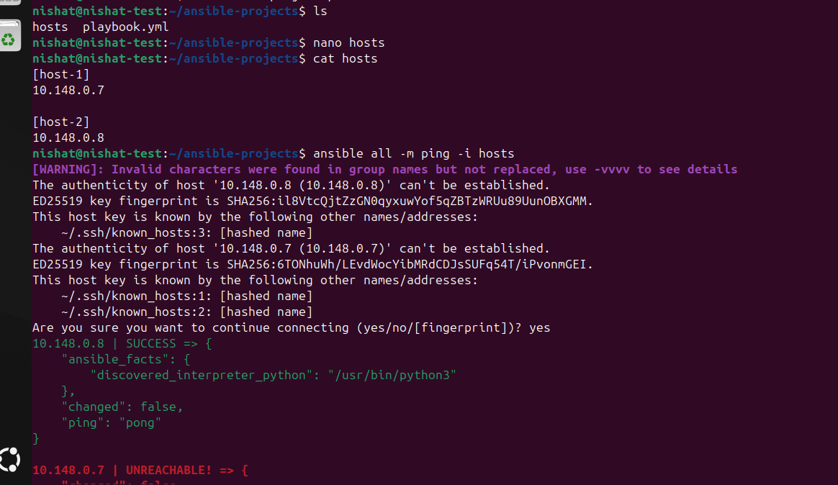
edit the playbook.yml file and add instructions for host machines
to install the Apache web server on your host VM, you can use the
following playbook.
Apache is intaldled in all host machine.
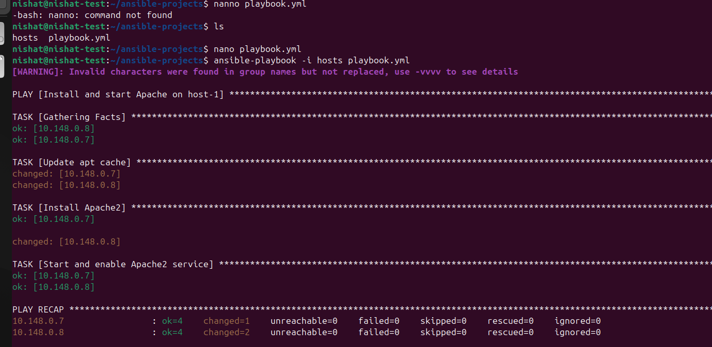

uninstalled:

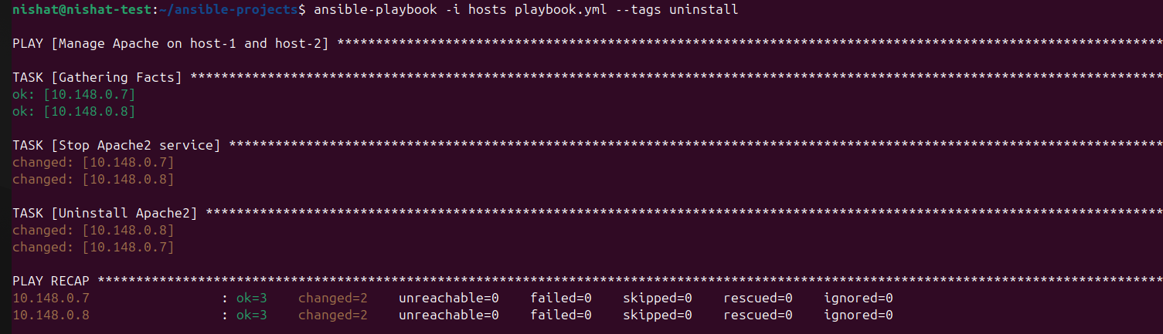here's the playbook .yml file for apache installation, update and delete.
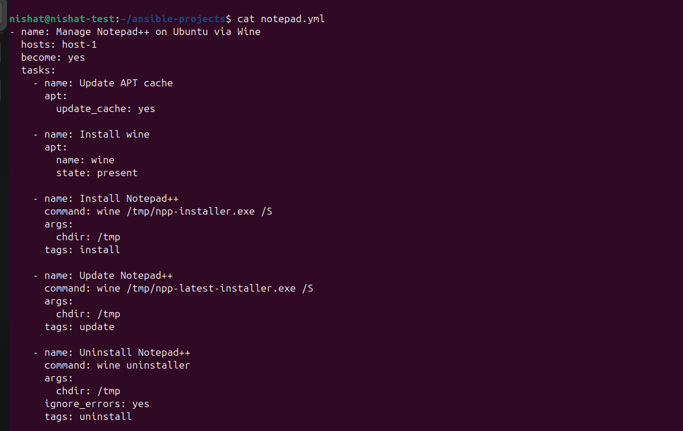
Repo url: https://dev.azure.com/fronturetech/Fronture%20ERP/_git/hands-on-lab-nishat?path=%2F&version=GBansible&_a=contents

Reference tutorial: https://youtu.be/7aRrHyQVD8o?si=Mjr7XM8t2zUKGakk
Notepad++ install,uninstall
**Set up the Ansible environment:**
> Follow the Ansible setup documentation to configure your Ansible controller and host machines.

**2. Installing Notepad++ on a Linux environment:**
> Since Notepad++ is a Windows application, you'll need to install **Wine** on your Linux host to run Windows executables.
> After setting up Wine, use an Ansible playbook to:
> * Install Notepad++

> * Simulate updating it to a newer version

> * Uninstall it using Wine

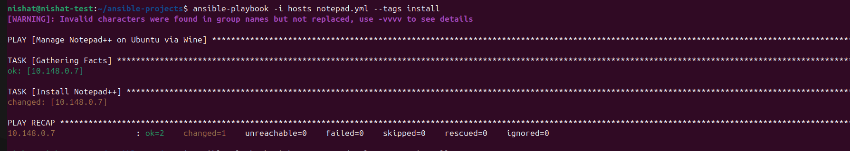
playbook .yml file
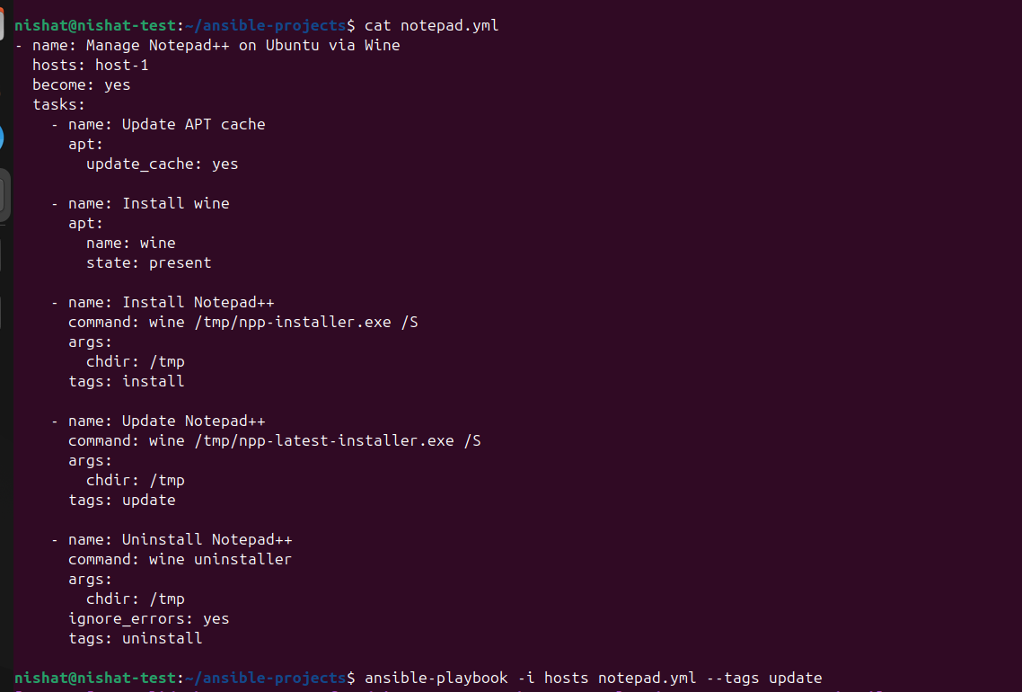

repo url: https://dev.azure.com/fronturetech/Fronture%20ERP/_git/hands-on-lab-nishat?path=%2F&version=GBansible&_a=contents

