# Installation Steps

**Update system:**

sudo apt update && sudo apt upgrade -y
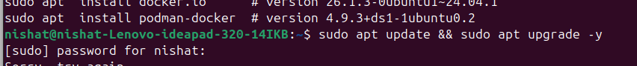
**Install dependencies:**

sudo apt install ca-certificates curl gnupg lsb-release
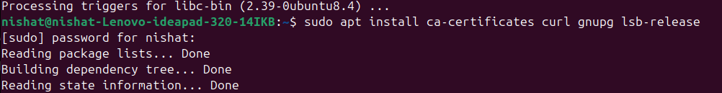
**Add Docker GPG key:**

sudo mkdir -p /etc/apt/keyrings
curl -fsSL https://download.docker.com/linux/ubuntu/gpg | \
sudo gpg --dearmor -o /etc/apt/keyrings/docker.gpg

**Add Docker’s repository:**

echo \
"deb [arch=$(dpkg --print-architecture) \
signed-by=/etc/apt/keyrings/docker.gpg] \
https://download.docker.com/linux/ubuntu \
$(lsb_release -cs) stable" | \
sudo tee /etc/apt/sources.list.d/docker.list > /dev/null

**Install Docker packages:**

sudo apt update
sudo apt install docker-ce docker-ce-cli containerd.io docker-buildx-plugin docker-compose-plugin -y
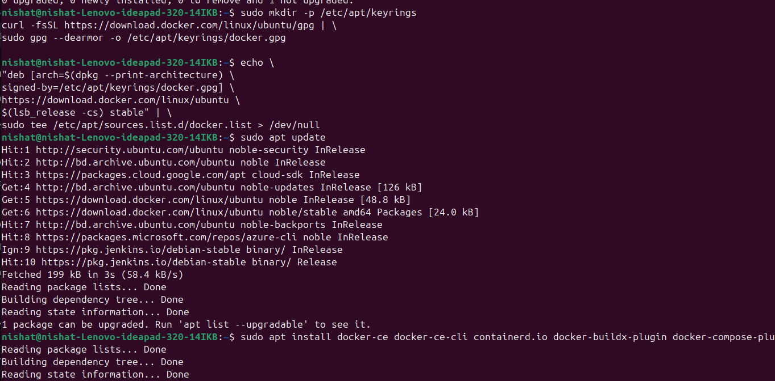
**Verify installation:**
docker --version
**Add user permission:**

sudo usermod -aG docker $USER

after running the command Now you must log out from your os and log back in, or reboot your system to apply the change.

Logging out and back in is important, otherwise the new permissions won’t apply!

**After re-login, test it again:**
After you have completed the installation, you can verify the installation is successful by running the hello-world image.

docker run hello-world

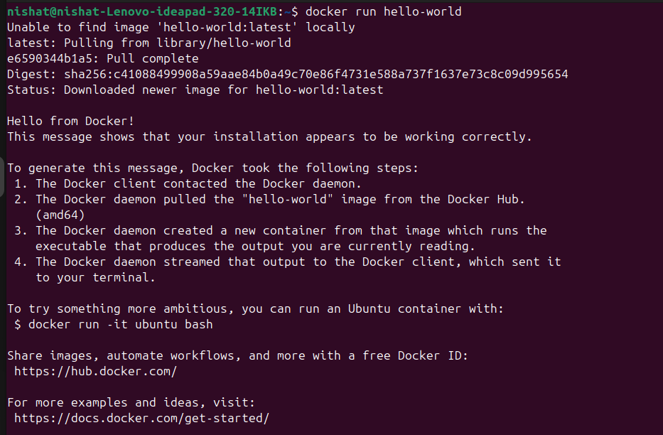
ref urls: https://docs.docker.com/engine/install/ubuntu/
https://www.tutorialspoint.com/docker/installing_docker_on_linux.htm

**Pushing the React App to Docker Hub**
----------------------------------------

### 1. **Login to Docker Hub**

First, log in to your Docker Hub account
docker login
make sure you have repo or create new one.
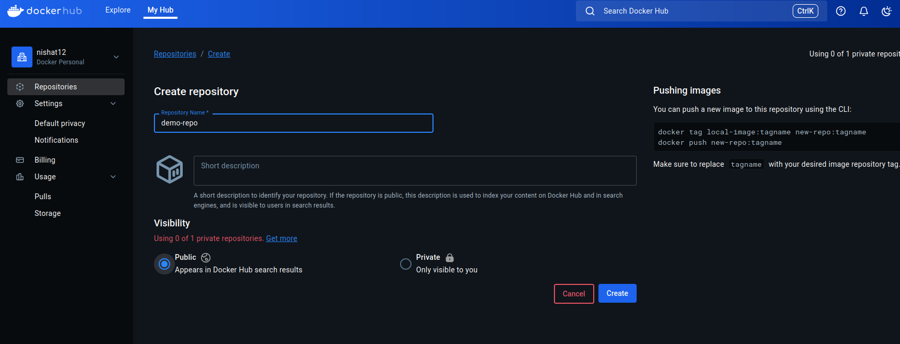
**2. Tag Your Docker Image and push it**

To push your image to Docker Hub, you need to tag it with your Docker Hub username and a version. Let's use reactjs-v1 for this example.
docker tag react-hello-app your-dockerhub-username/your-repo-name:reactjs-v1

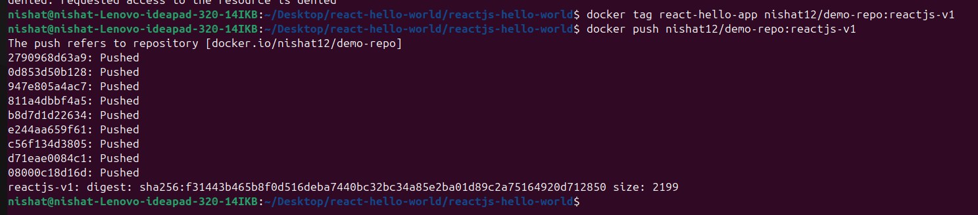
Docker will upload your image to your Docker Hub account.
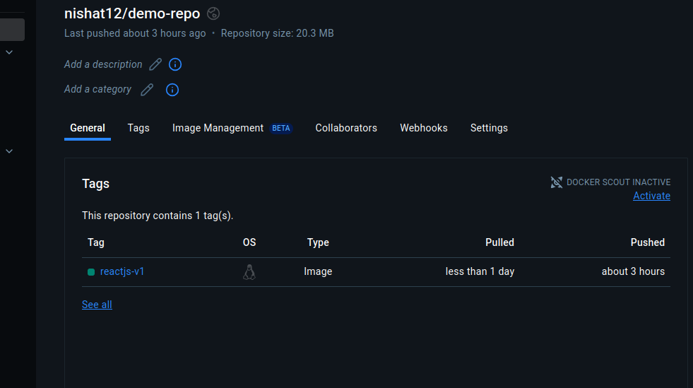
Here's what you need to do on your GCP VM:
1. SSH into your GCP VM

From your local laptop, open a terminal and connect to your VM:

gcloud compute ssh nishat-test

(Or use the GCP console "SSH" button if you prefer GUI.)
2. Install Docker on your GCP VM

If you haven't installed Docker there yet, install it:

sudo apt update
sudo apt install -y docker.io
sudo systemctl start docker
sudo systemctl enable docker

Check if Docker installed successfully:
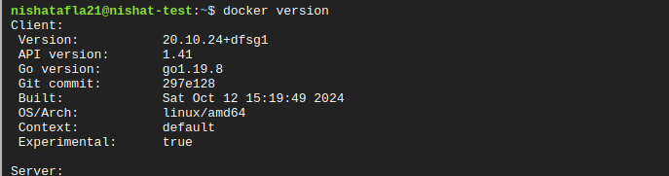
docker --version

3. Login to Docker Hub on GCP VM

On your VM terminal:

docker login

Enter your Docker Hub username and password.
4. Pull your Docker image

Pull your React app image from Docker Hub:

docker pull nishat21/demo-repo:reactjs-v1

5. Run the container

Run the container and map port 80 inside the container to port 8080 on the VM:

docker run -d -p 8080:80 your-dockerhub-username/react-hello-app:v1
## **⚡ Quick Important Note:**
if you encounter this problem make sure to allow firewall
If you cannot access the app, you must allow TCP port 8080(or, other ports) in the GCP Firewall:

Go to GCP Console → VPC Network → Firewall rules → Create Rule.

Allow Ingress traffic on TCP port8080 for your VM.
6. Access the app in your browser

Now you need to get the External IP address of your GCP VM:

Go to GCP Console → VM instances → Find nishat-test → Copy the External IP.

Then, open this URL from your laptop browser:
http://<your-vm-external-ip>:8080

You should see your ReactJS app!
React
here i containerized a simple ReactJS Hello World application using Docker, ensuring the app can be built, deployed, and accessed via a Docker container.

**Installed Docker on Ubuntu**
https://dev.azure.com/fronturetech/Fronture%20ERP/_wiki/wikis/Fronture-ERP.wiki/331/Docker-installation-on-ubuntu

**Created a Dockerfile**

[Dockerfile - Repos]https://dev.azure.com/fronturetech/Fronture%20ERP/_git/hands-on-lab-nishat?path=/reactjs-hello-world/Dockerfile&version=GBDocker&_a=contents

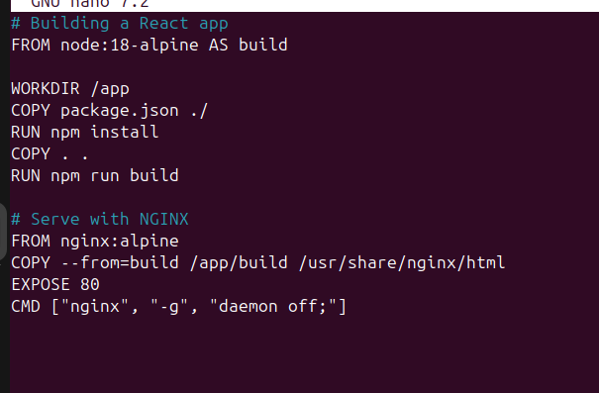
**Created .dockerignore**

To reduce build context size, a .dockerignore file was added

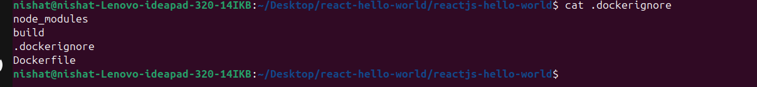
**Built Docker Image**
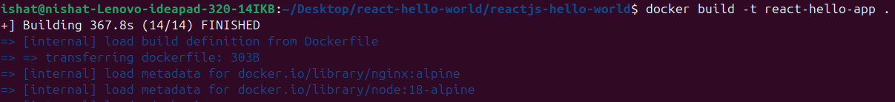

docker build -t react-hello-app .

**Ran the Docker Container in local**

Started a container from the built image and mapped port 3000 of the host to port 80 of the container:

docker run -d -p 3000:80 react-hello-app

Verified that the ReactJS app is accessible via:

http://localhost:3000

**Outcomes**

- Successfully containerized the ReactJS application.
- Application served using NGINX inside a Docker container.

## **create a snapshot image**
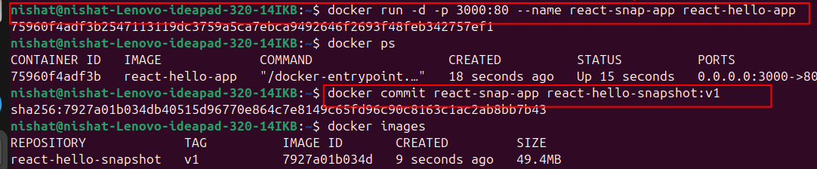here i gave this container a name react-snap-app

docker commit **react-snap-app** react-hello-snapshot:v1

This means:

You're taking a snapshot of the container named react-snap-app

Creating a new image named react-hello-snapshot with tag v1

**Create Dockerfile**

Navigate to the root directory of your Laravel application. Then create a Docker file with out any extension `Dockerfile` and a apache virtual host configuration file like `laravel-world.conf`

Open Dockerfile file :

```
FROM php:8.1-apache
USER root

RUN apt-get update && apt-get upgrade -y && apt-get install -y \
procps \
nano \
git \
unzip \
libicu-dev \
zlib1g-dev \
libxml2 \
libxml2-dev \
libreadline-dev \
supervisor \
cron \
sudo \
libzip-dev \
&& docker-php-ext-configure pdo_mysql --with-pdo-mysql=mysqlnd \
&& docker-php-ext-configure intl \
&& docker-php-ext-install \
pdo_mysql \
sockets \
intl \
opcache \
zip \
&& rm -rf /tmp/* \
&& rm -rf /var/list/apt/* \
&& rm -rf /var/lib/apt/lists/* \
&& apt-get clean

RUN a2dissite 000-default.conf
COPY laraveldock.conf /etc/apache2/sites-available/laraveldock.conf
RUN a2ensite laraveldock.conf
RUN a2enmod rewrite
RUN chown -R www-data:www-data /var/www/html
RUN curl -sS https://getcomposer.org/installer | php -- --install-dir=/usr/local/bin --filename=composer
WORKDIR /var/www/html
COPY . .
RUN chown -R www-data:www-data /var/www/html/storage
RUN chmod -R 775 /var/www/html/storage
RUN composer install
USER root

```

Open laravel-world.conf file:

```
<VirtualHost *:80>
ServerName docker23.local
DocumentRoot /var/www/html/public
<Directory /var/www/html/public>
Options Indexes FollowSymLinks
AllowOverride All
Require all granted
</Directory>
ErrorLog ${APACHE_LOG_DIR}/error.log
CustomLog ${APACHE_LOG_DIR}/access.log combined
</VirtualHost>
```

**Build and Run**

To build the image:
`sudo docker build -t laravel-world:t1`
here laravel-world is the image name and t1 is tag.

Run the image:
`sudo docker run -d -p 8097:80 --name laravel-container laravel-world:t1`

here, specified a port 8097 on localhost, laravel container is the container name and the image we want to run.

**Push the Image to Docker hub**
1. Tag Docker Image:
`docker tag laravel-world:t1 shakibesaib/laravel-world:t1`
2. Login to Docker Hub:
`docker login`
Provide login credential of Docker hub account
3. Push the Image to Docker Hub:
`docker push shakibesaib/laravel-world:t1`

**Deploy the container in GCP VM**
1. Create a vm in gcp. Ref: https://dev.azure.com/fronturetech/Fronture%20ERP/_wiki/wikis/Fronture-ERP.wiki/225/Create-VM-Using-GCP-portal(ubunto).

2. Connect to SSH
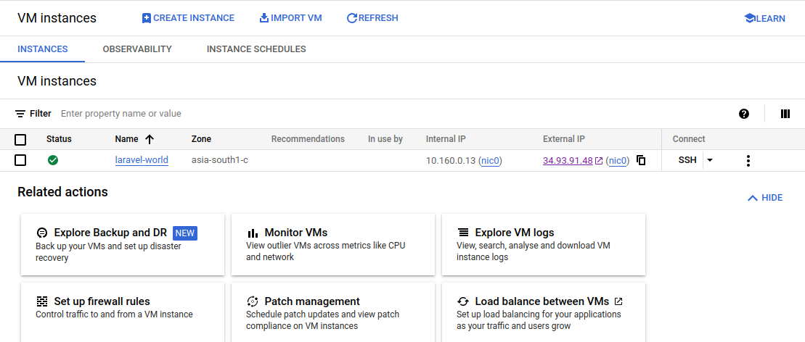

3. Install docker on vm.https://www.digitalocean.com/community/tutorials/how-to-install-and-use-docker-on-ubuntu-20-04

4. Pull the docker image from Docker Hub
`sudo docker pull shakibesaib/laravel-world:t1`

5. Login to Docker Hub.

6. Run the docker image.
`sudo docker run -d -p 80:80 --name laravel-container shakibesaib/laravel-world:t1`

7. Check container.
`Docker ps`

8. Hit the external ip address and the application would be running.


Troubleshoot:
1. **403 Forbidden**
. Make sure www-data (apache) has enough permission within the docker container to read write and execute.
. In host configuration make sure document root is perfectly set. `/var/www/html/public`.

2. **500 Internal server error**
. Make The .env file is available at the document root.

3. While building the docker image, make sure all the directories are defined perfectly and all the permission has given with in the docker file.

## **403 Forbidden Error**
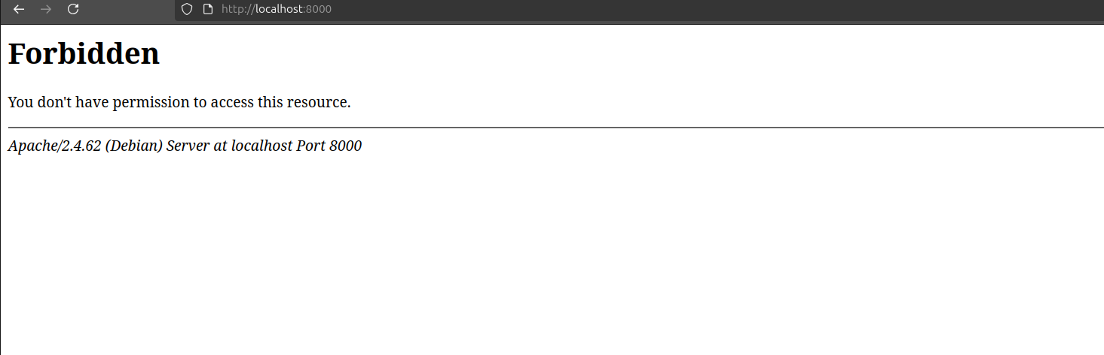Modify Apache to use Laravel's public/ directory

add the following line right after COPY . /var/www/html in your Dockerfile:

### Update Apache to serve Laravel's public directory
>command: RUN sed -i 's|DocumentRoot /var/www/html|DocumentRoot /var/www/html/public|g' /etc/apache2/sites-available/000-default.conf
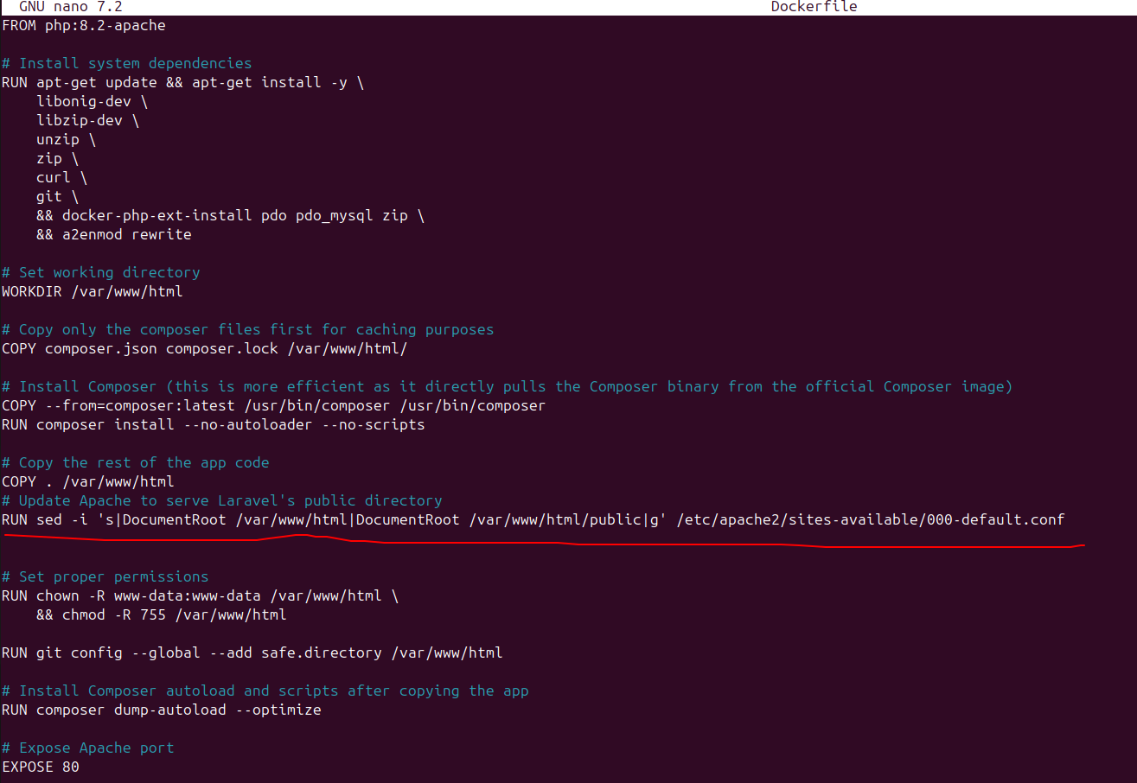
Rebuild Docker image:

>docker build -t laravel-app .

if old container exist then remove it before running again:

>docker rm -f laravel-container

Run container again:

>docker run -d -p 8000:80 --name laravel-container laravel-app

## **"no such table: sessions"** error:
**"no such table: sessions"** error means **Laravel is trying to use the `sessions` table from a database** (probably SQLite), but that table doesn't exist yet.
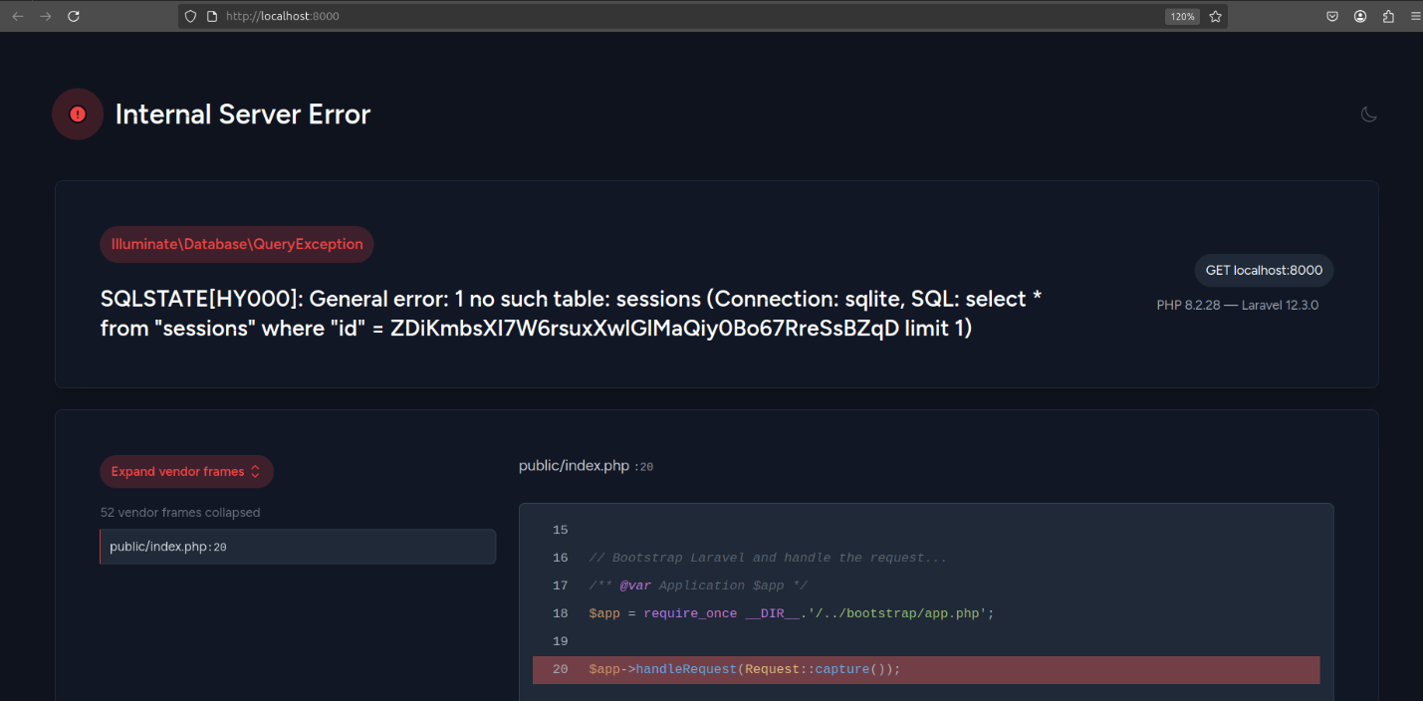for the sessions table run this :

>php artisan migrate

You need to run migrations inside the container. Here’s how:

Get inside the container:

>docker exec -it laravel-container bash

Inside the container, run:

>php artisan migrate

Then exit

Now reload http://localhost:8000 — the error should be gone.
Docker compose:
practical experience in containerizing frontend (ReactJS) and backend (Laravel) applications using Docker, and managing them together using Docker Compose.
ReactJS Dockerization:
https://dev.azure.com/fronturetech/Fronture%20ERP/_wiki/wikis/Fronture-ERP.wiki/333/Dockerizing-a-ReactJS-Application
Laravel Dockerization:
https://dev.azure.com/fronturetech/Fronture%20ERP/_wiki/wikis/Fronture-ERP.wiki/244/Dockerization-a-Laravel-App

Docker Compose Setup:
Created `docker-compose.yml`
https://dev.azure.com/fronturetech/Fronture%20ERP/_git/hands-on-lab-nishat?path=/docker-compose.yml&version=GBDocker&_a=contents

**now build the compose**
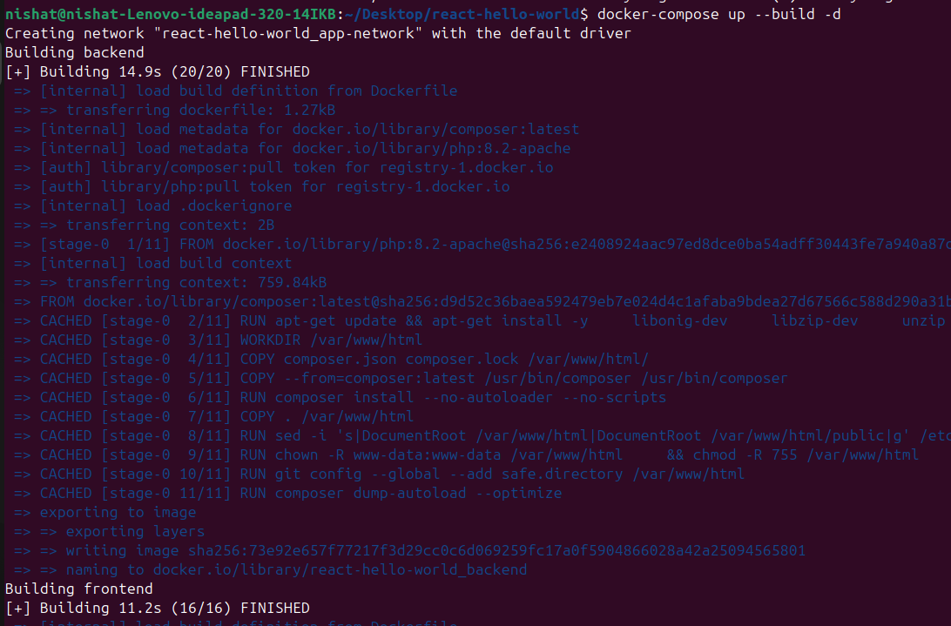
### Final Verification

After running `docker-compose up -d` , you confirmed:
* React app accessible at: `http://localhost:3000`

* Laravel backend accessible at: `http://localhost:8000 [can use other ports as well]

**ContainerConfig Error:**
The error `KeyError: 'ContainerConfig'` indicates that Docker is trying to access container configuration data that doesn't exist in the expected format.

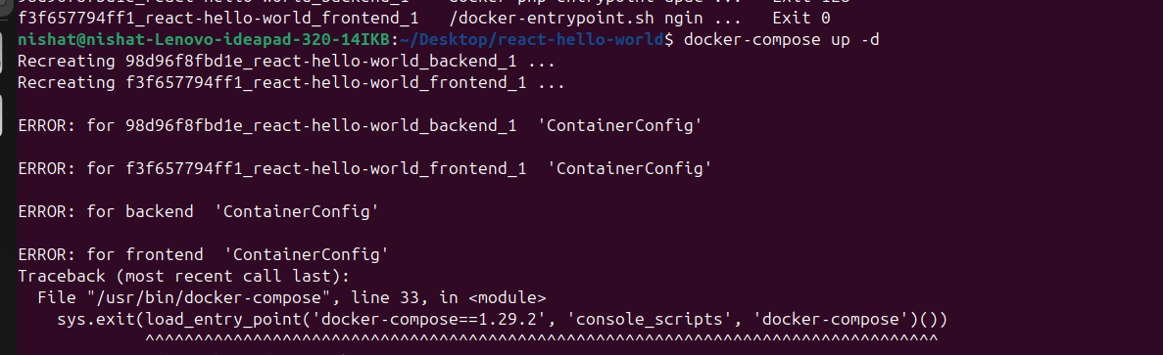Here are some steps to troubleshoot and fix this issue:
First, try removing the existing containers:
Then rebuild your services again. t will successfully build the composer again.
