Jenkins Declarative Pipeline to Start and Stop GCP VM

First Ensure that Jenkins and GCP is installed and running.

Now Create a GCP VM instance.
Then create a jenkins pipeline and configure it with credintial.
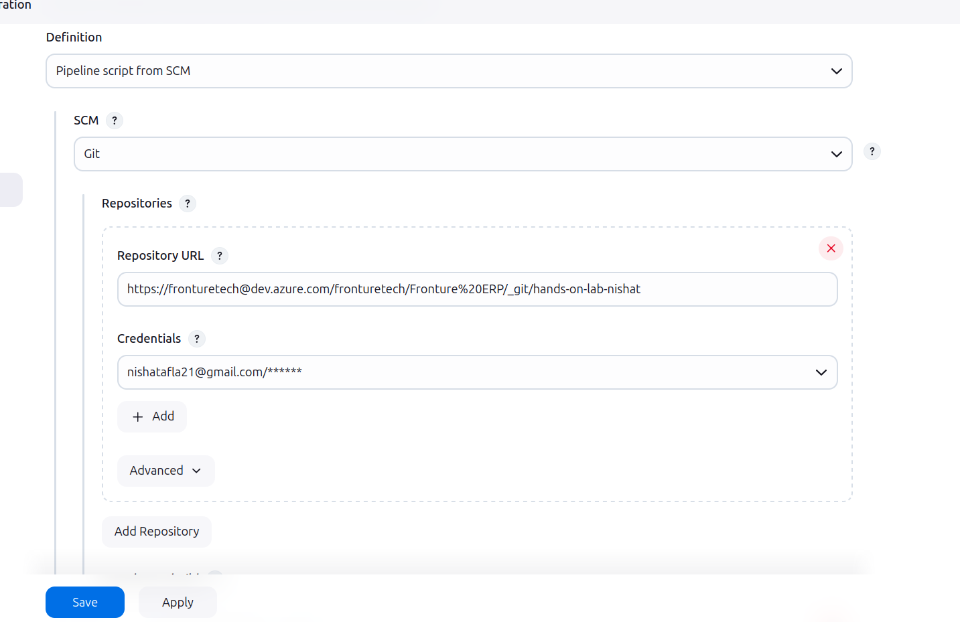then to connect it with jenkins server a Google Cloud Service Account is needed.
we can use service account from one of them as it has required permissions to access GCP.

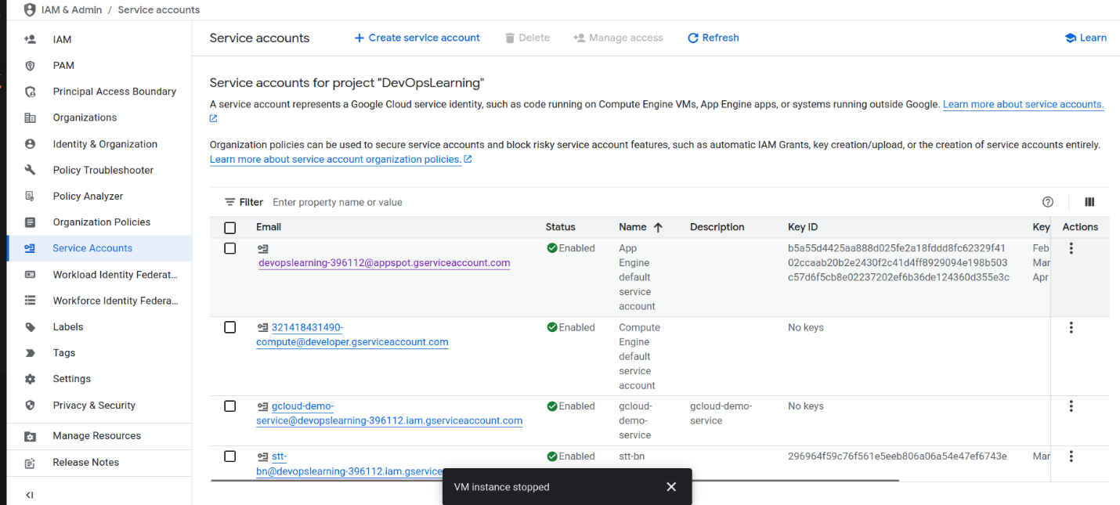otherwise create new service account but for that may needs owner or admins permission.
To create this:
1. In GCP , navigate to the **IAM & Admin** section.

2. **Create a Service Account** with necessary permissions.
After selecting service accout click on it, go to keys and create a new key.

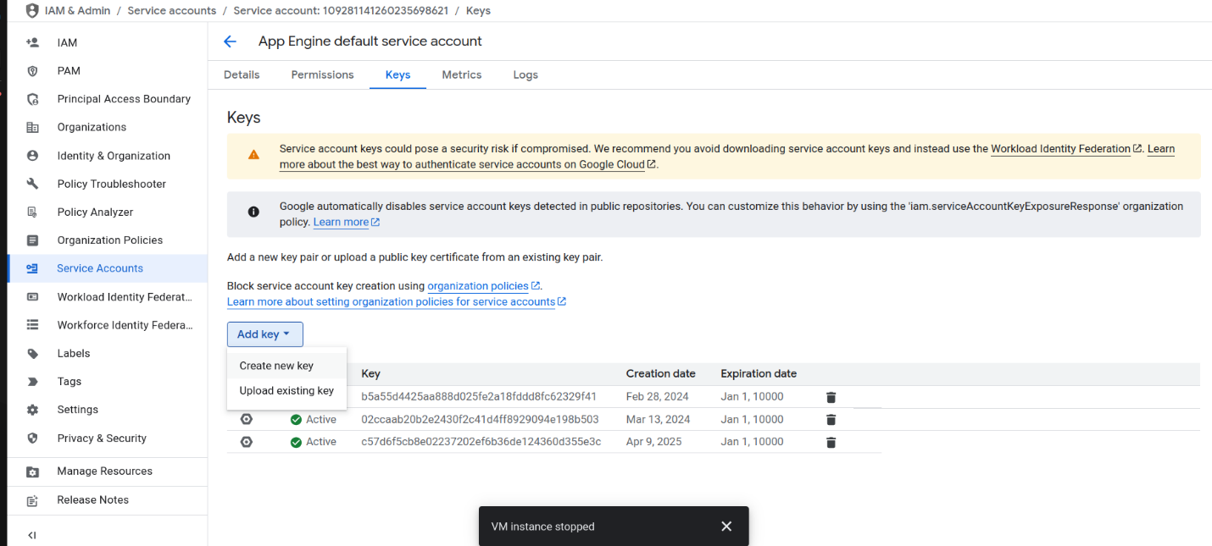Then click create to download the JSON file. this JSON key will be used to authenticate Jenkins.
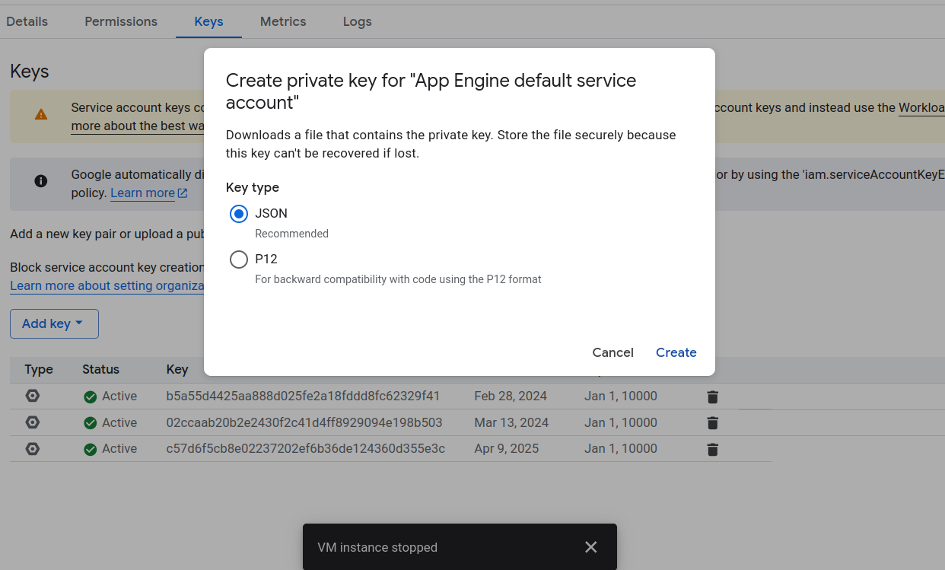

#### **Add** the Service Account Credentials to Jenkins

1. In **Jenkins**, navigate to **Manage Jenkins > Credentials**.

2. Add a new **Secret file** credential, and upload the JSON key file you downloaded from GCP.

3. Name the credential (e.g., `gcloud-creds1`).
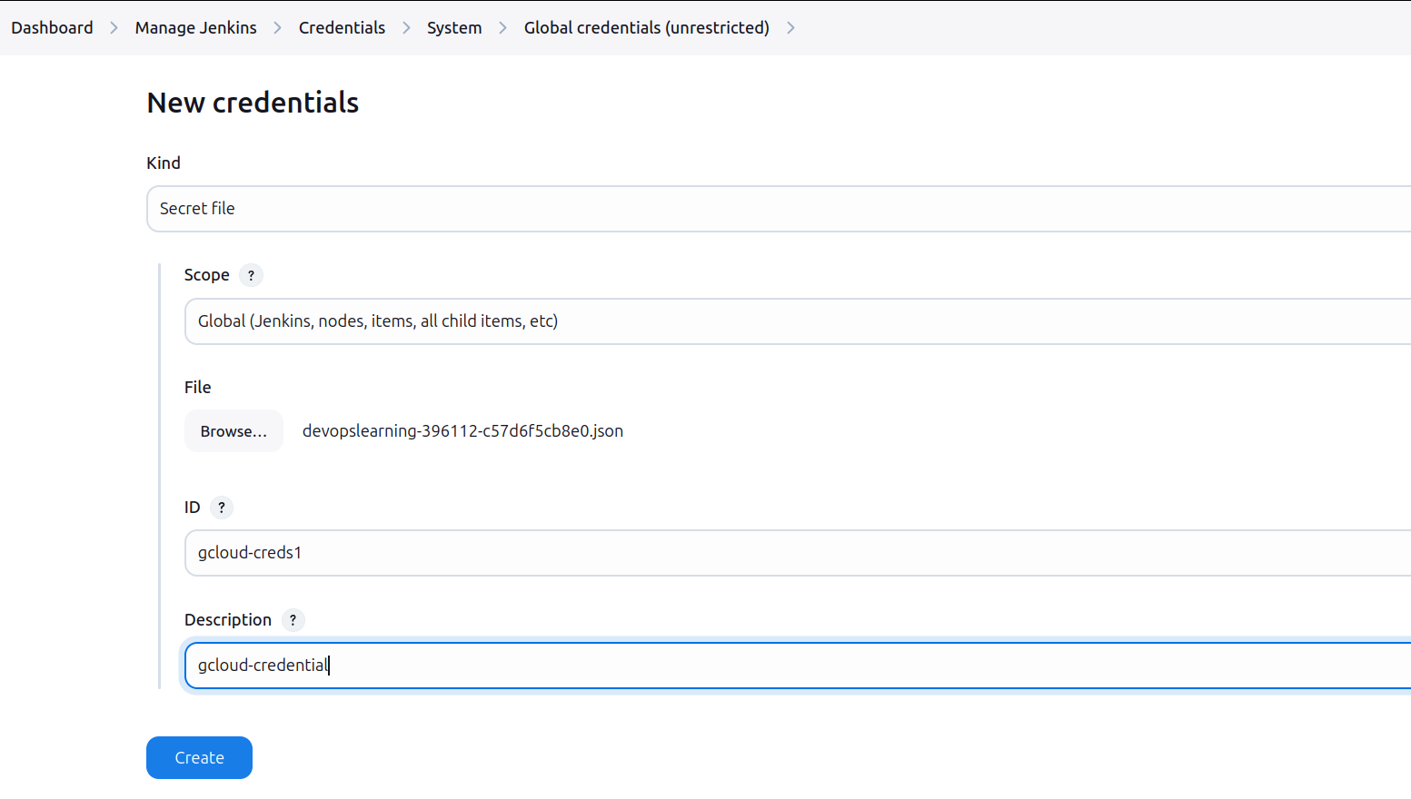

### Next Step: Create the Jenkinsfile

### Step 1: Create the Jenkinsfile

In terminal Navigate to your project directory: Go to the directory where your project is located (or where you want to add the Jenkinsfile) and create the file.

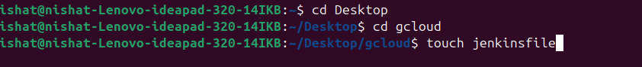

Add the pipeline script:
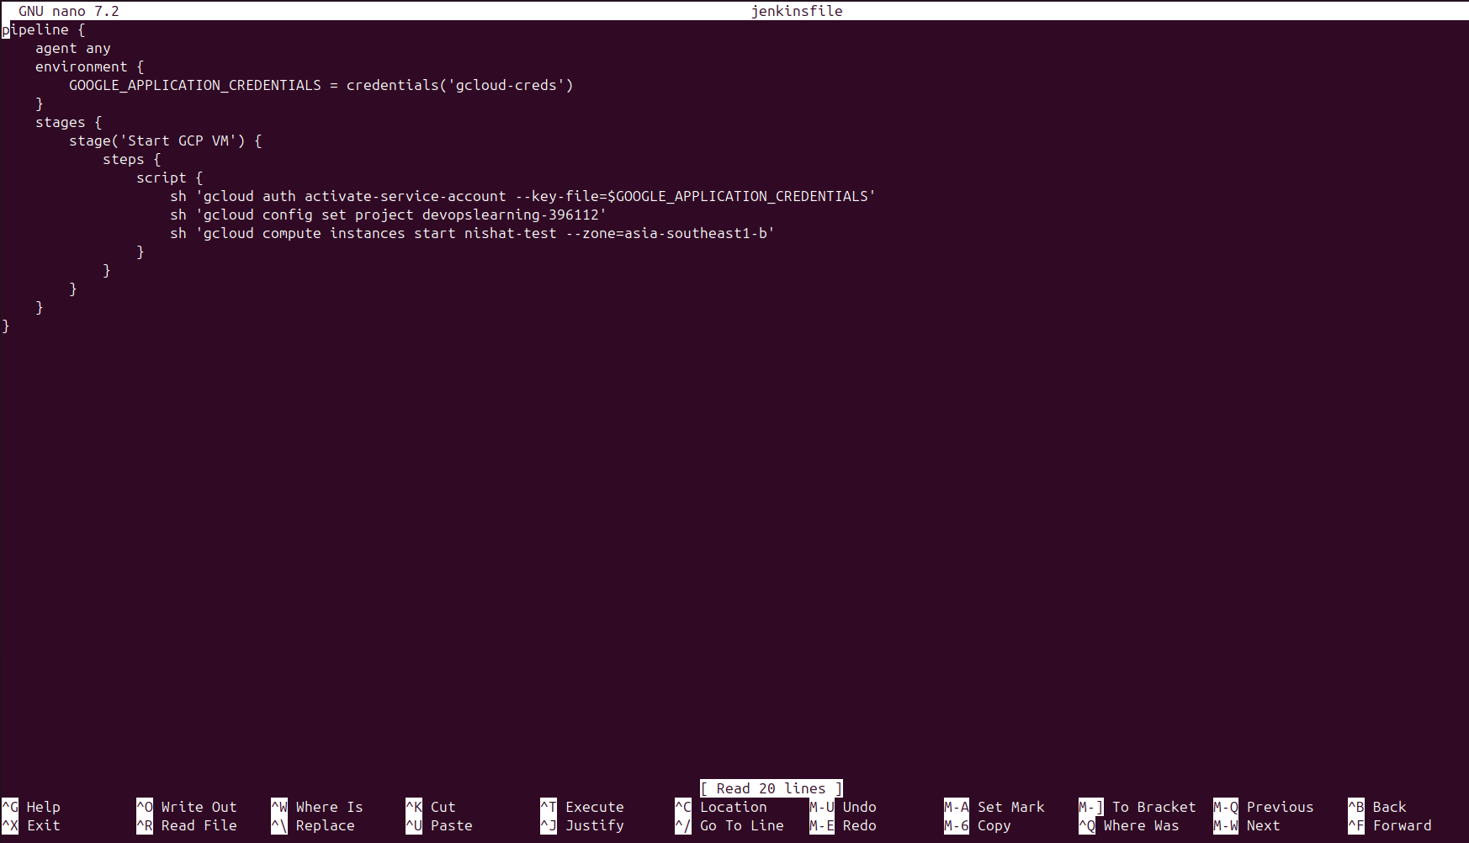**command to write file: nano jenkinsfile**

**pipeline {
https://dev.azure.com/fronturetech/Fronture%20ERP/_git/hands-on-lab-nishat?path=/jenkinsfile&version=GBGcloud-repo&_a=contents

>Replace 'your-jenkins-gcp-credentials-id' with the ID of the credential you created in Jenkins.

>Replace nishat-test with your existing VM name.

>Specify the correct GCP zone for your VM.

Save and exit: Press CTRL + X, then press Y to confirm saving the file, and **press Enter to exit.

**Add Jenkinsfile to Git Repository****
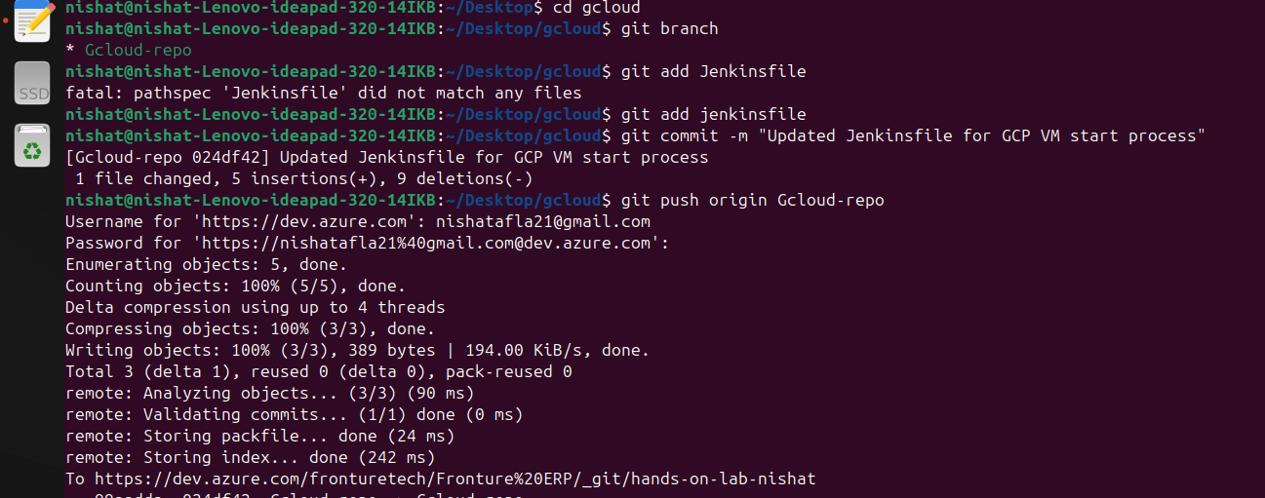
Initialize a Git repository (if not already initialized):

git init

Add the Jenkinsfile to the staging area:

git add Jenkinsfile

Commit the Jenkinsfile:

git commit -m "Add Jenkinsfile to start GCP VM"

Push the changes to your remote repository: If you haven’t already added a remote repository, add one with:

git remote add origin <repository-url>

Now, push your changes:

git push origin master or other branches

**Now Verify in Jenkins**

Go to Jenkins and build the created pipeline, and it should authenticate with GCP and run the script to start your VM.
**heres the console output**
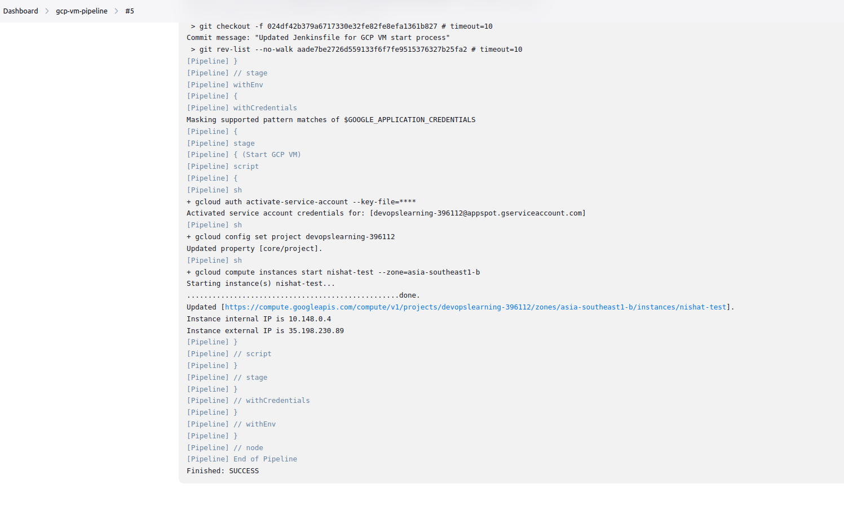

Jenkins-hello-world-configuration

After configuring Jenkins pipeline run this jenkins file through pippeline.
heres a pipeline script for simple hello world print in console.
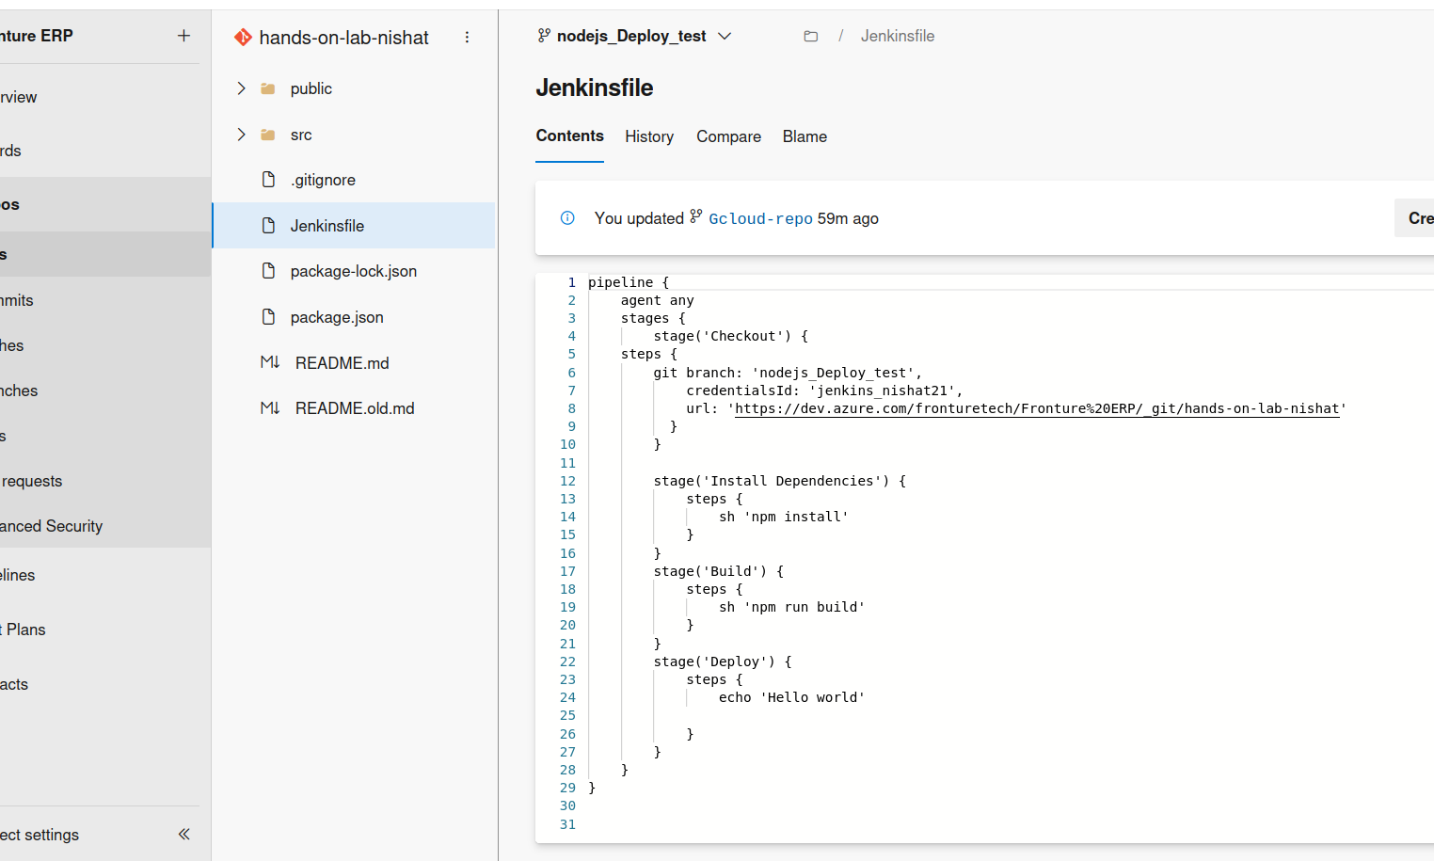pipeline {
agent any
stages {
stage('Checkout') {
steps {
git branch: 'nodejs_Deploy_test',
credentialsId: 'jenkins_nishat21',
url: 'https://dev.azure.com/fronturetech/Fronture%20ERP/_git/hands-on-lab-nishat'
}
}

stage('Install Dependencies') {
steps {
sh 'npm install'
}
}
stage('Build') {
steps {
sh 'npm run build'
}
}
stage('Deploy') {
steps {
echo 'Hello world'

}
}
}
}
# **summary:**
### **pipeline { agent any }**

* This sets up the pipeline to run on any available Jenkins agent (node). It tells Jenkins to run the pipeline without specifying a specific executor, so it can run on any available environment.

### 2. **stages { }**

* The `stages` block contains multiple stages that define different parts of the pipeline. Each stage represents a step in the CI/CD process.

### 3. **stage('Checkout') { }**

* This stage checks out the code from the repository:
* `git branch: 'nodejs_Deploy_test'`: Specifies the branch from which the code will be checked out (`nodejs_Deploy_test` in this case).

* `credentialsId: 'jenkins_nishat21'`: Refers to the credentials stored in Jenkins to authenticate with the Git repository.

* `url: 'https://dev.azure.com/fronturetech/Fronture%20ERP/_git/hands-on-lab-nishat'`: This is the URL of the Azure DevOps Git repository containing the source code.

* This step ensures the code is pulled from the specified branch before proceeding.

### 4. **stage('Install Dependencies') { }**

* This stage installs the necessary dependencies for the project:
* `sh 'npm install'`: Runs the `npm install` command in the terminal to install all required Node.js packages specified in the `package.json` file.

### 5. **stage('Build') { }**

* This stage runs the build process for the application:
* `sh 'npm run build'`: Executes the `npm run build` command, which usually compiles and bundles the React app for production. It prepares the app for deployment by generating the static files in the build directory.

### 6. **stage('Deploy') { }**

* This stage is where the actual deployment occurs:
* `echo 'Hello world'`: This is a placeholder for deployment logic. In a real-world scenario, this would be replaced with actual deployment commands .

* For now, it's just printing a message to the console (`Hello world`).

repo url : https://dev.azure.com/fronturetech/Fronture%20ERP/_git/hands-on-lab-nishat?path=%2F&version=GBnodejs_Deploy_test&_a=contents

