# Linux vm performance metric using prometheus, Loki, Grafana

## **Install Node Exporter (System Metrics Collector)**

Node Exporter collects CPU, RAM, disk, and network metrics from your Linux VM and exposes them to Prometheus.

### Download Node Exporter
`cd /opt`

`sudo wget https://github.com/prometheus/node_exporter/releases/download/$latest_version/node_exporter-${latest_version#v}.linux-amd64.tar.gz
`

**Extract and Move Binary**

`sudo tar -xvf node_exporter-*.tar.gz -C /opt`
Move the binary to `/usr/local/bin`:
`sudo mv /opt/node_exporter-*.linux-amd64/node_exporter /usr/local/bin/`
Check the binary works:
`/usr/local/bin/node_exporter --version`

create a systemd service so node_exporter starts automatically and runs in the background.

**Create the service file:**
`sudo nano /etc/systemd/system/node_exporter.service`

**Paste this:**

>[Unit]
Description=Node Exporter
After=network.target
[Service]
User=nobody {replace `User=nobody` with your actual Ubuntu username if different.}
ExecStart=/usr/local/bin/node_exporter
[Install]
WantedBy=default.target

**Start and Enable the Service**

sudo systemctl daemon-reexec
sudo systemctl daemon-reload
sudo systemctl enable node_exporter
sudo systemctl start node_exporter

Verify it's Running

http://localhost:9100/metrics
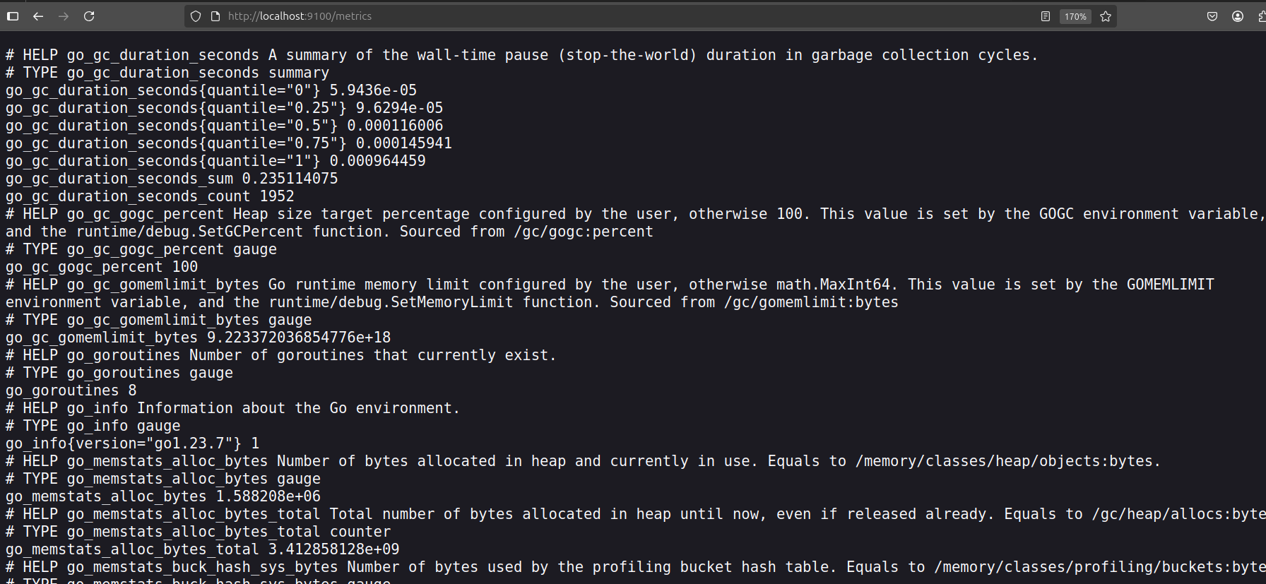
## **Install and configure Prometheus to scrape Node Exporter metrics**.**
### Install Prometheus

`cd /opt`

**Download the latest valid Prometheus version**
`sudo wget https://github.com/prometheus/prometheus/releases/download/v2.52.0/prometheus-2.52.0.linux-amd64.tar.gz`

**Extract it**
`sudo tar xvf prometheus-2.52.0.linux-amd64.tar.gz`
**Go into the directory**
`cd prometheus-2.52.0.linux-amd64`

_`sudo nano prometheus.yml`

_paste the content_:
>global:
scrape_interval: 15s
scrape_configs:
> - job_name: "prometheus"
static_configs:
- targets: ["localhost:9090"]

> - job_name: "node_exporter"
static_configs:
- targets: ["localhost:9100"]

**Start Prometheus**
>sudo chown -R $ USER:$ USER /opt/prometheus-2.52.0.linux-amd64/data
>./prometheus --config.file=prometheus.yml

You should see Prometheus starting logs.
Access Prometheus UI
>sudo bash -c "./prometheus --config.file=prometheus.yml > /opt/prometheus.log 2>&1 &"

Open your browser and go to:
👉 http://localhost:9090

## Install Loki (for logs collection)

Loki will collect and store logs — Promtail will send system logs to it.

**Download Loki**

cd /opt
latest_loki=$ (curl -s https://api.github.com/repos/grafana/loki/releases/latest | grep tag_name | cut -d '"' -f4)
wget https://github.com/grafana/loki/releases/download/$latest_loki/loki-linux-amd64.zip

**Unzip Loki**

sudo apt install unzip -y
unzip loki-linux-amd64.zip
chmod +x loki-linux-amd64

**Create Loki Config File**

Create the file:

nano loki-config.yaml

Paste the following content:
auth_enabled: false

server:
http_listen_port: 3100
log_level: info

ingester:
lifecycler:
ring:
kvstore:
store: inmemory
replication_factor: 1
chunk_idle_period: 5m
max_chunk_age: 1h
wal:
dir: /tmp/wal

schema_config:
configs:
- from: "2022-01-01"
store: boltdb
object_store: filesystem
schema: v11
index:
prefix: index_
period: 24h

storage_config:
boltdb:
directory: /tmp/loki/index
filesystem:
directory: /tmp/loki/chunks

limits_config:
reject_old_samples: true
reject_old_samples_max_age: 168h
allow_structured_metadata: false

table_manager:
retention_deletes_enabled: true
retention_period: 168h

**Start Loki in background**

>sudo bash -c "./loki-linux-amd64 -config.file=loki-config.yaml > loki.log 2>&1 &"
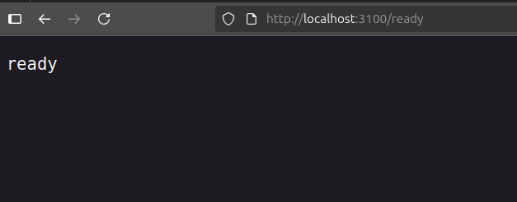
**Promtail Setup**
cd /opt
sudo wget https://github.com/grafana/loki/releases/download/v3.5.1/promtail-linux-amd64.zip

Then unzip it (also with sudo):

sudo unzip promtail-linux-amd64.zip

And make it executable:

sudo chmod +x promtail-linux-amd64

Create a file named `promtail-config.yaml` inside `/opt`:
>sudo nano /opt/promtail-config.yaml

server:
http_listen_port: 9080
grpc_listen_port: 0

positions:
filename: /tmp/positions.yaml

clients:
- url: http://localhost:3100/loki/api/v1/push

scrape_configs:
- job_name: system-logs
static_configs:
- targets:
- localhost
labels:
job: varlogs
__path__: /var/log/*.log
This will collect logs from files like `/var/log/syslog`, `/var/log/auth.log`, etc., and send them to Loki at `localhost:3100`.

run promptail in background:
sudo bash -c "./promtail-linux-amd64 -config.file=promtail-config.yaml > promtail.log 2>&1 &"

**Grafana:**
Manually add the GPG key for Grafana:

`sudo mkdir -p /etc/apt/keyrings
curl -fsSL https://packages.grafana.com/gpg.key | gpg --dearmor | sudo tee /etc/apt/keyrings/grafana.gpg > /dev/null`

Update your Grafana source to use the keyring:

`echo "deb [signed-by=/etc/apt/keyrings/grafana.gpg] https://packages.grafana.com/oss/deb stable main" | \
sudo tee /etc/apt/sources.list.d/grafana.list`

Update package list and install Grafana:

`sudo apt-get update`
`sudo apt-get install grafana`

Start and enable Grafana service:

`sudo systemctl start grafana-server`
`sudo systemctl enable grafana-server`

Access Grafana:
Open your browser and go to: http://localhost:3000
Default login cred:

Username: admin

Password: admin

**Now it’s time to **verify** each component and connect them inside **Grafana****

Visit this in your browser:
**[http://localhost:9090](http://localhost:9090)** → Prometheus web UI should open.
* Click **“Status” > “Targets”**
* You should see a **target like `localhost:9100`** (Node Exporter)

* **Health = "UP"** means Prometheus is pulling metrics from Node Exporter

in Grafana:
1. **Go to (Settings) > Data Sources**

Add datasource as prometheus:
* **Prometheus**
* URL: `http://localhost:9090`

**Loki**
* URL: `http://localhost:3100`

Click “Save & Test” on both. If successful = ✅
### **Import Dashboards**

Now you can import pre-built dashboards:
1. Go to Import**

2. Use these Dashboard IDs:
* **Node Exporter** → ID: `1860`

* **Loki logs dashboard** → ID: `13639`

3. Select your data source (Prometheus for Node Exporter, Loki for logs)

Done you’ll now see live CPU, memory, disk usage + logs!

**Real-time monitoring**
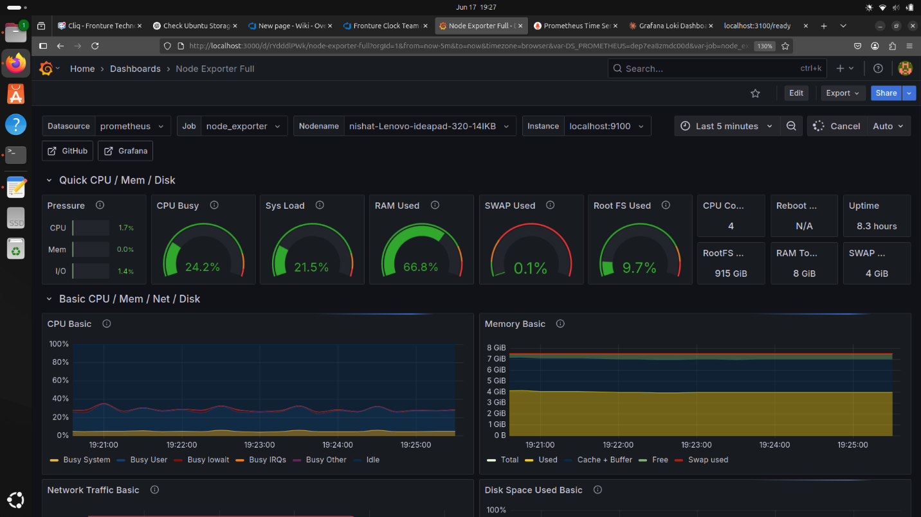
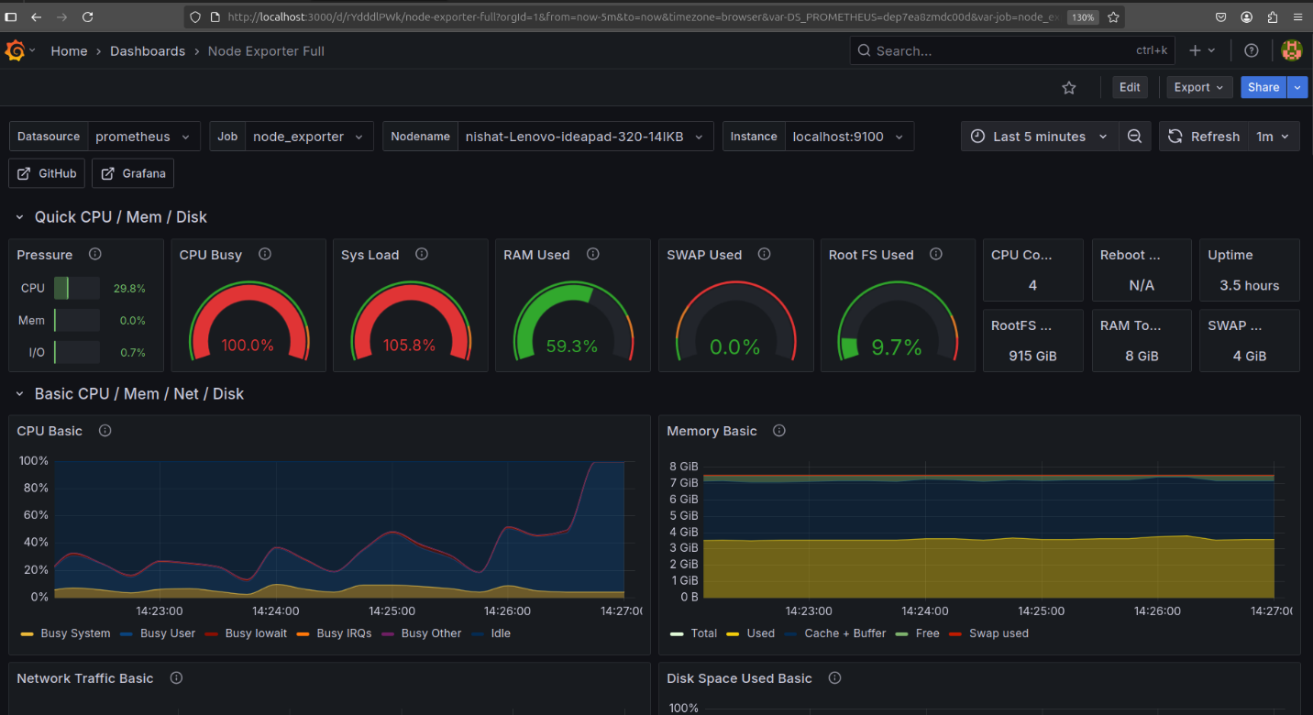**Log collection**
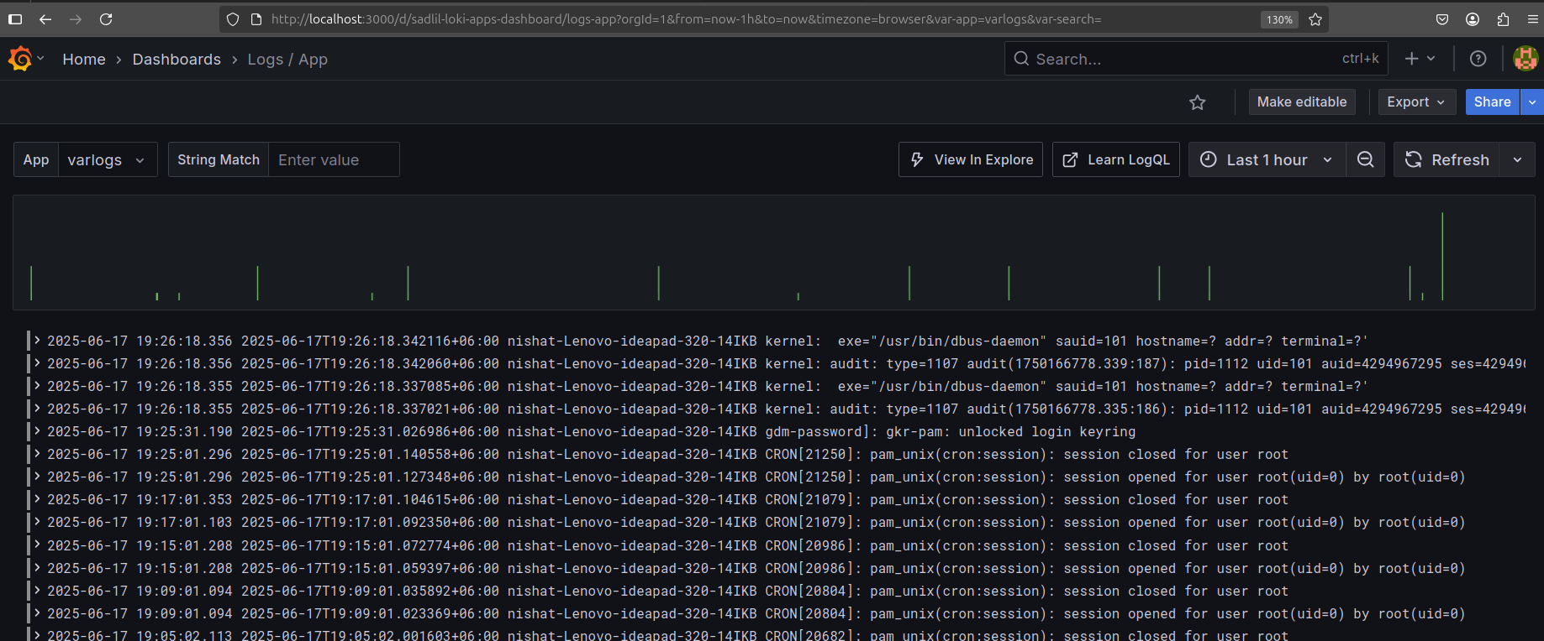##
## **event logs ( last 7 days vm on/off events) visualization using grafana:**
>**LogQL Query**: {job="syslog"} |= "Reached target"|~ "Shutdown|Hibernate|sleep|suspand"
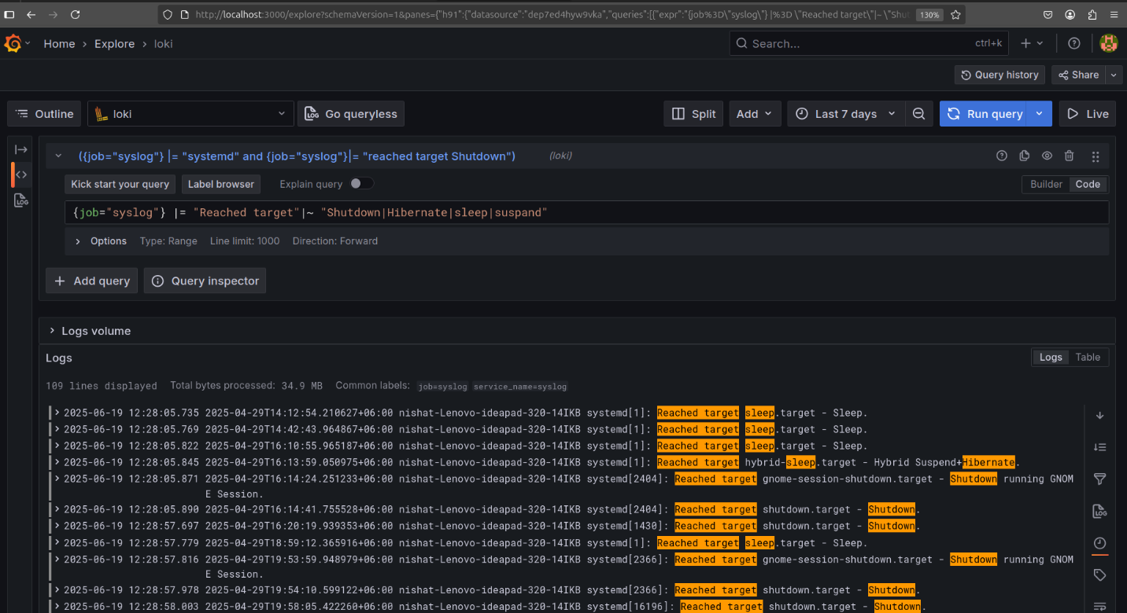
**alerting set up if cpu usage exceed 80%**
status: pending
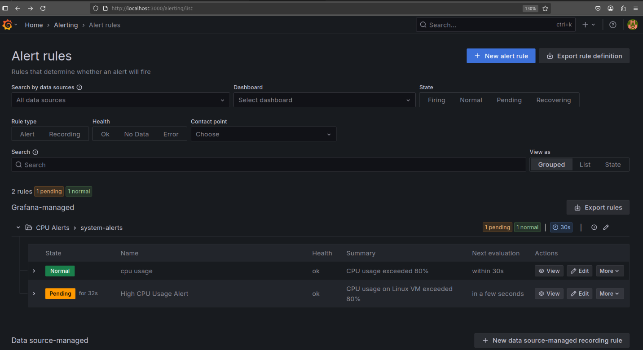status: firing
