Wireless Project

Performance Analysis of ASK, PSK, QPSK and FSK Digital Wireless Links over an AWGN Channel

Title: Integrate-and-dump receiver, threshold detection, BER and PER versus amplitude, sampling frequency, bit rate and SNR
Date: August-1, 2024

Submitted to

Dr. Monir Hossen
Professor
Department of Electronics and Communication Engineering
Khulna University of Engineering & Technology (KUET)

Dr. Shariful Alam
Professor
Department of Electronics and Communication Engineering
Khulna University of Engineering & Technology (KUET)

Submitted by
Nishat Taaha
B.Sc. in Electronics and Communication Engineering
Khulna University of Engineering & Technology (KUET)

Performance Analysis of ASK, PSK, QPSK and FSK Digital Wireless Links over an AWGN Channel

OBJECTIVE
1. This project studies a baseband-equivalent digital wireless link in which a random bit stream is modulated with one of four schemes (ASK, PSK, QPSK, FSK), corrupted by additive white Gaussian noise (AWGN)and recovered by an integrate-and-dump receiver followed by a threshold detector.
2. The study follows the task sheet: for each combination of the four project parameters (a) transmission scheme, (b) carrier amplitude, (c) sampling frequency and (d) bit rate, the bit error rate (BER) is measured by Monte Carlo simulation and compared with the Q-function theoryand BER is plotted against SNR for every parameter value.
3. Bit errors, packet errors, simulated and theoretical BER, packet error rate (PER) and SNR are all reported.
Main findings: At equal carrier amplitude the ranking is PSK and QPSK (best, identical BER), then FSK (about 3 dB worse), then ASK (about 6 dB worse). BER falls exponentially with carrier amplitude when the noise floor is fixedand rises with bit rate because less energy is collected per bit. When BER is plotted against SNR, the carrier amplitude has no effect at all (it cancels), while sampling frequency and bit rate shift the curves by the processing gain 10log10(fs/2BR). Simulated BER agrees with theory to within Monte Carlo error across all 100+ operating points.

2. INTRODUCTION AND SYSTEM ARCHITECTURE
The Figure 1 shows the transmitter builds the modulated signal from the bit stream and the carrier. The channel is an adder that injects white Gaussian noise. The receiver filters and demodulates, integrates over one bit under the control of the bit clockand applies a threshold. A performance block compares the detected bits with the transmitted bits and also evaluates the Q-function theory.
Block | Function | Key parameter
Message source + ADC | Produces the random bit stream m | BR = 5 to 8 bps
Modulator (Tx) | Maps bits to ASK, PSK, QPSK or FSK waveform s(t) | Vamp = 4 to 10 V
AWGN channel | Adds noise: r(t) = s(t) + n(t) | N0 or SNR (dB)
Processing circuits | Filtering and coherent demodulation to baseband r0(t) | fs = 12 to 22 Hz
Integrate and dump | Averages r0(t) over one bit (RC integrator with reset clock) | Window = Tb
Threshold detector | Decides 0 or 1 from the integrator output z | Threshold = midpoint
Performance analysis | Bit errors, packet errors, BER, PER, Q-function theory | 32-bit packets

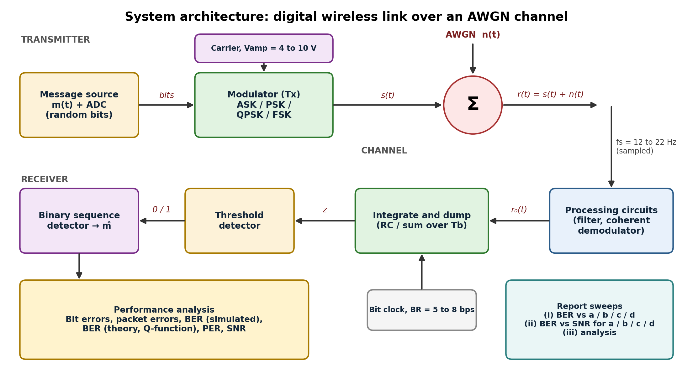
Figure 1. System architecture of the digital wireless link.

3. Signal model and theory

3.1 Modulation schemes
The simulation works on the complex-baseband equivalent of each passband signal, with one real sample per tick of fs per dimension. For a carrier of peak amplitude A the baseband amplitude is a = A/sqrt(2), so that signal power in the model equals the carrier power A^2/2.
Scheme | Bits per symbol | Average power | Decision rule | Theoretical BER
ASK (OOK) | 1 | A^2/4 | z > a/2 | Q( sqrt(Eb/N0) )
PSK (BPSK) | 1 | A^2/2 | z > 0 | Q( sqrt(2 Eb/N0) )
QPSK (Gray) | 2 | A^2/2 | sign of I and of Q | Q( sqrt(2 Eb/N0) )
FSK (coherent) | 1 | A^2/2 | larger of two correlators | Q( sqrt(Eb/N0) )

3.2 Q-function, SNR and energy per bit
Q(x) = (1/2) erfc( x / sqrt(2) )
Eb = Pavg * Tb = Pavg / BR N0 = 2 * sigma^2 / fs
SNR = Pavg / sigma^2 Eb/N0 = SNR * fs / (2 * BR)
SNR is defined as average signal power divided by noise power per sample, which matches the definition used in the original code. Two consequences follow directly and are verified by the simulation: the carrier amplitude cancels out of SNRand fs and BR enter only through the processing gain fs/(2 BR), the ratio of the noise bandwidth fs/2 to the bit rate.

3.3 Packet error rate
For packets of L = 32 bits, the theoretical packet error rate is PER = 1 - (1 - BER)^L. Because one wrong bit spoils a whole packet, PER is much larger than BER: a BER of 0.0075 already gives a PER of about 21 percent.

3.4 Effect of the sampling frequency
The number of samples in a bit window is fs/BR. When this ratio is not an integer (for example 14/6 = 2.33 or 22/6 = 3.67) some windows hold one more sample than others. The noise variance of the integrator output is sigma^2 divided by the number of samples, so the average BER differs slightly from the ideal value (it is usually a little worse). The report therefore plots two theory curves in the fs sweep: the ideal formula and an integer-sample version that averages Q(.) over the actual window lengths.

4. Simulation methodology
- Generate the message: draw 640,000 random bits for the fixed-noise sweeps and 320,000 for the SNR sweeps, grouped into 32-bit packets.
- Modulate: map each bit (or bit pair for QPSK) to its baseband amplitude, held for the samples that fall inside the bit window.
- Add noise: add Gaussian noise of variance N0*fs/2 (fixed-noise sweeps, N0 = 1) or Pavg/10^(SNR/10) (SNR sweeps).
- Integrate and dump: average the samples in each window, which is the discrete version of the RC integrator with a reset clock.
- Threshold: apply the decision rules of Section 3.1 to get the received bits.
- Score: count bit errors and packet errors, compute simulated BER and PERand compute the Q-function theory for the same operating point.
- Sweep: repeat for the four schemes, Vamp = 4/6/8/10 V, fs = 12/14/18/22 Hz, BR = 5/6/7/8 bpsand SNR = -6 to 10 dB in 2 dB steps for each parameter value.
Sweeps use 4 schemes x 13 fixed-noise points plus 4 schemes x 13 parameter values x 9 SNR points, giving more than 500 Monte Carlo runs, all stored in results.csv.

5. Results

5.1 Waveforms and receiver behaviour
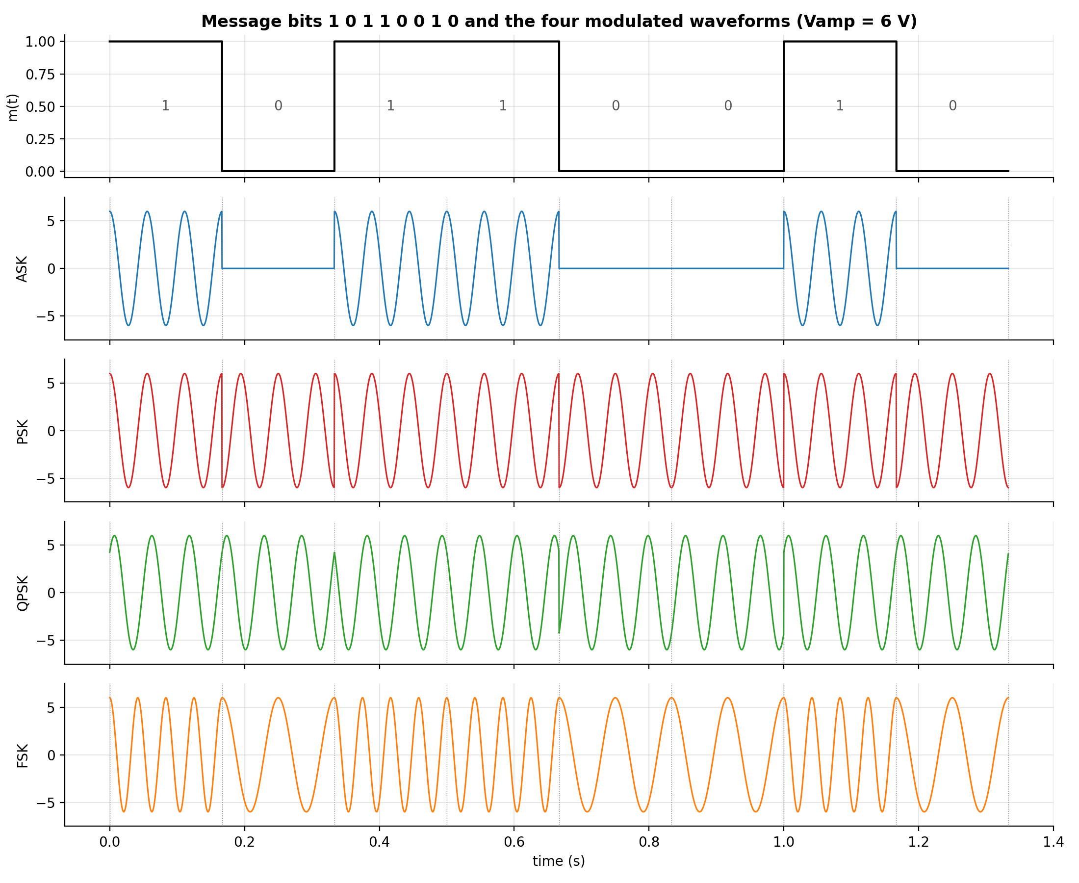
Figure 2. The message 10110010 and the four modulated waveforms at Vamp = 6 V (illustrative carrier of 18 Hz, tones of 12 and 24 Hz for FSK).
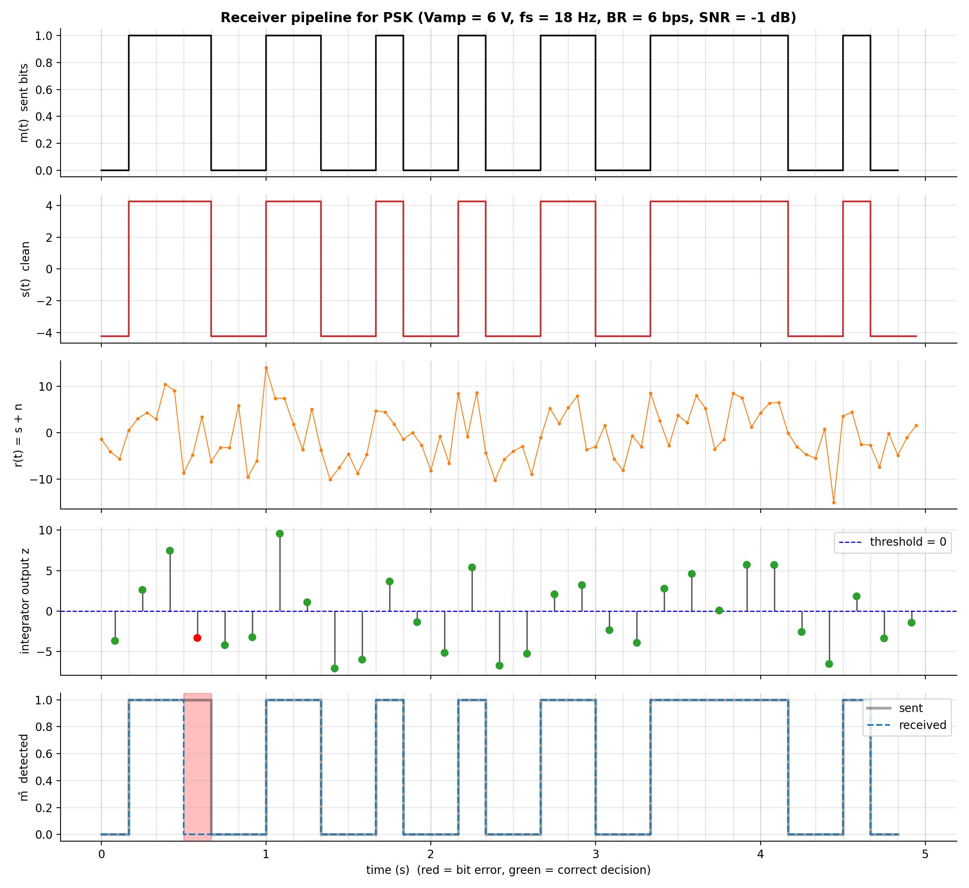
Figure 3. Receiver pipeline for PSK: sent bits, clean signal, noisy signal, integrator output with thresholdand detected bits with errors marked.
Figure 3 follows one packet of PSK through the receiver at a low SNR of -1 dB so that errors are visible. The integrator output z is plotted at each bit decision; points on the wrong side of the threshold (red) produce bit errors.
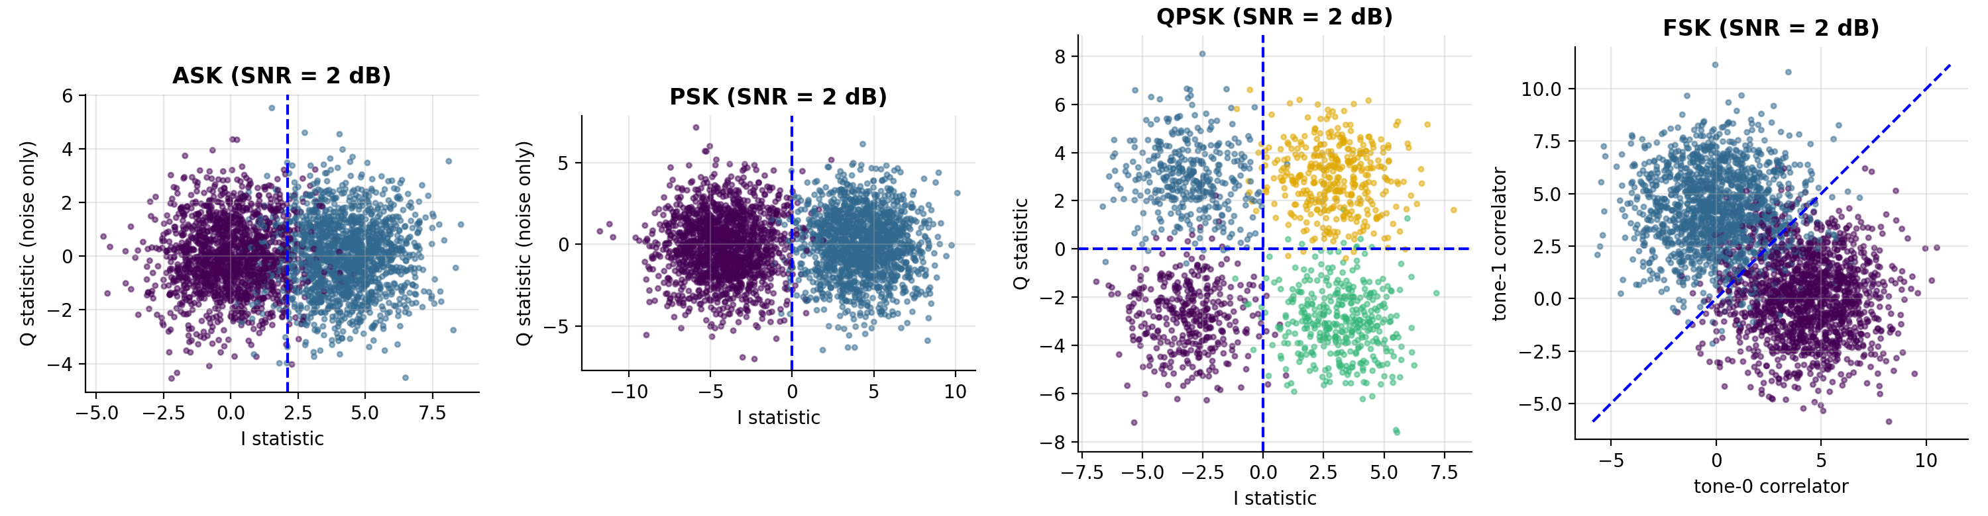
Figure 4. Decision statistics at SNR = 2 dB. Dashed lines are the decision boundaries; overlap across a line is a bit error.

5.2 Baseline operating point
Table 1 lists the baseline results (Vamp = 6 V, fs = 18 Hz, BR = 6 bps, N0 = 1, 640,000 bits, 20,000 packets).
Scheme | SNR (dB) | Eb/N0 (dB) | Bit errors | Packet errors | BER sim | BER theory | PER sim | PER theory
ASK | 0.00 | 1.76 | 70,639 | 19,557 | 0.1104 | 0.1103 | 0.978 | 0.976
PSK | 3.01 | 4.77 | 4,829 | 4,324 | 7.55e-3 | 7.15e-3 | 0.216 | 0.205
QPSK | 3.01 | 4.77 | 4,691 | 4,204 | 7.33e-3 | 7.15e-3 | 0.210 | 0.205
FSK | 3.01 | 4.77 | 26,352 | 14,732 | 0.0412 | 0.0416 | 0.737 | 0.744

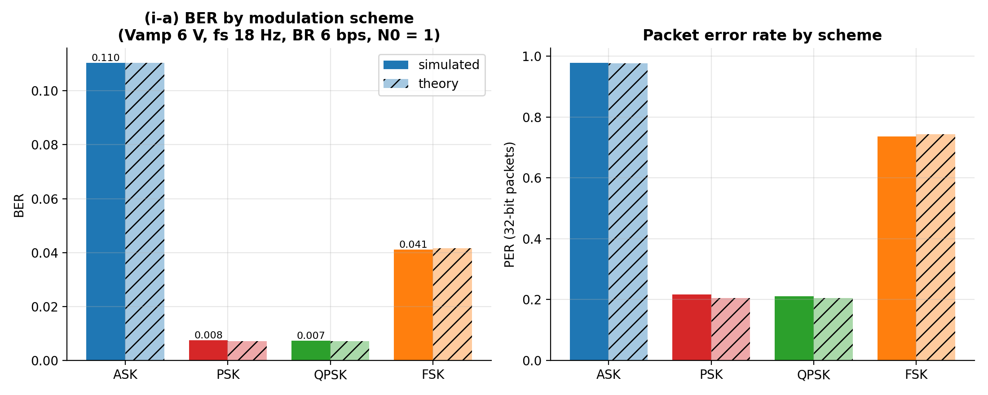
Figure 5. (i-a) BER and PER for the four schemes at the baseline operating point; hatched bars are theory.

5.3 (i) BER versus the parameters a, b, c, d
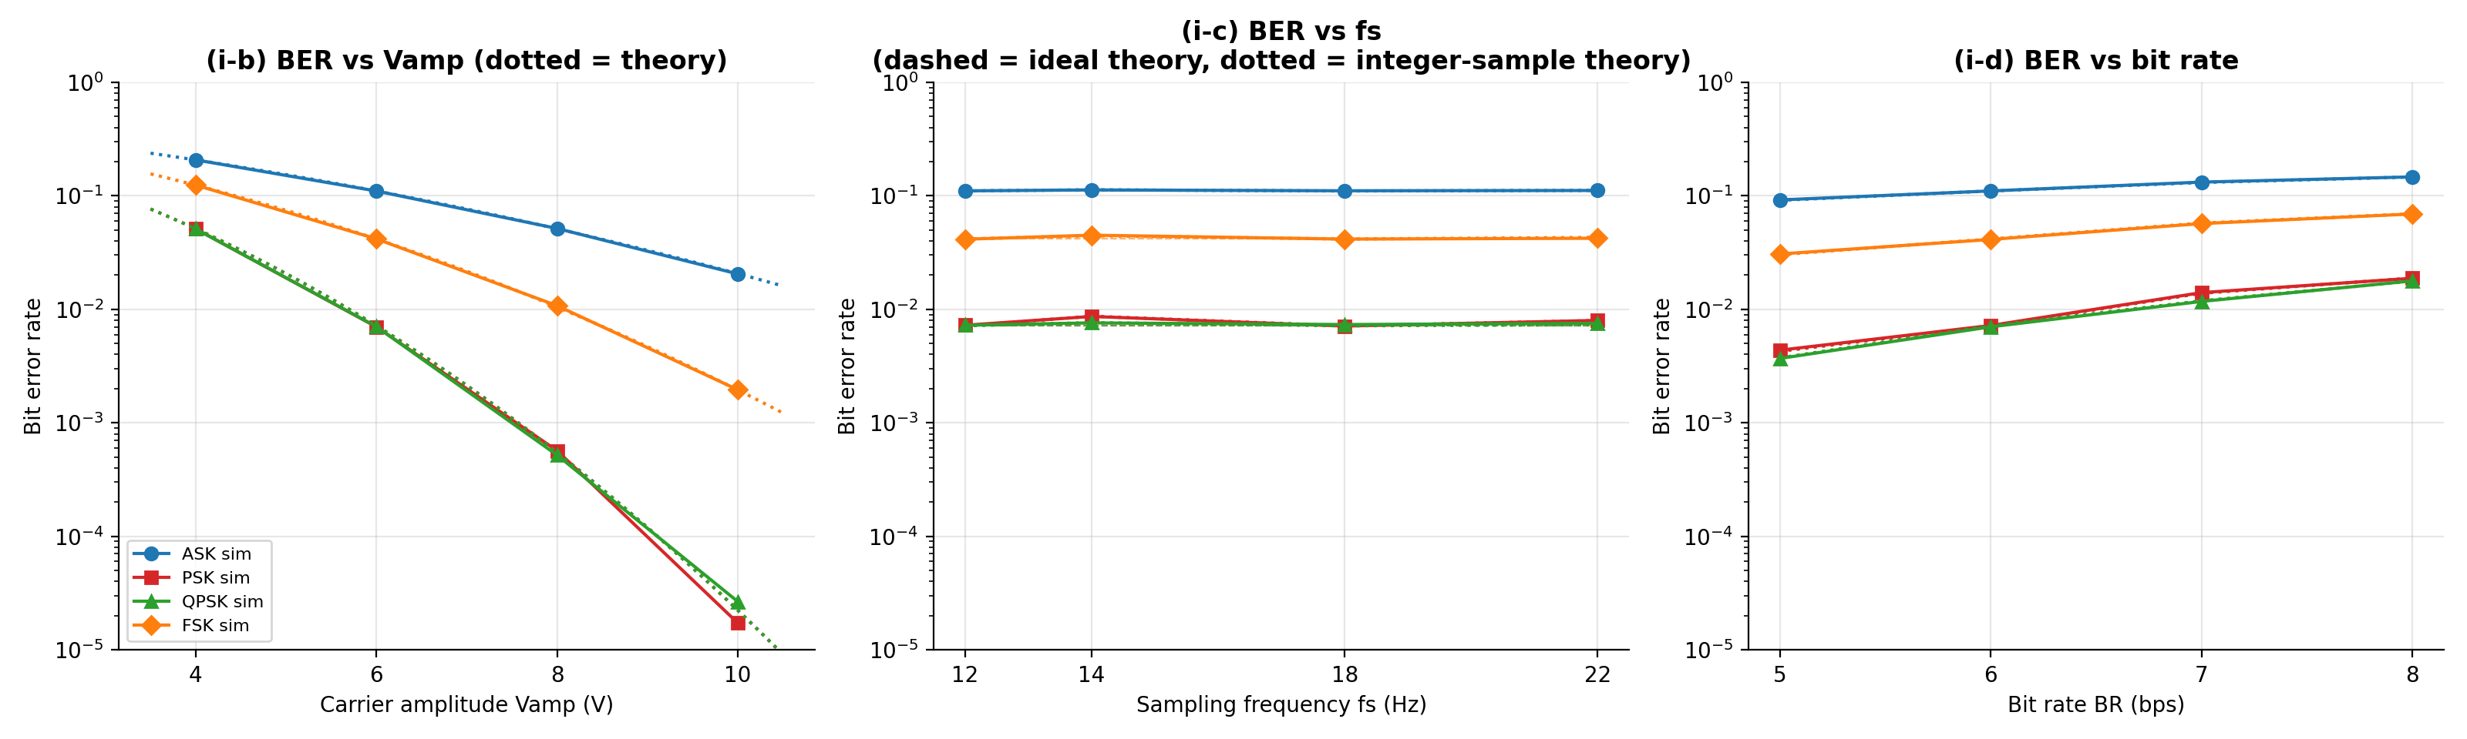
Figure 6. BER versus (b) carrier amplitude, (c) sampling frequency and (d) bit rate for all four schemes at a fixed noise floor N0 = 1.
Table 2. BER versus Vamp (V), with fs = 18 Hz and BR = 6 bps.
Vamp (V) | ASK sim | ASK theory | PSK sim | PSK theory | QPSK sim | QPSK theory | FSK sim | FSK theory
4 | 0.2074 | 0.2071 | 0.0511 | 0.0512 | 0.0511 | 0.0512 | 0.1243 | 0.1241
6 | 0.1103 | 0.1103 | 7.00e-3 | 7.15e-3 | 7.03e-3 | 7.15e-3 | 0.0418 | 0.0416
8 | 0.0516 | 0.0512 | 5.67e-4 | 5.45e-4 | 5.19e-4 | 5.45e-4 | 0.0108 | 0.0105
10 | 0.0205 | 0.0206 | 1.72e-5 | 2.23e-5 | 2.66e-5 | 2.23e-5 | 1.95e-3 | 1.95e-3

Table 3. BER versus sampling frequency (Hz), with Vamp = 6 V and BR = 6 bps. Theory is the integer-sample version.
fs (Hz) | ASK sim | ASK theory | PSK sim | PSK theory | QPSK sim | QPSK theory | FSK sim | FSK theory
12 | 0.1106 | 0.1103 | 7.24e-3 | 7.15e-3 | 7.24e-3 | 7.15e-3 | 0.0415 | 0.0416
14 | 0.1128 | 0.1131 | 8.65e-3 | 8.69e-3 | 7.59e-3 | 7.63e-3 | 0.0450 | 0.0445
18 | 0.1108 | 0.1103 | 7.12e-3 | 7.15e-3 | 7.34e-3 | 7.15e-3 | 0.0416 | 0.0416
22 | 0.1115 | 0.1116 | 7.98e-3 | 7.96e-3 | 7.52e-3 | 7.32e-3 | 0.0423 | 0.0430

Table 4. BER versus bit rate (bps), with Vamp = 6 V and fs = 18 Hz. Theory is the integer-sample version.
BR (bps) | ASK sim | ASK theory | PSK sim | PSK theory | QPSK sim | QPSK theory | FSK sim | FSK theory
5 | 0.0920 | 0.0913 | 4.36e-3 | 4.26e-3 | 3.69e-3 | 3.73e-3 | 0.0307 | 0.0303
6 | 0.1104 | 0.1103 | 7.20e-3 | 7.15e-3 | 7.01e-3 | 7.15e-3 | 0.0413 | 0.0416
7 | 0.1321 | 0.1310 | 0.0140 | 0.0138 | 0.0117 | 0.0119 | 0.0569 | 0.0575
8 | 0.1468 | 0.1466 | 0.0188 | 0.0189 | 0.0178 | 0.0177 | 0.0692 | 0.0694

5.4 (ii) BER versus SNR
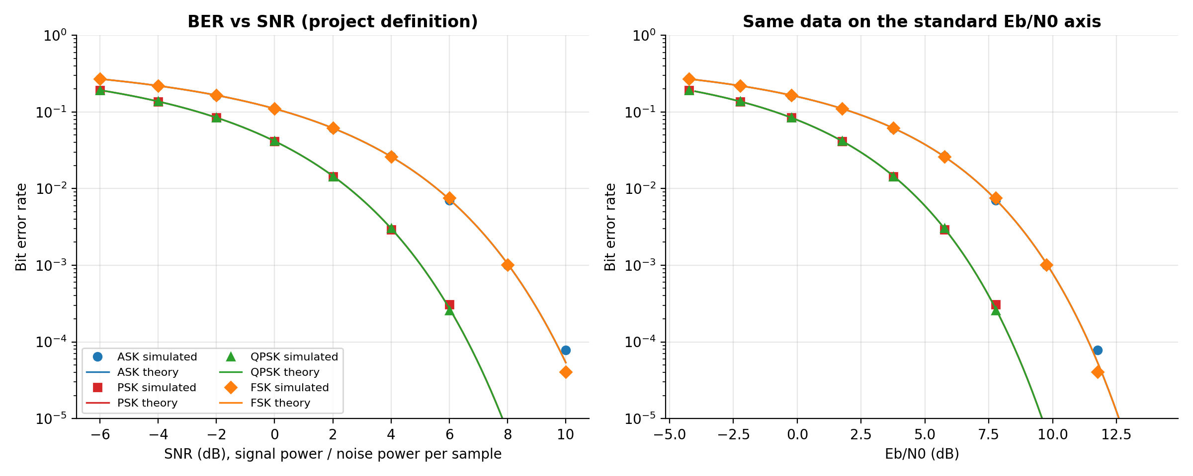
Figure 7. (ii-a) BER versus SNR for the four schemes at the baseline point; the right panel re-plots the same data against Eb/N0

5.4 (ii) BER versus SNR, continued
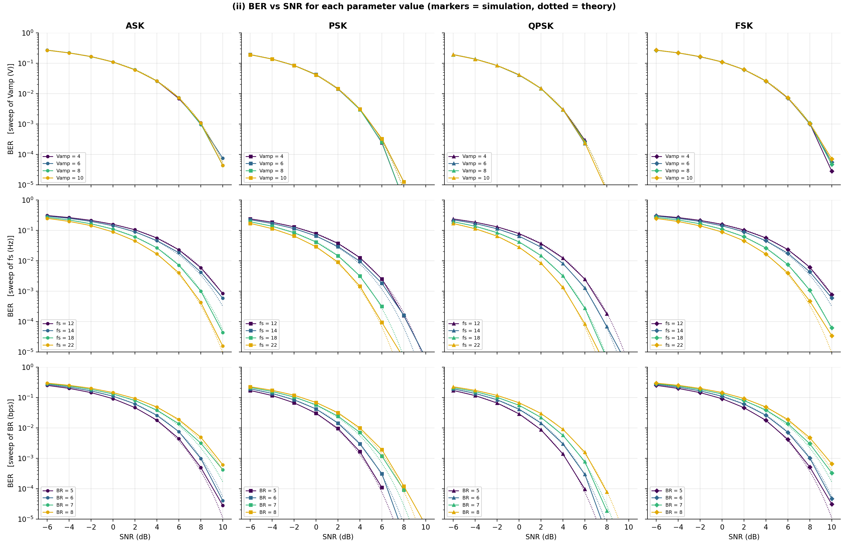
Figure 8. (ii-b, ii-c, ii-d) BER versus SNR for each Vamp (top row), each fs (middle row) and each BR (bottom row), one column per scheme.
.

5.5 Packet errors
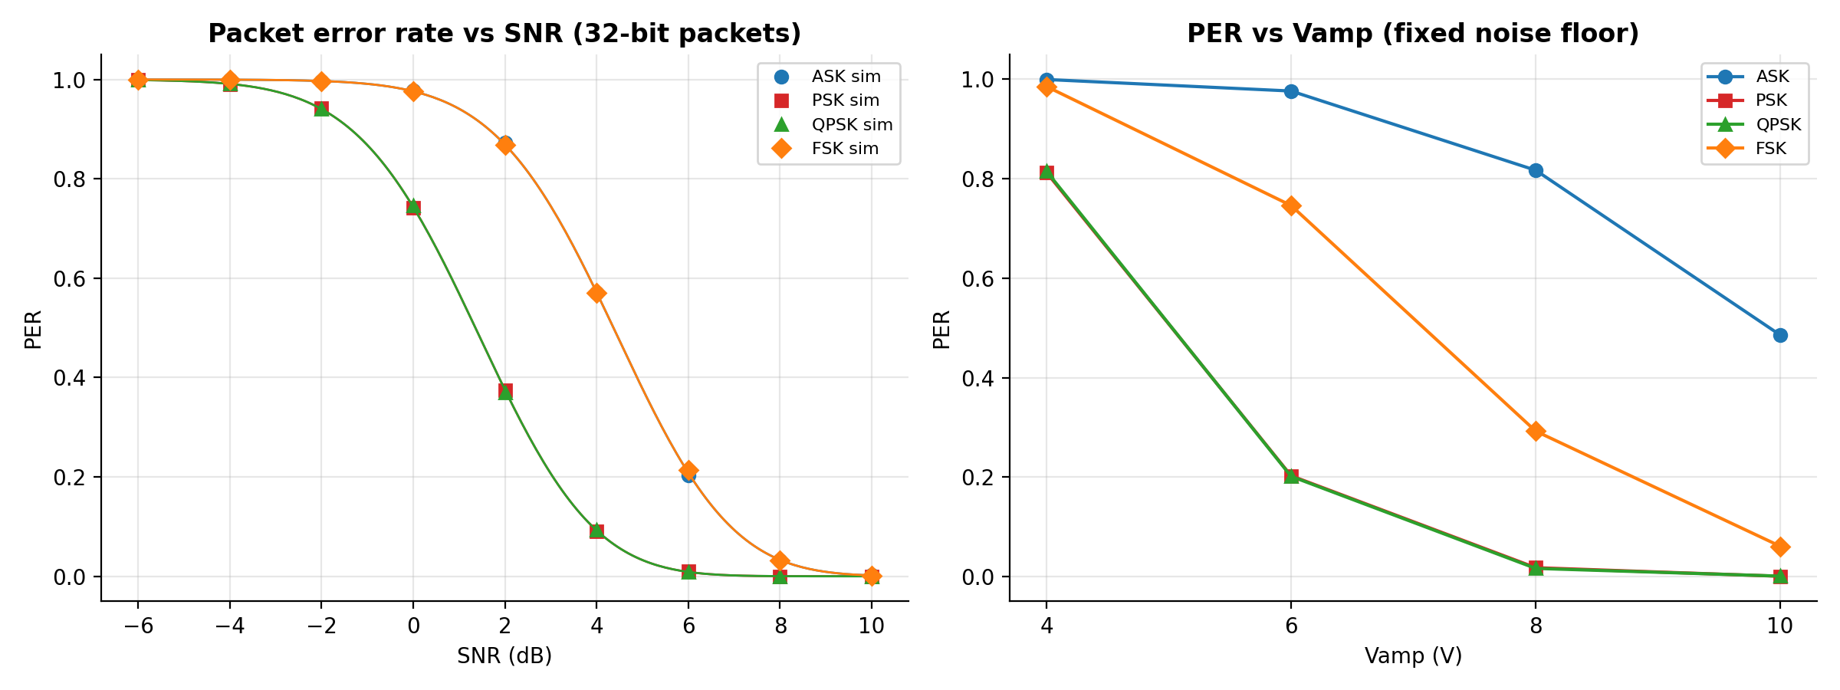
Figure 9. Packet error rate (32-bit packets) versus SNR and versus Vamp.

6. Analysis of the results (iii)

6.1 Effect of the modulation scheme (a)
At the same Vamp, PSK and QPSK give the same BER (0.0075 and 0.0073 at the baseline), FSK is about 5.5 times worse (0.041) and ASK is about 15 times worse (0.110). The reason is the distance between the decision points relative to the noise. PSK uses the two antipodal points +a and -a, a separation of 2a. FSK separates its two hypotheses by a*sqrt(2). ASK separates 0 and a only by aand its average power is half that of the others. In energy terms this is a 3 dB penalty for FSK and a 6 dB penalty for ASK relative to PSK at equal peak amplitude. For a target BER of 0.001, PSK needs Eb/N0 of about 6.8 dB while ASK and FSK with the same average energy per bit need about 9.8 dB.
QPSK carries two bits per symbol in the same bandwidth-time footprint and keeps the BER of PSK, so it doubles the throughput for no penalty in Eb/N0. Its price is a more complex coherent receiver with phase recovery on two quadrature branches. ASK is the simplest to build but is the least power efficient and the most sensitive to gain variations.

6.2 Effect of carrier amplitude (b)
With a fixed noise floor, raising Vamp from 4 V to 10 V cuts PSK BER from 0.051 to about 2e-5, three orders of magnitudeand ASK BER from 0.21 to 0.02. BER decays like exp(-A^2) because Eb/N0 grows with A^2, so the improvement per volt is largest at high amplitude on a logarithmic scale. This is the cleanest demonstration of the Q-function: the simulated points sit on the dotted theory lines in Figure 7 (left).
Important subtlety. In the BER versus SNR plots (top row of Figure 8) the four Vamp curves lie on top of each other. This is correct, not a plotting error: SNR is a ratio of signal power to noise power, so scaling the signal and the noise together leaves the error probability unchanged. Amplitude only helps when the noise floor is held constant, as in Figure 7. This distinction is worth stating explicitly in the project defence.

6.3 Effect of sampling frequency (c)
At a fixed noise floor N0, the sampling frequency has almost no effect on BER (PSK stays between 0.0071 and 0.0087 for fs = 12 to 22 Hz). The integrator averages fs/BR samples, each with noise variance proportional to fsand the two effects cancel exactly. What remains is a small quantisation effect: fs = 12 Hz and 18 Hz give integer samples per bit (2 and 3) and sit on the ideal value, while fs = 14 Hz (2.33) and 22 Hz (3.67) are slightly worse, in agreement with the integer-sample theory.
In the BER versus SNR plots (middle row of Figure 8) the picture changes. Because SNR is measured per sample, a higher fs spreads the same noise power over more samples, so more averaging happens per bit and the BER at a given SNR improves. Moving from fs = 12 Hz to 22 Hz with BR = 6 bps gives a processing gain of 10log10(22/12) = 2.6 dB, visible as a left shift of the curves. Sampling faster than the minimum is therefore a way to buy noise margin when SNR is defined per sample, but it does not help if the noise density is fixed.

6.4 Effect of bit rate (d)
BER rises steadily with bit rate (PSK: 0.0044 at 5 bps, 0.0072 at 6 bps, 0.0140 at 7 bps, 0.0188 at 8 bps), because a shorter bit has less time to integrate the signal, so Eb = Pavg/BR falls. Going from 5 to 8 bps costs 10log10(8/5) = 2.0 dB of Eb/N0. This is the basic rate versus reliability trade-off. In the SNR plots (bottom row of Figure 8) the same ordering appears, with the slowest rate (5 bps) the left-most curve.

6.5 Agreement between simulation and theory
Across every sweep the simulated BER matches the Q-function prediction. Deviations at the lowest BERs (for example PSK at 10 V, 1.7e-5 simulated versus 2.2e-5 theory) are within the expected statistical scatter for 640,000 bits, which contains only about a dozen errors at that point. Bits are counted over 640,000 trials, so BER values below about 1e-5 cannot be resolved and are omitted from the log plots.

6.6 Packet error rate
PER amplifies BER sharply. At the baseline, PSK has a BER under 1 percent yet loses about one 32-bit packet in fiveand ASK loses nearly every packet (0.978). A system that needs reliable packets must therefore operate at BER below roughly 1e-3 (PER about 3 percent for 32 bits), which for PSK means Eb/N0 of about 7 dB or more. Error correction coding or shorter packets would be the natural next steps.

7. Improvements over the original code
The code supplied with the project was reviewed and several issues limited its relevance. They are fixed in the new implementation.
Issue in the original script | Why it matters | Fix in the new simulation
Only one fixed setting (fs = 12, BR = 2, 2 V, 25 dB) | No sweeps, so (i) and (ii) cannot be produced | Full sweeps over scheme, Vamp, fs, BR and SNR
30-tap FIR low-pass with cutoff BR/2 | Group delay of 14.5 samples exceeds one bit at fs = 12, so decisions are misaligned; cutoff also removes signal energy | Integrate and dump matched to the bit window
Sampling with fs // BR from index 0 | Samples at the bit edge, not the centre or end; breaks for fs/BR non-integer (14/5, 22/7 and so on) | Window boundaries from ceil(k*fs/R); averaging over each window
Theoretical BER = Q(sqrt(2*SNR)) from a rearranged formula | Independent of amplitude, bit rate and scheme, so it cannot be compared with simulation across the sweeps | Scheme-specific theory with Eb/N0 = SNR*fs/(2 BR) and integer-sample correction
Noise scaled to measured symbol energy | Hides the effect of Vamp, so BER vs Vamp is flat | Both a fixed-N0 mode and a fixed-SNR mode
Two packets, packet error as one flag | PER is 0 or 1 and carries no information | 32-bit packets, PER simulated and theoretical
Only ASK-like on-off input | Task sheet lists ASK / PSK / QPSK / FSK | All four schemes implemented

8. Conclusions
- The architecture was implemented end to end and every requested output was produced: BER versus a, b, c, d; BER versus SNR for each parameter value; bit errors, packet errors, BER, PER and SNR.
- Simulation and Q-function theory agree across all operating points, which validates both the model and the code.
- Scheme ranking at equal amplitude is PSK = QPSK > FSK (about 3 dB worse) > ASK (about 6 dB worse); QPSK gives twice the throughput of PSK at the same BER.
- Higher amplitude lowers BER exponentially at a fixed noise floor; higher bit rate raises BER; sampling frequency has almost no effect at fixed N0 apart from a small penalty when fs/BR is not an integer.
- When BER is shown against SNR, amplitude drops out and fs and BR act only through the processing gain 10log10(fs/2BR).
- Packet errors are far more severe than bit errors, which motivates coding and a BER target near 1e-3 or better.

Limitations and possible extensions
The model assumes perfect carrier phase, perfect bit timing and a flat AWGN channel. Natural extensions are Rayleigh fading, phase and timing offset, higher-order QAM, forward error correctionand measuring BER on a real passband waveform with a bandpass front end.

