

**SWE4304**

SPL Draft Proposal

**HireUp**

**Name of Supervisor:**

SM Sabit Bananee

**Team Members:**

Nafisa Tasnim (220042114)

Nishat Tasnim (220042124)

Mrittika Jahan (220042150)

**Overview:**

The process of job searching in Bangladesh is surrounded by various obstacles, which hamper both the job seeker and the employer. The competition is high; hundreds of fresh graduates come into the job market every year, making some positions have too many numbers of job-seekers. This is worsen by the problem of skill mismatch, where most of the job-seekers cannot provide the qualifications which employers demand, which results in disappointing both parties. Besides, while there are more job opportunities in cities, those who live in rural areas face more difficulties to get a job. Additionally, job placement based on acquaintances or other personal networks puts those who do not have personal connections at a disadvantage in their search for opportunities. On the other hand, job circulars from companies can’t reach to enough people who are skilled for the specific field of work.

To tackle the challenges of job searching in Bangladesh, a well-designed job portal system can make a big difference. This platform will offer clear job listings that detail the skills and qualifications needed for each position so that seekers can understand what employers are looking for. It will reach a wide audience, including people in rural areas, so everyone has access to job opportunities. Moreover, incorporating networking tools within the portal can connect job seekers with industry professionals, making it easier for those without strong personal connections to find opportunities. Overall, a centralized job portal will greatly enhance the job search process for both candidates and employers.

So, we have decided to create HireUp to solve these problems. HireUp will take the information of the job applicants and job providers, then will create a profile for them. It’ll make the task of finding jobs easier and suggest jobs based on the requirements. This application will make sure that the job circulars will have detailed skills and qualification needed for it so that job applicants will not have any confusion.it will reach a wide audience so that everyone can access to job opportunities

**Motivation:**

The goal or purpose of HireUp is to facilitate the connection between job seekers and providers. Job Seekers can search for job opportunities based on their skills, experience, location, or preferences. They can also submit applications, generate resume and track application status.

Job providers can post job openings and define required qualifications, screen and review applications from potential candidates, find qualified candidates by browsing profiles and resumes.

In essence, HireUp will simplify the recruitment process, make it easier for both job seekers and providers to find the best match efficiently.

**Class Diagram:**

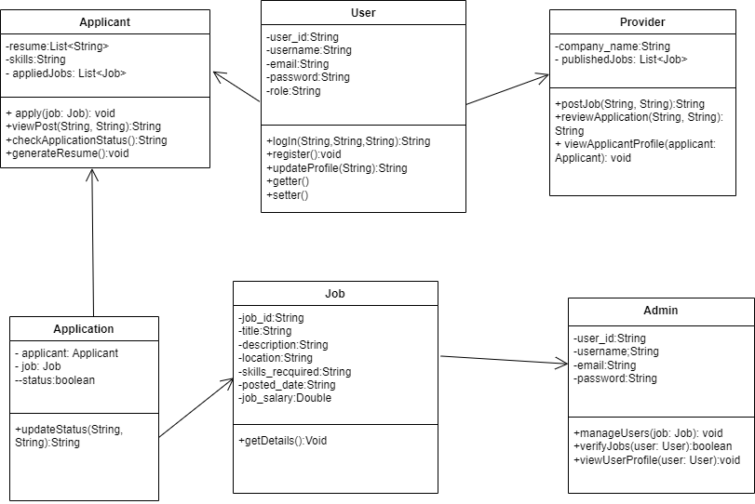

**Features:**

**Applicant:**

* **Registration:**

HireUp will take the job seeker’s basic information and register them.

* **Resume Creation:**

Using the provided information, this application will create a resume for the job applicant.

* **Job Preference:**

Job applicant will be able to find jobs according to their preferences.

* **Job Application:**

Applicants will be able to apply for jobs.

* **Job Status:**

Applicants will be able to see the list of the jobs for which they are shortlisted, confirmed or cancelled.

**Job Provider:**

* **Registration:**

HireUp will take the job provider’s basic information and the links for their social media platforms, website then create a profile.

* **Circular Publishing:**

Job providers can publish the job circulars.

* **Selection:**

They can see the list of the applicants for the job and see their profiles, then shortlist or reject the applicants.

* **View Shortlist:**

They can see the list of applicants who are shortlisted.

**Admin:**

* **View User Info:**

Admin can view a list of all users.

* **Account Handling:**

They can disable or delete user accounts.

* **Verification:**

Admin can check if job postings are fake and based on that they can approve or cancel job postings.

**Future Feature:**

* **Sort Applicant List:**

Using a particular requirement, job provider can sort the applicant list. This makes the process of shortlisting less time consuming.

**Tools & Technology:**

**Language:** Java

**IDE:** Intellij IDEA

**Database:** MySQL

**Version Control:** GitHub

**Proposed Timeline:**

**Week 1-2 - Initialization & System Architecture Finalization**

* Establish project boundaries, targets, and necessary criteria.
* Develop a comprehensive project plan with clear milestones and deliverables.
* Establish the development environment, setting up all required tools and libraries.

**Week 3-4 - Knowledge Gathering**

* Learning database and MySQL.
* Deepening the understanding of Java OOP.

**Week 4-5 -** **Design of Database Schema**

* Database design and create the necessary tables.
* Implement data models for applicant and job provider.
* Establish relationships between database tables.
* Test database functionality.

**Week 5-6 – User Profile Creation**

* Create form to get information of the two types of users.
* Implement the information in database and register them.

**Week 7-8 – Personalized Job Search and Application tracking**

* Resume creation for applicant.
* Add filter for different job preferences (Location, Salary, etc.).
* Develop job application functionality.
* Add functionality to see the list of job for which the applicants are shortlisted, confirmed or cancelled.

**Week 9-10 –** **Job Posting Application and Management**

* Implement the functionalities for publishing job circular.
* Create options for the job providers to shortlist or reject the applicants.
* Implement view shortlist to see the list of the applicants who are shortlisted.

**Week 11-12 – Account Control and Job Posting Validation**

* Add functionalities so that admin can view the list of all user.
* Implement account handling to disable or delete the unsuitable user account.
* Implement verification of the job posting.

**Week 5-13 –** **Testing and Debugging**

* Integrate the applicant and job provider panels with database.
* Perform unit testing.
* Debug and resolve any issue or bug identified during testing.