Retrieval-Augmented Generation (RAG)
An Overview of RAG Systems and Pipelines

Introduction to RAG
Retrieval-Augmented Generation (RAG) is a type of artificial intelligence system that combines data ingestion, embedding, and retrieval to enable intelligent context-aware generation.
RAG systems have been shown to be effective in a variety of applications, including natural language processing and text generation.
The key idea behind RAG is to leverage the power of retrieval to augment the generation process, allowing the system to draw upon a vast amount of knowledge and generate more accurate and informative responses.
This approach has been shown to be particularly effective in applications where the generation of text is critical, such as chatbots, language translation, and text summarization.
RAG systems have the potential to revolutionize the field of natural language processing and text generation by providing more accurate and informative responses to user queries.
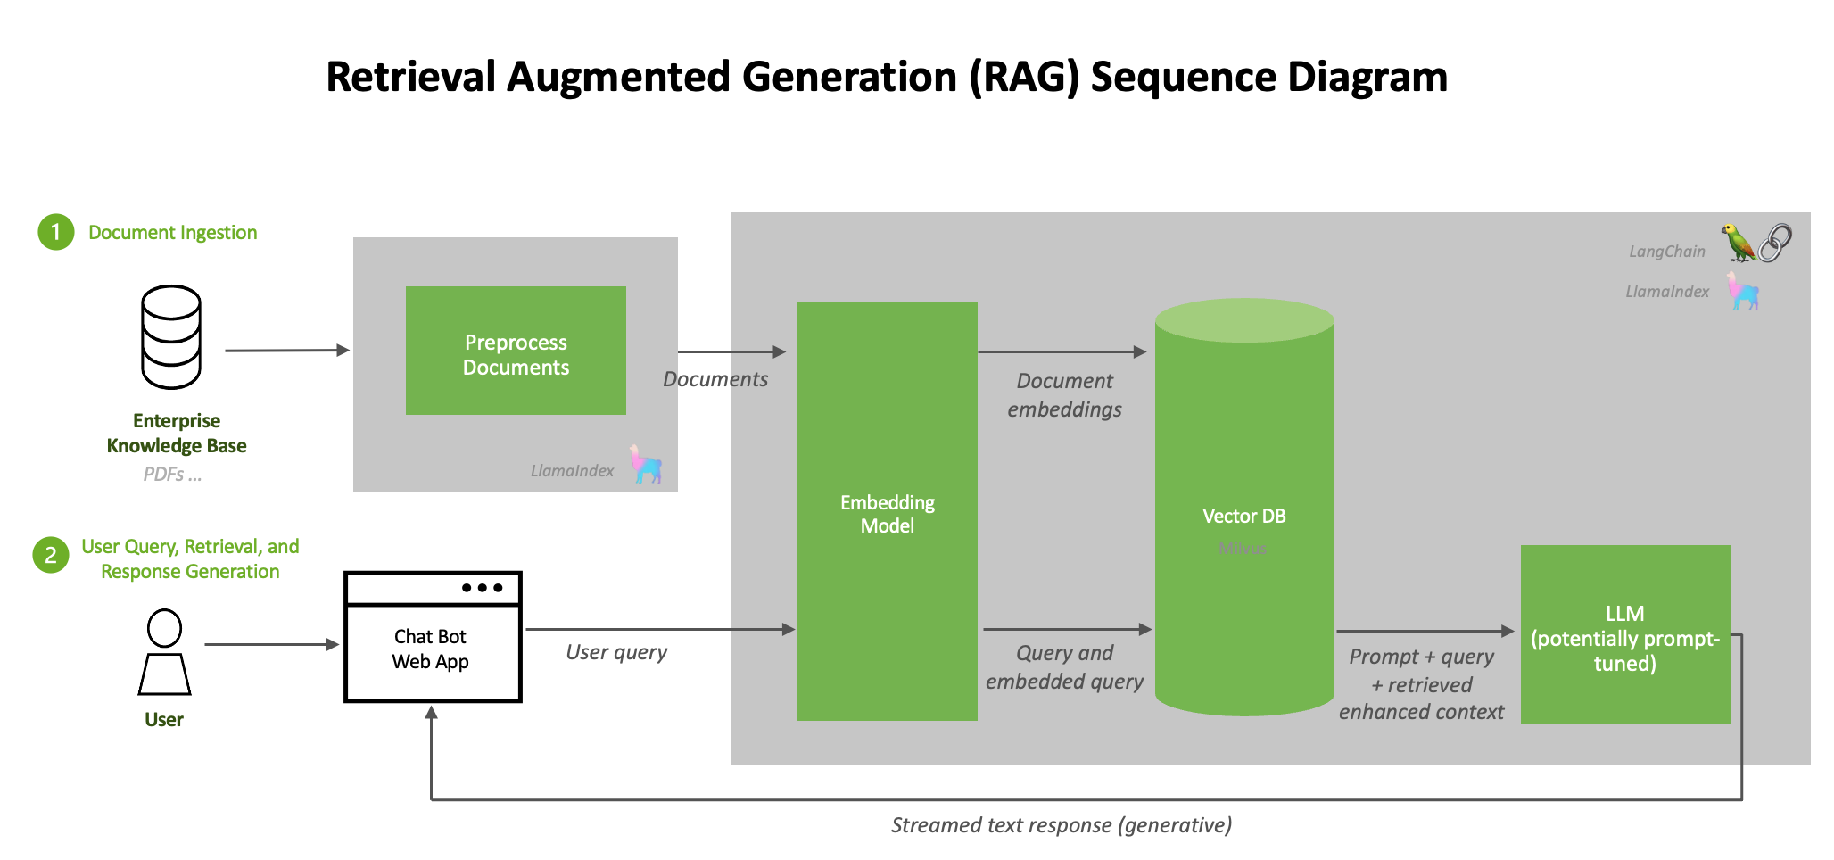
RAG pipeline ingest and query flow

RAG Pipeline Components
The RAG pipeline consists of several components, including data ingestion, embedding, and retrieval.
Each component plays a crucial role in the overall functioning of the RAG system.
The data ingestion component is responsible for collecting and processing the data that will be used to train the RAG model.
The embedding component is responsible for converting the input data into a format that can be used by the retrieval component.
The retrieval component is responsible for searching the database and retrieving the most relevant information to augment the generation process.
The RAG pipeline also includes a generation component, which uses the retrieved information to generate the final output.
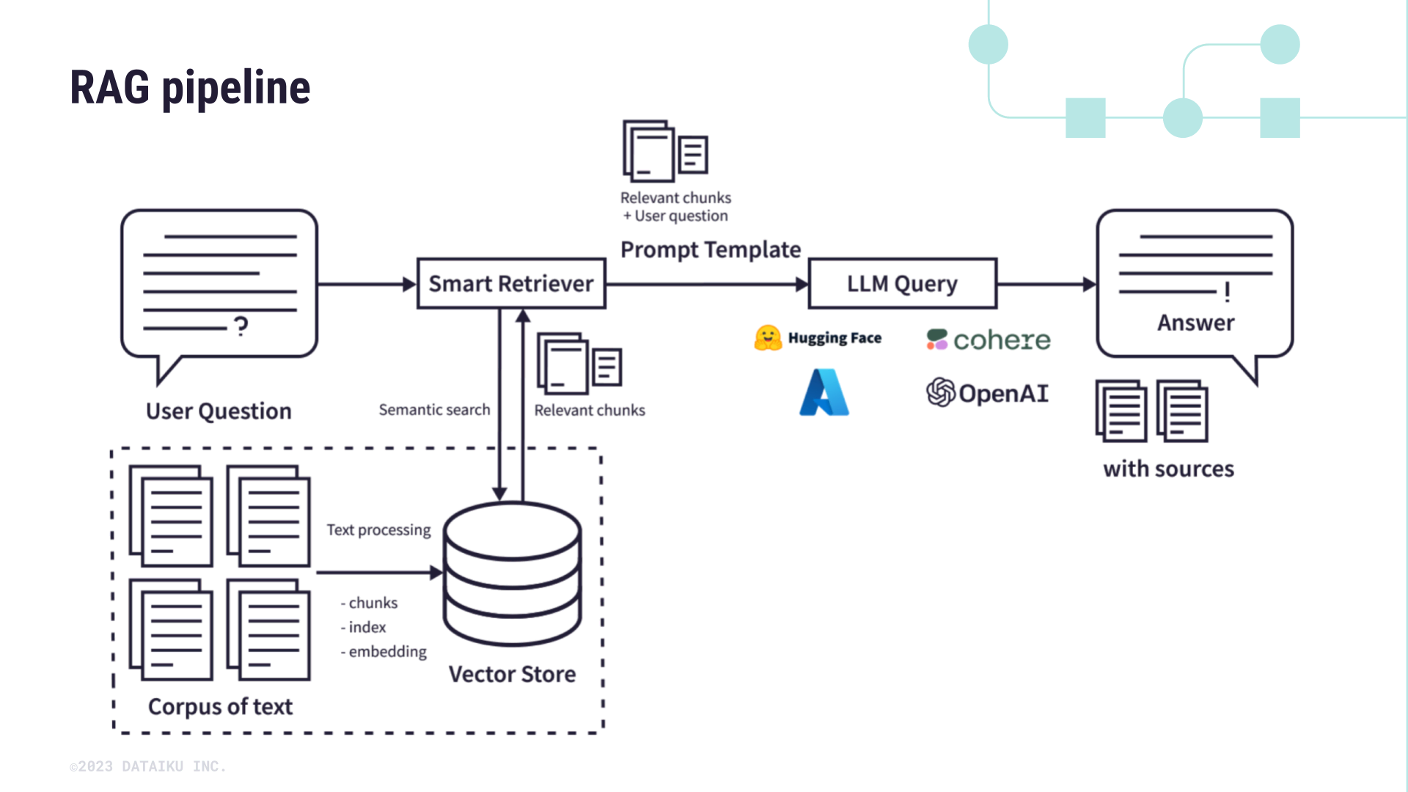
RAG pipeline components

Applications of RAG
RAG systems have been applied in a variety of domains, including natural language processing and text generation.
The use of RAG systems has been shown to improve the efficiency and effectiveness of these applications.
For example, RAG systems have been used to improve the accuracy of language translation systems, allowing for more accurate and fluent translations.
RAG systems have also been used to generate more informative and engaging text summaries, allowing users to quickly understand the main points of a document.
In addition, RAG systems have been used to improve the performance of chatbots, allowing them to provide more accurate and helpful responses to user queries.
RAG systems have also been used in other applications, such as text classification and sentiment analysis.

Benefits of RAG
The use of RAG systems has several benefits, including improved accuracy and efficiency.
RAG systems can generate more accurate and informative responses, allowing users to quickly understand the main points of a document or conversation.
RAG systems can also improve the efficiency of applications, allowing them to process and generate text more quickly.
In addition, RAG systems can be used to improve the performance of other AI systems, such as language translation and text summarization.
Overall, the use of RAG systems has the potential to revolutionize the field of natural language processing and text generation by providing more accurate and informative responses to user queries.
RAG systems can also be used to improve the user experience, by providing more personalized and relevant responses to user queries.

Challenges and Limitations of RAG
Despite the benefits of RAG systems, there are also several challenges and limitations to their use.
One of the main challenges is the need for large amounts of training data, which can be time-consuming and expensive to collect.
Another challenge is the need for complex algorithms and models, which can be difficult to develop and train.
In addition, RAG systems can be sensitive to the quality of the input data, and may not perform well if the data is noisy or incomplete.
Overall, the use of RAG systems requires careful consideration of these challenges and limitations, as well as ongoing research and development to improve their performance and efficiency.
RAG systems also require significant computational resources, which can be a challenge for some organizations.

Future Directions for RAG
The field of RAG is rapidly evolving, with new applications and technologies being developed all the time.
One area of research is the development of more advanced algorithms and models, such as those using deep learning and neural networks.
Another area of research is the application of RAG to new domains, such as image and speech processing.
In addition, there is a growing interest in the use of RAG for social good, such as improving language accessibility and promoting cultural understanding.
Overall, the future of RAG is exciting and full of possibilities, and it will be interesting to see how this technology continues to evolve and improve in the coming years.
RAG systems also have the potential to be used in a variety of industries, such as healthcare and finance, to improve the efficiency and effectiveness of text-based applications.

References
My visualization of a full Retrieval-Augmented Generation (RAG ... — https://www.reddit.com/r/Rag/comments/1oq7air/my_visualization_of_a_full_retrievalaugmented/
RAG 101: Demystifying Retrieval-Augmented Generation Pipelines — https://developer.nvidia.com/blog/rag-101-demystifying-retrieval-augmented-generation-pipelines/
Retrieval Augmented Generation (RAG) Pipeline - ResearchGate — https://www.researchgate.net/figure/Retrieval-Augmented-Generation-RAG-Pipeline_fig1_382591411
RAG Pipeline - Retrieval-Augmented Generation System Impl using ... — https://www.researchgate.net/profile/Mohammad-Masum-2
Effective Retrieval-Augmented Generation for Open Domain — https://www.researchgate.net/publication/382591411_Effective_Retrieval-Augmented_Generation_for_Open_Domain
Demystifying Retrieval-Augmented Generation Pipelines — https://developer.nvidia.com/blog/rag-101-demystifying-retrieval-augmented-generation-pipelines/

