- Create a new program file in the practical3 folder, called KeyboardInput.c
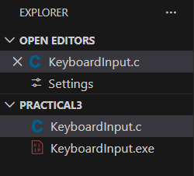

- Now add the following code to your program to read Hello, then World from the first line from the keyboard, and then the integer 4 on the second line, displaying them on two lines on the screen.
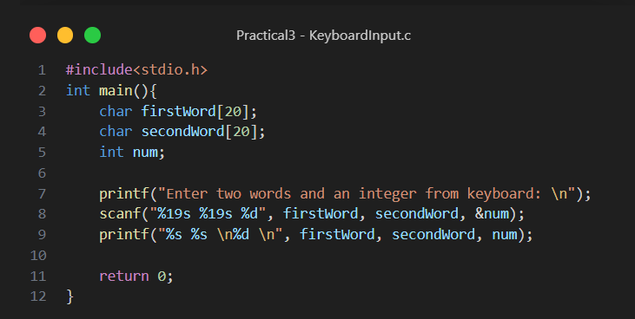

- Compile and Run your program to input and display the following input values from the keyboard:

Hello World
4

Note that in this case two input values (separated by spaces) are on the first line of input from the keyboard, and one input value is on the second line of input from the keyboard.
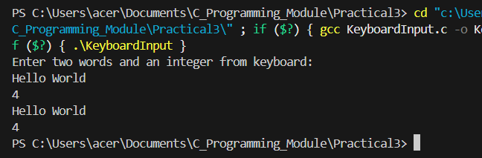

- Run your program again with the following input values from the keyboard:

Hello World 4

Note that in this case all three input values (separated by spaces) are on the same line of input from the keyboard. Does your program still work (i.e., is it still the same sequence of input values)?
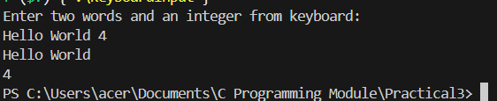

The program still works with the same output.

- Run your program again with the following line of input values:

Hello
World
4

Note that in this case each input value is on a separate line. Does your program still work (i.e.., is it still the same sequence of input values)?
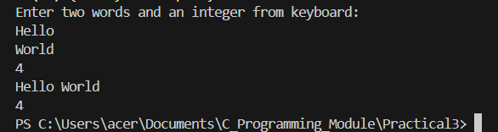

The program still works.

What happens if you type a word longer than 19 characters? Try it and observe.
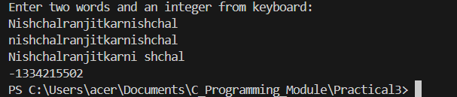

- first, to create a program file called ElectricityBillA.c in the practical3 folder that you have already created;
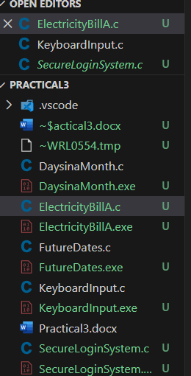

- second, to design, write and run a C program which will read input data from the keyboard which consists of 4 integers representing the previous metre reading, the present metre reading, day and month, each separated by a space/return (refer to Part 1 for this task).
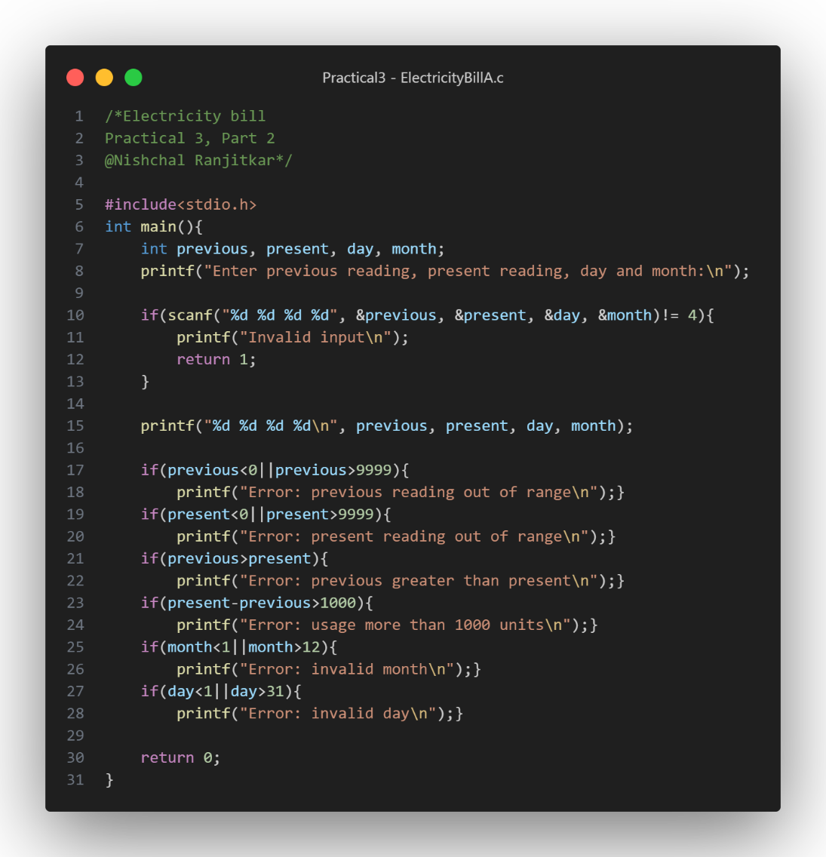

- Test your program with more input data given below. Note that you need to run your program again for each of the following sets of input values (run your program with one set of values at a time, e.g., run it 7 times).
