**RebalanceAI — AI-Powered Investment Portfolio Analyzer**

**Course: IE 5374 - Applied Generative AI**

**Team:** Group 4

**Members:**

- Nishchay Linge Gowda

- Shivakumar Hassan Lokesh

- Supriya Singh

**PROJECT OVERVIEW**

RebalanceAI is an AI-powered portfolio co-pilot that blends quantitative finance with LLM-based sentiment analysis to generate explainable investment recommendations from S&P 500 stocks.

Traditional strategies either rely only on past performance or only on hype-driven sentiment, we combine both into a fusion ranking model that balances stability + momentum.

**METHODOLOGY**

|  |  |  |
| --- | --- | --- |
| **Component** | **Source** | **Purpose** |
| Price Data (Sharpe Ratio) | Yahoo Finance via yfinance | Measures risk-adjusted performance |
| News Sentiment | Google News RSS + GPT Analysis | Captures market mood between -1 to +1 |
| Weighted Fusion Score | 0.6 × Sharpe + 0.4 × Sentiment | Ranks stocks objectively |

**MULTI-LLM EVALUATION & COMPARISON**

To satisfy cross-model evaluation, we compared sentiment scoring using:

|  |  |
| --- | --- |
| **Model** | **Behavior Observed** |
| GPT-3.5-Turbo | More volatile sentiment outputs (sensitive to wording) |
| GPT-4o-Mini | More stable & consistent across different headline formats |
| GPT-4-Turbo | Fast, consistent, and accurate |

**Conclusion:** GPT-4o-Mini was selected as the default sentiment engine due to its stability, numerical consistency, and reliable compliance with structured prompts.

**SETUP INSTRUCTIONS**

1) Install Dependencies

pip install, yfinance, pandas, NumPy, plotly, beautifulsoup4, OpenAI

2) Set OpenAI API Key

export OPENAI_API_KEY="your-key-here"

3) Run Backend Logic

from rebalance_backend import get_sp500_tickers, generate_portfolio

tickers = get_sp500_tickers()

df, fig1, fig2 = generate_portfolio(tickers[:50], client) # Top 50 for faster run

**OUTPUT VISUALS (Screenshots)**

**- Portfolio Allocation Pie Chart**

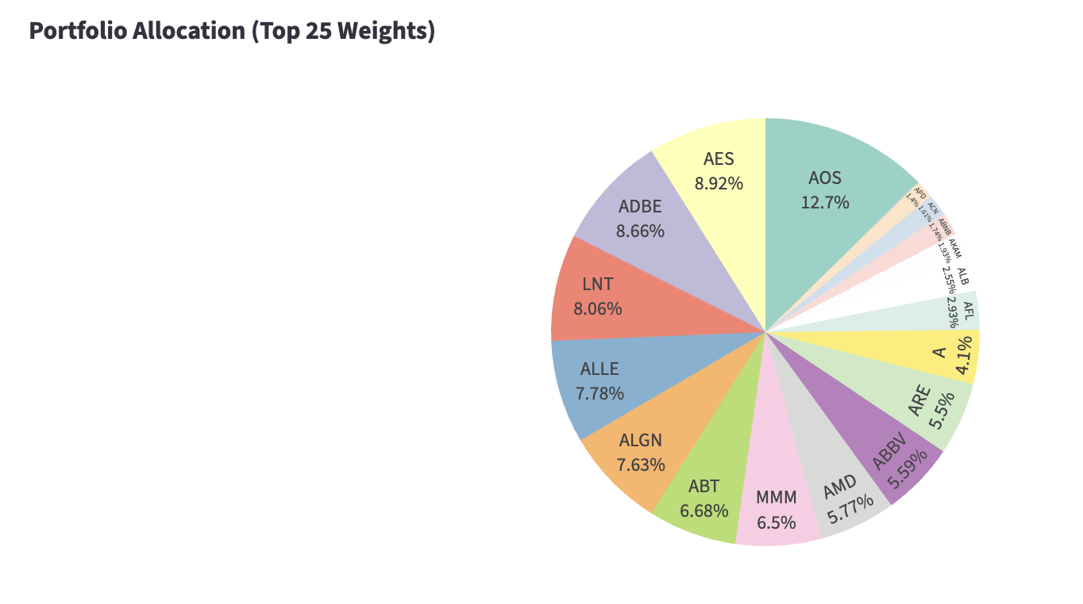

**- Sharpe vs Sentiment Scatter Plot**

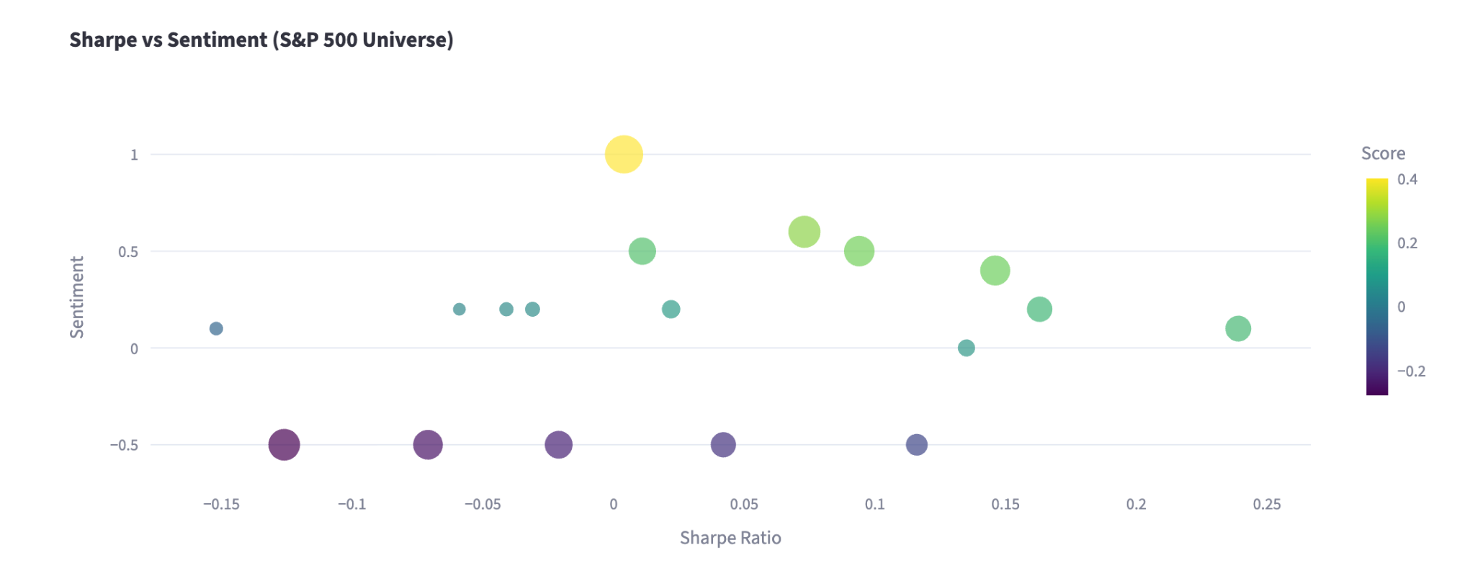

**- Top Allocations Table**

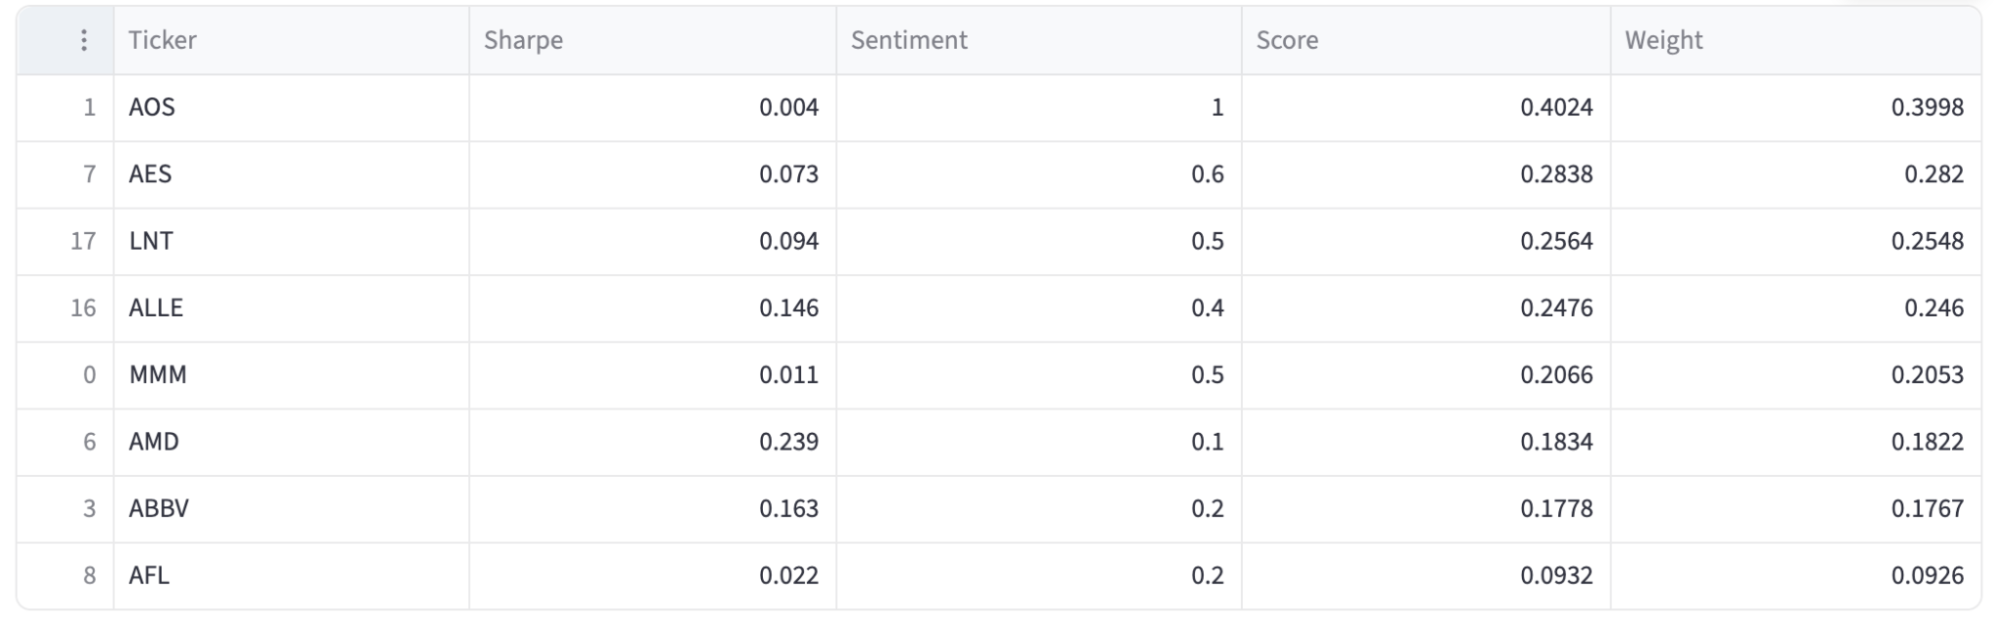

**SAMPLE AI INTERACTION**

User: "Which stock is overhyped but unstable in a short and direct way?”

AI: "The stock that is overhyped but unstable is APH. It has a high sentiment score of 0.2 but a low Sharpe ratio of 0.255, indicating it may be overvalued while also being unstable."

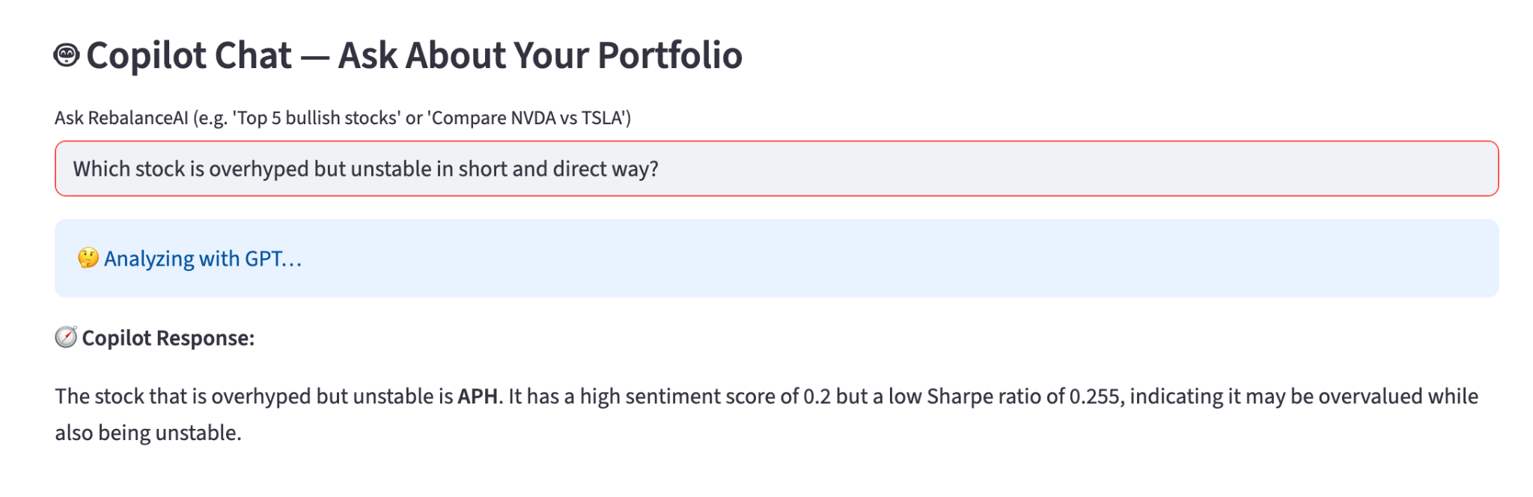

**KEY INSIGHTS**

- Sharpe alone is insufficient — it ignores short-term optimism  
 - Sentiment alone is risky — it rewards hype without grounding  
 - Fusion scoring combines rational stability + emotional awareness  
 - Multi-LLM validation improves sentiment reliability and reduces bias

**APPENDIX — TEAM COLLABORATION & CONTRIBUTIONS**

|  |  |
| --- | --- |
| **Team Member** | **Contributions** |
| Nishchay Linge Gowda | Sharpe Computation Backend, Portfolio Ranking Algorithm |
| Shivakumar Hassan Lokesh | Google News scraping, GPT sentiment prompting, multi-LLM testing |
| Supriya Singh | Fusion logic validation, presentation scripting, README/report preparation |

**REPOSITORY STRUCTURE**

Group4_RebalanceAI_Hackathon.zip

│-- Group4_RebalanceAI_README.txt

│-- Group4_RebalanceAI_Hackathon.ipynb

│-- Group4_RebalanceAI_Hackathon.ppt

│-- Demo video

|-- Sample Data