Ct coronary angiogram
Normal template:
CT – CORONARY ANGIOGRAM
- CLINICAL INDICATION:

CT CORONARY ANGIOGRAPHY: SEGMENTATION ANALYSIS
- CALCIUM SCORE: 0
- DOMINANCE: Right dominant
- ANOMALOUS ORIGINS / COURSE: Nil
- LEFT MAIN: Normal
- LEFT ANTERIOR DESCENDING:
Type:
Proximal: Normal
Mid: Normal
Distal: Normal
Diagonals: D1 and D2 are normal. D2 is a good sized vessel

- LEFT CIRCUMFLEX:
Proximal: Normal
Distal: Normal
Obtuse marginals: OM1 and OM2 are normal

- RIGHT CORONARY:
Proximal: Normal
Mid and Distal: Normal
Posterior descending: Normal
Posterolateral ventricular branch: Normal
GENERAL CARDIAC / GREAT VESSEL / EXTRACARDIAC ANATOMY:
- Myocardium:
Thickness: Uniform
Areas of infarction: No visible areas of infarction on this study
- Cardiac Chambers:
Left ventricle: Normal
Right ventricle: Normal
Left atrium: Normal
Right atrium: Normal
- Pericardium: Normal to the extent visualized.
- Pulmonary arteries and veins: Normal to the extent visualized.
- Aorta: Normal to the extent visualized.
- Lungs and pleura: Normal to the extent visualized.
- Mediastinum: Normal to the extent visualized.
- Bony cage: Normal to the extent visualized.

- IMPRESSION: Calcium Score- ; CADRADS-
- Right / left dominant coronary circulation.
- Normal CT angiogram study of the coronary arteries.
- No flow limiting coronary artery disease

BREAKDOWN OF EACH AND EVERY PARAMETER:
- CLINICAL INDICATION: usually used clinical indication. Key word are highlighted
- Left-sided chest pain, to rule out coronary artery disease
- Known hypertensive and diabetic patient, to rule out coronary artery disease
- Breathlessness or shortness of breath, to rule out coronary artery disease
- Atypical chest pain (not classic angina), for assessment of coronary arteries
- New onset of chest discomfort in a patient with normal prior ECG and stress test results
- Recurrent chest tightness in a patient with inconclusive prior testing
- Evaluation of possible coronary artery narrowing in a patient with risk factors (high blood pressure, diabetes, family history)
- Chest pain radiating to shoulder, jaw, or arm, to exclude coronary artery stenosis
- Assessment before cardiac surgery in a patient with symptoms suggestive of coronary disease
- Shortness of breath with exertion, to check for coronary blockages

- CALCIUM SCORE: Numerical value with no decimal.
One of the parameters of CADRADS scoring i.e the plaque burden is decided by the calcium score (table below for reference)
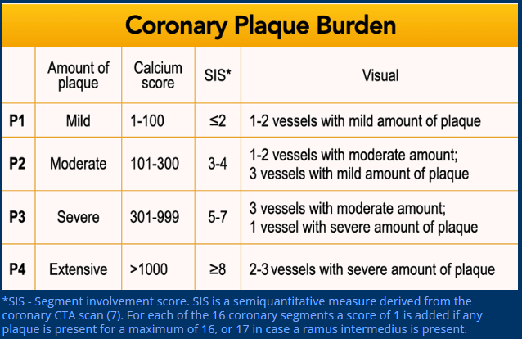
Eg in impression we write CADRADS- 3/P1 or 2/P2. The P1 to P4 is as described above.

- DOMINANCE:
Coronary artery dominance refers to which coronary artery gives rise to the posterior descending artery (PDA), determining the blood supply to the inferior portion of the heart
- Right Dominant: The right coronary artery (RCA) supplies the PDA. This is the most common pattern.
- Left Dominant: The left circumflex artery (LCx) gives rise to the PDA.
- Co-Dominant: Both the RCA and LCx provide branches to the PDA and posterolateral artery.
When we say right dominant the format will stay same.
In left dominant system:
Posterior descending: Normal
Posterolateral ventricular branch: Normal
These above two highlighted points will come under the heading of Left circumflex artery along with proximal and Distal segments point.
In Co-dominant system:
Posterior descending: Normal --This will come under Right coronary artery heading along with the proximal, mid Distal segments.
AND
Posterior descending: Normal
Posterolateral ventricular branch: Normal – This both will come under Left circumflex artery, along with Proximal and Distal segments point.

- ANOMALOUS ARTERIAL COURSE
Major Anomalous Coronary Artery Courses
- Interarterial course — the artery passes between the aorta and pulmonary artery.
This is the most clinically significant (“malignant”) course, increasing the risk of compression and ischemia during exertion.
- Retroaortic course — the artery passes posterior to the aorta.
Usually benign, commonly seen with left circumflex (LCx) arising from the right coronary sinus.
- Prepulmonic course — the artery travels anterior to the pulmonary artery.
Typically benign, often seen with LAD arising abnormally from the right coronary sinus.
- Transseptal (Subpulmonic) course — the artery courses through the interventricular septum beneath the pulmonary artery.
Generally benign, but important to distinguish from interarterial variants.
- Retrocardiac or posterior course — rare variant where the artery passes behind the left atrium before reaching target territory.
- Intramural course — the anomalous artery runs within the aortic wall in part of its proximal segment.
May lead to luminal compression and is considered potentially malignant.a
- High take-off — artery originates above the sinotubular junction.
May be asymptomatic, but occasionally associated with difficult catheter access and ischemia.

Report Writing Tip (with highlighted keywords)
When describing in a CT angiography report, use format such as:
- “Anomalous Right Coronary Artery (RCA) arising from the left coronary sinus with an interarterial course between the aorta and pulmonary artery.”
- “Left Circumflex Artery (LCx) arising from the right coronary sinus with a retroaortic course.”
- “Left Anterior Descending (LAD) artery shows a prepulmonic course anterior to the right ventricular outflow tract.”

- LEFT MAIN:
Length of the LMCA.
Bifurcation pattern:
- Normal bifurcation into Left Anterior Descending (LAD) and Left Circumflex (LCx) arteries. (No need to mention this normal)
- Trifurcation into LAD, LCx, and Ramus Intermedius (arising between LAD and LCx, usually of small caliber). (mention this when mention trifurcates (only the highlighted part). Then mention (Ramus intermedius) RI- normal, stenosed, diseased etc.
Anatomical variants:- Malignant or anomalous courses (less common but important): such as interarterial course, retroaortic, or intramural pathway.
Additional anomalies: Rarely, absence of LMCA or atypical origins (e.g., arising from the right coronary cusp).

- LEFT ANTERIOR DESCENDING:
- Type:
- Type I: A short LAD that terminates before reaching the left ventricular (LV) apex. In this type, the cardiac apex is supplied by other coronary arteries.
- Type II: An intermediate-length LAD that supplies part of the LV apex. The remaining portion of the apex is supplied by the right coronary artery.
- Type III: A longer LAD that supplies the entire apex of the left ventricle.
- Type IV (Wrap-around): The longest type of LAD. It supplies the entire apex and extends to wrap around it, supplying more than 25% of the inferior wall of the heart.

17. Impression:
Calcium Score- as mentioned should come.
CADRADS- Auto assessment with the help of findings above and keywords.
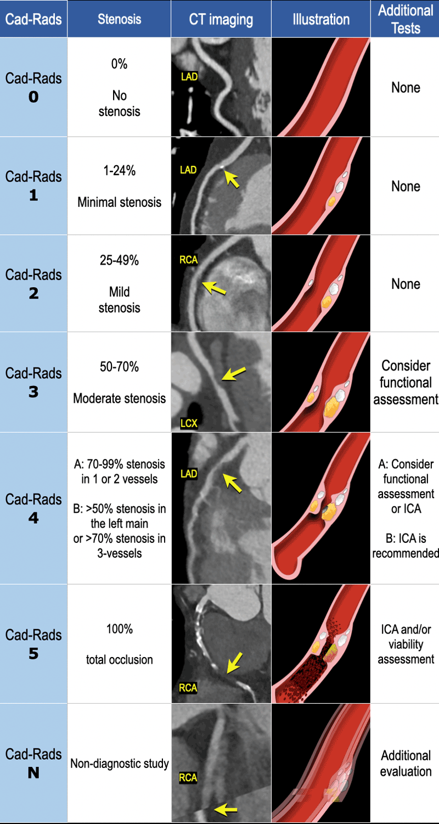

Then comes Plaque burden

Then comes modifiers:
6 modifiers that can be added to the Cad-Rads category:
- N: indicates that a study is non-diagnostic
- HRP: high-risk plaque (replaces V-vulnerable plaque)
- I: ischemia
- S: presence of stents
- G: coronary artery bypass grafts
- E: exceptions
Modifier N - nondiagnostic
If not all segments (>1.5 mm diameter) are diagnostic (e.g. motion artifacts), modifier N should be listed.
There are two ways of listing modifier N:
- In case of a non-diagnostic segment and the presence of no (0%), minimal (< 25%) or mild (25-49%) stenosis category CAD-RADS N should be used (no stenosis grade should be listed, since coronary CTA is not able to guide patient management).
- In case of stenosis degree ≥ 50% in one diagnostic segment the patient should be categorized as CAD-RADS 3/N.
Overall plaque burden should also be reported for non-diagnostic scans (N), if total coronary plaque burden can be assessed reliably.
In case of stenosis degree < 50% N should be placed before category P (e.g. CAD RADS N/P2).
If stenosis ≥ 50% then P should precede N (e.g. CAD RADS 3/P2/N).

Modifier HRP - high-risk plaque (key words are mentioned in the table above)
The term “vulnerable plaque” has been replaced by “high-risk plaque features” as modifier “HRP”.
High-risk plaque features include: low-attenuation plaque, positive remodelling, spotty calcification and napkin-ring sign. If two or more of these features are present modifier “HRP” should be added to the CAD-RADS category.
There are three plaque types on coronary CTA:
- calcified
- partially calcified
- non-calcified
Calcified plaque is an atherosclerotic plaque in which the entire plaque appears as calcium density (>130 HU on non-enhanced CT).
The previous terminology “hard plaque” is not recommended.
Partially calcified plaque is an atherosclerotic lesion with 2 components of which one is calcification.
The previous term was “mixed plaque”, which is no longer recommended.
Non-calcified plaque is a plaque without calcium content. The use of “soft-plaque”, “low-density plaque” and “fibrous plaque” should be avoided (8).
See also CTA features of stable and high risk plaques
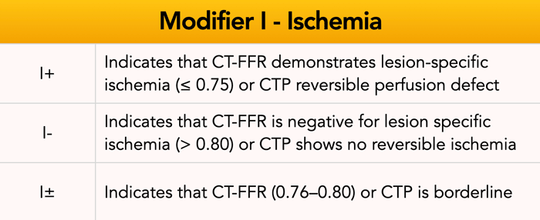
Modifier I - ischemia
CT-FFR (computed tomography fractional flow reserve) and stress CTP (computed tomography perfusion) are CTA derived non-invasive imaging techniques which allow to better define the hemodynamic significance of a stenosis ranging from 50 to 90% (CAD-RADS 3 and 4A).
CAD-RADS 2 lesions can be also considered if there is a proximal stenosis ≥ 40%, including the presence of high-risk plaque features.

So the impression goes like Calcium Score- As mentioned ; CADRADS- 1 to 5/Plaque burden(P1 to P4)/Modifiers (if any)

18. Dominance according to the findings.
Followed by priority in the descending order to be mentioned if only positive or relevant findings as described below ( in case of normal study the mentioned points remain as it is)
- Anomalous origin if any
- Stents or grafts if any
- Most severe stenosis – should be crisp, small and to the point. Eg Focal high-grade stenosis (70-80%) in mid LAD or Up to 60% stenosis in proximal RCA or Diffuse proximal LAD disease with 50-60% stenosis.
- Followed by other vessel or lesser grade of stenosis (other than the vessel mentioned above, unless same grade stenosis is present in more than one major vessel)
- If stenosis is present remove the normal 19. And 20. Points.

