Team Working Agreement
Course: Comp 3380 A01
Project Name: GiG
Team Name: The Four Stooges
Date Created: 01/23/2026

Team Members
Name | Program / Year (optional) | Preferred Name / Pronouns (optional)
Izzy Elskamp | Computer Science 4th year
Adejare Taiwo | Computer Science 4th year
Nishchay Kathuria | Computer Science 4th year
Dayaveer Gill | Computer Engineering 4th year

1. Shared Team Goals (can add more than 3)
As a team, we agree that our shared goals for this project are:
- Get tasks done a few days before the deadline.
- Communicate!
- Set realistic goals.
(Examples: learning specific technical skills, producing a high-quality final product, maintaining low stress, equal workload, meeting deadlines early, etc.)

2. Individual Goals
Each team member lists their personal goals for this project.
Team Member | Individual Goals
Izzy | Be open, honest, and help others out as much as possible. Get a better feel for working on software with a team.
Adejare | Learn something and contribute throughout the process, work together as a team to achieve good outcome.  Learn to work in a team and develop a full working app to better understand the workflow, collaboration and also get acquainted to android studio.
Nishchay  Dayaveer | Have a app which I can look back on in the future and still be proud of. Actively work with my teams and be a team player.

3. Roles and Responsibilities
Roles may rotate unless otherwise specified. Note: none of these are developer roles. You are all responsible for development as well and these are just recommended additional roles to define.
Role | Description | Assigned To
Project Coordinator | Organizes meetings, tracks deadlines | Nishchay
Technical Lead | Oversees technical decisions and code quality | Izzy
Documentation Lead | Maintains README/docs | Everyone
GitLab Manager | Manages repo structure, merges, issues | Adejare
Quality Checker | Reviews work before submission | Dayaveer
If responsibilities are shared or rotated, describe how below:

4. Communication Plan
Primary communication channel(s): Discord
(e.g., Discord, Slack, WhatsApp, email)
Expected response time:
- Weekdays: 24 hours
- Weekends: 24 hours
- During critical deadlines: 2 hours
When is escalation required?
(e.g., no response after 24–48 hours, missed meeting, blocked progress)
If we are nearing a deadline.

5. Meetings
Regular meeting time(s): MWF 10:20 ->
Meeting platform/location: Engineering building
Meeting norms (check all that apply):
- ☐ Agenda shared in advance
- ☐ Start/end on time
- ☐ Cameras on (if online)
- ☐ Action items documented
- ☐ Everyone contributes - YES
What happens if someone cannot attend?
They join online or we brief them after the meeting.

6. Work Expectations
- How tasks will be assigned (e.g., issues, task board): First come first serve.
- Definition of “done” for a task: It’s on the main branch, tested and proven.
- Expectations around code quality / documentation: Just comment!

7. Conflict Resolution & Unmet Expectations
If conflict arises or expectations are not met, we agree to follow this process in order:
- Team vote
- Team meeting
- Bring to instructor
(Examples: direct conversation → team discussion → instructor escalation)
How will concerns be raised respectfully?
Transparency and respectfulness

8. Responsible GenAI Use
As a team, we have discussed the responsible and ethical use of Generative AI tools (e.g., ChatGPT, Copilot) for this project. We agree on the following shared norms:
Allowed uses of GenAI in this project include:
• Come up with ideas
• Syntax help
•
Disallowed uses of GenAI in this project include:
• Make entire project
• Code large sections that you don’t understand
•
Key risks we have identified related to GenAI use (e.g., correctness, over-reliance, fairness, integrity):
• Over-reliance, getting it to write code you don’t understand
• It can hallucinate false data
How our team will ensure transparency, accountability, and shared understanding of AI-assisted work:
• Be honest
• Communicate!

9. Accountability
If a team member repeatedly misses deadlines or responsibilities, the team will:
- Sit down and talk to them about it respectfully

(Be explicit — vague answers are not acceptable.)

10. Agreement
By signing below, we confirm that we have discussed this document together and agree to follow it.
Name | Signature | Date
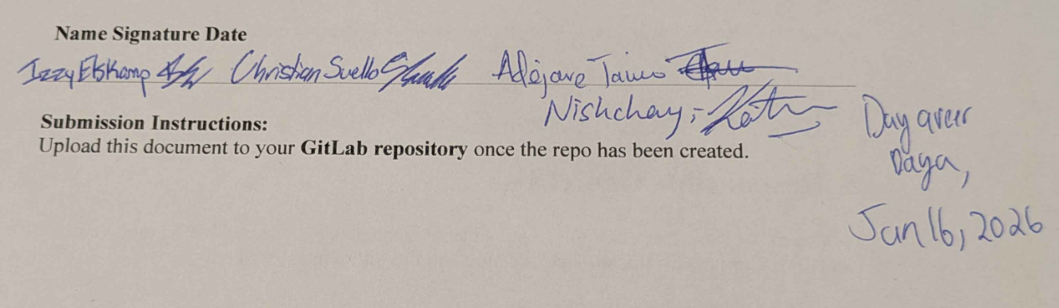

Submission Instructions:
Upload this document to your GitLab repository once the repo has been created.

